Pharmadex 2. Release Notes 2022-03-01

Contents

Motivation 1

Pre-requisite 2

Demo release particularities 2

Where to find 2

How to fine tune 3

Access control 4

# Motivation

* Main – develop de-registration feature (#1301)
* Item:
  + QA bug
    - monitoring feature
      * remove the duplicate trace and monitoring records
      * fix the error 404 in re-assigning executors for modification and de-registration
      * fix the error 404 in re-assigning executors in case of an empty list of executors
      * speed-up monitoring query
  + QA bug – Application history
    - remove the duplicate regular records
    - add all monitoring and trace records

# Pre-requisite

You must have a Gmail account that has not been registered in the Pharmadex 2 database. You should know the login and password for the supervisor user and have another login and password to log in as a business user, i.e., an applicant.

# Demo release particularities

This release may contain errors, bad user interface behavior, and inconsistencies. Please, report them to [alex.kurasoff@gmail.com](mailto:alex.kurasoff@gmail.com).

* The workflow implementation contains mistakes.
* The configurations described here are only for demonstration purposes.

De-registration feature (#1301)

The De-registration feature has been implemented only for the person and PVT-owned pharmacies. The reporting feature and the possibility to apply the feature to the transited pharmacies will be implemented next week. The wholesaler pharmacies will be applied after the wholesaler application implementation

## Where to find

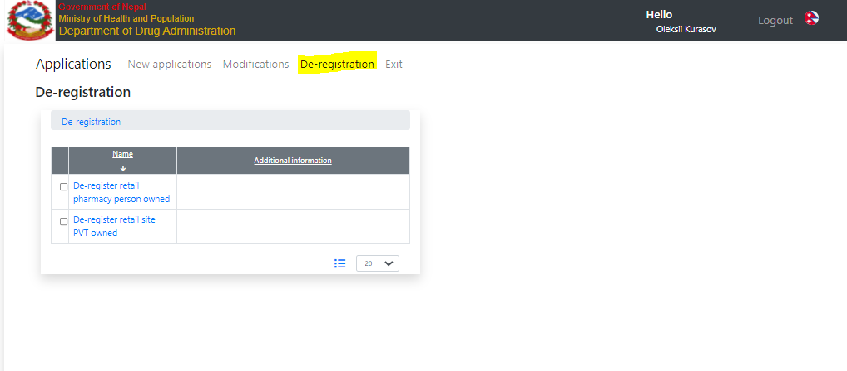

Figure 1. Select an object to de-register

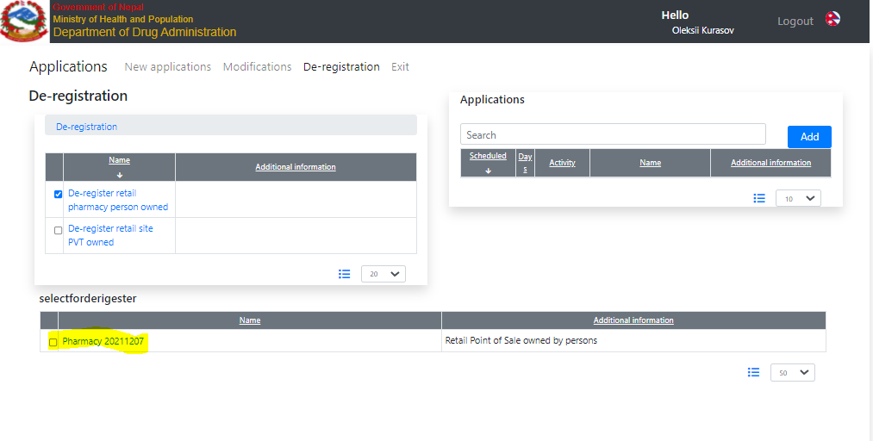

Figure 2. Select an object to de-registered

## How to fine-tune

All checklists are empty. Below are important data structures, checklists, resources, etc.

|  |  |
| --- | --- |
| **URL** | **Description** |
| Person(s) owned | |
| retail.site.owned.persons.deregistration | root data node |
| retail.site.owned.persons.deregistration.documents | the second tab |
| dictionary.retail.site.owned.persons.deregistration.documents | list of documents |
| dictionary.checklist.retail.site.owned.persons.deregistration | Self-check list |
| PVT owned | |
| retail.site.owned.pvt.deregistration | root data node |
| retail.site.owned.pvt.deregistration.documents | the second tab |
| dictionary.retail.site.owned.pvt.deregistration.documents | list of documnts |
| dictionary.checklist.retail.site.owned.pvt.deregistration | Self-check list |
| DDA workflow | |
| dictionary.checklist.deregistration.screening | Screener checklist |
| dictionary.checklist.deregistration.review | Reviewer checklist |
| dictionary.checklist.deregistration.approve | Approver checklist |
| deregistration.approve.register | Approve tab data |
| dictionary.checklist.deregistration.finalization | Finalization checklist |
| deregistration.finalization | finalization data |
| dictionary.finalization.deregistration.documents | List of the templates |
| finalization.deregistration.documents | Templates form |
| resource.finalization.deregistration.documents | Templates resource |

## Access control

Access to this application configured only for supervisors in

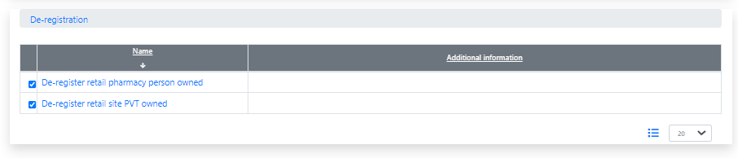

Figure 3. Where to configure access on the user access page