Pharmadex 2. Release Notes 2022-03-22

Contents

Motivation 1

Pre-requisite 1

Demo release particularities 1

The photo gallery in the certificate document 1

File uploaders and “onSelectionChange” 2

The system health monitoring approach 2

Transition company-owned wholesaler workflow 2

Inspection workflow approach 3

# Motivation

* Main – resolve bugs found by QA teal in the previous week (1370)
* Item:
  + add field to the payment form (1355)
  + add possibility to ask the new register number manually(1372)
  + new Apache log file format for monitoring long running APIs (1431)

# Pre-requisite

You must have a Gmail account that has not been registered in the Pharmadex 2 database. You should know the login and password for the supervisor user and have another login and password to log in as a business user, i.e., an applicant.

# Demo release particularities

This release may contain errors, bad user interface behavior, and inconsistencies. Please, report them to [alex.kurasoff@gmail.com](mailto:alex.kurasoff@gmail.com).

* The workflow implementation contains mistakes.
* The configurations described here are only for demonstration purposes.
* The certificate registration numbers starts in new sequency
* In the list of applications in the reports not all columns may be visiable.

# The bugs found by QA

* De-registration feature does not cancel all related processes
* Host applications do not set monitoring tasks for all supervisors
* The application history table does not contain all events
* The application events table contains many extra events
* The Person’s control displays “removed” values in the report form
* The function to get main applicstion data works completely incorrectly. It disables possibility to create more sophiscated Inspection feature (issue 1276)
* The de-registration and modification processes allowed while another process is running on this data. It is a critical bug, because, for example, allows a lot of de-registrations at once.

# Ask for the registration number manually

To avoid wrong number assignment (issue 1372) and allow to get new registration number after renewal and modification, the user can ask the Pharmadex 2 for the new number.

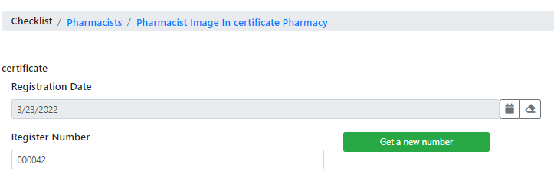

# New user interface for report

For speed-up performance and convenience the applicatin’s metha data in the report has been splitted into three tables

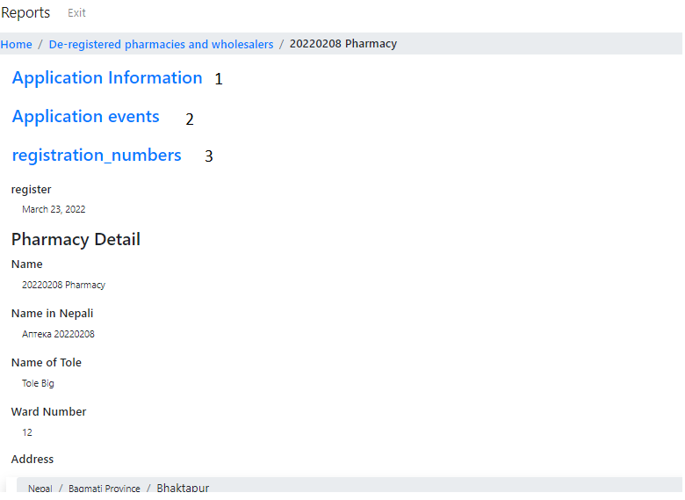

Figure . The new intrface collapsed

1. The full history of application processing
2. The modifications
3. All registration numbers assignment