Pharmadex 2. Release Notes 2022-04-05

Contents

Motivation 1

Pre-requisite 1

Demo release particularities 1

Modification report and new EL expressions 1

The bugs found by QA 3

Annex 1 The usage of @form and @changes convertors 3

The @form convertor 3

The @changes convertor 8

# Motivation

* Main – Modification report, letter, and new EL expressions (1358, 1327)
* Item:
  + Resolve bugs found by the QA team (1370)

# Pre-requisite

You must have a Gmail account that has not been registered in the Pharmadex 2 database. You should know the login and password for the supervisor user and have another login and password to log in as a business user, i.e., an applicant.

# Demo release particularities

This release may contain errors, bad user interface behavior, and inconsistencies. Please, report them to [alex.kurasoff@gmail.com](mailto:alex.kurasoff@gmail.com).

* The workflow implementation contains mistakes.
* The configurations described here are only for demonstration purposes.
* The certificate registration numbers start in new sequency
* In the list of applications in the reports, not all columns may be visible.
* It is possible the regress errors in EL expressions. The complete regress testing is a monthly procedure, because of time-consuming

# Modification report and new EL expressions

The original requirement is to provide the possibility to include modification data to the document template.

The modification data was available only using report functionality.

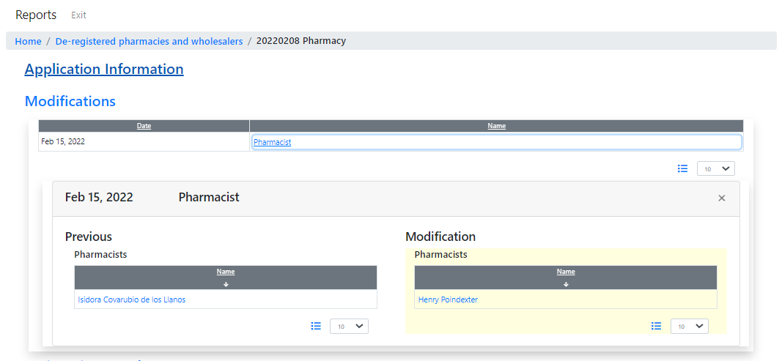

Figure The list of changes in the report

Despite this report can be copied and pasted to MS Word, it is inconvenient for most users. The EL expressions were unusable because the expression uses a convertor that allows extracting data at the field level. At current is know six types of modifications and the quantity will increase. It is too costly to develop and support a separate MS Word template for each type.

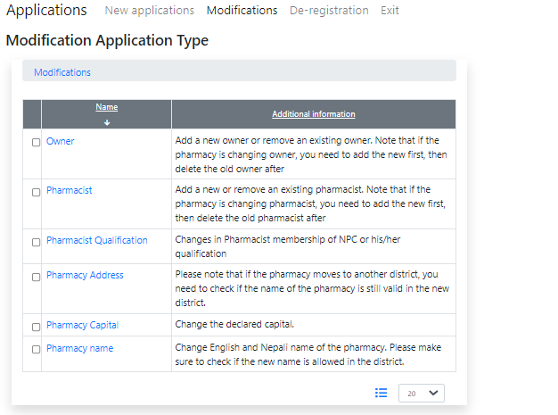

Figure . The types of modification

On the other hand, the on-screen forms in Pharmadex 2 are using the Data Configuration feature to manage on-screen data. The main idea of the new EL expression converters is to extract to the MS Word document the whole data form, using the Data Configuration.

From this release will be available two new convertors @form and @changes. These converters should be applied to the data form definitions and/or even to the whole application.

The @form converter allows the injection to the MS Word document of the whole on-screen data form, regardless of the fields used. This feature allows the reduced quantity of templates as well as application data and workflow definitions

The @changes convertor is applicable only for modification workflows and allows injecting to an MS Word document the list of changes, regardless of changed fields. This feature allows using the same workflow and templates for all modifications.

Annex 1 contains examples. The additions to EL Expression Guide will be ready soon.

# The bugs found by QA

* Remove person functionality does not work in owner/pharmacist modifications. In some cases, it completely removes the original data from the database. Fixed.
* Modification list in reports sometimes provides wrong data and did not refresh the data. Fixed.
* Some labels have been renamed to reflect the real semantics.
* The modification can be applied twice or more for the same application data. Not fixed yet.

# Annex 1 The usage of @form and @changes convertors

## The @form convertor

This converter may be applied only to the whole form or to the application data itself.

/@form

allows injecting to MS Word document the whole application, except the attached files and templates, indeed.

The result looks like

|  |  |
| --- | --- |
| **20220208 Pharmacy** |  |
| register |  |
| Register Number | 000070 |
| Registration Date | Feb 14, 2022 |
| certificate |  |
| Register Number | 000080 |
| Registration Date | Feb 7, 2022 |
| Expiry Date | Feb 7, 2024 |
| register |  |
| Register Number | APPLICATION-PHARMACY/000225 |
| Registration Date | Feb 6, 2022 |
| register |  |
| Register Number | 000023 |
| Registration Date | Mar 8, 2022 |
| Name | 20220208 Pharmacy |
| Name in Nepali | Аптека 20220208 |
| Name of Tole | Tole Big |
| Ward Number | 12 |
| Address |  |
| Bagmati Province, Bhaktapur, Bhaktapur Municipality | 27.67753109506275;85.43701268236283 |
| **Classifiers** |  |
| System of Medicine | Allopathy, GA |
| Service | Government, A) Lower level Health facility |
| **Company Detail** |  |
| Estimated Capital | 1 000 000 |
| Name | Pilulkin Ltd |
| Name in Nepali | ОАО "Пилюлькин" |
| Name of Tole | tole |
| Ward Number | 3 |
| Address |  |
| Bagmati Province, Bhaktapur, Bhaktapur Municipality | 27.67748789429414;85.43674446146134 |
| Phone Number | +1(067)3451297 |
| Email Address | nobody.nowhere@google.com |
| Company Registration Number | 222222 |
| **Authorized Person** |  |
| Name | Isidora Covarubio de los Llanos |
| Full Name in Nepali | Айсидора Коварубио Де Лос Ллянос |
| Name of Tole | tole |
| Ward Number | 1 |
| Address | Bagmati Province, Bhaktapur, Bhaktapur Municipality |
| Date of Birth | Feb 2, 2004 |
| Phone Number | +2(067)1234567 |
| Email Address | nobody.nowhere@gmail.com |
| Citizenship Number | 22222222 |
| **Pharmacists** |  |
| Name | Henry Poindexter |
| **Report Payment** |  |
| Mode of payment | Cash |
| Payment date | Feb 8, 2022 |
| Reciept Number | 222q2 |
| Name of Bank | Big Bank |

The @form convertor may be applied for any sub-form as well

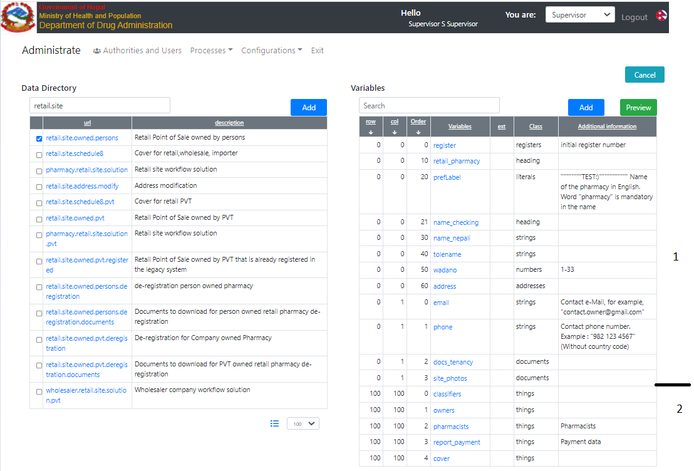

Figure . The data configuration for the example

1. The main (first) form – the whole application will be injected
2. Any “things” may be injected separately. For example, ${/classifiers@form} will produce:

|  |  |
| --- | --- |
| **Classifiers** |  |
| System of Medicine | Allopathy, GA |
| Service | Government, A) Lower level Health facility |

The @form converter works for a person. For example,

${/pharmacists@form} will produce

|  |  |  |  |  |
| --- | --- | --- | --- | --- |
| |  |  | | --- | --- | | **Pharmacists** |  | | Name | Henry Poindexter | |

${/pharmacists/pharmacists/0@form} will produce

|  |  |
| --- | --- |
| **Henry Poindexter** |  |
| Name | Henry Poindexter |
| Full Name in Nepali | Генри Пойндекстер |
| Name of Tole | tole |
| Ward Number | 12 |
| Address | Bagmati Province, Bhaktapur, Bhaktapur Municipality |
| Date of Birth | Feb 16, 2004 |
| Phone Number | +1(087)3451298 |
| Email Address | henry@headless.com |
| Citizenship Number | qwqwqwqwq |
| **Details** |  |
| Father's name | Father 1 |
| Mother's name | Mother 1 |
| Grandfather's name | Granpa 1 |
| **Pharmacist Qualification** |  |
| Academic Qualification | e) 2 Year Experience |
| Council Registration | Nepal Pharmacy Council |
| Council Registration Number/Professional Certificate No | wwwwwwwwwwwwwwwwwww |
| certificate validity |  |
| Valid from | Apr 6, 2022 |

## The @changes convertor

At current, this converter may be applied only to a modification application.

Example is

${/@changes} will produce

|  |  |  |
| --- | --- | --- |
| **Owner** |  |  |
|  | **Previous** | **Modification** |
| Estimated Capital | 300 000 | 1 233 330 |
| Name | Abdurahmann, Zeb Stump | Isidora Covarubio de los Llanos, Abdurahmann, Zeb Stump |