Pharmadex 2. Release Notes 2022-04-26

Contents

Motivation 1

Pre-requisite 2

Demo release particularities 2

The DAMS transition list 2

The certificate and full application must be downloadable by the Applicant and also by DDA 2

Ensure that the correct dates are assigned to applications. The date assigned is sometimes 1-2 days before today's date. 4

Ensure that Register Number is shown in reports. The column is empty for modification report. And in other reports it shows for only some applications. 4

# Motivation

* The DAMS transition list - need to be expanded - currently, it only has two items. And this is the workflow that will initially be used extensively. I have attached the list to upload, please. The list should be searchable.
* The certificate and full application must be downloadable by the Applicant and also by DDA.
* Ensure that the correct dates are assigned to applications. The date assigned is sometimes 1-2 days before today's date.
* Ensure that the Register Number is shown in reports. The column is empty for the modification report. And in other reports, it shows for only some applications.

# Pre-requisite

You must have a Gmail account that has not been registered in the Pharmadex 2 database. You should know the login and password for the supervisor user and have another login and password to log in as a business user, i.e., an applicant.

# Demo release particularities

This release may contain errors, bad user interface behavior, and inconsistencies. Please, report them to [alex.kurasoff@gmail.com](mailto:alex.kurasoff@gmail.com).

* The workflow implementation contains mistakes.
* The configurations described here are only for demonstration purposes.
* The certificate registration numbers start in new sequency
* In the list of applications in the reports, not all columns may be visible.
* It is possible the regress errors in EL expressions. The complete regress testing is a monthly procedure, because of time-consuming

# The DAMS transition list

The initial DAMS transition list provided has been pre-processed and imported.

1. The pre-processing result
2. All de-registered pharmacies have been excluded
3. The rest are split into two sheets in the Excel workbook – “legacy.pharmacies” and “legacy.ws”
4. The import protocol, along with the source data can be found here <https://www.dropbox.com/s/nq7i6puy9wkdxg3/Combined%20Pharmacy%20List%20NepalOut.xlsx?dl=0>

The import software cannot import data with wrong registration and expiration dates, as well as any other mandatory fields. The not imported data can be found in “Import errors” in the workbook.

# The certificate and full application must be downloadable by the Applicant and also by DDA

We’ve restored this functionality in the report section.

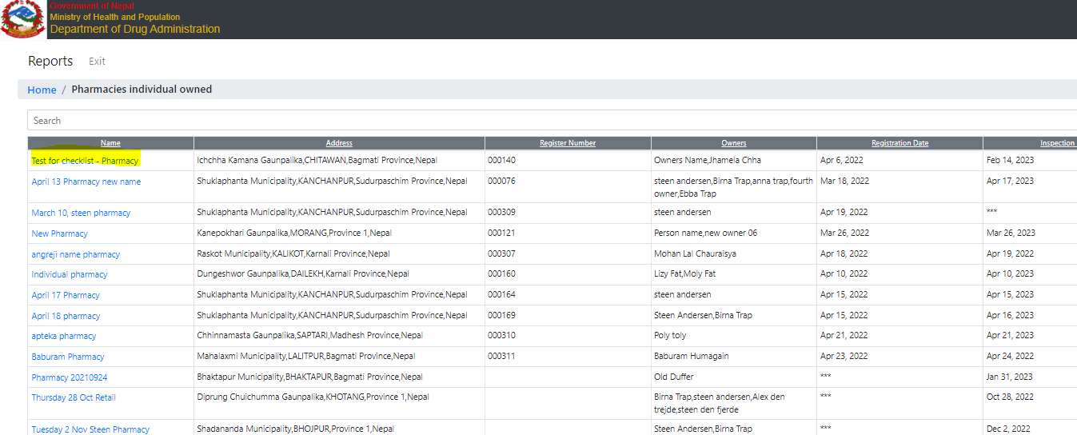

Figure . The applications are available using Reports

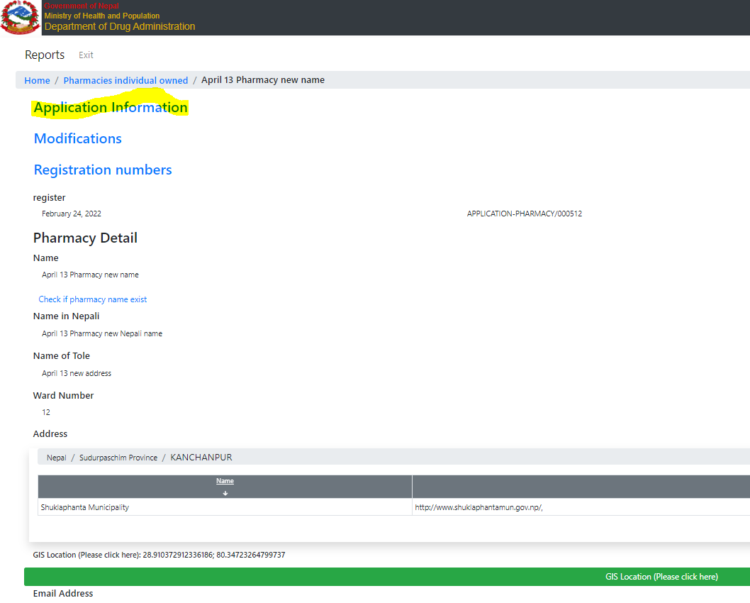

Figure . The application Information contains all required data

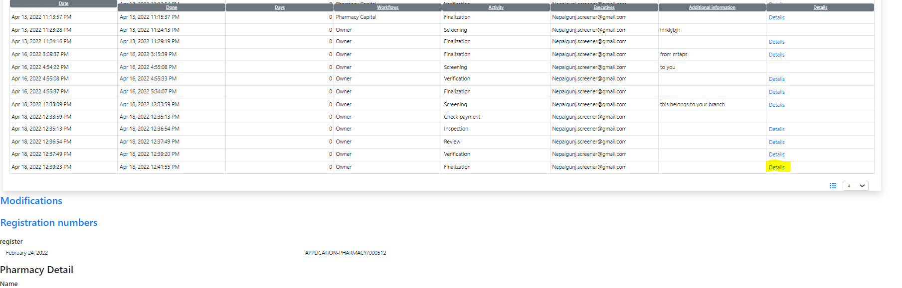

Figure . The last "Finalization" activity contains a certificate

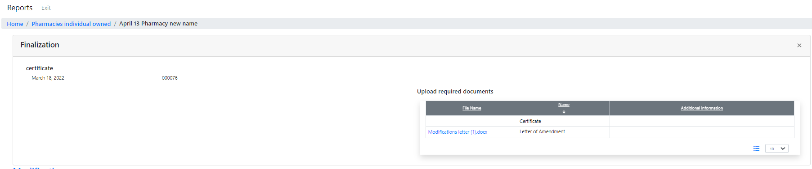

Figure . The certificate and documents are available

# Ensure that the correct dates are assigned to applications. The date assigned is sometimes 1-2 days before today's date.

It is a consequence of Nepal's particular time zone. The recommended approach[1] doesn’t work. Fixed using date to string to date conversion. This approach is not recommended, thus additional testing will be needed.

# Ensure that the Register Number is shown in reports. The column is empty for the modification report. And in other reports, it shows for only some applications.

For new application should work. For the old application will not. The data configuration should be checked against unconfirmed changes. Will be performed next week.

The system is for demonstration and testing. The production system will use stable and permanent data configurations.

# The checklists using

Please, put your attention that checklists are part of submitting feature. Thus, the checklists can’t be used in the regular data forms.

# Submit to the workflow

Please, put your attention that for each guest application the workflow should be defined and configured.

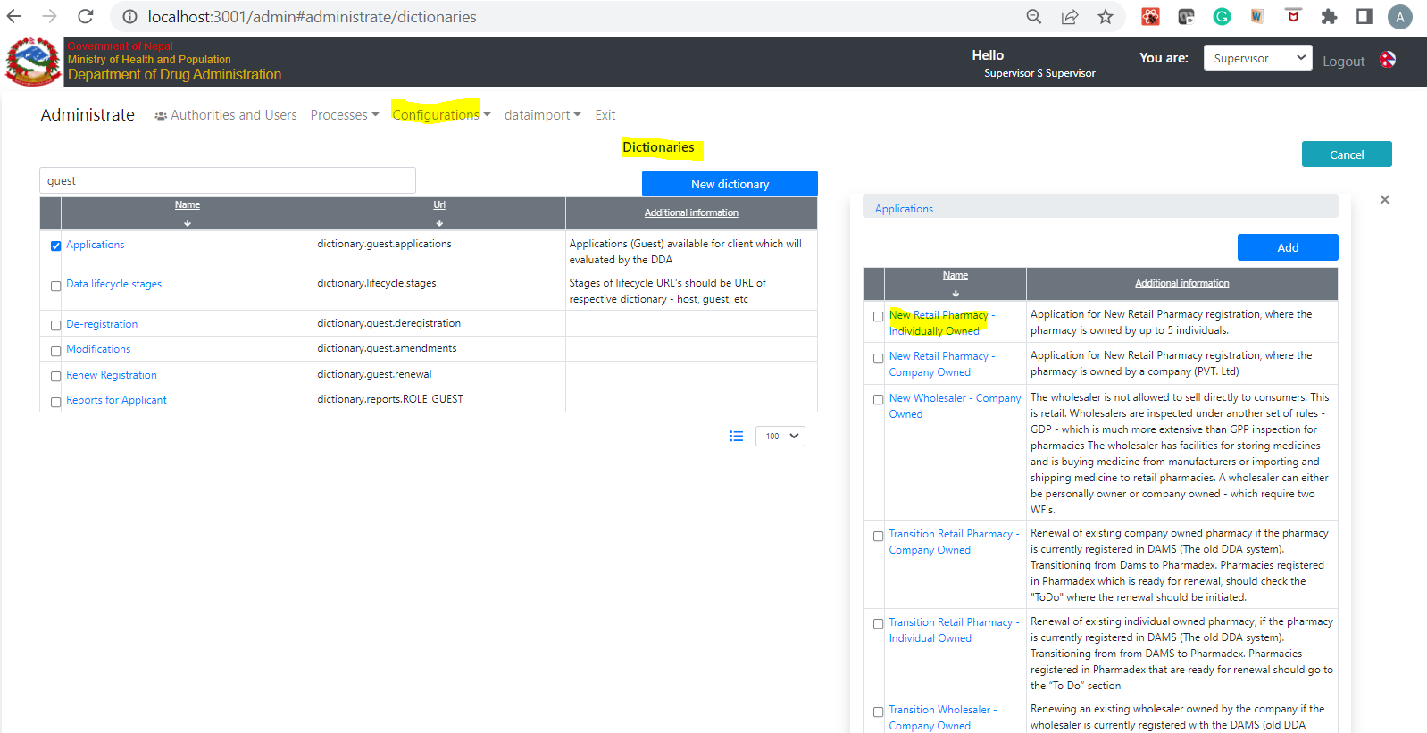

Figure . The guest application

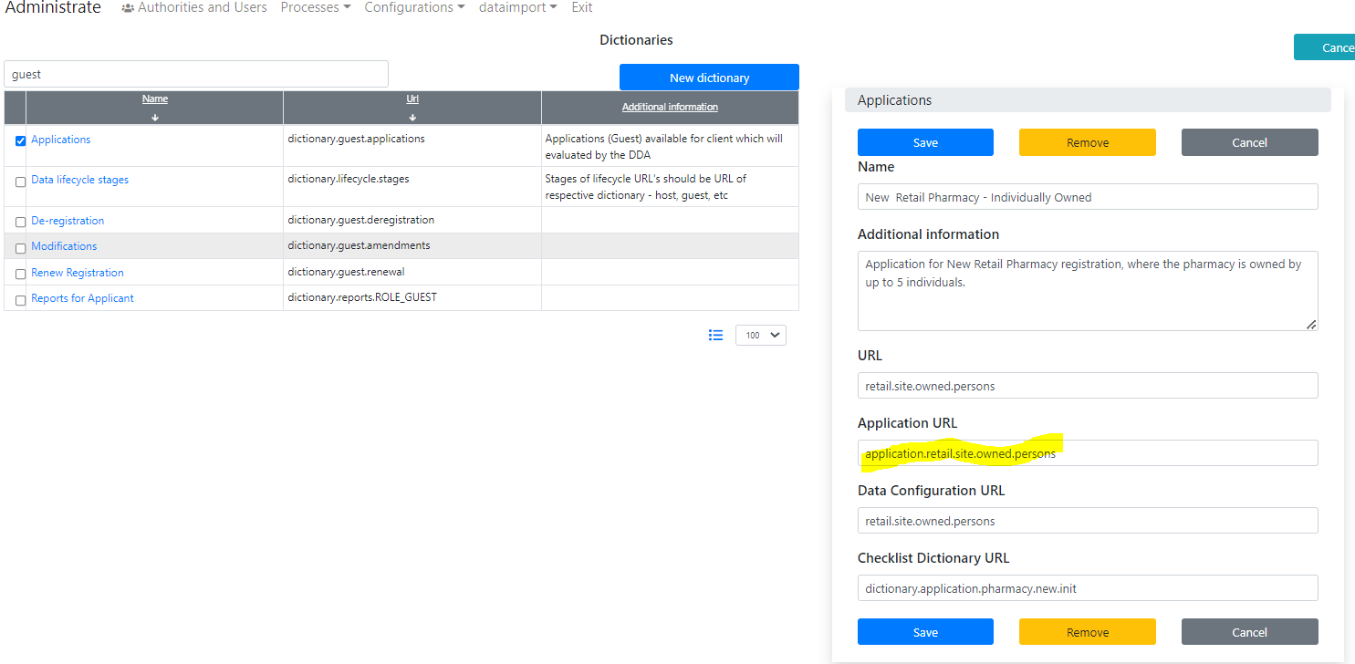

Figure . Application URL should be defined

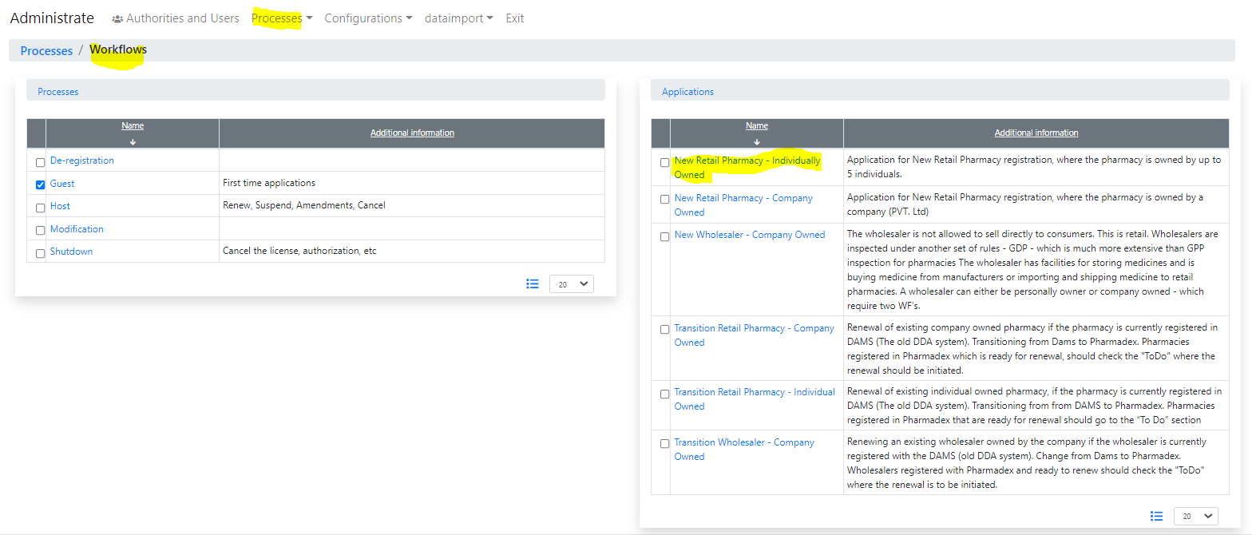

Figure . Go to Processes-Workflows

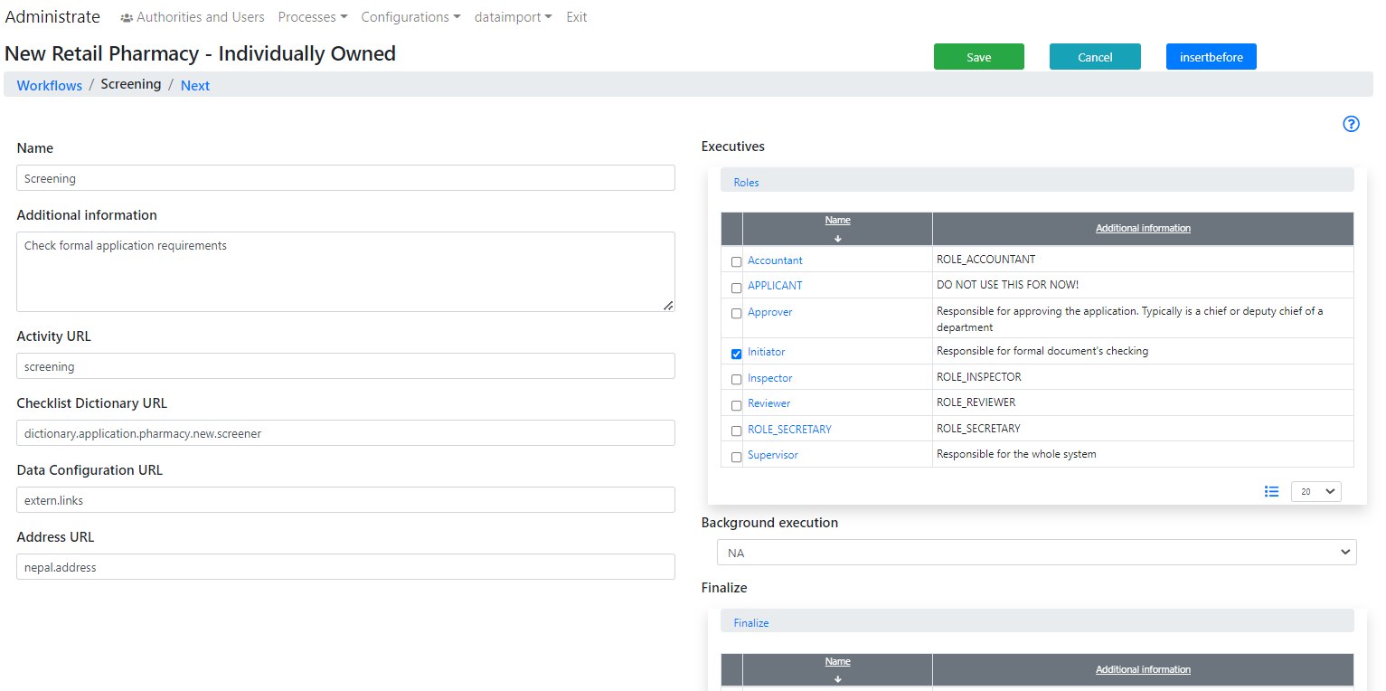

Figure . The wrokflow should be configured

1. https://www.baeldung.com/java-date-to-localdate-and-localdatetime