Pharmadex 2. Release Notes 2022-06-29

Contents

Motivation 1

Speed up Administrative-Authority and users 1

Allow applicant as not first workflow participant 1

Data Warehouse reports 1

Pre-requisite 2

Release particularities 2

# Motivation

## Speed up Administrative-Authority and users

The time to reply is speed-up sufficiently. The old inefficient codes have been replaced.

## Allow applicant as not first workflow participant

In the previous releases, an applicant can’t be the executor of activity after an activity managed by NMRA (DDA) executor. Currently, it is allowable.

## Data Warehouse reports

1. The external report DWH data preparation codes are currently run by schedule:
   1. In 15 minutes after Pharmadex 2 server is started
   2. Every 24 hours
2. It is possible to start the data preparation for DWH manually at any time

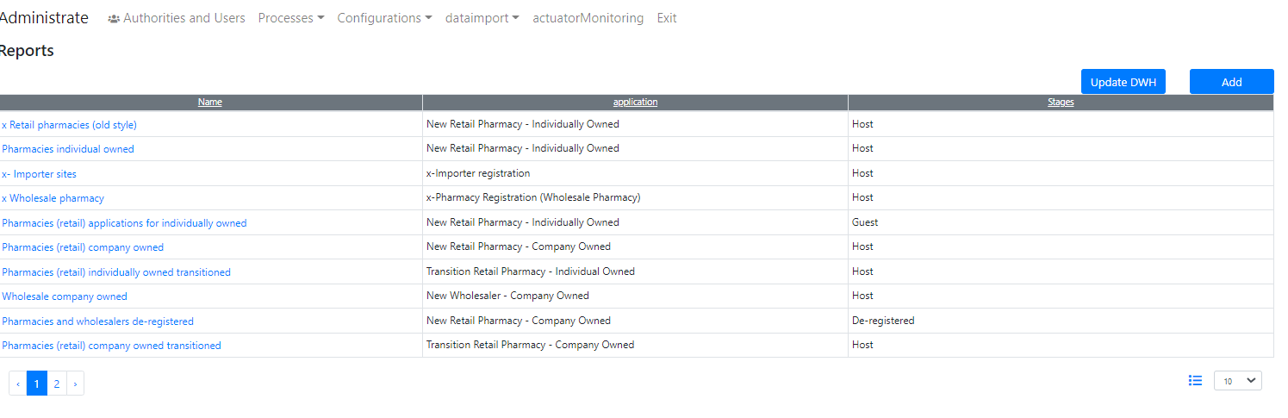

Figure Press Update DWH to update data for DWH. If this button is not active, the data preparation process is running

# Pre-requisite

You must have a Gmail account that has not been registered in the Pharmadex 2 database.

# Release particularities

**The database structure has been changed.**