Pharmadex 2. Release Notes 2022-08-28

Contents

Motivation 1

Disclaimer 1

The expandable section in the “conclude” and workflow forms 2

Administrative units import 3

# Motivation

1. Fixed bugs
   1. Legacy data components were available for selection in read-only mode. Currently is not available.
   2. Language-related bugs in administrative unit importing have been fixed. Before this only the Nepali language was allowed.
2. Using the VisualJVM profiling tool the time to reply has been decreased:
   1. Template processing – at least twice
   2. Electronic form load – at least 15%
3. To decrease whole form loading time for the “conclude” step and all workflows expandable by demand sections in electronic forms have been introduced. See below for details.
4. The importing of administrative units allows up to 4 units. The new template is attached
5. Minor changes in ETL process and reporting model database. The reporting manual will be issued next week.

# Disclaimer

All new and improved features have been tested against the particular testing examples.

Thus, this release may contain errors, bad user interface behavior, and inconsistencies. Please, report them to [alex.kurasoff@gmail.com](mailto:alex.kurasoff@gmail.com).

# The expandable section in the “conclude” and workflow forms

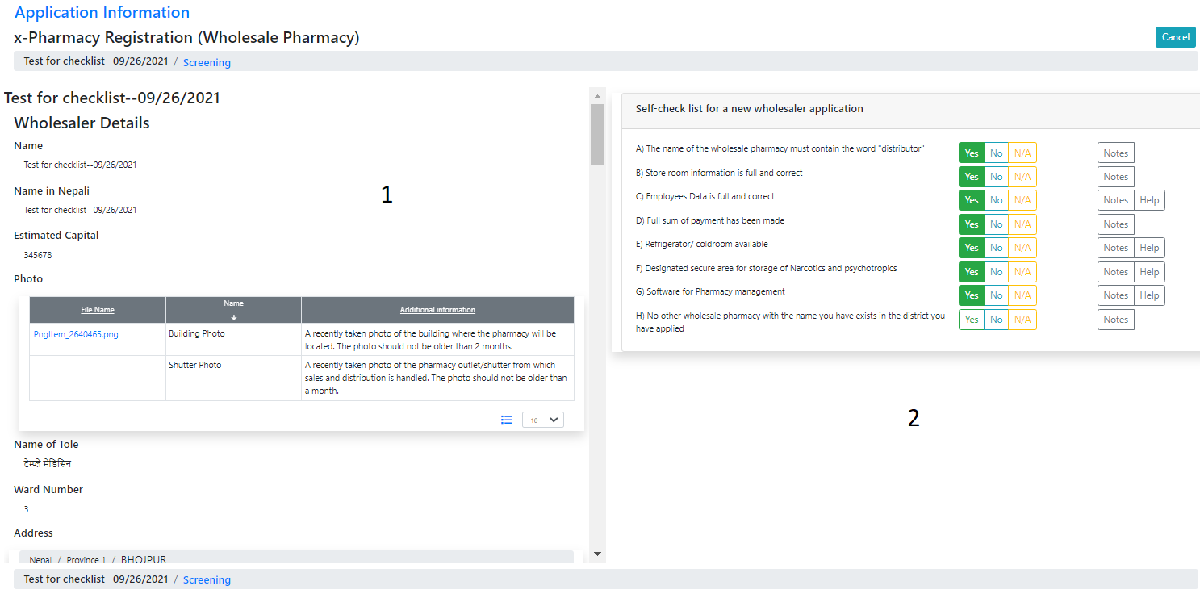

Figure A form consists of 2 columns. The left one (1) contains application data, and the right one - a checklist and, possible, additional data required by business logic

Typically, a user doesn’t need whole data on the left side at once. Before this release, Pharmadex 2 loaded all data at once. It took sufficient time as well as producing an extra workload on the server.

Since this release the data load implemented by demand, using expandable sections. The form load time and server’s workload have been decreased.

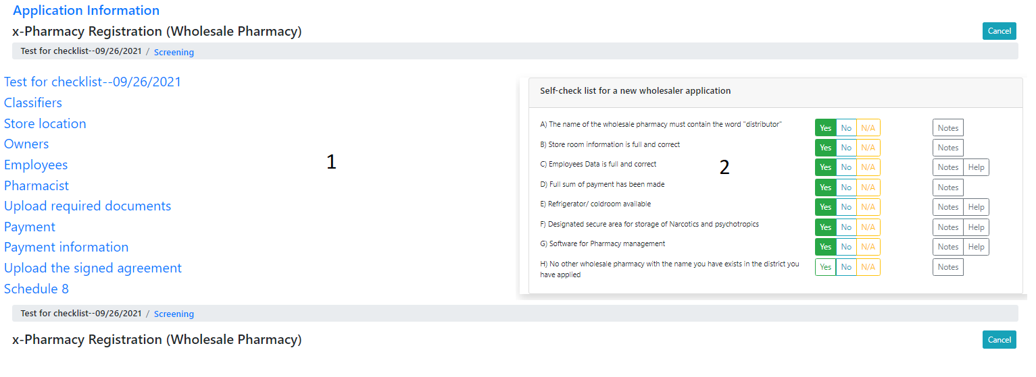

Figure All sections are collapsed. Data is not loaded

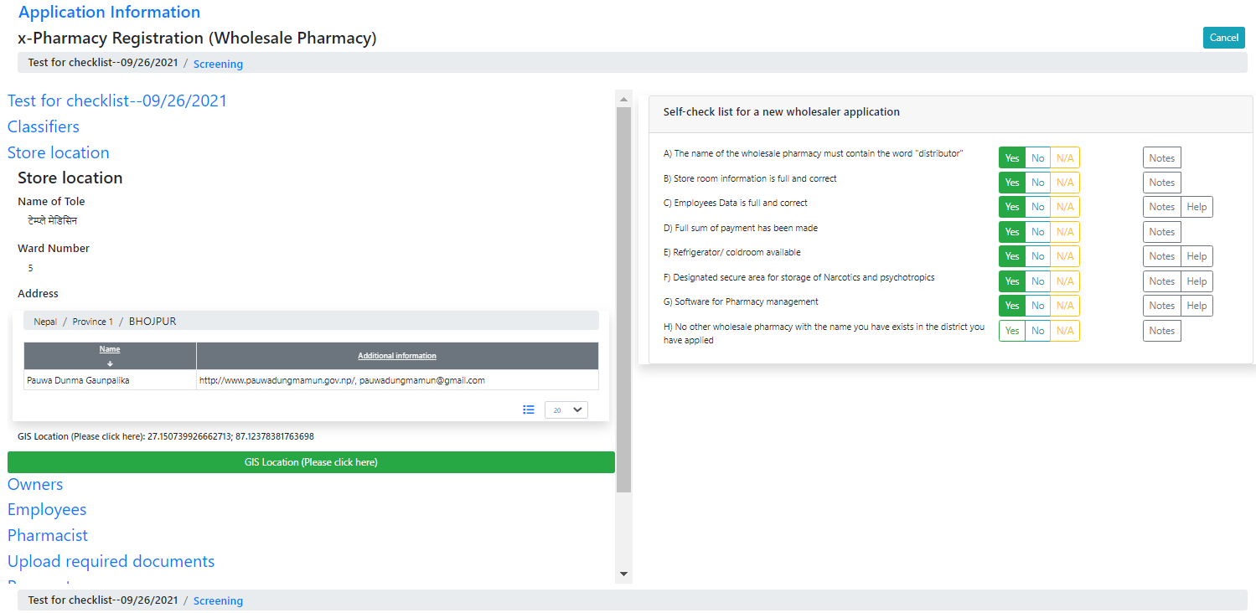

Figure Store location section is expanded. Only necessary data has been loaded

# Administrative units import

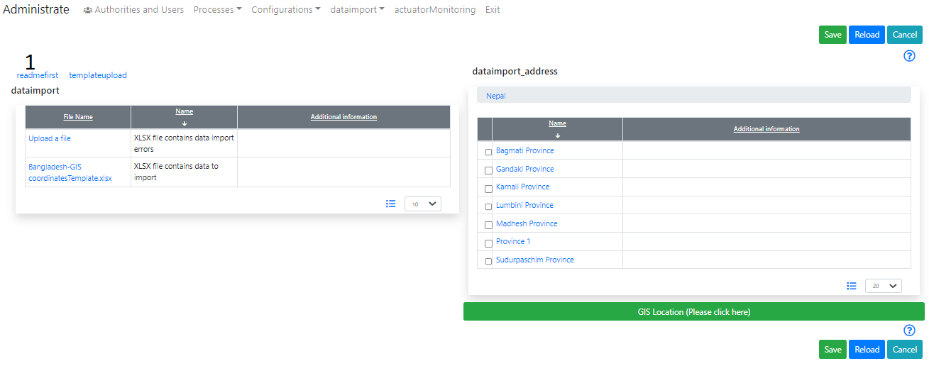

Figure log in as a Supervisor, and, then, open Administrate-dataimport-adminunits

1. First, upload the short manual.

***It will be a good idea to define human readable labels for this feature. Please, using Configuration-Messages for it.***