Pharmadex 2. Release Notes 2022-09-19

Contents

Motivation 1

Disclaimer 1

Administrative password change 1

ATC data import 2

# Motivation

1. Fixed bugs:
   1. Issue 1535 solved
2. Improvements:
   1. Administrative password change
   2. ATC data import

# Disclaimer

All new and improved features have been tested against the particular testing examples.

Thus, this release may contain errors, bad user interface behavior, and inconsistencies. Please, report them to [alex.kurasoff@gmail.com](mailto:alex.kurasoff@gmail.com).

# Administrative password change

The manual is here:

<http://redmine.inka.in.ua/documents/159>

***It will be a good idea to define human-readable labels for this feature. Please, use Configuration-Messages for it.***

# ATC data import

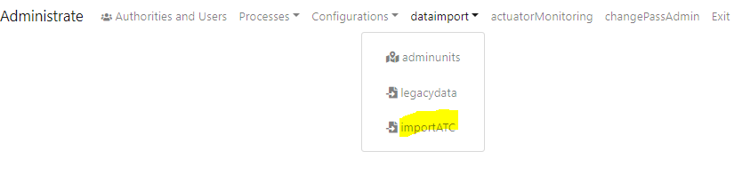

Figure Where to find it?

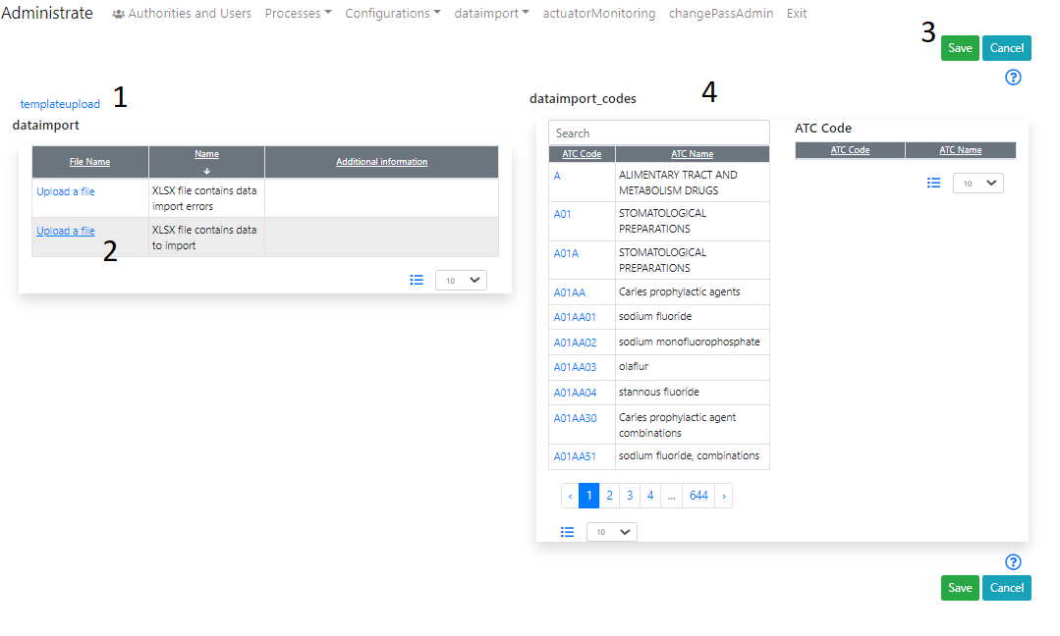

Figure ATC data import screen

1. Download an example of the data and, then, make necessary corrections if one
2. Upload the data
3. Press “Save” to import
4. The result will be here

***It will be a good idea to define human-readable labels for this feature. Please, use Configuration-Messages for it:***

1. importATC – The action in the menu
2. startImport – Start import
3. endImport – End import
4. startImportSheet - Start import sheet
5. notFindSheet - Not find sheet
6. dataimport – a header above the “upload” table
7. dataimport_result – “result” message
8. dataimport_codes – a header above the ATC table