Pharmadex 2. Release Notes 2022-10-24

Contents

Motivation 1

Disclaimer 1

# Motivation

## Bugs resolved

Error messages after unsuccessful file upload did not appear. It is fixed in this release

## Improvements

The source codes are ported to the latest version of the Spring Boot framework (2.7.4). Outdated internal configurations are replaced. The source codes are refactored to avoid circular references. It should improve memory management and stability of the executable codes.

Import to Excel configuration of a workflow feature has been added. See details below.

The ad-hoc report feature is revised.

## Documentation

The new ad-hoc reporting manual is available here http://redmine.inka.in.ua/documents/165

# How to import workflow configuration to Excel?

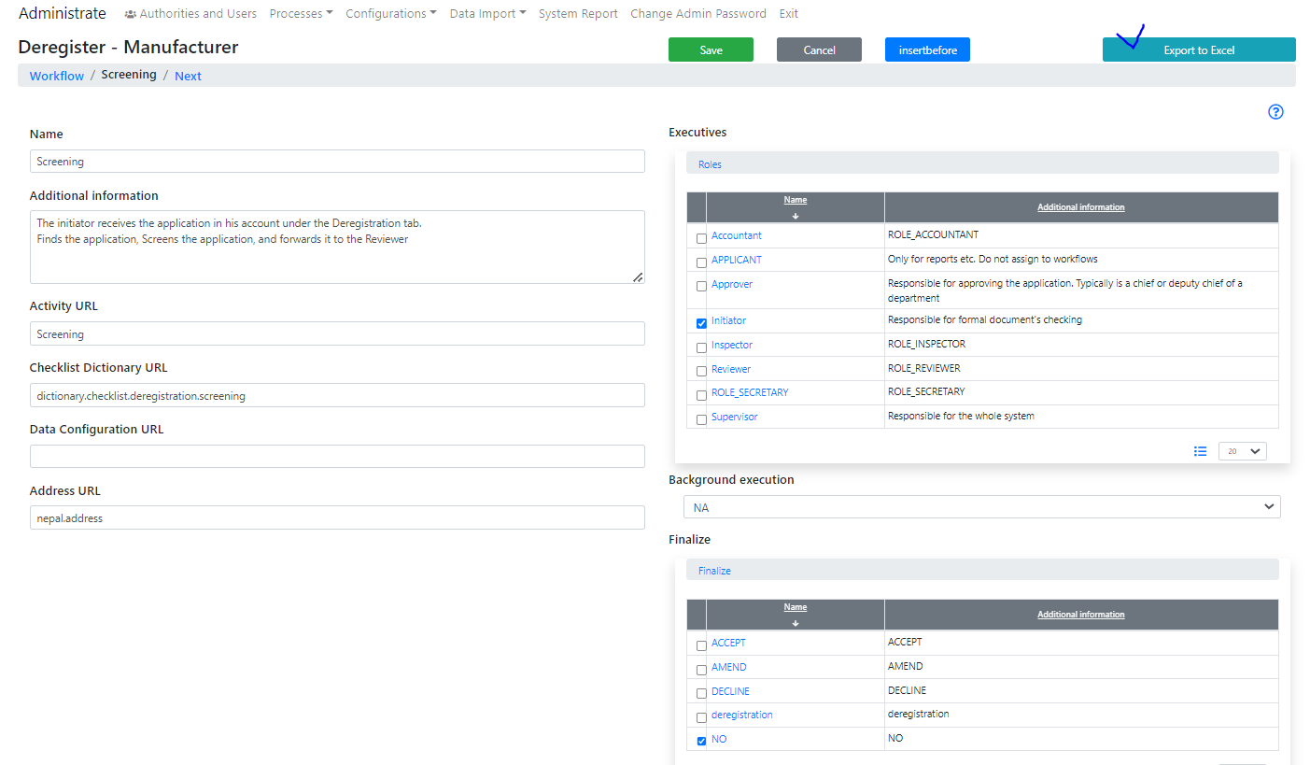

Figure Import to Excel configuration of a workflow feature has been added

# Disclaimer

All new and improved features have been tested against the particular testing examples.

Thus, this release may contain errors, bad user interface behavior, and inconsistencies. Please, report them to [alex.kurasoff@gmail.com](mailto:alex.kurasoff@gmail.com).