Pharmadex 2. Release Notes 2022-11-21

Contents

Motivation 1

Bugs fixed 1

Improvements 1

Documentation changes 2

Messages that should be defined 2

Disclaimer 3

How to bypass strict validation rules for the data configurations 3

How to customize Terms of Use and Privacy Policy documents? 4

# Motivation

The main problem in the current stage of implementation is difficulties in workflow design, implementation, and maintenance. The main causes of the difficulties are:

1. Poor and sometimes too strict application and configuration data validation features
2. The ETL process :
   1. collects data for external reports wrongly for de-registered applications and does not collect lost applications
   2. assigns to all non-applications data module “ACTIVE” status that, in general, is not true.
3. The “Pharmadex” should be re-branded to “OpenMRIS”

# Bugs fixed

The ETL process that collects data for external reports recognizes de-registered applications properly.

# Improvements

1. The internal procedures of the ETL process are completely rewritten and tested. The data structure of the data warehouse is left the same. Please, refer to <http://redmine.inka.in.ua/documents/158>
2. The statuses of non-application data modules have been fine-grained to “OTHER”, “LEGACY”, and “ATC”. Please, refer to <http://redmine.inka.in.ua/documents/158>
3. From this release, a variable name in the data configuration should be alphanumerical with possible Latin characters, dots, and underscores (issue 1549). From this release, the warning message has been implemented. We didn’t implement the error message to avoid possible conflicts with the existing data. Please, refer to <http://redmine.inka.in.ua/documents/129> or http://redmine.inka.in.ua/documents/116.
4. From this release the validation rules for a “guest” workflow will be empowered by the following rules:
   1. At least one mandatory component “registers” to collect the registration date, expiration date, and registration (certificate, etc.) number.
   2. At least one “scheduler” to schedule the next action on the application data in the future.
5. For an electronic form, a data configuration manages data collection and on-screen layout. Some changes in the data configuration may stop collecting the existing data in a form. To avoid data loss strict data configuration validation rules have been introduced. However, these rules became inconvenient for “sandbox” development. The new application configuration parameter variables.properties.edit=true allows us to bypass this check. Please, refer to <http://redmine.inka.in.ua/documents/129> or below.
6. In line with the re-branding, the design and functionality of a footer for all pages have been changed
   1. In the USAID logo has been added a link to the USAID site
   2. In the right corner, the permanent logo of OpenMRIS has been placed. This logo has a link to the OpenMRIS site
   3. Privacy policy and Terms of using links have been added:
      1. By default, the recommended documents will be displayed to a user
      2. It is possible to upload customized documents in PDF format that are particular to a country and in the country’s language. Please, refer to http://redmine.inka.in.ua/documents/129 or below.

# Documentation changes

* Workflow configuration reference guide - <http://redmine.inka.in.ua/documents/129>
* Deployment guide - <http://redmine.inka.in.ua/documents/116>
* How to use Pharmadex 2 reporting data model together with the Google Data Studio - http://redmine.inka.in.ua/documents/158

# Messages that should be defined

|  |  |  |
| --- | --- | --- |
| **Key** | **Meaning** | **Usage** |
| varNameHasError | A variable name in the data configuration should be alphanumerical with possible Latin characters, dots, and underscores. | Data configuration verification warning |
| varNameExtHasError | A variable name extension in the data configuration should be alphanumerical with possible Latin characters, dots, and underscores. | Data configuration verification warning |
| notFoundRegisters | Registers not found in Configuration. The action has been canceled. | Workflow configuration verification, when the workflow starts |
| notFoundSchedulers | Schedulers not found in Configuration | Workflow configuration verification, when the workflow starts |
| terms | Terms of use | The footer |
| privacy | Privacy policy | The footer |

# Disclaimer

All new and improved features have been tested against the particular testing examples.

Thus, this release may contain errors, bad user interface behavior, and inconsistencies. Please, report them to [alex.kurasoff@gmail.com](mailto:alex.kurasoff@gmail.com).

# How to bypass strict validation rules for the data configurations

Quote from Workflow configuration reference guide - <http://redmine.inka.in.ua/documents/129>

For an electronic form, a data configuration manages data collection and on-screen layout. Following changes in the data configuration may stop collecting the existing data to a form:

1. Re-naming a component
2. Removing a component
3. Changing the type of a component

By default, the data configuration editor disables the possibility to make the changes above in a data configuration if at least one of the conditions below occurs:

* The database already contains data created using the data configuration
* The data configuration is used by other data configuration
* The data configuration is used by activity configuration
* The data configuration is used by resource configuration

In the “sandbox” installations it is possible to bypass this restriction. To do this you must have access to edit “application.properties” file in the server installation folder

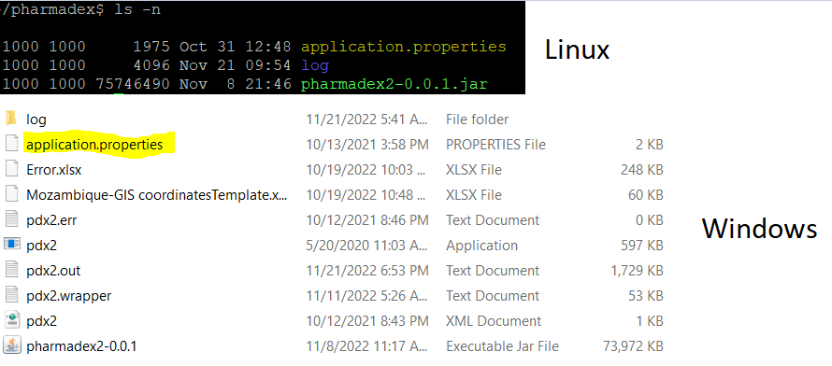

Figure 8 application.properties

Use any text editor to add to this file the configuration parameter variables.properties.edit=true. It allows bypassing the validation above.

To stop bypassing the rules, remove this line from the application.properties or set it to false.

variables.properties.edit=false

# How to customize Terms of Use and Privacy Policy documents?

Quote from the Deployment guide - <http://redmine.inka.in.ua/documents/116>

The software provides samples of Privacy Policy and Terms of use documents. These are available “as is” from the page footer



Figure 2 Terms of use and Privacy policy in the footer

To customize the documents as well as represent to local language:

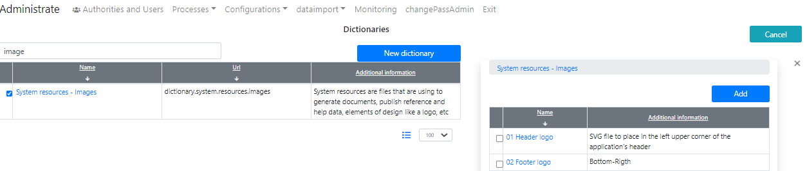

Figure 3 Open dictionary.system.resources.images

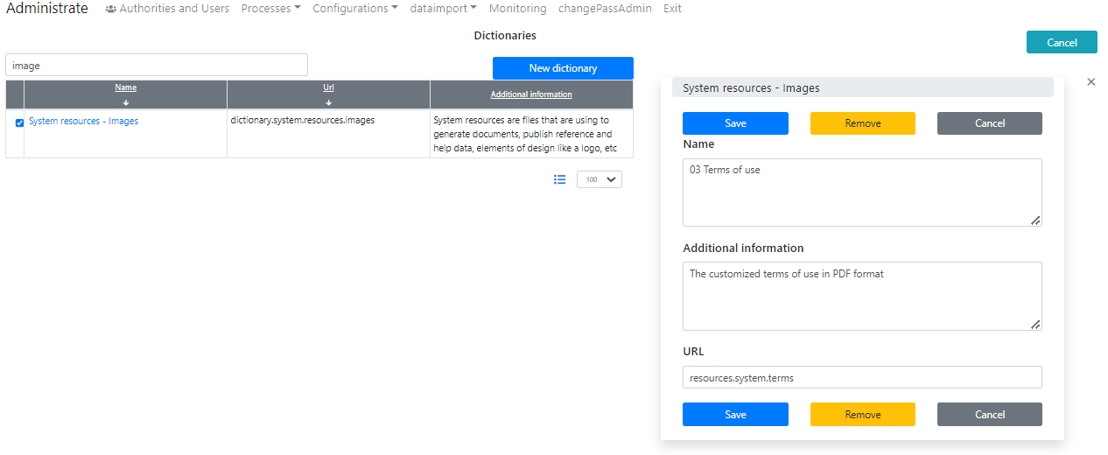

Figure 4 Add definition of Terms of use, URL is resources.system.terms

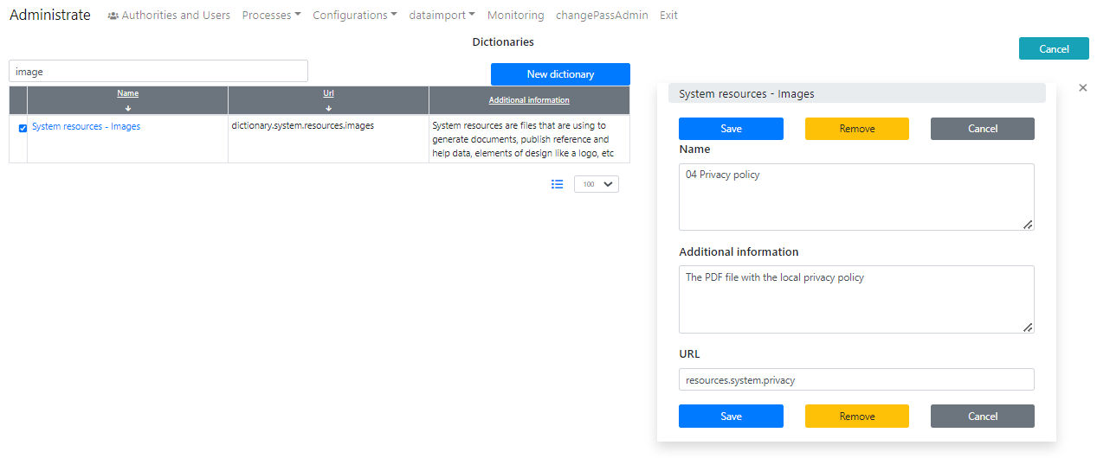

Figure 5 Add a definition for a Privacy policy. URL is resources.system.privacy

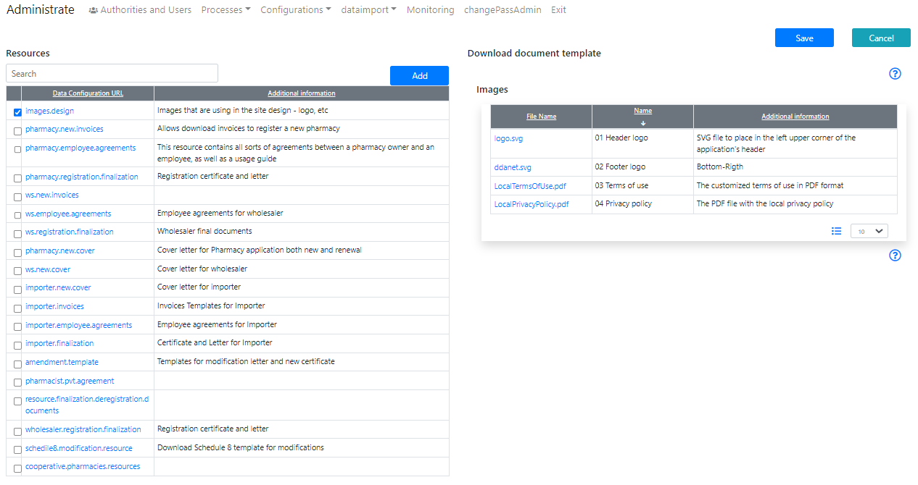

Figure 6 Upload the documents into images.design resource