Pharmadex 2. Release Notes 2022-12-01

Contents

Motivation 1

Bugs fixed 1

Improvements 1

Documentation changes 2

Messages that should be defined 2

How to find any application using the Monitoring menu 3

Disclaimer 4

# Motivation

The main motivations for this release are:

1. Bug fixing
2. Improvements in workflow processes
3. Rebranding to OpenMRIS
4. Redmine issues
5. Monthly routine QA testing to find possible regress errors in workflow implementations
6. Assessing the possibility of concurrent activities in the workflow

# Bugs fixed

1. Deadlock in DWH Update has been resolved
2. Too strict workflow configuration rules have been relaxed.
3. The OpenMRIS logo has been improved
4. The right mouse cursor shape has been implemented for the “logout” menu (#1571)

# Improvements

1. Disable submitting more than one modification/deregistration workflow for the same object (#1548, #1524)
2. The feature that allows Supervisor, Secretary, and Moderator to find any application in the database (see below)
3. Configurable mail message text after workflow activity completion (#1551)
4. Data validation notification accessibility has been improved (#1527)
5. A typeface “Evolventa” has been embedded in the OpenMRIS logotype

# Documentation changes

A reworked “workflow definition” presentation has been added to the Workflow definition guide (http://redmine.inka.in.ua/documents/134).

Added “The implementation of concurrent activities in workflows by OpenMRIS software” SRS document (<http://redmine.inka.in.ua/documents/175>).

Reworked “Managing application routing in Pharmadex 2” (<http://redmine.inka.in.ua/documents/107>). Particularities of Modification and Deregistration workflows have been added.

# Messages that should be defined

|  |  |  |
| --- | --- | --- |
| **Key** | **Meaning** | **Usage** |
| singletonError | Another application for this data is processing. Please, try again later. | Submit to NMRA |
| fullSearch | All available | Monitoring, finding all feature |
| dateactualLb | Data actual on | Monitoring, finding all feature |
|  |  |  |
|  |  |  |
|  |  |  |

# How to find any application using the Monitoring menu

Before using this feature, the DWH should be rebuilt. It will be after 15 min of software restart, daily or by demand using the Administrate-Configurations-Reports-Update DWH feature. The rebuild may last up to 20 minutes

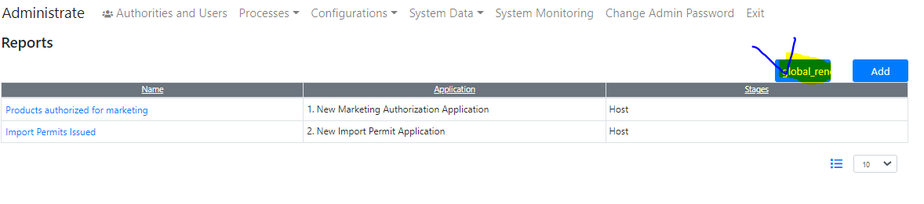

Figure Press this to re-build manually

For the main office Supervisor users, it is possible to find and inspect all available applications in one place. It is a convenient alternative for reporting, To Do, and other Monitoring features in a case when the application seems as not found anywhere.

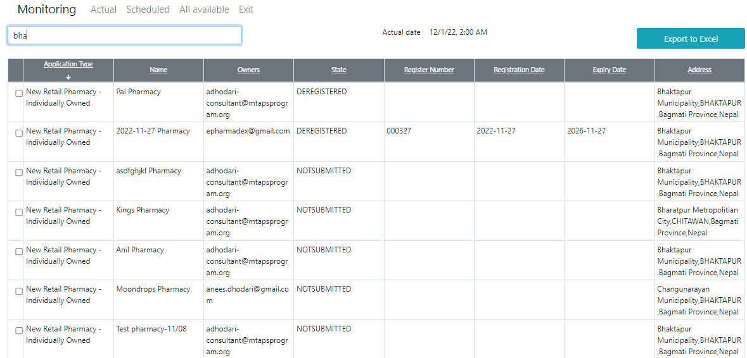

Figure Find all available applications using the text search

Unlike any other Monitoring features, the data in this screen is not real-time data. The actuality can be found above the table.

This feature intends only for Supervisors, Moderators, and applicants. For applicants, all applications initiated by it will be available regardless of state.

* For the main office Supervisor, all applications in the database will be available, regardless of type and territories
* For the main office moderator, applications will be available regardless of territory, however, restricted by types
* For the branch office Supervisor, all applications restricted by territory will be available, regardless of the types
* For the branch office moderator, all applications restricted by territory and type will be available

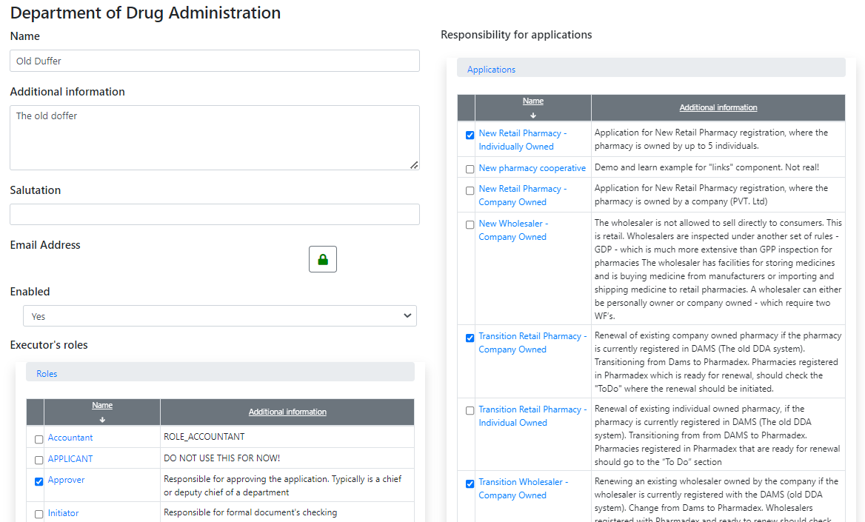

Figure This moderator of the main office will be restricted only to applications listed, regardless of territory

# Disclaimer

All new and improved features have been tested against the particular testing examples.

Thus, this release may contain errors, bad user interface behavior, and inconsistencies. Please, report them to [alex.kurasoff@gmail.com](mailto:alex.kurasoff@gmail.com).