Pharmadex 2. Release Notes 2022-12-08

Contents

Motivation 1

Bugs fixed 1

Improvements 1

Documentation changes 1

Messages that should be defined 2

New calendar feature example 2

Disclaimer 2

# Motivation

* The “Deployment Guide” document is completely rewritten in a line to revise the whole documentation set.
* The usability of the Calendar component is improved (see below)
* The “Return to Applicant” feature is completely revised (see below)
* The “Save” feature currently works as “Save” not as “Save and Close” (see below)

# Bugs fixed

Impossible to change class in the existing variable definition, even in development mode.

# Improvements

* The current calendar is convenient when the date to input is in the current month. However, it is inconvenient for dates defined in the future years or the previous year and century. The current implementation of the calendar proposes an initial choice:
  + The date may be in this year – months of this year
  + The date may be in 10 years – decades from the current year
  + Day of birth, in general, may not in this century – centuries
  + See <http://redmine.inka.in.ua/issues/1577>. An example is here New calendar feature example
* The return to applicant feature sometimes was unavailable where it should be, and sometimes is available in the wrong place. Currently, this function is available on all workflow steps, except “Finalization”. See <http://redmine.inka.in.ua/issues/1574>.
* The “Save” feature currently does not return to the previous screen. See (http://redmine.inka.in.ua/issues/1573)

# Documentation changes

The deployment guide is completely reworked (http://redmine.inka.in.ua/documents/116).

# Messages that should be defined

|  |  |  |
| --- | --- | --- |
| **Key** | **Meaning** | **Usage** |
|  |  |  |

# New calendar feature example

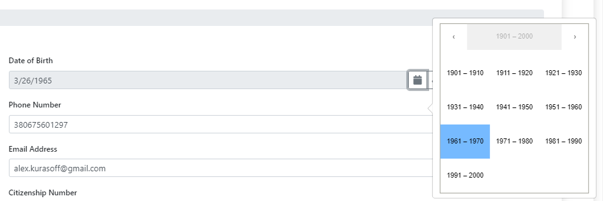

# Disclaimer

All new and improved features have been tested against the particular testing examples.

Thus, this release may contain errors, bad user interface behavior, and inconsistencies. Please, report them to [alex.kurasoff@gmail.com](mailto:alex.kurasoff@gmail.com).