Why does Database Synchronize from the model doesn’t work?

# ATTENTION

Since Oct 2023 the unused database tables should be removed from the database:

Upload from the GitHub [https://github.com/MSH/OpenRIMS/tree/main/database SQL script database_cleanup.sql](https://github.com/MSH/OpenRIMS/tree/main/database%20SQL%20script%20database_cleanup.sql)

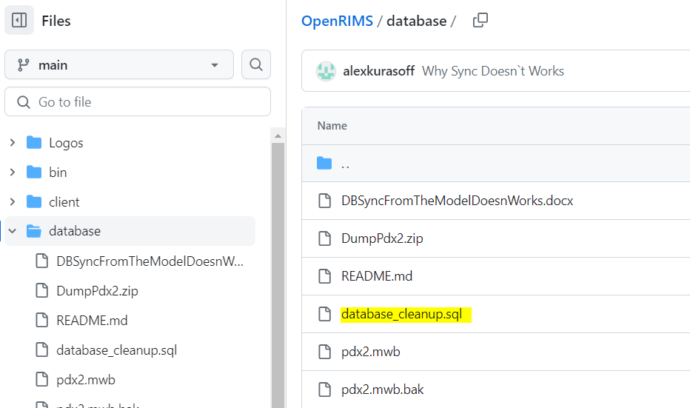

Figure Script to remove unused tables

Run this script any convenient way, for example using MySQL Workbench:

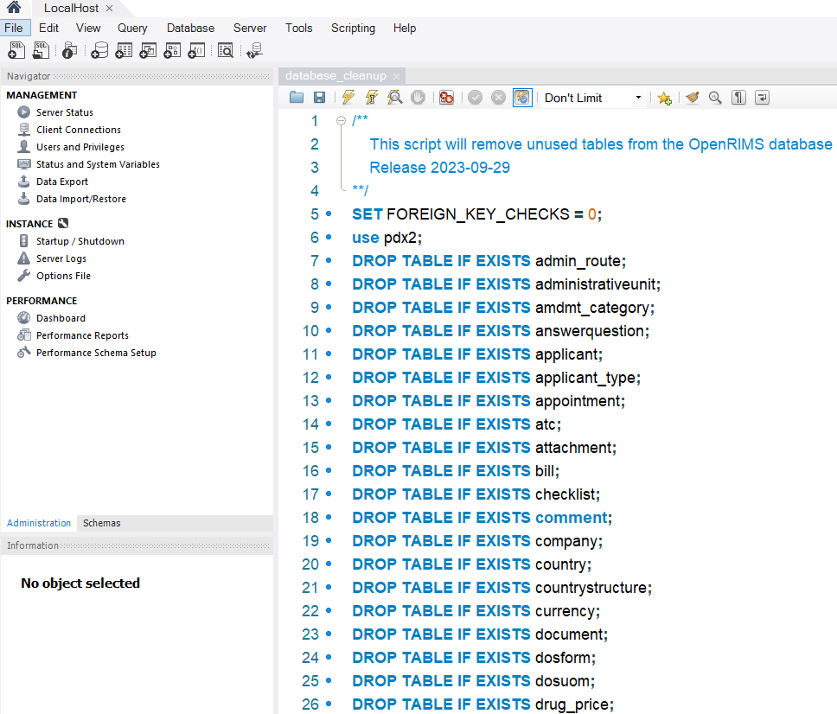

Figure MySQL Workbench usage

**Update the database structure from the model again.**