Uploading Labels for the EL Assistant

# Motivation

The EL Assistant feature requires about sixty new labels. These labels should conform to the EL expression electronic guide. The definitions of the EL Assistant are provided in elAssistantMessages.xlsx file.

Below are recommendations on how to upload these messages to the OpenRIMS installation.

# Steps to upload

**Install an OpenRIMS release from 2024-06-07**

Log in as a Supervisor, select Administrative-Configuration-Messages, and execute Get Lost

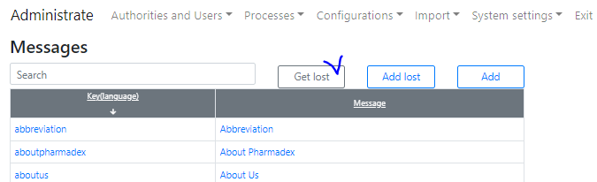

Figure 1 Get undefined messages

The result will be in the Excel file with the name lostmessages.xlsx. Open this file and delete all lines with messages, but leave the headers



Figure 2 In this example the second language is Portuguese

Copy contains columns Key and en_US from the elAssistantMessages.xlsx to lostmessages.xlsx

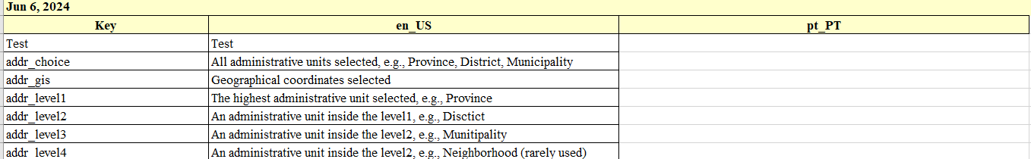

Figure 3 The provided messages have been copied

Translate all the messages to the second language and paste the translation into the third column

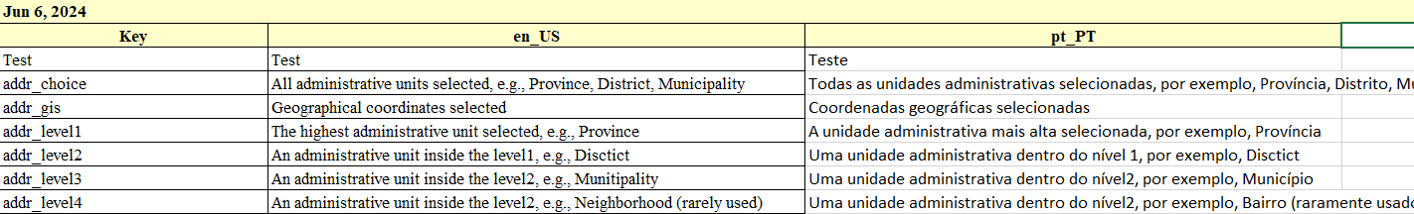

Figure 4 Messages have been translated

Select Add Lost, select a lostmessages.xlsx file, and press Save

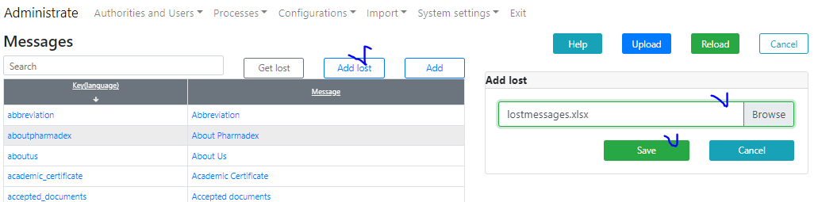

Figure 5 Add new messages