

**PViMS**

**Database Manual**



Contents

1 Introduction 5

1.1 Document Overview 5

1.2 Purpose of the Document 5

1.3 Audience 5

2 Database Entities 6

2.1 Work Plan Entities 6

2.1.1 Entity Relationship Diagram 6

2.1.2 Reference Entities 6

2.1.3 Bridging Entities 8

2.2 Dataset Entities 10

2.2.1 Entity Relationship Diagram 10

2.2.2 Reference Entities 11

2.2.3 Bridging Entities 12

2.2.4 Transaction Entities 14

2.3 Meta Framework Entities 23

2.3.1 Entity Relationship Diagram 23

2.3.2 Reference Entities 24

2.3.3 Transaction Entities 26

2.4 Patient Entities 30

2.4.1 Entity Relationship Diagram 30

2.4.2 Reference Entities 31

2.4.3 Transaction Entities 32

2.5 Encounter Entities 43

2.5.1 Entity Relationship Diagram 43

2.5.2 Transaction Entities 43

2.6 Workflow Entities 48

2.6.1 Entity Relationship Diagram 48

2.6.2 Reference Entities 49

2.6.3 Transaction Entities 51

2.7 Other Entities 55

2.7.1 Reference Entities 55

2.7.2 Custom Attribute Entities 64

2.7.3 Bridging Entities 65

2.7.4 Miscellaneous Entities 66

3 Database Security 71

3.1 Surface Area Reduction 71

3.2 Service Account Selection and Management 71

3.3 SQL Server Best Practises Analyser 71

3.4 Patching and Automated Windows Updates 72

3.5 Encryption 72

3.6 Administrator permissions 72

3.7 Database Ownership 73

3.8 Lockdown of System Stored Procedures 73

3.9 Authorisation 73

3.10 Authentication 74

3.11 Network Security 74

4 Database Maintenance 76

4.1 Database Backups 76

4.1.1 Full Backups 77

4.2 Maintenance Plans 79

4.2.1 Preparing the Maintenance Plan 80

4.2.2 Preparing the Database Backup Task (System Databases) 82

4.2.3 Preparing the Database Backup Task (PViMS Database) 87

4.2.4 Preparing the Database Integrity Task (PViMS Database) 92

4.2.5 Preparing the Index Optimise Task (PViMS Database) 94

5 Database Restore 96

# Introduction

## Document Overview

This document focuses on the technical aspects of the PViMS database implementation. Due to the use of an Object Relational Mapping tool (Entity Framework), PViMS is effectively database agnostic. However, the focal RDBMS of this implementation is MS SQL Server and as such this document is prepared with SQL Server in mind.

## Purpose of the Document

The purpose of the document is to describe the technical implementation of the PViMS database component. This includes: -

* Entity relationship diagrams per core area
* Data dictionary for all entities
* Description of database security, owner vs user model
* Database maintenance
* Continuity planning

## Audience

This document is targeted towards database administrators.

# Database Entities

## Work Plan Entities

|  |
| --- |
| This section contains all work plan related entities that facilitate the dynamic customization of clinical dataset elements to be rendered as part of the user interface. Work plans bridge the reason for encounter (encounter type) with the clinical elements needed for collection (dataset element) |

### Entity Relationship Diagram

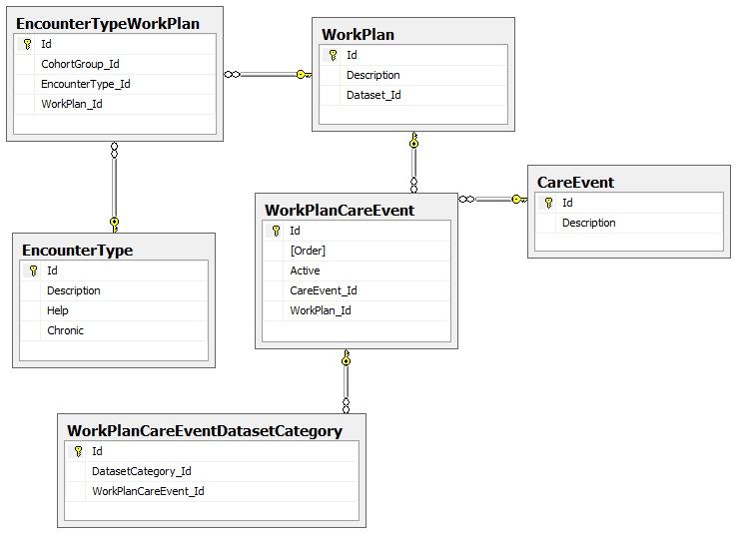

### Reference Entities

|  |  |  |  |  |  |  |  |
| --- | --- | --- | --- | --- | --- | --- | --- |
| **Field Name** | **Field Description** | **Data Type** | | **Field Constraints** | | **Primary/**  **Foreign** | **Nullable** |
| **Entity** | CareEvent | | | | | | |
| **Description** | Contains a list of care events. A care event is defined as an interaction between a health professional and a patient. | | | | | | |
| Id | Unique auto-incremented seed for table | Integer | | None | | Primary | No |
| Description | The name of the care event | Nvarchar | | Max length 50 | | N/A | No |
| **Entity** | EncounterType | | | | | | |
| **Description** | Contains a list of encounter types. An encounter type is defined as the primary reason the patient is attending the facility. | | | | | | |
| Id | Unique auto-incremented seed for table | Integer | | None | | Primary | No |
| Description | The name of the encounter type | Nvarchar | | Max length 50 | | N/A | No |
| Help | Additional help that supplements the description of the encounter type. | Nvarchar | | Max length 250 | | N/A | Yes |
| Chronic | Is this a chronic based encounter type? Dataset elements will be rendered based on the configuration of this encounter type. | Bit | | N/A | | N/A | No |
| **Entity** | WorkPlan | | | | | | |
| **Description** | Contains a list of work plans. A work plan can be aligned to an encounter type and is fundamentally the approach taken by a facility to treat a patient. For instance, a **chronic repeat visit** work plan can be designed to treat chronic patients who are visiting the facility to collect medication only. A work plan shares a one to many relationship per care event. | | | | | | |
| Id | Unique auto-incremented seed for table | | Integer | | None | Primary | No |
| Description | The name of the work plan | | Nvarchar | | Max length 50 | N/A | No |
| Dataset_Id | The associated dataset which contains all data elements that will be rendered as part of this work plan | | Integer | | FK to Dataset | Foreign | Yes |

### Bridging Entities

|  |  |  |  |  |  |
| --- | --- | --- | --- | --- | --- |
| **Field Name** | **Field Description** | **Data Type** | **Field Constraints** | **Primary/**  **Foreign** | **Nullable** |
| **Entity** | EncounterTypeWorkPlan | | | | |
| **Description** | Bridging table that links an encounter type to a work plan. In theory more than work plan can be defined per encounter type, but practically the system implements this as a one to one relationship. This is done to maintain simplicity but provides future scalability. | | | | |
| Id | Unique auto-incremented seed for table | Integer | None | Primary | No |
| CohortGroup_Id | Is this work plan implementation of an encounter type linked to a cohort study? This work plan will only be activated for patients on a particular study. | Integer | FK to CohortGroup | Foreign | Yes |
| EncounterType_Id | The encounter type that the work plan is associated to | Integer | FK to EncounterType | Foreign | No |
| WorkPlan_Id | The work plan that defines the approach to the encounter | Integer | FK to WorkPlan | Foreign | No |
| **Entity** | WorkPlanCareEvent | | | | |
| **Description** | Bridging table that links a work plan to its underlying care events. | | | | |
| Id | Unique auto-incremented seed for table | Integer | None | Primary | No |
| Order | The order of the care event in relation to the work plan. Care events run sequentially. Please note that this order is not currently enforced in PViMS but has been catered for to facilitate future upscaling | Integer |  | N/A | No |
| Active | Is this care event currently active | Bit | None | N/A | No |
| CareEvent_Id | The care event that has been linked to the work plan | Integer | FK to CareEvent | Foreign | No |
| WorkPlan_Id | The work plan that the care event has been linked to | Integer | FK to WorkPlan | Foreign | No |
| **Entity** | WorkPlanCareEventDatasetCategory | | | | |
| **Description** | Bridging table that links various dataset categories to a specific work plan care event. Functional implementation means these categories would be displayed for data collection depending on the associated care event being enforced | | | | |
| Id | Unique auto-incremented seed for table | Integer | None | Primary | No |
| DatasetCategory_Id | The dataset category that has been linked to the work plan care event. The dataset category must be linked to the dataset that has been assigned to the work plan | Integer | FK to DatasetCategory | Foreign | No |
| WorkPlanCareEvent_Id | The work plan care event that the dataset category has been linked to | Integer | FK to WorkPlanCareEvent | Foreign | No |

## Dataset Entities

|  |
| --- |
| This section contains all dataset related entities that facilitate the dynamic customization of clinical elements within the system. All clinical data can be distilled and governed on the basis of a dataset element which contains the definition of the element and governs data integrity in based on this definition. |

### Entity Relationship Diagram

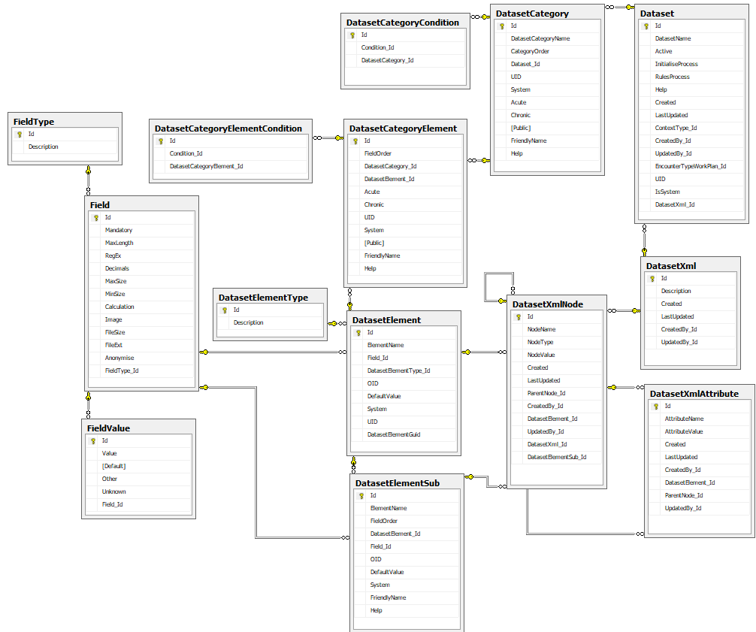

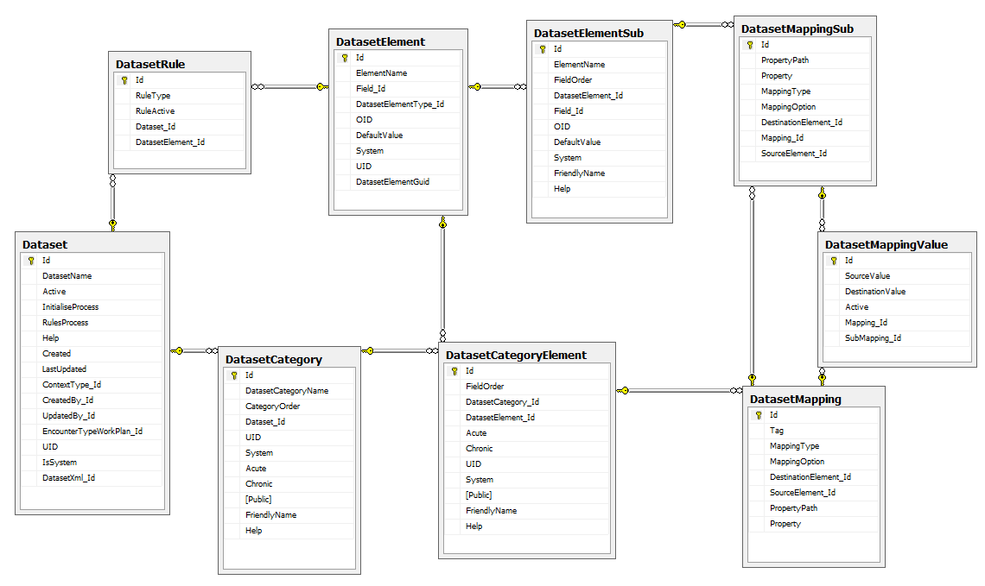

### Reference Entities

|  |  |  |  |  |  |
| --- | --- | --- | --- | --- | --- |
| **Field Name** | **Field Description** | **Data Type** | **Field Constraints** | **Primary/**  **Foreign** | **Nullable** |
| **Entity** | FieldType | | | | |
| **Description** | Contains a list of field types that specify what type of data will be stored within the dataset element. | | | | |
| Id | Unique auto-incremented seed for table | Integer | None | Primary | No |
| Description | The name of the field type | Nvarchar | Max length 50 | N/A | No |
|  | **Field Types**  Listbox  DropDownList  AlphaNumericTextbox  NumericTextbox  YesNo  Date  Table  System |  |  |  |  |
| **Entity** | DatasetElementType | | | | |
| **Description** | Contains a list of dataset element types. This will be used for future scalability. Primary definition of a data type is currently defined through the FieldType element.  **\*\* Not in use \*\*** | | | | |
| Id | Unique auto-incremented seed for table | Integer | None | Primary | No |
| Description | The name of the dataset element type | Nvarchar | Max length 50 | N/A | No |

### Bridging Entities

|  |  |  |  |  |  |
| --- | --- | --- | --- | --- | --- |
| **Field Name** | **Field Description** | **Data Type** | **Field Constraints** | **Primary/**  **Foreign** | **Nullable** |
| **Entity** | DatasetCategoryCondition | | | | |
| **Description** | Contains a list of chronic conditions that a category has been associated to (relevant if the chronic field has been set to true for the associated category) | | | | |
| Id | Unique auto-incremented seed for table | Integer | None | Primary | No |
| Condition_Id | The chronic condition the patient must have for the category to be rendered | Integer | FK to Condition | Foreign | No |
| DatasetCategory_Id | The dataset category that the chronic condition has been linked to | Integer | FK to DatasetCategory | Foreign | No |
| **Entity** | DatasetCategoryElement | | | | |
| **Description** | Contains a list of elements associated to a category | | | | |
| Id | Unique auto-incremented seed for table | Integer | None | Primary | No |
| FieldOrder | The order of the element in relation to the category | Smallint | None | N/A | No |
| DatasetCategory_Id | The dataset category that the element has been linked to. Elements can be linked to more than one category in more than one dataset | Integer | FK to DatasetCategory | Foreign | No |
| DatasetElement_Id | The element that is being linked to the dataset category | Integer | FK to DatasetElement | Foreign | No |
| Acute | Display element for acute encounter types (non-chronic) | Bit | None | N/A | No |
| Chronic | Display this element for chronic encounter types | Bit | None | N/A | No |
| UID | A unique ID for the dataset element  **\*\* not in use \*\*** | Nvarchar | Max length 10 | N/A | Yes |
| System | Is the dataset element system generated? System defined elements may not be removed. | Bit |  | N/A | No |
| Public | Collected in public mode only (not logged into PViMS)  **\*\* not in use \*\*** | Bit |  | N/A | No |
| FriendlyName | The friendly name of the dataset element when rendered in the current category | Nvarchar | Max length 150 | N/A | Yes |
| Help | Additional information that defines the use of the dataset element when rendered in the current category | Nvarchar | Max length 350 | N/A | Yes |
| **Entity** | DatasetCategoryElementCondition | | | | |
| **Description** | Contains a list of chronic conditions that an element has been associated to (relevant if the chronic field has been set to true for the associated element) | | | | |
| Id | Unique auto-incremented seed for table | Integer | None | Primary | No |
| Condition_Id | The chronic condition the patient must have for the element to be rendered | Integer | None | N/A | No |
| DatasetCategoryElement_Id | The dataset category element that the chronic condition has been linked to | Integer | FK to DatasetCategoryElement | Foreign | No |

### Transaction Entities

|  |  |  |  |  |  |  |
| --- | --- | --- | --- | --- | --- | --- |
| **Field Name** | **Field Description** | **Data Type** | **Field Constraints** | **Primary/**  **Foreign** | **Nullable** | |
| **Entity** | Dataset | | | | | |
| **Description** | Contains a list of datasets. A dataset is effectively a collection of dataset categories which are further sub divided into a collection of dataset elements per category. A dataset is effectively a collection of dataset elements that correlate to each other. | | | | | |
| Id | Unique auto-incremented seed for table | Integer | None | Primary | No | |
| DatasetName | The name of the dataset | Nvarchar | Max length 50 | N/A | No | |
| Active | Is this dataset currently active for data collection | Bit | None | N/A | No | |
| InitialiseProcess | A C# method that can be called to initialize the dataset on creation  **\*\* not in use \*\*** | Nvarchar | Max length 100 | N/A | Yes | |
| RulesProcess | A C# method that can be called to instantiate business rules against the dataset  **\*\* not in use \*\*** | Nvarchar | Max length 100 | N/A | Yes | |
| Help | Additional information that defines the use of the dataset | Nvarchar | Max length 250 | N/A | Yes | |
| Created | AUDIT: Date record was created | Datetime | None | N/A | No | |
| LastUpdated | AUDIT: Date record was last updated | Datetime | None | N/A | Yes | |
| ContextType_Id | The type of entity that this dataset associated to | Integer | FK to ContextType | Foreign | Yes | |
|  | **Context Types**  Encounter  Patient  Pregnancy  Global  PatientClinicalEvent  DatasetInstance |  |  |  |  | |
| CreatedBy_Id | AUDIT: The user that created this record | Integer | FK to User | Foreign | Yes | |
| UpdatedBy_Id | AUDIT: The user that last updated this record | Integer | FK to User | Foreign | Yes | |
| EncounterTypeWorkPlan_Id | The work plan that has been used to implement this dataset | Integer | FK to EncounterTypeWorkPlan | Foreign | Yes | |
| UID | A unique ID for the dataset  **\*\* not in use \*\*** | Nvarchar | Max length 10 | N/A | Yes | |
| IsSystem | Is the dataset system generated? System defined datasets may not be renamed or removed. | Bit |  | N/A | No | |
| DatasetXml_Id | The XML dataset structure this dataset is linked to. E2B R2 is defined through this XML dataset structure. | Integer | FK to DatasetXml | Foreign | Yes | |
| **Entity** | DatasetCategory | | | | | |
| **Description** | Contains a list of categories associated to the dataset. A dataset category is effectively made up of a collection of dataset elements that are related to each other as defined by the category itself. For instance, a **Vitals** category would contain all elements related to vitals, such as blood pressure, weight etc. | | | | | |
| Id | Unique auto-incremented seed for table | Integer | None | Primary | No | |
| DatasetCategoryName | The name of the category | Nvarchar | Max length 50 | N/A | No | |
| CategoryOrder | The order of the category in relation to the dataset | Smallint | None | N/A | No | |
| Dataset_Id | The dataset the category is associated to | Integer | FK to Dataset | Foreign | No | |
| UID | A unique ID for the dataset category  **\*\* not in use \*\*** | Nvarchar | Max length 10 | N/A | Yes | |
| System | Is the dataset category system generated? System defined categories may not be renamed or removed. | Bit |  | N/A | No | |
| Acute | Render the category for all non-chronic related patients | Bit |  | N/A | No | |
| Chronic | Render the category for all chronic related patients. For instance, this category will only be rendered if the patient has malaria. | Bit |  | N/A | No | |
| Public | Collected in public mode only (not logged into PViMS)  **\*\* not in use \*\*** | Bit |  | N/A | No | |
| Dataset_Id | The dataset the category is associated to | Integer | FK to Dataset | Foreign | No | |
| FriendlyName | The friendly name of the dataset category | Nvarchar | Max length 150 | N/A | Yes | |
| Help | Additional information that defines the use of the dataset category | Nvarchar | Max length 350 | N/A | Yes | |
| **Entity** | DatasetElement | | | | | |
| **Description** | Contains a list of unique dataset elements defined within the system. | | | | | |
| Id | Unique auto-incremented seed for table | Integer | None | Primary | No | |
| ElementName | The unique name of the dataset element (e.g. Weight) | Nvarchar | Max length 100 | N/A | No | |
| Field_Id | The field definition for this dataset element. Contains rules that are implemented to ensure data integrity | Integer | FK to Field | Foreign | No | |
| DatasetElementType_Id | The dataset element type  **\*\* not in use \*\*** | Integer | FK to DatasetElementType | Foreign | Yes | |
| OID | The OID for the dataset element. Used for E2B extracts. | Nvarchar | Max length 50 | N/A | Yes | |
| DefaultValue | The default value for an OID field in an E2B extract. | Nvarchar | Max length MAX | N/A | Yes | |
| System | Is this a system defined element? System defined elements may not be removed or renamed. | Bit | None | N/A | No | |
| UID | A unique ID for the dataset element  **\*\* not in use \*\*** | Nvarchar | Max length 10 | N/A | Yes | |
| DatasetElementGuid | A globally unique definition for the element. Used to match an element when called through the interoperability end point | Uniqueidentifier | None | N/A | No | |
| **Entity** | DatasetElementSub | | | | | |
| **Description** | Contains a list of unique dataset elements for the **TABLE** field type | | | | | |
| Id | Unique auto-incremented seed for table | Integer | None | Primary | No | |
| ElementName | The unique name of the dataset element (e.g. Weight) | Nvarchar | Max length 100 | N/A | No | |
| FieldOrder | The order of the element in relation to the table as a whole | Smallint | None | N/A | No | |
| DatasetElement_Id | The dataset element that the sub element is linked to | Integer | FK to DatasetElement | Foreign | No | |
| Field_Id | The field definition for this dataset element. Contains rules that are implemented to ensure data integrity | Integer | FK to Field | Foreign | No | |
| OID | The OID for the dataset element. Used for E2B extracts. | Nvarchar | Max length 50 | N/A | Yes | |
| DefaultValue | The default value for an OID field in an E2B extract. | Nvarchar | Max length MAX | N/A | Yes | |
| System | Is this a system defined element? System defined elements may not be removed or renamed. | Bit | None | N/A | No | |
| FriendlyName | The friendly name of the dataset element | Nvarchar | Max length 150 | N/A | Yes | |
| Help | Additional information that defines the use of the dataset element within the table | Nvarchar | Max length 350 | N/A | Yes | |
| **Entity** | DatasetMapping | | | | | |
| **Description** | Contains a list of mappings that maps one dataset element within one dataset to another dataset element within another dataset. These mappings are used to automate the defaulting of the E2B dataset on creation. | | | | | |
| Id | Unique auto-incremented seed for table | Integer | None | Primary | No | |
| Tag | Active for active reporting and Spontaneous for spontaneous reporting | Nvarchar | Max length 350 | N/A | Yes | |
| MappingType | The type of mapping   * ElementToElement * ValueToValue * AttributeToElement * AttributeToValue * FirstClassToElement * FirstClassToValue | Integer |  | N/A | No | |
| MappingOption | Additional formatting options when mapping takes place   * yyyyMMdd for date fields | Nvarchar | Max length MAX | N/A | Yes | |
| DestinationElement_Id | The dataset category element that will receive the translated value | Integer | FK to DatasetCategoryElement | Foreign | No | |
| SourceElement_Id | The dataset category element that will submit the translated value | Integer | FK to DatasetCategoryElement | Foreign | Yes | |
| PropertyPath | If a source element is not specified, then we need to reference a custom attribute | Nvarchar | Max length MAX | N/A | Yes | |
| Property | If a source element is not specified, then we need to reference a custom attribute | Nvarchar | Max length MAX | N/A | Yes | |
| **Entity** | DatasetMappingSub | | | | | |
| **Description** | Contains a list of mappings that maps one dataset element sub within one dataset mapping to another dataset element sub within another dataset mapping. These mappings are used to automate the defaulting of the E2B dataset on creation. | | | | | |
| Id | Unique auto-incremented seed for table | Integer | None | Primary | No | |
| MappingType | The type of mapping | Integer |  | N/A | No | |
|  | **Mapping Types**  ElementToElement  ValueToValue  AttributeToElement  AttributeToValue  FirstClassToElement  FirstClassToValue |  |  |  |  | |
| MappingOption | Additional formatting options when mapping takes place   * yyyyMMdd for date fields | Nvarchar | Max length MAX | N/A | Yes | |
| DestinationElement_Id | The dataset element sub that will receive the translated value | Integer | FK to DatasetElementSub | Foreign | No | |
| Mapping_Id | The dataset mapping that the sub mapping belongs to | Integer | FK to DatasetMapping | Foreign | No | |
| SourceElement_Id | The dataset element sub that will submit the translated value | Integer | FK to DatasetElementSub | Foreign | Yes | |
| PropertyPath | If a source element is not specified, then we need to reference a custom attribute | Nvarchar | Max length MAX | N/A | Yes | |
| Property | If a source element is not specified, then we need to reference a custom attribute | Nvarchar | Max length MAX | N/A | Yes | |
| **Entity** | DatasetMappingValue | | | | | |
| **Description** | Contains a list of mapping values that translate a source value to a destination value. These mappings are used to automate the defaulting of the E2B dataset on creation. | | | | | |
| Id | Unique auto-incremented seed for table | Integer | None | Primary | No | |
| SourceValue | The source value that is to be mapped | Nvarchar | Max length 100 | N/A | No | |
| DestinationValue | The destination value that is to be mapped to | Nvarchar | Max length 100 | N/A | Yes | |
| Active | Is the mapping currently active | Bit |  | N/A | No | |
| Mapping_Id | The dataset mapping that the mapping value belongs to | Integer | FK to DatasetMapping | Foreign | No | |
| SubMapping_Id | The dataset sub mapping that the mapping value belongs to | Integer | FK to DatasetMappingSub | Foreign | No | |
| **Entity** | DatasetRule | | | | |
| **Description** | Contains a list of implementable rules per dataset | | | | |
| Id | Unique auto-incremented seed for table | Integer | None | Primary | No |
| RuleType | The type of rule to be implemented | Integer |  | N/A | No |
|  | **Rule Types**  ElementCanoOnlyLinkToSingleDataset  MandatoryFieldsProminent |  |  |  |  |
| RuleActive | Is this dataset rule currently active | Bit |  | N/A | No |
| Dataset_Id | The dataset that the rule belongs to | Integer | FK to Dataset | Foreign | Yes |
| DatasetElement_Id | The dataset element that the rule belongs to | Integer | FK to DatasetElement | Foreign | Yes |
| **Entity** | DatasetXml | | | | |
| **Description** | Contains the description of the XML node set that has been attributed to a corresponding dataset. Used to generate the E2B XML data structure. | | | | |
| Id | Unique auto-incremented seed for table | Integer | None | Primary | No |
| Description | The description of the XML data structure. For instance, **E2B(R2) XML.** | Nvarchar | Max length 50 | N/A | Yes |
| Created | AUDIT: Date record was created | Datetime | None | N/A | No |
| LastUpdated | AUDIT: Date record was last updated | Datetime | None | N/A | Yes |
| CreatedBy_Id | AUDIT: The user that created this record | Integer | FK to User | Foreign | Yes |
| UpdatedBy_Id | AUDIT: The user that last updated this record | Integer | FK to User | Foreign | Yes |
| **Entity** | DatasetXmlAttribute | | | | |
| **Description** | Contains a list of XML attributes that correspond to an XML node. Used to generate the E2B XML data structure. | | | | |
| Id | Unique auto-incremented seed for table | Integer | None | Primary | No |
| AttributeName | The name of the XML attribute | Nvarchar | Max length 50 | N/A | No |
| AttributeValue | The default value of the attribute | Nvarchar | Max length MAX | N/A | Yes |
| Created | AUDIT: Date record was created | Datetime | None | N/A | No |
| LastUpdated | AUDIT: Date record was last updated | Datetime | None | N/A | Yes |
| CreatedBy_Id | AUDIT: The user that created this record | Integer | FK to User | Foreign | Yes |
| DatasetElement_Id | The dataset element that the XML attribute represents. The corresponding value of the element is transposed into the generated XML file. | Integer | FK to DatasetElement | Foreign | Yes |
| ParentNode_Id | The XML node that the attribute belongs to | Integer | FK to DatasetXmlNode | Foreign | No |
| UpdatedBy_Id | AUDIT: The user that last updated this record | Integer | FK to User | Foreign | Yes |
| **Entity** | DatasetXmlNode | | | | |
| **Description** | Contains a list of XML nodes that correspond to an XML dataset. Used to generate the E2B XML data structure. | | | | |
| Id | Unique auto-incremented seed for table | Integer | None | Primary | No |
| NodeName | The name of the XML node | Nvarchar | Max length 50 | N/A | No |
| NodeType | The type of XML node | Int |  | N/A | No |
| NodeType | **Node Types**  RootNode = 1  StandardNode = 2  RepeatingNode = 3 | Int |  | N/A | No |
| NodeValue | The default value of the node | Nvarchar | Max length MAX | N/A | Yes |
| Created | AUDIT: Date record was created | Datetime | None | N/A | No |
| LastUpdated | AUDIT: Date record was last updated | Datetime | None | N/A | Yes |
| ParentNode_Id | Self-referencing, does this node have a parent node. Used to create tree structure. | Integer | FK to DatasetXmlNode | Foreign | Yes |
| CreatedBy_Id | AUDIT: The user that created this record | Integer | FK to User | Foreign | Yes |
| DatasetElement_Id | The dataset element that the XML node represents. The corresponding value of the element is transposed into the generated XML file. | Integer | FK to DatasetElement | Foreign | Yes |
| UpdatedBy_Id | AUDIT: The user that last updated this record | Integer | FK to User | Foreign | Yes |
| DatasetXml_Id | The XML dataset that the node belongs to. | Integer | FK to DatasetXml | Foreign | Yes |
| DatasetElementSub_Id | The dataset element that the XML node represents. The corresponding value of the element is transposed into the generated XML file. | Integer | FK to DatasetElementSub | Foreign | Yes |
| **Entity** | Field | | | | |
| **Description** | Contains the data integrity rules for the associated dataset element | | | | |
| Id | Unique auto-incremented seed for table | Integer | None | Primary | No |
| Mandatory | Is the dataset element mandatory? Applicable for all field types. | Bit | None | N/A | No |
| MaxLength | The maximum length of the element value. Applicable to the AlphaNumericTextbox. | Smallint | None | N/A | Yes |
| RegEx | Is there a regular expression that should be executed when validating the element?  **\*\* not in use \*\*** | Nvarchar | Max length 100 | N/A | Yes |
| Decimals | The number of decimals for a numerical value. Applicable to the NumericTextbox | Smallint | None | N/A | Yes |
| MaxSize | The maximum value for a numerical value. Applicable to the NumericTextbox | Decimal(18.2) | None | N/A | Yes |
| MinSize | The minimum value for a numerical value. Applicable to the NumericTextbox | Decimal(18.2) | None | N/A | Yes |
| Calculation | Element value is defined as per the calculation attribute. For instance, BMI is calculated using the weight and length values. | Nvarchar | Max length 100 | N/A | Yes |
| Image | Clinical value is stored in the form of an image within the database. Can be used to store patient photos etc. | Image | None | N/A | Yes |
| FileSize | Maximum file size that can be stored. | Smallint | None | N/A | Yes |
| FileExt | The types of file extensions accepted for storage. | Nvarchar | Max length 100 | N/A | Yes |
| Anonymise | If the element is included in any extract or report, should this field be anonymized | Bit | None | N/A | No |
| FieldType_Id | The type of field | Integer | FK to FieldType | Foreign | Yes |
| **Entity** | FieldValue | | | | |
| **Description** | Contains a list of selection values for DropDownList field types | | | | |
| Id | Unique auto-incremented seed for table | Integer | None | Primary | No |
| Value | The value of the drop-down list | Nvarchar | Max length 100 | N/A | No |
| Default | Is this the default value for the drop-down list | Bit | None | N/A | No |
| Other | Drop down list value for OTHER | Bit | None | N/A | No |
| Unknown | Drop down list value for UNKNOWN | Bit | None | N/A | No |
| Field_Id | The field that the list of values is linked to | Integer | FK to Field | Foreign | No |

## Meta Framework Entities

|  |
| --- |
| This section contains all meta related entities that facilitate customization of reports within the reporting portal and content within the information portal. |

### Entity Relationship Diagram

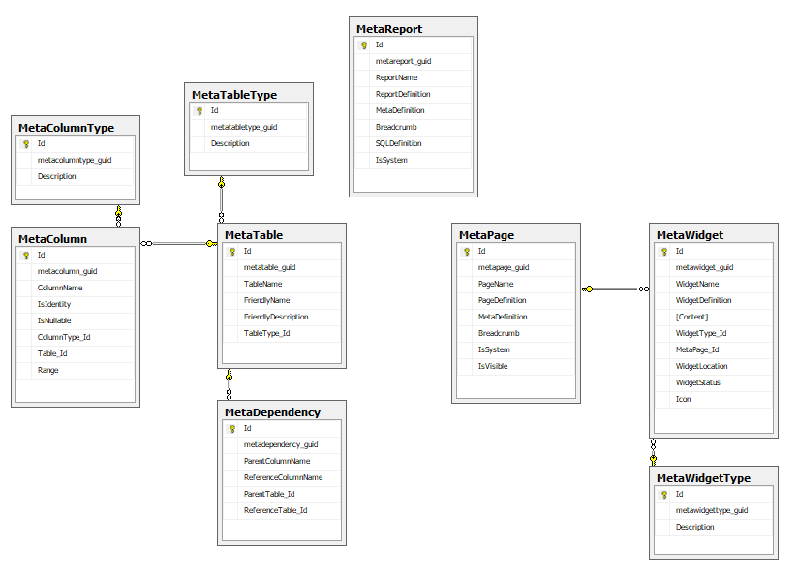

### Reference Entities

|  |  |  |  |  |  |
| --- | --- | --- | --- | --- | --- |
| **Field Name** | **Field Description** | **Data Type** | **Field Constraints** | **Primary/**  **Foreign** | **Nullable** |
| **Entity** | MetaWidgetType | | | | |
| **Description** | Contains a list of meta widget types which defines the type of widgets that can be added to the information portal | | | | |
| Id | Unique auto-incremented seed for table | Integer | None | Primary | No |
| Metawidgettype_GUID | A globally unique identifier for this widget type | UniqueIdentifier | None | N/A | No |
| Description | The name of the meta widget type | Nvarchar | Max length 50 | N/A | No |
|  | **Meta Widget Types**  General  Wiki  ItemList |  |  |  |  |
| **Entity** | MetaColumnType | | | | |
| **Description** | Contains a list of meta column types. A meta column type governs the type of columns that can be defined in the reporting portal | | | | |
| Id | Unique auto-incremented seed for table | Integer | None | Primary | No |
| Metacolumntype_GUID | A globally unique identifier for this column type | UniqueIdentifier | None | N/A | No |
| Description | The name of the meta column type | Nvarchar | Max length 50 | N/A | No |
|  | **Meta Column Types**  bigint  binary  bit  char  date  datetime  decimal  image  int  nchar  nvarchar  smallint  time  tinyint  uniqueidentifier  varbinary  varchar |  |  |  |  |
| **Entity** | MetaTableType | | | | |
| **Description** | Contains a list of meta table types. A meta table type governs the type of tables that can be defined in the reporting portal | | | | |
| Id | Unique auto-incremented seed for table | Integer | None | Primary | No |
| Metacolumntype_GUID | A globally unique identifier for this table type | UniqueIdentifier | None | N/A | No |
| Description | The name of the meta table type | Nvarchar | Max length 50 | N/A | No |
|  | **Meta Table Types**  Core  CoreChild  Child  History  Lookup |  |  |  |  |

### Transaction Entities

|  |  |  |  |  |  |
| --- | --- | --- | --- | --- | --- |
| **Field Name** | **Field Description** | **Data Type** | **Field Constraints** | **Primary/**  **Foreign** | **Nullable** |
| **Entity** | MetaReport | | | | |
| **Description** | Contains a list of custom and system defined reports. The reporting portal menu structure is dynamically populated based on the contents of this entity. | | | | |
| Id | Unique auto-incremented seed for table | Integer | None | Primary | No |
| Metareport_GUID | A globally unique identifier for this report | UniqueIdentifier | None | N/A | No |
| ReportName | The name of the report | Nvarchar | Max length 50 | N/A | No |
| ReportDefinition | A detailed description for the report | Nvarchar | Max length 250 | N/A | Yes |
| MetaDefinition | The configuration of the report stored in XML format. Contains a list of entities referenced, where statements and columns. | Nvarchar | Max length MAX | N/A | No |
| Breadcrumb | The menu structure for the report | Nvarchar | Max length 250 | N/A | No |
| SQLDefinition | The SQL statement needed to generate the report | Nvarchar | Max length MAX | N/A | No |
| IsSystem | Is this a system defined report? System reports may not be modified or removed. | Bit | None | N/A | No |
| **Entity** | MetaTable | | | | |
| **Description** | Contains a list of system generated META tables. This list is not administrable at run time but is governed systematically. | | | | |
| Id | Unique auto-incremented seed for table | Integer | None | Primary | No |
| Metatable_GUID | A globally unique identifier for this table | UniqueIdentifier | None | N/A | No |
| TableName | The name of the table | Nvarchar | Max length 50 | N/A | No |
| FriendlyName | A friendly name defining the contents of the table | Nvarchar | Max length 100 | N/A | Yes |
| FriendlyDescription | A friendly description of the table | Nvarchar | Max length 250 | N/A | Yes |
| TableType_Id | The type of table defined | Integer | FK to MetaTableType | Foreign | No |
| **Entity** | MetaColumn | | | | |
| **Description** | Contains a list of system generated META columns. This list is not administrable at run time but is governed systematically. | | | | |
| Id | Unique auto-incremented seed for table | Integer | None | Primary | No |
| Metacolumn_GUID | A globally unique identifier for this column | UniqueIdentifier | None | N/A | No |
| ColumnName | The name of the column | Nvarchar | Max length 50 | N/A | No |
| IsIdentity | Is this an identity column | Bit | None | N/A | No |
| IsNullable | Is this column nullable | Bit | None | N/A | No |
| ColumnType_Id | The type of column defined | Integer | FK to MetaColumnType | Foreign | No |
| Table_Id | The table the column is associated to | Integer | FK to MetaTable | Foreign | No |
| Range | Contains a list of selected values for drop down purposes, or contains a source reference to a reference table. | Nvarchar | Max length MAX | N/A | Yes |
| **Entity** | MetaDependency | | | | |
| **Description** | Defines dependency between all meta generated tables | | | | |
| Id | Unique auto-incremented seed for table | Integer | None | Primary | No |
| Metadependency_GUID | A globally unique identifier for this dependency | UniqueIdentifier | None | N/A | No |
| ParentColumnName | The name of the parent column in the relationship | Nvarchar | Max length 50 | N/A | No |
| ReferenceColumnName | The name of the reference column in the relationship | Nvarchar | Max length 50 | N/A | No |
| ParentTable_Id | The parent table in the relationship | Integer | FK to MetaTable | Foreign | No |
| ReferenceTable_Id | The reference table in the relationship | Integer | FK to MetaTable | Foreign | No |
| **Entity** | MetaPage | | | | |
| **Description** | Contains a list of META pages for publication within the information portal | | | | |
| Id | Unique auto-incremented seed for table | Integer | None | Primary | No |
| Metapage_GUID | A globally unique identifier for this page | UniqueIdentifier | None | N/A | No |
| PageName | The name of the publication page | Nvarchar | Max length 50 | N/A | No |
| PageDefinition | A detailed description for the page | Nvarchar | Max length 250 | N/A | Yes |
| MetaDefinition | The configuration of the page | Nvarchar | Max length MAX | N/A | No |
| Breadcrumb | The menu structure for the report | Nvarchar | Max length 250 | N/A | No |
| IsSystem | Is this a system defined page? System pages may not be adjusted. | Bit | None | N/A | No |
| IsVisible | Is this page visible in the menu structure of the information portal | Bit | None | N/A | No |
| **Entity** | MetaWidget | | | | |
| **Description** | Contains a list of META widgets that have been created for a page within the information portal | | | | |
| Id | Unique auto-incremented seed for table | Integer | None | Primary | No |
| Metawidget_GUID | A globally unique identifier for this widget | UniqueIdentifier | None | N/A | No |
| WidgetName | The name of the publication widget | Nvarchar | Max length 50 | N/A | No |
| WidgetDefinition | A detailed description for the widget | Nvarchar | Max length 250 | N/A | Yes |
| Content | The content of the widget | Nvarchar | Max length MAX | N/A | No |
| WidgetType_Id | The type of widget that has been added | Integer | FK to MetaWidgetType | N/A | No |
| MetaPage_Id | The page the widget is associated to | Integer | FK to MetaPage | N/A | No |
| WidgetLocation | The location of the widget within the page. A widget can only exist in one of these locations and a location can only contain one widget. | Integer |  | N/A | No |
|  | **Widget Locations**  TopLeft = 1  TopRight = 2  MiddleLeft = 3  MiddleRight = 4  BottomLeft = 5  BottomRight = 6  Unassigned = 7 |  |  |  |  |
| WidgetStatus | The status of the widget. | Integer |  | N/A | No |
|  | **Widget Status**  Published = 1  Unpublished = 2  Unpublished widgets are not rendered to the user. |  |  |  |  |
| Icon | The icon that should be displayed in the header of the widget. (http://fontawesome.com) | Nvarchar | Max length MAX | N/A | Yes |

## Patient Entities

|  |
| --- |
| This section contains all patient related entities |

### Entity Relationship Diagram

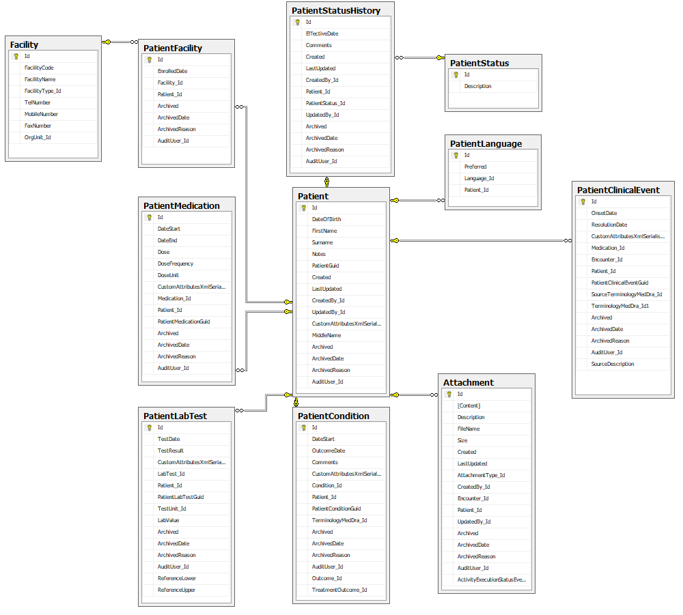

### Reference Entities

|  |  |  |  |  |  |
| --- | --- | --- | --- | --- | --- |
| **Field Name** | **Field Description** | **Data Type** | **Field Constraints** | **Primary/**  **Foreign** | **Nullable** |
| **Entity** | PatientStatus | | | | |
| **Description** | Contains a list of patient statuses | | | | |
| Id | Unique auto-incremented seed for table | Integer | None | Primary | No |
| Description | The name of the patient status | Nvarchar | Max length 50 | N/A | No |
|  | Patient Statuses   * Active * Suspended * Stopped ART * Investigation * LTF * Stopped PMTCT * Transferred Out * Died |  |  |  |  |
| **Entity** | Facility | | | | |
| **Description** | Contains a list of facilities | | | | |
| Id | Unique auto-incremented seed for table | Integer | None | Primary | No |
| FacilityCode | A unique code for the facility | Nvarchar | Max length 10 | N/A | No |
| FacilityName | A unique name for the facility | Nvarchar | Max length 100 | N/A | No |
| FacilityType_Id | The type of facility | Integer | FK to FacilityType | Foreign | Yes |
| TelNumber | The contact number for the facility | Nvarchar | Max length 30 | N/A | Yes |
| MobileNumber | The mobile number for the facility | Nvarchar | Max length 30 | N/A | Yes |
| FaxName | A fax number for the facility | Nvarchar | Max length 30 | N/A | Yes |
| OrgUnit_Id | **\*\* not used \*\*** | Integer | FK to OrgUnit | Foreign | Yes |

### Transaction Entities

|  |  |  |  |  |  |
| --- | --- | --- | --- | --- | --- |
| **Field Name** | **Field Description** | **Data Type** | **Field Constraints** | **Primary/**  **Foreign** | **Nullable** |
| **Entity** | Patient | | | | |
| **Description** | Core patient demographics table containing a single unique record per patient | | | | |
| Id | Unique auto-incremented seed for table | Integer | None | Primary | No |
| DateOfBirth | Patient date of birth | Date | None | N/A | No |
| FirstName | Patient first name | Nvarchar | Max length MAX  Allow A-Z, a-z, space | N/A | No |
| Surname | Patient surname | Nvarchar | Max length MAX  Allow A-Z, a-z, space | N/A | No |
| Notes | Generic patient notes | Nvarchar | Max length MAX | N/A | Yes |
| PatientGUID | A globally unique identifier for this patient | UniqueIdentifier | None | N/A | No |
| Created | AUDIT: Date record was created | Datetime | None | N/A | No |
| LastUpdated | AUDIT: Date record was last updated | Datetime | None | N/A | Yes |
| CreatedBy_Id | AUDIT: The user that created this record | Integer | FK to User | Foreign | Yes |
| UpdatedBy_Id | AUDIT: The user that last updated this record | Integer | FK to User | Foreign | Yes |
| CustomAttributesXmlSerialised | XML data structure containing all custom attributes | XML | None | N/A | Yes |
| MiddleName | The middle name of the patient | Nvarchar | Max length MAX  Allow A-Z, a-z, space | N/A | No |
| Archived | ARCHIVE: Is this record archived | Bit | None | N/A | No |
| ArchivedDate | ARCHIVE: The date the record was archived | DateTime | None | N/A | Yes |
| ArchivedReason | ARCHIVE: The reason the record was archived | Nvarchar | Max length 200 | N/A | Yes |
| AuditUser_Id | ARCHIVE: Who archived the record | Integer | FK to User | Foreign | Yes |
| **Entity** | PatientCondition | | | | |
| **Description** | A list of concomitant patient conditions | | | | |
| Id | Unique auto-incremented seed for table | Integer | None | Primary | No |
| DateStart | The start date of the condition | Date | None | N/A | Yes |
| OutcomeDate | The end date of the condition | Date | None | N/A | Yes |
| Comments | Generic condition notes | Nvarchar | Max length 500 | N/A | Yes |
| CustomAttributesXmlSerialised | XML data structure containing all custom attributes | XML | None | N/A | Yes |
| Patient_Id | The patient the condition is associated to | Integer | FK to Patient | Foreign | No |
| PatientConditionGUID | A globally unique identifier for this patient condition | UniqueIdentifier | None | N/A | No |
| TerminologyMedDRA_Id | The MedDRA term for the condition | Integer | FK to TerminologyMedDRA | Foreign | No |
| Archived | ARCHIVE: Is this record archived | Bit | None | N/A | No |
| ArchivedDate | ARCHIVE: The date the record was archived | DateTime | None | N/A | Yes |
| ArchivedReason | ARCHIVE: The reason the record was archived | Nvarchar | Max length 200 | N/A | Yes |
| AuditUser_Id | ARCHIVE: Who archived the record | Integer | FK to User | Foreign | Yes |
| Outcome_Id | The outcome of the condition | Integer | FK to Outcome | Foreign | No |
| TreatmentOutcome_Id | The treatment outcome of the condition | Integer | FK to TreatmentOutcome | Foreign | No |
| **Entity** | PatientMedication | | | | |
| **Description** | A comprehensive list of medications associated to the patient | | | | |
| Id | Unique auto-incremented seed for table | Integer | None | Primary | No |
| DateStart | The start date of the medication | Date | None | N/A | No |
| DateEnd | The end date of the medication | Date | None | N/A | Yes |
| Dose | The dose of the medication | Nvarchar | Max length 30 | N/A | Yes |
| DoseFrequency | The frequency of the dose | Nvarchar | Max length 30 | N/A | Yes |
| DoseUnit | The unit of the dose | Nvarchar | Max length 10 | N/A | Yes |
| CustomAttributesXmlSerialised | XML data structure containing all custom attributes | XML | None | N/A | Yes |
| Medication_Id | The medication the patient is taking | Integer | FK to Medication | Foreign | No |
| Patient_Id | The patient the medication is associated to | Integer | FK to Patient | Foreign | No |
| PatientMedicationGUID | A globally unique identifier for this patient medication | UniqueIdentifier | None | N/A | No |
| Archived | ARCHIVE: Is this record archived | Bit | None | N/A | No |
| ArchivedDate | ARCHIVE: The date the record was archived | DateTime | None | N/A | Yes |
| ArchivedReason | ARCHIVE: The reason the record was archived | Nvarchar | Max length 200 | N/A | Yes |
| AuditUser_Id | ARCHIVE: Who archived the record | Integer | FK to User | Foreign | Yes |

|  |  |  |  |  |  |
| --- | --- | --- | --- | --- | --- |
| **Entity** | PatientClinicalEvent | | | | |
| **Description** | A list of adverse events associated to the patient. These events form the basis for pharmacovigilance activities conducted in the analytical portal. | | | | |
| Id | Unique auto-incremented seed for table | Integer | None | Primary | No |
| OnsetDate | The onset date of the clinical event | Date | None | N/A | Yes |
| ResolutionDate | The resolution date of the clinical event | Date | None | N/A | Yes |
| CustomAttributesXmlSerialised | XML data structure containing all custom attributes | XML | None | N/A | Yes |
| Patient_Id | The patient the adverse event is associated to | Integer | FK to Patient | Foreign | No |
| PatientClinicalEventGuid | A globally unique identifier for this patient adverse event | UniqueIdentifier | None | N/A | No |
| SourceTerminologyMedDRA_Id | The MedDRA term for the clinical event that is selected by the clinician | Integer | FK to TerminologyMedDRA | Foreign | No |
| Archived | ARCHIVE: Is this record archived | Bit | None | N/A | No |
| ArchivedDate | ARCHIVE: The date the record was archived | DateTime | None | N/A | Yes |
| ArchivedReason | ARCHIVE: The reason the record was archived | Nvarchar | Max length 200 | N/A | Yes |
| AuditUser_Id | ARCHIVE: Who archived the record | Integer | FK to User | Foreign | Yes |
| SourceDescription | The adverse event description as per the patient or reporter | Nvarchar | Max length 500 | N/A | Yes |
| **Entity** | PatientLabTest | | | | |
| **Description** | A list of lab tests associated to the patient | | | | |
| Id | Unique auto-incremented seed for table | Integer | None | Primary | No |
| TestDate | The test date of the lab test | Date | None | N/A | No |
| TestResult | The result of the test | Nvarchar | Max length 50 | N/A | Yes |
| CustomAttributesXmlSerialised | XML data structure containing all custom attributes | XML | None | N/A | Yes |
| LabTest_Id | The lab test conducted | Integer | FK to LabTest | Foreign | No |
| Patient_Id | The patient the lab test is associated to | Integer | FK to Patient | Foreign | No |
| PatientLabTestGuid | A globally unique identifier for this patient lab test | UniqueIdentifier | None | N/A | No |
| TestUnit_Id | The unit of the test | Integer | FK to LabTestUnit | Foreign | Yes |
| LabValue | The value of the lab test | Nvarchar(20) | None | N/A | Yes |
| Archived | ARCHIVE: Is this record archived | Bit | None | N/A | No |
| ArchivedDate | ARCHIVE: The date the record was archived | DateTime | None | N/A | Yes |
| ArchivedReason | ARCHIVE: The reason the record was archived | Nvarchar | Max length 200 | N/A | Yes |
| AuditUser_Id | ARCHIVE: Who archived the record | Integer | FK to User | Foreign | Yes |
| ReferenceLower | The lower range of the lab test result | Nvarchar(20) | None | N/A | Yes |
| ReferenceUpper | The upper range of the lab test result | Nvarchar(20) | None | N/A | Yes |
| **Entity** | PatientFacility | | | | |
| **Description** | Facility history associated to the patient. The latest facility being the current facility the patient has been assigned to. | | | | |
| Id | Unique auto-incremented seed for table | Integer | None | Primary | No |
| EnrolledDate | The date the patient was enrolled into the facility | Date | None | N/A | No |
| Facility_Id | The facility the patient is linked to | Integer | FK to Facility | Foreign | No |
| Patient_Id | The patient the facility is associated to | Integer | FK to Patient | Foreign | No |
| Archived | ARCHIVE: Is this record archived | Bit | None | N/A | No |
| ArchivedDate | ARCHIVE: The date the record was archived | DateTime | None | N/A | Yes |
| ArchivedReason | ARCHIVE: The reason the record was archived | Nvarchar | Max length 200 | N/A | Yes |
| AuditUser_Id | ARCHIVE: Who archived the record | Integer | FK to User | Foreign | Yes |
| **Entity** | PatientLanguage | | | | |
| **Description** | A list of languages associated to the patient | | | | |
| Id | Unique auto-incremented seed for table | Integer | None | Primary | No |
| Preferred | Is this the preferred language of the patient | Bit | None | N/A | No |
| Language_Id | The language associated to the patient | Integer | FK to Language | Foreign | No |
| Patient_Id | The patient the language is associated to | Integer | FK to Patient | Foreign | No |
| **Entity** | Attachment | | | | |
| **Description** | A list of attachments associated to the patient | | | | |
| Id | Unique auto-incremented seed for table | Integer | None | Primary | No |
| Content | The content (in binary form) of the attachment | Varbinary | Max length Max | N/A | No |
| Description | A friendly description of the attachment | Nvarchar | Max length 100 | N/A | Yes |
| FileName | The filename of the attachment | Nvarchar | Max length 50 | N/A | No |
| Size | The size of the attachment | Bigint | None | N/A | No |
| Created | AUDIT: Date record was created | Datetime | None | N/A | No |
| LastUpdated | AUDIT: Date record was last updated | Datetime | None | N/A | Yes |
| AttachmentType_Id | The type of the attachment | Integer | FK to AttachmentType | Foreign | Yes |
| CreatedBy_Id | AUDIT: The user that created this record | Integer | FK to User | Foreign | Yes |
| Encounter_Id | The encounter the attachment is associated to | Integer | FK to Patient | Foreign | Yes |
| Patient_Id | The patient the attachment is associated to | Integer | FK to Patient | Foreign | Yes |
| UpdatedBy_Id | AUDIT: The user that last updated this record | Integer | FK to User | Foreign | Yes |
| Archived | ARCHIVE: Is this record archived | Bit | None | N/A | No |
| ArchivedDate | ARCHIVE: The date the record was archived | DateTime | None | N/A | Yes |
| ArchivedReason | ARCHIVE: The reason the record was archived | Nvarchar | Max length 200 | N/A | Yes |
| AuditUser_Id | ARCHIVE: Who archived the record | Integer | FK to User | Foreign | Yes |
| ActivityExecutionStatusEvent_Id | The work flow activity the attachment is associated to | Integer | FK to ActivityExecutionStatusEvent | Foreign | Yes |
| **Entity** | PatientStatusHistory | | | | |
| **Description** | A list of status updates associated to the patient | | | | |
| Id | Unique auto-incremented seed for table | Integer | None | Primary | No |
| EffectiveDate | The effective date of the status change | Datetime | None | N/A | No |
| Comments | Details associated to the status change | Nvarchar | Max length 100 | N/A | Yes |
| Created | AUDIT: Date record was created | Datetime | None | N/A | No |
| LastUpdated | AUDIT: Date record was last updated | Datetime | None | N/A | Yes |
| CreatedBy_Id | AUDIT: The user that created this record | Integer | FK to User | Foreign | Yes |
| Patient_Id | The patient the status change is associated to | Integer | FK to Patient | Foreign | No |
| PatientStatus_Id | The status change of the patient | Integer | FK to PatientStatus | Foreign | Yes |
| UpdatedBy_Id | AUDIT: The user that last updated this record | Integer | FK to User | Foreign | Yes |
| Archived | ARCHIVE: Is this record archived | Bit | None | N/A | No |
| ArchivedDate | ARCHIVE: The date the record was archived | DateTime | None | N/A | Yes |
| ArchivedReason | ARCHIVE: The reason the record was archived | Nvarchar | Max length 200 | N/A | Yes |
| AuditUser_Id | ARCHIVE: Who archived the record | Integer | FK to User | Foreign | Yes |

## Encounter Entities

|  |
| --- |
| This section contains all entities that relate to clinical data collected in context of a patient encounter. A patient’s longitudinal clinical history is effectively made up of a series of encounters. |

### Entity Relationship Diagram

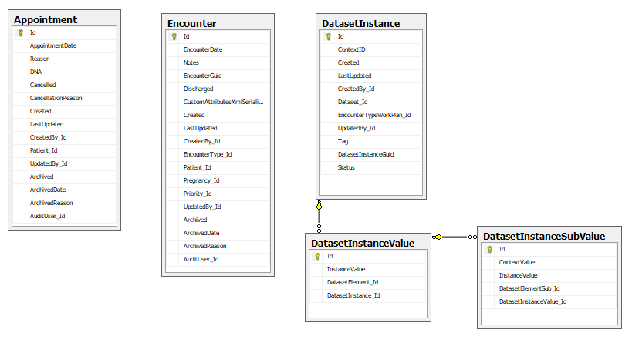

### Transaction Entities

|  |  |  |  |  |  |
| --- | --- | --- | --- | --- | --- |
| **Field Name** | **Field Description** | **Data Type** | **Field Constraints** | **Primary/**  **Foreign** | **Nullable** |
| **Entity** | Appointment | | | | |
| **Description** | A list of appointments associated to the patient | | | | |
| Id | Unique auto-incremented seed for table | Integer | None | Primary | No |
| AppointmentDate | The date of the appointment | Datetime | None | N/A | No |
| Reason | The reason for the appointment | Nvarchar | Max length 250 | N/A | No |
| DNA | The patient did not arrive for their appointment | Bit | None | N/A | No |
| CancellationReason | The reason the appointment was cancelled | Nvarchar | Max length 250 | N/A | Yes |
| Created | AUDIT: Date record was created | Datetime | None | N/A | No |
| LastUpdated | AUDIT: Date record was last updated | Datetime | None | N/A | Yes |
| CreatedBy_Id | AUDIT: The user that created this record | Integer | FK to User | Foreign | Yes |
| Patient_Id | The patient the appointment is associated to | Integer | FK to Patient | Foreign | No |
| UpdatedBy_Id | AUDIT: The user that last updated this record | Integer | FK to User | Foreign | Yes |
| Archived | ARCHIVE: Is this record archived | Bit | None | N/A | No |
| ArchivedDate | ARCHIVE: The date the record was archived | DateTime | None | N/A | Yes |
| ArchivedReason | ARCHIVE: The reason the record was archived | Nvarchar | Max length 200 | N/A | Yes |
| AuditUser_Id | ARCHIVE: Who archived the record | Integer | FK to User | Foreign | Yes |
| **Entity** | Encounter | | | | |
| **Description** | A list of encounters associated to the patient | | | | |
| Id | Unique auto-incremented seed for table | Integer | None | Primary | No |
| EncounterDate | The date of the encounter | Datetime | None | N/A | No |
| Notes | General notes for the encounter | Nvarchar | Max length MAX | N/A | Yes |
| EncounterGUID | A globally unique identifier for this encounter | UniqueIdentifier | None | N/A | No |
| Discharged  **\*\* not in use \*\*** | Is the encounter closed | Bit | None | N/A | No |
| CustomAttributesXmlSerialised | XML data structure containing all custom attributes | XML | None | N/A | Yes |
| Created | AUDIT: Date record was created | Datetime | None | N/A | No |
| LastUpdated | AUDIT: Date record was last updated | Datetime | None | N/A | Yes |
| CreatedBy_Id | AUDIT: The user that created this record | Integer | FK to User | Foreign | Yes |
| EncounterType_Id | The type of encounter | Integer | FK to EncounterType | Foreign | No |
| Patient_Id | The patient the encounter is associated to | Integer | FK to Patient | Foreign | No |
| Priority_Id | The priority of the encounter | Integer | FK to Priority | Foreign | Yes |
| Pregnancy_Id  **\*\* not in use \*\*** | Is the patient pregnant | Integer | FK to Pregnancy | Foreign | Yes |
| UpdatedBy_Id | AUDIT: The user that last updated this record | Integer | FK to User | Foreign | Yes |
| Archived | ARCHIVE: Is this record archived | Bit | None | N/A | No |
| ArchivedDate | ARCHIVE: The date the record was archived | DateTime | None | N/A | Yes |
| ArchivedReason | ARCHIVE: The reason the record was archived | Nvarchar | Max length 200 | N/A | Yes |
| AuditUser_Id | ARCHIVE: Who archived the record | Integer | FK to User | Foreign | Yes |
| **Entity** | DatasetInstance | | | | |
| **Description** | A list of dataset instances. A dataset instance is a physical instantiation of a dataset and contains clinical data collected. | | | | |
| Id | Unique auto-incremented seed for table | Integer | None | Primary | No |
| ContextID | The unique id of the associated entity. | Integer | None | N/A | No |
| Created | AUDIT: Date record was created | Datetime | None | N/A | No |
| LastUpdated | AUDIT: Date record was last updated | Datetime | None | N/A | Yes |
| CreatedBy_Id | AUDIT: The user that created this record | Integer | FK to User | Foreign | Yes |
| Dataset_Id | The dataset associated to the instance. This link defines what data can be expected to be collected within the instance. | Integer | FK to Dataset | Foreign | No |
| EncounterTypeWorkPlan_Id | The encounter type work plan that resulted in the instantiation of the dataset | Integer | FK to EncounterTypeWorkPlan | Foreign | No |
| UpdatedBy_Id | AUDIT: The user that last updated this record | Integer | FK to User | Foreign | Yes |
| Tag | Active for active reporting and Spontaneous for spontaneous reporting | Nvarchar | Max length MAX | N/A | Yes |
| DatasetInstanceGUID | A globally unique identifier for this dataset instance | UniqueIdentifier | None | N/A | No |
| Status | The current status of the dataset instance  Incomplete = 1,  Complete = 2 | Integer |  | N/A | No |
| **Entity** | DatasetInstanceValue | | | | |
| **Description** | A list of clinical values collected per dataset instance | | | | |
| Id | Unique auto-incremented seed for table | Integer | None | Primary | No |
| InstanceValue | The value of the associated clinical element | Nvarchar | Max length 10 | N/A | No |
| DatasetElement_Id | The dataset element that defines the corresponding value | Integer | FK to DatasetElement | Foreign | No |
| DatasetInstance_Id | The dataset instance that contains the collection of instance values | Integer | FK to DatasetInstance | Foreign | No |
| **Entity** | DatasetInstanceSubValue | | | | |
| **Description** | A list of clinical values per dataset element table | | | | |
| Id | Unique auto-incremented seed for table | Integer | None | Primary | No |
| ContextValue | A globally unique identifier for this sub table row | UniqueIdentifier | None | N/A | No |
| InstanceValue | The value of the associated clinical element | Nvarchar | Max length 10 | N/A | No |
| DatasetElementSub_Id | The dataset sub-element that defines the corresponding value | Integer | FK to DatasetElementSub | Foreign | No |
| DatasetInstanceValue_Id | The dataset instance value that contains the collection of sub instance values | Integer | FK to DatasetInstanceValue | Foreign | No |

## Workflow Entities

|  |
| --- |
| This section contains a list of all work flow entities that govern the processing of workflow-based pharmacovigilance activities for newly created adverse event reports. |

### Entity Relationship Diagram

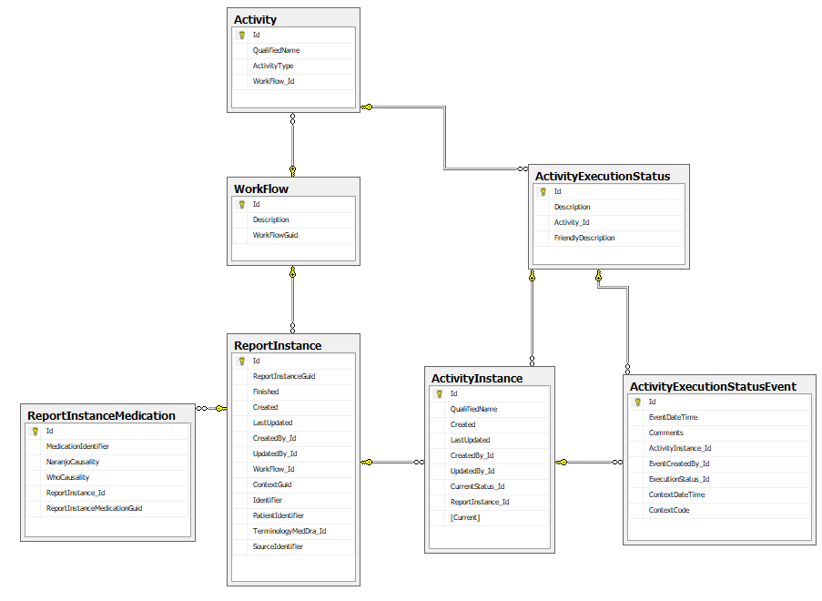

### Reference Entities

|  |  |  |  |  |  |
| --- | --- | --- | --- | --- | --- |
| **Field Name** | **Field Description** | **Data Type** | **Field Constraints** | **Primary/**  **Foreign** | **Nullable** |
| **Entity** | Activity | | | | |
| **Description** | Contains a list of available activities to be conducted by the pharmacovigilance unit per report type. | | | | |
| Id | Unique auto-incremented seed for table | Integer | None | Primary | No |
| QualifiedName | Qualified name of the workflow activity | Nvarchar | Max length 50 | N/A | No |
|  | **Activities**  Confirm Report Data  Set MedDRA and Causality  Extract E2B |  |  |  |  |
| ActivityType | Type of activity | Integer |  | N/A | No |
|  | **Activity Types**  UserDrivenActivity = 1,  SystemDrivenActivity = 2,  PublicationActivity = 3 |  |  |  |  |
| Workflow_Id | The workflow the activity is associated to | Integer | FK to WorkFlow | Foreign | No |
| **Entity** | ActivityExecutionStatus | | | | |
| **Description** | Contains a list of available statuses per activity | | | | |
| Id | Unique auto-incremented seed for table | Integer | None | Primary | No |
| Description | The name of the status | Nvarchar | Max length 50 | N/A | No |
|  | **Activities**  UNCONFIRMED  CONFIRMED  DELETED  NOTSET  MEDDRASET  CAUSALITYSET  NOTGENERATED  E2BINITIATED  E2BGENERATED  E2BSUBMITTED |  |  |  |  |
| FriendlyDescription | A friendly description of the activity status | Nvarchar | Max length 100 | N/A | Yes |
| Activity_Id | The activity the status is associated to | Integer | FK to Activity | Foreign | No |
| **Entity** | WorkFlow | | | | |
| **Description** | Contains a list of available work flows for implementation | | | | |
| Id | Unique auto-incremented seed for table | Integer | None | Primary | No |
| Description | Workflow name | Nvarchar | Max length 100 | N/A | No |
|  | **Workflows**  New Active Surveillance Report  New Spontaneous Surveillance Report |  |  |  |  |
| WorkFlowGUID | A globally unique identifier for this workflow | UniqueIdentifier | None | N/A | No |

### Transaction Entities

|  |  |  |  |  |  |
| --- | --- | --- | --- | --- | --- |
| **Field Name** | **Field Description** | **Data Type** | **Field Constraints** | **Primary/**  **Foreign** | **Nullable** |
| **Entity** | ActivityExecutionStatusEvent | | | | |
| **Description** | A series of timestamped status changes logged per report activity. Track progress on workflow. | | | | |
| Id | Unique auto-incremented seed for table | Integer | None | Primary | No |
| EventDateTime | The date and time of the activity status change | Datetime |  | N/A | No |
| Comments | Comments noted by the user when changing status | Nvarchar | Max length MAX | N/A | Yes |
| ActivityInstance_Id | The activity instance the status change is associated to | Integer | FK to ActivityInstance | Foreign | No |
| EventCreatedBy_Id | The user that generated the status change | Integer | FK to User | Foreign | Yes |
| ExecutionStatus_Id | The new activity status | Integer | FK to ActivityExecutionStatus | Foreign | No |
| ContextDateTime | Contextual date and time based on the status change | Datetime |  | N/A | Yes |
| ContextCode | Contextual code based on the status change | Nvarchar | Max length 20 | N/A | Yes |
| **Entity** | ActivityInstance | | | | |
| **Description** | Physical instantiation of a work flow activity. A work flow will be comprised of multiple activities as they move from one state to the next | | | | |
| Id | Unique auto-incremented seed for table | Integer | None | Primary | No |
| QualifiedName | Qualified name of the workflow activity | Nvarchar | Max length 50 | N/A | No |
| Created | AUDIT: Date record was created | Datetime | None | N/A | No |
| LastUpdated | AUDIT: Date record was last updated | Datetime | None | N/A | Yes |
| CreatedBy_Id | AUDIT: The user that created this record | Integer | FK to User | Foreign | Yes |
| UpdatedBy_Id | AUDIT: The user that last updated this record | Integer | FK to User | Foreign | Yes |
| CurrentStatus_Id | The current event for this activity | Integer | FK to ActivityExecutionStatusEvent | Foreign | Yes |
| ReportInstance_Id | The report instance the activity is associated to | Integer | FK to ReportInstance | Foreign | No |
| Current | Is this activity the current activity for the report instance | Bit |  | N/A | No |
| **Entity** | ReportInstance | | | | |
| **Description** | Physical instantiation of a work flow for a newly logged adverse event report | | | | |
| Id | Unique auto-incremented seed for table | Integer | None | Primary | No |
| ReportInstanceGUID | A globally unique identifier for this report instance | UniqueIdentifier | None | N/A | No |
| Finished | The date of completions | Datetime |  | N/A | Yes |
| Created | AUDIT: Date record was created | Datetime | None | N/A | No |
| LastUpdated | AUDIT: Date record was last updated | Datetime | None | N/A | Yes |
| CreatedBy_Id | AUDIT: The user that created this record | Integer | FK to User | Foreign | Yes |
| UpdatedBy_Id | AUDIT: The user that last updated this record | Integer | FK to User | Foreign | Yes |
| WorkFlow_Id | The workflow the report instance is associated to | Integer | FK to WorkFlow | Foreign | No |
| ContextGUID | The unique identifier of the adverse event report | UniqueIdentifier | None | N/A | No |
| Identifier | A unique identifier for the adverse event report | Nvarchar | Max length MAX | N/A | No |
| PatientIdentifier | A unique patient identifier for the adverse event report | Nvarchar | Max length MAX | N/A | No |
| TerminologyMedDra_Id | The MedDRA terminology set by the pharmacovigilance unit for this event | Integer | FK to TerminologyMedDra | Foreign | Yes |
| SourceIdentifier | A description of the source event | Nvarchar | Max length MAX | N/A | No |
| **Entity** | ReportInstanceMedication | | | | |
| **Description** | Medications associated to a physical instantiation of a work flow for a newly logged adverse event report Medications who overlap the onset date of the adverse event will be automatically linked to the report instance on creation. | | | | |
| Id | Unique auto-incremented seed for table | Integer | None | Primary | No |
| MedicationIdentifier | A unique medication identifier for the adverse event report | Nvarchar | Max length MAX | N/A | Yes |
| NaranjoCausality | Naranjo causality setting for medication | Nvarchar | Max length 30 | N/A | Yes |
| WHOCausality | WHO causality setting for medication | Nvarchar | Max length 30 | N/A | Yes |
| ReportInstance_Id | The report instance the medication is associated to | Integer | FK to ReportInstance | Foreign | No |
| ReportInstanceMedicationGUID | A globally unique identifier for this medication | UniqueIdentifier | None | N/A | No |

## Other Entities

|  |
| --- |
| This section contains a list of all remaining entities. |

### Reference Entities

|  |  |  |  |  |  |
| --- | --- | --- | --- | --- | --- |
| **Field Name** | **Field Description** | **Data Type** | **Field Constraints** | **Primary/**  **Foreign** | **Nullable** |
| **Entity** | AttachmentType | | | | |
| **Description** | Contains a list of attachment types | | | | |
| Id | Unique auto-incremented seed for table | Integer | None | Primary | No |
| Description | The name of the attachment type | Nvarchar | Max length 50 | N/A | No |
| Key | The name of the attachment type | Nvarchar | Max length 4 | N/A | No |
|  | **Attachment Types**  MS Word 2003-2007 Document  MS Excel 2003-2007 Document  MS Word Document  MS Excel Document  Portable Document Format  Image | JPEG  Image | JPEG  Image | PNG  Image | BMP |  |  |  |  |
| **Entity** | Condition | | | | |
| **Description** | Contains a list of concomitant conditions | | | | |
| Id | Unique auto-incremented seed for table | Integer | None | Primary | No |
| Description | The description of the condition | Nvarchar | Max length 50 | N/A | No |
| Chronic | Is this condition chronic | Bit |  | N/A | No |
|  | **Conditions**  HIV  Malaria  TB |  |  |  |  |
| **Entity** | ContextType | | | | |
| **Description** | Contains a list of context types. A context type is defined as the type of entity a dataset will reference | | | | |
| Id | Unique auto-incremented seed for table | Integer | None | Primary | No |
| Description | The name of the context type | Nvarchar | Max length 50 | N/A | No |
|  | **Context Types**  Encounter  Patient  Pregnancy  Global  PatientClinicalEvent  DatasetInstance |  |  |  |  |
| **Entity** | FacilityType | | | | |
| **Description** | Contains a list of facility types | | | | |
| Id | Unique auto-incremented seed for table | Integer | None | Primary | No |
| Description | The name of the facility type | Nvarchar | Max length 50 | N/A | No |
|  | **Facility Types**  Unknown  Hospital  CHC  PHC |  |  |  |  |
| **Entity** | Holiday | | | | |
| **Description** | Contains a list of holidays administered within the system | | | | |
| Id | Unique auto-incremented seed for table | Integer | None | Primary | No |
| HolidayDate | The date of the holiday | Datetime |  | N/A | No |
| Description | The name of the facility type | Nvarchar | Max length 100 | N/A | No |
| **Entity** | LabResult | | | | |
| **Description** | Contains a list of laboratory results | | | | |
| Id | Unique auto-incremented seed for table | Integer | None | Primary | No |
| Description | The name of the laboratory result | Nvarchar | Max length 50 | N/A | No |
|  | **Laboratory Results**  Abnormal  Borderline  Improved  Inconclusive  Negative  Normal  Positive  Progressed  Seronegative  Seropositive  Stable |  |  |  |  |
| **Entity** | LabTest | | | | |
| **Description** | Contains a list of lab tests | | | | |
| Id | Unique auto-incremented seed for table | Integer | None | Primary | No |
| Active | Is the lab test currently active for selection | Bit | None | N/A | No |
| Description | The name of the lab test | Nvarchar | Max length 50 | N/A | No |
|  | **Lab Tests**  AFB Smear Result  Albumin  Alkaline phosphatase  ALT (SGPT)  Amylase  AST (SGOT)  Audiometry  Blood Glucose  CD4 Count  Chest X-Ray  Creatinine Clearance  Culture Results  ESR  Glucose  Haemoglobin  HBC IgM  HBsAg  HCV Ab  Hearing test  Heart Rate  Hematocrit  Hepatitis B Virus  Hepatitis C Virus  HIV Antibody  Lactic acid  Lipase  Neurological Exam  Platelet Count  PR Interval  Pregnancy Test  QRS Duration  QT Duration  QT Interval (Fredericia)  QT Interval (uncorrected)  QTc interval  RBC Count  Serum Calcium (Ca++)  Serum Creatinine (SCr)  Serum Magnesium (Mg++)  Serum Potassium (K+)  Smear  Total Bilirubin  Total WBC  TSH  Visual acuity  WBC Count |  |  |  |  |
| **Entity** | LabTestUnit | | | | |
| **Description** | Contains a list of lab test units | | | | |
| Id | Unique auto-incremented seed for table | Integer | None | Primary | No |
| Active | Is the lab test unit currently active for selection | Bit | None | N/A | No |
| Description | The name of the lab test unit | Nvarchar | Max length 50 | N/A | No |
|  | **Lab Test Unit**  %  % hearing loss left ear  % hearing loss right ear  µg/dL  µg/L  beats per minute  breaths per minute  cavities  cells/mm 3  Eye, Left (OS)  Eye, Right (OD)  g/dL  g/L  IU/L  kg/m 2  mEq/L  mg/24 hr  mg/dL  Milliseconds  min  mL/min  mm Hg  mm/h  mmol/kg  mmol/L  mOsm/kg  ms  N/A  ng/dL  ng/L  ng/mL  ng/mL/hr  nmol/L  pg/mL  pH  pmol/L  sec  U/L  X 10 3 /mm 3  X 10 6 /mm 3  X 10 9 /L  μg/dL  μg/L  μmol/L  μU/L  μU/mL |  |  |  |  |
| **Entity** | Language | | | | |
| **Description** | Contains a list of languages.  **\*\* not in use \*\*** | | | | |
| Id | Unique auto-incremented seed for table | Integer | None | Primary | No |
| Description | The name of the language | Nvarchar | Max length 20 | N/A | No |
| **Entity** | Medication | | | | |
| **Description** | Contains a list of medications | | | | |
| Id | Unique auto-incremented seed for table | Integer | None | Primary | No |
| DrugName | The name of the drug | Nvarchar | Max length 100 | N/A | No |
| Active | Is the medication active and available for use in the system | Bit | None | N/A | No |
| PackSize | The pack size of the medication | Integer | None | N/A | No |
| Strength | The strength of the medication | Nvarchar | Max length 40 | N/A | No |
| CatalogNo | The catalog number of the medication | Nvarchar | Max length 10 | N/A | Yes |
| MedicationForm_Id | The form of the medication | Integer | FK to MedicationForm | Foreign | Yes |
| **Entity** | MedicationForm | | | | |
| **Description** | Contains a list of medication forms | | | | |
| Id | Unique auto-incremented seed for table | Integer | None | Primary | No |
| Description | The name of the medication form | Nvarchar | Max length 50 | N/A | No |
|  | **Medication Forms**  Ampoule  Bottle  Cartridge  Condom  Cream  Disc for lab testing  Disposable  Each  Ear drops  Elixir  Enema  Gas  Gel  Granules  Inhaler  IUD  Liquid  Lotion  Nasal drops  Nasal spray  Net  Ointment  Ophthalmic drops  Ophthalmic ointment  Ophthalmic strips  Oral drops  Oral gel  Pessary  Powder  Rectal tube  Respiratory solution  Rod  Shampoo  Solid  Solution  Spray  Suppository  Suspension  Syringe  Syrup  Tablet or capsule  Test  Tincture  Transdermal patch  Unknown  Vial |  |  |  |  |
| **Entity** | Outcome | | | | |
| **Description** | Contains a list of condition outcomes | | | | |
| Id | Unique auto-incremented seed for table | Integer | None | Primary | No |
| Description | The description of the outcome | Nvarchar | Max length 50 | N/A | No |
|  | **Outcomes**  Recovered/Resolved  Recovered/Resolved With Sequelae  Recovering/Resolving  Not Recovered/Not Resolved  Fatal  Unknown |  |  |  |  |
| **Entity** | Priority | | | | |
| **Description** | Contains a list of priorities | | | | |
| Id | Unique auto-incremented seed for table | Integer | None | Primary | No |
| Description | The description of the priority | Nvarchar | Max length 50 | N/A | No |
|  | **Priorities**  Urgent  High  Medium  Low |  |  |  |  |
| **Entity** | Role | | | | |
| **Description** | Contains a list of security roles | | | | |
| Id | Unique auto-incremented seed for table | Integer | None | Primary | No |
| Name | The name of the role | Nvarchar | Max length 30 | N/A | No |
| Key | The unique key for this role | Nvarchar | Max length 30 | N/A | No |
|  | **Roles**  Administrator  Registration Clerk  Data Capturer  Clinician  Analytics  Reporter  Publisher  Reporter Administrator  Publisher Administrator |  |  |  |  |
| **Entity** | TerminologyMedDRA | | | | |
| **Description** | Contains a list of all MedDRA definitions | | | | |
| Id | Unique auto-incremented seed for table | Integer | None | Primary | No |
| MedDraTerm | The MedDRA term | Nvarchar | Max length 100 | N/A | No |
| MedDraCode | The MedDRA code | Nvarchar | Max length 10 | N/A | No |
| MedDraTermType | The MedDRA term type | Nvarchar | Max length 4 | N/A | No |
|  | **MedDRA Term Types**  LLT  HLGT  SOC  PT  HLT |  |  |  |  |
| Parent_Id | The parent of this MedDRA term | Integer | FK to TerminologyMedDRA | Foreign | Yes |
| **Entity** | TreatmentOutcome | | | | |
| **Description** | Contains a list of treatment outcomes | | | | |
| Id | Unique auto-incremented seed for table | Integer | None | Primary | No |
| Description | The description of the treatment outcome | Nvarchar | Max length 50 | N/A | No |
|  | **Treatment Outcomes**  Cured  Treatment Completed  Treatment Failed  Died  Lost to Follow-up  Not Evaluated |  |  |  |  |
| **Entity** | User | | | | |
| **Description** | Contains a list of system users. | | | | |
| Id | Unique auto-incremented seed for table | Integer | None | Primary | No |
| Email | The email address of the user | Nvarchar | Max length 256 | N/A | Yes |
| EmailConfirmed | Is email address confirmed | Bit | None | N/A | No |
| PasswordHash | Encrypted user password | Nvarchar | Max length MAX | N/A | Yes |
| SecurityStamp | Invalidate existing sign ins if user details changed | Nvarchar | Max length MAX | N/A | Yes |
| PhoneNumber | The phone number of the user | Nvarchar | Max length MAX | N/A | Yes |
| PhoneNumberConfirmed | Is phone number confirmed | Bit | None | N/A | No |
| TwoFactorEnabled | Two forms of security validation | Bit | None | N/A | No |
| LockoutEndDateUtc | Locked out date | Datetime | None | N/A | Yes |
| LockoutEnabled | User has been locked out of account | Bit | None | N/A | No |
| AccessFailedCount | Number of times user has failed security validations | Integer | None | N/A | No |
| UserName | The user name of the user | Nvarchar | Max length 256 | N/A | No |
| FirstName | The first name of the user | Nvarchar | Max length MAX | N/A | Yes |
| LastName | The last name of the user | Nvarchar | Max length MAX | N/A | Yes |
| Active | User is currently active | Bit | None | N/A | No |
| CurrentContext | The portal the user is currently logged into | Nvarchar | Max length MAX | N/A | Yes |
| EulaAcceptanceDate | The date the user accepted the EULA on first login | Datetime | None | N/A | Yes |
| AllowDatasetDownload | Does the user have the ability to download data from the analytical portal | Bit | None | N/A | No |

### Custom Attribute Entities

|  |  |  |  |  |  |
| --- | --- | --- | --- | --- | --- |
| **Field Name** | **Field Description** | **Data Type** | **Field Constraints** | **Primary/**  **Foreign** | **Nullable** |
| **Entity** | CustomAttributeConfiguration | | | | |
| **Description** | Contains a list of custom attributes that extend core system entities | | | | |
| Id | Unique auto-incremented seed for table | Integer | None | Primary | No |
| ExtendableTypeName | The entity that the custom attribute belongs to | Nvarchar | Max length MAX | N/A | Yes |
| CustomAttributeType | The type of custom attribute | Integer |  | N/A | No |
|  | **Custom Attribute Types**  None = 0  Numeric = 1  String = 2  Selection = 3  DateTime = 4  FirstClassProperty = 5 |  |  |  |  |
| Category | The category that the attribute is allocated to | Nvarchar | Max length MAX | N/A | Yes |
| AttributeKey | The unique name of the attribute | Nvarchar | Max length MAX | N/A | Yes |
| IsRequired | Is this attribute mandatory | Bit | None | N/A | No |
| StringMaxLength | Maximum length of the string attribute | Integer | None | N/A | Yes |
| NumericMinValue | Minimum value of the numeric attribute | Integer | None | N/A | Yes |
| NumericMaxValue | Maximum value of the numeric attribute | Integer | None | N/A | Yes |
| FutureDateOnly | For date attributes, must the attribute be in the future | Bit | None | N/A | No |
| PastDateOnly | For date attributes, must the attribute be in the past | Bit | None | N/A | No |
| IsSearchable | Include this attribute in the patient or encounter search functions | Bit | None | N/A | No |
| AttributeDetail | Additional help for the attribute | Nvarchar | Max length 150 | N/A | Yes |
| **Entity** | SelectionDataItem | | | | |
| **Description** | A list of selection values for a selection custom attribute | | | | |
| Id | Unique auto-incremented seed for table | Integer | None | Primary | No |
| AttributeKey | The unique name of the attribute | Nvarchar | Max length MAX | N/A | Yes |
| SelectionKey | A unique value identifying the selection value | Nvarchar | Max length MAX | N/A | Yes |
| Value | A description of the selection value | Nvarchar | Max length MAX | N/A | Yes |

### Bridging Entities

|  |  |  |  |  |  |
| --- | --- | --- | --- | --- | --- |
| **Field Name** | **Field Description** | **Data Type** | **Field Constraints** | **Primary/**  **Foreign** | **Nullable** |
| **Entity** | ConditionLabTest | | | | |
| **Description** | A list of lab tests associated to the corresponding condition | | | | |
| Id | Unique auto-incremented seed for table | Integer | None | Primary | No |
| Condition_Id | The condition that the lab test is associated to | Integer | FK to Condition | N/A | No |
| LabTest_Id | The lab test that has been associated to the condition | Integer | FK to LabTest | N/A | No |
| **Entity** | ConditionMeddra | | | | |
| **Description** | A list of MedDra terms associated to the corresponding condition | | | | |
| Id | Unique auto-incremented seed for table | Integer | None | Primary | No |
| Condition_Id | The condition that the MedDra term is associated to | Integer | FK to Condition | N/A | No |
| TerminologyMedDra_Id | The MedDra term that has been associated to the condition | Integer | FK to TerminologyMedDra | N/A | No |
| **Entity** | ConditionMedication | | | | |
| **Description** | A list of medications associated to the corresponding condition | | | | |
| Id | Unique auto-incremented seed for table | Integer | None | Primary | No |
| Condition_Id | The condition that the medication is associated to | Integer | FK to Condition | N/A | No |
| Medication_Id | The medication that has been associated to the condition | Integer | FK to Medication | N/A | No |
| **Entity** | UserFacility | | | | |
| **Description** | A list of facilities that the user has access to | | | | |
| Id | Unique auto-incremented seed for table | Integer | None | Primary | No |
| Facility_Id | The facility that has been linked to the user | Integer | FK to Facility | N/A | No |
| User_Id | The user that is been administered | Integer | FK to User | N/A | No |
| **Entity** | UserRole | | | | |
| **Description** | A list of roles that the user has access to | | | | |
| Id | Unique auto-incremented seed for table | Integer | None | Primary | No |
| Role_Id | The role that has been linked to the user | Integer | FK to Role | N/A | No |
| User_Id | The user that is been administered | Integer | FK to User | N/A | No |

### Miscellaneous Entities

|  |  |  |  |  |  |  |
| --- | --- | --- | --- | --- | --- | --- |
| **Field Name** | **Field Description** | **Data Type** | **Field Constraints** | **Primary/**  **Foreign** | **Nullable** | |
| **Entity** | AuditLog | | | | | |
| **Description** | A detailed audit log of PViMS activity | | | | | |
| Id | Unique auto-incremented seed for table | Integer | None | Primary | No | |
| AuditType | The type of activity being audited | Integer | None | N/A | No | |
|  | **Audit Types**  InvalidSubscriberAccess = 1  ValidSubscriberAccess = 2  InValidSubscriberPost = 3  ValidSubscriberPost = 4  UserLogin = 5  InValidMedDRAImport = 6  ValidMedDRAImport = 7 |  |  |  |  | |
| ActionDate | The date and time of the activity | DateTime | None | N/A | No | |
| Details | Additional details describing the activity | Nvarchar | Max length MAX | N/A | Yes | |
| User_Id | The user that conducted the activity | Integer | FK to User | N/A | Yes | |
| Log | Additional details logged during the activity | Nvarchar | Max length MAX | N/A | Yes | |
| **Entity** | CohortGroup | | | | | |
| **Description** | A list of cohorts that have been configured in the system | | | | | |
| Id | Unique auto-incremented seed for table | Integer | None | Primary | No | |
| CohortName | The name of the cohort | Nvarchar | Max length 50 | N/A | No | |
| CohortCode | A unique code identifying the cohort | Nvarchar | Max length 5 | N/A | No | |
| LastPatientNo | **\*\* not in use \*\*** | Integer | None | N/A | No | |
| StartDate | The start date of the cohort. Used as the minimum start date when generating the population set when doing cohort analysis | Datetime | None | N/A | No | |
| FinishDate | The end date of the cohort. Used as the maximum start date when generating the population set when doing cohort analysis | Datetime | None | N/A | No | |
| MinEnrolment | **\*\* not in use \*\*** | Integer | None | N/A | No | |
| MaxEnrolment | **\*\* not in use \*\*** | Integer | None | N/A | No | |
| Condition_Id | Is this cohort targeting a specific condition? | Integer | FK to Condition | N/A | Yes | |
| **Entity** | CohortGroupEnrolment | | | | | |
| **Description** | A list of patients enrolled into the cohort | | | | | |
| Id | Unique auto-incremented seed for table | Integer | None | Primary | | No |
| EnroledDate | The date the patient was enrolled into the cohort | Datetime | None | N/A | | No |
| CohortGroup_Id | The cohort the patient has been enrolled into | Integer | FK to CohortGroup | N/A | Yes | |
| Patient_Id | The patient that is being enrolled into the cohort | Integer | FK to Patient | N/A | Yes | |
| DeenroledDate | The date the patient was de-enrolled from the cohort | Datetime | None | N/A | | Yes |
| Archived | ARCHIVE: Is this record archived | Bit | None | N/A | | No |
| ArchivedDate | ARCHIVE: The date the record was archived | DateTime | None | N/A | | Yes |
| ArchivedReason | ARCHIVE: The reason the record was archived | Nvarchar | Max length 200 | N/A | | Yes |
| AuditUser_Id | ARCHIVE: Who archived the record | Integer | FK to User | Foreign | | Yes |
| **Entity** | Config | | | | | |
| **Description** | A list of configurable PViMS values | | | | | |
| Id | Unique auto-incremented seed for table | Integer | None | Primary | No | |
| ConfigType | The type of configuration | Integer | None | N/A | No | |
|  | **Config Types**  E2BVersion = 1  WebServiceSubscriberList = 2  AssessmentScale = 3  MedDRAVersion = 4  ReportInstanceNewAlertCount = 5  MedicationOnsetCheckPeriodWeeks = 6  MetaDataLastUpdated = 7 |  |  |  |  | |
| ConfigValue | The value of the configuration | Nvarchar | Max length 100 | N/A | No | |
| Created | AUDIT: Date record was created | Datetime | None | N/A | No | |
| LastUpdated | AUDIT: Date record was last updated | Datetime | None | N/A | Yes | |
| CreatedBy_Id | AUDIT: The user that created this record | Integer | FK to User | Foreign | Yes | |
| UpdatedBy_Id | AUDIT: The user that last updated this record | Integer | FK to User | Foreign | Yes | |
| **Entity** | PostDeployment | | | | | |
| **Description** | A list of post implementation scripts that need to be executed against the PViMS database. Scripts must be stored in the PostDeploymentScripts folder. | | | | | |
| Id | Unique auto-incremented seed for table | Integer | None | Primary | No | |
| ScriptGUID | A globally unique identifier for this script | UniqueIdentifier | None | N/A | No | |
| ScriptFileName | The name of the script to be executed | Nvarchar | Max length 200 | N/A | No | |
| ScriptDescription | **A description of the script to be executed** | Nvarchar | Max length 200 | N/A | No | |
| RunDate | The date the script was run | Datetime | None | N/A | Yes | |
| StatusCode | The status of the script execution | Integer | None | N/A | Yes | |
|  | **Script Status**  200 successful  404 not found |  |  |  |  | |
| StatusMessage | Status message, File not found | Nvarchar | Max length 200 | N/A | Yes | |
| RunRank | Order the script should be executed in | Integer | None | N/A | No | |
| **Entity** | RiskFactor | | | | | |
| **Description** | Risk factors that have been configured for use in the analytical portal. | | | | | |
| Id | Unique auto-incremented seed for table | Integer | None | Primary | No | |
| FactorName | A unique name describing the risk factor | Nvarchar | Max length 50 | N/A | No | |
| Criteria | The SQL query that is incorporated into the analyser stored procedure | Nvarchar | Max length MAX | N/A | No | |
| Display | The name that is displayed in the analytical portal | Nvarchar | Max length 20 | N/A | Yes | |
| IsSystem | Is this a system defined risk factor | Bit | None | N/A | No | |
| Active | Is this risk factor active for selection | Bit | None | N/A | No | |
| **Entity** | RiskFactorOption | | | | | |
| **Description** | Sub options per risk factor | | | | | |
| Id | Unique auto-incremented seed for table | Integer | None | Primary | No | |
| OptionName | A unique name describing the risk factor option | Nvarchar | Max length 50 | N/A | No | |
| Criteria | The criteria that is consumed by the risk factor to determine if the patient is successfully matched to the risk factor | Nvarchar | Max length 250 | N/A | No | |
| Display | The name that is displayed in the analytical portal | Nvarchar | Max length 30 | N/A | Yes | |
| RiskFactor_Id | The risk factor that the option is associated to | Integer | FK to RiskFactor | N/A | Yes | |
| **Entity** | SiteContactDetail | | | | | |
| **Description** | List of contact details that are used to populate the E2B extract | | | | | |
| Id | Unique auto-incremented seed for table | Integer | None | Primary | No | |
| ContactType | The type of address | Integer | None | N/A | No | |
|  | **Contact Types**  RegulatoryAuthority = 1  ReportingAuthority = 2 |  |  |  |  | |
| ContactFirstName | The first name of the primary contact | Nvarchar | Max length 30 | N/A | No | |
| ContactSurname | The surname of the primary contact | Nvarchar | Max length 30 | N/A | No | |
| StreetAddress | Contact details | Nvarchar | Max length 100 | N/A | No | |
| City | Nvarchar | Max length 50 | N/A | No | |
| State | Nvarchar | Max length 50 | N/A | Yes | |
| PostCode | Nvarchar | Max length 20 | N/A | Yes | |
| ContactNumber | Nvarchar | Max length 50 | N/A | Yes | |
| ContactEmail | Nvarchar | Max length 50 | N/A | Yes | |
| CountryCode | Nvarchar | Max length 10 | N/A | Yes | |
| OrganisationName | The name of the organisation | Nvarchar | Max length 50 | N/A | Yes | |
| Created | AUDIT: Date record was created | Datetime | None | N/A | No | |
| LastUpdated | AUDIT: Date record was last updated | Datetime | None | N/A | Yes | |
| CreatedBy_Id | AUDIT: The user that created this record | Integer | FK to User | Foreign | Yes | |
| UpdatedBy_Id | AUDIT: The user that last updated this record | Integer | FK to User | Foreign | Yes | |

# Database Security

This section details administrative and operational best practises that should be performed from a security perspective when implementing the PViMS database.

## Surface Area Reduction

It is best practise to only install the SQL Server options that are required for PViMS to operate, thereby reducing the attack surface. The following best practise should be observed to reduce the attack service:

* Install only those components that you will immediately use. Additional components can always be installed as needed.
* Enable only the optional features that you will immediately use.
* Review optional feature usage before doing an in-place upgrade and disable unneeded features either before or after the upgrade.
* Develop a policy with respect to permitted network connectivity choices. Use SQL Server Policy-Based Management to standardize this policy.
* Develop a policy for the usage of optional features. Use SQL Server Policy-Based Management to standardize optional feature enabling. Document any exceptions to the policy on a per-instance basis.
* Turn off unneeded services by setting the service to either *manual startup* or *disabled*.
* Configure only those server network interfaces that you will actually use.

## Service Account Selection and Management

SQL Server 2008 executes as a set of windows services which can be configured to use its own account. When choosing service accounts, consider the principle of least privilege which dictates that the service account has the exact permissions needed to execute the service and nothing more. Account should also be implemented in isolation so that service account should not only be different from one another, they should not be used by any other services on the same server. The following best practise should be observed when selecting service accounts:

* Always use SQL Server Configuration Manager to change service accounts.
* If you use a user or domain account, change the service account password at regular intervals.
* Use CREDENTIALs to execute job steps that require specific privileges rather than adjusting the privilege to the SQL Server Agent service account.
* If a user needs to execute a job that requires different Windows credentials, assign them a proxy account that has just enough permissions to get the task done.

## SQL Server Best Practises Analyser

SQL Server 2008 R2 Best Practices Analyzer (BPA) gathers data from Microsoft Windows and SQL Server configuration settings and uses a predefined list of SQL Server 2008/2008 R2 recommendations and best practices to determine if there are potential security issues in the PViMS database environment.

* Run SQL Server Best Practices Analyzer against SQL Server 2008/2008 R2.
* Use Microsoft Security Compliance Manager to provide centralized security baseline management.
* Consider running antivirus software on the SQL Server machine if appropriate.

## Patching and Automated Windows Updates

The best way to ensure the security of the PViMS database server is to install security hotfixes and service packs as soon as possible. Use manual updates on an operating system basis by using Windows Update or Microsoft Update as updates should be tested before they are applied to the live PViMS server. All hotfixes should be installed immediately, and service packs should be tested and installed as soon as possible.

* Always stay as current as possible.
* Enable automatic updates whenever feasible but test them before applying to production systems.

## Encryption

**Best practices for data encryption**

* Encrypt high-value and sensitive data.
* Use symmetric keys to encrypt data, and asymmetric keys or certificates to protect the symmetric keys.
* Password-protect keys and remove master key encryption for the most secure configuration.
* Do not delete pre-provisioned system certificates in the **master** database
* Always back up the service master key, database master keys, and certificates by using the key-specific DDL statements.
* Always back up your database to back up your symmetric and asymmetric keys.
* TDE is recommended for encrypting existing applications or for performance sensitive applications.
* Cell-level encryption can be used for defense in depth both for a database encrypted by TDE and for limited access control through the use of passwords.
* Use EKM with both database-level and cell-level encryption for more comprehensive key management and hardware-based cryptography.

## Administrator permissions

**Best practices for administrator privileges**

* Use administrator privileges only when needed.
* Minimize the number of administrators.
* Have multiple distinct administrators if more than one is needed.
* Avoid dependency on the builtin\administrators Windows group.

## Database Ownership

A SQL Server instance can contain multiple user databases. Each user database has a specific owner; the owner defaults to the database creator. By definition, members of the sysadmin server role are database owners (DBOs) in every user database. In addition, there is a database role, db_owner, in every user database. Members of the db_owner role have approximately the same privileges as the dbo user.

Therefore, several best practices should be implemented regarding these special ownerships:

* Minimize the number of users that have the db_owner role for each database.
* Have distinct owners for databases; not all databases should be owned by SA or by any other user in the sysadmin server role.
* Use user-defined server roles as an alternative to assigning server-level privileges to individual users.

## Lockdown of System Stored Procedures

SQL Server ships with various system stored procedures such as xp_cmdshell or sp_send_dbmail that interact with the operating system or execute code outside of a normal SQL Server permission and may constitute additional security risks.

Therefore, several best practices should be implemented regarding these stored procedures:

* Disable **xp_cmdshell** unless it is absolutely needed
* Disable COM components once all COM components have been converted to SQLCLR
* Disable both mail procedures (Database Mail and SQL Mail) unless you need to send mail from SQL Server
* Use Policy-Based Management to enforce a standard policy for extended procedure usage
* Document each exception to the standard policy
* Do not remove the system stored procedures by dropping them
* Do not modify the default permissions on system objects
* Do not DENY all users/administrators access to the extended procedures

## Authorisation

Authorisation is the process of granting permissions on securables to users. In SQL Server, securables are database objects. SQL Server principals include both instance-level principals, such as Windows logins, Windows group logins, SQL Server logins, and server roles and database-level principals, such as users, database roles, and application roles. Except for a few objects that are instance-scoped, most database objects, such as tables, views, and procedures are schema-scoped. This means that authorization is usually granted to database-level principals.

**Best practices for database object authorization**

* Manage permissions via database roles or Windows groups
* Use permission granularity to implement the principle of least privilege
* Do not enable **guest** access in any database
* Use users without logins instead of application roles

## Authentication

SQL Server has two authentication modes: Windows Authentication and Mixed Mode Authentication. In Windows Authentication mode, specific Windows user and group accounts are trusted to log in to SQL Server. Windows credentials are used in the process; that is, either Kerberos or NTLM authentication credentials. Windows accounts use a series of encrypted messages to authenticate to SQL Server; no passwords are passed across the network during the authentication process. In Mixed Mode Authentication, both Windows accounts and SQL Server-specific accounts (known as SQL logins) are permitted. When SQL logins are used, SQL login passwords are passed across the network for authentication. This makes SQL logins less secure than Windows logins.

**Best practices for authentication mode and logins**

* Always use Windows Authentication mode if possible
* Use Mixed Mode Authentication only for legacy applications, non-Windows users, and users from untrusted domains
* Use the standard login DDL statements instead of the compatibility system procedures
* It the **sa** account is not going to be used, you should disable it. Change the **sa** account password to a known value if you might ever need to use it. Always use a strong password for the **sa** account and change the **sa** account password periodically
* Do not manage SQL Server by using the **sa** login account; assign **sysadmin** privilege to a knows user or group
* Rename the **sa** account to a different account name to prevent attacks on the **sa** account by name
* Do not delete internal built-in logins
* Use Windows Logins rather than Windows Group to control access to SQL Server and use care when using Windows Group logins to prevent group overlap for a particular user
* Use login triggers for more granular control of the login process

## Network Security

A standard network protocol is required to connect to the SQL Server database. There are no internal connections that bypass the network.

SQL Server has introduced an abstraction for managing any connectivity channel—entry points into a SQL Server instance are all represented as endpoints. Endpoints exist for the following network client connectivity protocols:

* Shared Memory
* Named Pipes
* TCP/IP
* Dedicated administrator connection

**Best practices for network connectivity**

* Enable Windows Firewall and limit the network protocols supported
* Do not enable network protocols unless they are needed
* Disable NETBIOS and SMB protocol unless specifically needed
* Do not expose a server that is running SQL Server to the public Internet
* Configure named instances of SQL Server to use specific port assignments for TCP/IP rather than dynamic ports
* Grant CONNECT permission only on endpoints to logins that need to use them. Explicitly deny CONNECT permission to endpoints that are not needed by users or groups

# Database Maintenance

## Database Backups

SQL Server backup and restore operations occur within the context of the recovery model of the database. Recovery models are designed to control transaction log maintenance. A recovery model is a database property that controls how transactions are logged, whether the transaction log requires (and allows) backing up, and what kinds of restore operations are available. Three recovery models exist: simple, full, and bulk-logged. Typically, a database uses the full recovery model or simple recovery model. A database can be switched to another recovery model at any time.

| **Recovery model** | **Description** | **Work loss exposure** | **Recover to point in time?** |
| --- | --- | --- | --- |
| **Simple** | No log backups.  Automatically reclaims log space to keep space requirements small, essentially eliminating the need to manage the transaction log space. | Changes since the most recent backup are unprotected. In the event of a disaster, those changes must be redone. | Can recover only to the end of a backup. |
| **Full** | Requires log backups.  No work is lost due to a lost or damaged data file.  Can recover to an arbitrary point in time (for example, prior to application or user error). | Normally none.  If the tail of the log is damaged, changes since the most recent log backup must be redone. | Can recover to a specific point in time, assuming that your backups are complete up to that point in time.   Note: If you have two or more full-recovery-model databases that must be logically consistent, you may have to implement special procedures to make sure the recoverability of these databases. |
| **Bulk logged** | Requires log backups.  An adjunct of the full recovery model that permits high-performance bulk copy operations.  Reduces log space usage by using minimal logging for most bulk operations. | If the log is damaged or bulk-logged operations occurred since the most recent log backup, changes since that last backup must be redone.  Otherwise, no work is lost. | Can recover to the end of any backup. Point-in-time recovery is not supported. |

### Full Backups

|  |
| --- |
| The full recovery model uses log backups to prevent data loss in the broadest range of failure scenarios and backing and restoring the transaction log (log backups) is required. |

The advantage of using log backups is that they let you restore a database to any point of time that is contained within a log backup (point-in-time recovery). You can use a series of log backups to roll a database forward to any point in time that is contained in one of the log backups. Be aware that to minimize your restore time, you can supplement each full back up with a series of differential backups of the same data.

Assuming you can back up the active log after a disaster occurs, you can restore the database up to the point of failure without data loss. The disadvantages of using log backups are that they require storage space and increase restore time and complexity.

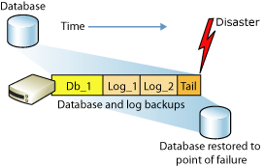

|  |
| --- |
| The transaction log is a serial record of all the transactions that have been performed against the database since the transaction log was last backed up. With transaction log backups, you can recover the database to a specific point in time (for example, prior to entering unwanted data), or to the point of failure. |

Minimally, you must have created at least one full back up before you can create any log backups. After that, the transaction log can be backed up at any time unless the log is already being backed up. We recommend that you take log backups frequently, both to minimize work loss exposure and to truncate the transaction log. Typically, a database administrator creates a full database backup occasionally, such as weekly, and, optionally, creates a series of differential database backup at a shorter interval, such as daily. Independently of the database backups, the database administrator backs up the transaction log at frequent intervals, such as every 10 minutes. For a given type of backup, the optimal interval depends on factors such as the importance of the data, the size of the database, and the workload of the server.

The sequence of transaction log backups is independent of the database backups. You make one sequence of transaction log backups, and then make periodic database backups that are used to start a restore operation. For example, assume the following sequence of events.

|  |  |
| --- | --- |
| **Time** | **Event** |
| 8:00 A.M. | Back up database |
| Noon | Back up transaction log |
| 4:00 P.M. | Back up transaction log |
| 6:00 P.M. | Back up database |
| 8:00 P.M. | Back up transaction log |
| 10:00 P.M. | Failure occurs |

|  |  |  |  |  |
| --- | --- | --- | --- | --- |
| Data Server | System Failure | Secure equipment room, backup server, UPS | Switch over to backup server, validate that UPS is running | Fix/replace primary server, fail back to primary server |
| Corrupted DB | To minimize data corruption, it is recommended to use a db analyse utility regularly. Prevent power outages. Ensure that there is enough disk space | You need to determine the extent of the corruption so that you can figure out what your options are in terms of restore or repair (or potentially just fail over and deal with the corruption offline). | Restore or repair DB |
| Data Loss | Implement RAID system, fault tolerance, and ensure that entire array is available. Check logs, activate automatic notifications so that alerts can be monitored | Restore application data and VM from backups | In the event that a disk has failed, replace disk so that entire array is available |

For databases that use full and bulk-logged recovery, database backups are necessary but not sufficient. Transaction log backups are also required. The following illustration shows the least complex backup strategy that is possible under the full recovery model.

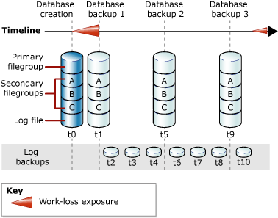

## Maintenance Plans

Maintenance plans can be created to perform the following tasks:

* Reorganize the data on the data and index pages by rebuilding indexes with a new fill factor. Rebuilding indexes with a new fill factor makes sure that database pages contain an equally distributed amount of data and free space. It also enables faster growth in the future
* Compress data files by removing empty database pages
* Update index statistics to make sure the query optimizer has current information about the distribution of data values in the tables. This enables the query optimizer to make better judgments about the best way to access data, because it has more information about the data stored in the database
* Perform internal consistency checks of the data and data pages within the database to make sure that a system or software problem has not damaged data
* Back up the database and transaction log files. Database and log backups can be retained for a specified period. This lets you create a history of backups to be used if you have to restore the database to a time earlier than the last database backup. You can also perform differential backups

### Preparing the Maintenance Plan

|  |
| --- |
| All maintenance plans are implemented using Ola Hallengren’s SQL Server Maintenance Solution which is licensed under the MIT license, a populate widely used open source license.  **Please note,** this section assumes you are using MS SQL Express which does not have an inbuilt SQL Server Agent to execute jobs created by the MaintenanceSolution automatically. If you are using the Standard or Enterprise Editions of SQL Server, you will not need to create a window task to execute these maintenance plans. |

* Create two folders on the SQL server – **C:\AppData\Backups** and **C:\AppData\Reports** (these folders do not need to be created on the c drive, this can be adjusted as necessary)
* Download [MaintenanceSolution.sql](https://ola.hallengren.com/scripts/MaintenanceSolution.sql), which is a script that creates all objects needed to facilitate the backup process.
* Save this file in the folder **X:\AppData\**
* Open this file using SQL Server Management Studio (log in as an administrator)
* Locate the following lines of code near the top of the script (around line 32)

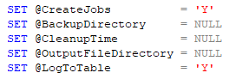

* Amend these variables as follows:

|  |  |
| --- | --- |
| **Variable** | **Modification** |
| CreateJobs | Change to **‘N’** if you are using SQL Server Express else leave as **‘Y’.**  **Please note,** ensure the SQL Server Agent is started before executing this stored procedure if you have set this variable to **‘Y’** |
| BackupDirectory | * Replace the value of the BackupDirectory variable (NULL) with the preferred backup path, **C:\AppData\Backups**. The provided path will be used as a root directory for storing backup files |
| CleanupTime | Set the integer value for the CleanupTime. This value specifies how long (in hours) will each backup file be kept on the drive. After the specified time passes, the file will be deleted automatically. If default NULL value is left in the script, the backup files will never be deleted automatically. Set this value to **120 (5 days).** |
| OutputFileDirectory | Replace the value of the OutputFileDirectory variable (NULL) with the preferred backup path, **C:\AppData\Reports. T**his variable specifies the path for the log files that will be created after each job is run. |
| LogToTable | Default value is set to Yes, and leaving this value as is will log the results of each created job in the CommandLog table |

* Execute the MaintenanceSolution.sql against the server. The script creates one table (dbo.CommandLog), one function, and four stored procedures in the master database. It also creates 11 pre-created SQL Server Agent jobs if you have set the CreateJobs parameter to **‘Y’**

|  |
| --- |
| Please ensure you receive a Command(s) completed successfully message once you have executed the step above |

**The following table and stored procedures are created**

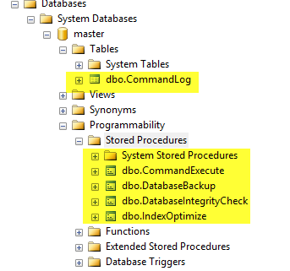

|  |  |
| --- | --- |
| **Object** | **Description** |
| CommandLog Table | Used for logging |
| CommandExecute Stored Procedure | * Core component of the Maintenance Solution as it is used by all other procedures and jobs |
| DatabaseBackup | Manages all backup tasks |
| DatabaseIntegrityCheck | Manages all integrity tasks |
| IndexOptimise | Manages index optimization tasks |

### Preparing the Database Backup Task (System Databases)

|  |
| --- |
| This section uses the Database Backup Stored Procedure created in section 4.2.1.  **Please note,** this section assumes you are using MS SQL Express which does not have an inbuilt SQL Server Agent to execute jobs created by the Maintenance Solution. If you are using the Standard or Enterprise Editions of SQL Server, you will not need to create a windows task to execute these maintenance plans, instead schedule the appropriate Database Backup job using SQL Server Agent. If you are using the SQL Server Express Edition, please follow the steps outlined below. |

Please ensure you have access to the Core.PViMS.Backup.zip file provided as part of system implementation. Extract contents of this zip file to the **C:\AppData\** folder on the SQL Server.

**STEP 1: Prepare the SQL Script**

|  |  |  |  |  |  |  |  |  |  |  |  |  |  |  |  |  |  |  |  |  |  |
| --- | --- | --- | --- | --- | --- | --- | --- | --- | --- | --- | --- | --- | --- | --- | --- | --- | --- | --- | --- | --- | --- |
| Please note, the file **backup_all_sys_dbs.sql** Is used to execute the DatabaseBackup stored procedure and contains all the configuration parameters needed to backup the Master Database as part of this process.  **Variables**   |  |  |  | | --- | --- | --- | | @Databases | SYSTEM_DATABASES | All system databases (master, msdb, and model) | | @Directory | C:\AppData\Backups | Backup to the following directory | | @BackupType | FULL | Do a full backup | | @Verify | Y | Verify the backup after it has completed | | @CheckSum | Y | Enable backup checksums | | @CleanupTime | 120 | Set for 5 days | | @CleanupMode | AFTER_BACKUP | Remove old backup files after successful completion of the backup | |

* Browse to the **C:\AppData\** folder andopen **backup_all_sys_dbs.sql** using SQL Server Management Studio (log in as an administrator)
* Amend these variables as follows:

|  |  |
| --- | --- |
| **Variable** | **Modification** |
| BackupDirectory | * Replace the value of the BackupDirectory variable with the preferred backup path, **C:\AppData\Backups**. The provided path will be used as a root directory for storing backup files |
| CleanupTime | Set the integer value for the CleanupTime. This value specifies how long (in hours) will each backup file be kept on the drive. After the specified time passes, the file will be deleted automatically. If default NULL value is left in the script, the backup files will never be deleted automatically. Set this value to **120 (5 days).** |

**STEP 2: Prepare the Command File**

|  |  |  |  |  |  |  |  |  |  |  |
| --- | --- | --- | --- | --- | --- | --- | --- | --- | --- | --- |
| Please note, the file **full_weekly_backup.cmd** Is used to connect to the SQL database using the SQLCMD program and execute the **backup_all_sys_dbs.sql** script.  **SQLCmd Parameters**   |  |  | | --- | --- | | -E | Use a trusted SQL connection | | -S | C:\AppData\Backups | | -d | The name of the database (master) | | -i | The input file name **(backup_all_sys_dbs.sql**) | | -o | The output file name | |

* Browse to the **C:\AppData\** folder andopen **full_weekly_backup.cmd** using notepad
* Amend these variables as follows:

|  |  |
| --- | --- |
| **Variable** | **Modification** |
| **SERVERANDINSTANCENAME** | * Specify the name of the Windows Server, followed by a backslash followed by the name of the SQL Server Instance and then specify the port number if required * **Example** * .\SQLEXPRESS * PVIMSSERVER\SQLEXPRESS * .\SQLEXPRESS,1433 |
| **OUTPUTFILENAME** | The name of the output file. Reports\FullWeeklyBackup_Log.txt |

**STEP 3: Create a Weekly Task**

|  |
| --- |
| Please note, this task must be created on the same server as the files that have been edited in step 1 and 2. Please ensure you are logged in to the server as an administrator. |

|  |  |
| --- | --- |
| Open Server Manager 🡪 Tools 🡪 Task Scheduler |  |
| Create a new task |  |
| General Settings   * Enter a task name | **PViMS Weekly Master Database Backup** * Ensure Run when user is logged on or not is selected |  |
| Trigger Settings   * Add a new trigger   + Ensure task is configured to run weekly every Sunday   + Ensure task is configured to start on the current date plus one day   + Ensure task is configured to start at 12:00 AM   + Under advanced settings, ensure task is enabled   + Click OK to add trigger |  |
| Ensure trigger appears in trigger list |  |
| Action Settings   * Add a new action   + Ensure Start a Program is select   + Browse to the location of the **full_ weekly_backup.cmd** file in **C:\AppData**   + Click OK to add action |  |
| Ensure action appears in the list  Click OK to add this task to the server. You may be prompted to confirm your administrator user name and password to add the task. |  |

### Preparing the Database Backup Task (PViMS Database)

|  |
| --- |
| This section uses the Database Backup Stored Procedure created in section 4.2.1.  **Please note,** this section assumes you are using MS SQL Express which does not have an inbuilt SQL Server Agent to execute jobs created by the Maintenance Solution. If you are using the Standard or Enterprise Editions of SQL Server, you will not need to create a windows task to execute these maintenance plans, instead schedule the appropriate Database Backup job using SQL Server Agent. If you are using the SQL Server Express Edition, please follow the steps outlined below. |

Please ensure you have access to the Core.PViMS.Backup.zip file provided as part of system implementation. Extract contents of this zip file to the **C:\AppData\** folder on the SQL Server.

**STEP 1: Prepare the SQL Script**

|  |  |  |  |  |  |  |  |  |  |  |  |  |  |  |  |  |  |  |  |  |  |
| --- | --- | --- | --- | --- | --- | --- | --- | --- | --- | --- | --- | --- | --- | --- | --- | --- | --- | --- | --- | --- | --- |
| Please note, the file **backup_pvims_db.sql** Is used to execute the DatabaseBackup stored procedure and contains all the configuration parameters needed to backup the PVIMS Database as part of this process.  **Variables**   |  |  |  | | --- | --- | --- | | @Databases | PViMS | Backup the PViMS database (specify USER_DATABASES to backup all databases) | | @Directory | C:\AppData\Backups | Backup to the following directory | | @BackupType | FULL | Do a full backup | | @Verify | Y | Verify the backup after it has completed | | @CheckSum | Y | Enable backup checksums | | @CleanupTime | 120 | Set for 5 days | | @CleanupMode | AFTER_BACKUP | Remove old backup files after successful completion of the backup | |

* Browse to the **C:\AppData\** folder andopen **backup_pvims _db.sql** using SQL Server Management Studio (log in as an administrator)
* Amend these variables as follows:

|  |  |
| --- | --- |
| **Variable** | **Modification** |
| Databases | * Replace the value of the Databases variable with the correct database name if the default name has been changed |
| BackupDirectory | * Replace the value of the BackupDirectory variable (NULL) with the preferred backup path, **C:\AppData\Backups**. The provided path will be used as a root directory for storing backup files |
| CleanupTime | Set the integer value for the CleanupTime. This value specifies how long (in hours) will each backup file be kept on the drive. After the specified time passes, the file will be deleted automatically. If default NULL value is left in the script, the backup files will never be deleted automatically. Set this value to **120 (5 days).** |

**STEP 2: Prepare the Command File**

|  |  |  |  |  |  |  |  |  |  |  |
| --- | --- | --- | --- | --- | --- | --- | --- | --- | --- | --- |
| Please note, the file **full_daily_backup.cmd** Is used to connect to the SQL database using the SQLCMD program and execute the **backup_pvims_db.sql** script.  **SQLCmd Parameters**   |  |  | | --- | --- | | -E | Use a trusted SQL connection | | -S | C:\AppData\Backups | | -d | The name of the database (master) | | -i | The input file name **(backup_pvims_db.sql**) | | -o | The output file name | |

* Browse to the **C:\AppData\** folder andopen **full_daily_backup.cmd** using notepad
* Amend these variables as follows:

|  |  |
| --- | --- |
| **Variable** | **Modification** |
| **SERVERANDINSTANCENAME** | * Specify the name of the Windows Server, followed by a backslash followed by the name of the SQL Server Instance and then specify the port number if required * **Example** * .\SQLEXPRESS * PVIMSSERVER\SQLEXPRESS * .\SQLEXPRESS,1433 |
| **OUTPUTFILENAME** | The name of the output file. Reports\FullDailyBackup_Log.txt |

**STEP 3: Create a Daily Task**

|  |
| --- |
| Please note, this task must be created on the same server as the files that have been edited in step 1 and 2. Please ensure you are logged in to the server as an administrator. |

|  |  |
| --- | --- |
| Open Server Manager 🡪 Tools 🡪 Task Scheduler |  |
| Create a new task |  |
| General Settings   * Enter a task name | **PViMS Daily Database Backup** * Ensure Run when user is logged on or not is selected |  |
| Trigger Settings   * Add a new trigger   + Ensure task is configured to run daily   + Ensure task is configured to start on the current date plus one day   + Ensure task is configured to start at 12:00 AM   + Under advanced settings, ensure task is enabled   + Click OK to add trigger |  |
| Ensure trigger appears in trigger list |  |
| Action Settings   * Add a new action   + Ensure Start a Program is select   + Browse to the location of the **full_daily_backup.cmd** file in **C:\AppData**   + Click OK to add action |  |
| Ensure action appears in the list  Click OK to add this task to the server. You may be prompted to confirm your administrator user name and password to add the task. |  |

### Preparing the Database Integrity Task (PViMS Database)

|  |
| --- |
| This section uses the Database Integrity Check Stored Procedure created in section 4.2.1.  **Please note,** this section assumes you are using MS SQL Express which does not have an inbuilt SQL Server Agent to execute jobs created by the Maintenance Solution. If you are using the Standard or Enterprise Editions of SQL Server, you will not need to create a windows task to execute these maintenance plans, instead schedule the appropriate Database Backup job using SQL Server Agent. If you are using the SQL Server Express Edition, please follow the steps outlined below. |

Please ensure you have access to the Core.PViMS.Backup.zip file provided as part of system implementation. Extract contents of this zip file to the **C:\AppData\** folder on the SQL Server.

**STEP 1: Prepare the SQL Script**

|  |  |  |  |  |  |  |
| --- | --- | --- | --- | --- | --- | --- |
| Please note, the file **integrity_pvims_db.sql** Is used to execute the Database Integrity Check stored procedure and contains all the configuration parameters needed to integrity check the PVIMS Database as part of this process.  **Variables**   |  |  |  | | --- | --- | --- | | @Databases | PViMS | Verify the integrity of the PViMS database (specify USER_DATABASES to verify all user databases) | | @CheckCommands | CHECKDB | Check the integrity of the whole database | |

* Browse to the **C:\AppData\** folder andopen **integrity_pvims_db.sql** using SQL Server Management Studio (log in as an administrator)
* Amend these variables as follows:

|  |  |
| --- | --- |
| **Variable** | **Modification** |
| Databases | * Replace the value of the Databases variable with the correct database name if the default name has been changed |

**STEP 2: Prepare the Command File**

|  |  |  |  |  |  |  |  |  |  |  |
| --- | --- | --- | --- | --- | --- | --- | --- | --- | --- | --- |
| Please note, the file **full_weekly_integrity.cmd** Is used to connect to the SQL database using the SQLCMD program and execute the **integrity_pvims_db.sql** script.  **SQLCmd Parameters**   |  |  | | --- | --- | | -E | Use a trusted SQL connection | | -S | C:\AppData\Backups | | -d | The name of the database (master) | | -i | The input file name **(integrity_pvims_db.sql**) | | -o | The output file name | |

* Browse to the **C:\AppData\** folder andopen **full_weekly_integrity.cmd** using notepad
* Amend these variables as follows:

|  |  |
| --- | --- |
| **Variable** | **Modification** |
| **SERVERANDINSTANCENAME** | * Specify the name of the Windows Server, followed by a backslash followed by the name of the SQL Server Instance and then specify the port number if required * **Example** * .\SQLEXPRESS * PVIMSSERVER\SQLEXPRESS * .\SQLEXPRESS,1433 |
| **OUTPUTFILENAME** | The name of the output file. Reports\FullWeeklyIntegrity_Log.txt |

**STEP 3: Create a Weekly Task**

|  |
| --- |
| Please note, this task must be created on the same server as the files that have been edited in step 1 and 2. Please ensure you are logged in to the server as an administrator.  Please see step 3 for preparing the Database Backup Task (System Databases) for steps on how to create a weekly task to execute this task. |

### Preparing the Index Optimise Task (PViMS Database)

|  |
| --- |
| This section uses the Index Optimize Stored Procedure created in section 4.2.1.  **Please note,** this section assumes you are using MS SQL Express which does not have an inbuilt SQL Server Agent to execute jobs created by the Maintenance Solution. If you are using the Standard or Enterprise Editions of SQL Server, you will not need to create a windows task to execute these maintenance plans, instead schedule the appropriate Database Backup job using SQL Server Agent. If you are using the SQL Server Express Edition, please follow the steps outlined below. |

Please ensure you have access to the Core.PViMS.Backup.zip file provided as part of system implementation. Extract contents of this zip file to the **C:\AppData\** folder on the SQL Server.

**STEP 1: Prepare the SQL Script**

|  |  |  |  |  |  |  |  |  |  |  |  |  |  |  |  |  |  |  |  |  |  |  |  |  |
| --- | --- | --- | --- | --- | --- | --- | --- | --- | --- | --- | --- | --- | --- | --- | --- | --- | --- | --- | --- | --- | --- | --- | --- | --- |
| Please note, the file **optimise_pvims_db.sql** Is used to execute the Index Optimise stored procedure and contains all the configuration parameters needed to optimise the PVIMS Database as part of this process.  **Variables**   |  |  |  | | --- | --- | --- | | @Databases | PViMS | Optimise the PViMS database (specify USER_DATABASES to optimise all user databases) | | @FragmentationLow | NULL | Do not defragment indexes with low fragmentation | | @FragmentationMedium | INDEX_REORGANIZE  INDEX_REBUILD_ONLINE  INDEX_REBUILD_OFFLINE | Reorganise and rebuild indexes with medium fragmentation | | @FragmentationHigh | INDEX_REBUILD_ONLINE  INDEX_REBUILD_OFFLINE | Reorganise and rebuild indexes with high fragmentation | | @FragmentationLevel1 | 5 | Set the lower limit, as a percentage, for medium fragmentation. The default is 5 percent. This is based on Microsoft’s recommendation | | @FragmentationLevel2 | 30 | Set the lower limit, as a percentage, for high fragmentation. The default is 30 percent. This is based on Microsoft’s recommendation | | @UpdateStatistics | ALL | Update index and column statistics | | @OnlyModifiedStatistics | Y | Update statistics only if any rows have been modified since the most recent statistics update | |

* Browse to the **C:\AppData\** folder andopen **optimise_pvims _db.sql** using SQL Server Management Studio (log in as an administrator)
* Amend these variables as follows:

|  |  |
| --- | --- |
| **Variable** | **Modification** |
| Databases | * Replace the value of the Databases variable with the correct database name if the default name has been changed |

**STEP 2: Prepare the Command File**

|  |  |  |  |  |  |  |  |  |  |  |
| --- | --- | --- | --- | --- | --- | --- | --- | --- | --- | --- |
| Please note, the file **full_weekly_optimise.cmd** Is used to connect to the SQL database using the SQLCMD program and execute the **optimise_pvims_db.sql** script.  **SQLCmd Parameters**   |  |  | | --- | --- | | -E | Use a trusted SQL connection | | -S | C:\AppData\Backups | | -d | The name of the database (master) | | -i | The input file name **(optimise_pvims_db.sql**) | | -o | The output file name | |

* Browse to the **C:\AppData\** folder andopen **full_weekly_optimise.cmd** using notepad
* Amend these variables as follows:

|  |  |
| --- | --- |
| **Variable** | **Modification** |
| **SERVERANDINSTANCENAME** | * Specify the name of the Windows Server, followed by a backslash followed by the name of the SQL Server Instance and then specify the port number if required * **Example** * .\SQLEXPRESS * PVIMSSERVER\SQLEXPRESS * .\SQLEXPRESS,1433 |
| **OUTPUTFILENAME** | The name of the output file. Reports\FullWeeklyOptimise_Log.txt |

**STEP 3: Create a Weekly Task**

|  |
| --- |
| Please note, this task must be created on the same server as the files that have been edited in step 1 and 2. Please ensure you are logged in to the server as an administrator.  Please see step 3 for preparing the Database Backup Task (System Databases) for steps on how to create a weekly task to execute this task. |

# Database Restore

|  |
| --- |
| This section describes how to restore a database backup onto the PViMS SQL Server. |

Open SQL Server Management Studio and login as an administrator. Once logged in, right click on the Databases node and select ‘Restore Database’.

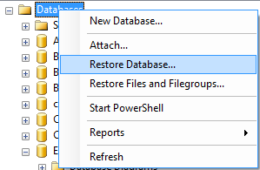

* Click the ellipses button next to ‘From device’ under the ‘Source for restore’ section.

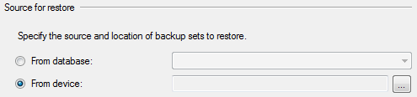

* Set ‘File’ as the backup media and then click ‘Add’.

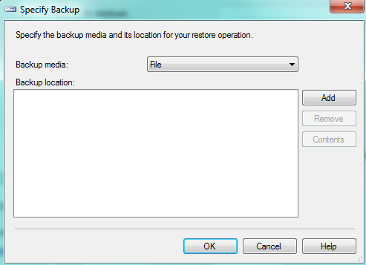

* Browse to the SQL backup (BAK) file you want to restore.
* In the Restore Database dialog, type or select the name of the database you want this backup restored to.
* If you select an existing database, this database will be replaced by the contents of the backup
* If you type a database name which does not currently exist in your SQL Server installation, a new database will be created.
* Next, select the restore point you want to use. Since a SQL backup file can hold multiple backups you may see more than one restore point listed.

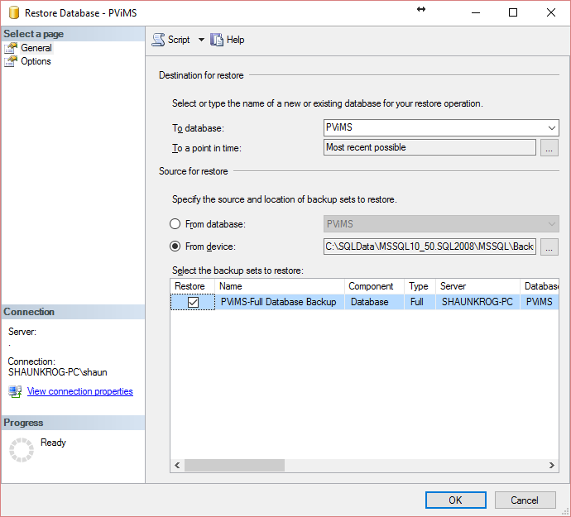

At this point, enough information has been entered for the database to be restored. However, SQL backup files store information about where data files are copied so if there are any file system problems such as the destination directory not existing or conflicting data file names an error will occur. These problems are common when restoring a backup created on a different SQL Server installation.

To review and change the file system settings, click the Options page on the left in the Restore Database dialog.



On the options page, you will want to make sure the ‘Restore As’ column points to valid folder locations (you can change them as needed). These files do not have to exist; however, the folder path must exist. If the respective files do exist, SQL Server follows a simple set of rules:

If the ‘To database’ (from the General page) matches the restore database backup (i.e. restoring to matching databases), the respective files will be overwritten as part of the restore.

If the ‘To database’ does not match the restore database backup (i.e. restoring to a different database), the ‘Overwrite the existing database’ will need to be checked for the restore process to complete. Use this function with caution as you can potentially restore database backup information on top of data files from a completely different database.

Generally, you can tell the databases differ based on the ‘Original File Name’ which is the internal name SQL Server uses to reference the respective files.

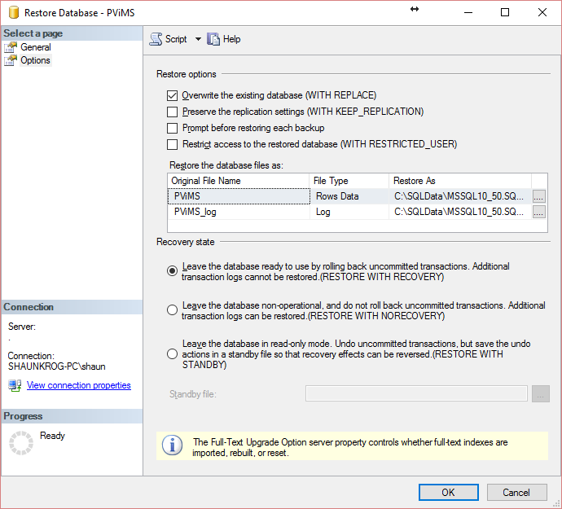

Once restore options are set, click Ok and the database will be restored.