QuanTB installer. Troubleshooting guide

In this guide, we will collect cases of unusual behavior of QuanTB installers and related workarounds. The permanent address of the actual version of this guide is the same as for the QuanTB installer.

Contents

Installer doesn’t run on Windows 1

Symptoms 1

Possible causes 1

Solutions 1

Installer runs with error message “A JNI Error has occurred...” 3

Symptoms 3

Possible causes 3

Solution 3

# The installer doesn’t run on Windows

## Symptoms

QuanTB installer downloaded doesn’t run without any message

## Possible causes

* You are lost the installation window
* You are not right to install software on this computer
* Java software has not been installed or installation is incorrect
* Antivirus disable this installation
* Installer is broken

## Solutions

First press Alt-Tab and switch to the installation window using the mouse

Otherwise, run the installer as an Administrator. To do this, right-click the installer and select “Run as Administrator”

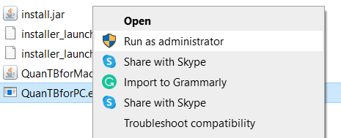

Figure Right-click on the installer and, then, select Run as administrator

Otherwise, check Java installed

First, run the command prompt

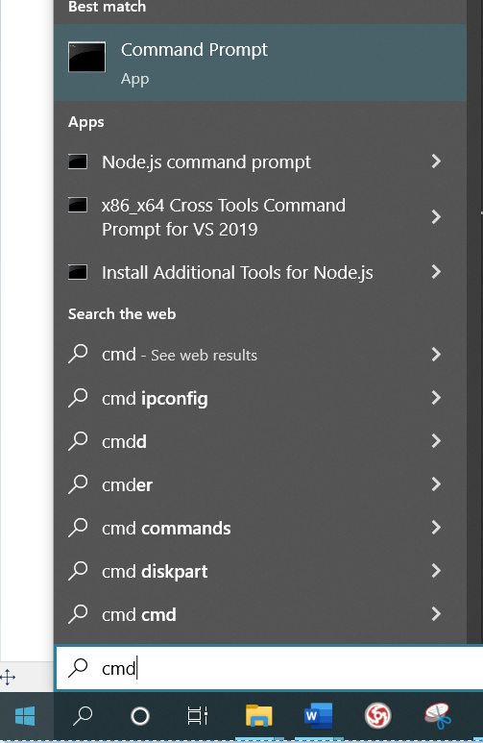

Figure click on Windows Start and, then, type cmd

Second, check Java

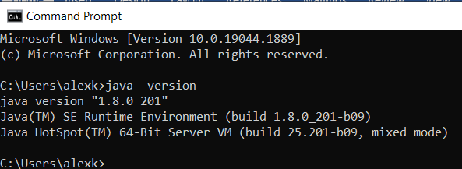

Figure Type java -version

If the screen will not look like the above, Install Java as noted in the Installation Manual

Otherwise, turn off the antivirus, make installation, and, then turn the antivirus on

Otherwise, download the installer again.

# The installer runs with the error message “A JNI Error has occurred...”

## Symptoms

Message from the installer

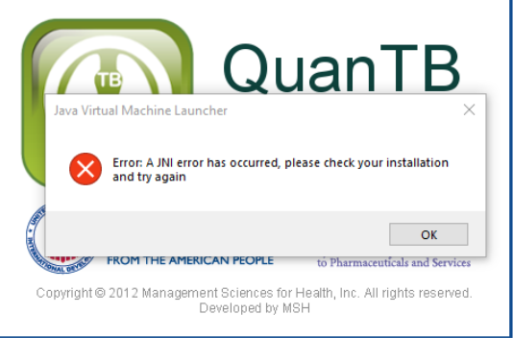

## Possible causes

Wrong Java version – below 1.8

## Solution

Install Java as noted in the Installation Manual