e-TB Manager Entity Relational Diagrams

Febryary 2017

By Ricardo Memoria

# 

# 

Summary

**Introduction** **3**

What is e-TB Manager? 3

Target Audience 3

**Workspace and Administration Model** **4**

**Authorization and Authentication Model** **5**

**Transaction Log Model** **6**

**Case Management Model** **7**

**Case Management Module – Exam tables** **8**

**Case Management Module – Other Data tables** **9**

**Medicine Module Model (Core)** **10**

**Medicine Module (Sequence)** **11**

**Configuration and Supporting Tables** **12**

# 

# 

# Introduction

This document contains the entity relationship diagrams of e-TB Manager database. Because the whole diagram doesn't fit in one single page, it was created several diagrams split by context. This division will promote an easier understanding of e-TB Manager database structure.

## What is e-TB Manager?

e-TB Manager is a web-based tool for managing all the information needed by national TB control programs. It integrates data across all aspects of TB control, including information on suspects, patients, medicines, laboratory testing, diagnosis, treatment, and outcome.

## Target Audience

The main audience of this document is software developers interested in maintaining the source code of e-TB Manager, or database administrators interested in a fine tuning of the database.

# Workspace and Administration Model

C:\Users\Ricardo Memoria\Documents\Administration.png

# Authorization and Authentication Model

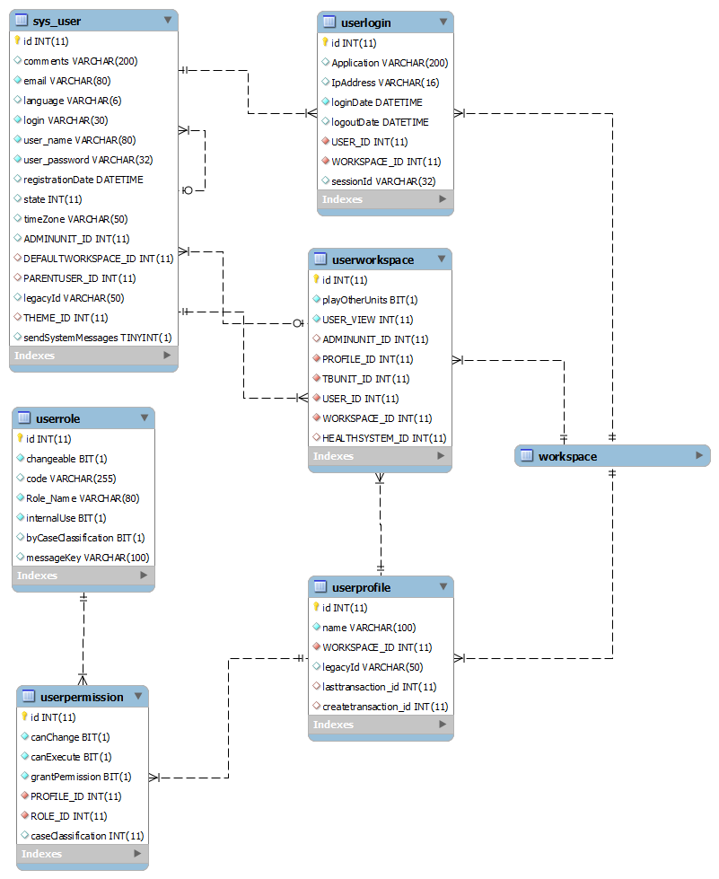

# Transaction Log Model

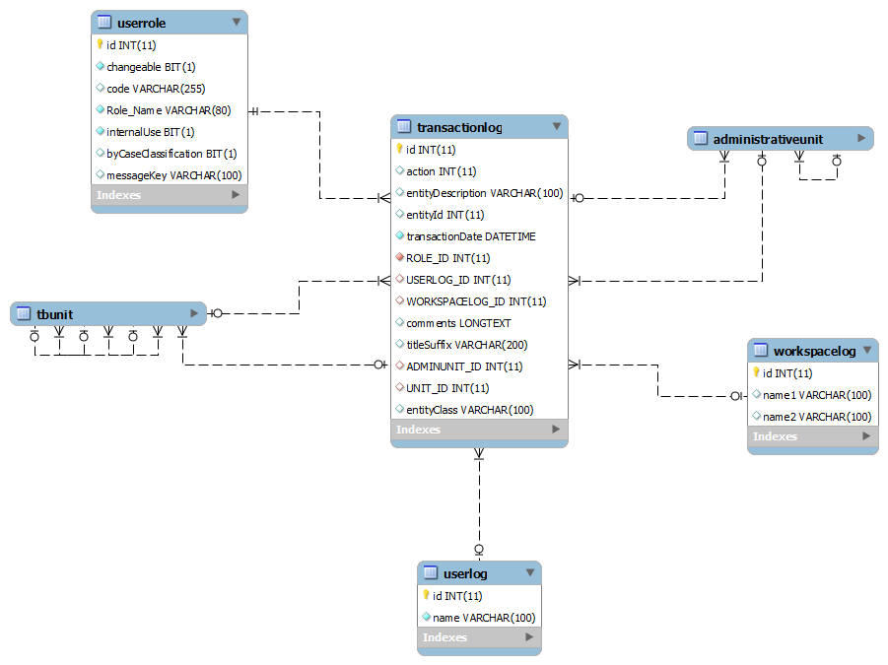

# Case Management Model

(Main Case/Suspect tables)

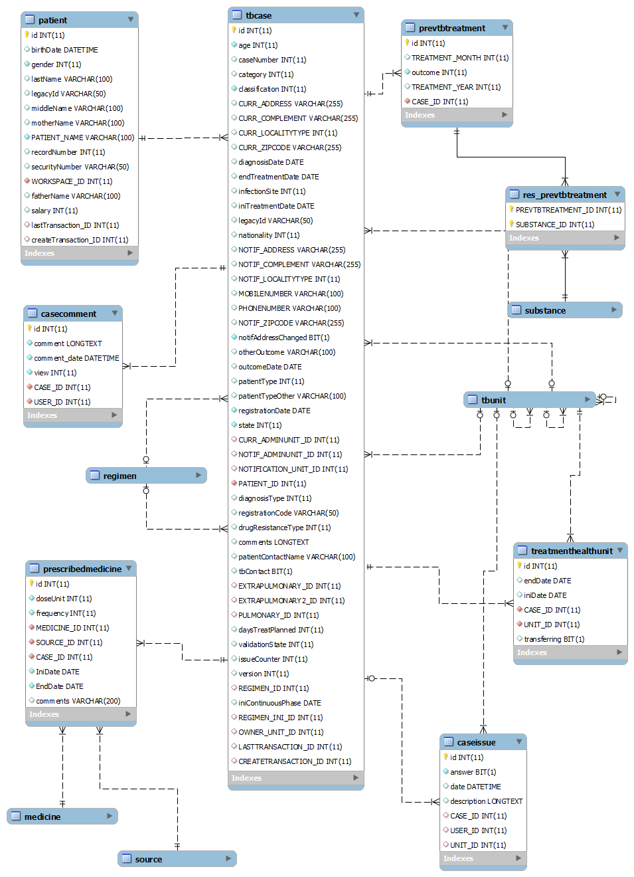

# Case Management Module – Exam tables

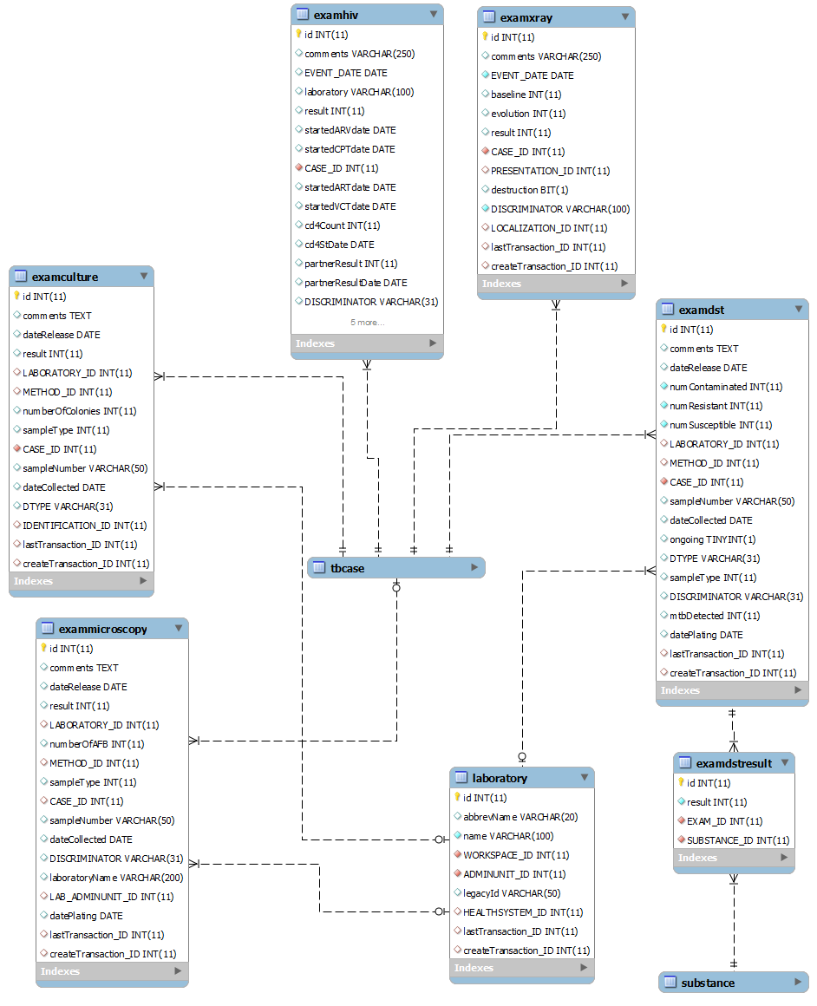

# Case Management Module – Other Data tables

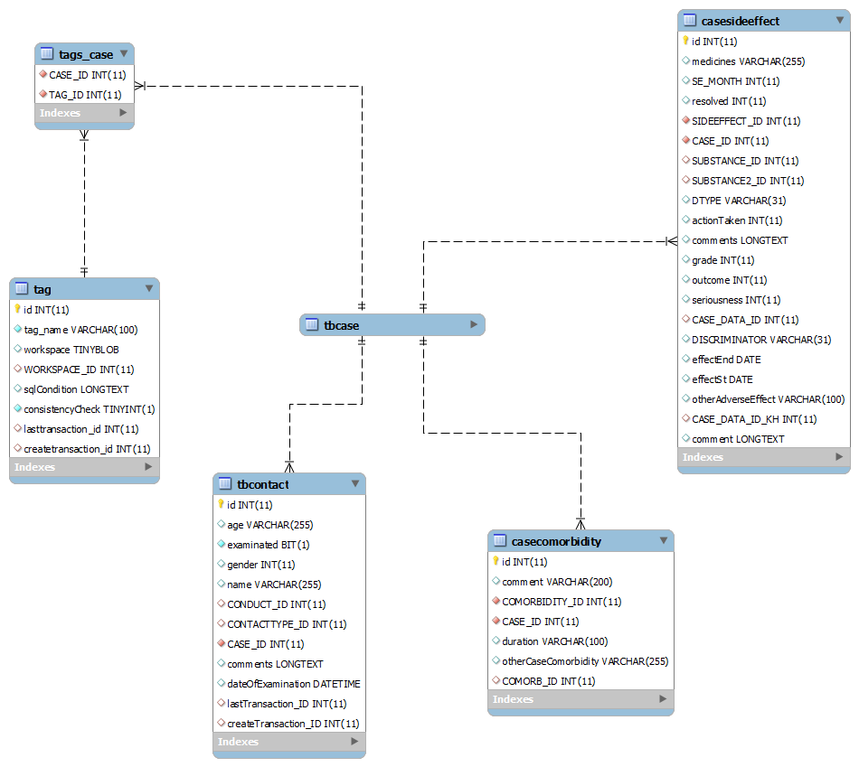

# Medicine Module Model (Core)

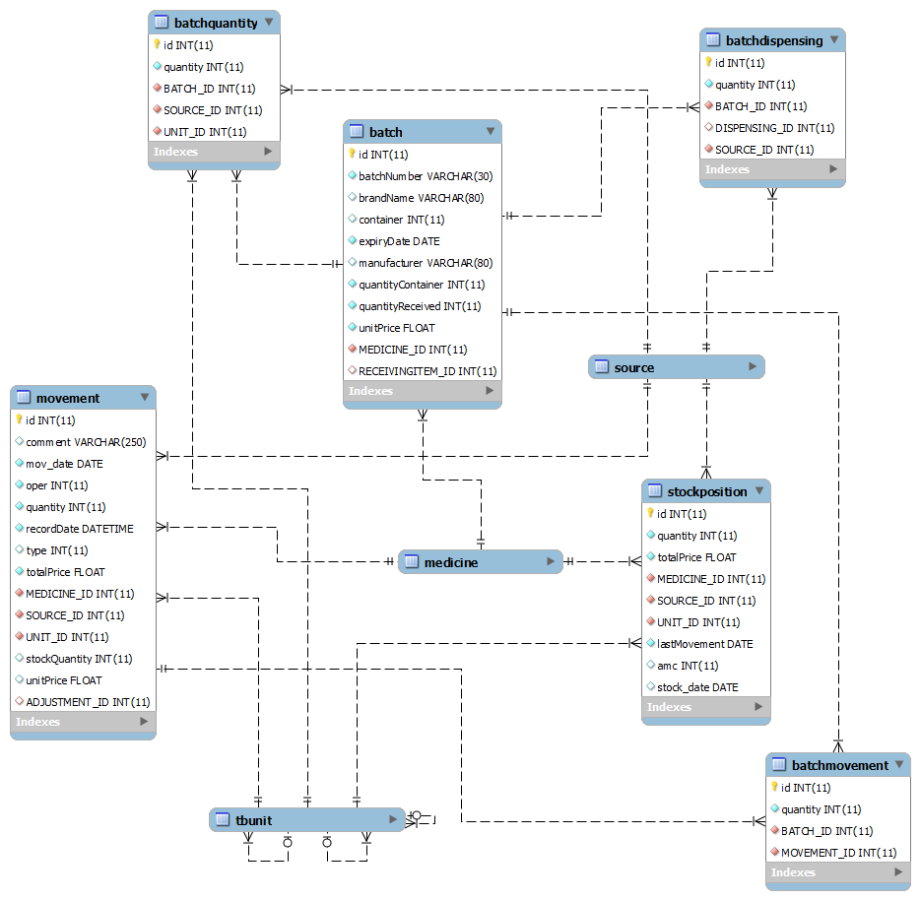

# Medicine Module (Sequence)

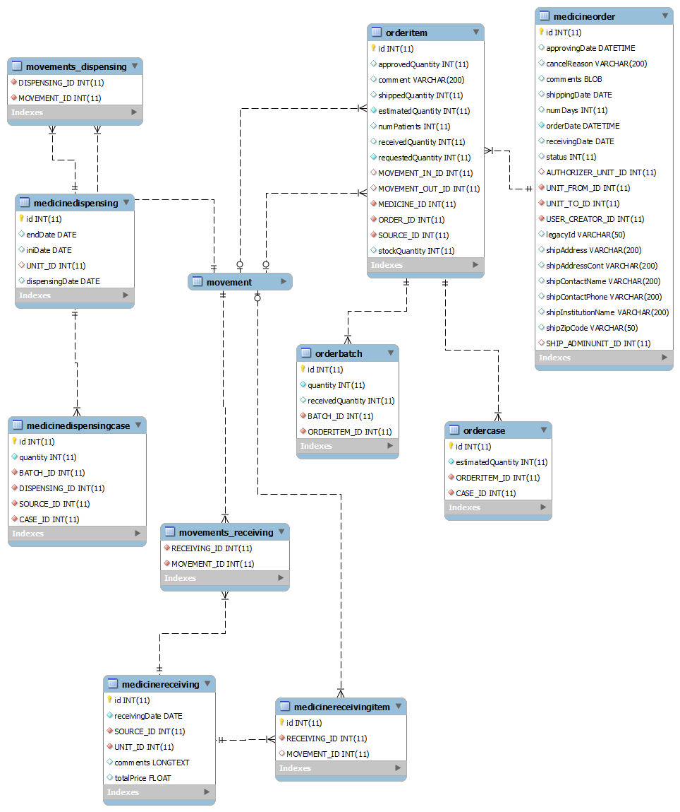

# Configuration and Supporting Tables

