Introduction
Mental health problems among university students have become an important area of research due to their potential effects on academic performance, daily functioning, and overall well-being. Depression, anxiety, and stress are among the most common psychological challenges experienced by students.
The Depression Anxiety Stress Scales-21 (DASS-21) is a widely used instrument for assessing symptoms related to depression, anxiety, and stress. This study aims to analyze student mental health data using statistical methods in R and to investigate whether demographic factors such as age, gender, and academic year are associated with differences in mental health scores.
The objectives of this project are:
- To describe the levels of depression, anxiety, and stress among students.
- To examine the relationship between age and mental health scores.
- To compare mental health scores between genders.
- To investigate differences in depression, anxiety, and stress across academic years.
Statistical analyses, including correlation tests, independent samples t-tests, analysis of variance (ANOVA), and visualization techniques, were performed to explore patterns in student mental health data.
Methods
Dataset
The dataset used in this project contains information collected from university students. The variables include demographic characteristics such as age, gender, and academic year, as well as responses to the DASS-21 questionnaire.
The DASS-21 questionnaire was used to calculate three mental health subscale scores:
- Depression score
- Anxiety score
- Stress score
Software and Tools
All data processing, statistical analysis, and visualization were performed using the R programming language in RStudio.
Statistical Analysis
Several statistical methods were applied:
- Descriptive statistics were used to summarize depression, anxiety, and stress scores.
- Pearson correlation tests were performed to examine relationships between age and mental health scores.
- Independent samples t-tests were used to compare mental health scores between male and female students.
- One-way ANOVA tests were conducted to examine differences in mental health scores across academic years.
- Tukey post-hoc tests were applied following significant ANOVA results to identify specific group differences.
- Data visualization techniques were used to present patterns and comparisons between groups.
All statistical analyses were performed using a significance level of 0.05.
Results
Descriptive Statistics
The descriptive analysis showed that the mean scores of the DASS-21 subscales were:
- Depression: Mean = 5.03
- Anxiety: Mean = 4.00
- Stress: Mean = 6.71
Among the three mental health indicators, stress showed the highest average score.
Relationship Between Age and Mental Health Scores
Pearson correlation tests were conducted to examine the relationship between age and mental health scores.
No significant correlation was found between age and depression scores (r = 0.018, p = 0.622).
Similarly, age was not significantly associated with anxiety scores (r = 0.016, p = 0.650) or stress scores (r = 0.031, p = 0.394).
Gender Differences in Mental Health Scores
Independent samples t-tests were performed to compare mental health scores between female and male students.
The results showed no statistically significant differences between genders for:
- Depression scores (p = 0.698)
- Anxiety scores (p = 0.499)
- Stress scores (p = 0.123)
Although females showed slightly higher mean scores in all three measures, these differences were not statistically significant.

Differences Across Academic Years
One-way ANOVA was used to investigate differences in mental health scores across academic years.
A significant difference was found for depression scores across academic years:
(F(3,758) = 7.11, p = 0.000103)
This indicates that depression scores were significantly different between academic years. The Tukey post-hoc test was used to identify specific differences between groups.
For anxiety scores, ANOVA also showed a significant difference across years:
(F(3,757) = 5.11, p = 0.00167)
The Tukey post-hoc test indicated a significant difference between 2019 and 2020.
However, stress scores did not significantly differ across academic years:
(F(3,758) = 1.57, p = 0.195).

Figures
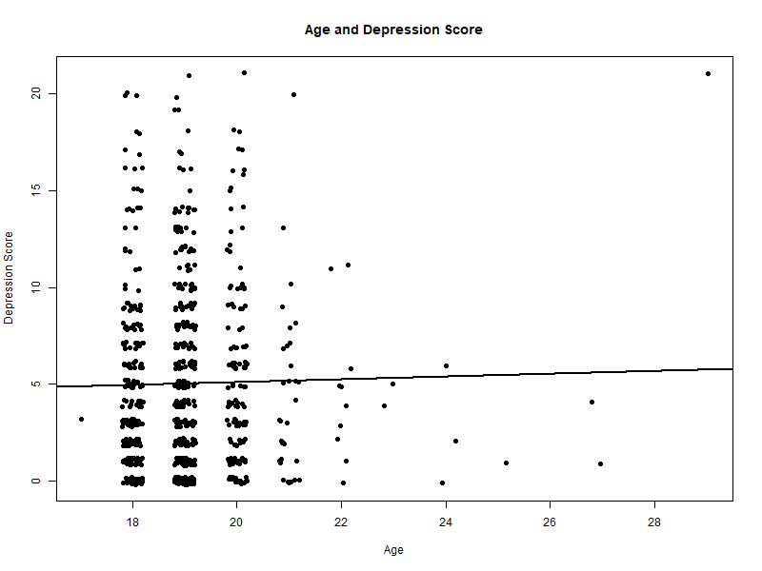
Figure 1. Age and Depression Score Relationship

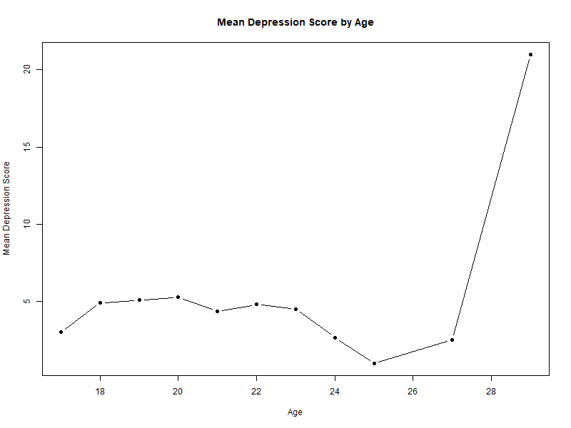
Figure 2. Mean Depression Score by Age
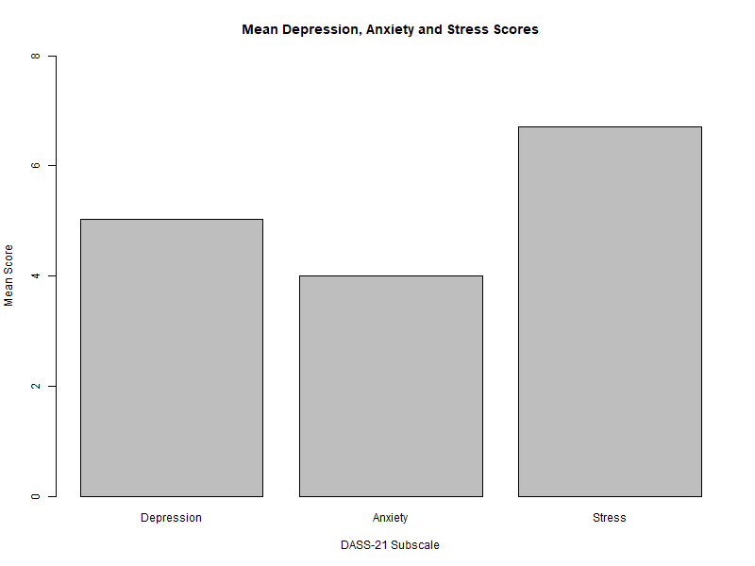
Figure 3. Mean Depression, Anxiety and Stress Scores
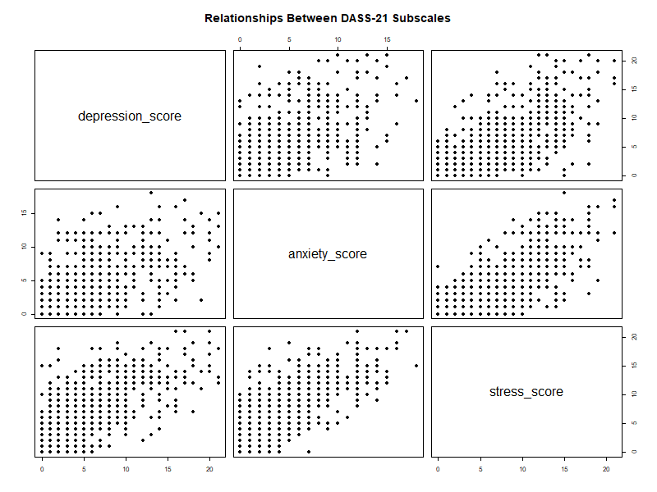
Figure 4. Relationships Between DASS-21 Subscales
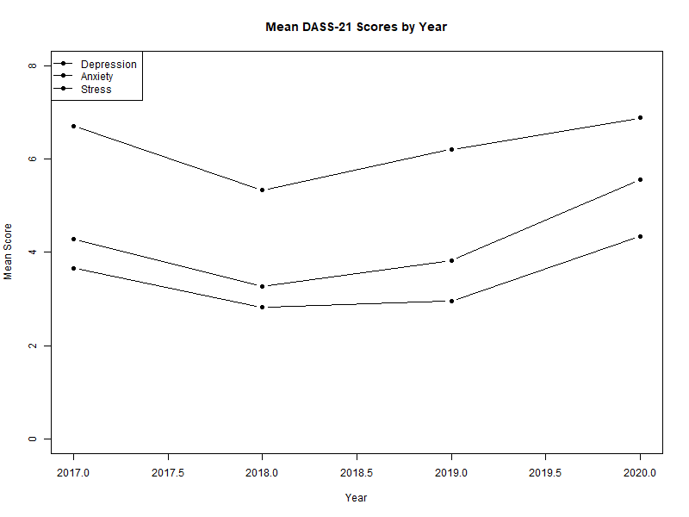
Figure 5. Mean DASS-21 Scores Across Years
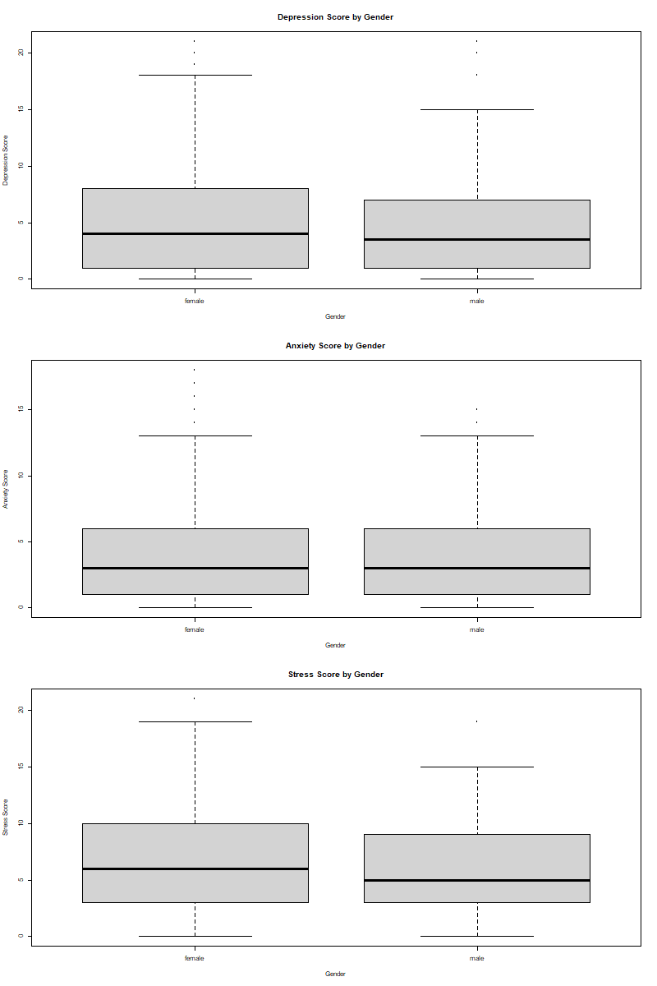
Figure 6. Mental Health Scores by Gender
Discussion
This study investigated the relationship between demographic factors and students' mental health scores using DASS-21 measures of depression, anxiety, and stress.
The findings showed that age was not significantly associated with depression, anxiety, or stress scores. This suggests that within this sample, differences in age did not strongly influence mental health levels.
Gender comparisons also showed no statistically significant differences between male and female students. Although female students had slightly higher average scores for depression, anxiety, and stress, these differences were not large enough to reach statistical significance.
In contrast, academic year showed significant differences in depression and anxiety scores. The increase observed in 2020 may suggest that students experienced higher psychological challenges during this period. However, stress scores did not significantly differ between years, indicating that changes across years may have affected specific aspects of mental health differently.
The correlation analysis between DASS-21 subscales showed positive relationships between depression, anxiety, and stress. This indicates that students experiencing higher levels of one mental health symptom may also experience higher levels of other symptoms.

Conclusion
This project analyzed student mental health data using statistical analysis and visualization techniques in R.
The main findings were:
- Age was not significantly related to depression, anxiety, or stress.
- No significant differences were found between genders.
- Academic year was associated with differences in depression and anxiety levels.
- Depression, anxiety, and stress were positively related to each other.
Overall, the results highlight the importance of monitoring student mental health and considering academic and environmental factors when developing support programs for university students.

Table 1. Summary of Statistical Test Results
Analysis | P_value
Age - Depression | 0.622
Age - Anxiety | 0.6498
Age - Stress | 0.3939
Gender - Depression | 0.6979
Gender - Anxiety | 0.4992
Gender - Stress | 0.1233
Year - Depression | 0.000103
Year - Anxiety | 0.00167
Year - Stress | 0.195

6. References
- Lovibond, S. H., & Lovibond, P. F. (1995).
Manual for the Depression Anxiety Stress Scales (2nd ed.).
Sydney: Psychology Foundation.
- R Core Team. (2024).
R: A Language and Environment for Statistical Computing.
R Foundation for Statistical Computing, Vienna, Austria.
- RStudio Team. (2024).
RStudio: Integrated Development Environment for R.
Posit Software, PBC.
- Field, A. (2018).
Discovering Statistics Using IBM SPSS Statistics (5th ed.).
London: SAGE Publications.
- Wickham, H., & Grolemund, G. (2017).
R for Data Science: Import, Tidy, Transform, Visualize, and Model Data.
O'Reilly Media.

