Hari Prasad M S

727721euit044

**CC-1**

**Question 1**

**Code:**

package pom.ca.ca1;

import org.openqa.selenium.By;

import org.openqa.selenium.WebDriver;

import org.openqa.selenium.WebElement;

import org.openqa.selenium.chrome.ChromeDriver;

import org.openqa.selenium.chrome.ChromeOptions;

import io.github.bonigarcia.wdm.WebDriverManager;

public class cc1 {

public static void main(String[] args) {

ChromeOptions co=new ChromeOptions();

co.addArguments ("--remote-allow-origins=*");

WebDriverManager.chromedriver().setup ();

WebDriver driver=new ChromeDriver(co);

driver.get ("https://www.saucedemo.com/");

driver.manage().window().maximize() ;

WebElement txtBoxl=driver.findElement(By.xpath("//*[@id=\"user-name\"]"));

txtBoxl.sendKeys("standard_user");

WebElement txtBox2=driver.findElement(By.xpath("//*[@id=\"password\"]"));

txtBox2.sendKeys("secret_sauce");

driver.findElement(By.xpath("//*[@id=\"login-button\"]")).click();

driver.findElement(By.xpath("//*[@id=\"add-to-cart-sauce-labs-backpack\"]")).click();

driver.findElement(By.xpath("//*[@id=\"shopping_cart_container\"]/a")).click();

driver.findElement(By.xpath("//*[@id=\"checkout\"]")).click();

driver.findElement(By.xpath("//*[@id=\"first-name\"]")).sendKeys("Hari");

driver.findElement(By.xpath("//*[@id=\"last-name\"]")).sendKeys("Prasad");

driver.findElement(By.xpath("//*[@id=\"postal-code\"]")).sendKeys("628005");

driver.findElement(By.xpath("//*[@id=\"continue\"]")).click();

String detail1=driver.findElement(By.xpath("//*[@id=\"item_4_title_link\"]/div")).getText();

System.out.println(detail1);

String detail2=driver.findElement(By.xpath("//*[@id=\"checkout_summary_container\"]/div/div[1]/div[3]/div[2]/div[2]/div")).getText();

System.out.println(detail2);

String t= driver.getTitle();

String t1="Swag Labs";

if(t.equals(t1)) {

System.out.println("TITLE MATCHED");

}

else

System.out.println("TITLE NOT MATCHED");

String url1= driver.getCurrentUrl();

String url2="https://www.saucedemo.com/checkout-step-two.html";

if(url1.equals(url2)) {

System.out.println("Url MATCHED");

}

else

System.out.println("Url NOT MATCHED");

}

}

**Output:**

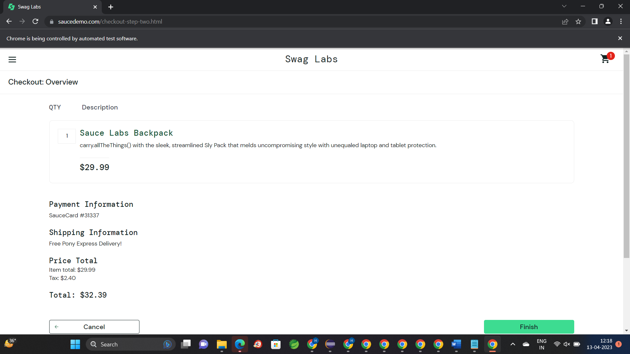

**Question 2**

**Code:**

package pom.ca.ca1;

import org.openqa.selenium.By;

import org.openqa.selenium.WebDriver;

import org.openqa.selenium.WebElement;

import org.openqa.selenium.chrome.ChromeDriver;

import org.openqa.selenium.chrome.ChromeOptions;

import io.github.bonigarcia.wdm.WebDriverManager;

public class ccc2 {

public static void main(String[] args) throws InterruptedException {

// TODO Auto-generated method stub

ChromeOptions co=new ChromeOptions();

co.addArguments ("--remote-allow-origins=*");

WebDriverManager.chromedriver().setup ();

WebDriver driver=new ChromeDriver(co);

driver.get ("https://www.saucedemo.com/");

driver.manage().window().maximize() ;

WebElement txtBoxl=driver.findElement(By.xpath("//*[@id=\"user-name\"]"));

txtBoxl.sendKeys("standard_user");

WebElement txtBox2=driver.findElement(By.xpath("//*[@id=\"password\"]"));

txtBox2.sendKeys("secret_sauce");

driver.findElement(By.xpath("//*[@id=\"login-button\"]")).click();

String txt1=driver.findElement(By.xpath("//*[@id=\"item_4_title_link\"]/div")).getText();

System.out.println(txt1);

driver.findElement(By.xpath("//*[@id=\"header_container\"]/div[2]/div/span/select")).click();

driver.findElement(By.xpath("//*[@id=\"header_container\"]/div[2]/div/span/select/option[2]")).click();

String txt2=driver.findElement(By.xpath("//*[@id=\"item_3_title_link\"]/div")).getText();

System.out.println(txt2);

driver.findElement(By.xpath("//*[@id=\"header_container\"]/div[2]/div/span/select")).click();

driver.findElement(By.xpath("//*[@id=\"header_container\"]/div[2]/div/span/select/option[3]")).click();

String txt3=driver.findElement(By.xpath("//*[@id=\"item_2_title_link\"]/div")).getText();

System.out.println(txt3);

driver.findElement(By.xpath("//*[@id=\"header_container\"]/div[2]/div/span/select")).click();

driver.findElement(By.xpath("//*[@id=\"header_container\"]/div[2]/div/span/select/option[4]")).click();

String txt4=driver.findElement(By.xpath("//*[@id=\"item_5_title_link\"]/div")).getText();

System.out.println(txt4);

Thread.sleep(5000);

}

}

**Output:**

