EDU Stats: Descriptive & Comparative: Assignment #2

**Once you have identified a dataset, explain how you accessed it. What links did you click? Was there any registration required? Did you download directly or was there an online system you navigated?**

Initially, I googled open infertility data sets. The results provided a link to the fertility clinics registered with the CDC. I selected the data set regarding clinic success rates in Texas. The data were downloaded into a spreadsheet for use.

**In R: Import the data**

* + Provide a list of variables in the dataset
    - Copy and paste this list in your word document

names(cdc2)

[1] "TotNumberCycles" "IVF_Rate" “Unstimulated_Rate" "Diag_OvulatoryRate" "Diag_MaleRate"

**What is the structure of the data? Which variables are character and which are numeric? Copy and paste this list in your word document**

> str("TotNumberCycles")

chr "TotNumberCycles"

> str("IVF_Rate")

chr "IVF_Rate"

> str("TotUsingFrozenEggs")

chr " TotUsingFrozenEggs "

> str("Diag_OvulatoryRate")

chr "Diag_OvulatoryRate"

> str("Diag_MaleRate")

chr "Diag_MaleRate"

*Changes had to be made in excel to convert any spaces or commas into “numeric” under “text-to-column” function.*

**Terms Explained**

TotNumberCycles Total cycles excluding approved research

IVF_Rate ART types & procedures % of cycles using IVF

TotUsingFrozenEggs Cycles using frsh emb from frzn nondnr eggs

Diag_OvulatoryRate Patient diagnosis % of cycles with ovulatory dysfunction

Diag_MaleRate Patient diagnosis % of cycles with male factor

**Describe the data through Central Tendencies:**

**Median, Mean, & Mode of 5 variables:**

TotNumberCycles**:** Median – 118.0, Mean -220.0, Mode – 118 and 130

IVF_Rate: Median – 1, Mean – 1, Mode – 1

TotUsingFrozenEggs Median – 01.000, Mean – 1.907, Mode – 0

Diag_OvulatoryRate Median – 0.1600, Mean – 0.2109, Mode – 0.11

Diag_MaleRate Median – 0.3400, Mean – 0.3614, Mode – 0.31

**Variance, Range, and Standard Deviation of Diag_OvulatoryRate**

Variance – 0.02140864

Standard Deviation – 0.1463169

Range – 0.00 to 0.63

**Histogram**

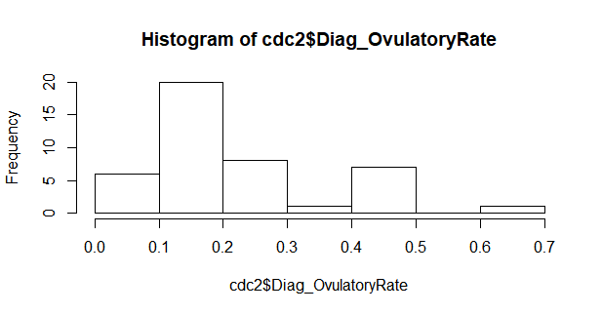

**Box-Plot**

