Adding figures with odt.py
This document shows how to add figures to an Open Document Foundation text document using the odt module.
odt is a wrapper for, and therefore requires, the odfpy module. odfpy can be installed with "python pip install odfpy".

Adding figures
Using odt and Python to write out Open Document (.odt) files with figures is straightforward. In Python, first import the module with "from msl.odt import Document", next open a document with, e.g., "doc=Document(my_odt_file)".
The primary function for adding images in odt is addfigure() which takes arguments:
- image_filename of type: str Default value: Required
- image_width of type: str Default value: Required
- image_height of type: str Default value: Required
- caption_text of type: Optional[str] Default value: None
and would be called as, e.g., doc.addfigure(image_file, "5cm", "7cm") or
doc.addfigure(image_file, image_width=image_width, image_height=image_height),
where image_file, image_width and image_height are variables of type: str.

Example images
The following images are publically available:
- htps://commons.wikimedia.org/wiki/File:Sweden_TV1_colour_1969.png
- https://commons.wikimedia.org/wiki/File:PM5544_with_non-PAL_signals.png
and will be used as the test images in this document and
will be labelled "TESTCARD_1" and "TESTCARD_2" in the examples below.
See over the page - pagebreak created using doc.addpagebreak() - for examples.

Example 1
Basic figure addition:
doc.addfigure(TESTCARD_1, "7cm", "5cm")
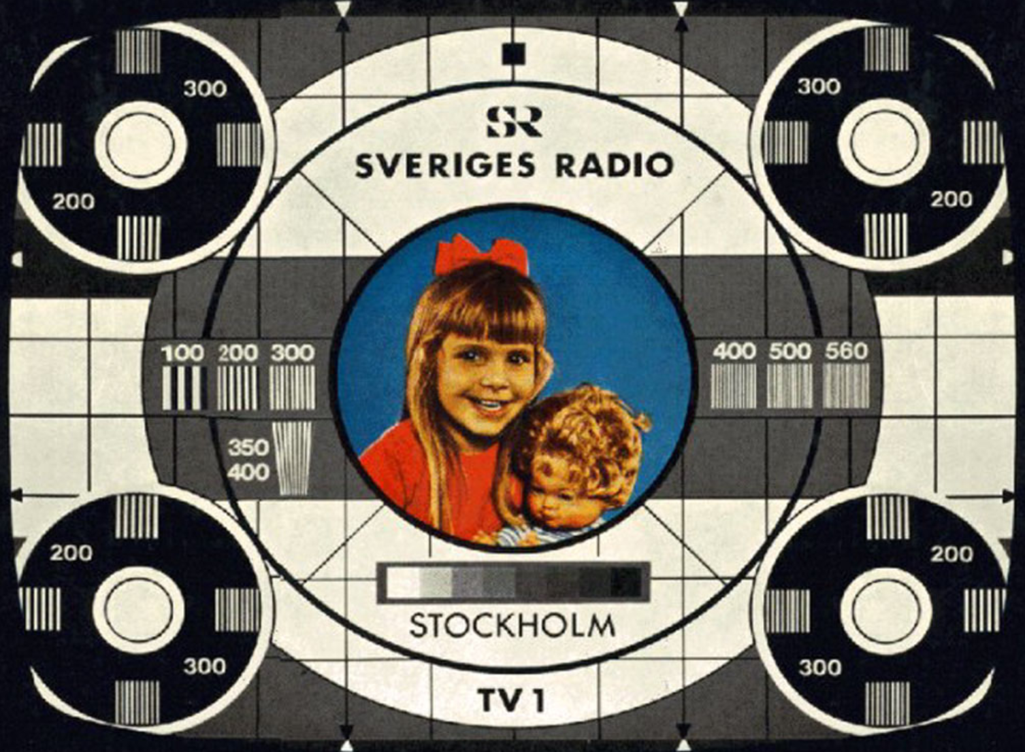
Note: no caption

Example 2
Figure addition with caption:
doc.addfigure(TESTCARD_2,
image_width=image_width,
image_height=image_height,
caption_text=caption_text)

Figure 2. The PM5544 test card
where:
- image_width="8cm"
- image_height="8cm"
- caption_text="Figure 2. The PM5544 test card"
Note: addfigure() does not do automatic numbering or labelling of captions.

