**How to use this program:**

There are two important inputs for the program other than terminal commands. The constraint files and the objective function files.

The constraint files are lists of linear equations that will determine the feasible region of the program. Each element in the equation is delimited by a space. The last two elements are the sign and the right-hand side of “b” value and the rest of the elements before that are the coefficients in front of each variable in each column. The variables’ coefficients are implicitly assigned by their order from left to right. A variable cannot be skipped and its coefficient must be explicitly defined as ‘0’.

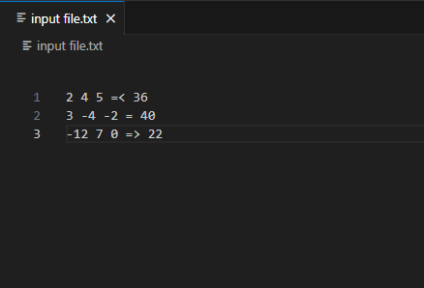

The above constraint file is equivalent to the following constraints:

$$2x_{1}+4x_{2}+5x_{3}≤36$$

$$3x_{1}-4x_{2}-2x_{3}≤40$$

$$-12x_{1}+7x_{2}≤22$$

Once the constraint file has been written, the user must load it from the program in runtime using the load command.

The command is written like so:

* load constraint “input file.txt”

Where “input.txt” is the relative path to the constraint file from where the executable is being run or the absolute path of the constraint file. The double quotes are necessary so that spaces in the file’s name are recognized as part of the file’s name when written in the command.

Objective functions are loaded the same way using syntax like so:

* load objective “input file.txt”

An example of what “input file.txt” would be if it contained information on an objective function is:

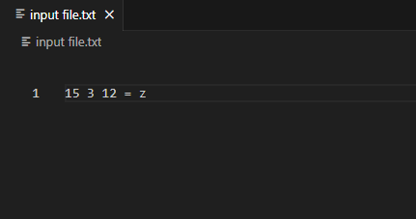

Just like before ethe numbers before the sign are implicit assignments of the coefficients of the decision variables. However, the sign is always an equal sign, and the right-hand side value is always z. These symbols are still included to make these files distinguishable from constraint files with only one constraint.

Once both files are loaded, the constraints or objective function can be overwritten by the aforementioned commands, or the following commands can be run with these files loaded:

* max: Maximize the objective function with respect to the loaded constraints.
* min: The same but minimize the objective function.
* Int max: Find maximum valued integer solution with respect to the objective function inside the constraints.
* Int min: Find minimum integer solution.
* Pivot [column]: Pivot the constraints of a loaded linear program, choosing the exiting variable corresponding the integer written over [column].
* Phase 1: Reduce sum of artificial variables to zero and find the first feasible solution.