**Wisdom of the Crowds for Genetic Search**

**Introduction**

The goal of this project is to demonstrate the wisdom of the crowds for the traveling salesman problem. It is often found that the aggregate of multiple individual solutions to a problem is better than the majority of individual solutions. This project aims to show that this can be combined with a genetic algorithm. More specifically, the population generated by a genetic algorithm can be used as individual solutions to the problem and a subset of these solutions called experts can be aggregated to provide a solution that is potentially better than the best of the solutions provided by the genetic algorithm alone. This paper reports on the approach taken to aggregate these solutions and the results of that approach including the optimality of the solution and the time it takes to achieve said solution.

**Approach**

The aggregation method used on the population is like the one used in “Wisdom of the Crowds in Traveling Salesman Problems” with the exception that, instead of using the Lin Kernighan heuristic for the final phase, an asymmetric 3opt method is used.

Ten percent of solutions with the lowest edge lengths of the last generation of the pure genetic search are used as the experts for the aggregation. Then an agreement matrix of n x n dimensions (where n is the number of vertices in input problem) is filled with the proportion of the expert solutions that contains an edge from vertex A to B. It is important to note that the edges of this graph are directed and the weight of an edge from A to B is most likely does not have the same weight as the edge from B to A.

After the matrix is completed, the proportions are input into the two-parameter inverse beta function and the result is subtracted from 1. These are what will be referred to as the agreement costs of the edges in the graph and will be used to calculate how much a path agrees with the experts. Then a graph with these weights is solved as another traveling salesperson problem, aiming to find the path that has edges the most in common with the experts by minimizing the agreement cost of a path that visits all the same vertices in the traveling salesperson problem.

A 3-opt method is used on the path in the expert population that has the lowest agreement cost in the hopes that the result will have as low of an agreement cost as possible. This will be best for testing the premise of the problem. Each combination of three edges from the path are considered for replacement with a combination three new edges that reconnect the graph. If one combination of replacement edges decreases the cost of the path, the edges are replaced, and the search is restarted on the improved path. This process is repeated until no more improvements can be made by replacing three edges. In an asymmetric traveling salesman problem, there is only ever one set of three edges that can ever be used to replace for any other combination of three edges to remove. The effectiveness of this aggregation method is possibly limited and may have had an impact on the results.

The expert population is the top 10 percent of the population. For all experiments the parameters for beta inverse are 2 for A and 2 for B.

**Data**

*Optimality*

The genetic algorithm was run on six datasets and solutions for the genetic algorithm were produced. Experiments varied the generation limits on the pure genetic algorithm and then measured how much the aggregation method changed the solution over said limits. The goal of this project was to find how many generations would have to be produced by the genetic algorithm before the aggregation method would make the most improvement. The genetic algorithm was run 15 times for with generation limits starting at five generations going to 50 generations incrementing by 5. The average lengths of the most fit individuals in the final generations would be plotted alongside the results of the aggregation function on final generations. The data did not show results that were expected, and some statistics were compiled to see if the agreement cost metric correlated with the length of the solution, i.e., are paths that are closer to the aggregate path better performers on average? To this end, Pearson correlation coefficients were calculated using the agreement costs of individuals in the final generations and correlating them to their lengths. The average Pearson correlation was calculated for the generation limits mentioned above.

*Time*

The average runtime of both algorithms was calculated for problems of varying sizes. The results were compared to see how much runtime the aggregation method adds relative to the genetic algorithm alone.

**Results**

*Optimality*

The enhanced solutions are consistently inferior to the best solution provided by the genetic algorithm alone. This does not change with the generation limit of the genetic algorithm, nor does it change with the size of the problem.

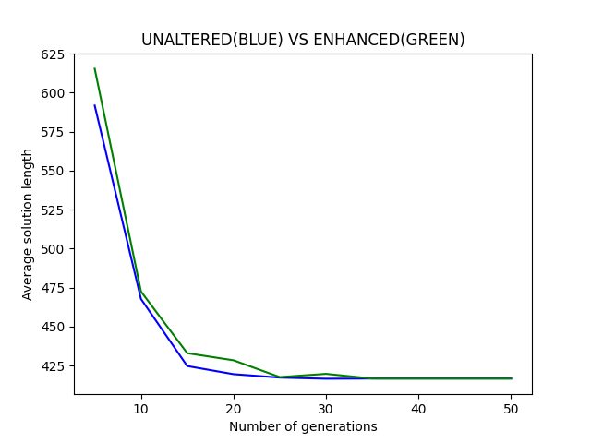

“Enhanced” vs Unaltered for problem size n = 22

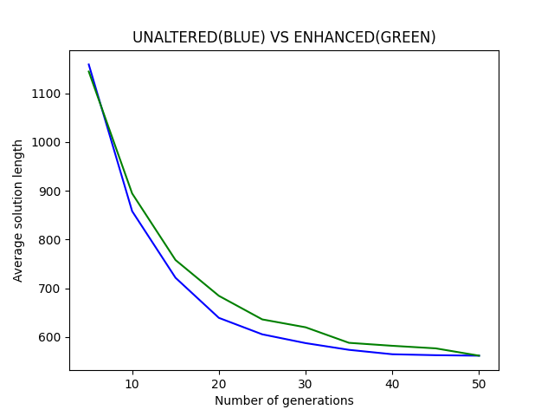

“Enhanced” vs Unaltered for problem size n = 44

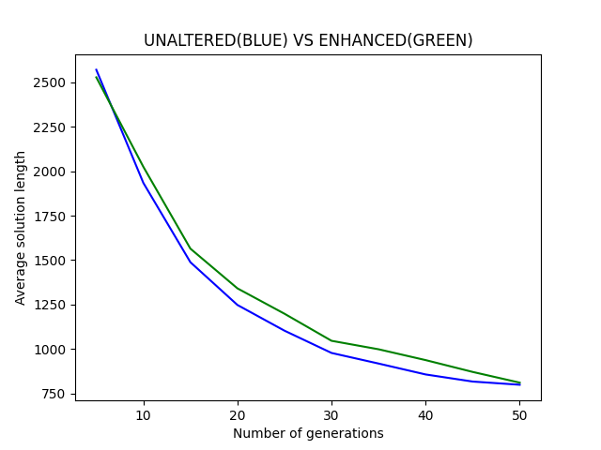

“Enhanced” vs Unaltered for problem size n = 77

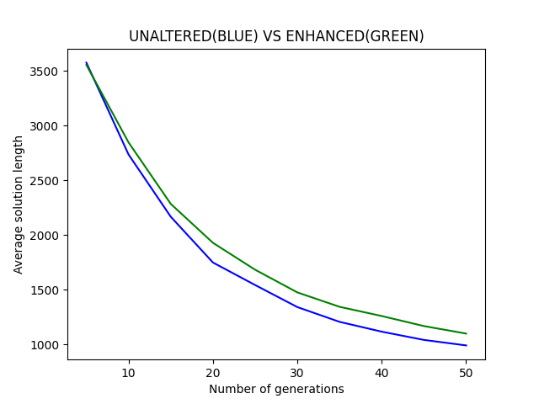

“Enhanced” vs Unaltered for problem size n = 97

Each figure calculates the average length of results over a sample size of 15 for each problem size. The difference between the averages of the unaltered and enhanced solutions increases until the solutions in the genetic search converge and the difference is near zero again. This is clearly because, when the solutions are nearly identical, there will be few changes made to the base solution by the 3opt algorithm to lower the cost. It is likely that the proportion of agreement values of the aggregation matrix will be non-zero for nearly the number of edges that is in a single solution thus a cost optimized path will be identical or nearly identical to a single member of the population. With all of this in mind, lower agreement costs are nevertheless correlated with lower path lengths. The following is a scatter plot that compares the agreement costs of a population of paths with their lengths. Each solution of each population has 97 edges and belongs to the 50th generation of a genetic search.

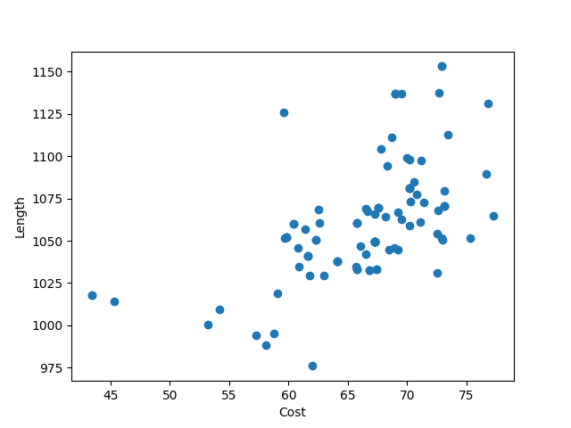

Scatterplot of the agreement cost of a path vs its length. Ge

Here are, additionally, some graphs that track the average Pearson correlation over generations on different sized problems:

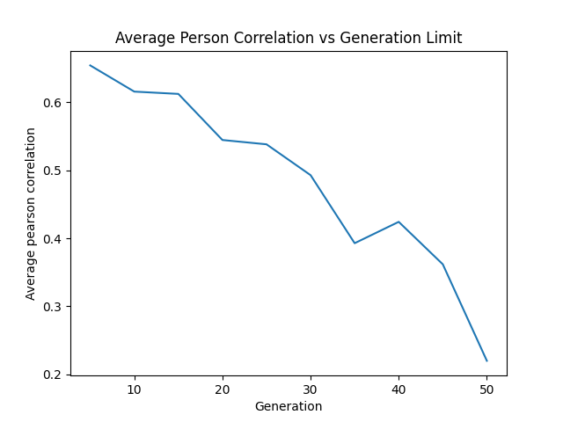

Average Pearson ‘r’ coefficient over generation. Problem size: 44

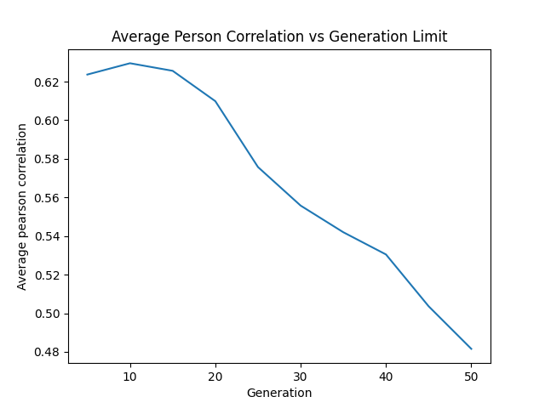

Average Pearson ‘r’ coefficient over generation. Problem size: 77

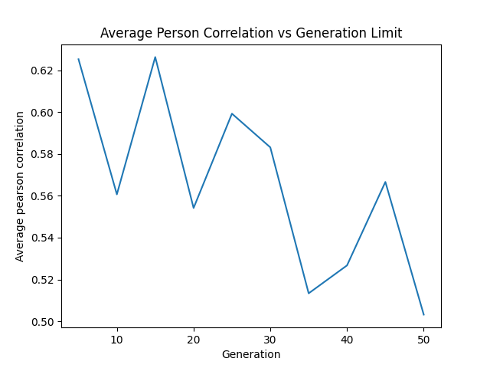

Average Pearson ‘r’ coefficient over generation. Problem size: 97

The correlation coefficients remain positive over generations and problem sizes and, surprisingly, the correlation between cost and length decreases with consecutive generations.

*Time Performance*

The time performance of the aggregation algorithm is evaluated on its own. The timer is started after a solution is loaded from a file and stopped after the aggregation algorithm returns its result. This result is compared to the average runtime of the genetic algorithm alone. Each base solution from the pure genetic algorithm has a generation limit of 50.

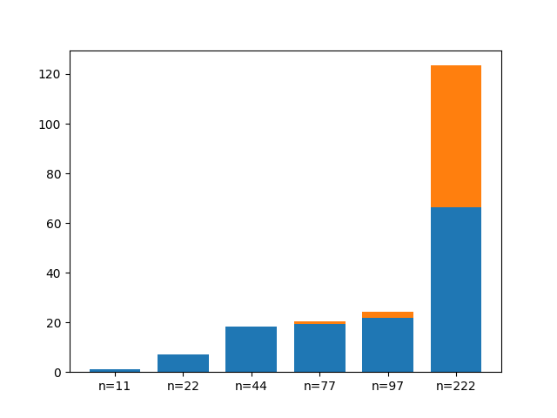

Runtimes, in seconds, of the full algorithm for problem sizes n broken into the genetic algorithm phase and the aggregation phase.

The run time of the aggregation algorithm appears to grow asymptotically faster than the run time of the genetic algorithm alone. It is easy to see that for lower values of n, the addon of aggregation is negligible but, for n=77 and n=97 the cost is starting to catch up until, at n=222 they are nearly the same. The edge recombination algorithm proves to be quite efficient compared to, at least, the modified asymmetrical 3 opt method for high values of n. Both algorithms, after all are used to solve a traveling salesman problem with different weights on its edges.

**Discussion**

The results of this lab were disappointing. The aggregation method added nothing that the optimal solution to the pure solution could not provide. It is likely that some error in logic was committed in the code as low agreement costs clearly correlate with lower path lengths. Making solutions that are more like expert solutions should intuitively improve the results, but the aggregation method consistently shows otherwise.

More consideration should have been given to balancing out the time consumption of the aggregation method with the improvement in results that it could have provided. The asymptotic bound of the aggregation method was clearly higher than the genetic algorithm. For larger solutions, it might be best to simply continue to run the genetic algorithm.

**References**

Kung, Sheng & Yi, Michael & Steyvers, Mark & Lee, Michael. (2011). Wisdom of the Crowds in Traveling Salesman Problems.