ITA0609 – MACHINE LEARNING
Name: M S Mukilan
Reg Num: 192412071

Assignment 17: Design a Machine Learning Model for Solar Energy Generation Prediction

SDG Mapping
SDG 7 – Affordable and Clean Energy.
The model predicts solar energy generation to improve efficient renewable energy utilization.

Problem Understanding
Objective: Predict solar energy generation using environmental parameters such as sunlight hours, temperature and cloud cover.

Algorithms Used
- Linear Regression (Prediction)
- NumPy (Matrix computation)
- Pandas (Dataset handling)
- Matplotlib (Visualization)

Dataset Features
Input: SunlightHours, Temperature, CloudCover
Output: EnergyGenerated

Data Collection & Preprocessing
Collect solar/weather data, remove missing values, convert numeric values, normalize if required.

Analysis using NumPy and Pandas
Pandas is used to load and preprocess the dataset. NumPy performs matrix calculations to estimate regression coefficients.

Python IDLE Code
import pandas as pd
import numpy as np
import matplotlib.pyplot as plt
df = pd.read_csv("solar_energy.csv")
X = df[["SunlightHours","Temperature","CloudCover"]].values
X = np.c_[np.ones(len(X)), X]
y = df["EnergyGenerated"].values
beta = np.linalg.inv(X.T @ X) @ X.T @ y
prediction = X @ beta
print("Regression Coefficients:", beta)
plt.scatter(y,prediction)
plt.xlabel("Actual")
plt.ylabel("Predicted")
plt.title("Solar Energy Prediction")
plt.show()

Expected Output
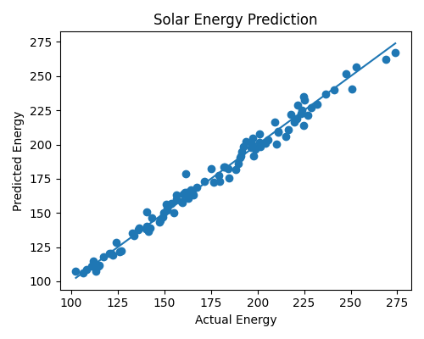

Interpretation
The predicted values closely follow the actual energy values, indicating that linear regression successfully models the relationship between weather parameters and solar energy generation.

Innovation & SDG Linkage
The model can assist smart grids, solar farms and rooftop solar systems in forecasting power generation. This supports SDG 7 by improving renewable energy planning and reducing dependence on fossil fuels.

Conclusion
A Machine Learning model based on Linear Regression accurately predicts solar energy generation using weather parameters. NumPy, Pandas and Matplotlib provide efficient analysis, visualization and prediction.

