IBM AGENTIC AI ASSIGNMENT-2

ASSIGNMENT: AI-Powered Customer Support Automation System
NAME: Malisetty Sai Nikhit
REG.NO: 24BCE2642
EMAIL: malisetty.sainikhit2024@vitstudent.ac.in
BATCH NO: 01

OUTPUT SCREENSHOTS

Query -1: What are the pricing plans available for your software?
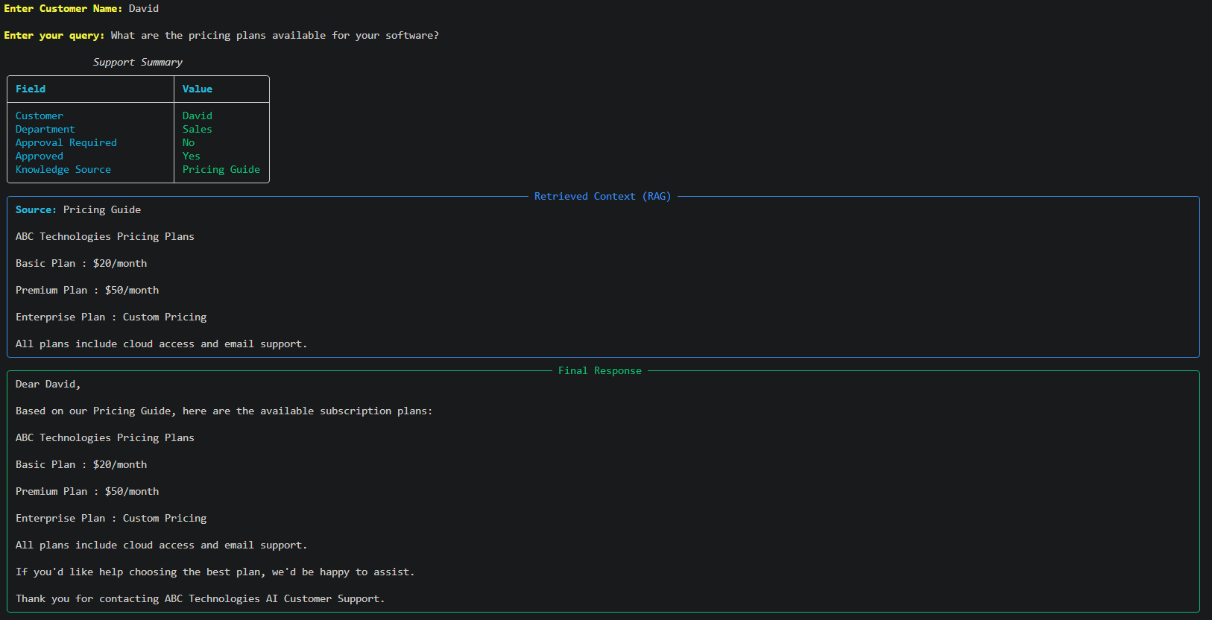
Query-2: I forgot my account password.

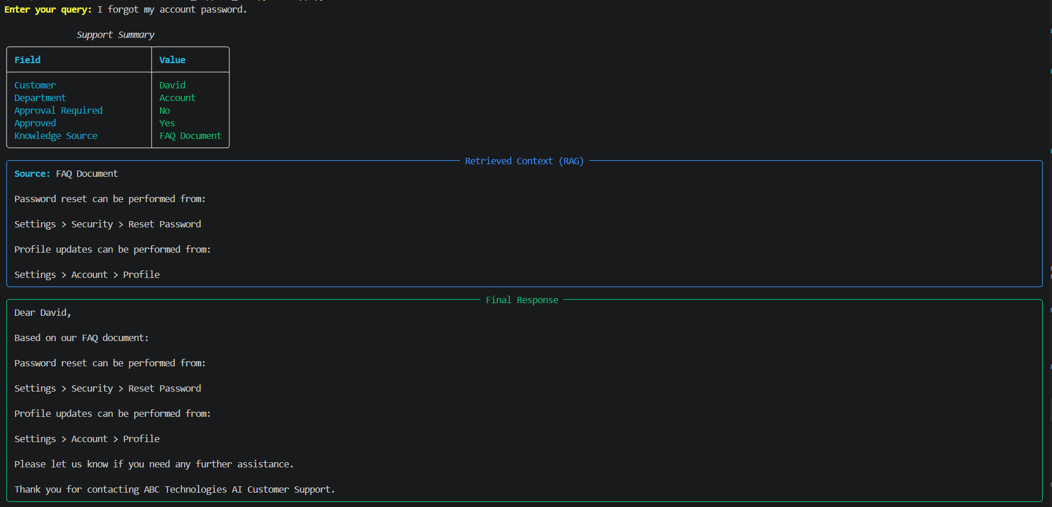

Query-3: My application crashes whenever I upload a file.
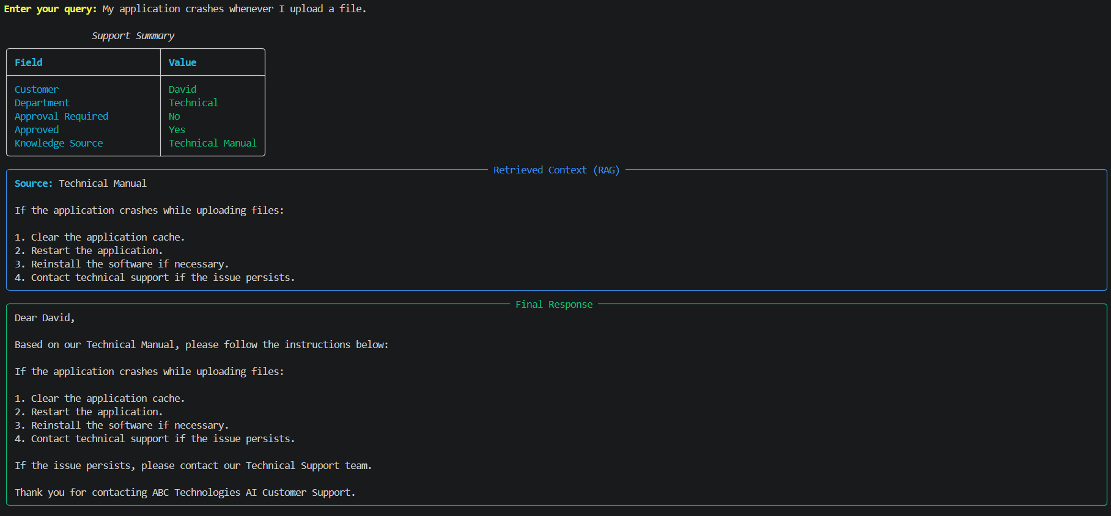
Query-4: I need a refund for my annual subscription.

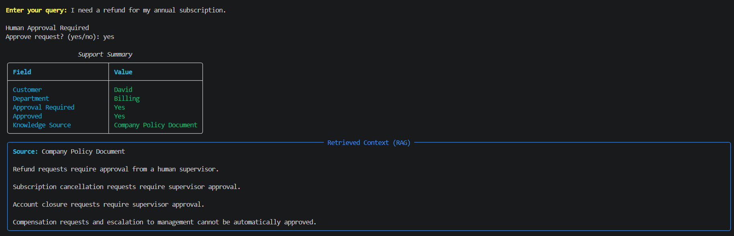
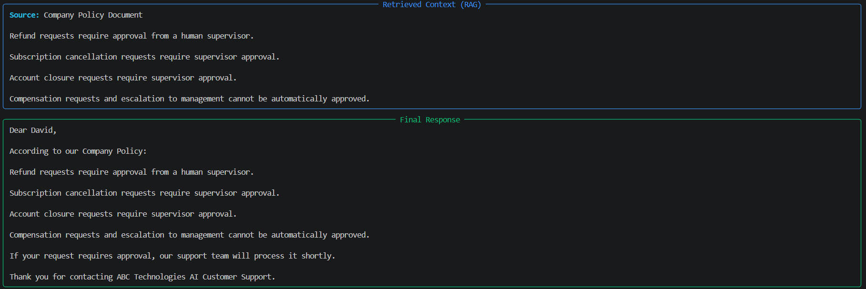

Query-5: What was my previous support issue?



  

