This is a web application project with Angular 11 for UI , back-end - spring boot and cloud SQL - DB.

Please make sure you have the latest version of Java and Nodejs installed on your system.Use the following links to download:

Nodej :- <https://nodejs.org/en/download/>

Java(for windows) - <https://www.java.com/en/download/>

## **Start UI:**

* In order to start the project in your local, Please clone the code from the repo.
* Note: Cloning the project will take some time because node modules are included.
* Once it is cloned, go to the respective folder where your cloned project is.
* Go to the **angular-11-client** folder.

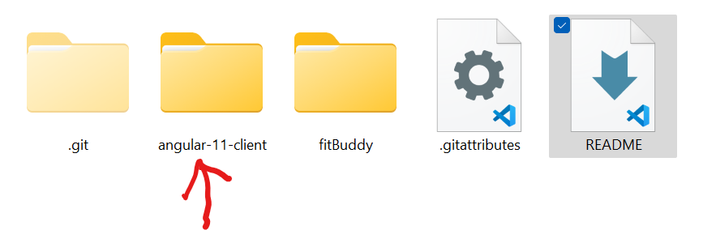

* Then open the command prompt inside the **angular-11-client**  and go **npm install-** just to be sure all the node modules are downloaded(I’ve already included all of them. This is just to be sure)
* Once it is done, do **ng serve** , to start the app.
* Then open localhost:[**http://localhost:4200/**](http://localhost:4200/)to see the UI app running.
* To see the code, make sure to open in any of them IDE that you have. I personally prefer visual studio code for this.

**Note: However, make sure you run the spring boot app before go to see the whole app up and running.**

## **Start Backend (Springboot app):**

* Now that you already have the cloned project, go to the fitBuddy folder.(This has the backend code)
* In order to run this, open, Spring Tool Suite or Eclipse. Please use this link to download STS - <https://spring.io/tools>
* Once you have it downloaded, open the app.
* Once you have the app opened, **click on File**.

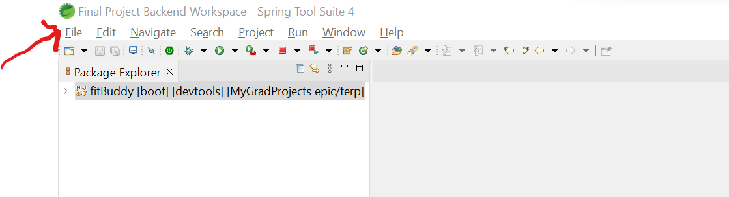

* Here click on **import**:

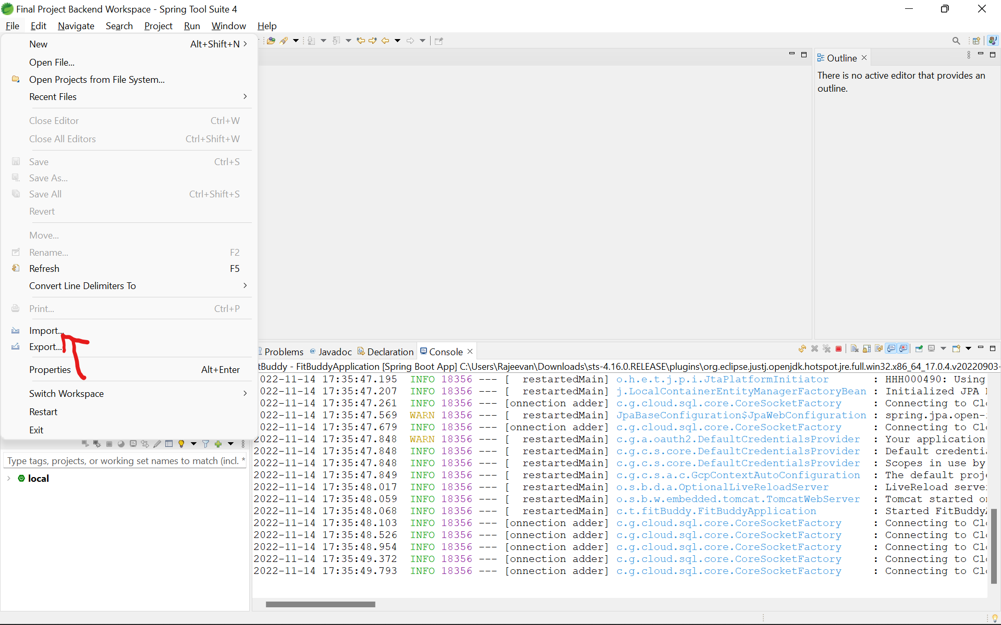

* A pop up like this will open and then click on **Maven> Existing Maven Project.**

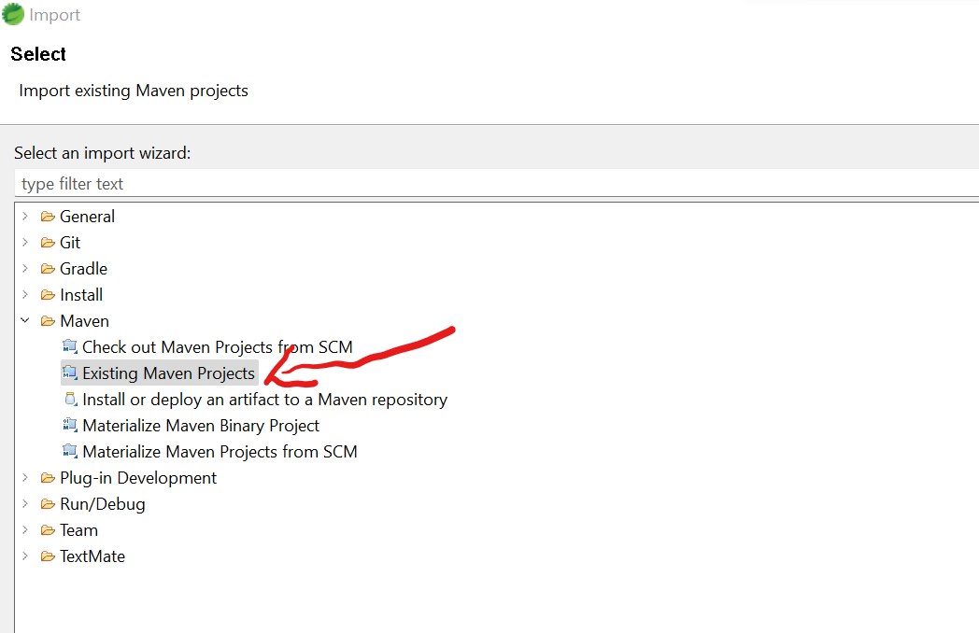

* Click **Next.**
* Click the Browse button and **open the fitBuddy folder from the cloned project**.
* You’ll see a **pom.xml** file here like this:

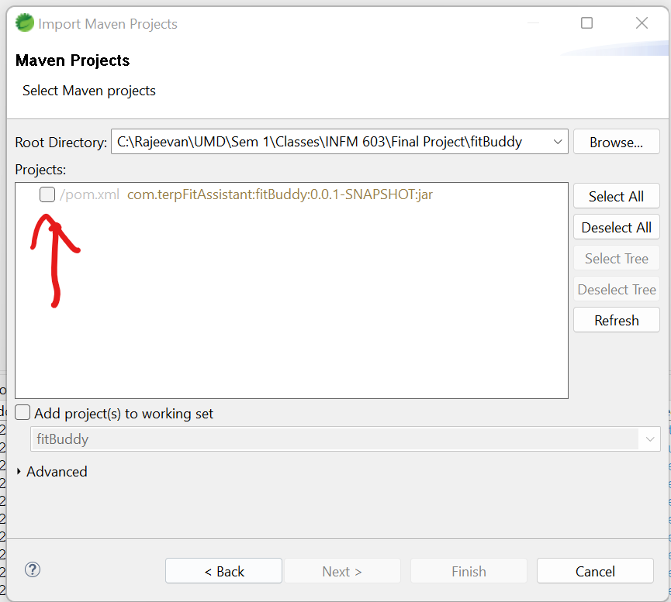

* **Select the box next to the pom.xml and click on finish**.
* In about 30 seconds, the project will be opened completely and you’ll see it in this format when you expand the project.

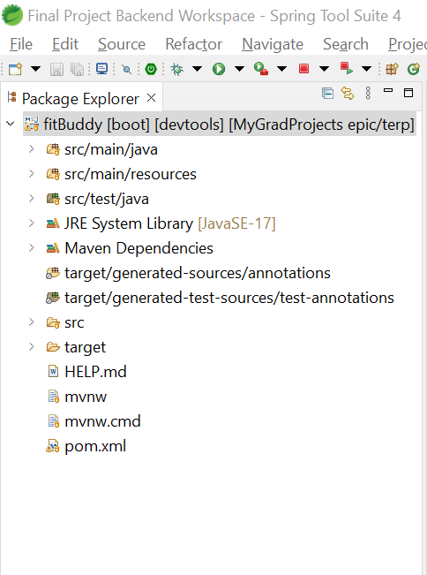

**Before doing the following set up, please follow these instructions.**

Download the 

File which I will be sharing with the assignment. This is a json file with the credentials and keys which we use to connect our spring boot app to google cloud. Then once you open the springboot app in your IDE, go to 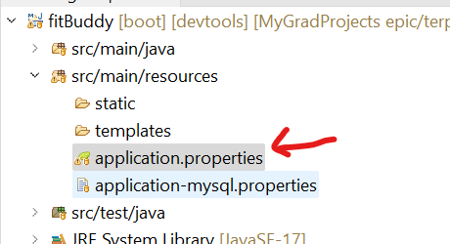

This **application.properties** file and open it. Then in **line 15, change the C:/Rajeevan/UMD/file**

**-name with your local location of the above downloaded file**.



**This will be moved to a secure bucket online and directly accessed while running from spring boot so that we don’t have to share the credentials to anyone in the next phase of the project.**

* Then right click on the fitBuddy ( whole project ) and you’ll see these options:

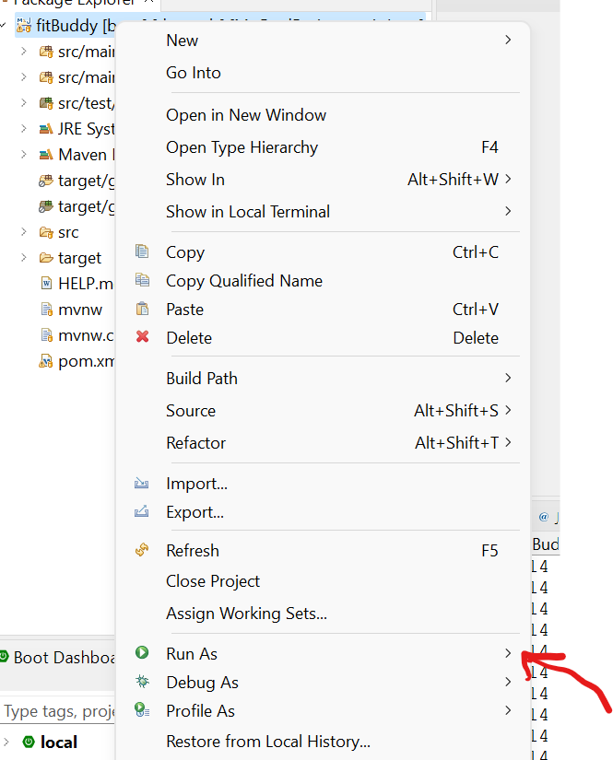

* Click on **Run as>** and it’ll open a list of new options:

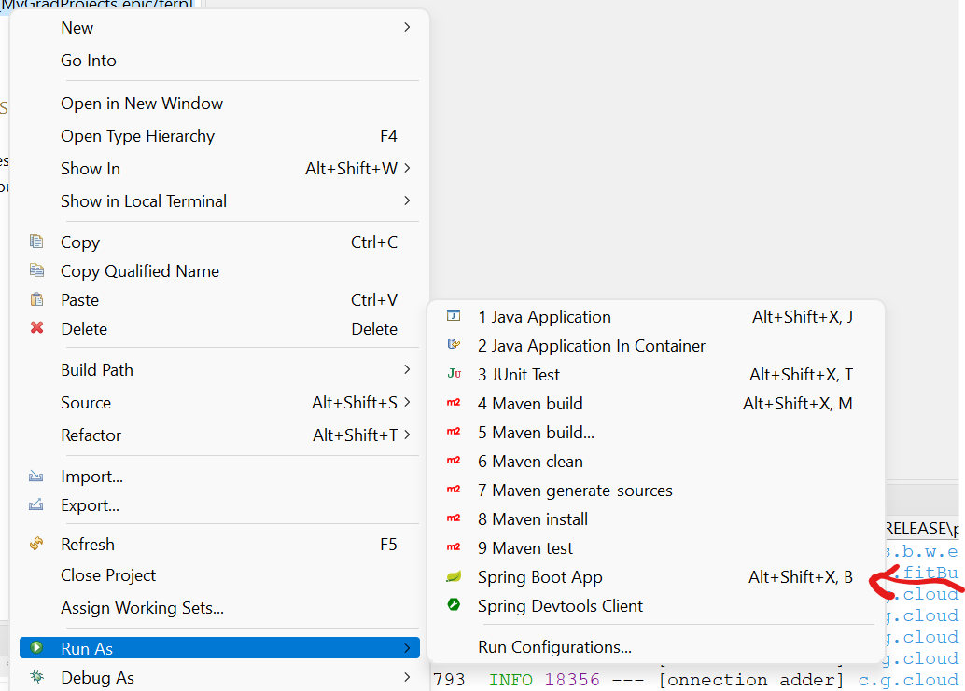

* Then click on **Spring Boot App.** This will start the application.
* And you’ll be able to see the app is running on port:8080 without any errors.

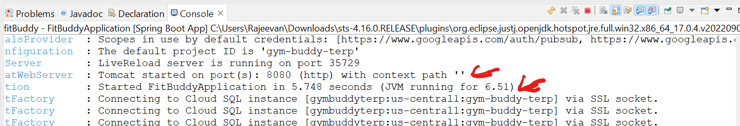

* **In case there are any errors while running**, Please go to a project Clean.(**Project > clean** )
* Then go back to Run As by right clicking the project and do Maven Install. **(Run As > Maven Install ).** (Note: This might give you error saying unit test cases failed. Since we have to start on unit testing cases from next week.)
* Then go ahead and try running the project again following the same instructions as before.

Now that you have UI and Backend up, you can open localhost:4200 and see the app running.

Since we need the DB running all the time, we created a project in Google cloud services so that it’ll be up and running instead of being in a local machine. And this integration is done between Back-end and Cloud SQL. So, thankfully, you don’t have to worry about bringing up the db in your local Machine.

Here is a screenshot of our app in google cloud services:-

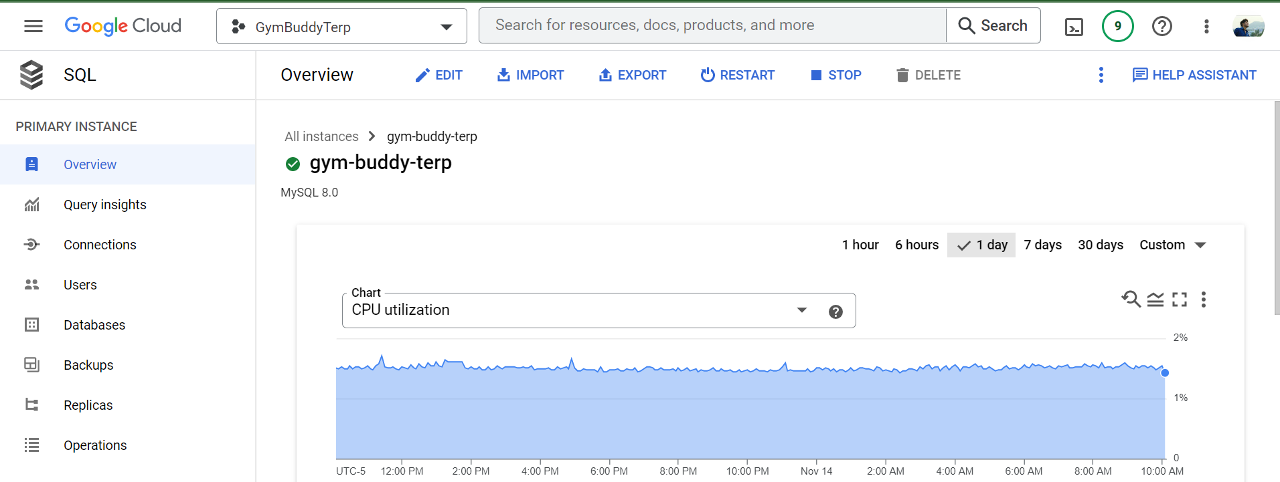

We had to learn a little bit about google cloud for this and a few other functionalities that we have in the app which was just pain! And trying to integrate all these services to our app was a nightmare. However, it was totally worth it. Got to learn a lot of new things to create the app and make it actually running. It was a lot of fun!