Election|Connection
Team Members: Michael Benimovich, Lakshman Boddoju, Nicolas Finkelstein, Michael Tobia
Studio: 65

Computer Prototype 2
Task
The task we decided to test for this prototype was to have participants use our site’s “Match me with a Candidate” page to find a candidate that matches closely with their own political views. We decided to test this task since matching users with candidates is one of the key functions we decided our site will implement. To use this functionality, starting from the home page, the participant would press the blue “Match me with a Candidate” button. This button leads to a page where the participant fills out their political stances in response to questions on the page. Once their answers are selected, the participant continues forward by pressing the “Match me with a Candidate” button at the bottom of the page. Once this button is pressed, a short loading screen shows to prime the user for viewing their match results. The loading screen automatically redirects the user to their results after two seconds. The results page shows four candidates along with the position they are running for, and their party affiliation. Along with candidate information, a match percentage for each candidate is displayed, showing how likely the participant would be to agree with each respective candidate. For the purposes of testing, these percentages are hard-coded in, and not based of the participants responses to the political stance questions. With this task, we are able to test a large amount of the functional portion of our site.

Component
We chose to implement the data collection form component for this stage of prototyping, as is essential that our users can input their political views to find a candidate that shares their views.

Link
https://lakshman.neocities.org/

Observations
As typical for testing, we began by debriefing the participants on the purpose of the test and roughly what they would be doing. The test then began by handing a note card indicating their task of using the “Match me” function of the site to find a candidate that shares their political views. The following images show the four pages involved in this task.

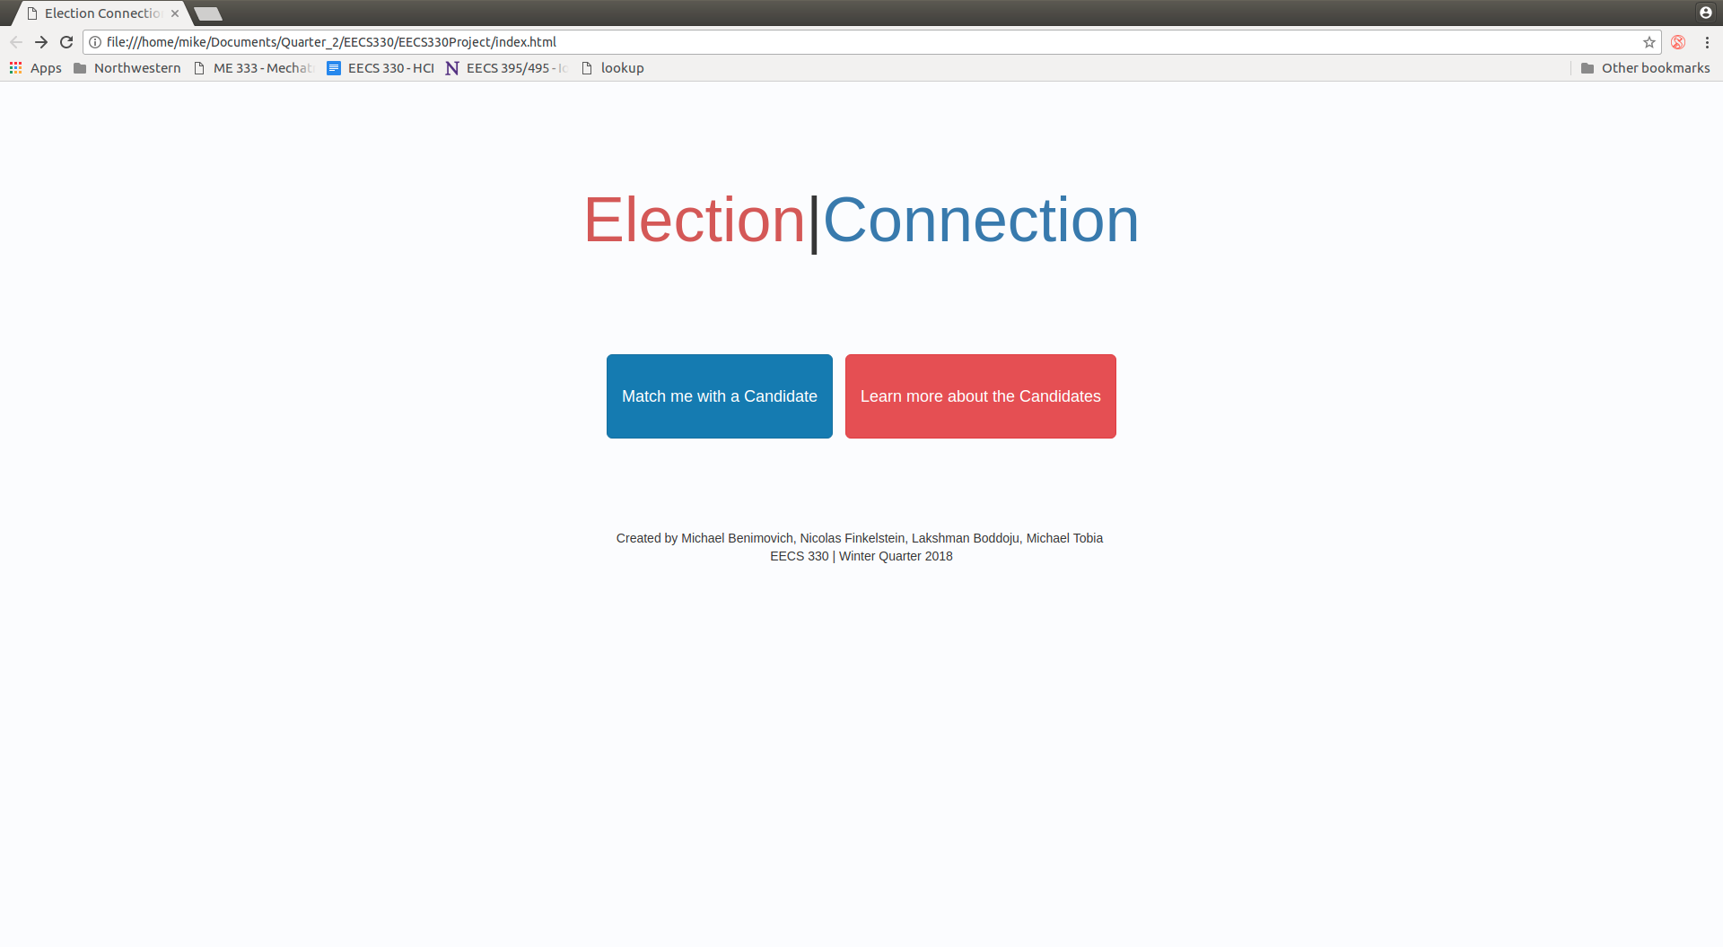

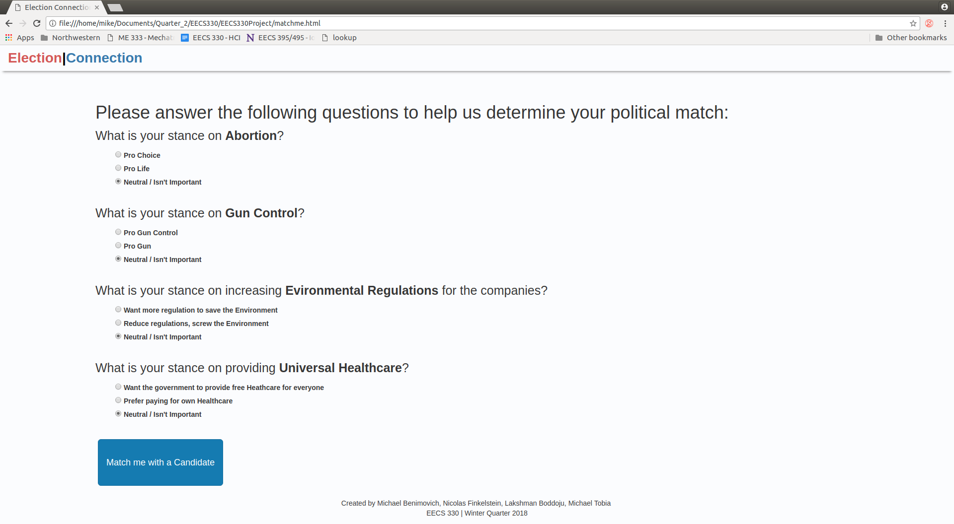

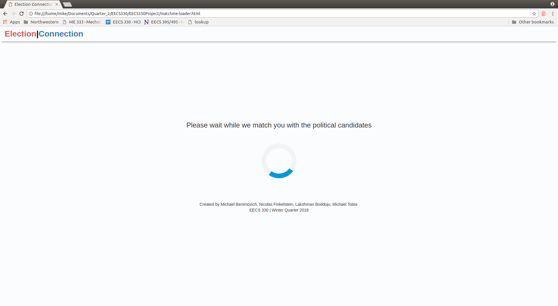

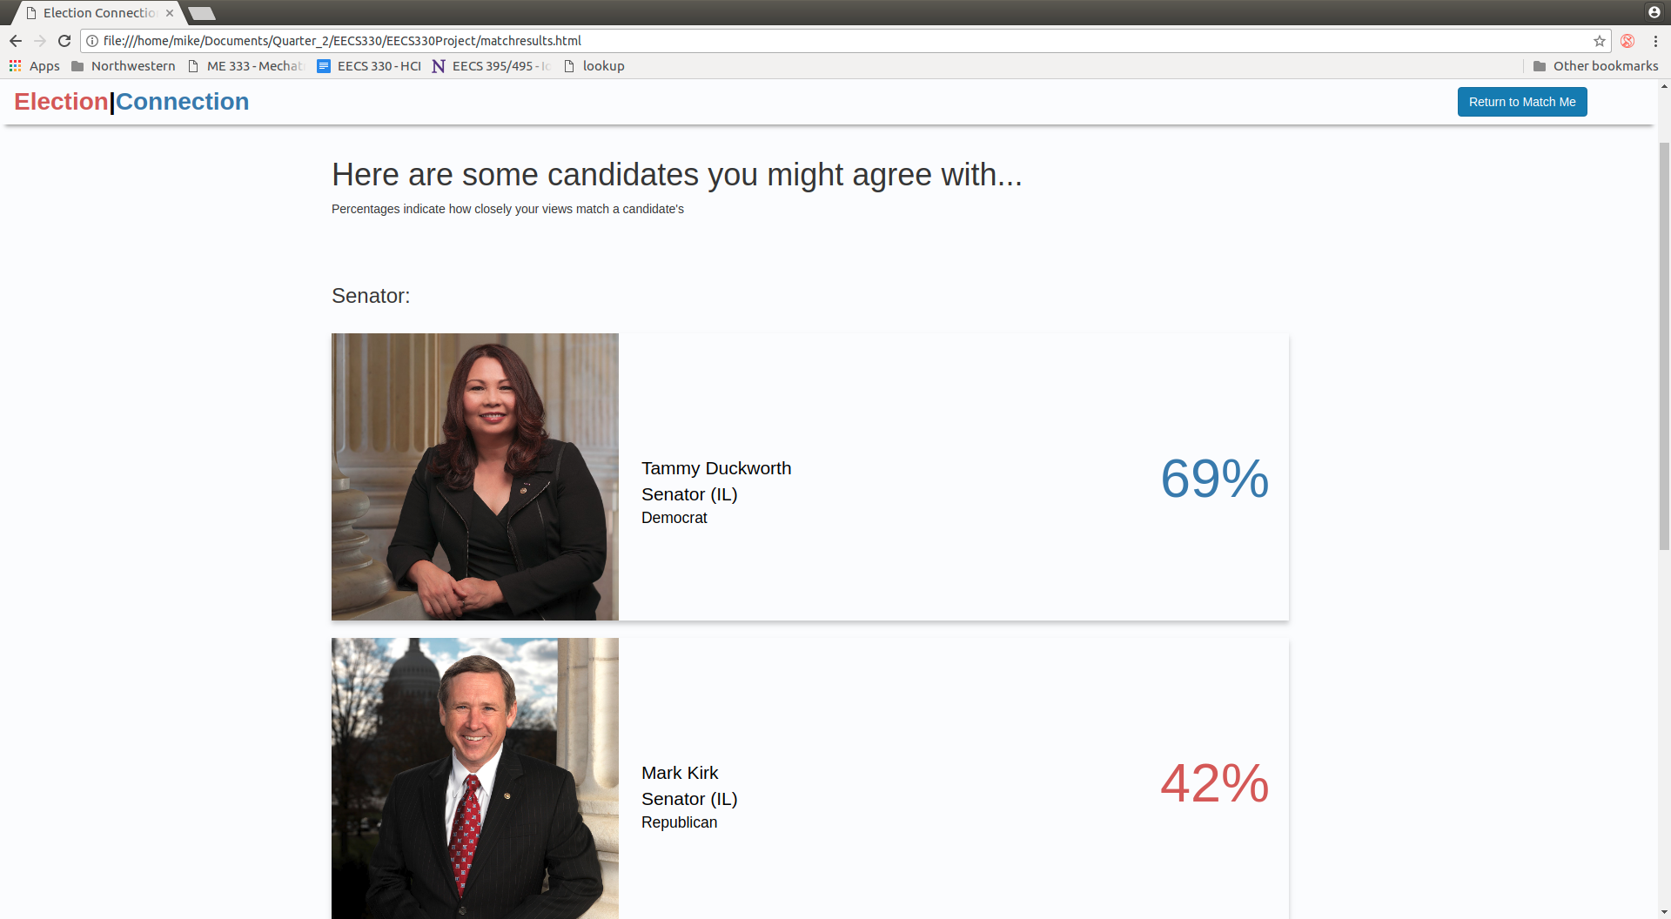

Observations (cont.)
Upon beginning the test, some participants clicked on the “Learn more about the Candidates” button instead of the “Match me with a Candidate” button. This was an issue with the paper prototype and its interesting that it remains an issue in the web prototype. Regardless, going this route is still an option for the task at hand. Once on the “learn more about candidates page” participants remarked that the “desktop” icon for the link to the candidates homepage was confusing. Upon following this link, the participant could learn more about the candidate of their choosing.
The participants that did use the “Match me with a Candidate” button on the homepage had no issue filling out the question page and continuing on to their results. Once on the results page, some participants remarked that the gradient used on each result card was confusing, referring to both the colors and the style itself. Participants also were confused about the ordering of candidates on the result page.
Another minor point to note; many participants disliked the colors of the logo, stating that they were too bright and clashed with the rest of the site, which uses less saturated colors.

Resolutions
Participant issues with the site were very straight forward for this round of testing, and most could be immediately fixed. On the “Learn More about Candidates” page, “desktop” icons that lead to each candidates page were changed to globe icons, which seem to cause much less issues. On the match results page, gradients were removed entirely. These gradients were replaced by coloring the result percentages with colors corresponding to each candidates respective party affiliation. On the same subject, colors on the logo were changed to slightly reduce brightness. To be consistent, the colors on the rest of the site features were changed to correspond to the logo.
To respond to the confusing order of the results page, headers for “senator” and “local representative” were added to clarify that the ordering was by the position the candidate was running for.
As for future improvements, since participants still used the “Learn more about candidates” button when presented with this matching task, effort will be placed into making the distinction between the “Learn more about candidates” button and the “match me with a candidate button” more clear.

