
Lab Module 1.0:
Prerequisites
WorkshopPLUS – Power Platform: Power Apps for Power User

Published: May 2022

Table of contents

Exercise 1: Connect to your M365 tenant 2
Task 1: Access to Labs on Demand / Skillable 3
Task 2: Connect to your hands-on labs Microsoft 365 tenant 6
Exercise 2: Set up prerequisites 8
Task 1: Create a database in the default environment 9
Task 2: Create a new SharePoint site and lists 11
Task 3: Approvals provisioning 14

Exercise 1:
Connect to your Microsoft 365 tenant
 | Important
If you are experiencing problems with access, or you cannot find any of the resources and components described in this exercise – please, notify your instructor as soon as possible.

Objectives:
- Access to Labs on Demand / Skillable
- Retrieve and use your Microsoft 365 credentials to access your hands-on labs

Estimated time:
15 minutes

Task 1: Access to Labs on Demand / Skillable
Important – Use Incognito/InPrivate mode
All the labs in this course require you to use the latest version of Edge or Chrome in Incognito/InPrivate mode.
It’s needed to avoid interference with your corporate account session.
If you are experiencing any problems with starting up a browser in Incognito/InPrivate mode – please, notify your instructor as soon as possible.

- Open preferred browser in Incognito/InPrivate mode and navigate to:
https://aka.ms/lod
- Click Sign In button
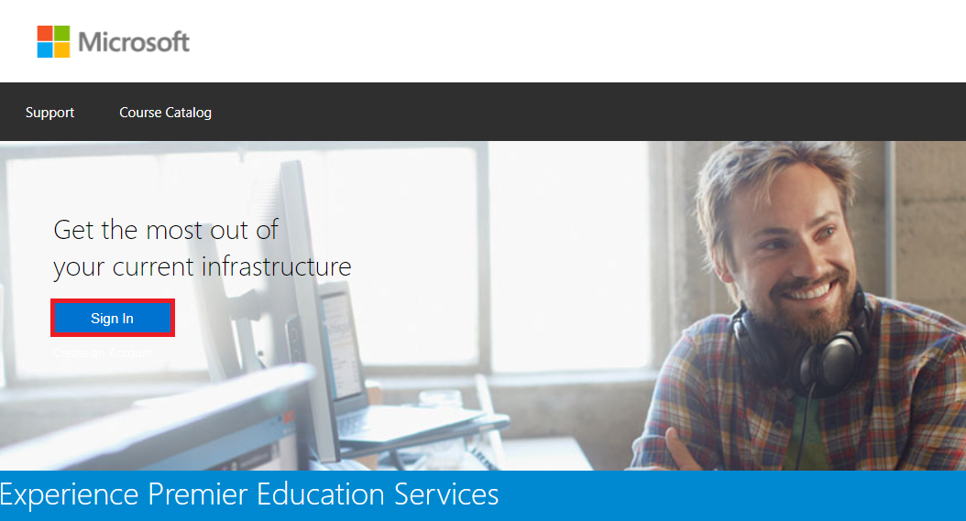
- Choose Microsoft Account option
Organization policies may not allow to use your Corporate Account, that’s why we recommend using Microsoft Account to connect to Labs on Demand / Skillable.
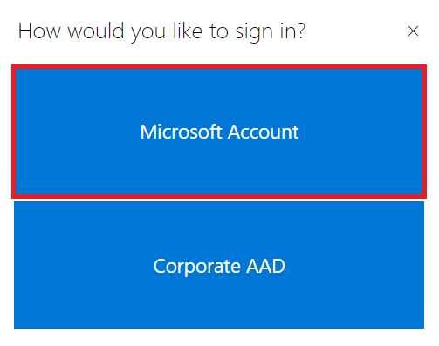
- Sign in using your personal Microsoft Account
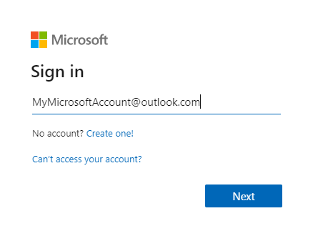
- After you logged in, go to WorkshopPlus -> My Training
Click Redeem Training Key and provide the training key provided by the Instructor
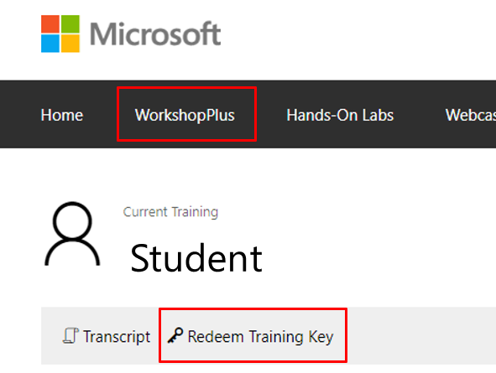
- Find activity Lab machine and click Launch
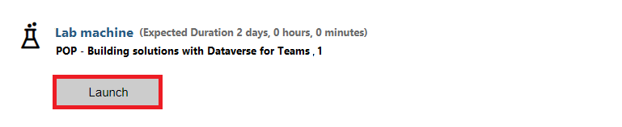
- New window should open, give it some time to load lab contents:
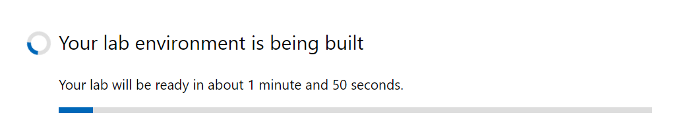
- When the lab is loaded, navigate to Resources tab
Important – Office 365 Credentials
Office 365 credentials displayed in Resources tab will be used in ALL lab exercises.
Please, copy them locally and use them to login to Microsoft 365 tenant in the next and all following tasks.
When you see M365xXXXXXX URLs and Usernames in your lab docs, please, replace it with TenantPrefix of your lab tenant.
For example: admin@M365xXXXXXX.onmicrosoft.com should be replaced with the actual username provided in the Resources tab.

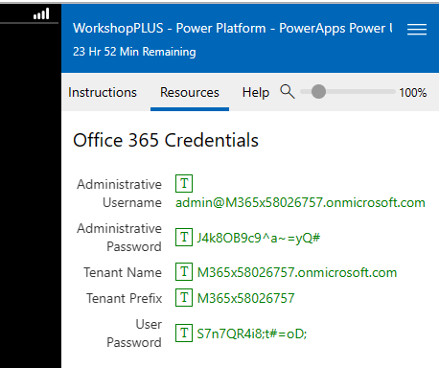

Task 2: Connect to your hands-on labs Microsoft 365 tenant

- Please, have your Username and Password information (found in LoD lab resources tab) ready – it will be used across all the hands-on labs in this course.
- Open preferred browser in Incognito/InPrivate mode and navigate to:
https://office.com
- Click Sign in button and provide your Username and Password:
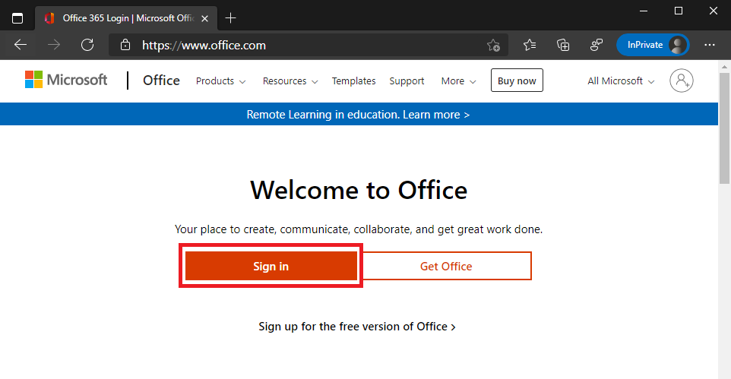
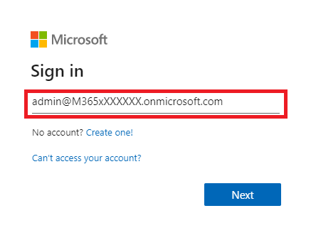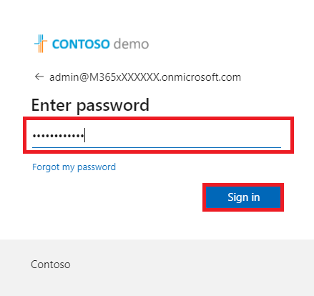
- In Stay signed in? dialog, check Don’t show this again and click Yes
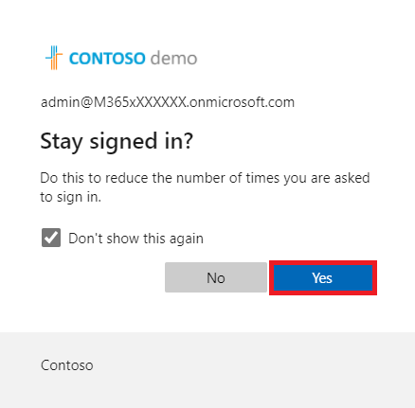
- Now you are signed into your hands-on labs Microsoft 365 tenant. Use this session in all other labs.
Important
If you accidentally logged out, please, return to this lab and repeat these steps to log in once again.
Always remember to replace M365xXXXXXX with your actual lab tenant prefix.

Exercise 2:
Set up prerequisites

Objectives:
- Create a database in the default environment
- Create a new SharePoint site and lists
- Provision Approvals to the environment

Estimated time:
15 minutes

Task 1: Create a database in the default environment

- In InPrivate/Incognito browser mode, while logged in into your M365xXXXXXX lab tenant, navigate to Power Platform Admin Center https://aka.ms/ppac
- In the left navigation menu select Environments

- Find the default environment <tenantname> (default), e.g., Contoso (default) and click it
- We will need a database in this environment to use features like Approvals and AI Builder in the further labs.
Click +Add database to add a database to the environment.
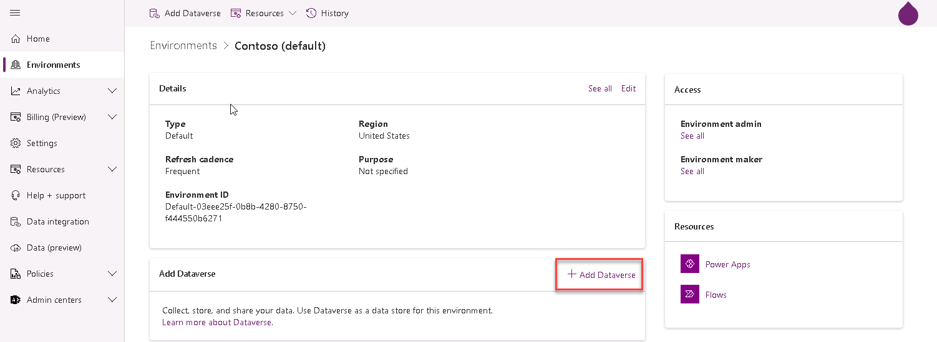
- Select your Language and Currency and click Add.
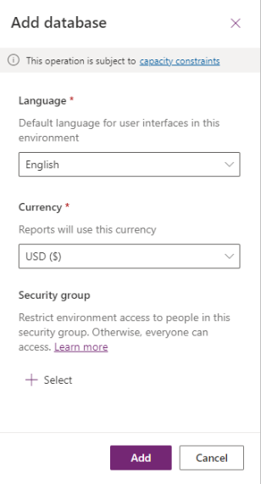
- This may take a few minutes to complete. Wait for it to complete before moving to the next task.
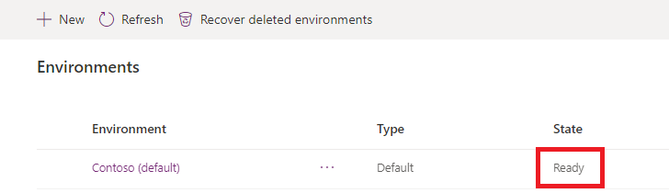

Task 2: Create a new SharePoint site and lists

- In InPrivate/Incognito browser mode, while logged in into your M365xXXXXXX lab tenant, navigate to Office 365 homepage https://office.com
- In the search bar start typing “SharePoint” and then select proposed app
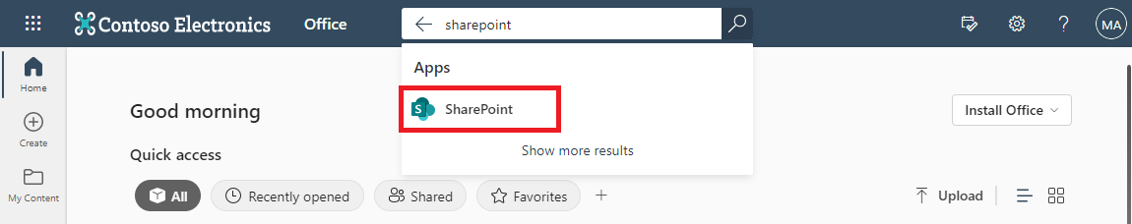
- In the SharePoint home page, select +Create Site, and create Team Site.
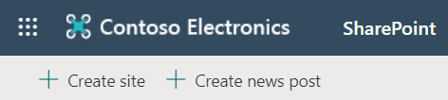
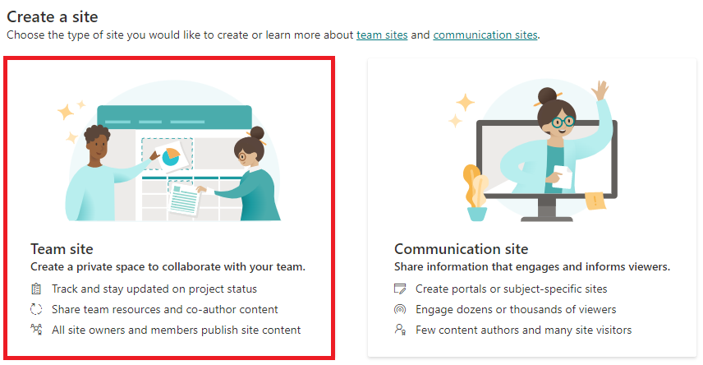

- Input “Power Apps” as the site name and click Next, then click Finish and you will be redirected to the site you just created.
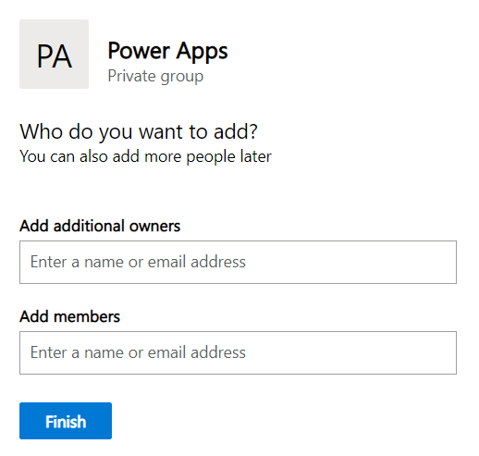
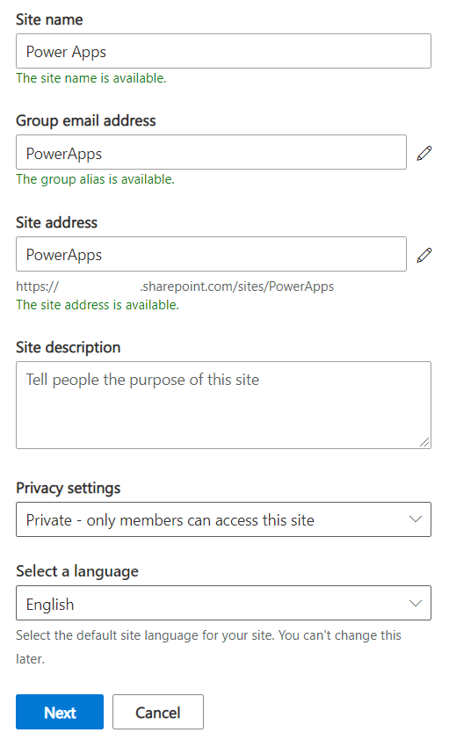

- Go to the SharePoint site you created in the previous step and select + New > List. Under “Create a list”, select Blank list.
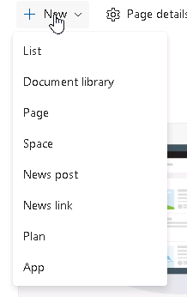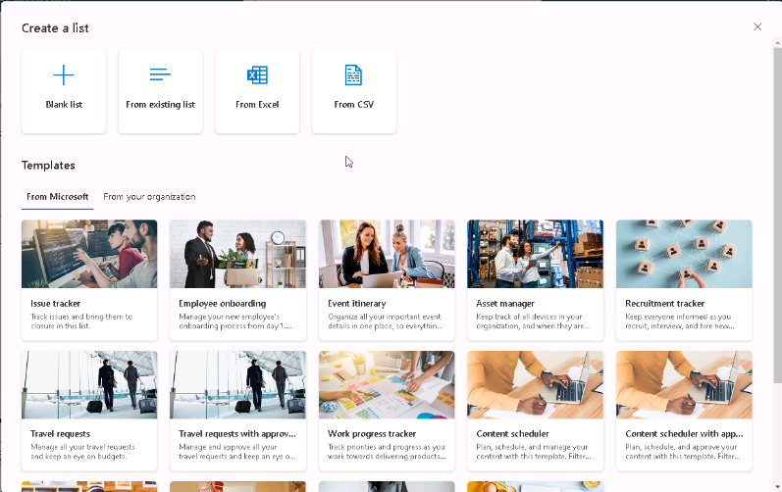
- Name the list as “Order Data” and select Create.
- Add the following columns to the list:
- Price (number)
- OrderStatus (single line of text)
- Comments (single line of text)
Title column exists out-of-box and will be used later DO NOT rename it.
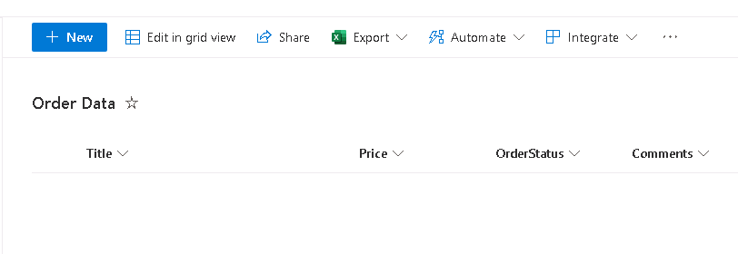
- Go to the SharePoint site that you have created and select + New > List. Under “Create a list”, select Blank list.
- Name the list as “New Device Requests” and select Create.
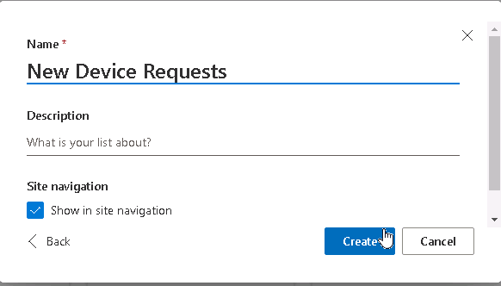
- Add columns to the newly created list.
- Price (number)
- Processor (single line of text)
- Memory (single line of text)
- Storage (single line of text)
- Screen Size (single line of text)
After adding all columns, New Device Requests should look as shown below:
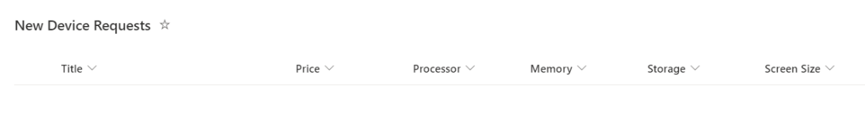

Task 3: Approvals provisioning
Why do Approvals need provisioning?
Approvals is a built-in application that uses database to store its data model.
You may be familiar with this application, if you have ever created any flows and apps, that use Approvals connector.
By default, all the data tables related to Approvals are not provisioned in the environment.
Provisioning happens on-demand when any user creates an approval for the first time in that environment.
It may take some time, that’s why we will start it right in the first lab.
More info: Power Automate Approvals Provisioning Overview and Troubleshooting (microsoft.com)

- In InPrivate/Incognito browser mode, while logged in into your M365xXXXXXX lab tenant, navigate to Power Automate https://make.powerautomate.com/
**Please note you may need to click “Sign in” in the top right corner of the page
- In the left navigation select Create, then click Instant cloud flow option
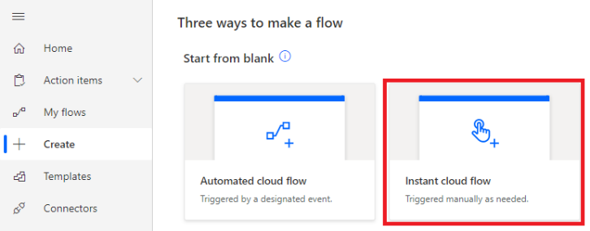
- Set Flow name as ProvisioningFlow
Select Manually trigger a flow trigger
Click Create button (example on screenshot below)
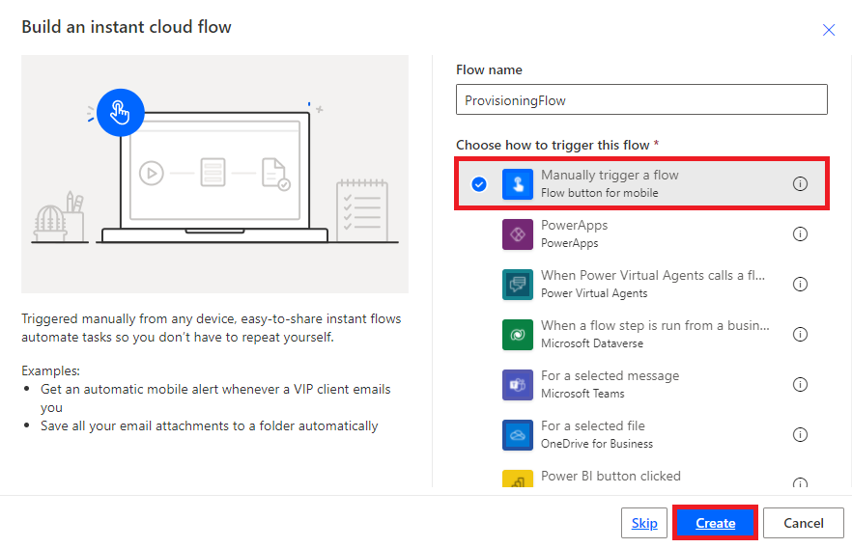
- Click +New step button
Select Create an approval action in Approvals connector by clicking on it
(use Search, if this connector or action is not present)
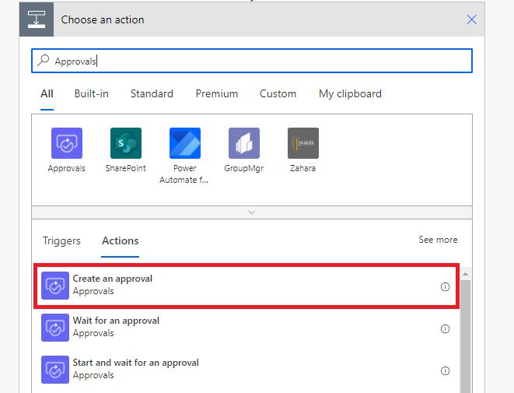
- Set properties for Create an approval:
Approval type: Approve/Reject – First to respond
Title: ProvisioningFlow
Assigned to: admin@m365xXXXXXX.onmicrosoft.com
(replace m365xXXXXXX with your actual Tenant Prefix)
Details: any text
See an example on screenshot below.
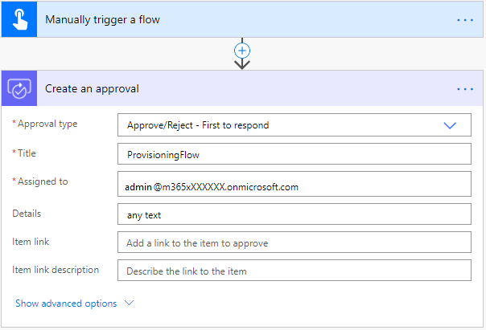
- Save a flow
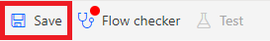
Notice that Flow checker has a warning, if you click on it, you should see the following:
Power Automate Approvals has not been installed for this environment. Run this approval flow to initiate provisioning.
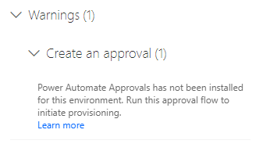
This is the exact reason of why we are creating this ProvisioningFlow.
- After the flow is saved, click Test button
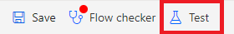
- Select Manually option and click Save & Test button to start a test flow run.
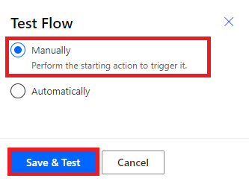
- Flow checker may show the warning once again. If it happens, just close it.
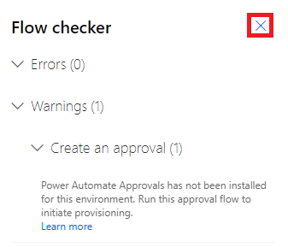
- Confirm sign in details for a flow test by clicking Continue button:
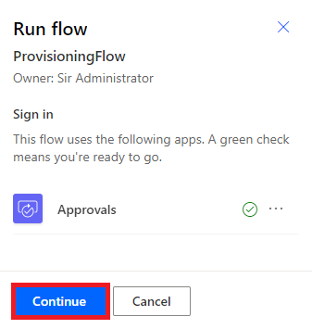
- Click Run flow button to finally run the flow.
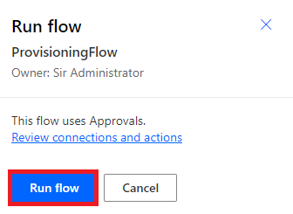
Check that the flow is running, but don’t wait for it now.
This flow will fail, but it will start Approvals provisioning process, that may take some time.
Task is completed.

