Lab Module 1.1:
Starting with connectors, screens, and controls
WorkshopPLUS – Power Platform: Power Apps for Power User

Published: May 2022

Table of contents
Lab overview 1
Introduction 1
Objectives 1
Prerequisites 1
Estimated time to complete this lab 1
Scenario 1
Exercise 1: Creating the app 2
Task 1: Sign into Power Apps 2
Task 2: Create a new app 3
Task 3: Rename the screen 4
Task 4: Save the application 5
Exercise 2: Building the app header 7
Task 1: Add a header containing the app name and logged in user’s name 7

Lab overview

Introduction

In this lab, you will start to design Power Apps by renaming the screen and adding headers.

Objectives
After completing this lab, you will be able to:
• Rename screens in Power Apps
• Add and manipulate the label control in Power Apps

Prerequisites

Ensure you are using the “Incognito” or “InPrivate” browsing session of your modern browser.
Additionally, use the latest version of Microsoft Edge for the best performance.

Estimated time to complete this lab
15 mins

Scenario
The organization wishes to build apps using Microsoft Power Platform to take advantage of No Code/Low Code application development in the cloud. As part of this effort, you are required to use Power Apps and manipulate different screens and controls.

Exercise 1: Creating the app
 | Important
Do not start this exercise unless Prerequisites are complete.
If you are experiencing problems with progressing through these labs – please, ask your instructor for help.

Task 1: Sign into Power Apps

In this task, you will sign into Power Apps

- Navigate to https://make.powerapps.com and sign in with your business or school account if you have not already done so
- Before creating an app, switch to the correct environment (where your organization permits development apps to be created).
Click the Environments drop-down in the top right of the screen to switch to the correct environment.
Ask instructor if you have doubts.
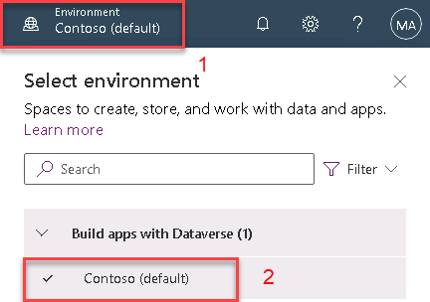

Task 2: Create a new app

- In the Create screen, click ‘Blank app’
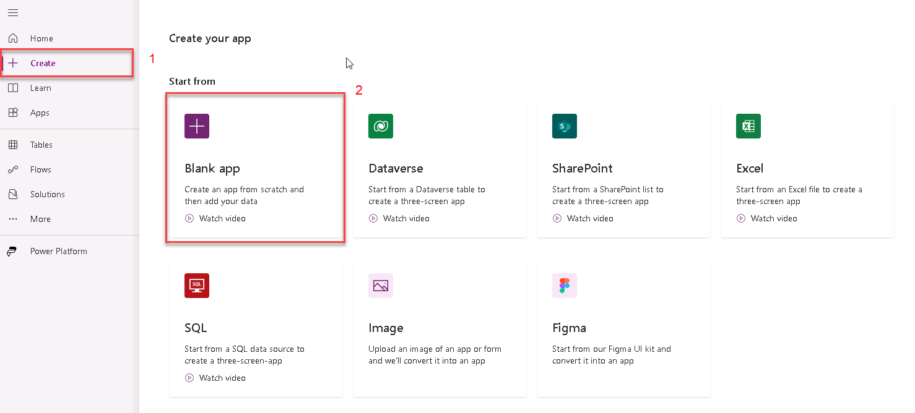
- In the next dialog under ‘Blank canvas app’ option click ‘Create’

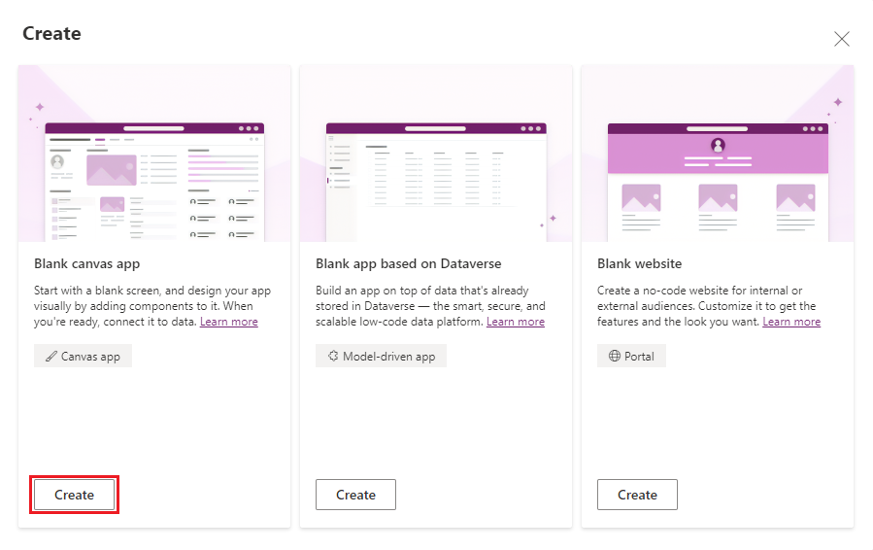

- Input ‘Device Orders’ in the App name field. Select ‘Tablet’ for Format. Click ‘Create’

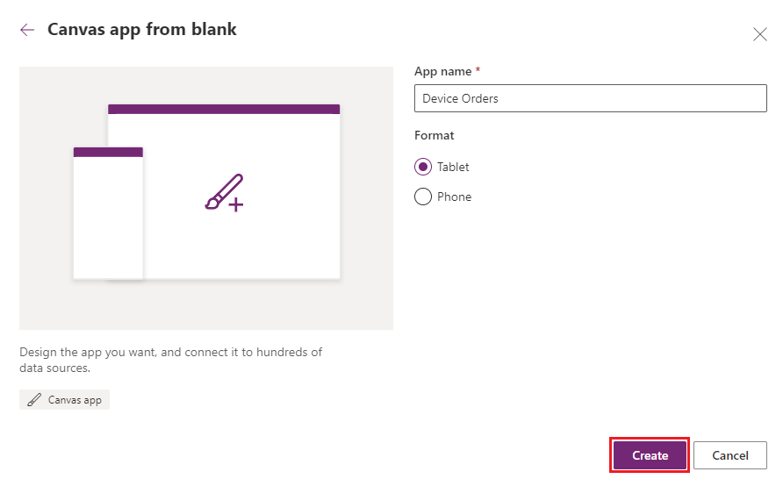
- Click ‘Skip’ if you receive the Welcome to PowerApps Studio prompt
- If prompted, select your region, then click ‘Get Started’

Task 3: Rename the screen
 | Canvas Apps Coding Standards and Guidelines
It is a good practice to rename screens and controls as you create them so that they are easier to locate as you work with formulas that reference different controls. In this lab, we will rely on the best practices and naming conventions defined in Canvas apps coding standards and guidelines.
Full document link: https://aka.ms/powerappscanvasguidelines

- Make sure you have selected Tree View in the App authoring pane
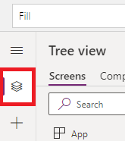
- Select the screen by clicking on Screen1 in Tree View
- Click “…” next to Screen1 (or right click) and select the Rename option

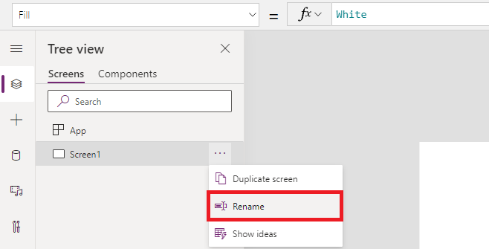

- Change the name to ‘Main Screen’

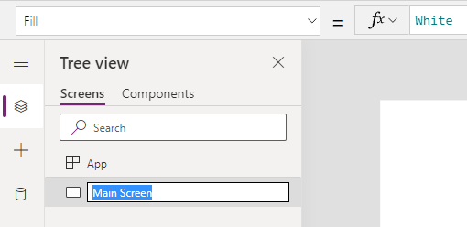

Task 4: Save the application

In this task, you will save an initial version of the app. Power Apps saves automatically each 2 minutes after the first save (Tip: This setting can be disabled).

- First, check if there are any errors in the app. Click on the ‘App checker’ icon
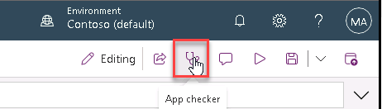
- App checker pane will become visible. If there are any errors, they will be displayed here
- Close the App checker pane
- Click the Settings Gear Icon down in the Tree View

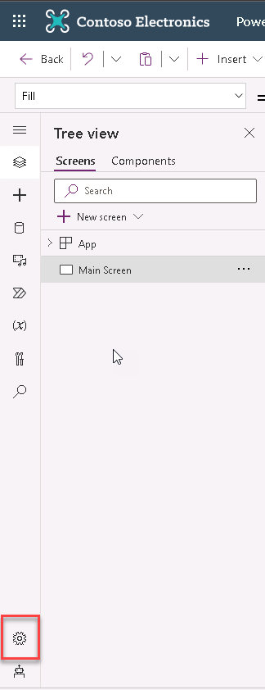
- In the Settings – General dialog, you can:
  - Change your App name
  - Customize the App icon (choose a background color and icon)
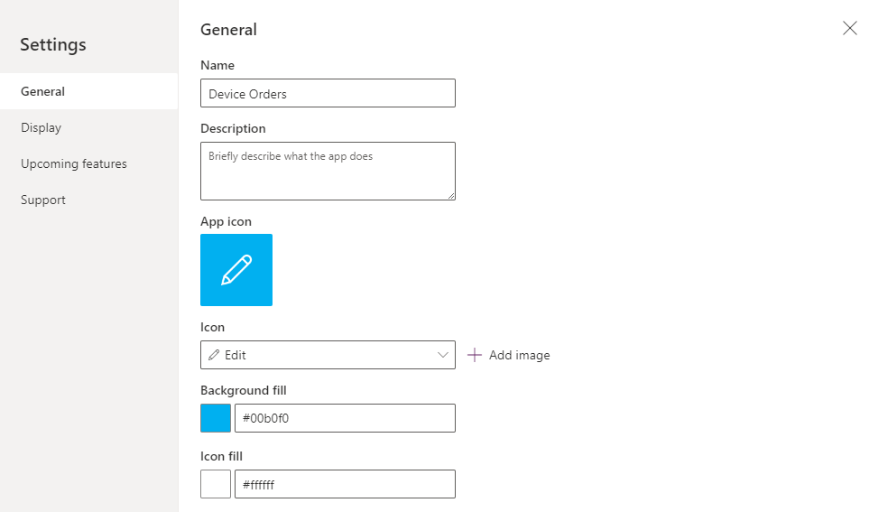
- Select Display tab to view available screen size and orientation and aspect ratio settings. For this app, we will leave it at the default setting of Landscape with 16:9 aspect ratio
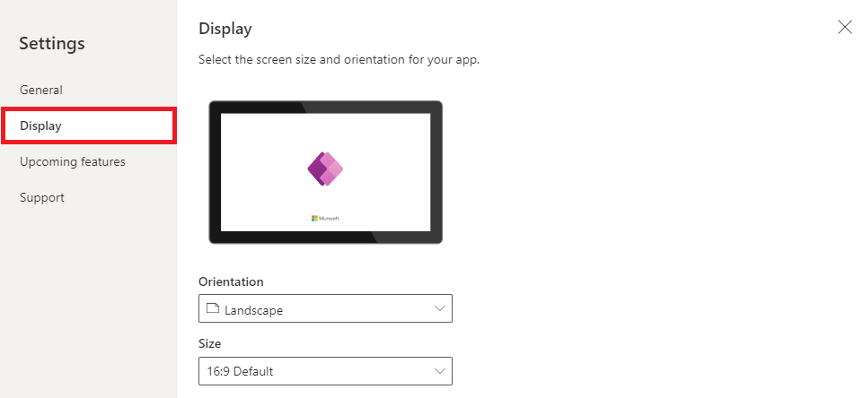
- Click ‘X’ in the top-right corner to close the dialog
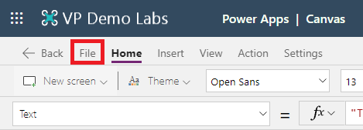
- Click Save button in the ribbon and select Save in the left menu. Click the Save button
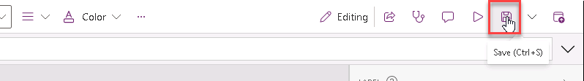
Tip: In PowerApps, when you save a version of your app, the first version is published by default and available to everyone that you share the app with. Subsequent saves are only visible to the app maker in the studio. You must explicitly publish it for all app users to get the update.
For more info: https://docs.microsoft.com/en-us/powerapps/maker/canvas-apps/share-app

Exercise 2: Building the app header
In this exercise you will learn how to add a header to the app and display the logged in user’s name.

Task 1: Add a header containing the app name and logged in user’s name

In this task, you will add a header to the Main Screen that displays the app name and the logged in user’s name

- Select the ‘Insert’ tab in the ribbon and select ‘Label’
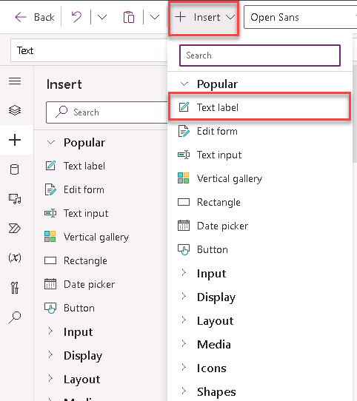
- Rename the label from Label1 to lblHeader
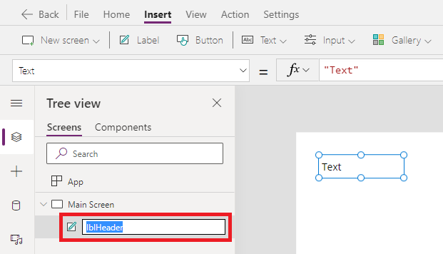
- Select Text from the property drop-down list and enter “Device Orders” in the formula bar. You can also type directly into the label by double-clicking it
Text
"Device Orders"

- Resize the label width by setting the Width property as Parent.Width
Width
Parent.Width
- Resize the label width by setting the Height property as 80
Height
80
- Select the Home tab
- In Align menu, select Align center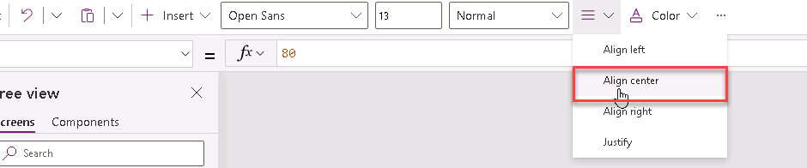
- Change the font Color to White
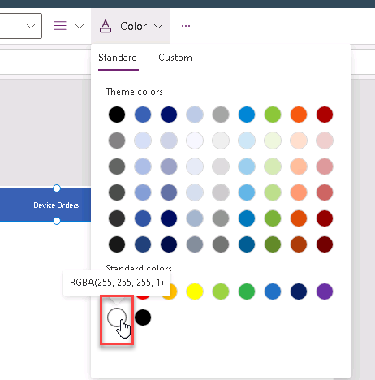
- Change the Background color to Blue
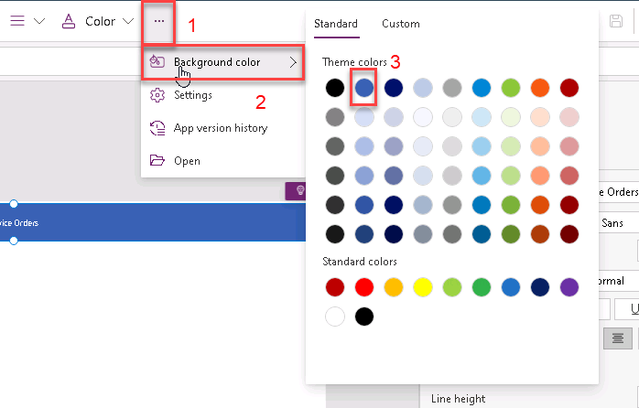
- Change the Font Size to 24
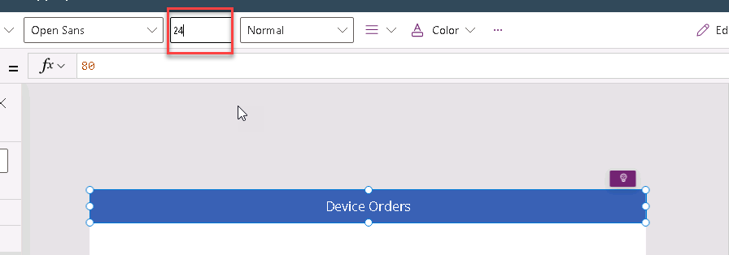

- From the Insert tab, select one more Label
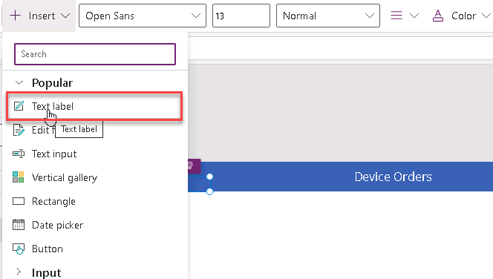
- Drag the label to the far-right side of the screen and center the label vertically to be in line with the header text.
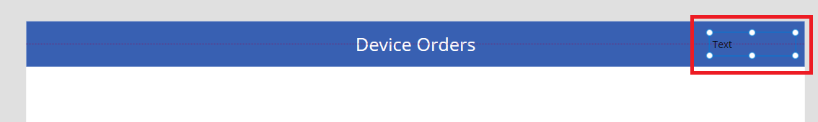
- Rename the label to lblUserName
- For lblUserName label, select the Text property and change the value to
Text
"Hello, " & User().FullName

Tip: All functions in Power Apps are case-sensitive. As you start typing ‘User’ you will see a drop-down of available choices. It is a good idea to pick from the auto-complete options. You will also notice help text at the top showing the parameters that are expected, in this case it requires no input parameters.

- Set the text alignment of the label text to Right in the Home tab on the ribbon
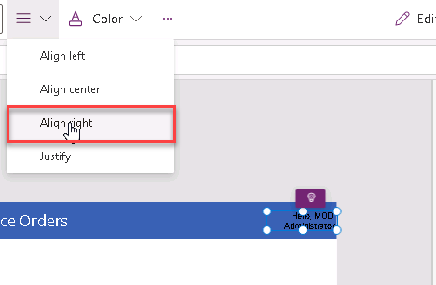
- Change the Color to White
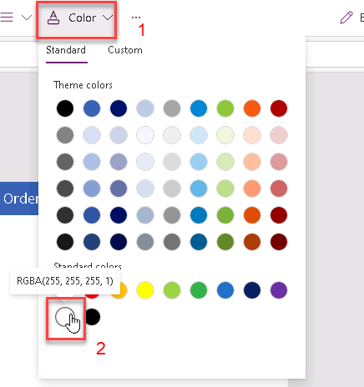
- If necessary, widen the label so that the text doesn’t wrap
- Change the PaddingRight property from 5 to 20. You can do this quickly by using the Properties pane on the right-hand side.
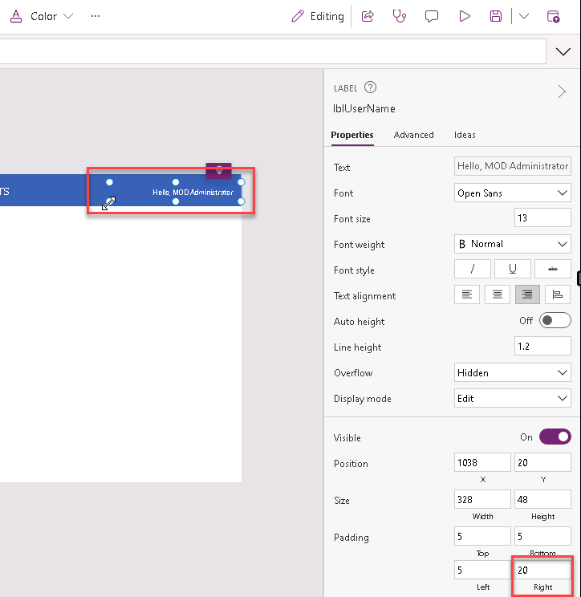
- Your app header may look like this. The task is complete.
