Lab Module 2.0:
Building with controls, fields, and formulas
WorkshopPLUS – Power Platform: Power Apps for Power User

Published: May 2022

Table of contents
Lab overview 1
Introduction 1
Objectives 1
Prerequisites 1
Estimated time to complete this lab 1
Scenario 1
Exercise 1: Connect the app to data 2
Task 1: Import static data from Excel 2
Task 2: Create a connection to SharePoint 5
Exercise 2: Add a device gallery to the Main Screen 8
Task 1: Add a device gallery 9
Task 2: Arrange the device gallery 11
Task 3: Add a gallery to show manufacturers 12
Task 4: Display the manufacturer logo 16
Task 5: Highlight the selected item in the gallery 18
Task 6: Filter the devices based on the selected manufacturer 19
Task 7: Configure text labels in the device gallery 21
Task 8: Conditional formatting to highlight devices above $1,000 23
Task 9: Add a checkbox to add a device to Compare list 24
Task 10: Create a collection for the selected devices 26
Task 11: Set the default selection to the first manufacturer 30

Lab overview

Introduction
In this lab, you will perform the actions necessary for building Power Apps by adding controls, fields, and formulas.

Objectives
After completing this lab, you will be able to:
- Add device gallery and connect to data source
- Arrange the device gallery
- Add gallery to show manufacturers
- Connect galManufacturers gallery to manufacturer's table
- Highlight the selected item in the gallery
- Filter the devices based on the selected manufacturer
- Configure text labels in the device gallery
- Apply conditional formation to highlight devices above $1,000
- Add a checkbox to add a device to the Compare list
- Create a collection for the selected devices
- Set the default selection to the first manufacturer and test the app.

Prerequisites
Ensure you are using the “Incognito” or “InPrivate” browsing session of your modern browser.
Additionally, use the latest version of Microsoft Edge for the best performance.

Estimated time to complete this lab
45 mins

Scenario
The organization wishes to build app using Power Apps to take advantage of No Code/Low Code application development in the cloud. As part of this effort, you are required to add controls and create formulas to add functionality to your canvas app.

Exercise 1: Connect the app to data

In this exercise you will learn how to connect the app to the various data sources required for the app to both display devices and track device orders.

Tip: What is a data connection? In Power Apps, a data connection adds data to your app. Your canvas app can connect to SharePoint, Dataverse / Dataverse for Teams, SQL Server, Office 365 and over 650 first- and third-party services.

Task 1: Import static data from Excel

In this task you will learn how to create a connection to the Excel spreadsheet containing device data for the solution.

- In the app authoring pane, click the Data icon
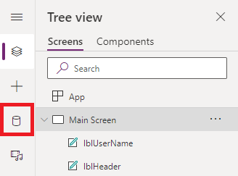
- Click +Add data dropdown, in popup menu type Excel into the search box
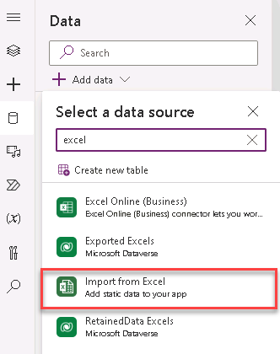
- Click Import from Excel
- The Open dialog will appear, browse to the location where the spreadsheet ‘device-order-data.xlsx’ is saved (this would be one of the lab files provided by your instructor)

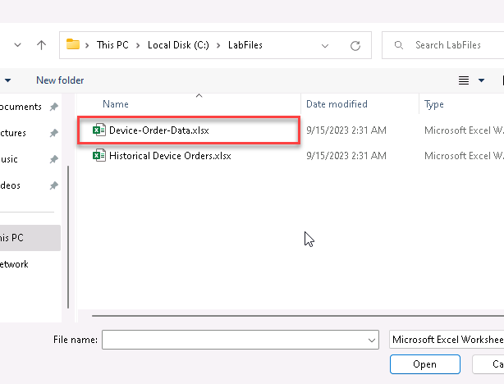

- Click Open
- In the right-hand pane, from the Choose a table dialog, select both the Devices and Manufacturers tables
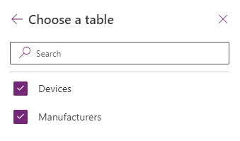
- Click Connect

- The Devices and Manufacturers connections should be listed in the Data pane
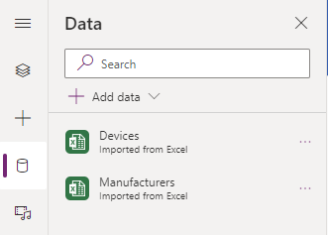

Task 2: Create a connection to SharePoint

In this task you will learn how to create a connection to the SharePoint site that contains the Order Data list (check with Prerequisites labs).

- In the app authoring pane, click the Data icon
- Click +Add data dropdown, in popup menu type SharePoint into the search box
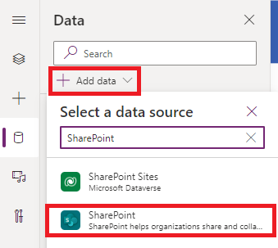
- Select SharePoint
- Click Add a connection
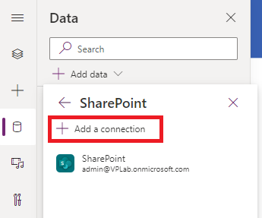

- Ensure that Connect directly (cloud services) is selected
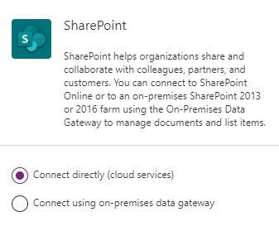
- Click Connect
- In the ‘Enter the SharePoint URL for the location of your list’ input box, paste the URL of your SharePoint site that you created at Lab 1.0 – Exercise 2 – Task 2, or select the sire URL from the list of recent sites and click Connect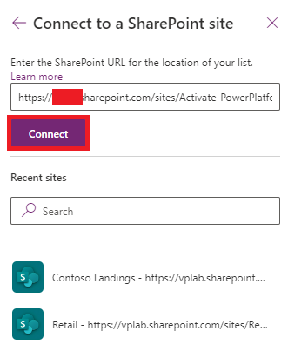

- In the ‘Choose a list’ dialog, select the ‘Order Data’ list (created in task four of the Prerequisites)
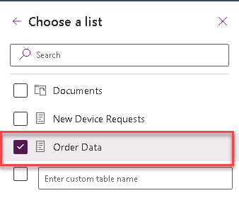

- Click Connect
- Your Order Data list connection will appear in the list of connections in the Data pane
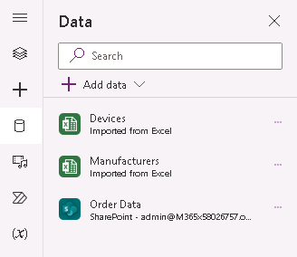

Exercise 2:
Add a device gallery to the Main Screen

In this exercise, you will add a gallery containing all available devices making it easy for users to browse the list and get a quick overview of the devices available.

Tips on working with galleries:
- Galleries provide a powerful way to visualize tabular data in Power Apps. It is important to become familiar with customizing a gallery. Key components of a gallery include the gallery control, the template cell (first cell), and controls within the template cell.

- To select the entire gallery – click on the gallery in the tree view on the left or click on the second or third cell. Clicking any cell that is not the first cell of the gallery will select the entire gallery. Now, you can specify properties that apply to the entire gallery, such as the data source, the gallery fill color, and borders.

- To customize how each item is displayed in the gallery, you will customize the template cell. Select the template by clicking the first cell of the gallery or the edit (pencil) icon 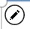 in the top left corner when the entire gallery is selected.

- With template cell selected, you can add, remove, and customize the controls within it. These changes will repeat across each item or row in the gallery.

Task 1: Add a device gallery

In this task you will learn how to add a gallery control to your app containing a list of all devices.

- Select the Insert tab
- Click Gallery and select Horizontal
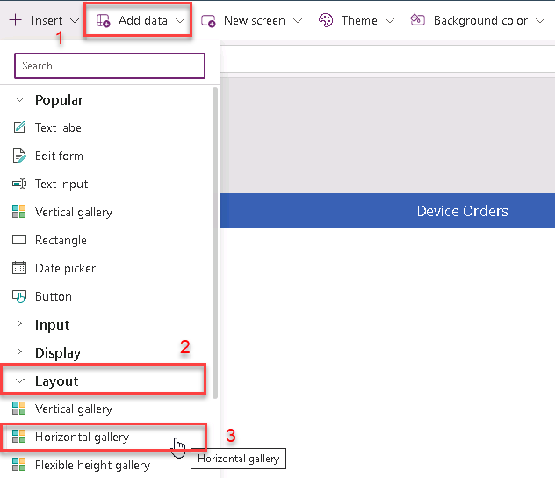
This will add a gallery called Gallery1 onto the screen. Notice the control tree view on the left displays this gallery with three controls within it – two labels and an image. A data pane will pop up on the right.
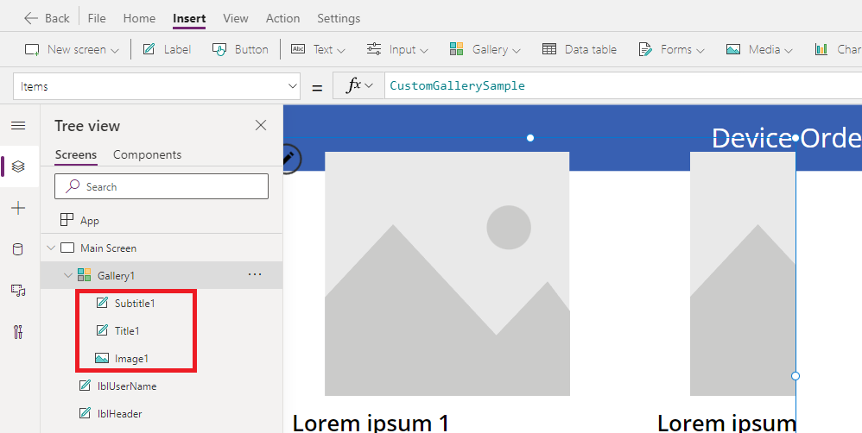

- Deselect Gallery1 (click on anything else in the tree view) and select Gallery1 again in the tree view. This will open a fly-out on the gallery (shown in the next step)

- Select ‘Devices’ from the list of data connections under the ‘In your app’ section, in the fly out. Alternatively, in the Properties pane on the right, select the drop-down in the Data source property and choose ‘Devices’.
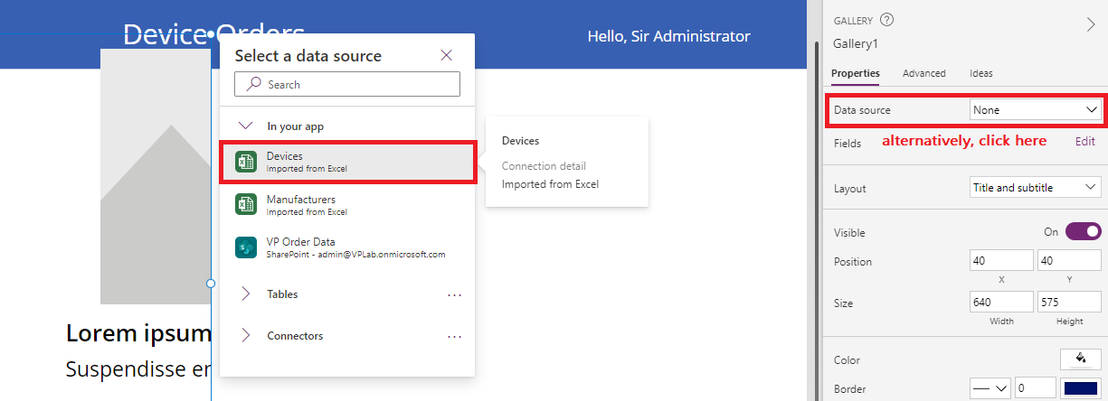
- Click on Gallery1, at the top of the Properties pane and rename it to galDevices
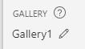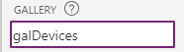

Task 2: Arrange the device gallery

In this task you will learn how to resize, reposition and update the controls within the gallery template.

- Drag-n-drop, resize and reposition galDevices gallery or just modify X, Y, Width, Height properties in Properties pane on the right, or clicking on the property below the type in fields (X, Y, Width, Height) and update in the Formula bar.
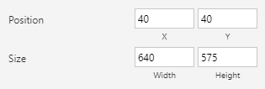

- Select the galDevices and click the Edit (pencil) icon in the top left to edit the template
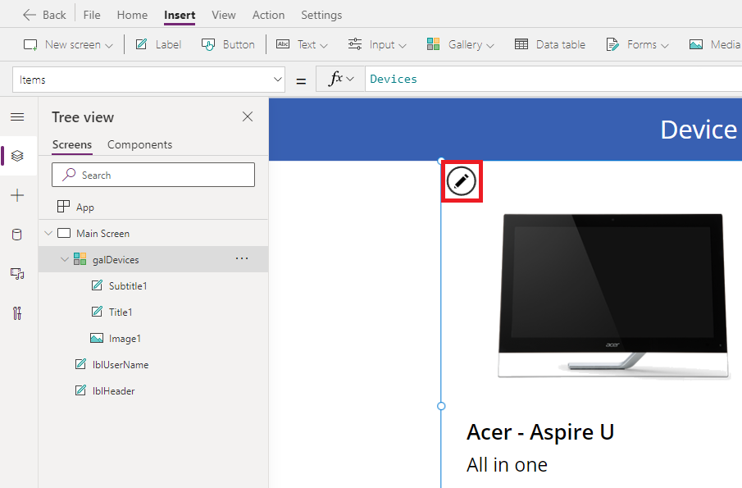
- Using the right drag control, resize the first box to be narrower. Notice that all the items get narrower and more devices are visible to the user on the screen
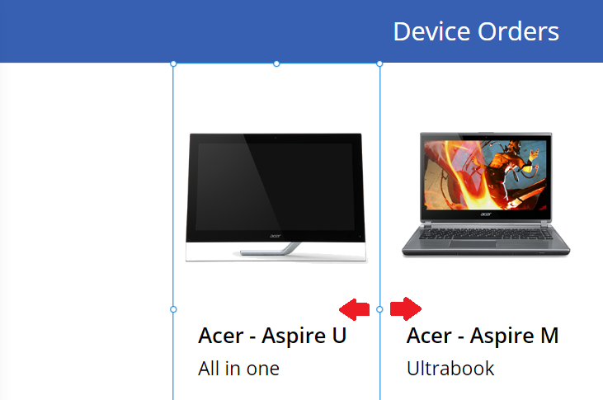

- Narrow the image as well by clicking on the image control and resizing it using the drag handles. Make sure the width of the image control is positioned within the template.
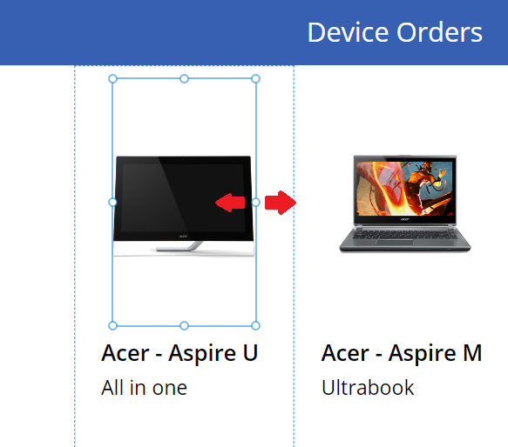
- Rename the image to be imgDevice
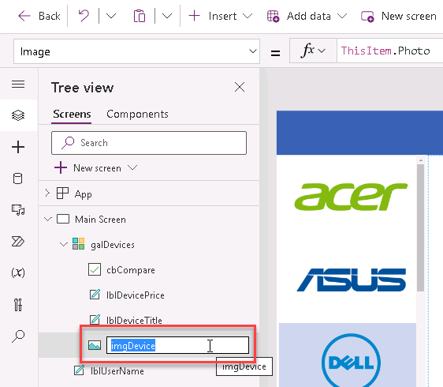

Task 3: Add a gallery to show manufacturers

In this task you will add a second gallery that lists the various device manufacturers. This will be a single column vertical gallery positioned on the left side of the screen, with each cell displaying the manufacturers logo image. This gallery will later be used as a filter for the device gallery created above.

- Select the Main Screen
- Select the Insert tab on the ribbon and open the Gallery drop-down, then select Vertical
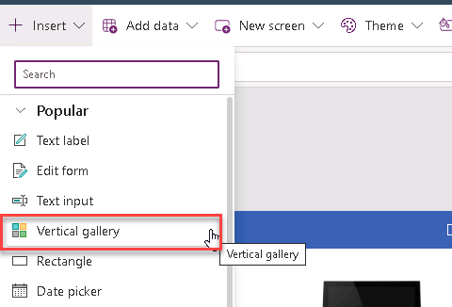

- In the ‘Select a data source’ dialog, select Manufacturers
- Rename the gallery to galManufacturers

- Move the galManufacturers gallery so that it is left aligned with the left edge of the screen and top aligned with the top of the device gallery.
The app should look like the image below
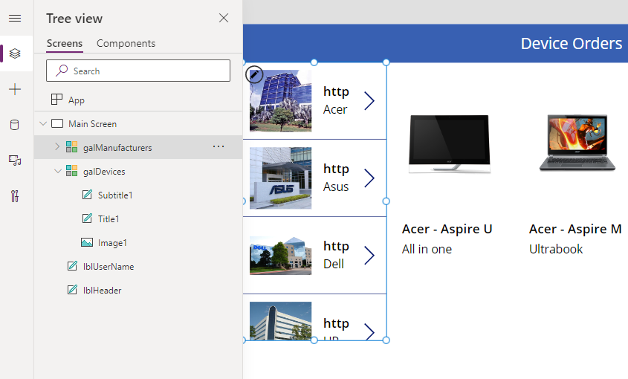
- Select the galManufacturers (not the template cell), then in the Properties pane on the right, click Layout
Scroll down to the Gallery section and select 2 columns
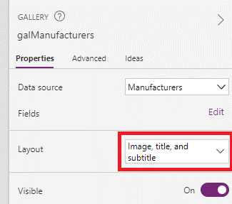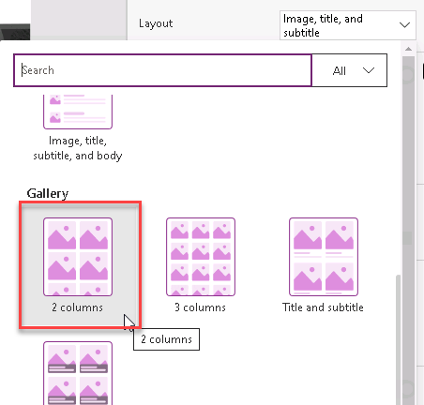
- Change the Wrap Count from 2 to 1. This will change the gallery to a single column
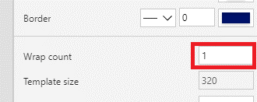

- Select the Image Control within the gallery and reduce its height by dragging the middle bottom drag control upwards. The image size will be reduced whereas the template size will still be expanded
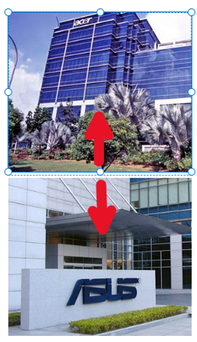
- Reduce the height of the template cell to match the image below by click on the white space below the first image, and selected the middle-bottom dot to adjust the template cell. We want the image to occupy the entire cell
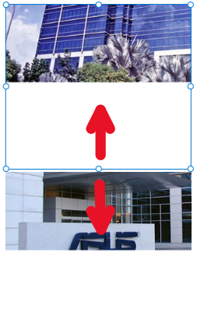 |  | 

- Click File and Save the application
- Click on the Back arrow

Task 4: Display the manufacturer logo

In task three, you added a single column, vertical gallery connected to the manufacturers table in the Excel data connection. In this task, you will update the gallery to display the manufacturer logo.

- Select the galManufacturers. Make sure the whole gallery is selected, and not just the first cell
- Select Items from the property drop-down and ensure that Manufacturers is visible
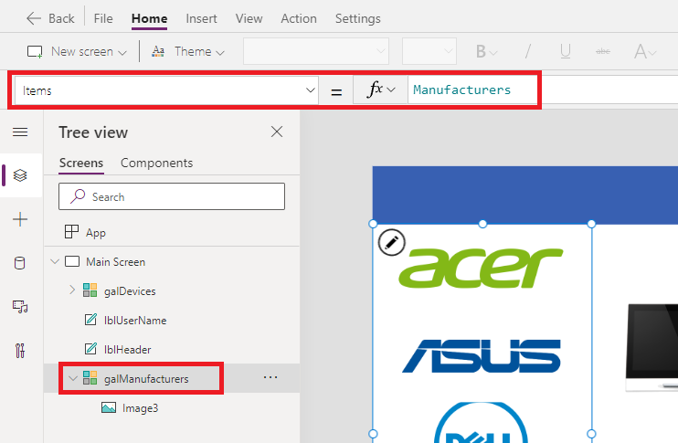
- Select the image control in the first template cell in the gallery and make sure that the value of Image in the formula bar is not ThisItem.HQ but ThisItem.Logo.
All items in the gallery will now display logo images
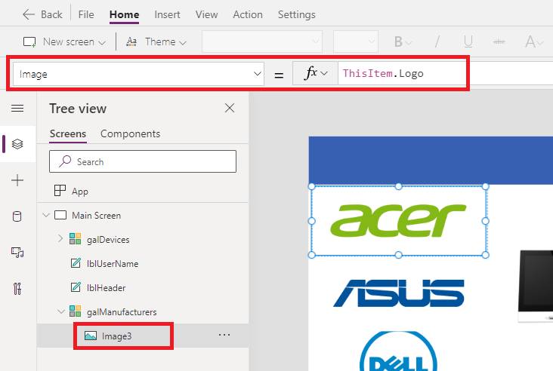

- Select the first image (topmost) and using the Properties pane on the right, set the image position to Fit
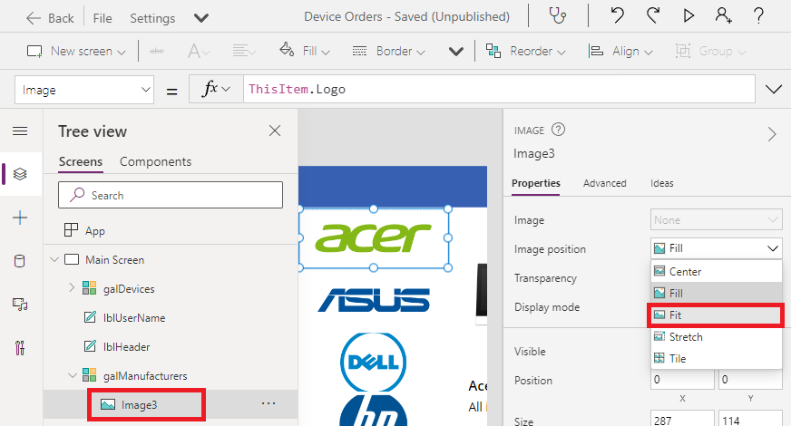
- Rename image3 to be imgLogo
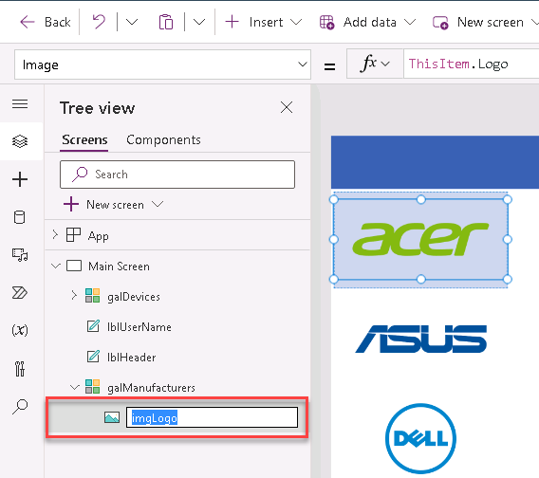

Task 5: Highlight the selected item in the gallery

In this task, you will learn how to use the TemplateFill property of the manufacturer gallery to specify a highlight color for the item.

- Select the galManufacturers
- From the properties drop-down, select the TemplateFill property
- In the formula bar, enter the following:
TemplateFill
If(ThisItem.IsSelected, ColorFade(lblHeader.Fill, 75%))
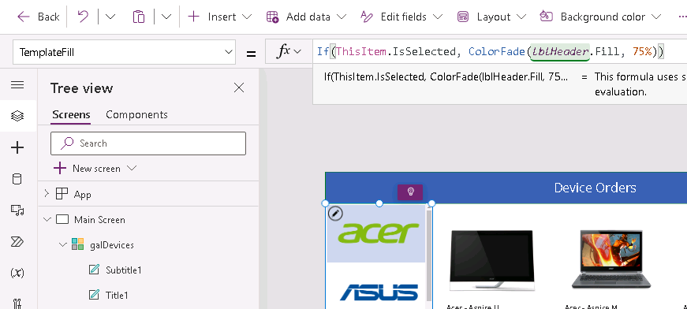

for alternate/European locales, enter:
TemplateFill
If(ThisItem.IsSelected; ColorFade(lblHeader.Fill; 75%))

- Use the preview mode to perform a quick test of the highlighting. You can enable preview mode by holding down the Alt key and clicking a few different manufacturers in the gallery. Preview mode ends when you stop holding the Alt key.

Tip: You could alternatively click the Play button to enter preview mode, and to exit this you would click the X in the upper right corner, or use the Esc key.

Task 6: Filter the devices based on the selected manufacturer

In this task, you will learn to use the Filter() function to filter the items in the galDevices to only display devices that match the selected item in the galManufacturers.

- Select the galDevices
- From the properties drop-down, select the Items property
- Enter the following expression in the formula bar:
Filter(
Devices,
ManufacturerID = galManufacturers.Selected.ManufacturerID
)

Items

This will filter the device gallery to only display items that match the selected manufacturer based on ManufacturerID.
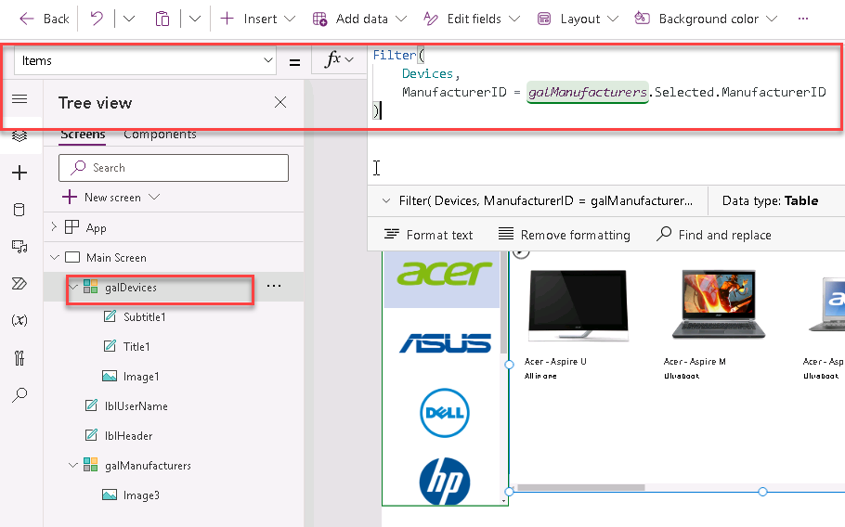
for alternate/European locales, enter:
Filter(
Devices;
ManufacturerID = galManufacturers.Selected.ManufacturerID
)

Items

- Enter preview mode

- Select a different item in the manufacturer gallery on the left, and you will notice the device gallery will update accordingly
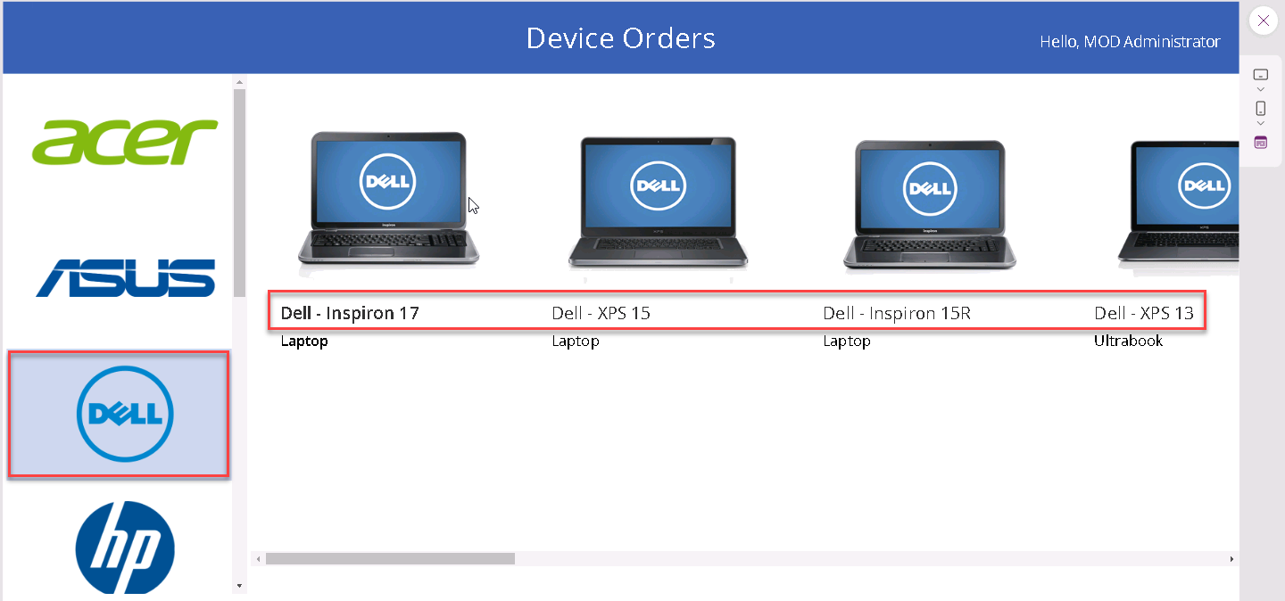

Task 7: Configure text labels in the device gallery

In this task you will learn how to configure text label formatting to the template cell.

- Select the template cell in the galDevices
- Select the title, it is named Title1 in the left navigation
- Rename it to lblDeviceTitle
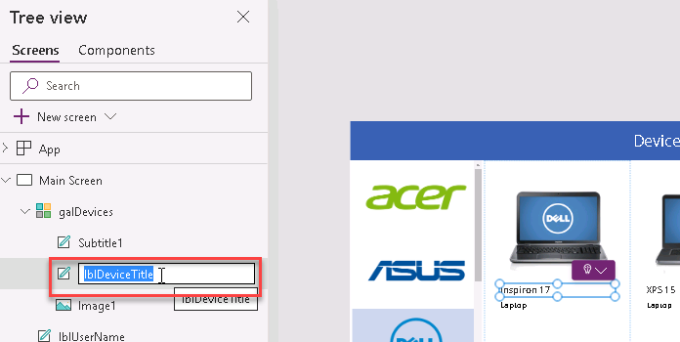
- Change the label to the device name by setting the label’s Text property to ThisItem.Title
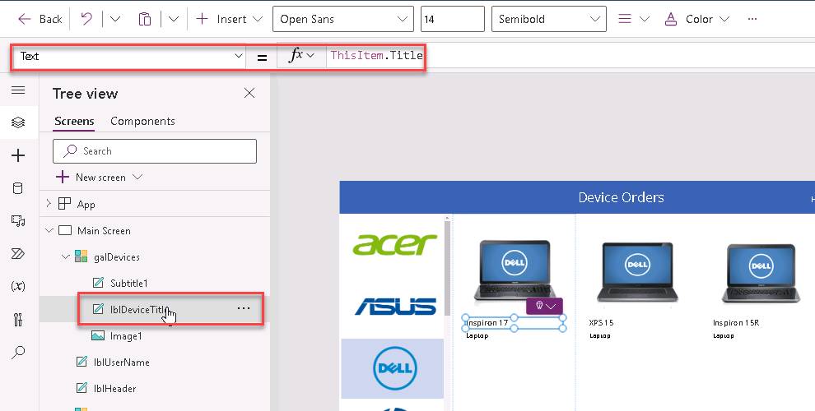
Formatting suggestions (these are optional, feel free to move forward to step 4).

- Expand the width of the label to the template width
- Change the PaddingLeft from 0 to 10
- Change the Font to Segoe UI
- Select the Subtitle1 control
- Rename it to lblDeviceTitle
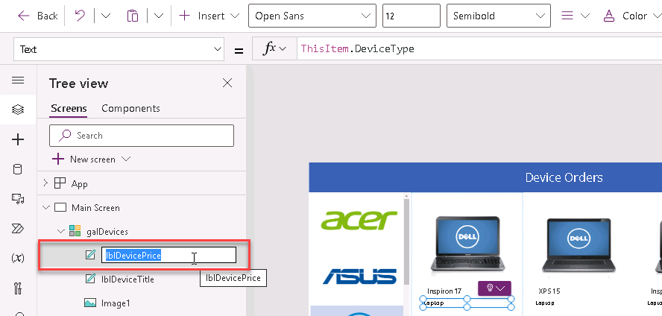

- In the property drop-down list, select the Text property change it to ThisItem.Price:
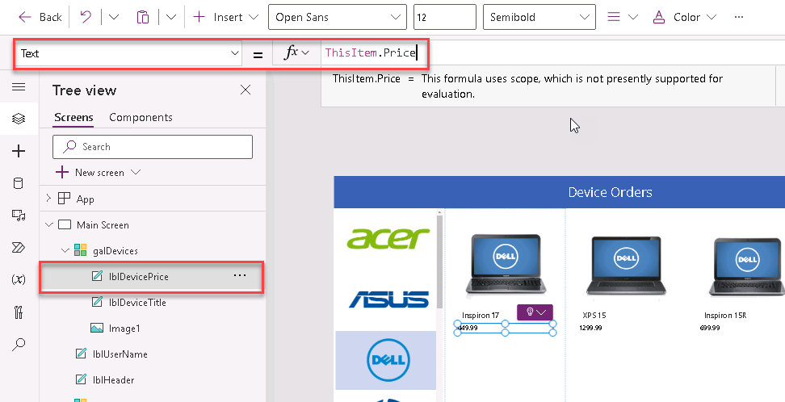

- To add the currency formatting, use the text expression:
Text
Text(ThisItem.Price, "[$-en-US]$##,###.00")
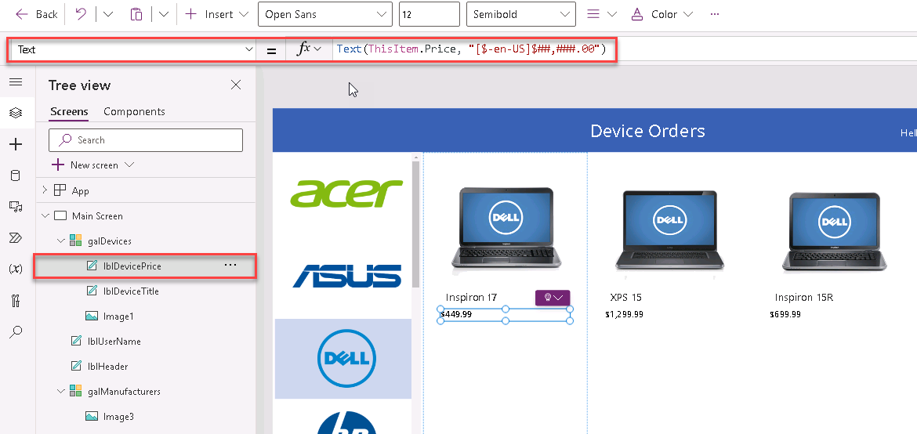
Note: After you enter the above expression in the formula bar, it will automatically resolve to include your locale, e.g. [$en-US]. If you see an error here, it might be because your local is not yet supported, in which case as a workaround, manually change it to [$-en-US].

Task 8: Conditional formatting to highlight devices above $1,000

In this task, you are going to format devices that have a value greater than $1,000 by displaying the price in Red.

- Select the label in the template cell that displays the price
- In the properties drop-down, select the Color property
- In the formula bar, enter the following:
Color
If(ThisItem.Price>1000, Color.OrangeRed, Color.Gray)
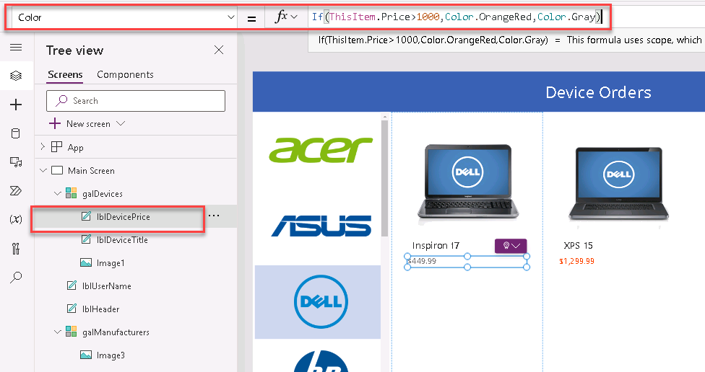

for alternate/European locales, enter:
Color
If(ThisItem.Price>1000; Color.OrangeRed; Color.Gray)

Task 9: Add a checkbox to add a device to Compare list

We want to be able to allow users to compare devices before making an order, in this task you will learn how.

- Select the galDevices
- Click the pencil icon in the top left of the gallery to select the template cell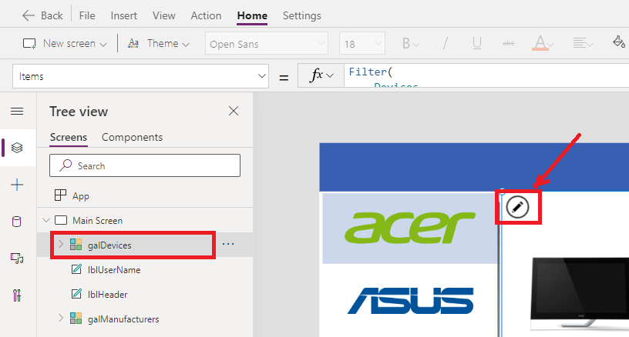
- Make sure that only the first item in the gallery is selected
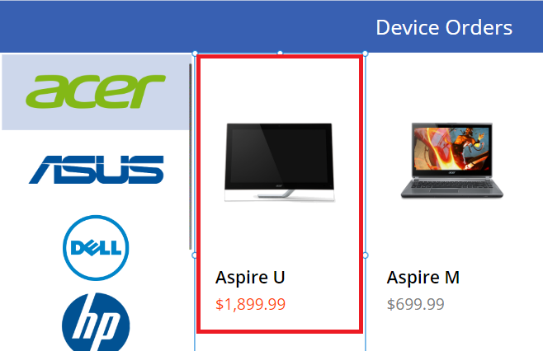
- Select Insert tab in the ribbon, click Input
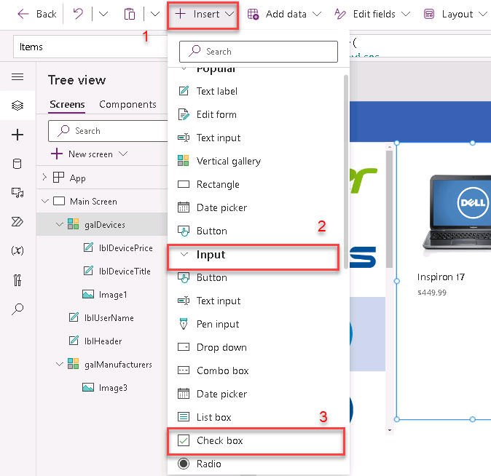
- Under the Controls drop-down, select Checkbox

- Drag the checkbox control below the price
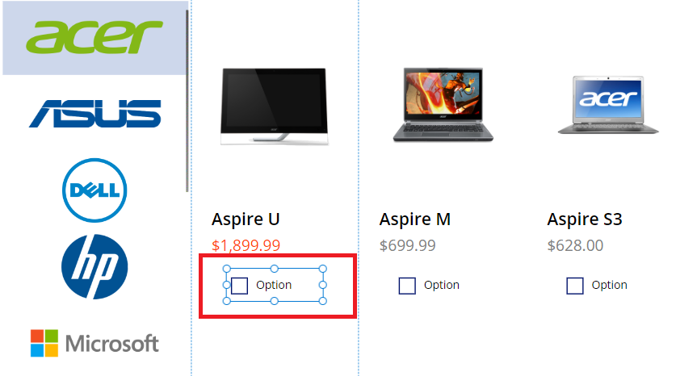
- Rename the checkbox to be cbCompare
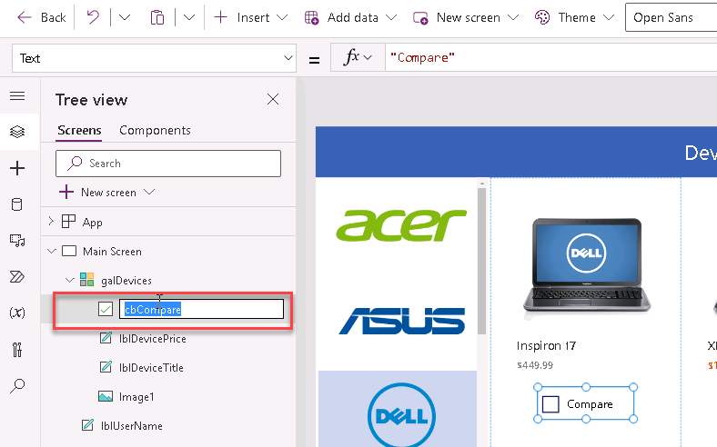
- Change the checkbox text to ‘Compare’ (you can do this by setting the Text property or click within the text of the control and typing directly into the control)
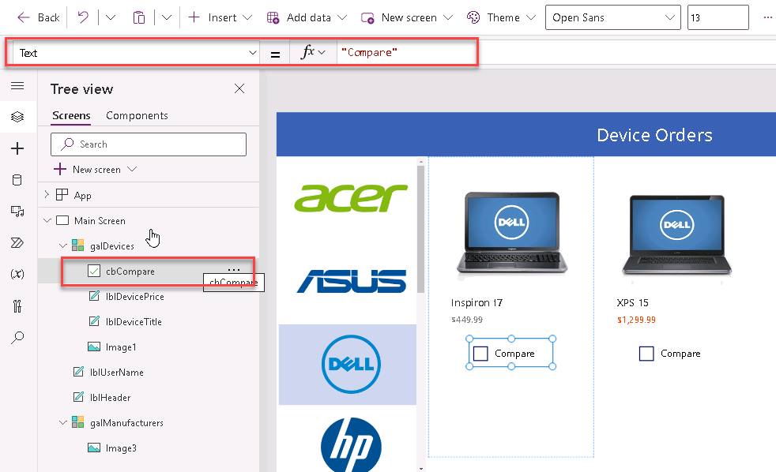

Task 10: Create a collection for the selected devices

In this task you will create a collection called CompareList. This will allow users to compare devices before deciding to place an order.

Tip: What is a collection? A collection is a group of items that are similar, such as devices in a device list

- Select the Checkbox control and Choose OnCheck from the Properties List
- Click the OnCheck value and type the following expression in the formula bar:
OnCheck
Collect(CompareList, ThisItem)
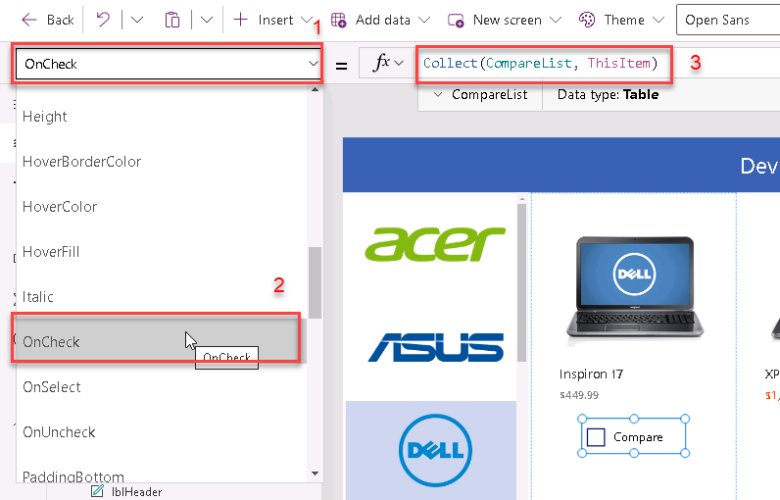

for alternate/European locales, enter:
OnCheck
Collect(CompareList; ThisItem)

- Click the OnUncheck value and type the following expression in the formula bar
OnUncheck
Remove(CompareList, ThisItem)
for alternate/European locales, enter:
OnUncheck
Remove(CompareList; ThisItem)

- From the properties drop-down, select the Default property
- Set Default property as follows:
Default
ThisItem in CompareList
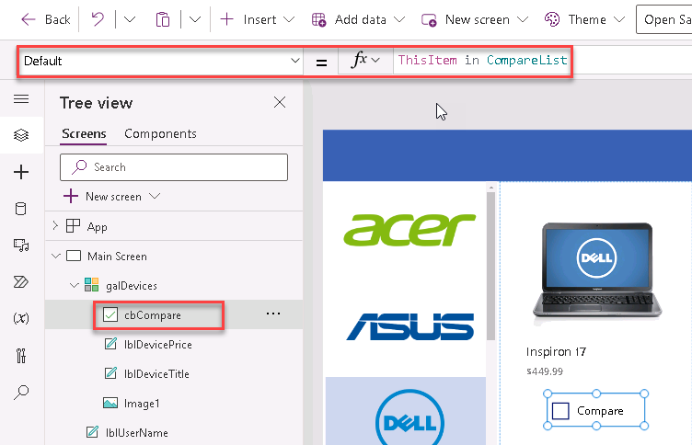
Note: The Default property of the checkbox is a Boolean (true of false) value that determines if the checkbox should be checked or not by default. Setting it to this formula will ensure that the checkbox is checked by default if the item has already been added to the collection since the result will be true, i.e., this item ‘is’ in the CompareList collection.

- Test the checkbox functionality. Run the app in preview mode (F5) or by clicking the preview button, click on checkboxes of three items
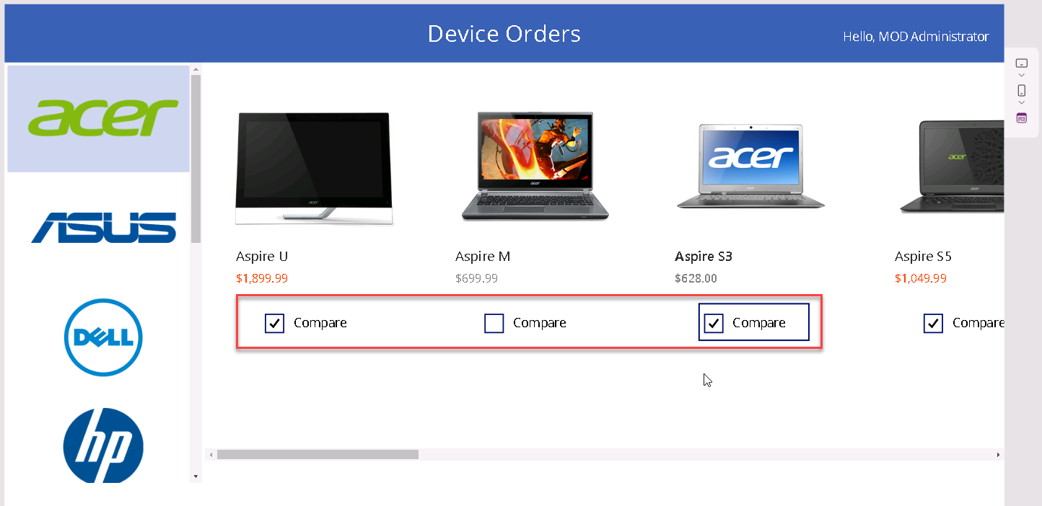
- Close preview mode (clicking X)
- Click on the Variables from Left Menu and expand Collections

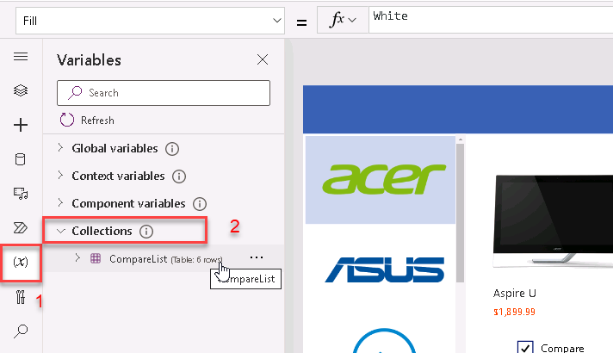
- To view CompareList collection, you need to click on three dots then click View Table
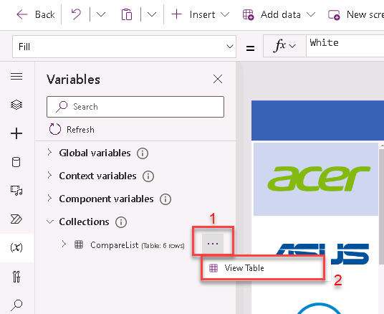
- You should see the CompareList collection and the three items that you selected
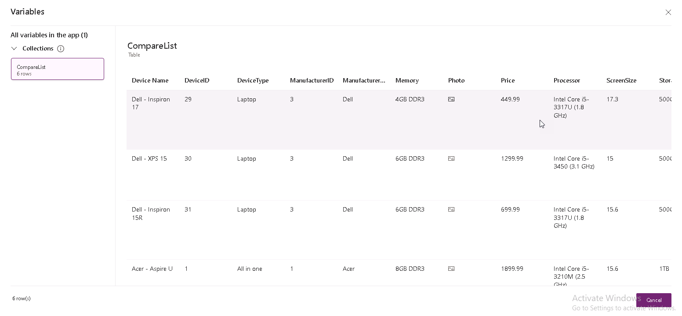
- Run the app in preview mode (F5) or by clicking the preview button, click on checkboxes of three items to uncheck them
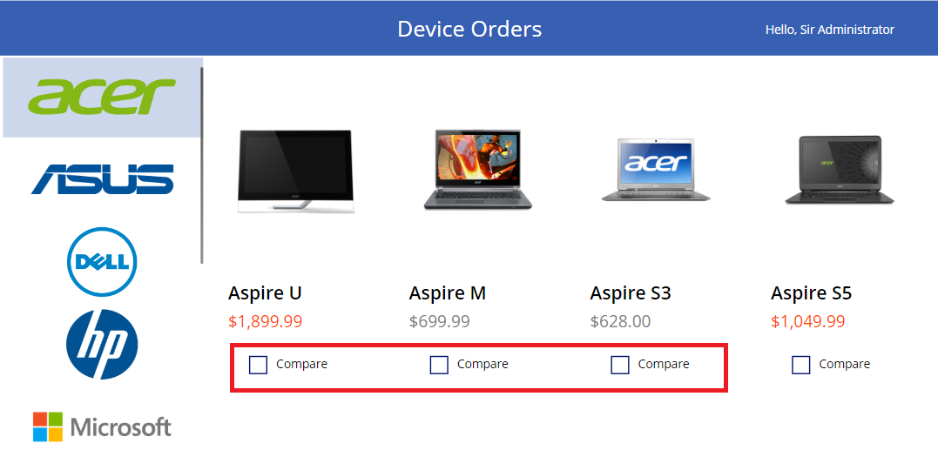
- Close preview mode (clicking X)
- Open Collections again
- Check that all items were removed from the CompareList collection
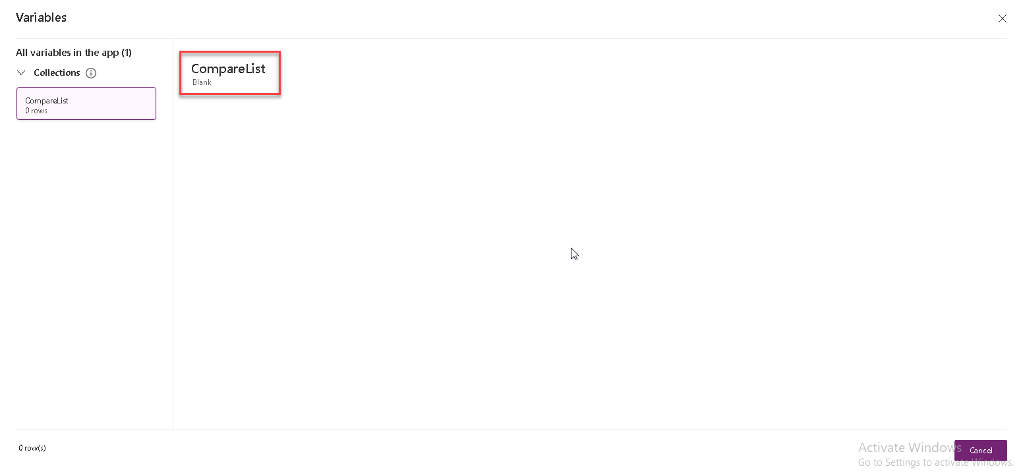

Task 11: Set the default selection to the first manufacturer

In this task, you will learn how to ensure that the app doesn’t display a blank list of devices when the app starts by setting the default item in the Manufacturer gallery to be the first item.

- Select the galManufacturers in the tree view in the left pane
- From the properties drop-down, select the Default property
- Enter the following expression in the formula bar
Default
First(Manufacturers)
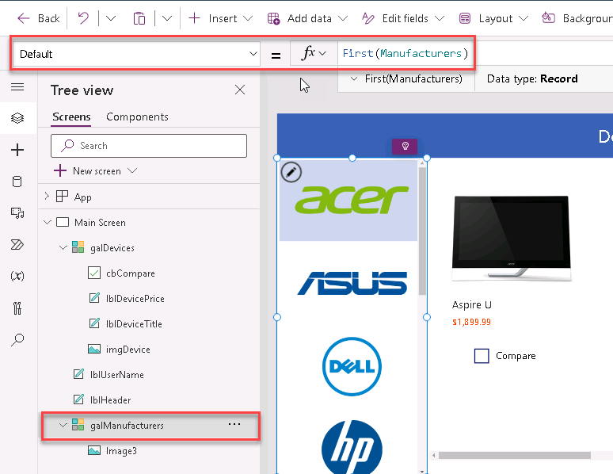
- Run the app in preview mode (F5)
- The app should look like the image below
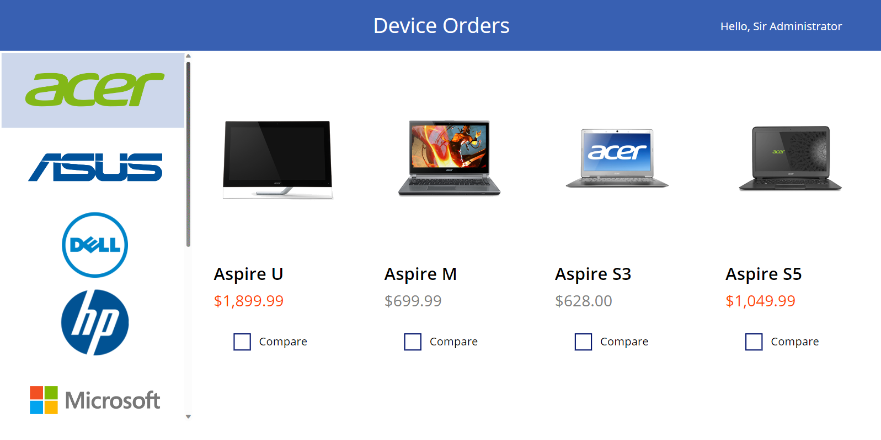
- Close preview mode (clicking X)

