Lab Module 3.0:
Add compare screen and add/remove
gallery controls
WorkshopPLUS – Power Platform: Power Apps for Power User

Published: May 2022

Table of contents
Lab overview 1
Introduction 1
Objectives 1
Prerequisites 1
Estimated time to complete this lab 1
Scenario 1
Exercise 1: Add a compare screen 2
Task 1: Add a screen 2
Task 2: Add compare and clear buttons to Main Screen 3
Task 3: Add controls to the Compare Screen 6
Task 4: Configure the gallery 9
Task 5: Remove and add controls to the gallery 10
Task 6: Highlight the selected device 13
Task 7: Add an icon to navigate to the Main Screen 14

Lab overview

Introduction
In this lab, you will perform the actions necessary for building Power Apps by adding a compare screen, adding/removing gallery controls, and testing the app.

Objectives
After completing this lab, you will be able to:
- Add Compare Screen
- Remove and add controls to the gallery
- Highlight selected device
- Add icon to navigate

Prerequisites
Ensure you are using the “Incognito” or “InPrivate” browsing session of your modern browser.
Additionally, use the latest version of Microsoft Edge for the best performance.

Estimated time to complete this lab
30 mins

Scenario
The organization wishes to build an app using Power Apps to take advantage of No Code/Low Code application development in the cloud. As part of this effort, you are required to add compare screens, add/remove gallery controls, manipulate the navigation, and test the functionality of your app.

Exercise 1: Add a compare screen

The compare screen is where users will compare the selected devices and then choose the device that they wish to submit for approval.

This screen will include:

- A back button for navigation back to the Main Screen
- A list of selected devices for comparison
- Additional detail for each device
- Highlighting the selected device

Task 1: Add a screen

In this task you will add the Compare Screen to the app.

- From the ribbon click New Screen
- Select Blank
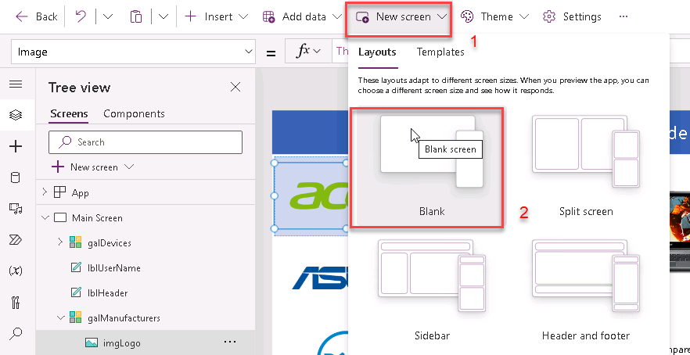
- Rename the screen to Compare Screen
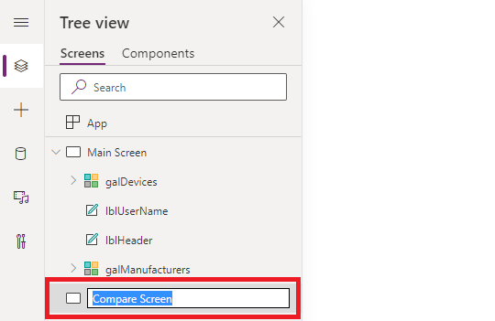

Task 2: Add compare and clear buttons to Main Screen

In this task you will learn how to add buttons to the Main Screen that add functionality to the app to navigate to the Compare Screen and clear the selected devices for comparison

- In the Tree View, select Main Screen
- Click the Insert tab in the ribbon
- Select Button to add a button onto the screen
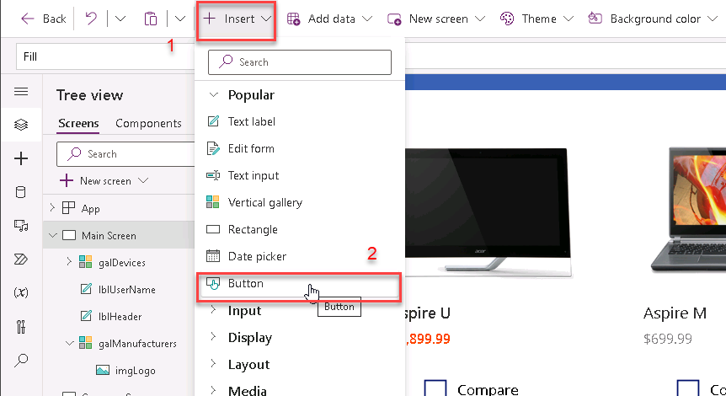
- Place the button in the bottom right corner of the screen
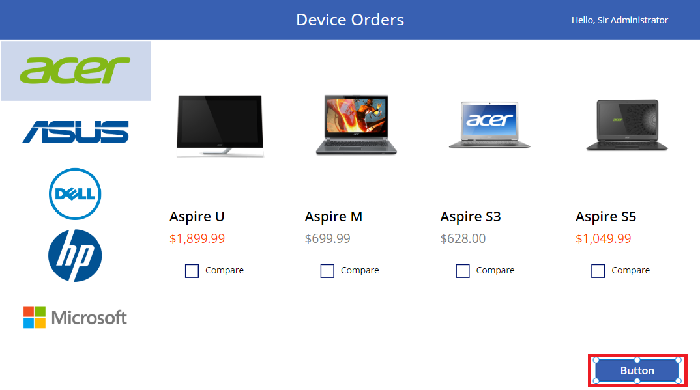
- For the button, in formula bar set Text property as:
Text
"Compare " & CountRows(CompareList) & " item(s)"
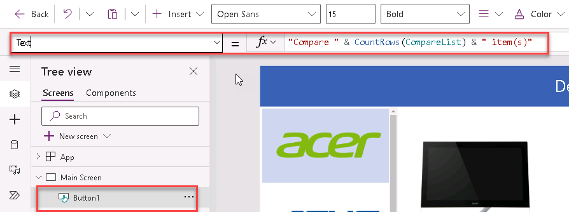

- Resize the button so the text fits without wrapping
- Select the button and set the DisplayMode property expression to:
  - If(CountRows(CompareList) > 0, DisplayMode.Edit, DisplayMode.Disabled)
Note: When leaving the Formula Bar it may hide the “DisplayMode.” from the formula, but add them back in when you click into the Formula Bar
DisplayMode
If(CountRows(CompareList) > 0, Edit, Disabled)
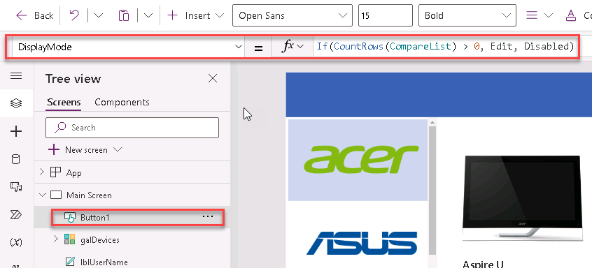

for alternate/European locales, enter:
DisplayMode
If(CountRows(CompareList) > 0; Edit; Disabled)
- Run the app in preview mode (F5)
- Select a few devices
- Check that the button displays the number of devices selected for comparison
- Close preview mode (clicking X)
- Run the app in preview mode (F5)
- Unselect the devices
- Check that the button is disabled
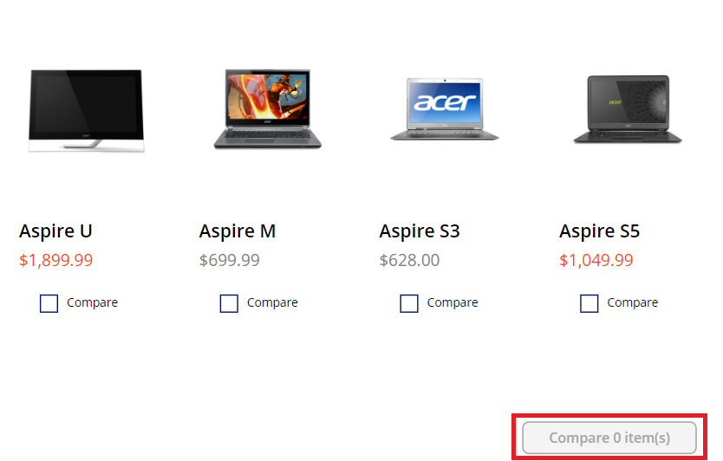
- Close preview mode (clicking X)
- In Tree View, rename this button as btnCompare
- Select the btnCompare and copy it (Ctrl+C)
- Paste the button on the same screen (Ctrl+V)
- Position the button to the left of the compare button
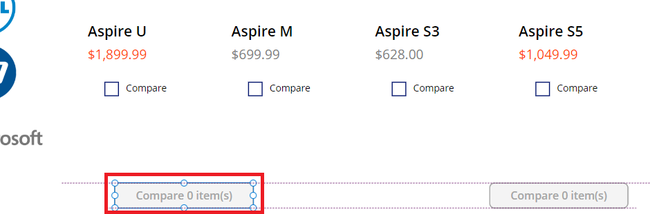
- Change the Text property in the Properties pane to Clear selection
(If using the formula bar, enter “Clear selection” including standard quotation marks)
- In Tree View, rename this button as btnClear
- Set the OnSelect property of the button to the following expression:
OnSelect
Clear(CompareList)
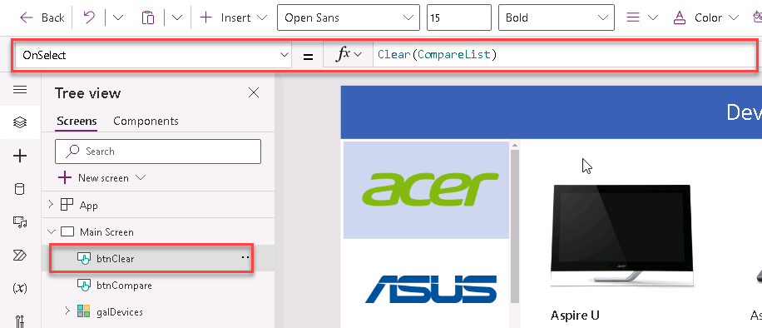
Note: This will remove all the items in the CompareList collection when the user clicks the button

- Select the btnCompare button
- Set the OnSelect property of the button to the following expression:
OnSelect
Navigate('Compare Screen',ScreenTransition.None)
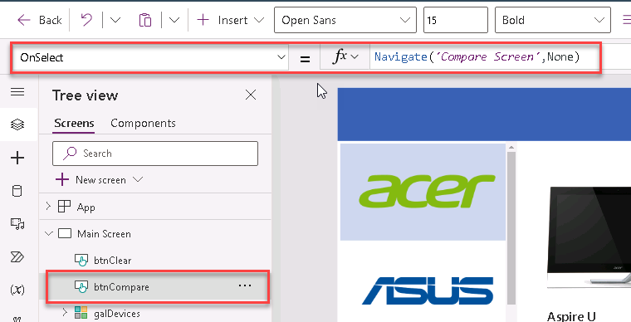
- Click Preview and select a couple of devices and click the Compare button
- Verify that it takes you to the Compare Screen, then close Preview (clicking X)

Task 3: Add controls to the Compare Screen

In this task, you will copy the various controls that you want to display on both the Main Screen and Compare Screen.

- In the tree view, select the Main Screen
- Select both the lblHeader and lblUserName (hold Shift key whilst selecting)
- Right click and select Group
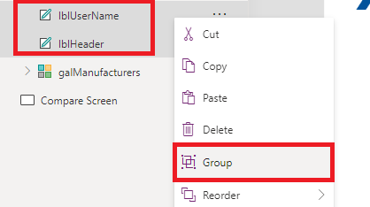
- Rename the group Header-Main
- Click on the ellipsis of the Header
- Select Copy
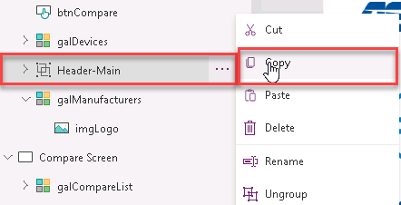
- Right click on the Compare Screen
- Select Paste
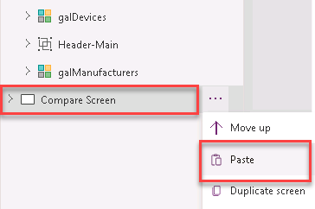
- Select the Compare Screen
- Select the Header_1 Group and rename to Header-Compare

- Click on the Align button and select Align Top
- The Header-Compare in the Compare Screen should look like the image below:
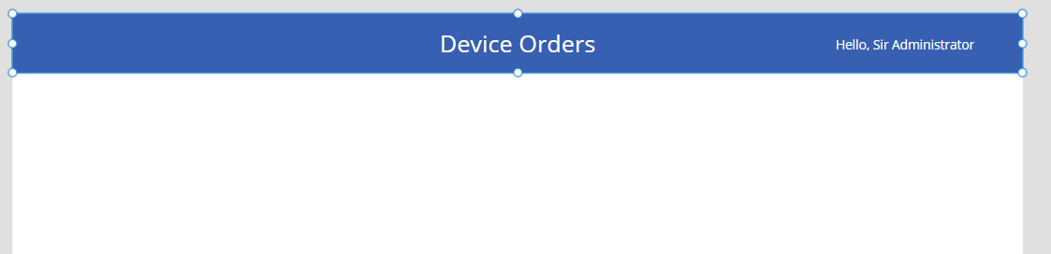
- Copy the galDevices from the Main Screen and paste into the Compare Screen
- Expand the gallery to the full width of the screen.
Align the top of the gallery to be just under the header banner.
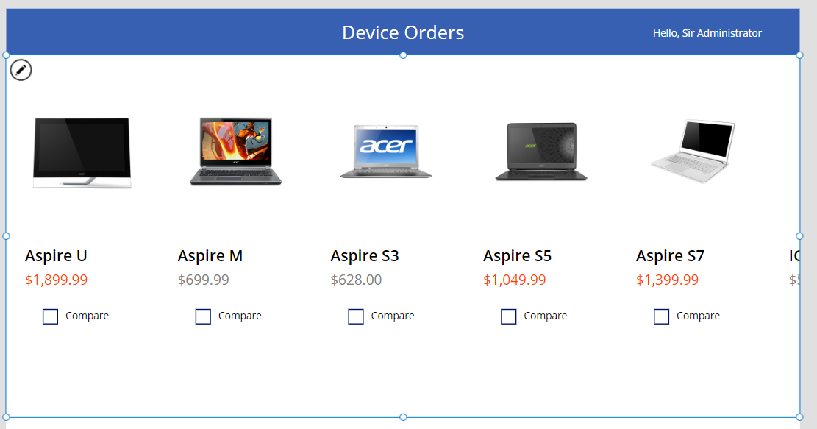
- Rename this gallery to galCompareList
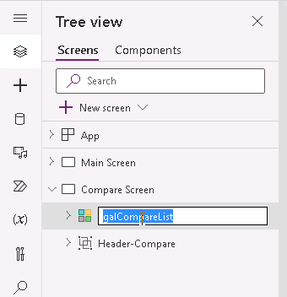

Task 4: Configure the gallery

In this task you will configure the gallery to show devices that were selected from the comparison gallery on the Main Screen.

- Select the new galCompareList
- Select the Items property drop-down and in the formula bar set it to CompareList
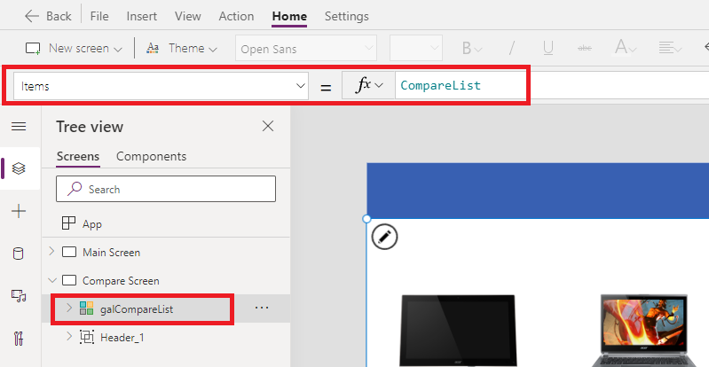
- The gallery will now show the selected items from the Main Screen
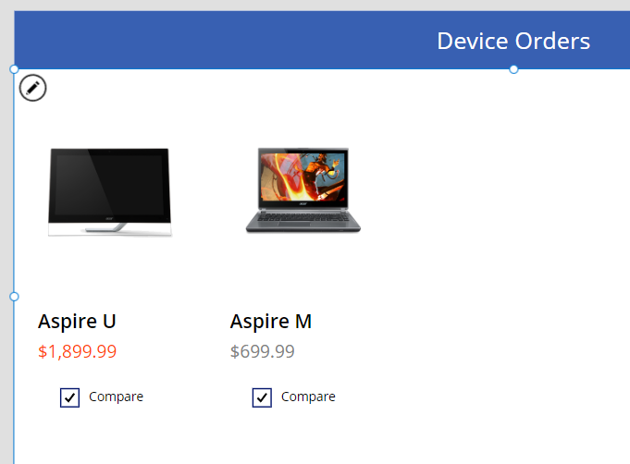

Task 5: Remove and add controls to the gallery

In the Compare Screen we are selecting a specific item to place an order/ submit for approval, so we no longer require the compare checkbox. In this task you will remove the compare checkbox and add new controls to the template cell.

- Select the Compare Screen
- Select the galCompareList template cell
- Select the Compare checkbox on the template cell and press the Delete key to delete the checkbox
- Rename the rest of controls as below
Control | New Name
lblDevicePrice_1 | lblCLDevicePrice
lblDeviceTitle_1 | lblCLDeviceTitle
imgDevice_1 | imgCLDevice

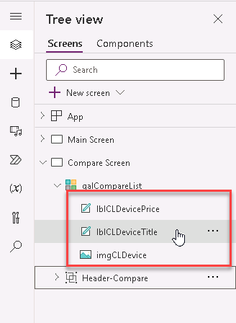
- Click the pencil icon in the top left of the gallery to select the template cell
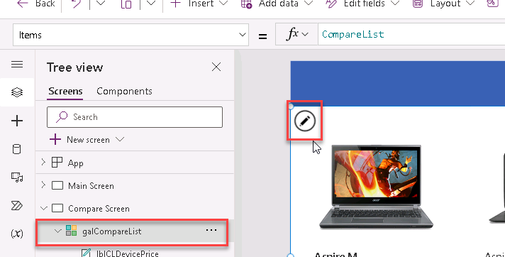
- Click the Insert tab on the ribbon
- Click Label
- Rename the label lblCLManufacturerName
- Set the Text property to the following expression:
Text
ThisItem.ManufacturerName
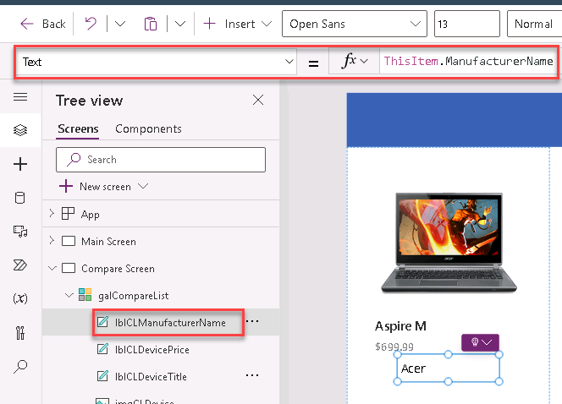

- Copy and paste the label
- Rename the new copy lblCLDeviceMemory
- Set the Text property to the following expression:
Text
ThisItem.Memory
- Repeat this process to add in the following labels:
Label | Text property
lblCLDeviceProcessor | ThisItem.Processor
lblCLDeviceStorage | ThisItem.Storage
lblCLDeviceScreenSize | ThisItem.ScreenSize
- Your gallery should look like this now
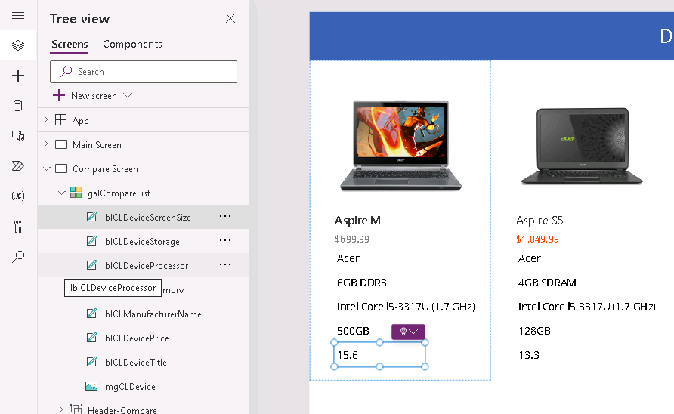

Task 6: Highlight the selected device

In this task you will recreate the behavior of the selected manufacturer in the Main Screen. When a user clicks on a device, you will set the template fill to show that it is highlighted.

- Select the galCompareList
- From the properties drop-down, select the TemplateFill property
- In the formula bar, enter the following expression:
TemplateFill
If(ThisItem.IsSelected, ColorFade(lblHeader.Fill, 75%))
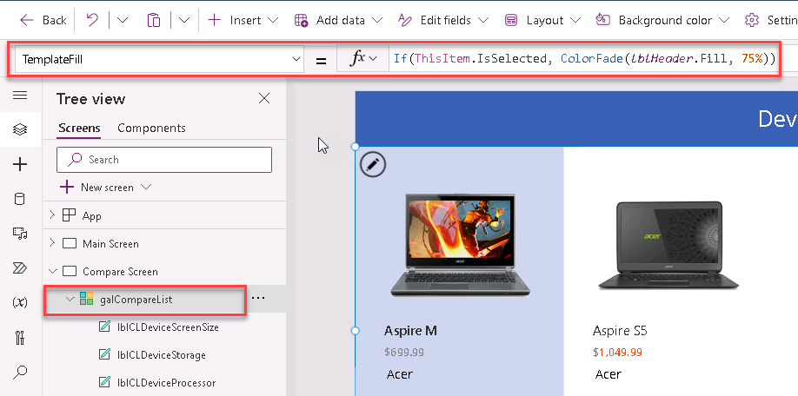
for alternate/European locales, enter:
TemplateFill
If(ThisItem.IsSelected; ColorFade(lblHeader.Fill; 75%))

This is conditionally setting the Fill color if the cell is selected. Click a few different items in the gallery, notice the selected item is highlighted in a light blue color.

Task 7: Add an icon to navigate to the Main Screen

In this task you will learn how to add an icon to navigate back to the Main Screen.

- Select the Compare Screen
- Select the Insert tab from the ribbon
- Select Icons, and then select the Back icon
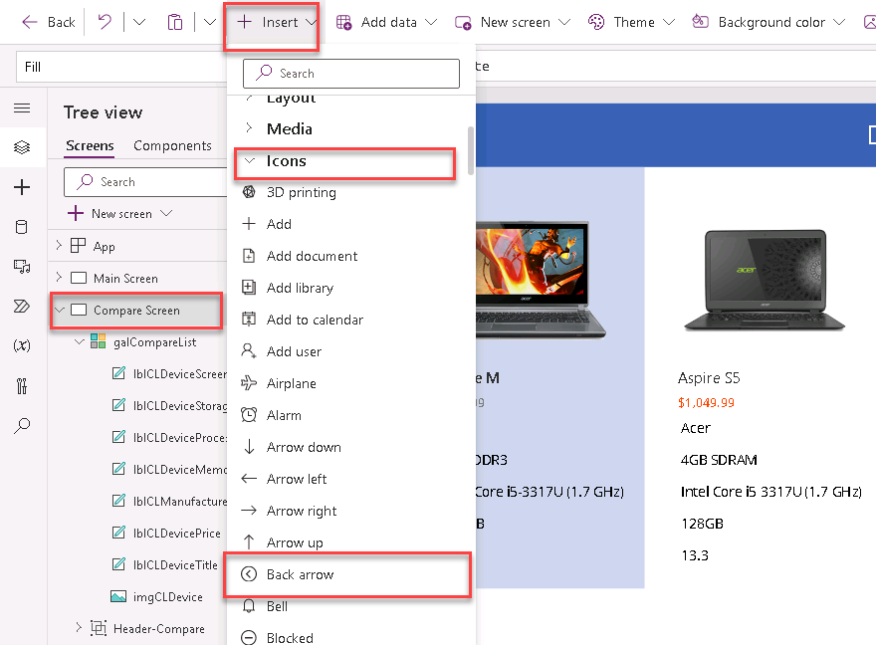
- Position it in the top left corner of the screen
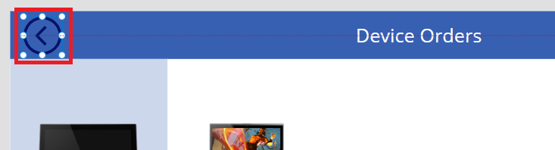
- Rename it from icon1 to iconBack
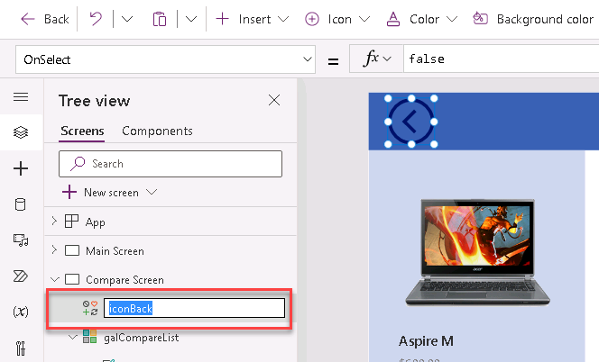

- Select the Icon and change the Color to White
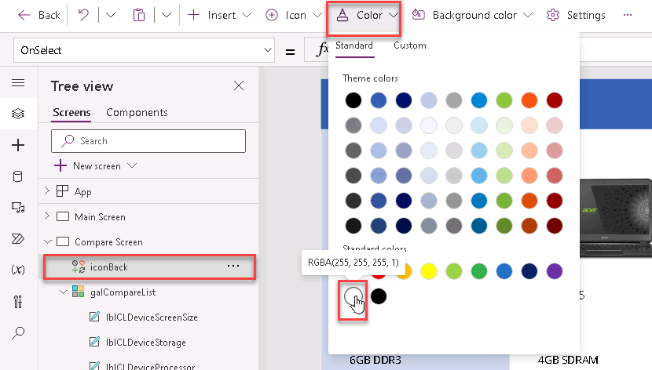
- From the properties drop-down select the OnSelect property and in the formula bar enter the following expression:
OnSelect
Back()
Note: This will cause navigation back to the previous screen.

