Lab Module 4.0:
Connect the data from the canvas app and
submit device request
WorkshopPLUS – Power Platform: Power Apps for Power User

Published: May 2022

Table of contents
Lab overview 1
Introduction 1
Objectives 1
Prerequisites 1
Estimated time to complete this lab 1
Scenario 1
Exercise 1: Ordering a device for approval 2
Task 1: Create an edit form 2
Task 2: Configure the title field 5
Task 3: Configure the Price and OrderStatus fields 7
Task 4: Configure the Comments field 8
Task 5: Add a button to submit the form 10
Task 6: On successful submission navigate to a new screen 12
Task 7: Verify successful submission 14

Lab overview

Introduction
Now that you have created the list to store device order requests, let’s connect Device Ordering App to this list and add a form to submit device approval requests.

Objectives
After completing this lab, you will be able to:
- Connect SharePoint list as data source
- Configure and add form
- Submit Form
- Add success screen
- Test the app
- Verify successful submission

Prerequisites
Ensure you are using the “Incognito” or “InPrivate” browsing session of your modern browser.
Additionally, use the latest version of Microsoft Edge (aka Edge Chromium) for the best performance.

Estimated time to complete this lab
45 mins

Scenario
The organization wishes to build an app using Power Apps to take advantage of No Code/Low Code application development in the cloud. As part of this effort, you are required to add new data source (SharePoint list), configure, add and submit form, add/remove gallery controls, manipulate the navigation, and test the functionality of your app.

Exercise 1:
Ordering a device for approval

So far, you have built the app. Users can browse and compare devices. In this exercise you will add additional functionality so that users can create an order using form and submit a device for approval. In this lab, device orders will be managed in a SharePoint list (created as part of the prerequisites). Power Automate flow will be created in subsequent exercises to manage the approval process.

Task 1: Create an edit form

In this task, you will add an Edit Form to the Compare Screen.

- Select Main Screen
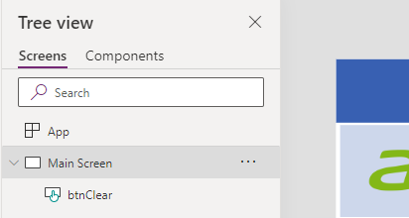
- Select a few devices by clicking on checkboxes, while holding Alt-key
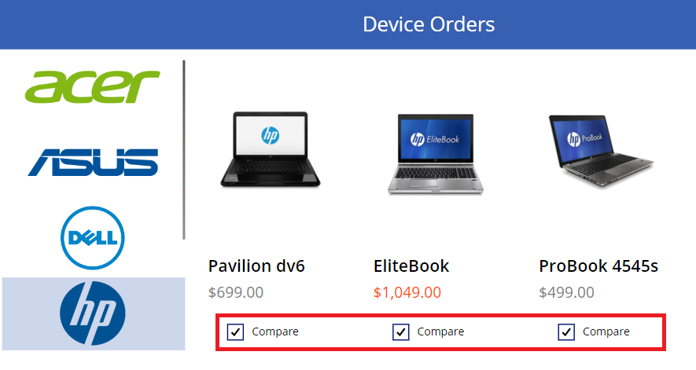
- Select Compare Screen.
You will now have the selected devices. 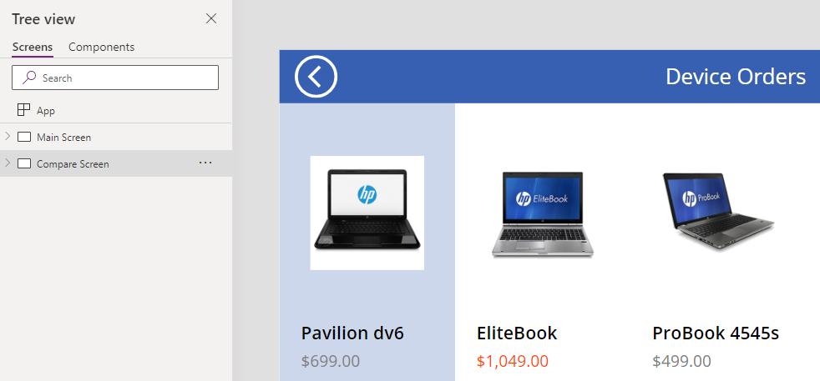
- Select the Insert tab, click Forms, and select Edit. Rename Form1 to frmSubmitOrder
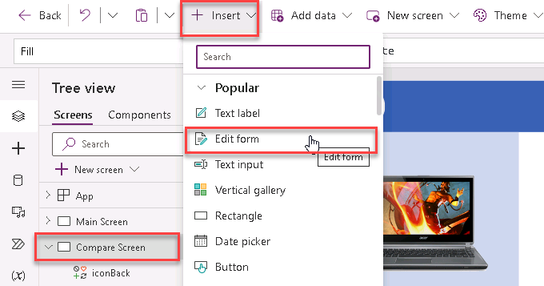
- Select frmSubmitOrder
In Properties Pane, select Data source drop-down and then select your Order Data list (SharePoint data source)
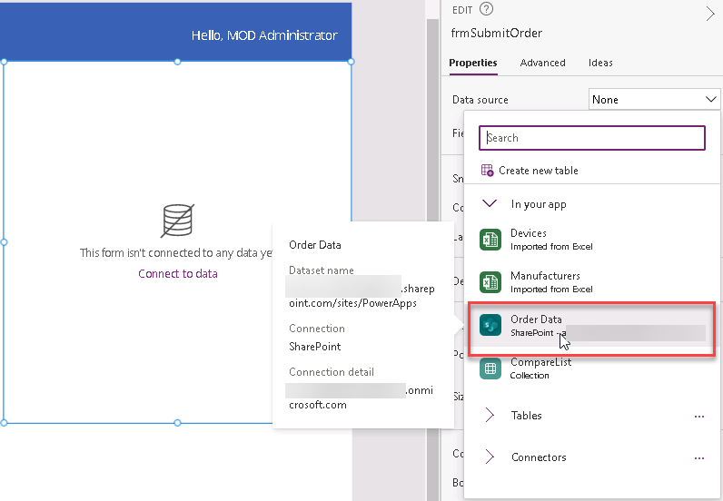
- In Properties Pane, click Edit fields
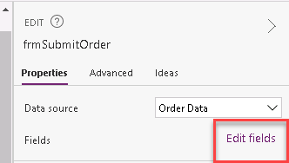
- Remove Attachments field
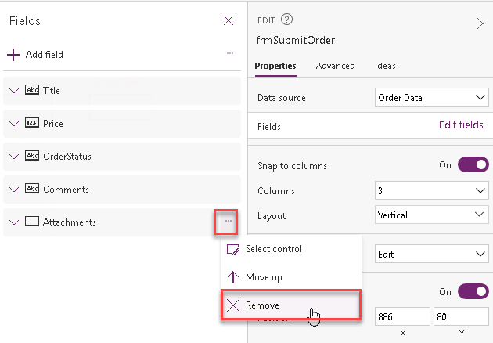
- Set Columns property to 1 and Default mode to New
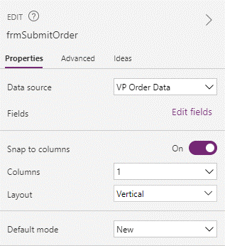

Task 2: Configure the title field

In the next few steps, you will configure each of the form fields.
- Let’s start by configuring Title form field to display the manufacturer and device name for the selected device.
For example, if the user selects the Surface Pro device, we want the device order to have the title: “Microsoft – Surface Pro.”
- Expand and select Title_DataCard
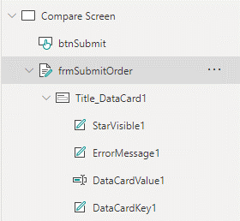
Notice that the default card contains a few controls:
- StarVisible1: This is a label control that has an asterisk (*) which has its Visible property set to true or false depending on whether the field is Required or not. Since the Title field was marked as Required when you configured the entity, its Required property is set to true.
- ErrorMessage1: This is a label that is just below the main data entry field which displays error messages.
- DataCardValue1: This is the text input control where you can enter the Title. For this scenario, we will set the title based on the selected device.
- DataCardKey1: This is the label that displays the title of the field.
- Select Title_DataCard1 and click Advanced
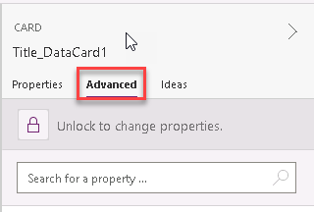
- Click Unlock to change properties, so you can customize the card
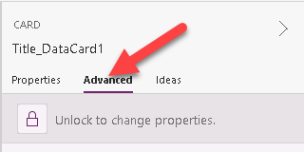
For the next few steps, we will use the Advanced properties pane to customize control properties within the form, note that you can perform the same customizations using the property drop-down, and formula bar in the top left of the studio.
- Change DisplayName and Required fields as below
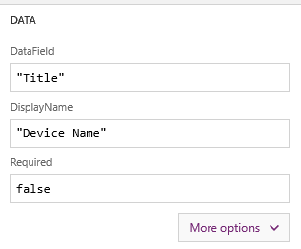
- To display the selected item in the Title field, set the Default property to
galCompareList.Selected.ManufacturerName & "-" & galCompareList.Selected.Title
{
Title: ThisItem.Title,
Price: ThisItem.Price,
OrderStatus: "In review"
}
)

Default

- Scroll down for the Advanced property pane till you reach the last property. We are going to change the Device Name field to be read-only.

- Change the DisplayMode to DisplayMode.View. This will prevent users from changing the value within the text box.
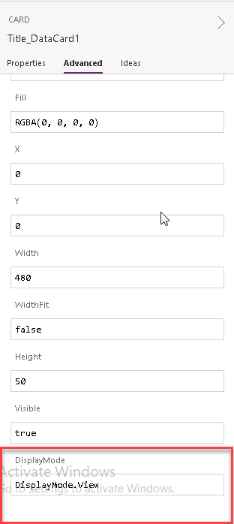

Task 3: Configure the Price and OrderStatus fields
In this task, we are going to set the price to the price of the item and then make it read-only.

- Expand Price_DataCard.
- Select the DataCardValue.
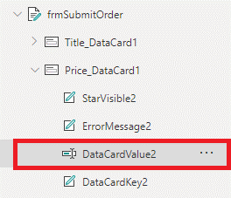
- Select the Advanced tab and click Unlock to change properties.
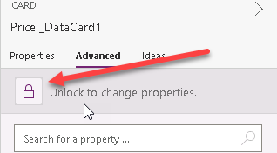
- Change the Default property to:
Text(galCompareList.Selected.Price,"[$-en-US]$##,###.00")
Default

for alternate/European locales, enter:
Text(galCompareList.Selected.Price; "[$-en-US]$##,###.00")
Default

- Select Price_DataCard and change the DisplayMode property to DisplayMode.View.
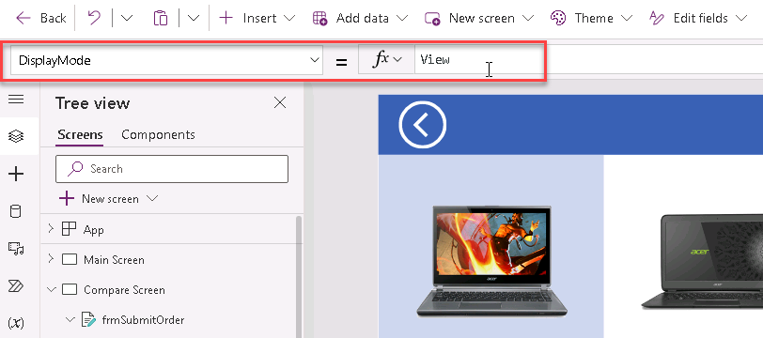
- Select OrderStatus_DataCard and in Advanced property tab Unlock to change properties
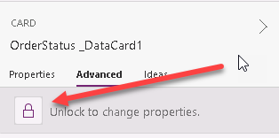
- For OrderStatus_DataCard, set DisplayMode to DisplayMode.View
- For OrderStatus_DataCard, set Default property as "Pending"

Task 4: Configure the Comments field

- Expand the Comments field and select the DataCardValue.
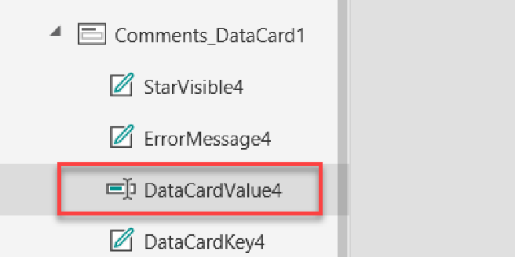
- Select the Advanced tab and Unlock to change properties.
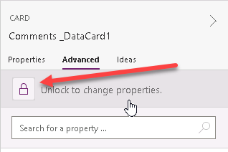
- Select DataCardValue4
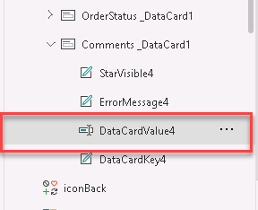
- Change the Mode to TextMode.MultiLine
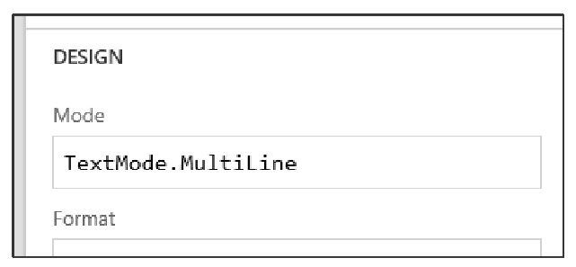
- Select the Properties tab and change the Size -> Height value to 80. 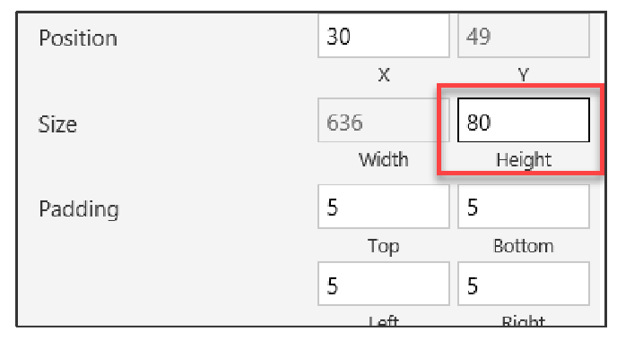
- Optionally, you may select the Text Input control DataCardValue4 and set its HintText property to: “Enter justification” (without quotes).
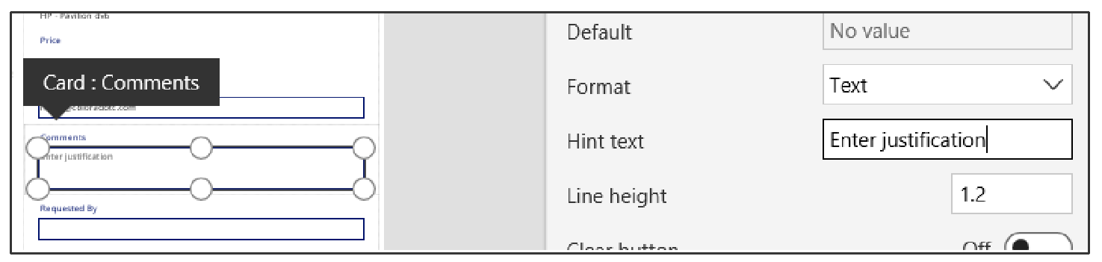

Task 5: Add a button to submit the form

- Select the Main Screen
- Copy the Compare button from the first screen, which has the correct color values.
- Go back to the Compare Screen and paste (Ctrl+V) the button.
- Position it in the bottom right of the screen, center aligned with the Form.
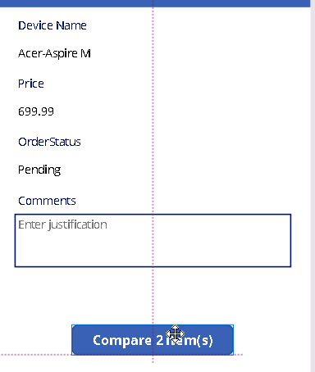
- Make the button larger – you can resize to 280x60 using the Properties pane on the right.
- Set the button’s Text property to “Submit device request”
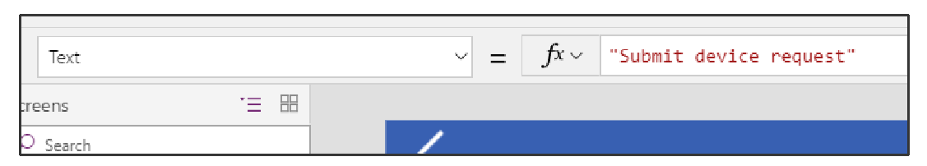
- Rename the button to btnSubmit
- The button should be enabled only if a device is selected. To do this, change the button’s DisplayMode property to:
If(!IsBlank(galCompareList.Selected), Edit, Disabled)
DisplayMode

for alternate/European locales, enter:
If(!IsBlank(galCompareList.Selected); Edit; Disabled)
DisplayMode

Note: You might notice the exclamation mark (!) in the formula !IsBlank() Normally if you just have IsBlank() the check is for blank. Adding the exclamation mark (!) in front of it changes it to check if it is NOT blank.

- Next, we are going to configure what we want to happen when the button is clicked. For btnSubmit, set the OnSelect property to:
Now, when the button is pressed, the form data will be submitted to the SharePoint list.
OnSelect
SubmitForm(frmSubmitOrder)

- Finally, the submit form should look like below:
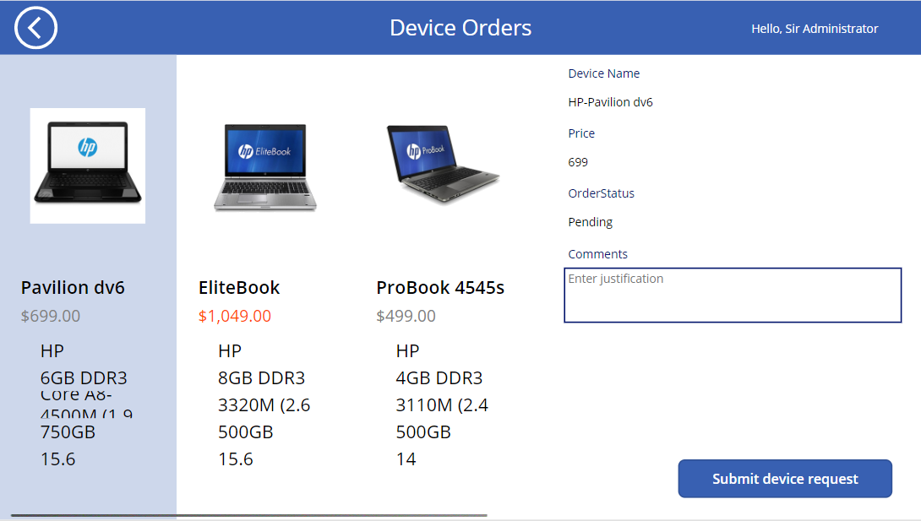

Task 6: On successful submission navigate to a new screen

- Create a new screen then choose Templates and select Success and rename it as Success Screen
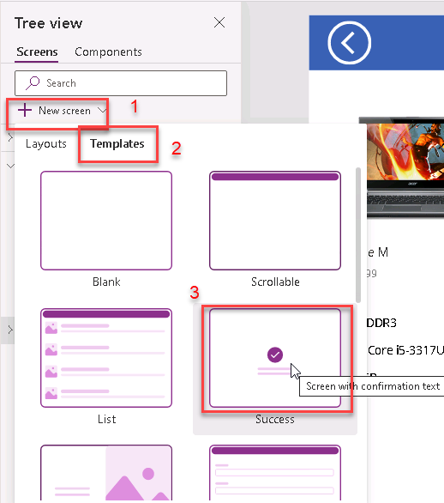
- Update the text of the new screen as shown below “Device request was successfully completed”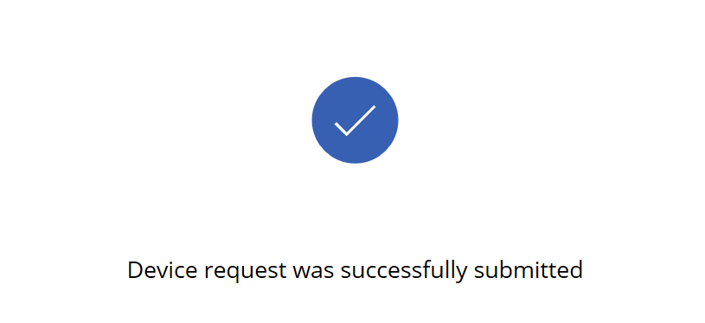
- Insert a Timer control to the Success Screen, then rename it to timerSuccess
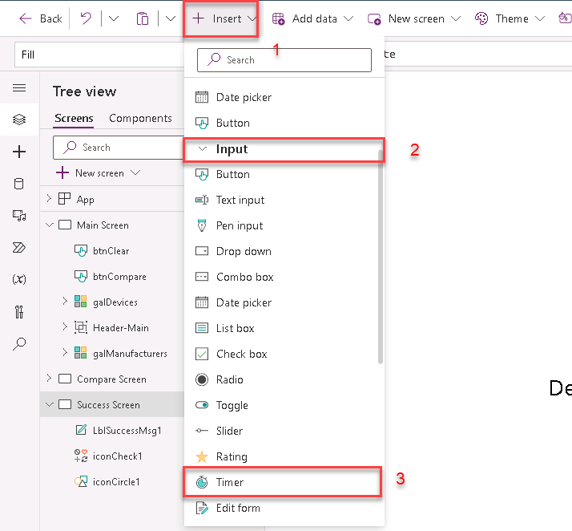
- Select timerSuccess and in Advanced property pane specify the following:
OnTimerEnd: Navigate('Main Screen')
Duration: 3000
Reset: true
AutoStart: true
Visible: false (optional, to make timer invisible)
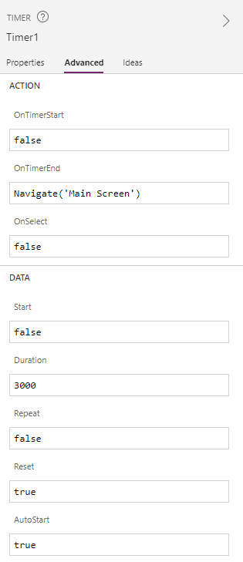
- Select Compare Screen > frmSubmitOrder > Advanced, set OnSuccess value:
OnSuccess
Navigate('Success Screen', ScreenTransition.Fade)

for alternate/European locales, enter:
OnSuccess
Navigate('Success Screen'; ScreenTransition.Fade)

Task 7: Verify successful submission

- Test application by selecting a few laptops and by submitting an order for one of them. Make sure that navigation between screens works correctly.
- Browse to the SharePoint list with Order Data
- Make sure successful submissions are stored in the list.
