Lab Module 4.1:
Build your own Power Automate flows in
an easy-to-use visual designer
WorkshopPLUS – Power Platform: Power Apps for Power User

Published: May 2022

Table of contents
Lab overview 1
Introduction 1
Objectives 1
Prerequisites 1
Estimated time to complete this lab 1
Scenario 1
Exercise 1: Creating the approval flow 2
Task 1: Create a new flow 2
Task 2: Lookup the requestors line manager 4
Task 3: Add an approval 7
Task 4: Add a condition 10
Exercise 2: Testing Device Orders solution 17
Task 1: Testing the compare device functionality 17
Task 2: Testing the flow 19

Lab overview

Introduction
In this lab, you will perform the actions necessary to build your own flows in an easy-to-use visual designer.

Objectives
After completing this lab, you will be able to:
- Add triggers to flow
- Add steps to flow
- Add Actions to flow
- Configure ‘Send an Email’ action in flow
- View all your Power Automate flows
- View flow history
- View flow run details
- Test your solution: app and flow working together

Prerequisites
Ensure you are using the “Incognito” or “InPrivate” browsing session of your modern browser.
Additionally, use the latest version of Microsoft Edge (aka Edge Chromium) for the best performance.

Estimated time to complete this lab
30 mins

Scenario
The organization wishes to automate business processes using the Power Automate to take advantage of No Code/Low Code workflow automation. As part of this effort, you are required to create approval flow for your device orders.

Exercise 1:
Creating the approval flow

In this exercise, you will be introduced to Microsoft Power Automate.
You will learn how to build a basic approval flow for the device ordering process.

Task 1: Create a new flow

- In the browser, go to https://make.powerautomate.com/
- In the top right of the screen, click Sign In
- Before creating a flow, switch to the correct environment (where your organization permits development apps to be created).
Click the Environments drop-down in the top right of the screen to switch to the correct environment.
Ask instructor if you have doubts.
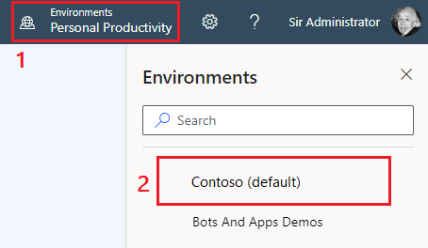

- In the left navigation, click Create
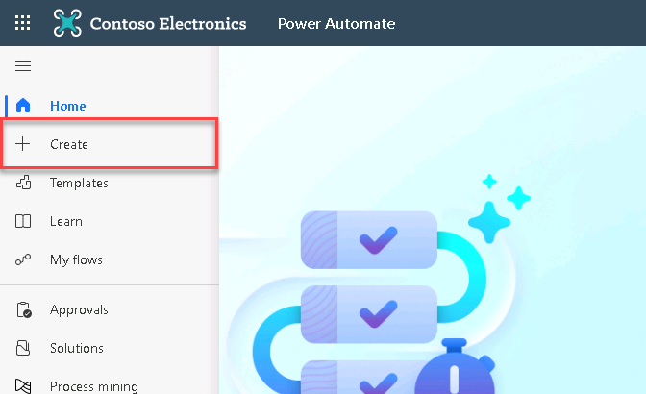
- In the Create screen, select the ‘Automated flow’ option
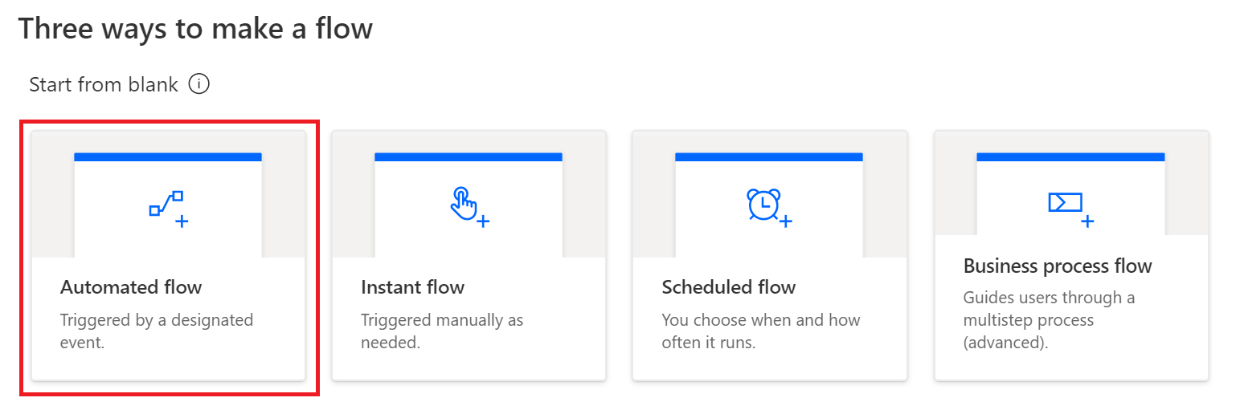
Tip: Flows are started with a ‘Trigger’. There are three basic triggers to start a flow:
- Automated: designated events will start the Flow; for example: a new item created in a SharePoint list
- Instant: Flows are started manually by the user
- Scheduled: Flows are started at a frequency specified; for example: every day at 10:00 hours

- In the ‘Build an automate cloud flow’ dialog, enter Purchase approval in the Flow name box, select ‘When an item is created’ (SharePoint) and finally click Create
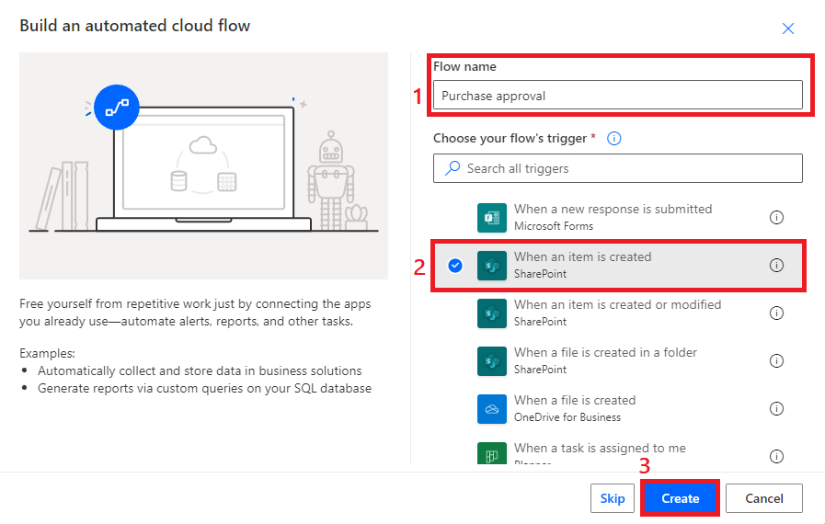
- Click in the Site address input box, select Enter custom value and type/ paste the URL of the SharePoint site that you created for Order Data, and in the List name drop down, select your Order Data list
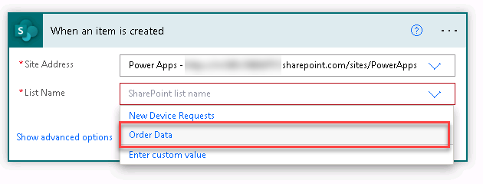

Task 2: Lookup the requestors line manager

- Click New step
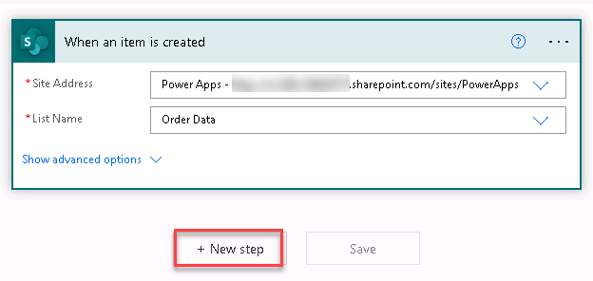
- In the Choose an action dialog, enter Office 365 Users in the search box. Then select Office 365 Users from the results pane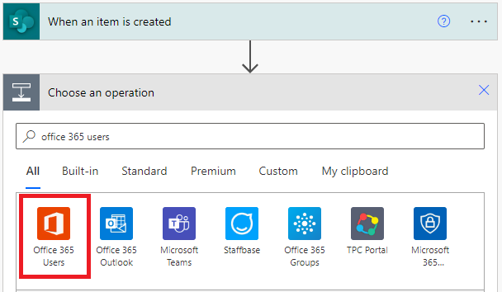

- In the actions list, select Get Manager (v2)
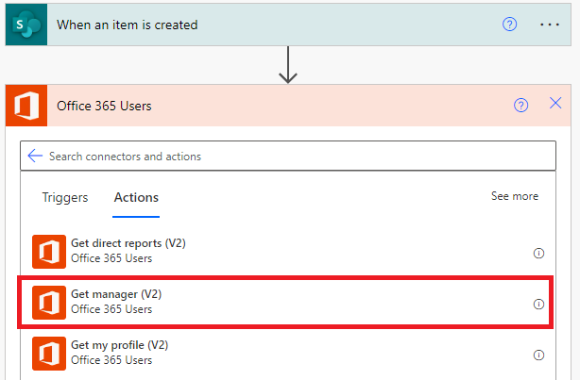
- Click on the ellipsis (…) and select ‘Rename’
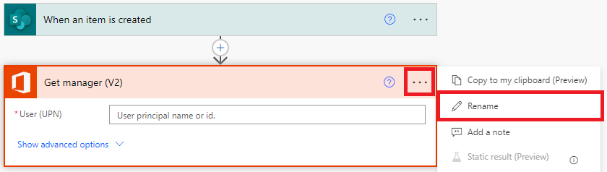
- Enter ‘Lookup user manager’
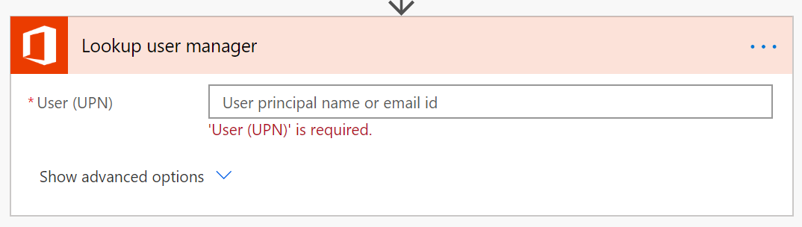
- Click the ellipsis (…), then select ‘Add a note’. In the comment box, enter ‘This step looks up the requester manager’
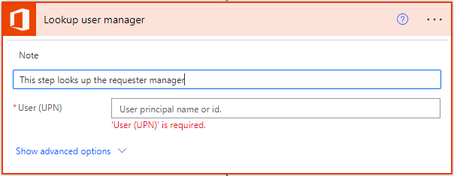

Tip: Renaming actions and providing comments is a good practice as it ensures that co-owners of the flow understand the context and purpose of specific actions.

- Click inside the User (UPN) box and select ‘Add a dynamic content’ icon
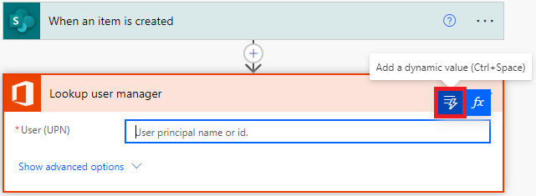
- Search for Created by Email property retrieved from SharePoint trigger
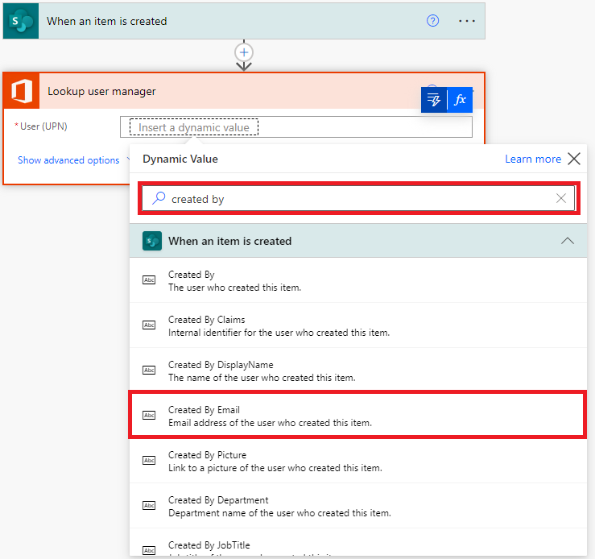
- The flow should now look like the screenshot below
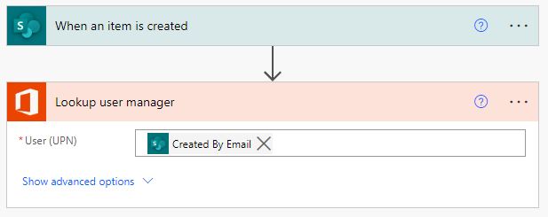

Task 3: Add an approval

In this task you will learn how to use the Approvals connector.
Note: If your organization blocks this via DLP (Data Loss Prevention) policies, then you will not be able to proceed with this task.

- Click New step
- In the search box, type ‘Approvals’ and then select Approvals
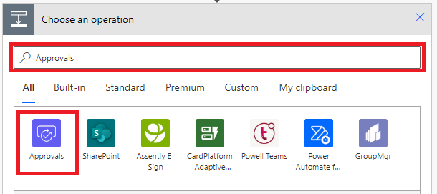
- From the list of available actions, select ‘Create an approval’
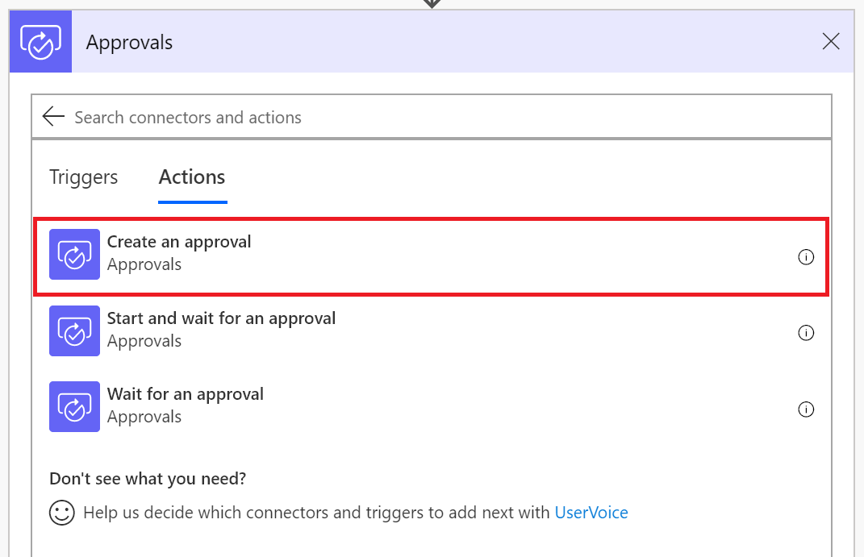
- In the approval type drop-down, select ‘Custom responses – wait for one response’

- In the Create an approval action, enter the following:

- Response options item 1: Approve
To add an additional response option click “+ Add new item” button
- Response options item 2: Reject
- Title: New device request approval
- Assigned to: Enter YOUR OWN email
- Details: You have received a new device request from (select ‘Created By DisplayName’ from the When an item is created trigger in dynamic content)
- Item link: Select Link to item from the ‘When an item is created’ trigger
- Item link description: Enter any link description text

- The ‘Create an approval’ action should look the same as the screen shot below:
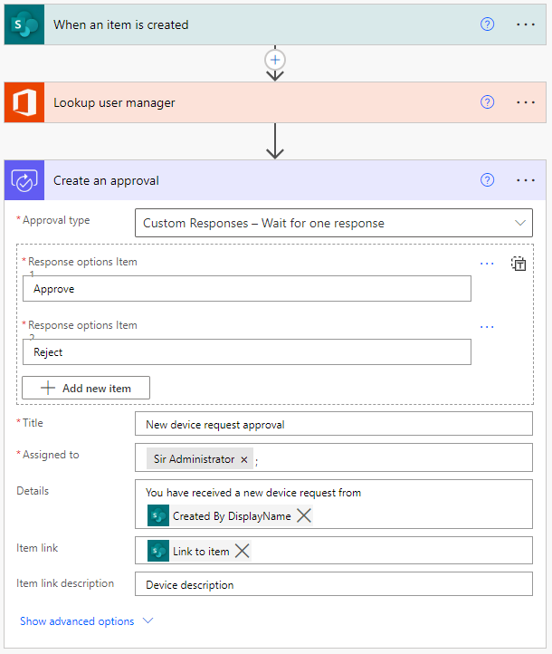
Note: We are not using manager email to avoid sending it to your manager as a part of this lab
- Click ‘New step’
- Type ‘Approval’ in the search box, then select ‘Wait for an approval’
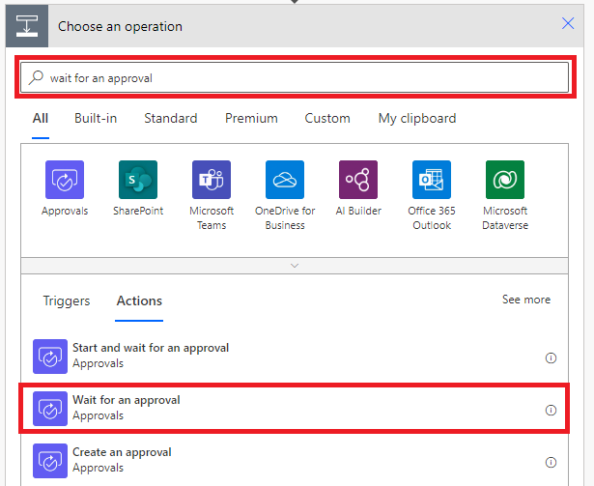
- Click the ellipsis (…), rename the step ‘Wait for approval decision’
- Click the ‘Approval ID’ box, and from the dynamic content dialog, select ‘Approval ID’
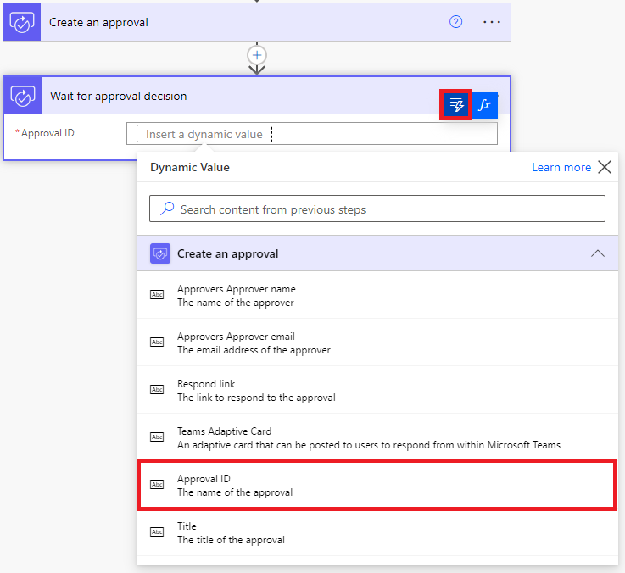

Task 4: Add a condition

In this task you will learn how to add in a condition. A condition action handles specific conditions in your Flow, such as ‘If a property equals a value’, or ‘If a property is greater than a value’.
- Click ‘New step’
- In the actions window, select ‘Condition’
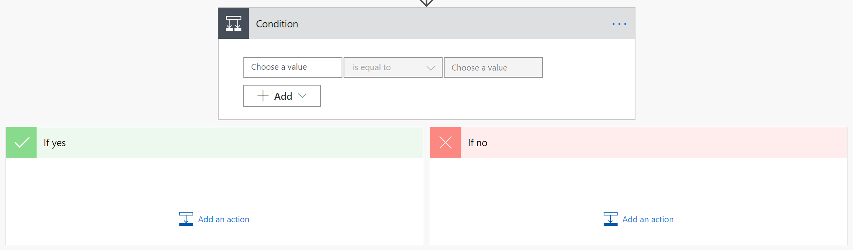
- Click the ellipsis (…), then rename the step ‘Approval decision’, and add in a comment ‘This condition handles the approval or rejection of the request’
- Click inside the ‘Choose a value’ box and from the dynamic content dialog, select ‘Outcome’
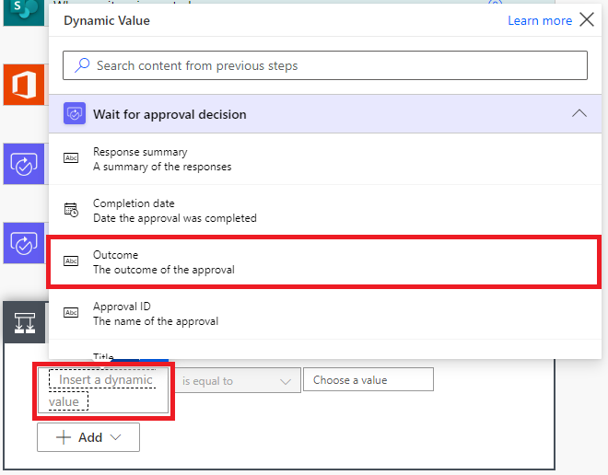
- Check that ‘is equal to’ is selected, and in the ‘Choose a value’ box type Approve

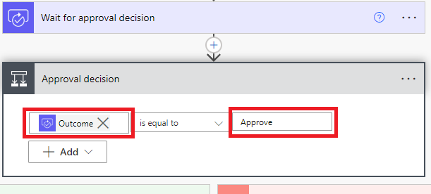
- In the ‘If yes’ branch of the condition, click Add an action
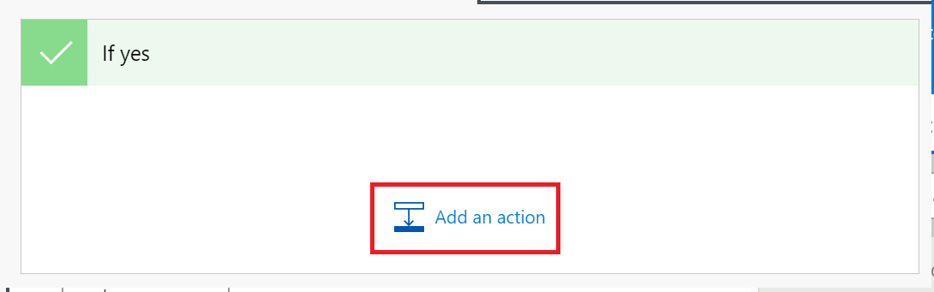
- In the search box type Email and from the list of available connectors, select Office 365 Outlook. From the list of available actions, select ‘Send an email (V2)’:
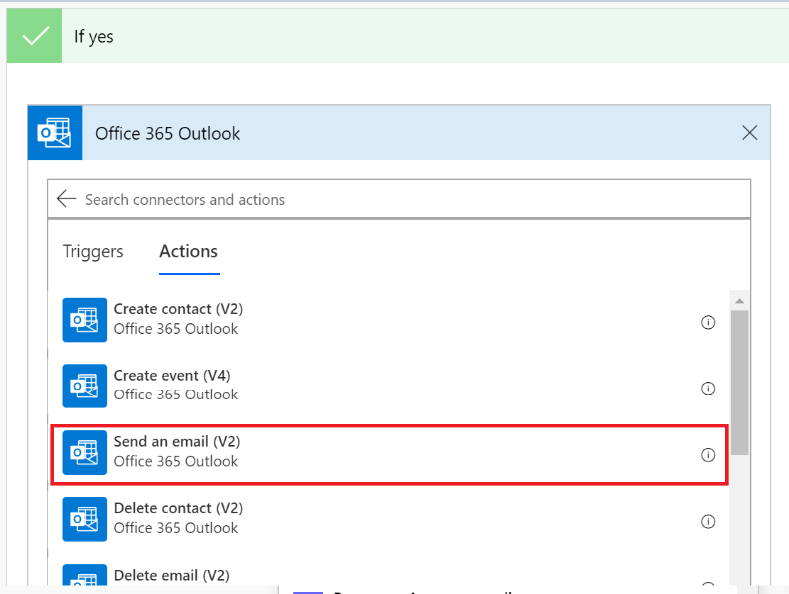

- Rename the action ‘Confirmation Email’
- Click inside the To box, and then ‘Add a dynamic value icon’
- Select ‘Created By Email’ from the dynamic content area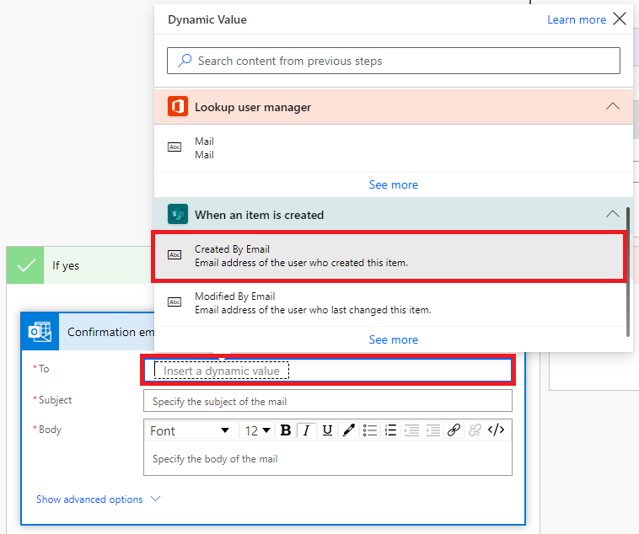
- In the subject box, type: Confirmation of your device order
- In the body area, type the following, note: the blue properties (Created By DisplayName & Title) are taken from the dynamic content dialog:
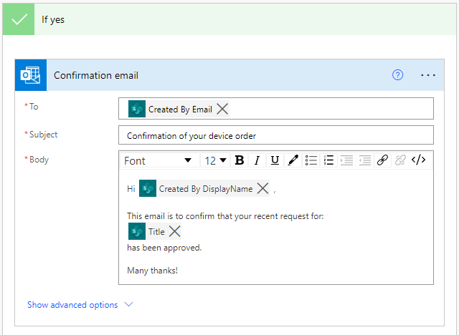
- Click ‘Add an Action’
- In the ‘search connectors’ box, type SharePoint
- Select SharePoint in the list of connectors
- Scroll down and select ‘Update item’
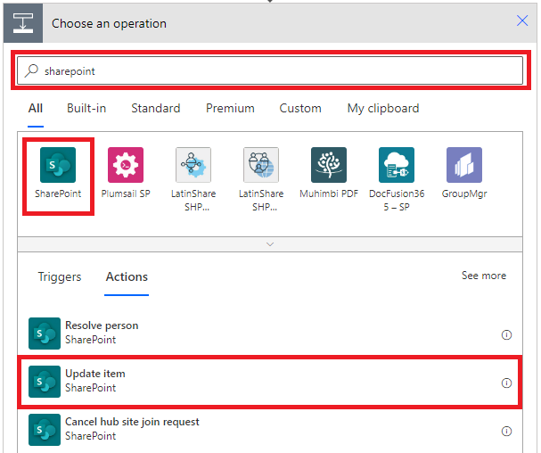
- In the Site Address box, enter the URL of the SharePoint site
- Select the your Order Data list from the List drop-down
- In the Id field, select ID from the dynamic content dialog
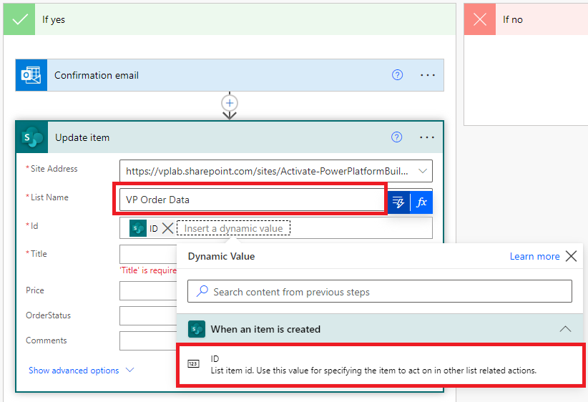

- In the Title & Price fields, select the correct property from the dynamic content dialog.
- In the OrderStatus field, enter: Approved
Your action should look like the following screenshot:
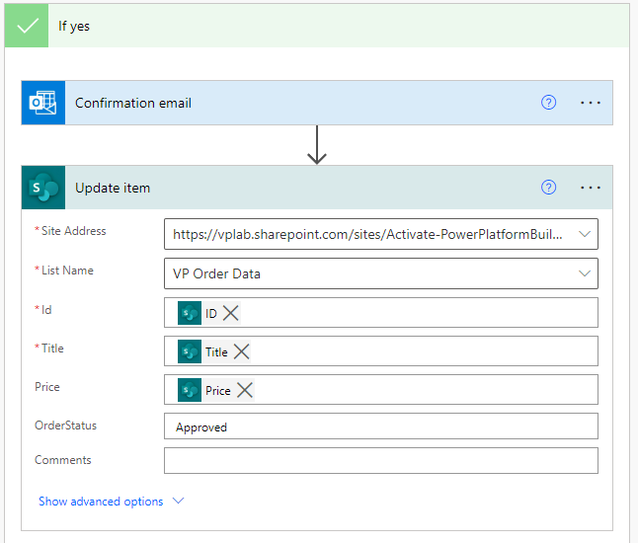
- Now click Add an action in the If no branch of the condition
- In the connector search box, type Office 365 Outlook
- From the list of actions, select Send an email (V2)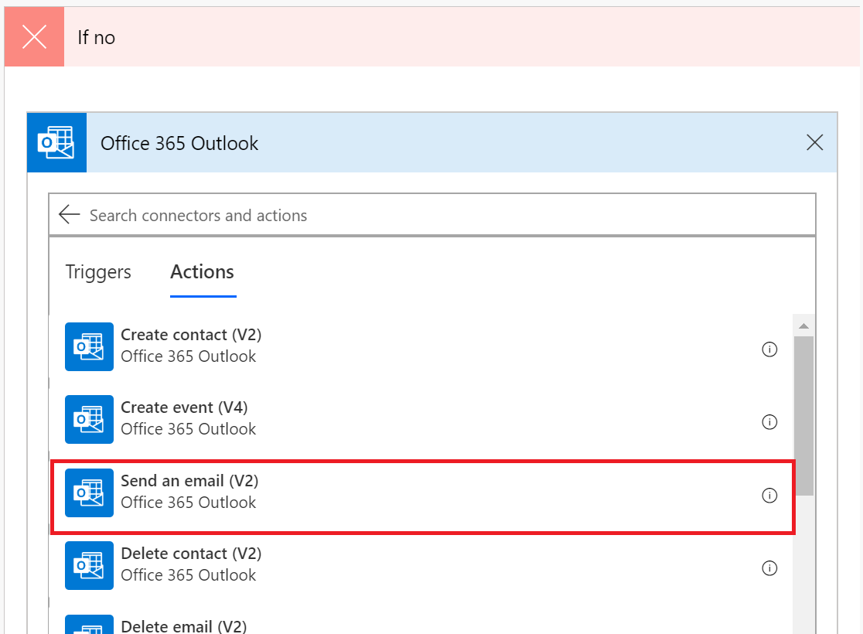
- Rename the action to Rejection email
- Enter the following information:

- To: Created By Email (from dynamic content)
- Subject: Update about your device order
- Body: Hi ‘Created By DisplayName’ (from dynamic content),
This email is to confirm that your recent request for:

Title (from dynamic content)

Has been rejected,
Many thanks
- Your action should look like the following image: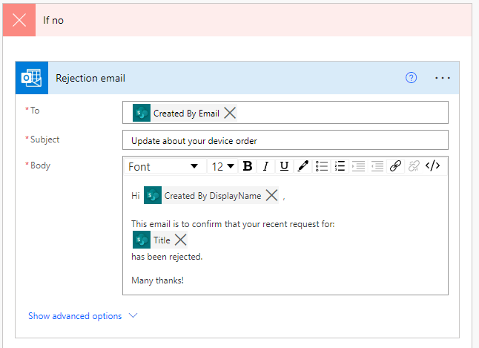
- In the If no branch, click Add an action
- In the search connectors box, type SharePoint
- From the list of actions returned, select Update item
- Enter the following information:
- Site Address: Enter the URL of your SharePoint site
- List Name: Select the your Order Data list
- Id: Select ID from the SharePoint trigger
- Title: Select Title from the SharePoint trigger
- Price: Select Price from the SharePoint trigger
- OrderStatus: Enter ‘Rejected’

- Your action should look the same as the image below:
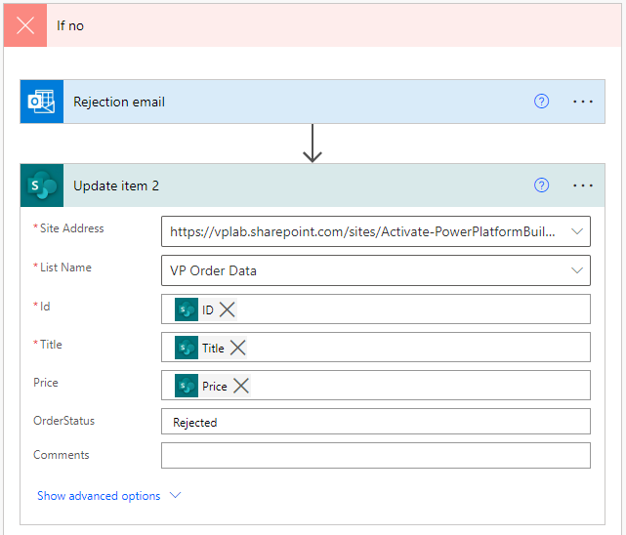
- Save your flow

Exercise 2:
Testing Device Orders solution

It is a good idea to save and test your app regularly. There are a few ways in which you can test your app:

- Hold the Alt key down and click on controls to activate the functionality
- Enter preview mode (F5)
- Play the app

In this exercise you will run through some tests of your app

Task 1: Testing the compare device functionality

In this task you will perform some tests in your app.

- Go to the Main Screen and Preview the app by clicking the Play button in the top right
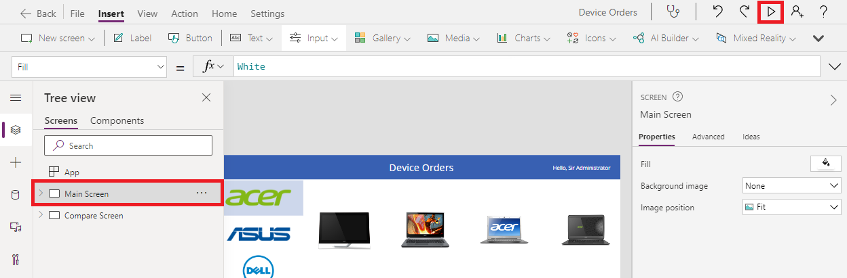
- Uncheck if there are any checked devices
- Select Microsoft on the left to show a filtered set of devices
- Check the compare box on a few devices on the main screen from a few different manufacturers
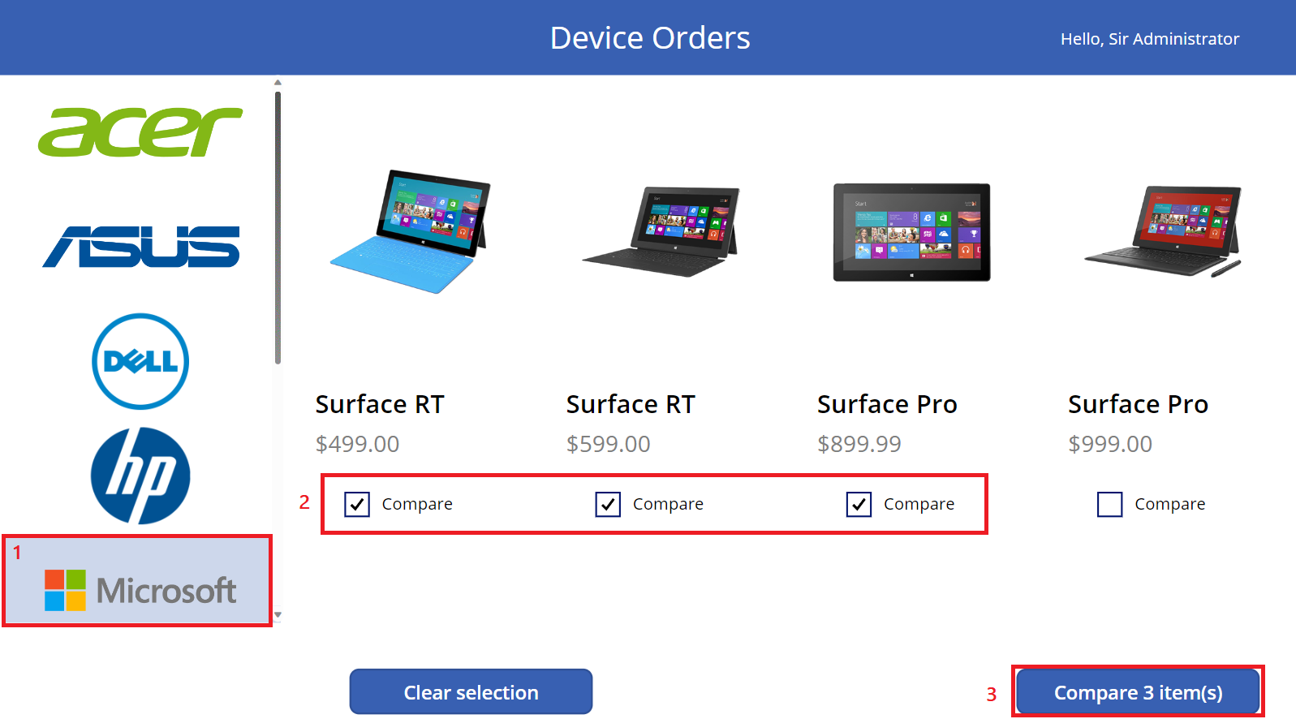

- Click on different devices in the gallery and verify that the selection highlight works.
- Click the Back button and confirm you get back to the main screen
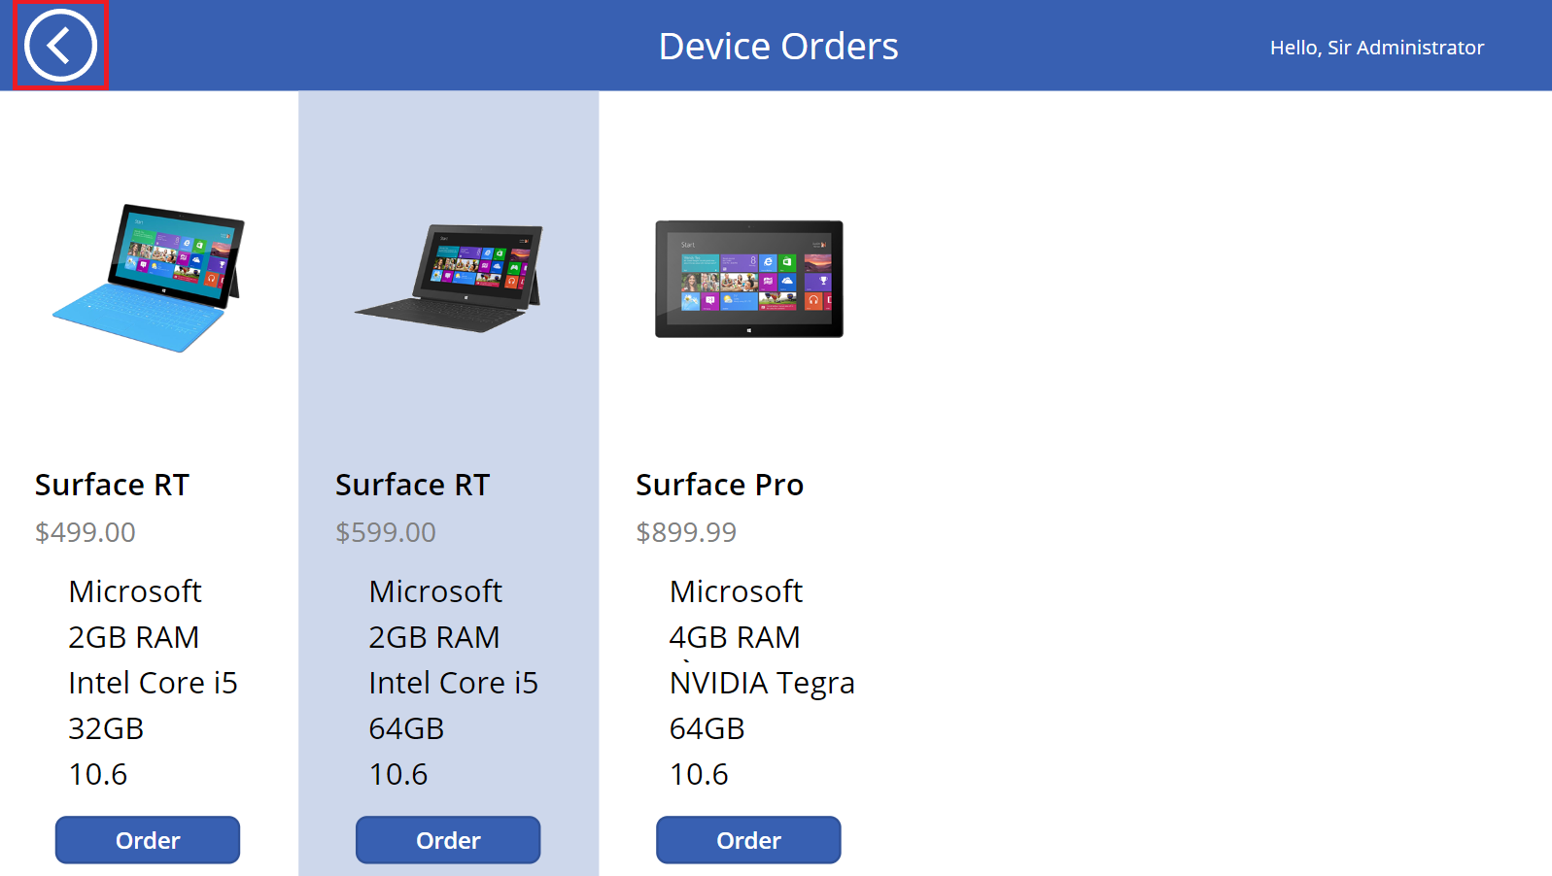
- Click Clear Selection
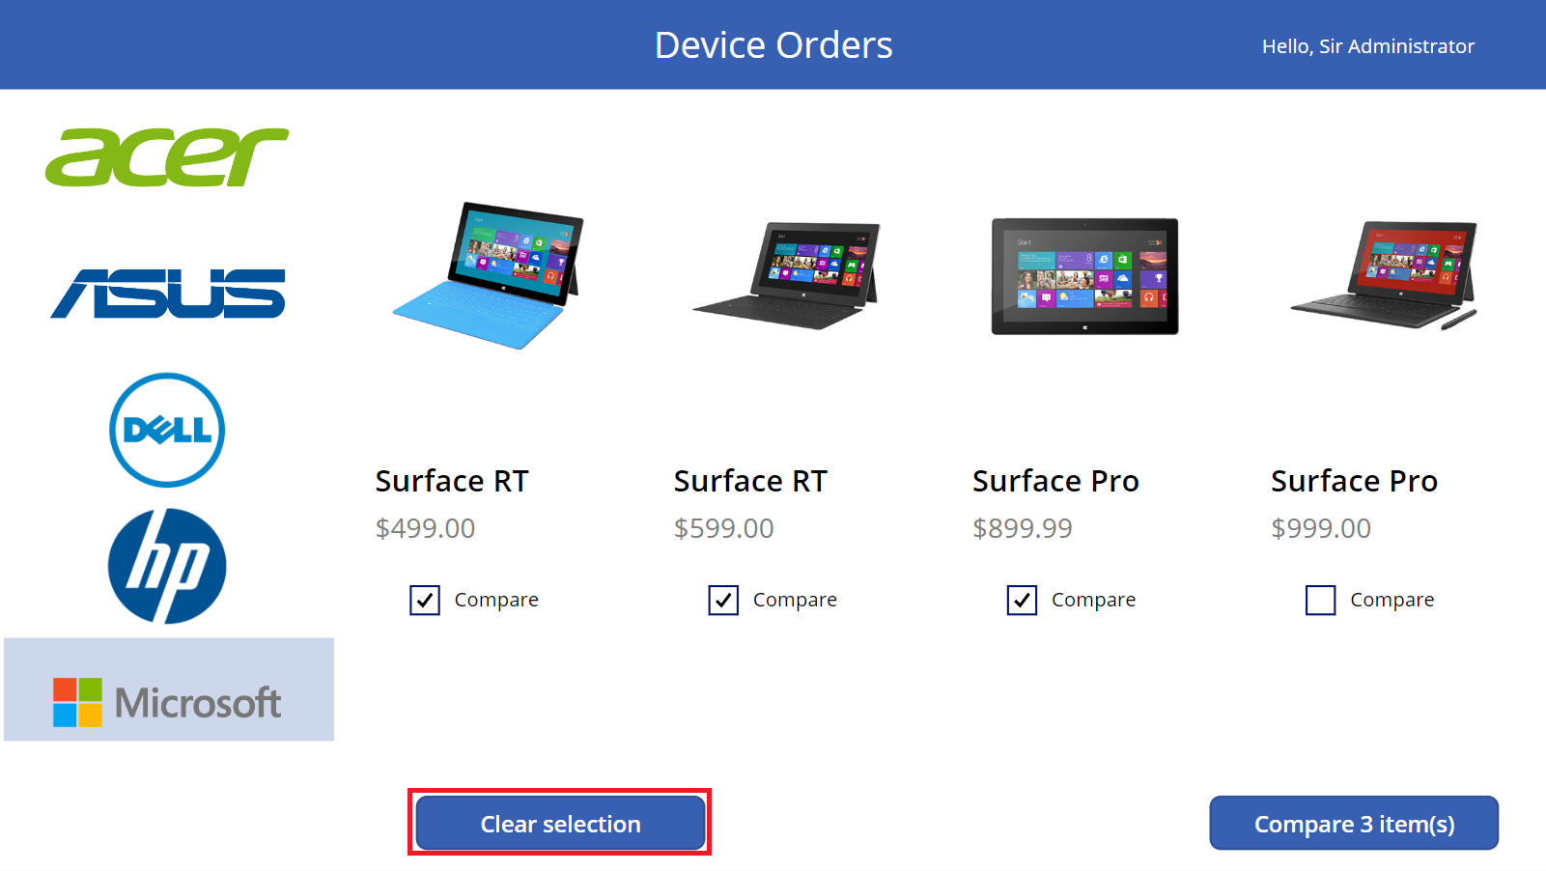
- The CompareList collection will clear, and the Compare button will become disabled
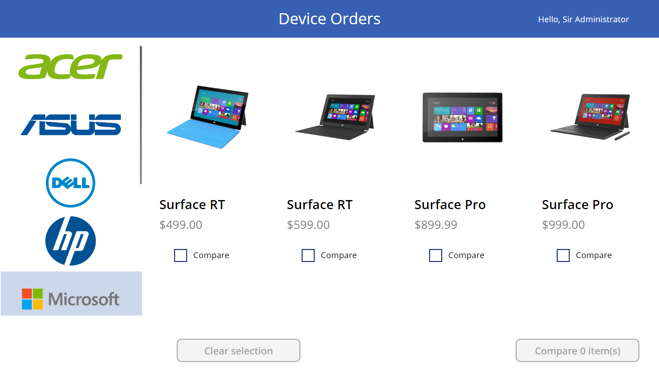
- Close the preview

Task 2: Testing the flow

In this task, you will test the flow. When a device order is placed, a corresponding item is created in SharePoint. Creation of this list item will trigger the flow

- Go to https://outlook.office.com and confirm that when you place a request for a new device, you receive the following email:
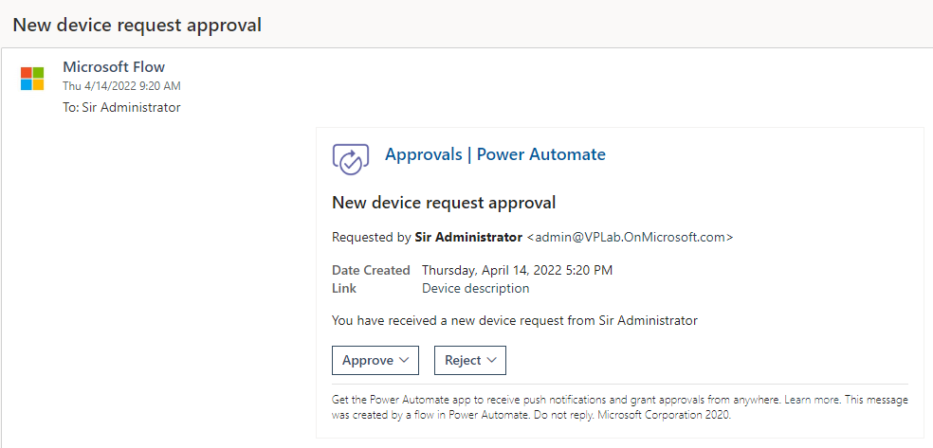
- Click ‘Approve’
- Click ‘Submit’
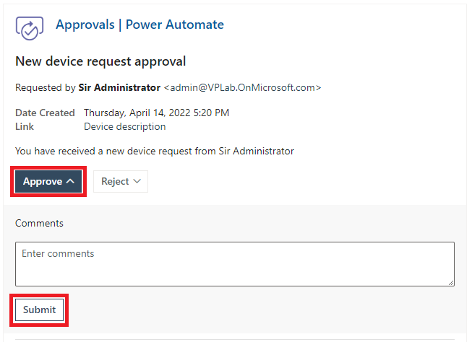
- Go to the SharePoint site and confirm that the request OrderStatus column has been updated to ‘Approved’
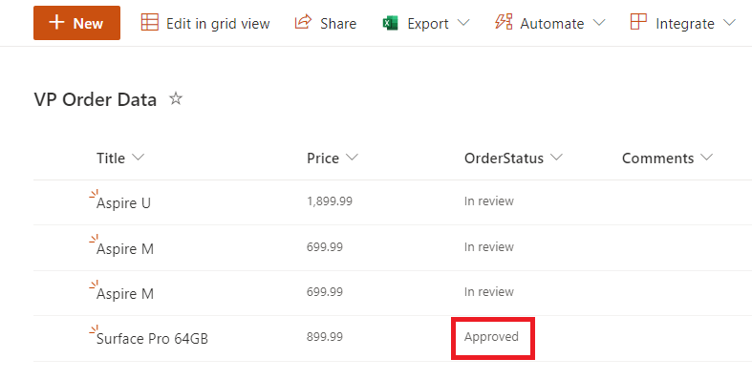
- Go back to Outlook and check that you have received the approval email
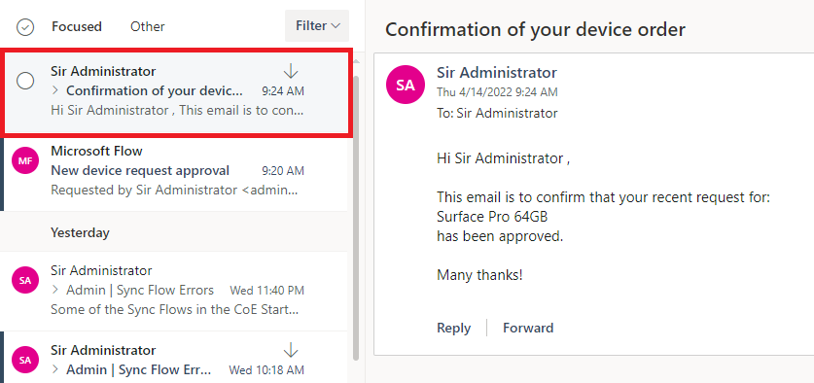
- Follow from Step 1 again, this time reject the request.
- Check that the SharePoint list item OrderStatus column is updated and that you receive the rejection email

