Lab Module 5.1 (Optional):
Connect the data from the canvas app, and implement an AI Builder form processor
WorkshopPLUS – Power Platform: Power Apps for Power User

Published: September 2022

Contents
Lab overview 1
Introduction 1
Objectives 1
Prerequisites 1
Estimated time to complete this lab 1
Scenario 1
Exercise 1: AI Builder 2
Task 1: Create the form processing model 2
Task 2: Create a new app and add the model to it 14
Task 3: Adding model fields 16

Lab overview

Introduction
Now that you have created the list to store device order requests, let’s connect your Device Orders app to this entity and add a form to submit device approval requests.

Objectives
After completing this lab, you will be able to:
- Connect SharePoint list as data source
- Configure AI Builder form processor
- Configure and add form
- Submit Form

Prerequisites
Ensure you are using the “Incognito” or “InPrivate” browsing session of your modern browser.
Additionally, use the latest version of Microsoft Edge (aka Edge Chromium) for the best performance.

Estimated time to complete this lab
45 mins

Scenario
The organization wishes to build apps using the Power Apps platform to take advantage of No Code/Low Code application development in the cloud. As part of this effort, you are required to add new data source (SharePoint list), configure, add and submit form, add/remove gallery controls, manipulate the navigation, and test the functionality of your app.

Exercise 1: AI Builder

In this exercise, you will learn how to use AI builder to create a form processing app.

Note: Prerequisites – you should ensure that before attempting this module, that you have saved the five sample invoices to a local folder.

Task 1: Create the form processing model

In this task, you will learn how to create a form processing model. Form processing identifies the structure of your documents based on examples you provide to extract text from any matching form.

- Navigate to https://make.powerapps.com , then select AI Builder -> Explore in the left navigation menu
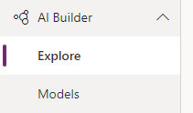
- Click Start free trial (or Extend trial if you tried it before)
- Select Form Processing – Extract custom information from documents
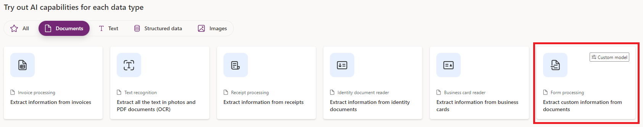

- In the next dialog click Get started
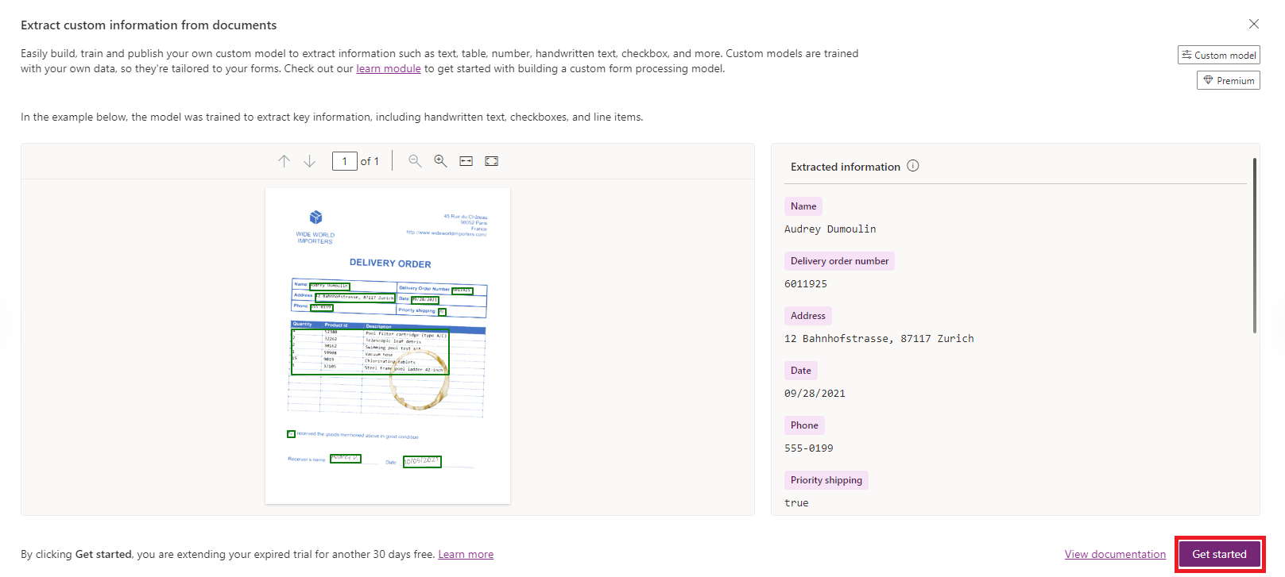
- In the top right corner click on Form Processing model name
and rename it to Contoso Invoice processing
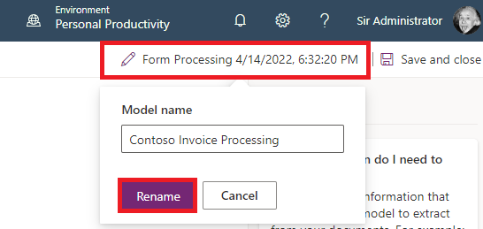
- Click Rename
- Select Structured documents and click Next
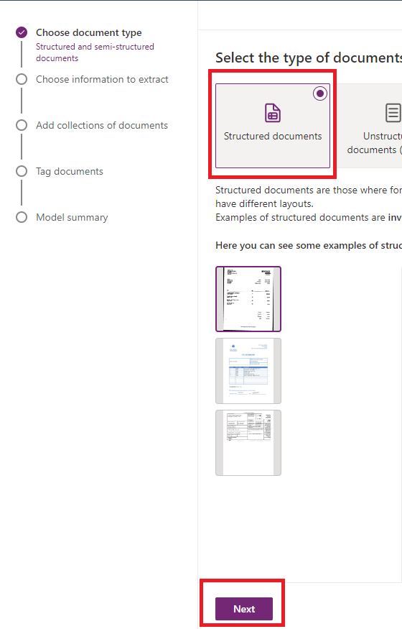

- In ‘Choose information to extract’ step, click +Add button
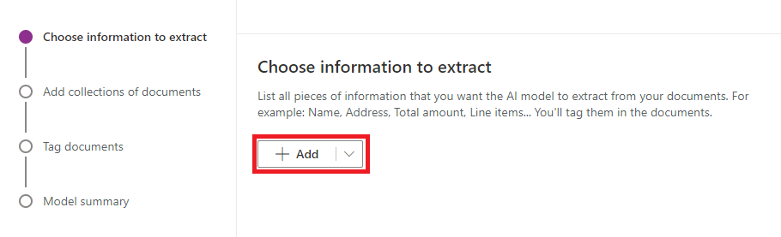
- In Add dialog, select Field, and click Next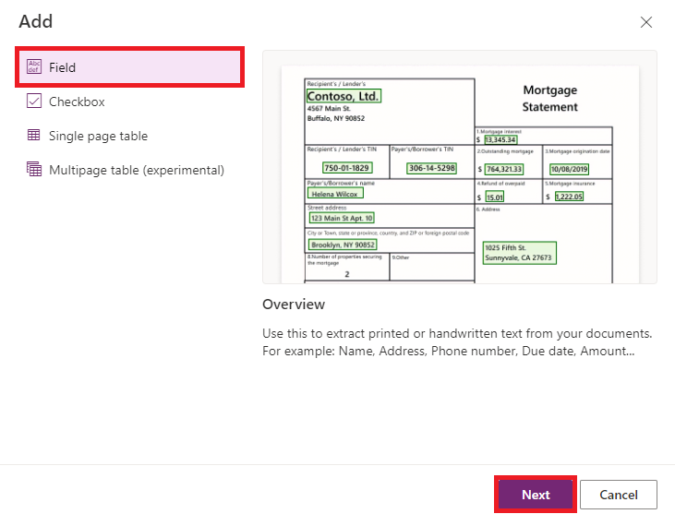
- Set the name of the field as Address
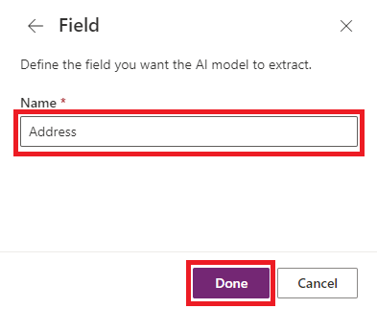
- Repeat steps 7-9 to add Date, Comments, Total Price fields
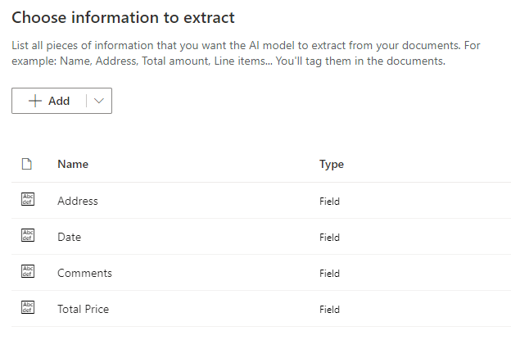

- In ‘Choose information to extract’ step, click +Add button

- In Add dialog, select Single page table, and click Next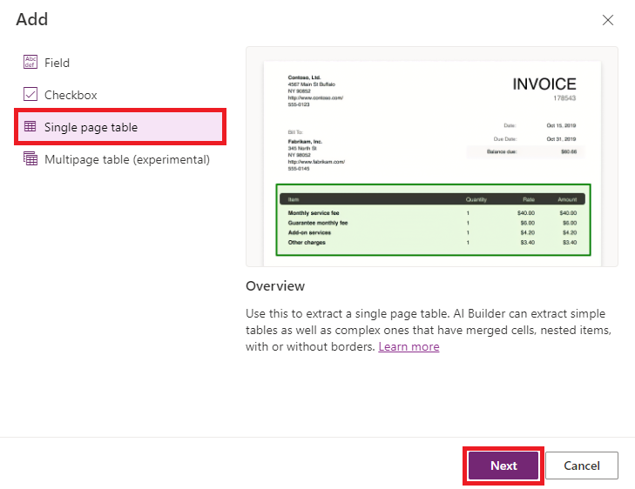
- Set the name of the field as SalesPeople and set up the following columns:
Salesperson, PO Number, Requisitioner, Shipped via, FOB Point, Terms
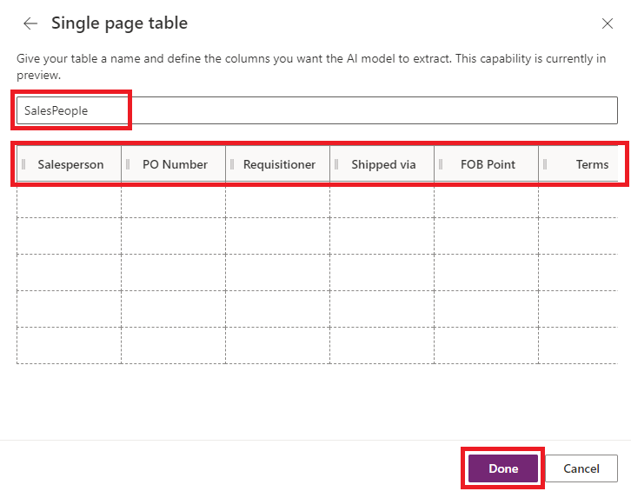
Click Done

- Add one more single Page table called OrderItems with the following columns: Quantity, Description, Unit Price, and Total
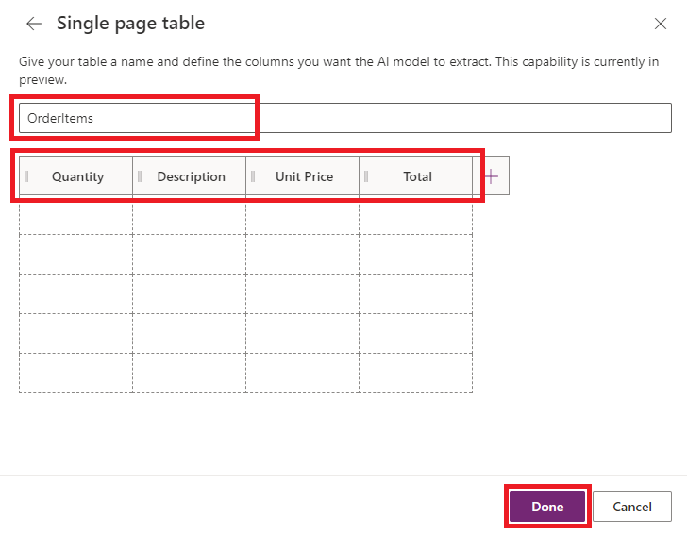

- Check that you have all the required fields and tables and click Next
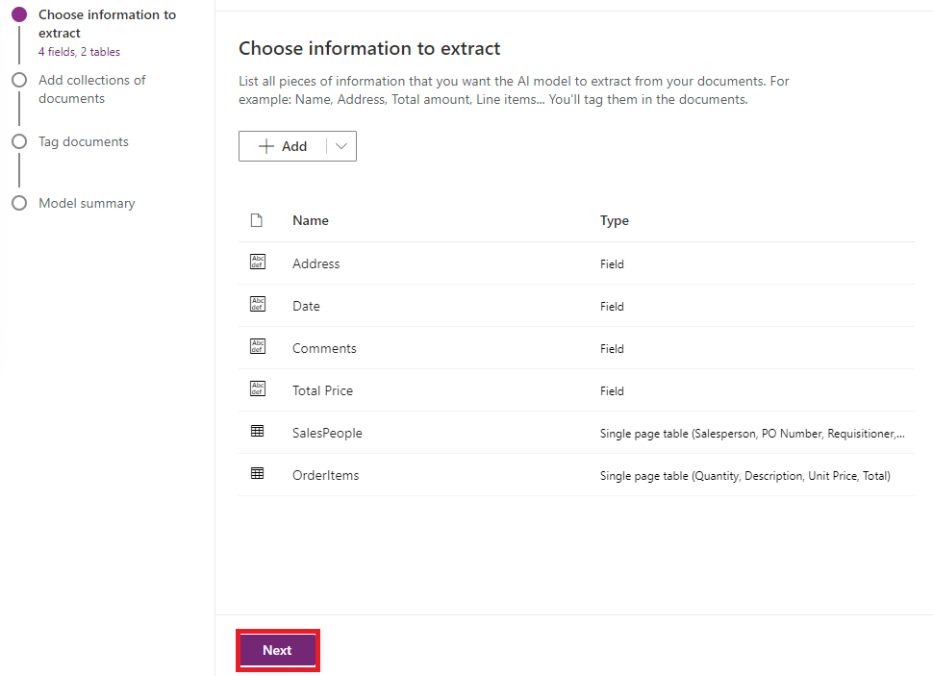

- In ‘Add collections of documents’ step, click New collection button
- Then click on Collection 1 that was just added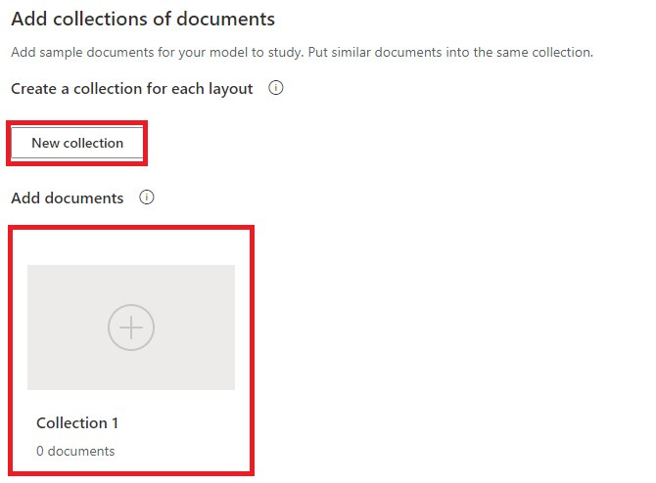
- In right side panel for Collection 1, click Add documents button
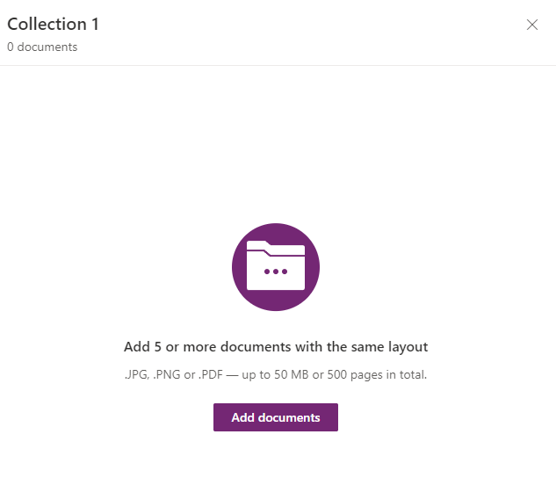
- Select Upload from local storage
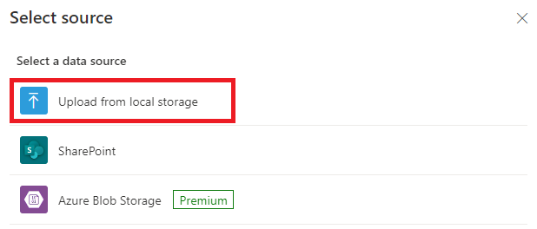
- Browse to the location where you have saved the five example invoices and select all
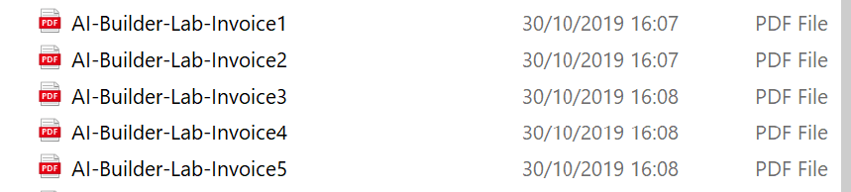
- Check that all files are selected to use for the model
- Click Upload 5 documents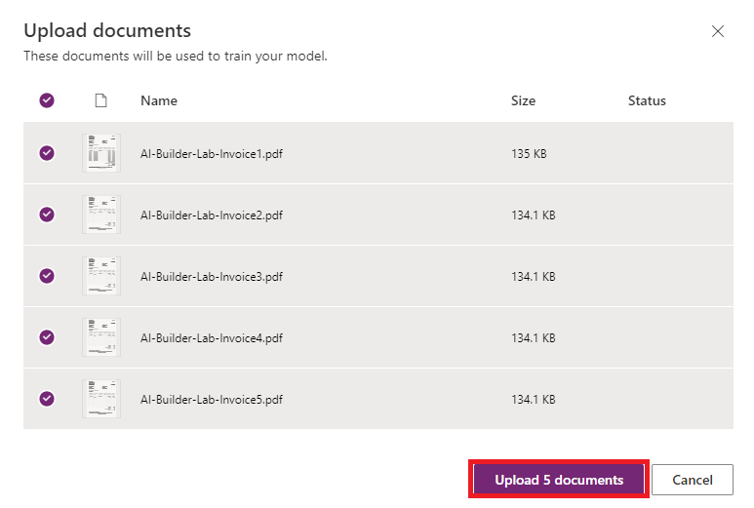
The upload feature will complete, check that green ticks appear next to all files
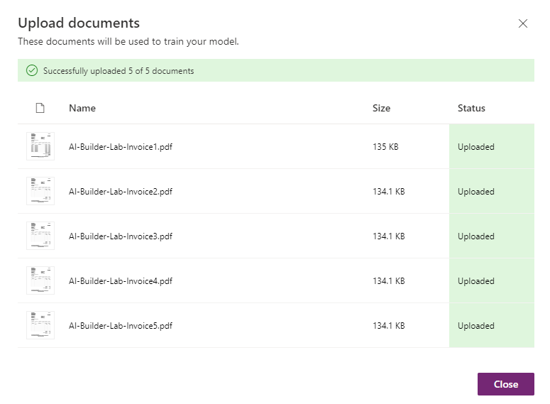
- Click Close

- Click Next and wait for analysis to complete
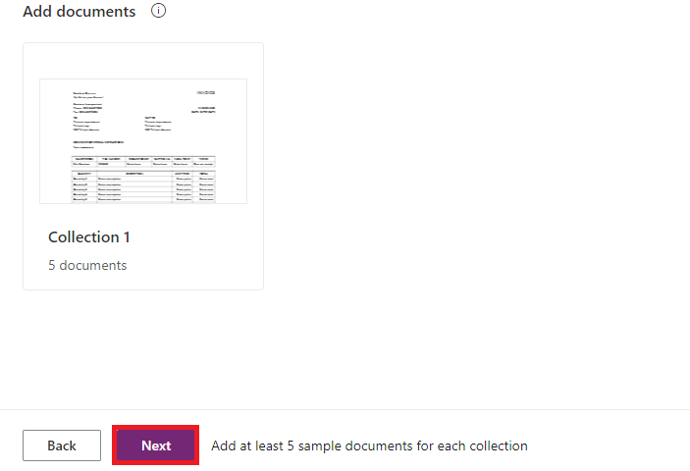
- In ‘Tag documents’ step, you will need to tag fields and tables that we defined before for each uploaded document
Select region of the document with cursor and assign one of existing field/table tags.
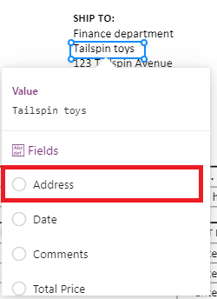
- When tagging SalesPeople and OrderItems table, you will also need to tag each column in special Advanced tagging mode
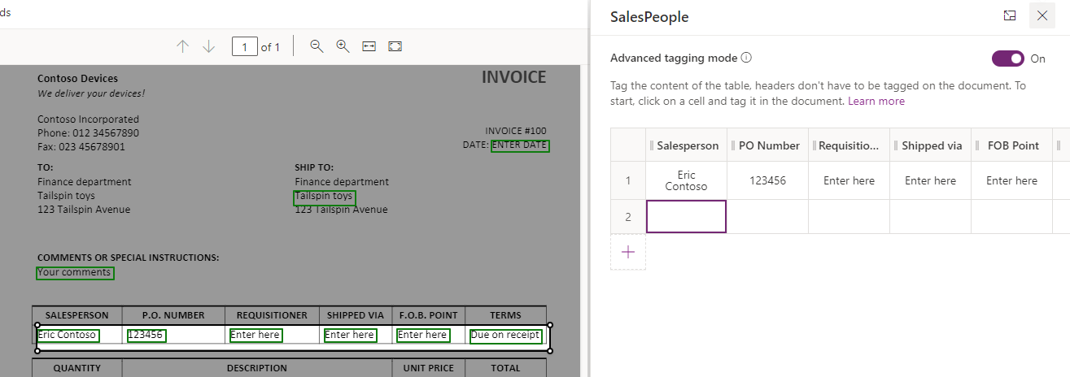
After tagging all the uploaded documents, click Next
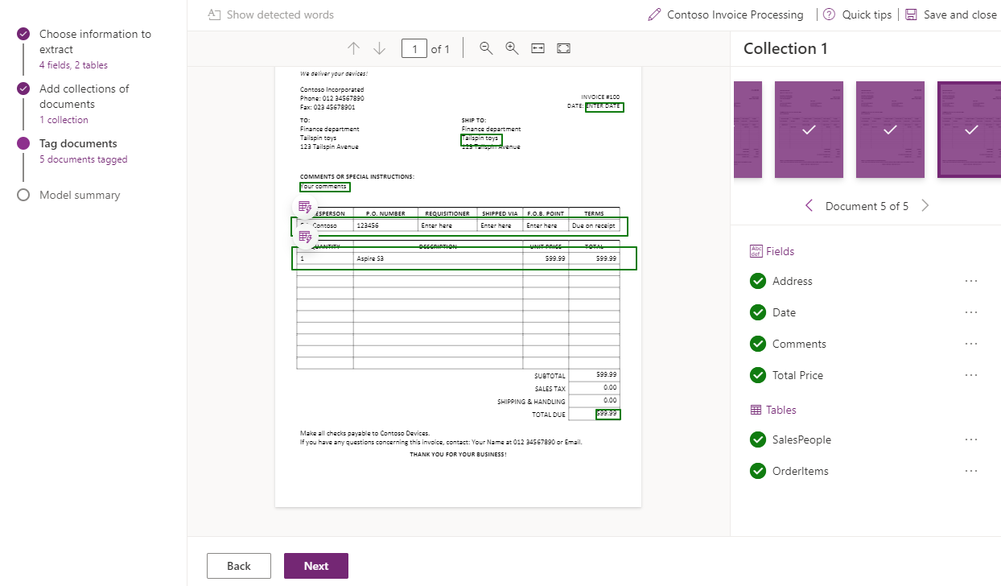
- Review Model summary and click Train button
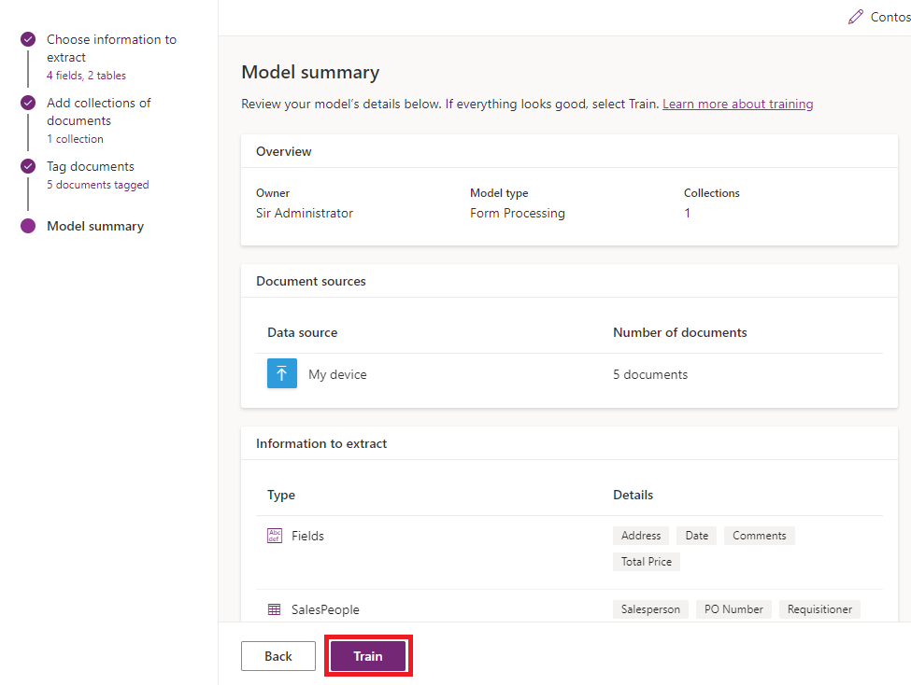
- Wait while you model is training, then click Go to models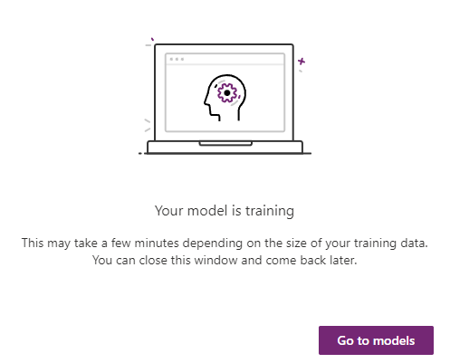
Note: Wait until the Status column has completed training. Select your model once completed
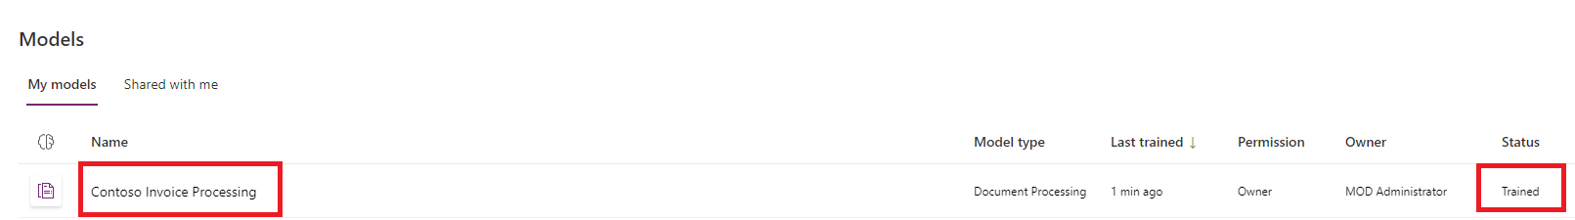

- Click Quick test
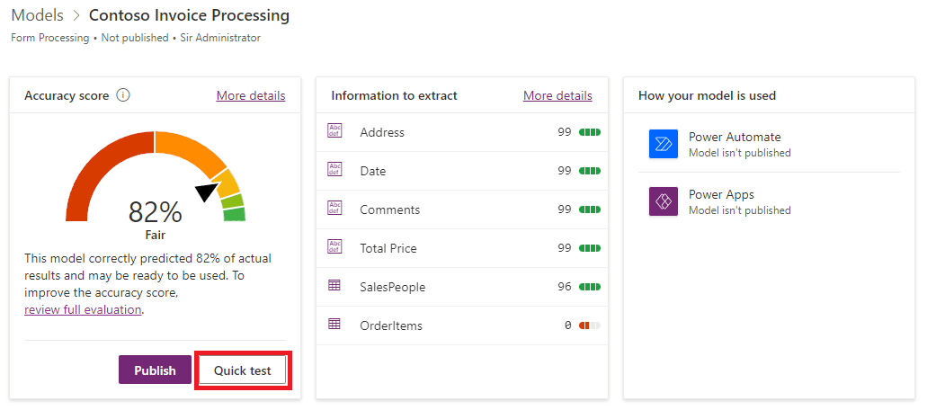
- Upload one of the invoices from your local folder and check that fields and tables are recognized correctly
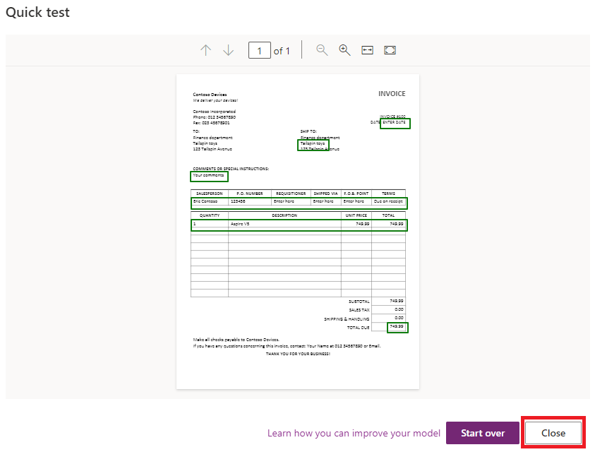
Click Close
- Click Publish and wait till the model gets published
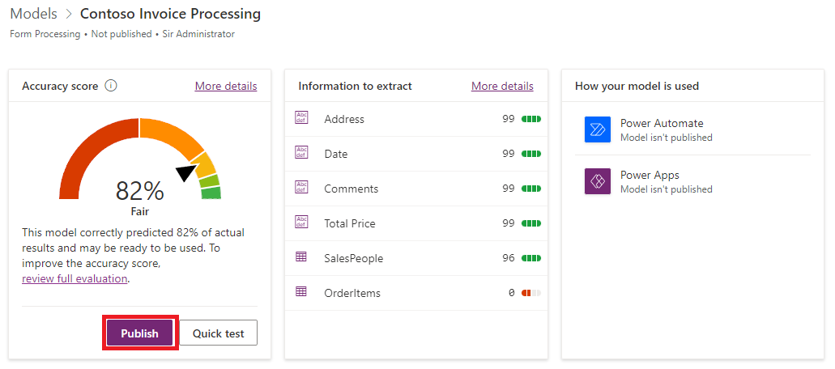

Task 2: Create a new app and add the model to it

In this task, you will add the form processing model to a new PowerApp.

- Browse to https://make.powerapps.com
- Click Create new app
- Click +Blank app -> Canvas app
- In the App name box, enter AI Builder Demo
- Click Insert in the command bar
- Click AI Builder
- Select Form processor
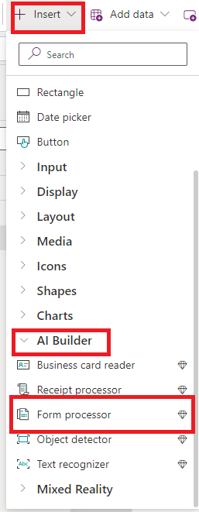

- In the AI model dialog, select the Contoso Invoice Processing model that you created in Task 1.
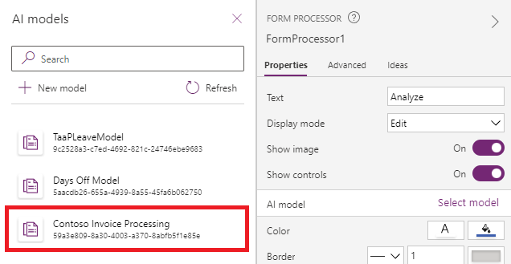
- Resize the form processing control
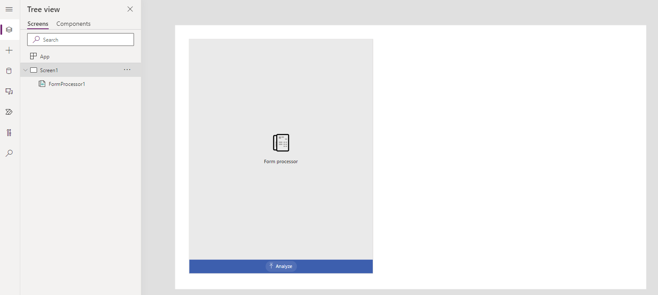

Task 3: Adding model fields

In this task, you will add in data fields from the Contoso Invoice Processing model and display them in the app. You will then add a few test invoices to check that the model is functioning as expected.

- Click Insert on the command bar
- Click Text label
- Move the label to the top center of the screen
- Rename the label lblCustomerAddress
- In the Text property, enter the following expression
Text
"Customer: " & FormProcessor1.Fields.Address
- Click Insert on the command bar
- Click Data table
- Move the data table to the right hand side of the screen
- From the properties drop-down, select Items
- In the formula bar, enter the following expression
Items
FormProcessor1.Tables.OrderItems
- In the right-hand property pane, click Edit fields
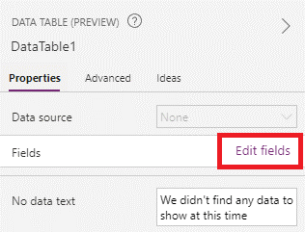
- In the Data dialog, click on Add field then in the Choose a filed list, select all fields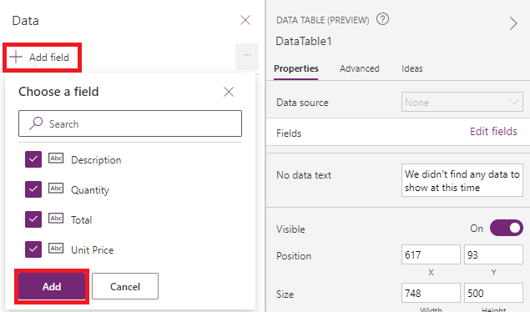
- The Data dialog will display each field, you can move these fields to reorder table columns
Close the dialog when you are ready
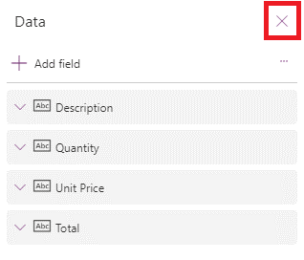
- Your app should look like the image below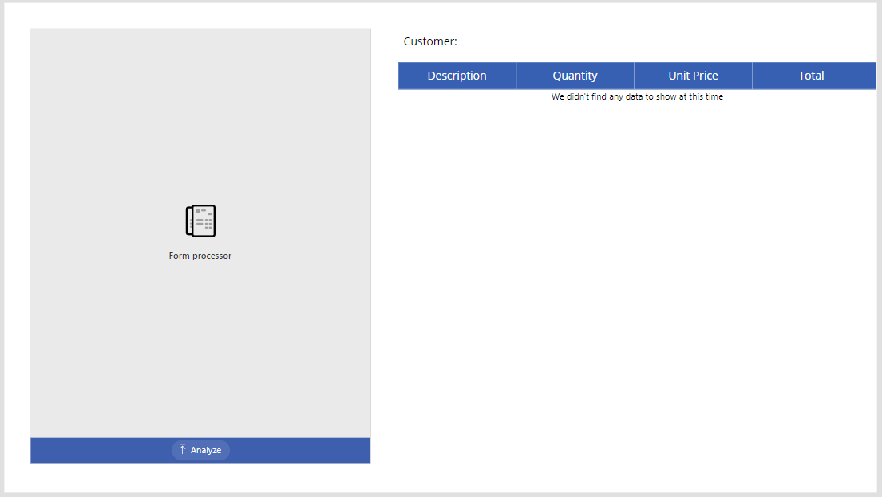
- Enter preview mode (F5)
- Click Analyze
- In the file explorer window, browse to the location where you have saved the invoice files and select one
- Click Open
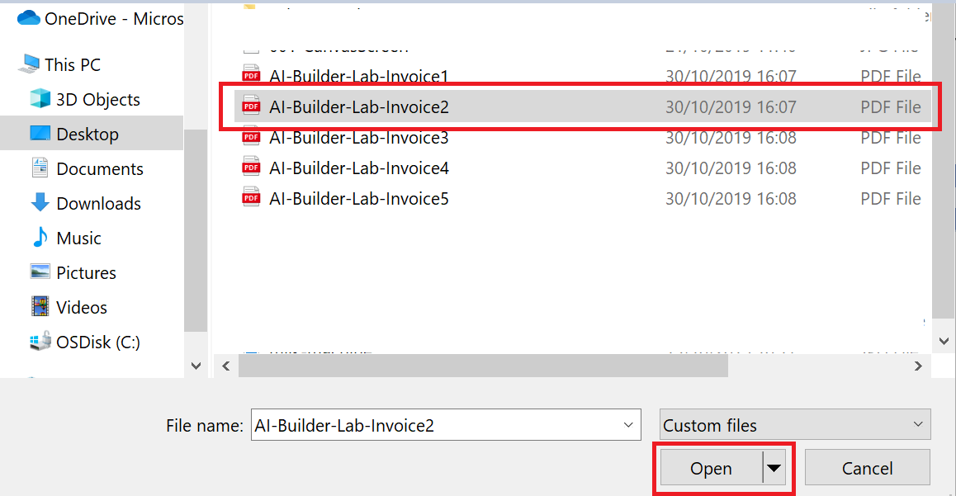
- After a short delay, the table should be populated with data from the invoice:
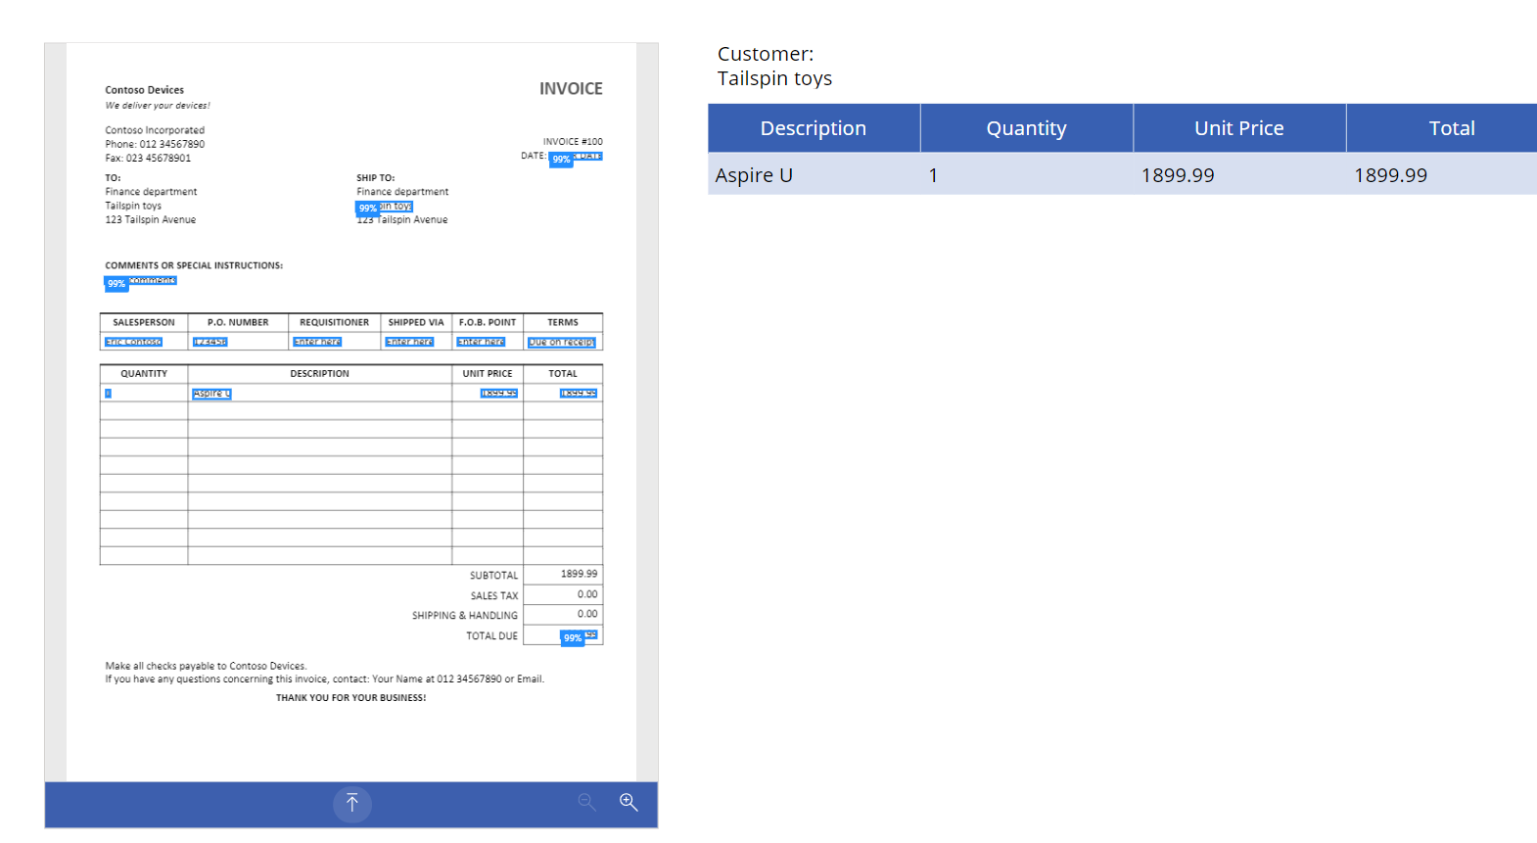
Test again with a few other invoices.
Lab is complete.

