|  |
| --- |
|  |

Lab Module 0:  
Prerequisites

WorkshopPLUS – Power Platform: Power Apps for Power User

Published: September 2022

Contents

Task 1: Create a new SharePoint site and lists 2

# Task 1: Create a new SharePoint site and lists

1. In the search bar start typing “**SharePoint**” and then select proposed app

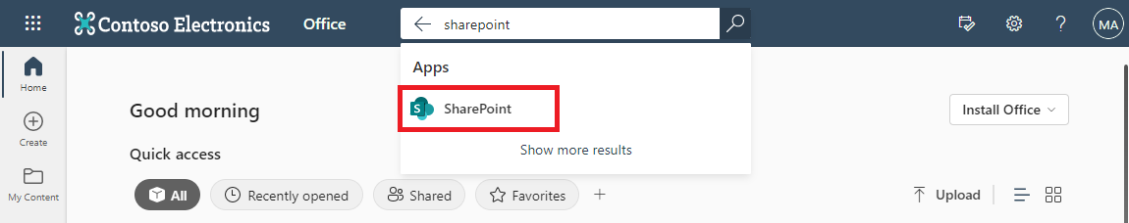

1. In the SharePoint home page, select **+Create Site**, and create **Team Site**.

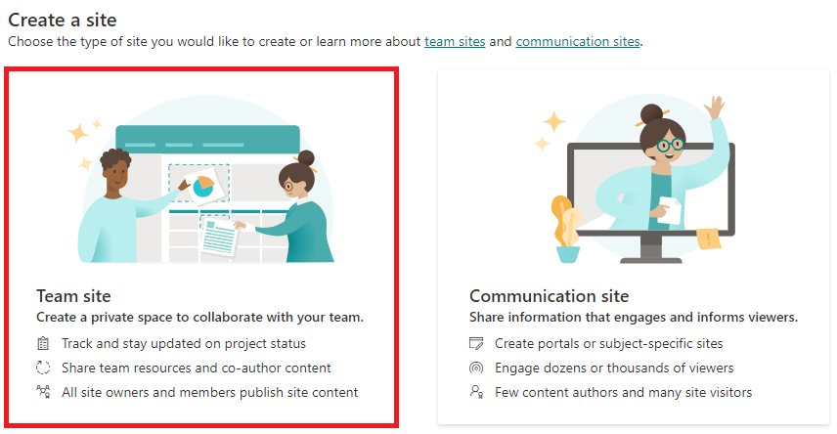

1. Input “Power Apps” as the site name and click **Next**, then click **Finish** and you will be redirected to the site you just created.

1. Go to the SharePoint site you created in the previous step and select **+ New** > **List**. Under “Create a list”, select **Blank list**.

1. Name the list as “**Order Data**” and select **Create**.
2. The **Title** column exists out-of-box and will be used later **DO NOT rename it**. Add the following columns to the list:

* **Price** (number)
* **OrderStatus** (single line of text)
* **Comments** (single line of text)

1. Go to the SharePoint site that you have created and select **+ New** > **List**. Under “Create a list”, select **Blank list**.
2. Name the list as “**New Device Requests**” and select **Create**.

1. Add columns to the newly created list.

* **Price** (number)
* **Processor** (single line of text)
* **Memory** (single line of text)
* **Storage** (single line of text)
* **Screen Size** (single line of text)

After adding all columns, **New Device Requests** should look as shown below:



