Lab Module 1:   
Starting with connectors, screens, and controls

WorkshopPLUS – Power Platform: Power Apps for Power User

Published: September 2022

Contents

Lab overview 3

Introduction 3

Objectives 3

Prerequisites 3

Estimated time to complete this lab 3

Scenario 3

Exercise 1: Creating the app 4

Task 1: Sign into Power Apps 4

Task 2: Create a new app 5

Task 3: Rename the screen 6

Task 4: Save the application 7

Exercise 2: Building the app header 10

Task 1: Add a header containing the app name and logged in user’s name 10

|  |
| --- |
| Lab overview |

## Introduction

In this lab, you will start to design Power Apps by renaming the screen and adding headers.

## Objectives

After completing this lab, you will be able to:

• Rename screens in Power Apps

• Add and manipulate the label control in Power Apps

Prerequisites

Ensure you are using the “Incognito” or “InPrivate” browsing session of your modern browser.

Additionally, use the latest version of Microsoft Edge for the best performance.

## Estimated time to complete this lab

20 mins

## Scenario

The organization wishes to build apps using Microsoft Power Platform to take advantage of **No Code/Low Code** application development in the cloud. As part of this effort, you are required to use Power Apps and manipulate different screens and controls.

# Exercise 1: Creating the app

|  |  |
| --- | --- |
| Comment Important with solid fill | Important |
| Do not start this exercise unless Prerequisites are complete.  If you are experiencing problems with progressing through these labs – please, **ask your instructor for help.** | |

## Task 1: Sign into Power Apps

In this task, you will sign into Power Apps

1. Navigate to <https://make.powerapps.com> and sign in with your business or school account if you have not already done so
2. Before creating an app, switch to the correct environment (where your organization permits development apps to be created).

Click the **Environments** drop-down in the top right of the screen to switch to the correct environment.

Ask instructor if you have doubts.

## Task 2: Create a new app

1. In the **Home** screen, click **‘Blank app’**
2. In the next dialog under ‘Blank canvas app’ option click **‘Create’**

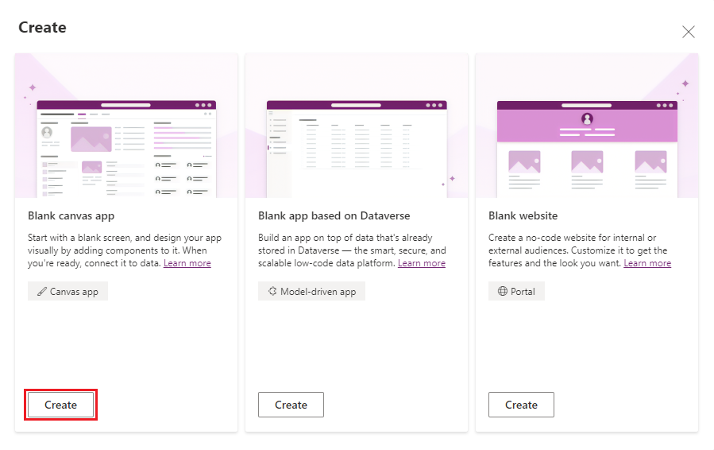

1. Input ‘**Device Orders**’ in the App name field. Select ‘**Tablet’** for Format. Click ‘**Create**’

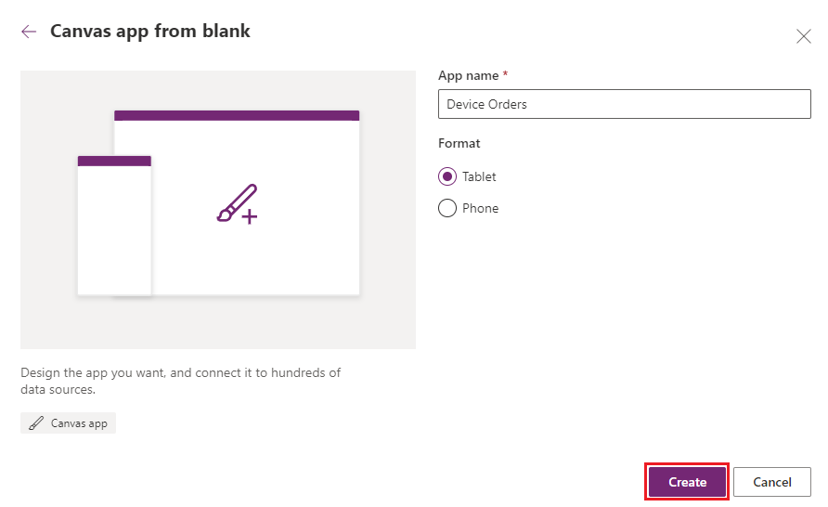

1. Click ‘**Skip**’ if you receive the Welcome to PowerApps Studio prompt
2. If prompted, select your region, then click ‘**Get Started**’

## Task 3: Rename the screen

|  |  |
| --- | --- |
| Gears with solid fill | Canvas Apps Coding Standards and Guidelines |
| It is a good practice to rename screens and controls as you create them so that they are easier to locate as you work with formulas that reference different controls. In this lab, we will rely on the best practices and naming conventions defined in Canvas apps coding standards and guidelines.  Full document link: <https://aka.ms/powerappscanvasguidelines> | |

1. Make sure you have selected **Tree View** in the **App authoring pane**

1. Select the screen by clicking on **Screen1** in **Tree View**
2. Click **“…”** next to Screen1 (or right click) and select the **Rename** option

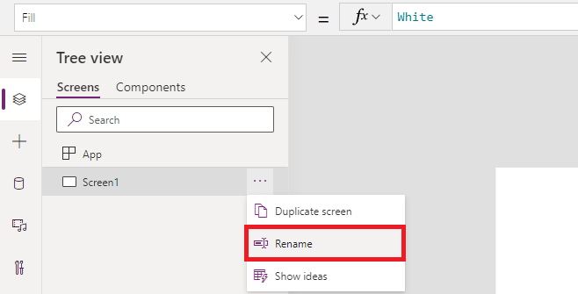

1. Change the name to ‘**Main Screen**’

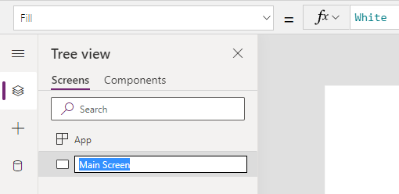

## Task 4: Save the application

In this task, you will save an initial version of the app. Power Apps saves automatically each 2 minutes after the first save (Tip: This setting can be disabled).

1. First, check if there are any errors in the app. Click on the ‘**App checker**’ icon

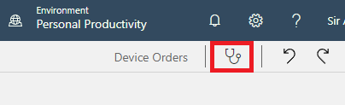

1. **App checker** pane will become visible. If there are any errors, they will be displayed here
2. Close the App checker pane
3. Click **the Settings tab** in the command bar

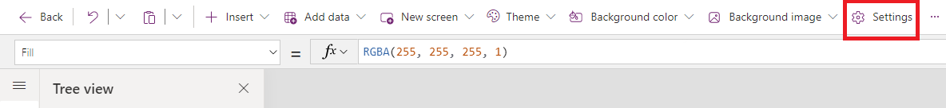

1. In the **Settings – General** dialog, you can:
   1. Change your App name
   2. Customize the App icon (choose a background color and icon)

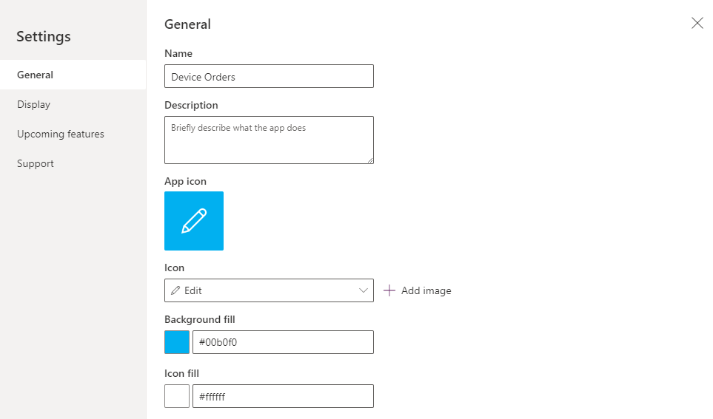

1. Select **Display** tab to view available **screen size and orientation** and aspect ratio settings. For this app, we will leave it at the default setting of Landscape with 16:9 aspect ratio

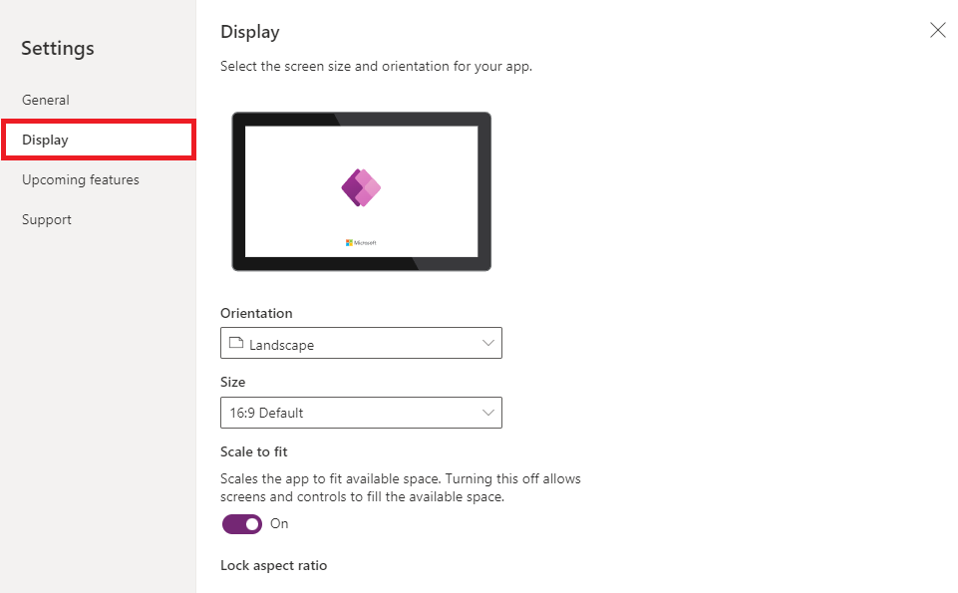

1. Select **Upcoming Features** tab to view preview features that may or may not be enabled. Scroll near the bottom to turn the modern command bar on or off. This manual will assume the modern command bar is **On.**

1. Click ‘**X**’ in the top-right corner to close the dialog
2. Click the **Save** iconin the command bar and select **Save** button in the dialog.

Tip: In PowerApps, when you save a version of your app, the first version is published by default and available to everyone that you share the app with. Subsequent saves are only visible to the app maker in the studio. You must explicitly publish it for all app users to get the update.

For more info: <https://docs.microsoft.com/en-us/powerapps/maker/canvas-apps/share-app>

# Exercise 2: Building the app header

In this exercise you will learn how to add a header to the app and display the logged in user’s name.

## Task 1: Add a header containing the app name and logged in user’s name

In this task, you will add a header to the **Main Screen** that displays the app name and the logged in user’s name

1. Select the ‘**Insert**’ tab in the command bar and select ‘**Text label**’

1. Rename the label from Label1 to **lblHeader**

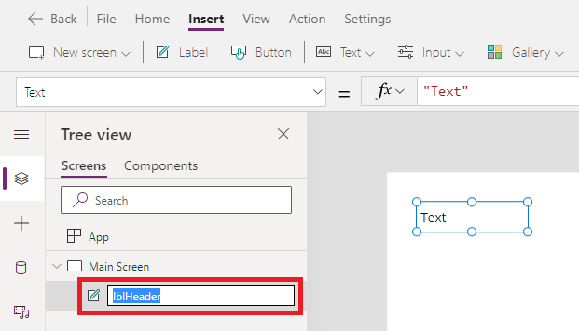

1. Select **Text** from the property drop-down list and enter **“Device Orders”** in the formula bar. You can also type directly into the label by double-clicking it



Text

"Device Orders"

1. Resize the label width by setting the **Width** property as **Parent.Width**



Width

Parent.Width

1. Resize the label width by setting the **Height** property as **80**



Height

80

1. In **Align** menu, select **Align center**

1. Set the X and Y positions in the properties pane to both be **0.**

1. Change the **Background color** to **Blue**

1. Change the font **Color** to **White** and the **Font Size** to **24**

1. From the **Insert** tab, select one more **Text label**

1. Drag the label to the far-right side of the screen and center the label vertically to be in line with the header text.

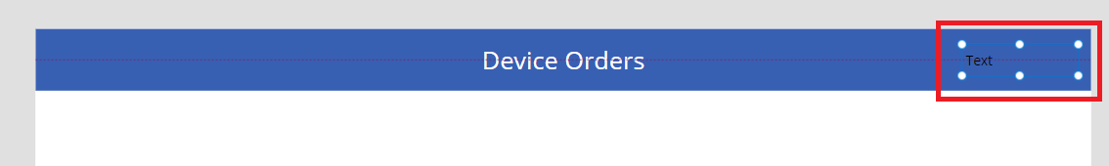

1. **Rename** the label to **lblUserName**
2. For **lblUserName** label, select the **Text** property and change the value to



Text

"Hello, " & User().FullName

Tip: All functions in Power Apps are case-sensitive. As you start typing ‘User’ you will see a drop-down of available choices. It is a good idea to pick from the auto-complete options. You will also notice help text at the top showing the parameters that are expected, in this case it requires no input parameters.

1. Set the text alignmentof the label text to **Align right** in the **Align** tab on the command bar.
2. Change the **Color** to **White**
3. If necessary, widen the label so that the text doesn’t wrap
4. Change the **PaddingRight** property from 5 to **20**. You can do this quickly by using the Properties pane on the right-hand side.
5. Your app header may look like this. The task is complete.

