Lab Module 3.0:

Add compare screen and add/remove   
gallery controls

WorkshopPLUS – Power Platform: Power Apps for Power User

Published: September 2022

Contents

Lab overview 1

Introduction 1

Objectives 1

Prerequisites 1

Estimated time to complete this lab 1

Scenario 1

Exercise 1: Add a compare screen 2

Task 1: Add a screen 2

Task 2: Add compare and clear buttons to Main Screen 4

Task 3: Add controls to the Compare Screen 8

Task 4: Configure the gallery 10

Task 5: Remove and add controls to the gallery 11

Task 6: Highlight the selected device 14

Task 7: Add an icon to navigate to the Main Screen 15

|  |
| --- |
| Lab overview |

## Introduction

In this lab, you will perform the actions necessary for building Power Apps by adding a compare screen, adding/removing gallery controls, and testing the app.

## Objectives

After completing this lab, you will be able to:

* Add Compare Screen
* Remove and add controls to the gallery
* Highlight selected device
* Add icon to navigate

## Prerequisites

Ensure you are using the “Incognito” or “InPrivate” browsing session of your modern browser.

Additionally, use the latest version of Microsoft Edge for the best performance.

## Estimated time to complete this lab

30 mins

## Scenario

The organization wishes to build an app using Power Apps to take advantage of **No Code/Low Code** application development in the cloud. As part of this effort, you are required to add compare screens, add/remove gallery controls, manipulate the navigation, and test the functionality of your app.

# Exercise 1: Add a compare screen

The compare screen is where users will compare the selected devices and then choose the device that they wish to submit for approval.

This screen will include:

* A back button for navigation back to the Main Screen
* A list of selected devices for comparison
* Additional detail for each device
* Highlighting the selected device

## Task 1: Add a screen

In this task you will add the **Compare Screen** to the app.

1. From the command bar open **New screen**
2. Under **Layouts**, select **Blank**

1. Rename the screen to **Compare Screen**

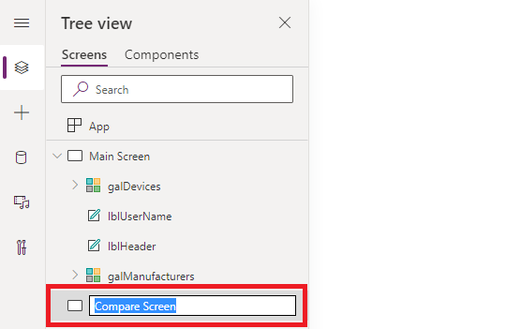

## Task 2: Add compare and clear buttons to Main Screen

In this task you will learn how to add buttons to the Main Screen that add functionality to the app to navigate to the Compare Screen and clear the selected devices for comparison

1. In the **Tree View**, select **Main Screen**
2. Click the **Insert** tab in the command bar
3. Open **Input**, then select **Button** to add a button onto the screen

1. Place the button in the bottom right corner of the screen

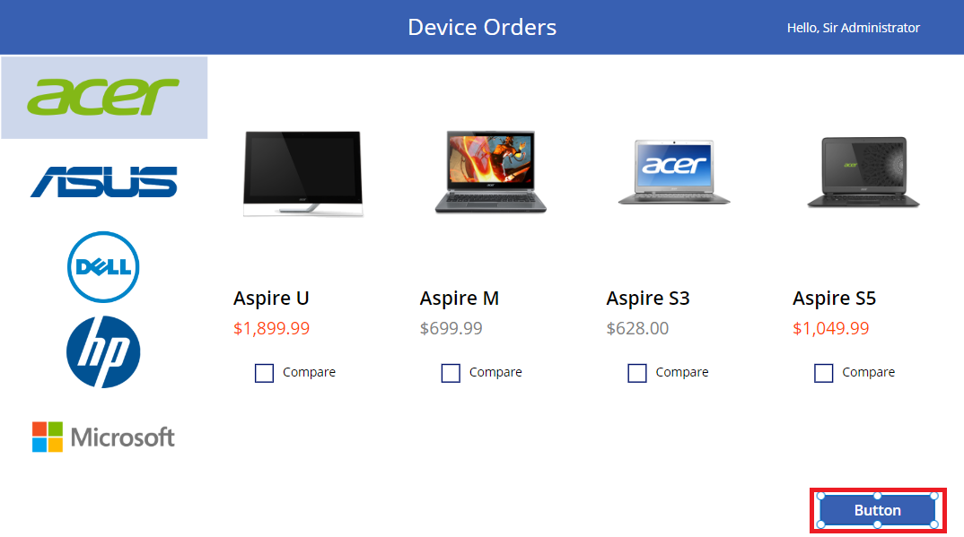

1. For the button, in formula bar set **Text** property as:



Text

"Compare " & CountRows(CompareList) & " item(s)"

1. Resize the button so the text fits without wrapping
2. Select the button and set the **DisplayMode** property expression to:



DisplayMode

If(CountRows(CompareList) > 0, Edit, Disabled)



for alternate/European locales, enter:



DisplayMode

If(CountRows(CompareList) > 0; Edit; Disabled)

1. Run the app in **preview** mode (F5)
2. **Select** a few devices
3. Check that the button displays the number of devices selected for comparison
4. **Close** preview mode (clicking X)
5. Run the app in **preview mode** (F5)
6. **Unselect** the devices
7. Check that the button is **disabled**

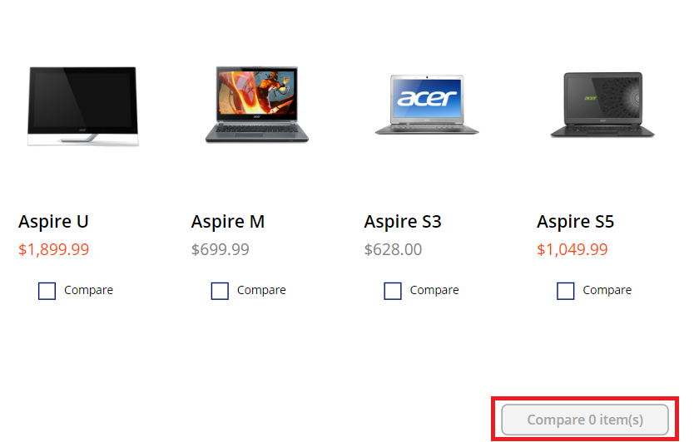

1. **Close** preview mode (clicking X)
2. In **Tree View,** rename this button as **btnCompare**
3. **Select** the **btnCompare** and **copy** it (Ctrl+C)
4. **Paste** the button on the same screen (Ctrl+V)
5. Position the button to the left of the compare button

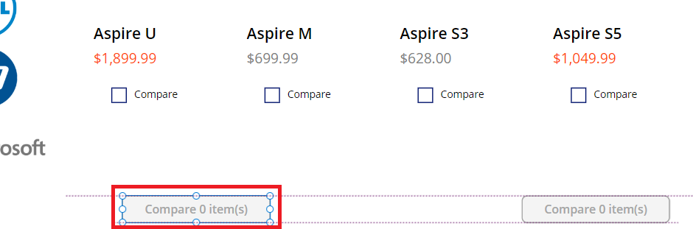

1. Change the **Text** property in the Properties pane to **Clear selection**  
   (If using the formula bar, enter **“Clear selection”** including standard quotation marks)
2. In **Tree View,** rename this button as **btnClear**
3. Set the **OnSelect** property of the button to the following expression:



OnSelect

Clear(CompareList)

**Note:** This will remove all the items in the **CompareList** collection when the user clicks the button

1. In **Tree View, select the btnCompare** button
2. Set the **OnSelect** property of the button to the following expression:



OnSelect

Navigate(*'Compare Screen'*, None)

1. Click **Preview** and select a couple of devices and click the Compare button
2. **Verify** that it takes you to the Compare Screen, then close Preview (clicking X)

## Task 3: Add controls to the Compare Screen

In this task, you will copy the various controls that you want to display on both the Main Screen and Compare Screen.

1. In the tree view, select the **Main Screen**
2. **Select** both the **lblHeader** and **lblUserName** (hold Shift key whilst selecting)
3. **Right click** and **select Group**

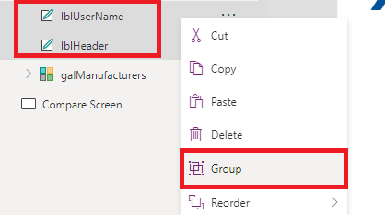

1. Rename the group **Header**
2. **Click** on the ellipsis **(…)** of the Header
3. **Select** Copy

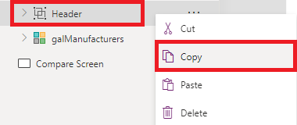

1. Right click on the **Compare Screen**
2. Select **Paste**

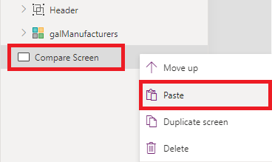

1. **Select** the **Compare Screen**
2. **Select** the **Header_1** Group
3. **Click** on the **Align** button and select **Align Top**
4. The **Header_1** in the **Compare Screen** should look like the image below:

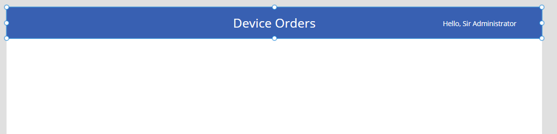

1. **Copy** the **galDevices** from the **Main Screen** and **paste** into the **Compare Screen**
2. Expand the gallery to the full width of the screen.   
   Align the top of the gallery to be just under the header banner.

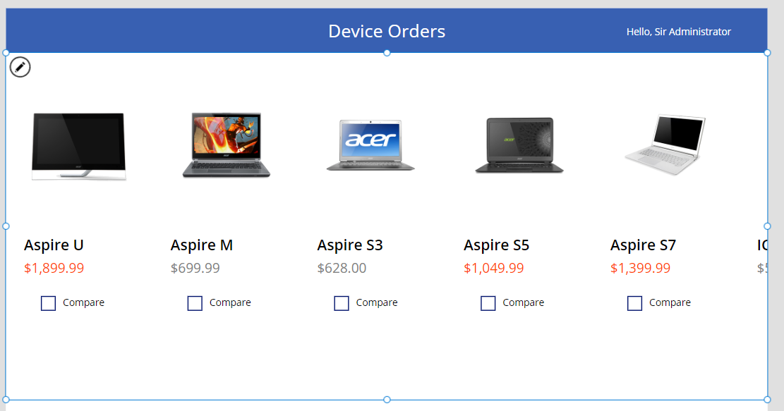

1. **Rename** this gallery to **galCompareList**

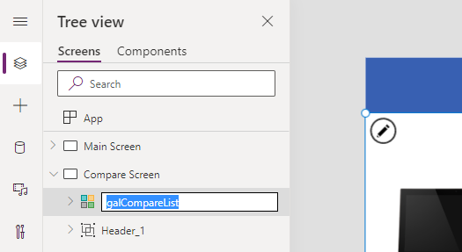

## Task 4: Configure the gallery

In this task you will configure the gallery to show devices that were selected from the comparison gallery on the Main Screen.

1. Select the new **galCompareList**
2. Select the **Items** property drop-down and in the formula bar set it to **CompareList**

1. The gallery will now show the selected items from the **Main Screen**

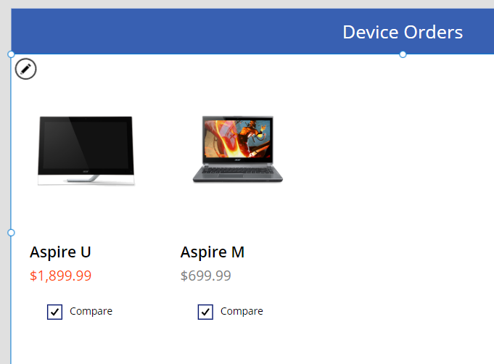

## Task 5: Remove and add controls to the gallery

In the Compare Screen we are selecting a specific item to place an order/ submit for approval, so we no longer require the compare checkbox. In this task you will remove the compare checkbox and add new controls to the template cell.

1. **Select** the **Compare Screen**
2. **Select** the **galCompareList** template cell
3. **Select** the **Compare** checkbox on the template cell and press the **Delete** key to delete the checkbox
4. Click the **pencil icon** in the top left of the gallery to select the template cell

1. Click the **Insert** tab on the command bar
2. Click **Label**
3. **Rename** the label **lblManufacturerName**
4. Set the **Text** property to the following expression:



Text

ThisItem.ManufacturerName

1. Use the command bar to change the font weight from **Normal** to **Semibold** and change the **size** property from 13 to 18

1. **Copy** and paste the label
2. **Rename** the new copy **lblDeviceMemory**
3. **Set** the **Text** property to the following expression:



Text

ThisItem.Memory

1. **Repeat** this process to add in the following labels:

|  |  |
| --- | --- |
| Label | Text property |
| lblDeviceProcessor | ThisItem.Processor |
| lblDeviceStorage | ThisItem.Storage |
| lblDeviceScreenSize | ThisItem.ScreenSize |

1. Your gallery should look like this now

## Task 6: Highlight the selected device

In this task you will recreate the behavior of the selected manufacturer in the Main Screen. When a user clicks on a device, you will set the template fill to show that it is highlighted.

1. Select the **galCompareList**
2. From the properties drop-down, select the **TemplateFill** property
3. In the formula bar, enter the following expression:



TemplateFill

If(ThisItem.IsSelected, ColorFade(*lblHeader*.Fill, 75%))



for alternate/European locales, enter:



TemplateFill

If(ThisItem.IsSelected; ColorFade(*lblHeader*.Fill; 75%))

This is conditionally setting the Fill color if the cell is selected. Click a few different items in the gallery, notice the selected item is highlighted in a light blue color.

## Task 7: Add an icon to navigate to the Main Screen

In this task you will learn how to add an icon to navigate back to the Main Screen.

1. Select the **Compare Screen**
2. Select the **Insert** tab from the command bar
3. Select **Icons**, and then select the **Back arrow**

1. Position it in the top left corner of the screen

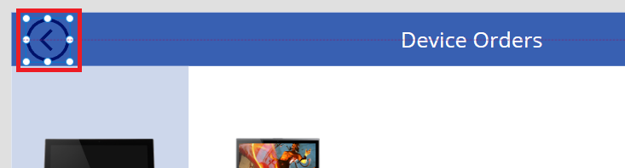

1. Select the Icon and change the **Color** to **White**

1. From the properties drop-down select the **OnSelect** property and in the formula bar enter the following expression:



OnSelect

Back()

**Note:** This will cause navigation back to the previous screen.

1. Save your app by pressing **Ctrl+S.**