Lab Module 4:

Connect the data from the canvas app and   
submit device request

WorkshopPLUS – Power Platform: Power Apps for Power User

Published: September 2022

Contents

Lab overview 1

Introduction 1

Objectives 1

Prerequisites 1

Estimated time to complete this lab 1

Scenario 1

Exercise 1: Ordering a device for approval 2

Task 1: Create an edit form 2

Task 2: Configure the title field 6

Task 3: Configure the Price and OrderStatus fields 8

Task 4: Configure the Comments field 9

Task 5: Add a button to submit the form 11

Task 6: On successful submission navigate to a new screen 13

Task 7: Verify successful submission 16

|  |
| --- |
| Lab overview |

## Introduction

Now that you have created the list to store device order requests, let’s connect Device Ordering App to this list and add a form to submit device approval requests.

## Objectives

After completing this lab, you will be able to:

* Connect SharePoint list as data source
* Configure and add form
* Submit Form
* Add success screen
* Test the app
* Verify successful submission

## Prerequisites

Ensure you are using the “Incognito” or “InPrivate” browsing session of your modern browser.

Additionally, use the latest version of Microsoft Edge (aka Edge Chromium) for the best performance.

## Estimated time to complete this lab

45 mins

## Scenario

The organization wishes to build an app using Power Apps to take advantage of **No Code/Low Code** application development in the cloud. As part of this effort, you are required to add new data source (SharePoint list), configure, add and submit form, add/remove gallery controls, manipulate the navigation, and test the functionality of your app.

# Exercise 1: Ordering a device for approval

So far, you have built the app. Users can browse and compare devices. In this exercise you will add additional functionality so that users can create an order using form and submit a device for approval. In this lab, device orders will be managed in a SharePoint list (created as part of the prerequisites). Power Automate flow will be created in subsequent exercises to manage the approval process.

## Task 1: Create an edit form

In this task, you will add an **Edit Form** to the **Compare Screen**.

1. Select **Main Screen**

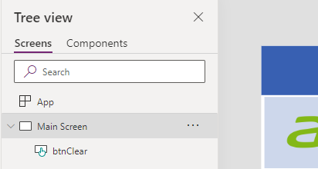

1. Select a few devices by clicking on checkboxes, while holding **Alt-key**

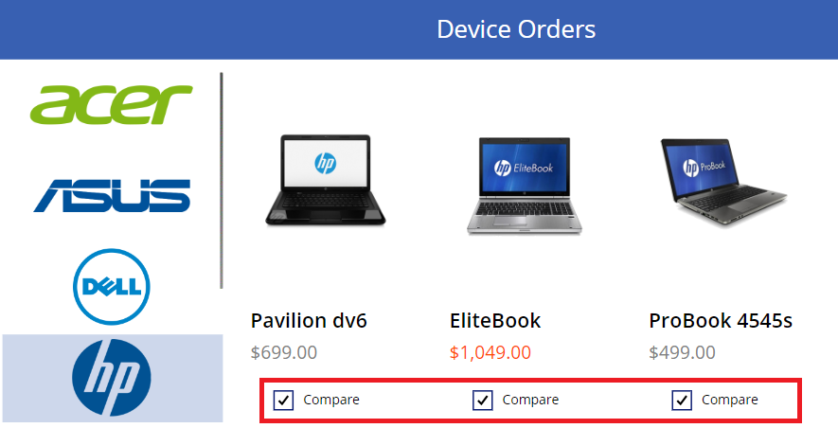

1. Select **Compare Screen**.   
   You will now have the selected devices. 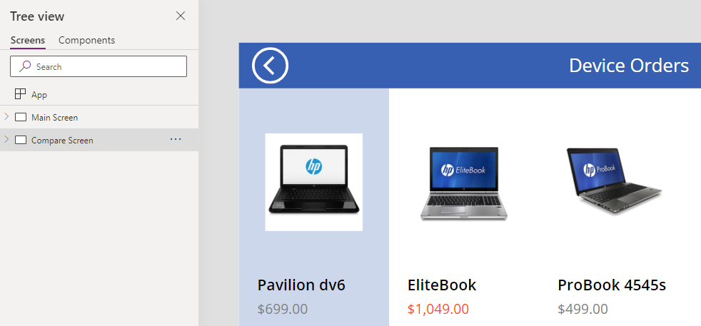
2. Select the **Insert** tab, open **Input** tree, and select **Edit form**. Rename Form1 to **frmSubmitOrder**

1. Select **frmSubmitOrder**  
   In **Properties Pane**, select **Data source** drop-down and then select your **Order Data** list (SharePoint data source)

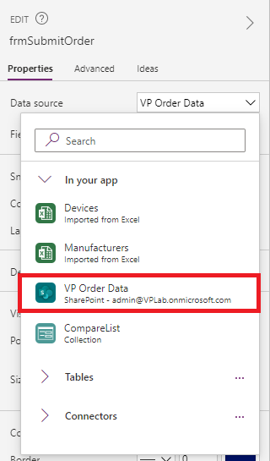

1. In Properties Pane, click **Edit fields**

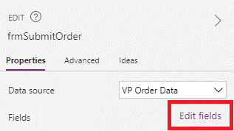

1. Remove **Attachments** field

1. Set **Columns** property to 1 and **Default mode** to New

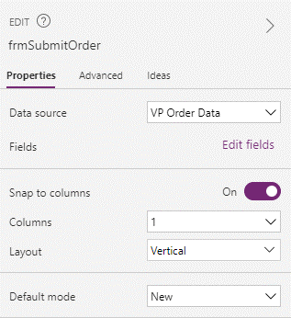

## Task 2: Configure the title field

In the next few steps, you will configure each of the form fields.

1. Let’s start by configuring **Title** form field to display the manufacturer and device name for the selected device.   
   For example, if the user selects the Surface Pro device, we want the device order to have the title: “Microsoft – Surface Pro.”
2. Expand and select **Title_DataCard1**

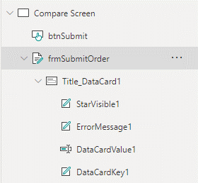

Notice that the default card contains a few controls:

* **StarVisible1**: This is a label control that has an asterisk (*) which has its Visible property set to true or false depending on whether the field is Required or not. Since the Title field was marked as Required when you configured the entity, its Required property is set to true.
* **ErrorMessage1**: This is a label that is just below the main data entry field which displays error messages.
* **DataCardValue1**: This is the text input control where you can enter the Title. For this scenario, we will set the title based on the selected device.
* **DataCardKey1:** This is the label that displays the title of the field.

1. Select **Title_DataCard1** and click **Advanced**

1. Click **Unlock to change properties**, so you can customize the card

For the next few steps, we will use the **Advanced** properties pane to customize control properties within the form, note that you can perform the same customizations using the property drop-down, and formula bar in the top left of the studio.

1. Change **DisplayName** and **Required** fields as below

1. To display the selected item in the **Title** field, set the **Default** property to



*galCompareList*.Selected.ManufacturerName & "-" & *galCompareList*.Selected.Title

{

Title: ThisItem.Title,

Price: ThisItem.Price,

OrderStatus: "In review"

}

)

Default

1. Change the **DisplayMode** to DisplayMode.View. This will prevent users from changing the value within the text box.

## Task 3: Configure the Price and OrderStatus fields

In this task, we are going to set the price to the price of the item and then make it read-only.

1. Expand **Price_DataCard1**.
2. Select the **DataCardValue2.**

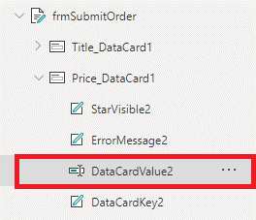

1. Select the **Advanced** tab and click **Unlock to change properties**.

1. Change the **Default** property to:



Text(*galCompareList*.Selected.Price,"[$-en-US]$##,###.00")

Default



for alternate/European locales, enter:



Text(*galCompareList*.Selected.Price; "[$-en-US]$##,###.00")

Default

1. Select **Price_DataCard1** and change the **DisplayMode** property to DisplayMode.View**.**

1. Select **OrderStatus_DataCard1** and in **Advanced** property tab **Unlock to change properties**

1. For **OrderStatus_DataCard1**, set **DisplayMode** to DisplayMode.View
2. For **OrderStatus_DataCard**, set **Default** property as "Pending"

## Task 4: Configure the Comments field

1. Expand the **Comments** field and select the **DataCardValue**.

1. Select the **Advanced** tab and **Unlock to change properties**.

1. Change the **Mode** to TextMode.MultiLine

1. Select the **Properties** tab and change the **Size -> Height** value to **80**. A screenshot of a cell phone

   Description automatically generated
2. Optionally, you may select the Text Input control **DataCardValue4** and set its **HintText** property to: “Enter justification” (without quotes).

## Task 5: Add a button to submit the form

1. Select the **Main Screen**
2. Copy the **Compare button** from the first screen, which has the correct color values.
3. Go back to the **Compare Screen** and paste (Ctrl+V) the button.
4. Position it in the bottom right of the screen, center aligned with the Form.
5. Make the button larger – you can resize to 280x60 using the Properties pane on the right.
6. Set the button’s **Text** property to “Submit device request”

1. Rename the button to **btnSubmit**
2. The button should be enabled only if a device is selected. To do this, change the button’s **DisplayMode** property to:



If(!IsBlank(*galCompareList*.Selected), Edit, Disabled)

DisplayMode



for alternate/European locales, enter:



If(!IsBlank(*galCompareList*.Selected); Edit; Disabled)

DisplayMode

**Note:** You might notice the exclamation mark (!) in the formula !IsBlank() Normally if you just have IsBlank() the check is for blank. Adding the exclamation mark (!) in front of it changes it to check if it is NOT blank.

1. Next, we are going to configure what we want to happen when the button is clicked. For **btnSubmit**, set the **OnSelect** property to:

Now, when the button is pressed, the form data will be submitted to the SharePoint list, and a new form will be set.

OnSelect

SubmitForm(*frmSubmitOrder*); NewForm(*frmSubmitOrder*)

1. Finally, the submit form should look like below:

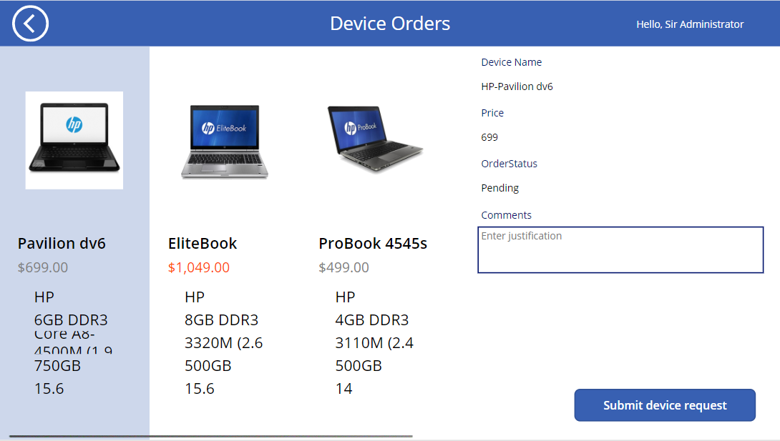

## Task 6: On successful submission navigate to a new screen

1. Create a **new screen** (Success) and rename it as **Success Screen**

1. Update the text of the new screen as shown belowA close up of a logo

   Description automatically generated
2. Insert a **Timer** control to the **Success Screen**

1. Select **Timer1** and in **Advanced** property pane specify the following:

OnTimerEnd: Navigate(*'Main Screen')*

Duration: 3000

Reset: true

AutoStart: true

Visible: false (optional, to make timer invisible)

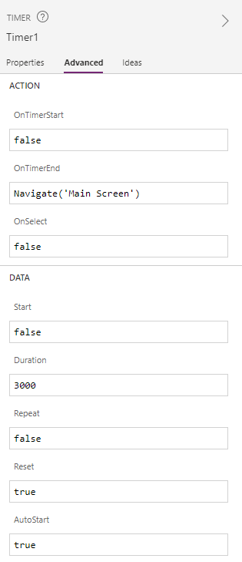

1. Select **Compare Screen > frmSubmitOrder > Advanced**, set **OnSuccess** value:



OnSuccess

Navigate(*'Success Screen'*, ScreenTransition.Fade)



for alternate/European locales, enter:



OnSuccess

Navigate(*'Success Screen'*; ScreenTransition.Fade)

6.



## Task 7: Verify successful submission

1. Save your app by pressing **Ctrl+S**
2. Test application by selecting a few laptops and by submitting an order for one of them. Make sure that navigation between screens works correctly.
3. Browse to the SharePoint list with Order Data
4. Make sure successful submissions are stored in the list.

