Lab Module 5.0 (Optional):

Build your own Power Automate flows in   
an easy-to-use visual designer

WorkshopPLUS – Power Platform: Power Apps for Power User

Published: September 2022

Contents

Lab overview 1

Introduction 1

Objectives 1

Prerequisites 1

Estimated time to complete this lab 1

Scenario 1

Exercise 1: Creating the approval flow 2

Task 1: Create a new flow 2

Task 2: Add an approval 5

Task 3: Add a condition 9

Exercise 2: Testing Device Orders solution 16

Task 1: Testing the compare device functionality 16

Task 2: Testing the flow 19

|  |
| --- |
| Lab overview |

## Introduction

In this lab, you will perform the actions necessary to build your own flows in an easy-to-use visual designer.

## Objectives

After completing this lab, you will be able to:

* Add triggers to flow
* Add steps to flow
* Add Actions to flow
* Configure ‘Send an Email’ action in flow
* View all your Power Automate flows
* View flow history
* View flow run details
* Test your solution: app and flow working together

## Prerequisites

Ensure you are using the “Incognito” or “InPrivate” browsing session of your modern browser.

Additionally, use the latest version of Microsoft Edge (aka Edge Chromium) for the best performance.

## Estimated time to complete this lab

30 mins

## Scenario

The organization wishes to automate business processes using the Power Automate to take advantage of **No Code/Low Code** workflow automation. As part of this effort, you are required to create approval flow for your device orders.

# Exercise 1: Creating the approval flow

In this exercise, you will be introduced to Microsoft Power Automate.   
You will learn how to build a basic approval flow for the device ordering process.

## Task 1: Create a new flow

1. In the browser, go to <https://make.powerautomate.com>
2. If needed, in the top right of the screen, click **Sign In**
3. Before creating a flow, switch to the correct environment (where your organization permits development apps to be created).

Click the **Environments** drop-down in the top right of the screen to switch to the correct environment.

Ask instructor if you have doubts.

1. In the left navigation, click **Create**

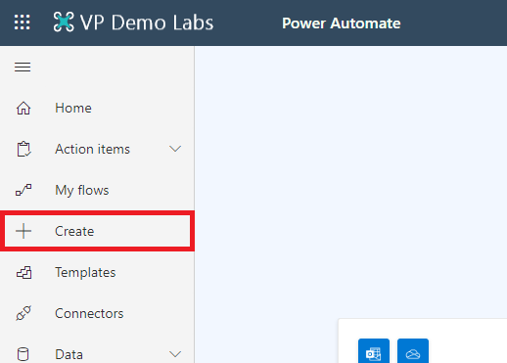

1. In the **Create** screen, select the ‘**Automated cloud flow**’ option

Tip: Flows are started with a ‘Trigger’. There are three basic triggers to start a flow:

* **Automated:** designated events will start the Flow; for example: a new item created in a SharePoint list
* **Instant:** Flows are started manually by the user
* **Scheduled:** Flows are started at a frequency specified; for example: every day at 10:00 hours

1. In the ‘Build an automate cloud flow’ dialog, enter **Purchase approval** in the Flow name box, select ‘**When an item is created**’ (SharePoint) and finally click **Create**

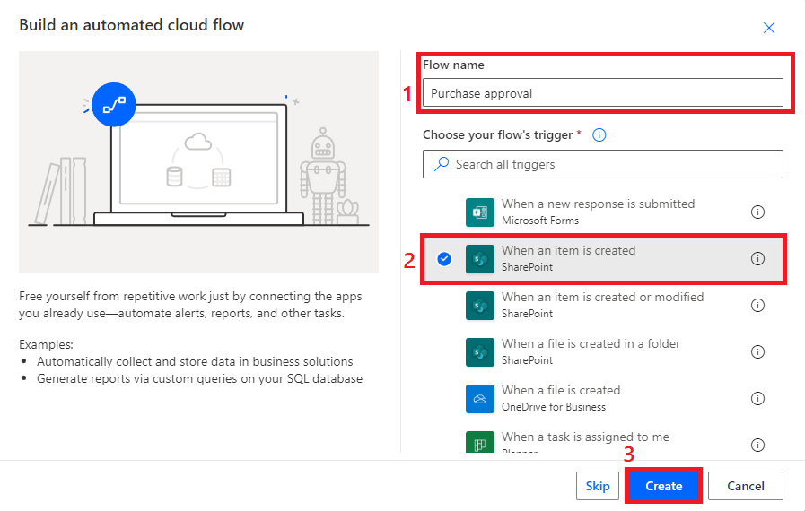

1. Click in the **Site address** input box, select Enter custom value and **type/ paste the URL of the SharePoint site** that you created for Order Data, and in the **List** name drop down, select your **Order Data** list

## Task 2: Add an approval

In this task you will learn how to use the Approvals connector.   
**Note:** If your organization blocks this via DLP (Data Loss Prevention) policies, then you will not be able to proceed with this task.

1. Click **New step**

In this task you will learn how to use the Approvals connector.   
**Note:** If your organization blocks this via DLP (Data Loss Prevention) policies, then you will not be able to proceed with this task.

1. Click **New step**
2. In the search box, type ‘**Approvals**’ and then select Approvals

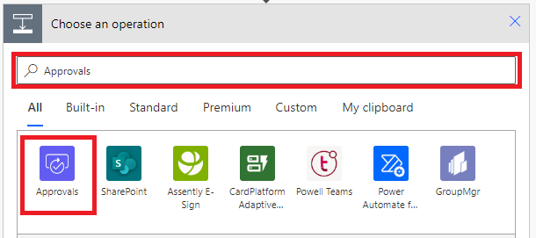

1. From the list of available actions, select ‘**Create an approval**’

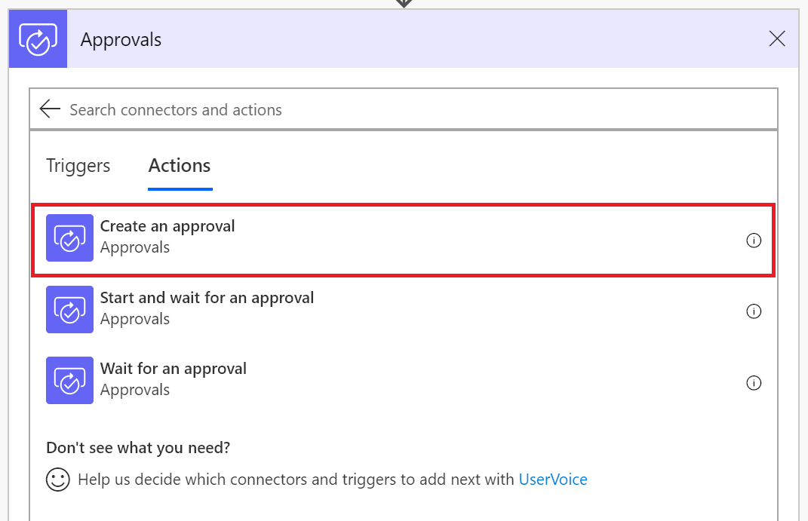

1. In the approval type drop-down, select ‘**Custom responses – wait for one response**’
2. In the **Create an approval** action, **enter** the following:

* **Response options item 1**: Approve  
  *To add an additional response option click* ***“+ Add new item”*** *button*
* **Response options item 2:** Reject
* **Title:** New device request approval
* **Assigned to:** Enter **YOUR OWN** email in tenant
* **Details:** You have received a new device request from (select ‘Created By DisplayName’ from the *When an item is created trigger* in **dynamic content**)
* **Item link:** Select Link to item from the ‘When an item is created’ trigger
* **Item link description:** Enter any link description text

1. The **‘Create an approval’** action should look the same as the screen shot below:

1. Click ‘**New step**’
2. Type ‘**Approval**’ in the search box, then select ‘**Wait for an approval**’

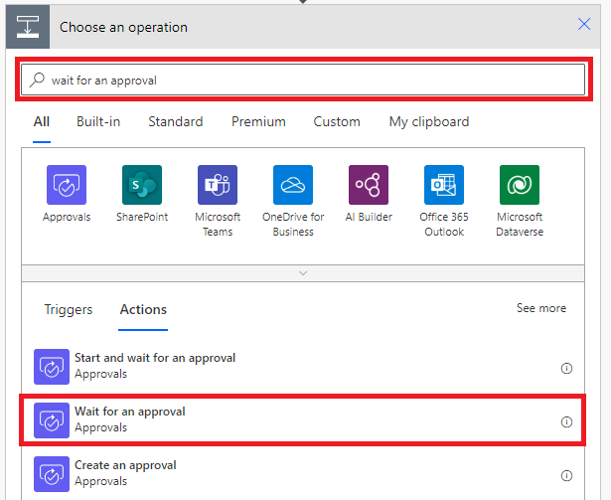

1. **Click** the ellipsis (**…**), rename the step ‘**Wait for approval decision**’
2. **Click** the ‘**Approval ID**’ box, and from the dynamic content dialog, select ‘**Approval ID**’

## Task 3: Add a condition

In this task you will learn how to add in a condition. A condition action handles specific conditions in your Flow, such as ‘If a property equals a value’, or ‘If a property is greater than a value’.

1. Click ‘**New step**’
2. In the actions window, select ‘**Condition**’

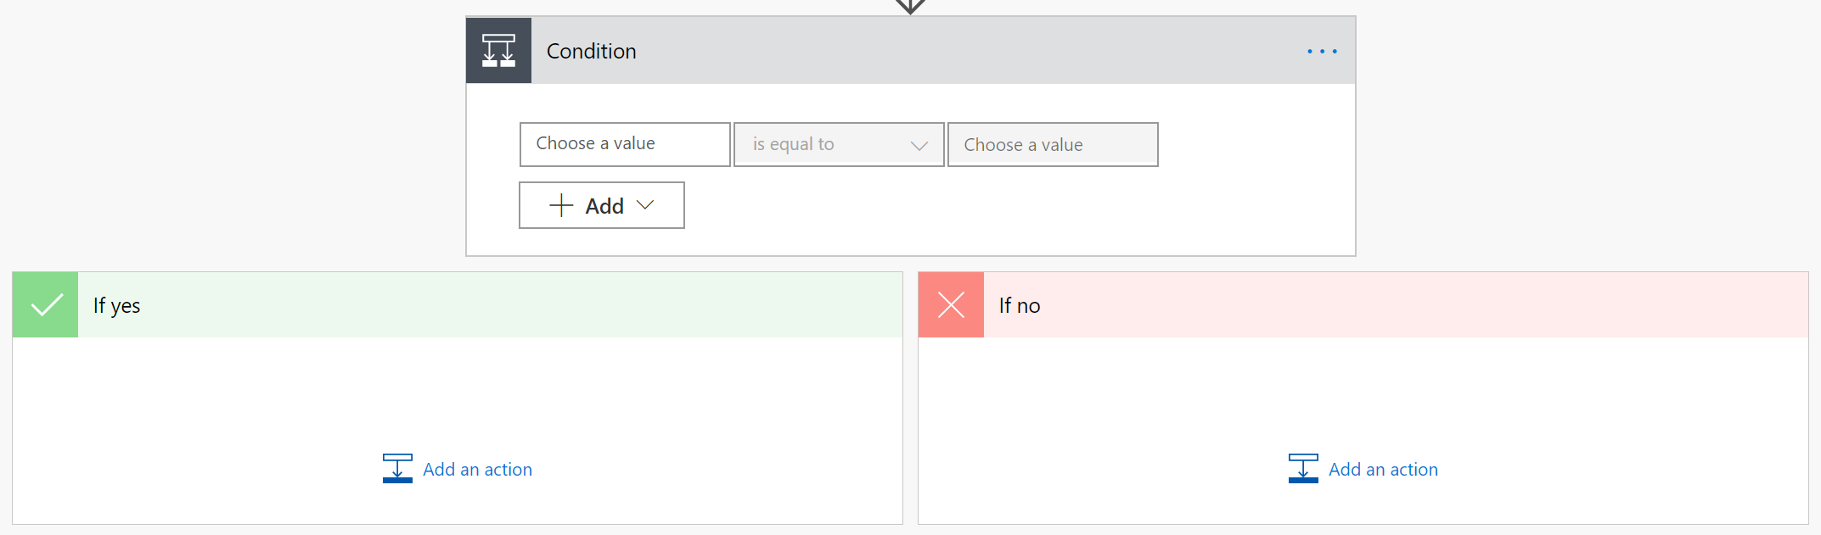

1. **Click** the ellipsis (…), then **rename** the step ‘Approval decision’, and **add in a comment** ‘This condition handles the approval or rejection of the request’
2. **Click** inside the ‘**Choose a value**’ box and from the dynamic content dialog, select ‘**Outcome**’

1. **Check** that ‘**is equal to**’ is selected, and in the ‘Choose a value’ box type **Approve**

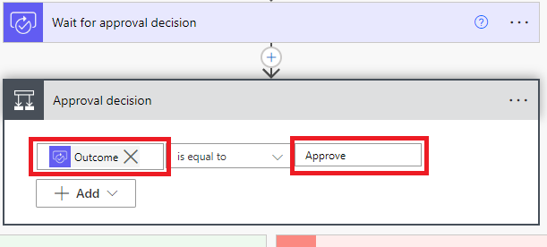

1. In the ‘**If yes**’ branch of the condition, click **Add an action**

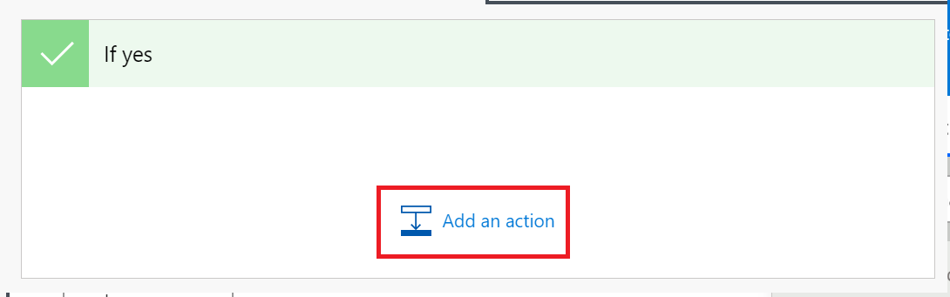

1. In the search box type **Email** and from the list of available connectors, select **Office 365 Outlook**. From the list of available actions, select ‘**Send an email (V2)**’:

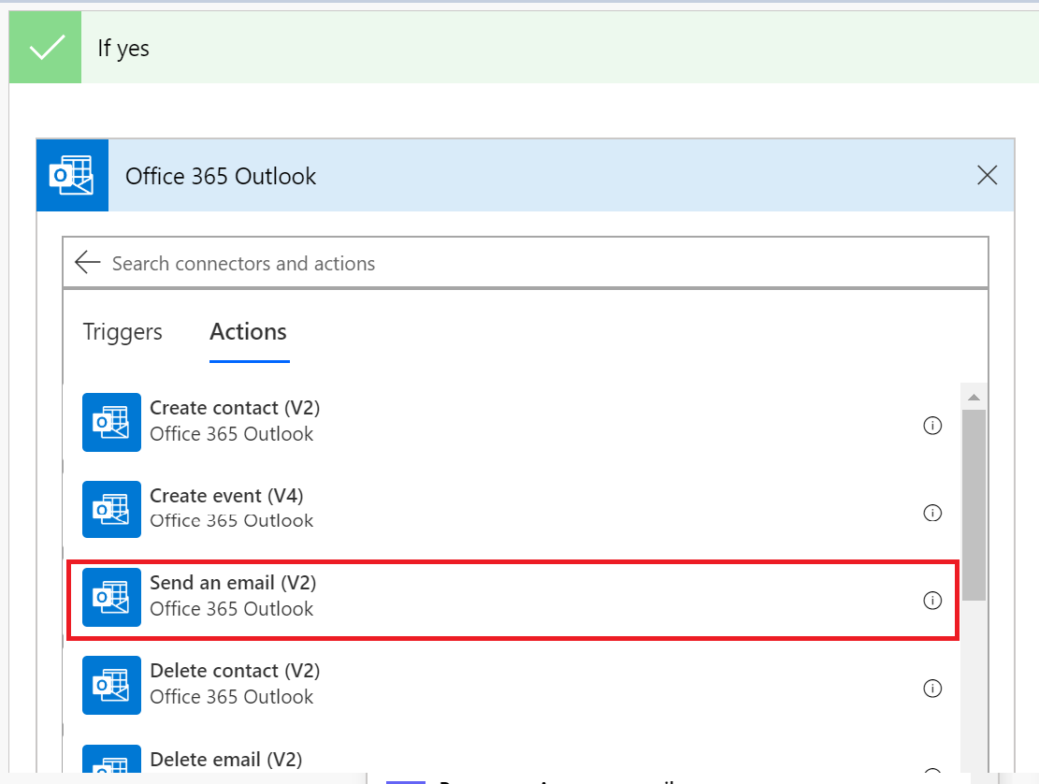

1. **Rename** the action ‘**Confirmation Email**’
2. **Click** inside the **To** box, and then ‘Add a dynamic value icon’
3. Select ‘**Created By Email**’ from the dynamic content area

1. In the **subject** box, **type**: Confirmation of your device order
2. In the **body** area, **type** the following, note: the *properties* (**Created By DisplayName** & **Title**) are taken from the dynamic content dialog:

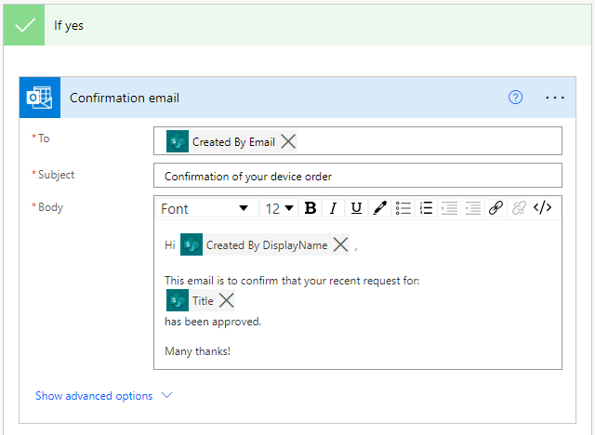

1. Click ‘**Add an Action**’
2. In the ‘search connectors’ box, type **SharePoint**
3. Select SharePoint in the list of connectors
4. Scroll down and select ‘**Update item**’

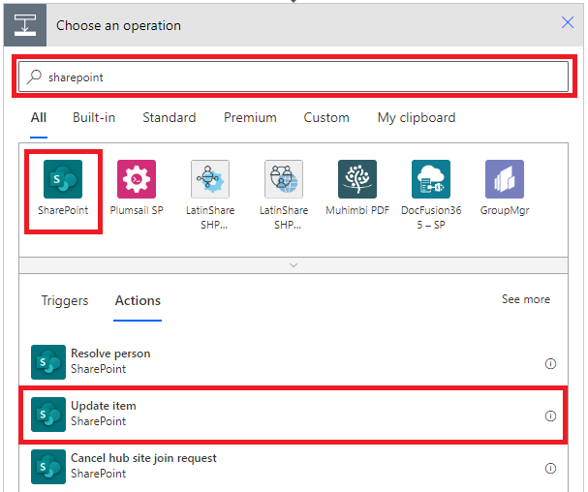

1. In the **Site Address box**, enter the URL of the SharePoint site
2. Select the your **Order Data** list from the List drop-down
3. In the **Id** field, select **ID** from the dynamic content dialog

1. In the **Title & Price** fields, select the correct property from the dynamic content dialog.
2. In the **OrderStatus** field, enter: **Approved**

Your action should look like the following screenshot:

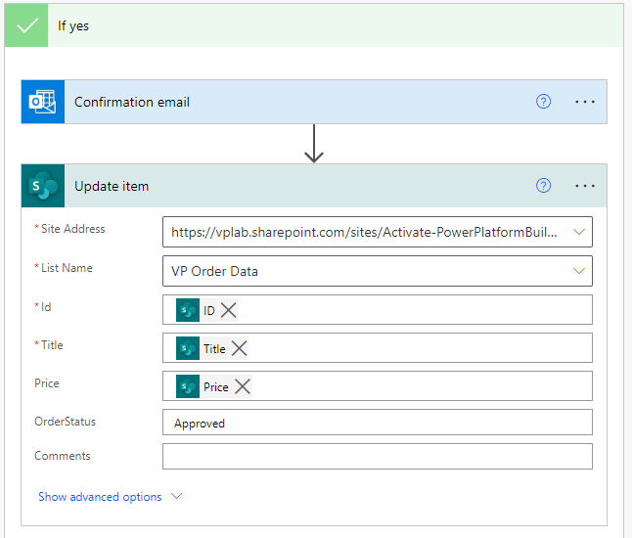

1. Now click **Add an action** in the If no branch of the condition
2. In the connector search box, type **Office 365 Outlook**
3. From the list of actions, select **Send an email (V2)**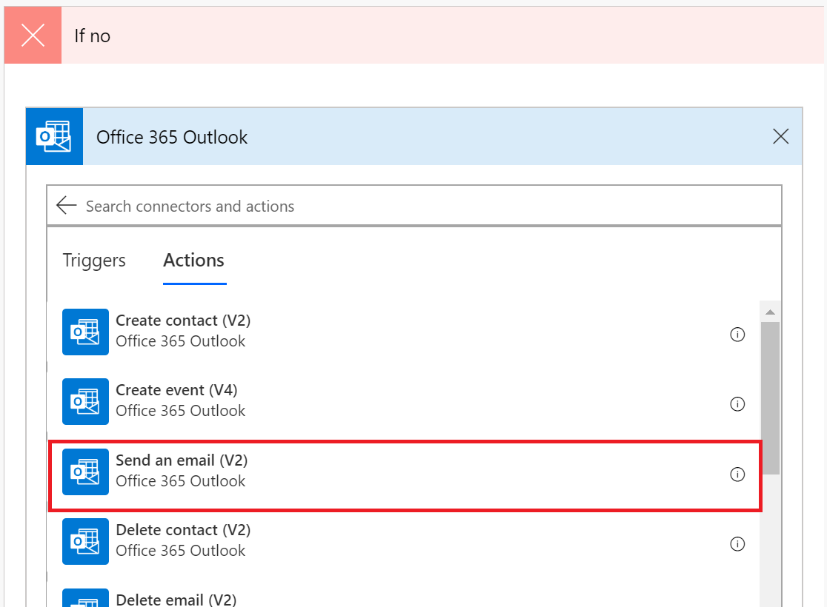
4. **Rename** the action to **Rejection email**
5. Enter the following information:

* **To:** Created By Email (from dynamic content)
* **Subject:** Update about your device order
* **Body:** Hi ‘Created By DisplayName’ (from dynamic content),

This email is to confirm that your recent request for:

Title (from dynamic content)

Has been rejected,

Many thanks

1. Your action should look like the following image: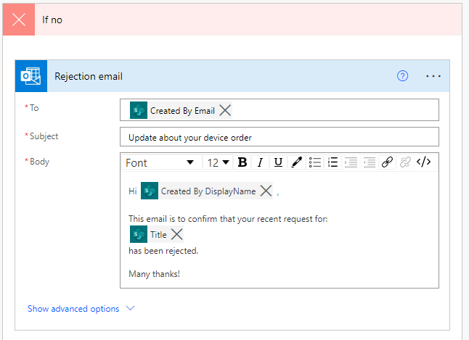
2. In the **If no** branch, click **Add an action**
3. In the search connectors box, type **SharePoint**
4. From the list of actions returned, select **Update item**
5. Enter the following information:

* **Site Address:** Enter the URL of your SharePoint site
* **List Name:** Select the your Order Data list
* **Id:** Select ID from the SharePoint trigger
* **Title:** Select Title from the SharePoint trigger
* **Price:** Select Price from the SharePoint trigger
* **OrderStatus:** Enter ‘Rejected’

1. Your action should look the same as the image below:

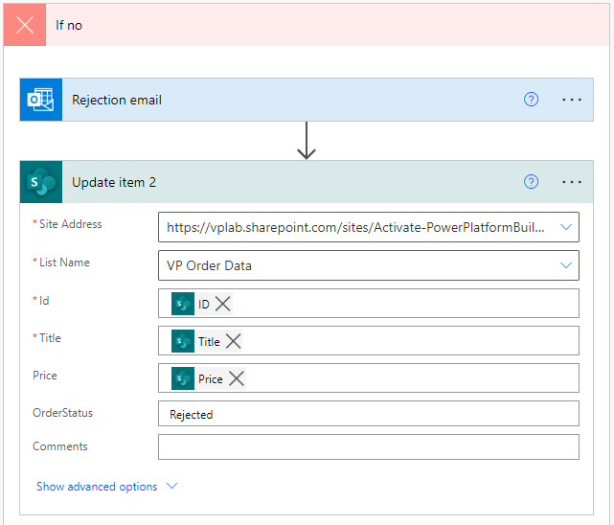

1. **Save** your flow

# Exercise 2: Testing Device Orders solution

It is a good idea to save and test your app regularly. There are a few ways in which you can test your app:

* Hold the Alt key down and click on controls to activate the functionality
* Enter preview mode (F5)
* Play the app

In this exercise you will run through some tests of your app

## Task 1: Testing the compare device functionality

In this task you will perform some tests in your app.

1. Go to the **Main Screen** and **Preview** the app by clicking the **Play** button in the top right

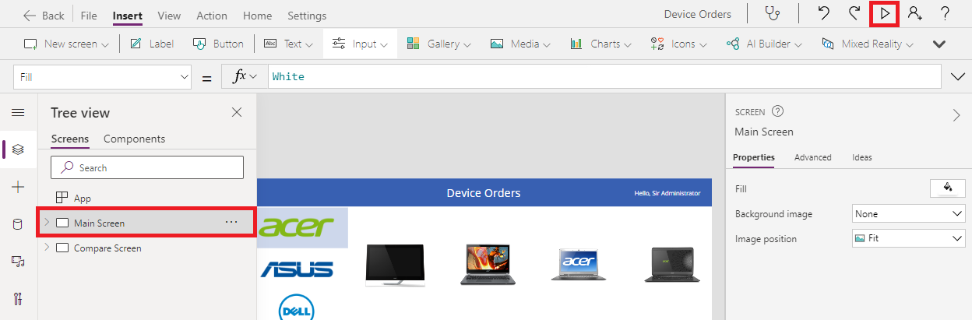

1. **Uncheck** if there are any checked devices
2. Select **Microsoft** on the left to show a filtered set of devices
3. Check the compare box on a few devices on the main screen from a few different manufacturers

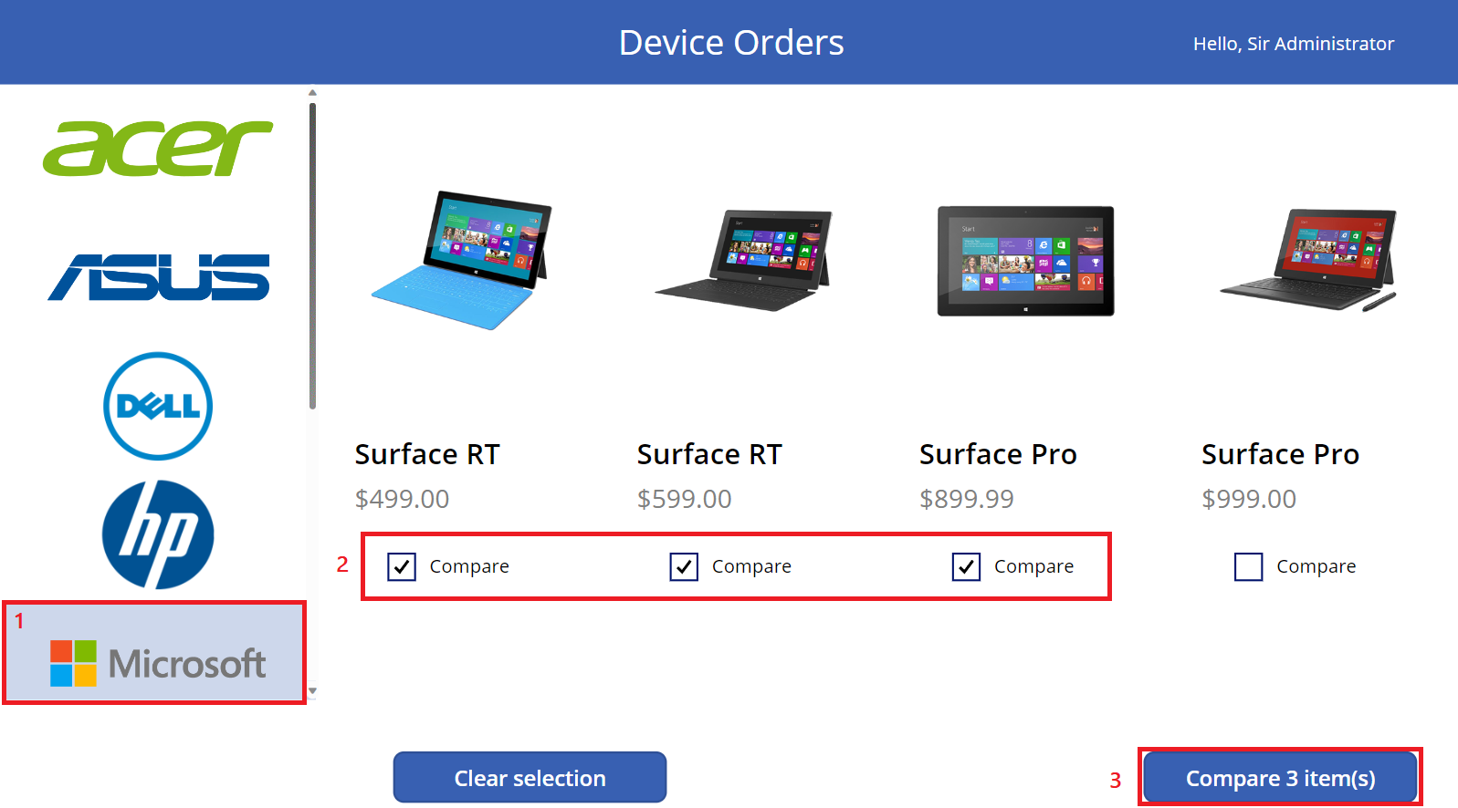

1. Click on different devices in the gallery and verify that the selection highlight works.
2. Click the **Back** button and confirm you get back to the main screen

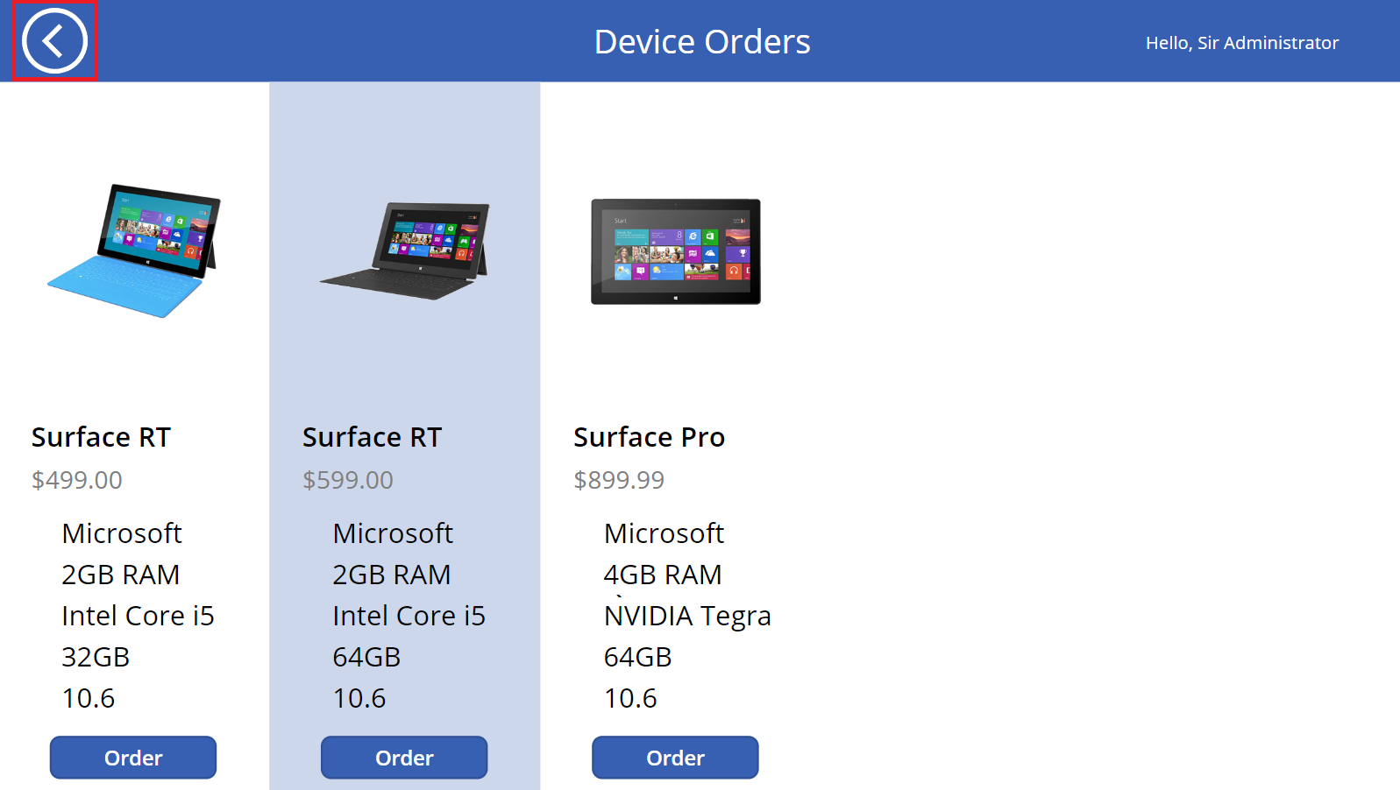

1. Click **Clear** Selection

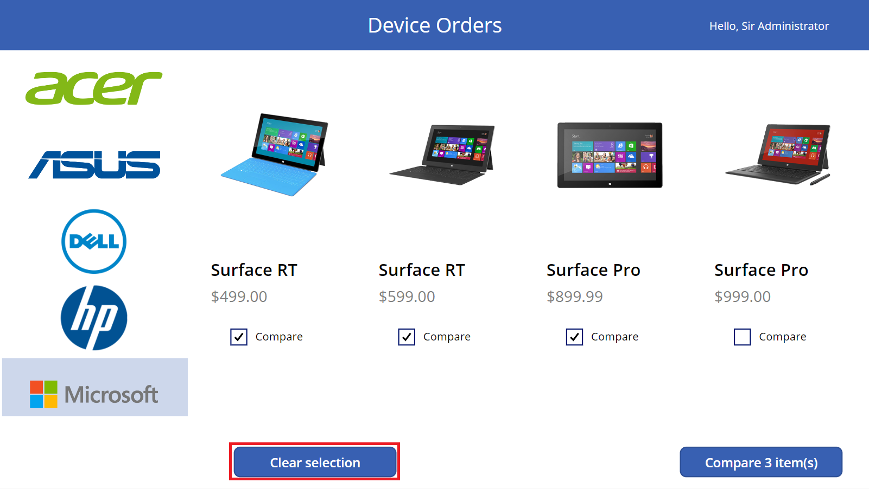

1. The **CompareList** collection will clear, and the **Compare** button will become disabled

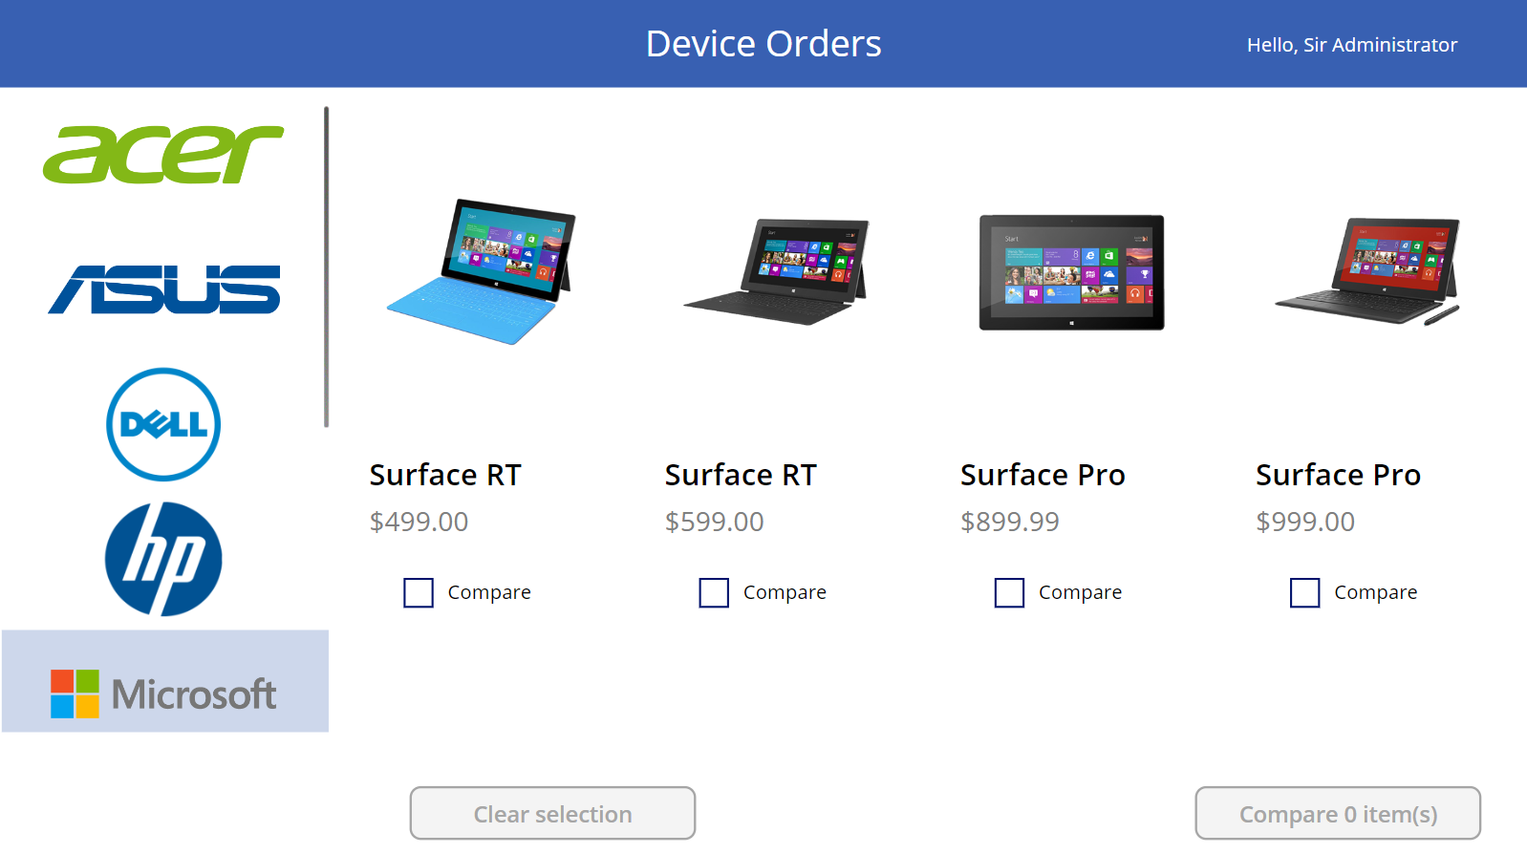

1. Close the preview

## Task 2: Testing the flow

In this task, you will test the flow. When a device order is placed, a corresponding item is created in SharePoint. Creation of this list item will trigger the flow

1. Go back to the flow we just created and open the flow details screen**.**

In the next step, after submitting a device order, the flow will start and display that run instance in the “28-day run history”.

1. Test your Power app, and submit a device request to the SharePoint List
2. Return to the run history in step 1, and click on the new run instance to view the visual history of the flow run for that device order request approval/rejection process.
3. Go to <https://outlook.office.com> and confirm that when you place a request for a new device, you receive the following email:

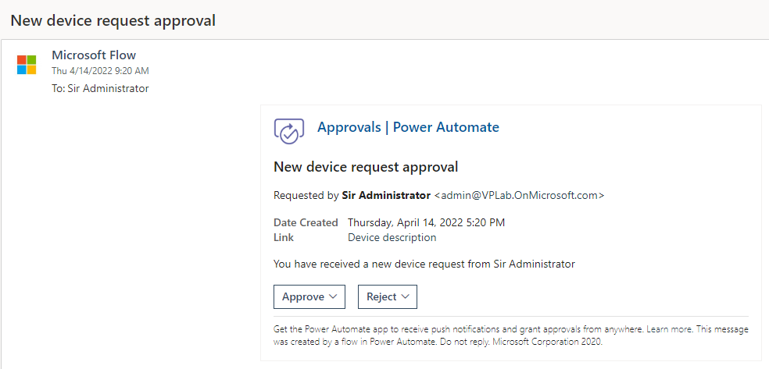

1. Click ‘**Approve**’
2. Click **‘Submit’**

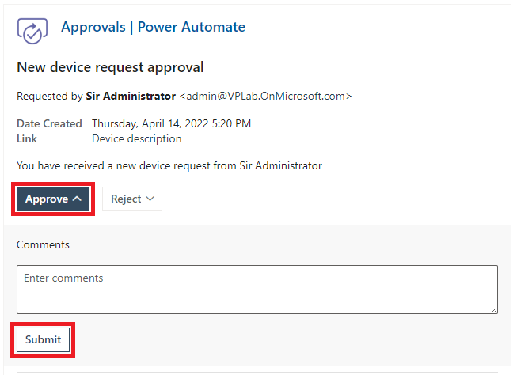

1. Go to the **SharePoint site** and confirm that the request **OrderStatus** column has been updated to ‘Approved’  
   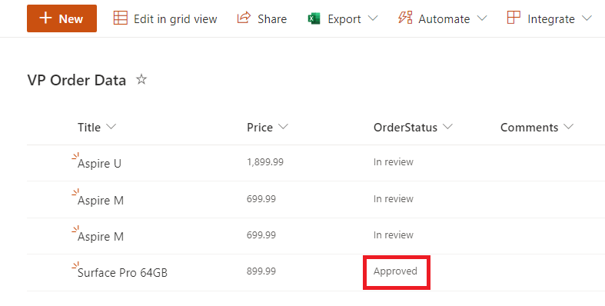
2. Go back to Outlook and check that you have received the approval email

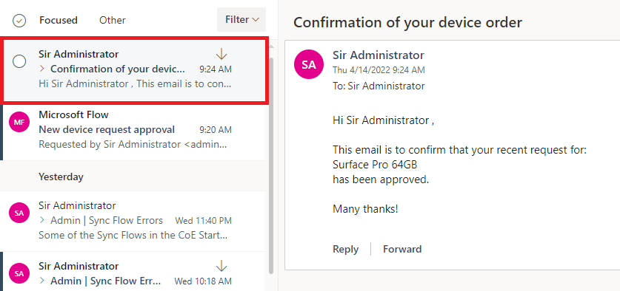

1. Follow from **Step 1** again, this time reject the request.
2. Check that the SharePoint list item OrderStatus column is updated and that you receive the rejection email