CIS020-2 – Systems Development and Modern Database Practices

Assignment 2 – Student Information Kiosk (SIK) Case Study - Group Assignment

Group Number – group 12

1814927 – Michael Songer

Contents

Team member roles 2

Introduction 2

Plan of work 2

Role identification 2

Users 2

Client/stakeholder 2

Service/audience 2

Soft Systems Methodology (SSM) 3

Rich Picture 3

Root Definition 3

CATWOE 3

Conceptual Data Model 3

The three E’s 3

Requirements 3

Use case diagram 4

Activity diagram 5

Class diagram 7

Entity relationship diagram 7

Skeleton Tables 7

Entity Relationships 7

Data Dictionary 7

User-interface design 7

Security 7

Implementation of kiosk 7

Innovations 7

Test system 7

Future evolutions 7

Conclusion 7

References 7

Appendix 7

# Team member roles

1814927 - Michael songer

Team manager, group report, introduction, plan of work, role identification, soft system methodology, requirements,

Zaid

Use case diagram, activity diagram,

# Introduction

The goal of the assignment is to design and make a student information kiosk that will be a useful tool for university students. It should have a variety of tools that informs students about different what’s happening both in the university and locally.

# Plan of work

The group originally started as six people but ended up going down to two, making doing the work very difficult. So, we tried to split the work evenly. Michael was set as group leader, but assigning the work was agreed together. Michael was to come up with the requirements and design the soft system methodologies. From the requirements zaid was to do the UML diagrams. Michael then was to work on the database design and GUI design. Once all the designing was done and agreed upon it will be implemented into oracle apex.

# Role identification

## Users

Students, university staff and admin. The university staff and admin will be the ones who add things like event details and local points of interest.

## Client/stakeholder

University dean, university students, university staff, university event management team, university administration.

## Service/audience

The service is an online kiosk that is designed to provide information to students of the university of Bedfordshire. The information will be things like local places of interest, events (both on campus and near). It will also inform the students of where they can get support if they require it.

# Soft Systems Methodology (SSM)

## Rich Picture

## Root Definition

The student information kiosk is made to easily show students anything that will be of interest to them (x), by means of a simple/easy to use online system(y), in order to aid them in getting a memorable university experience and meet other students with similar interest.

## CATWOE

C – Students

A – University staff

T – Increase popularity/knowledge of things students may be interested in.

W – Having students socialise together more will help their social skills for the future and having students at local events will increase people’s views on the university.

O – University dean and university event management team.

E – University budget, internet/mobile data connectivity, student devices, interest.

## Conceptual Data Model

## The three E’s

Efficacy -

Efficiency -

Effectiveness -

# Requirements

We were able to get an initial list of requirements from the clients brief.

|  |  |  |  |  |
| --- | --- | --- | --- | --- |
| Functional requirements | | | | |
| ID | Requirement | Priority | Owner | Source |
| 1.0 | Track campus events | High | Michael | Client brief |
| 1.0.1 | Bookmark campus events | Medium | Michael | Client brief |
| 1.1 | Track local events | High | Michael | Client brief |
| 1.1.1 | Bookmark local events | Medium | Michael | Client brief |
| 1.2 | Track points of interest | High | Michael | Client brief |
| 1.2.1 | Bookmark points of interest | Medium | Michael | Client brief |
| 1.3 | Track local support for students | High | Michael | Client brief |
| 1.3.1 | Bookmark local support for students | Medium | Michael | Client brief |

|  |  |  |  |  |
| --- | --- | --- | --- | --- |
| Non-functional requirements | | | | |
| ID | Requirement | Priority | Owner | Source |
| 2. | Accessibility options | High | Michael | Client brief |
| 3. | Efficient data usage | High | Michael | Client brief |
| 4. | Simple to use | High | Michael | Client brief |
| 5. | Minimum device storage | Medium | Michael | Client brief |

# Use case diagram

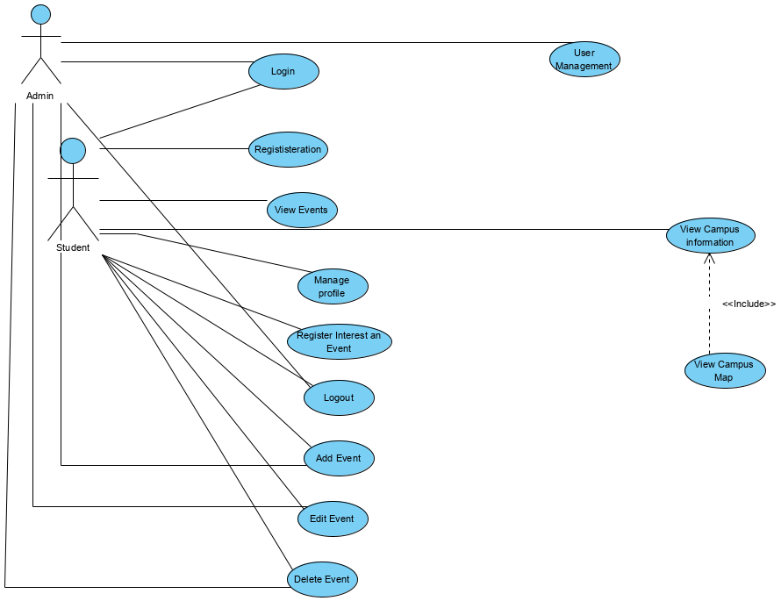

# Activity diagram

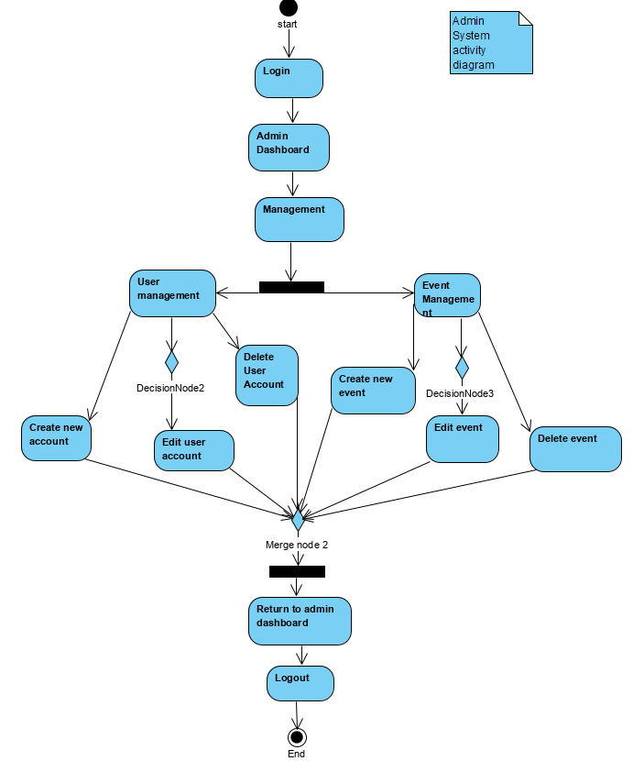

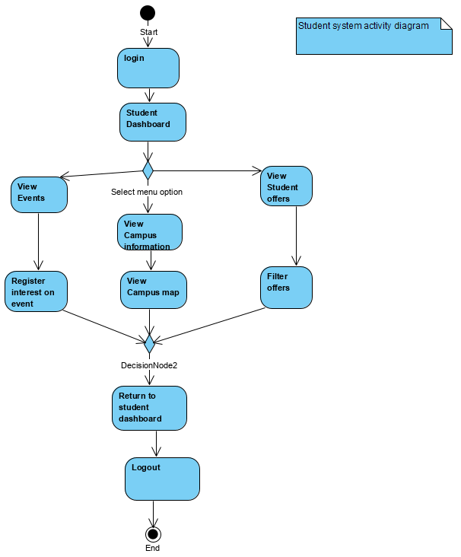

# Class diagram

# Entity relationship diagram

# Skeleton Tables

# Entity Relationships

# Data Dictionary

# User-interface design

# Security

# Implementation of kiosk

# Innovations

# Test system

# Future evolutions

# Conclusion

# References

# Appendix