Contents

Description 1

History 1

Supported AWS Region 1

Synopsis 1

Step 1: Create an S3 Bucket manually (Not Mandatory) 1

Step 2: Manually upload Cloud Formation Script(s) and Lambda Code into S3 2

Step 3: Launch DynamoDB Tables using CloudFormation Script 2

Step 4: Launch Lambda + API Gateway using CloudFormation Script 2

[Optional] Step 5: Testing 3

PersistParentChildMap API 3

GetParentChildMap API 4

# Description

This is a short guide to get your APIs up and running in AWS. There are 4 steps altogether.

# History

10 Sep 2016 Added for Lambda Software Package 0.0.1-SNAPSHOT

# Supported AWS Region

Oregon (US-WEST-2)

# Synopsis

There are 4 steps required:

1. Create an **S3 Bucket** manually

This is to create S3 bucket that consist of cloud formation script and code.

1. Manually **upload** cloud formation script(s) and lambda code into S3

This is to make available these files to CloudFormation during subsequent steps

1. Launch a **DynamoDB Table** using CloudFormation Script

This is to store data created by the Lambda application.

1. Launch **Lambda** and **API Gateway** using CloudFormation Script

# Step 1: Create an S3 Bucket manually (Not Mandatory)

Difficulty: **Simple**

Time: **2 minute**

Steps

1. Go to AWS Console
2. Go to S3
3. Create the bucket with name ‘**YOUR_CHOICE_NAME’** and make sure you select **Oregon** Region .

# Step 2: Manually upload Cloud Formation Script(s) and Lambda Code into S3

Difficulty: **Simple**

Time: **2 minute**

Steps

1. Go to AWS Console
2. Go to S3
3. Locate the bucket ‘‘**YOUR_CHOICE_NAME’** that was newly created in step 1.
4. Upload the Lambda Jar file ‘**persistData-0.0.1-SNAPSHOT.jar’**.
5. Copy the all URLs of cloud formation script(s).

# Step 3: Launch DynamoDB Tables using CloudFormation Script

CloudFormation Script: **aws-dynamo-db.template**

Difficulty: **Simple**

Time: **2 minute**

Steps

1. Go to AWS Console
2. Go to CloudFormation
3. Create Stack using **‘Specify an Amazon S3 template URL’** and paste the URL that was copied in Step 2-5.
4. Give the stack a name, this name is not important and only for your reference.
5. Accept default settings and complete the stack creation.

# Step 4: Launch Lambda + API Gateway using CloudFormation Script

CloudFormation Script: **lambda-and-api-gateway.template**

Difficulty: **Simple**

Time: **5 minute**

Steps

1. Go to AWS Console
2. Go to CloudFormation
3. Create Stack using **‘Specify an Amazon S3 template URL’** and paste the URL that was copied in Step 2-5.
4. Give the stack a name, this name is not important and only for your reference.
5. Provide **S3** bucket name & lambda code file name as you created/upload in Step 1 and Step 20 respectively and click Next.

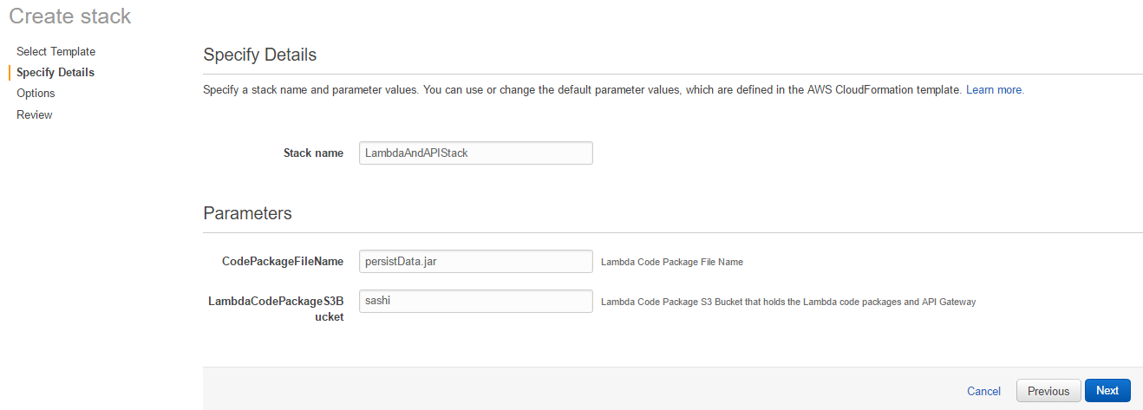

1. Provide Tags if you want, else you can skip this step and Click Next.
2. Select the “**I acknowledge that AWS CloudFormation might create IAM resources.”**

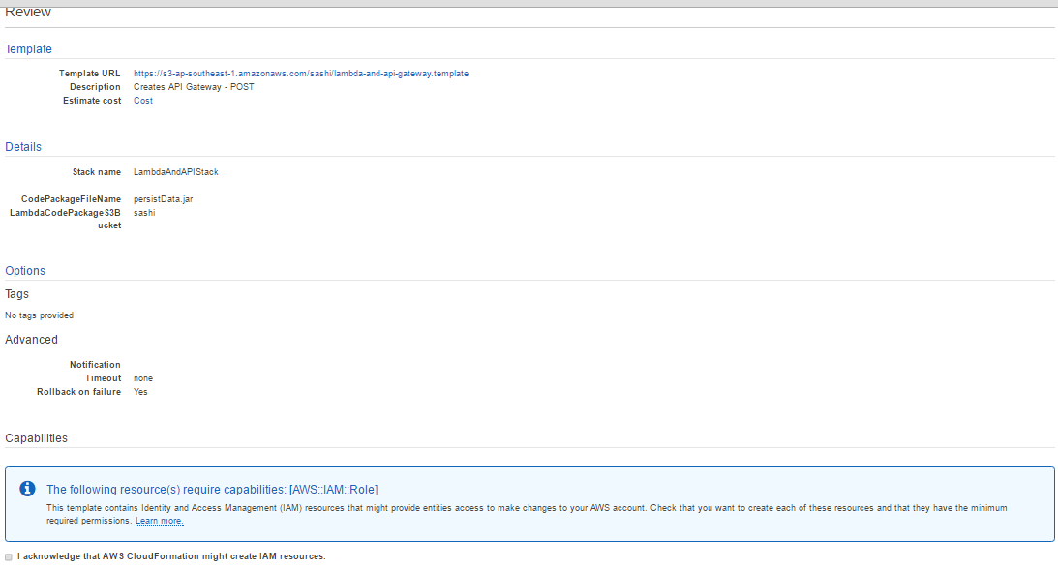

1. Complete the stack creation.

# [Optional] Step 5: Testing

## PersistParentChildMap API

Difficulty: **Simple**

Time: **1 minute**

URL: **https://g50awvi3a1.execute-api.ap-southeast-1.amazonaws.com/production/parentchildmap**

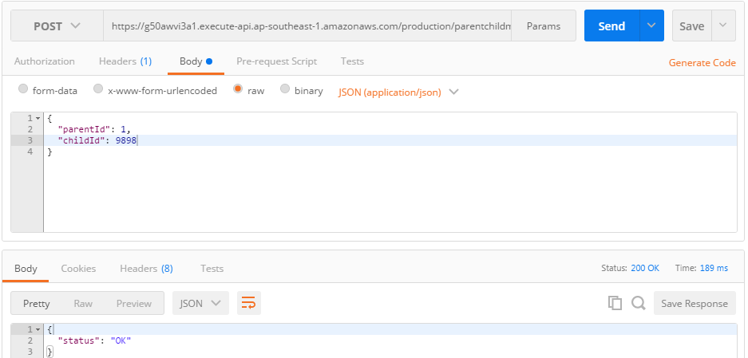

## GetParentChildMap API

Difficulty: **Simple**

Time: **1 minute**

URL: **https://g50awvi3a1.execute-api.ap-southeast-1.amazonaws.com/production/parentchildmap**

