Income based Data Analysis on US Census
Krishna Chaitanya S, Meghana B S, Nirupam K N, Sharath R
Department of Computer Science, M S Ramaiah Institute of Technology

Abstract — The US Census Bureau conducts the American Community Survey generating a massive dataset with millions of data points. The rich dataset contains detailed information of approximately 3.5 million households about who they are and how they live including ancestry, education, work, transportation, internet use and residency. The objective of the paper is to reveal unique insights into the lives of the population comprising the survey using Statistical analysis. The main focus of this paper is to concentrate on bringing out unique insights into the income and the economic status of the citizens. Using relevant attributes demographic graphs are plotted, conclusions are drawn and classification into various economic classes is done.
Keywords: Demographic graphs, Benford’s law, income, K- means clustering, Naïve Bayes classifier

INTRODUCTION
“A large income is the best recipe for happiness I ever heard of “quotes the famous English novelist Jane Austen. Income is a primary concern that dictates the standard of living and economic status of an individual. Taking into account, its importance and impact on determining a nation’s growth, this paper aims at presenting meaningful insights which can be used to serve as the basis for many wiser decisions by the nation’s administrators. The massive dataset ^{[1]} used for the conclusion derived consists of over 3.5 million data points representing various aspects of information about the population and is about 4.5GB in size. It consists of many attributes describing the population such as age, income, degree, internet usage, region, gender, domains of work, expenditure, occupation, fuel cost, transportation method, internet access details and so on. The idea is to implement statistical analysis and various algorithms such as K-means algorithm, Naïve Bayes Classifier and others to arrive at crucial information of value. Robert E. Fay et al., explore an adaptation of the James-Stein estimator applied to sample estimates of income for small places (i.e., population less than 1,000) from the 1970 Census of Population and Housing. The adaptation incorporates linear regression in the context of unequal variances. The new estimates for these small places now form the basis for the Census Bureau's updated estimates of per capita income for the General Revenue Sharing Program ^{[2]}. N. Krieger et al., in their paper, discuss concepts and methodologies concerning, and guidelines for measuring, social class and other aspects of socioeconomic position (e.g. income, poverty, deprivation, wealth, education). These data is collected at the individual, household, and neighborhood level, to characterize both childhood and adult socioeconomic position. Guidelines for linking census-based socioeconomic measures are presented, as are recommendations for analyses involving social class, race/ethnicity, and gender. Suggestions for research on socioeconomic measures are provided, to aid monitoring steps toward social equity in health ^{[3]}. George A Kaplan et al. explored the degree of income inequality, defined as the percentage of total household income received by the less well of 50% of households, calculated changes in income inequality for the 50 states in 1980 and 1990. It was concluded that variation between states in the inequality of the distribution of income are significantly associated with variations between states in a large number of health of health outcomes and social indicators and with mortality trends ^{[4]}.
In this paper, modules have been created to deal with the huge dataset and to bring out unique insights into the lifestyle of the population. Various combinations of attributes of the population are explored and careful selection of the primary essential attributes is done. The main concentration lies on using income as the basis to bring out the economic inequality in the society, gender inequality in the domain of income and to get to the root of these inequalities by determining the relationship level between income and education level. The module involving the classification into economic classes is extended further to predict to which category of economic class people belong, on the basis of factors such as state, number of vehicles owned, employment history and so on. The above prediction is done using Naive- Bayes classifier. As an additional step in further exploring the cause of the inequalities, the number of children without access to internet in the country has been estimated region-wise.
Various algorithms and techniques have been implemented in order to bring about efficiency of computation in terms of time and space, as well as to ensure the accuracy of the results.

DESIGN
The dataset is loaded into Hadoop for processing. Here PIG is used for Map Reduce as it is found to be efficient in terms of efficiency in time and space. Here, the given dataset is checked for the required attributes and any null tuples that exist for the required data are eliminated. This brings about normalization. The normalized data obtained from this process is used for statistical analysis and to implement data mining techniques. Various algorithms such as K-means clustering, Naïve Bayes classifier have been applied to derive results. The final processed data thus obtained is graphically represented using demographic graphs and heat maps to aid visual interpretation of the insights. The system architecture is as shown in Fig 1.
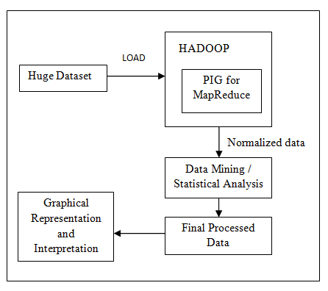
Fig 1. Architecture and design of the system

IMPLEMENTATION

The software is executed by running a python program on the terminal.
A. Hadoop: Apache Hadoop is an open-source software framework written in Java for distributed storage and distributed processing of very large data sets on computer clusters built from commodity hardware ^{[5]}.
B. Java 1.7: Java is used to work with Apache Hadoop.
C. Python: Python is a widely used general-purpose, high-level programming language and it is used for passing and editing the dataset ^{[6]}.
D. R: R is a language widely used for data mining because of its exhaustive libraries for algorithms such as K-mean, Naive Bayes Classifier and so on.
E. PIG: Pig is a data flow platform for writing Hadoop operations in a language called Pig Latin. Apache is a high-level procedural language platform developed to simplify querying large data sets in Apache Hadoop and MapReduce. It provides SQL-like interface to process data on Hadoop and thus help the programmer focus on business logic and help increase productivity. It supports a variety of data types and the use of user-defined functions (UDFs) to write custom operations in Java, Python and JavaScript ^{[7][8]}.

IV. MODULES

The paper deals with the implementation of 5 modules to bring out unique insights.

A. Gender distribution in occupation
In this module, the focus is primarily on bringing out the gender distribution in occupations, i.e., the percentage distribution of men and women in the workforce. Various occupations have been considered for this analysis. It also effectively brings out gender inequality in various sectors. The result of this analysis is depicted in Fig 2.
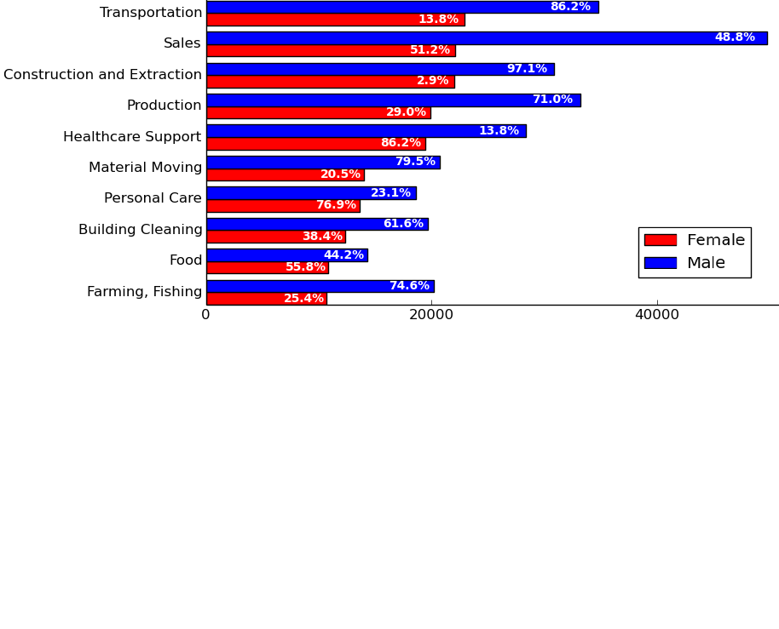
Fig 2. Gender distribution in occupation

B. Education - Salary relationship
This module uses statistical analysis to predict the average salary a person can expect based on his education level. Here an attempt is made to predict a person’s income based on his education degree, field of work, place of stay and other parameters where the total income of the entire population is segregated into a few a classes of income. The result of this analysis is depicted in Fig 3.

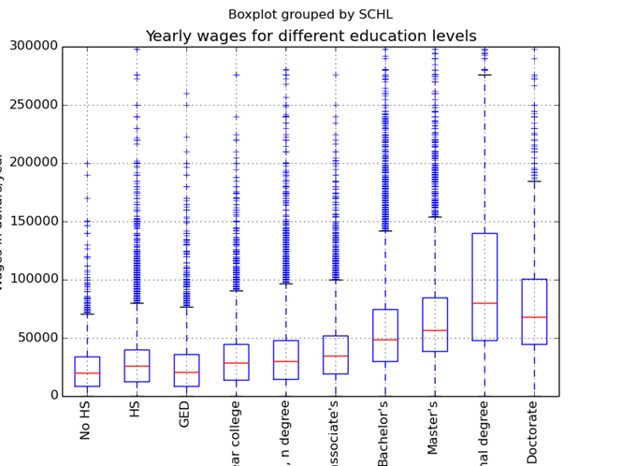
Fig 3. Education – Salary relationship

C. English proficiency with Bitmap
In this module, exploration of the spoken English language proficiency among the people who participated in the survey is performed. On a scale of 0-4, with 0 being the lowest and 4 being the highest, in this module we focus on assessing the knowledge of the participants in the English language and represent the same using Bitmap image. This pie chart gives us a clear picture regarding the people with their abilities to communicate well in English. It is surprising to see that, English though being a national language and also addressed as universal language, the people with hurdles in communicating English exist. The reasons may be the migrating foreigners or the lack of proper education and so forth. These interpretations influence many major decisions taken on the democracy. The result of this analysis is depicted in Fig 4.
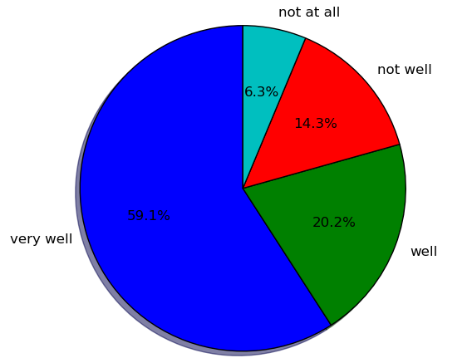
Fig 4. English proficiency levels of the population

D. Economic hierarchy using K-means and income prediction using Naive Bayes classifier
This module uses K-means ^{[9]} to classify the people who participated in the survey into various economic classes based on various parameters such as household, supplementary, total, other income etc. Based on the number of clusters given as input, categorization of the Economic class hierarchy is done. The result of this analysis is depicted in Fig 5.

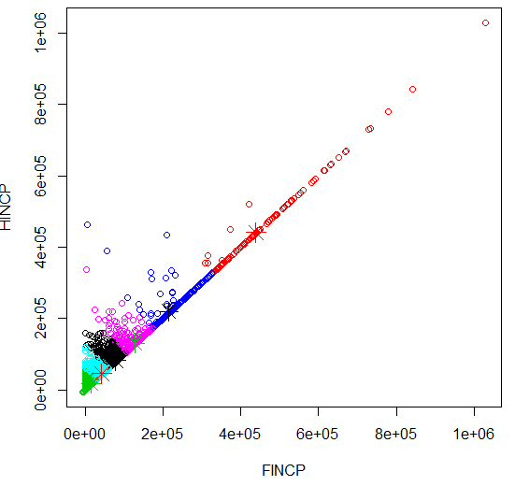
Fig 5. Economic hierarchy based on income

Using this as the basis, we use Naive Bayes classifier ^{[10]} to classify the people among various classes of income (taken from the output of K-means) and checked with their original economic class to which they belong. The below output table shows the efficiency. The elements along the principal diagonal are rightly predicted and the rest are the cases of erroneous predictions. The result of this analysis is depicted in Fig 6.

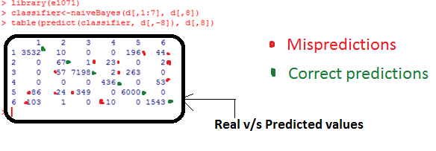
Fig 6. Naïve Bayes Classifier output
E. Benford’s Law of US Income
Benford's law, also called the First-Digit Law, is a phenomenological law about the frequency distribution of leading digits in many real-life sets of numerical data. The law states that in many naturally occurring collections of numbers the small digits occurs disproportionately often as leading significant digits ^{[11][12]}. .Here, Benford’s law has been used to obtain a distribution of US income and is comparison is shown between the values computed theoretically and experimentally. The result of this analysis is depicted in Fig 7.

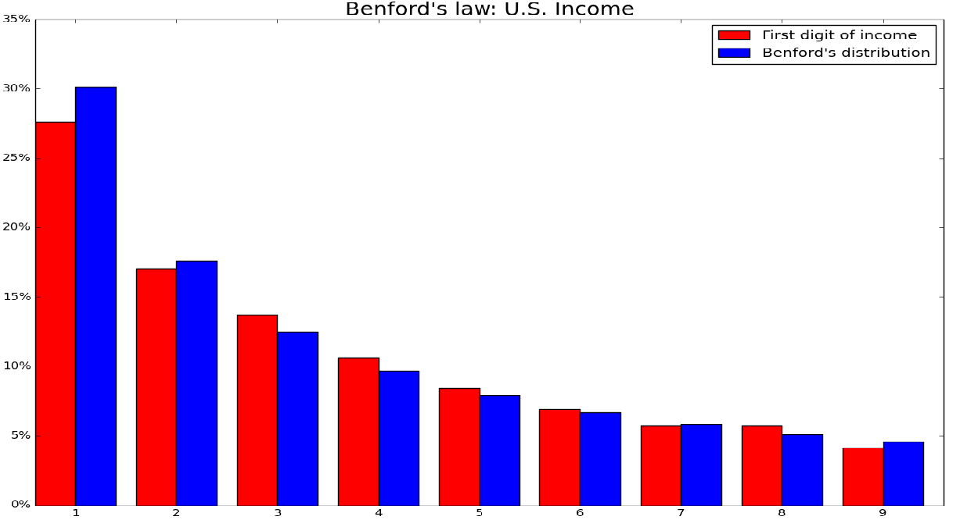
Fig 7. Benford’s law of distribution for US income

F. Percentage of Internet Usage among children

With the advent of technology the gathering of information has been possible through Internet just by sitting within the four walls of the room. Today’s youth is exposed to this technical privilege. Right from a very young age, they can feed their curiosity with right thoughts through Internet. Internet usage might also have several complications associated with it, such as undesired maturity at a small age, hindrance to physical and social development and so on. However with a proper parental or guardian guidance these hurdles can be resolved. In the light of these scenarios, a module is presented depicting the usage of Internet by children across various parts of the country. The bitmap images are used to show the degree of usage across all states with a colour scale. This module indirectly hints the economic conditions across the nation. The result of this analysis is depicted in Fig 8.

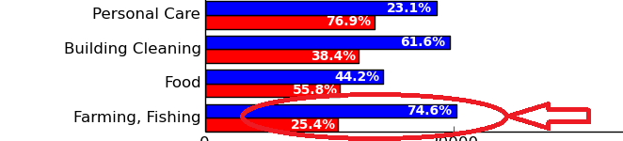
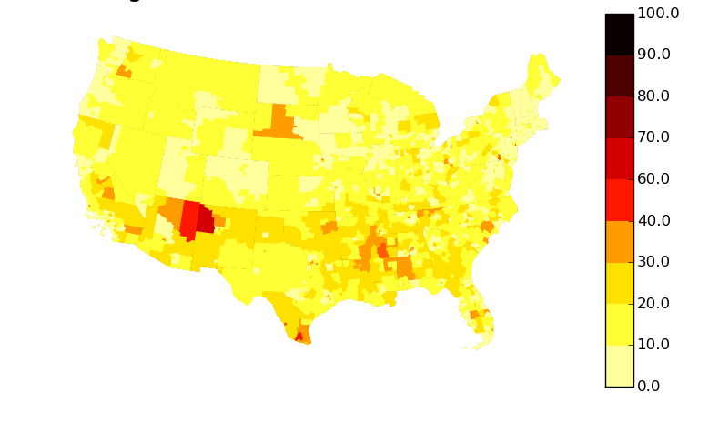Fig 8. Heat map depicting children without access to internet

V. OPTIMIZATION

Optimization has been done to increase the efficiency of time complexity. Two levels of normalization have been implemented to achieve this decrease in time. The results of optimization for two modules are shown in Table 1.

Module | Given dataset  (in seconds) | Level 1 Normalization  (With null tuples) (in sec) | Level 2 Normalization  (Without null tuples) (in sec)
Gender distribution in occupation | 60.023703 | 28.935224 | 17.782561
Benford’s law | 63.656673 | 13.593124 | 13.455113

Table 1 – Time complexity of modules for given dataset, with Level-1 normalization and with Level-2 normalization

It can be seen from the above table that the time for handling and processing the data after normalization has been significantly reduced as compared to the given dataset used to start with.
Without normalization, the percentage of women in farming and fishing sector was found to be 77.4%. After normalization, the result for the same sector was found to be 74.6%, showing a decrease of a 3.6%. The result of this analysis is depicted in Fig 9 – without normalization and Fig 10 – after normalization.

Fig 9. Gender distribution in occupation without normalization

Fig 10. Gender distribution in occupation with normalization

VI. FUTURE WORK

The income is a pivotal factor which a country needs to focus on. The meaningful insights provided by the above modules produce considerable number of factors which gives the picture of the economic clout. With income being the major domain of concentration of this paper, appropriate conclusions are derived on it. The Internet usage among children is also studied which may have an indirect impact on the Economy. Based on the economic rungs, the major decisions based on the parliamentary budget and others can be banked upon. In the light of bringing higher efficiencies, improved algorithms for prediction and classification can be focussed. The deeper delineation in case of graphs or histograms might provide much more scope for deriving insights.

VII. CONCLUSION

A wealth of insights into the lives of the population represented by the US Census data has been derived using statistical analysis and a variety of algorithms. These bring out the economic inequality in the society, gender inequality in the domain of income and also showcase one of the root causes for these inequalities by determining the relationship level between income and education level. A classification into economic classes that has been achieved can be used to predict to which categories of economic class people belong and by extension, their standard of living and social standing. As an additional step in further exploring the cause of the inequalities, the number of children without access to internet in the country has been estimated region-wise. These insights can be used to influence future economic and regional reforms in the country, and can also be used to affect changes in the work sector and at various education levels. Further work can be done to build upon the insights that have been uncovered in this paper.

References

- www.kaggle.com – Source of dataset used
- Estimates of income for small places: An application of James-Stein Procedures to Census data – Paper published in Journal of the American Statistical Association, Volume 74, Issue 366a, 1979
- Measuring social class in US Public health research: Concepts, Methodologies and guidelines : Paper published in Annual review of public health Vol. 18: 341-378
- https://en.wikipedia.org/wiki/Apache_Hadoop: Hadoop Wikipedia
- https://www.researchgate.net/publication/14496913_Inequality_in_income_and_mortality_in_US._Lower_mortality_in_Hispanic_population_may_have_affected_findings: Inequality in income and mortality in the United States – Paper published on Analysis of mortality and potential pathways
- https://en.wikipedia.org/wiki/Python_(programming_language) : Python Wikipedia
- https://cwiki.apache.org/confluence/display/PIG/PigTutorial: Pig tutorials
- http://www.orzota.com/pig-tutorialfor-beginners/: Detailed Pig definition and description
- http://www.r-statistics.com/2013/08/k-means-clustering-from-r-in-action : webpage on k-means clustering using R
- http://www.rdatamining.com/examples/association-rules : webpage on Naïve Bayes Classifier using R
- https://en.wikipedia.org/wiki/Benford%27s_law : Benford’s law Wikipedia page
- Arno Berger and Theodore P Hill, Benford's Law Strikes Back: No Simple Explanation in Sight for Mathematical Gem, 2011 – Benford’s law explanation

