**M S Ramaiah Institute of Technology**

(An Autonomous Institute, Affiliated to VTU)

MSR nagar, MSRIT post, Bangalore-54

A Dissertation Report on

**Sentiment Analysis: Amazon Product Movie Review**

Submitted by

Bharath Kumar S 1MS12CS018

Ganapati R Hegde 1MS12CS032

Jivitesh Mopuri 1MS12CS042

Keshava R 1MS12CS045

*in partial fulfillment for the award of the degree of*

# *Bachelor of Engineering in Computer Science & Engineering*



**DEPARTMENT OF COMPUTER SCIENCE & ENGINEERING**

**M.S.RAMAIAH INSTITUTE OF TECHNOLOGY**

**(Autonomous Institute, Affiliated to VTU)**

**BANGALORE-560054**

[www.msrit.edu](http://www.msrit.edu), **JANUARY 2015**

# Abstract

Sentiment analysis is language processing task that uses a computational approach to identify opinionated content and categorize it as positive or negative. The unstructured textual data on the Web often carries expression of opinions of users. Sentiment analysis tries to identify the expressions of opinion and mood of writers. A simple sentiment analysis algorithm attempts to classify a document as ‘positive’ or ‘negative’, based on the opinion expressed in it. The document-level sentiment analysis problem is essentially as follows: Given a set of documents, a sentiment analysis algorithm classifies each document into one of the two classes, *positive* and *negative*. Positive label denotes that the document expresses a positive opinion and negative label means that expresses a negative opinion of the user. More sophisticated algorithms try to identify the sentiment at sentence-level, feature-level or entity-level.

There are broadly three types of approaches for sentiment classification of texts: (a) using a machine learning based text classifier -such as Naïve Bayes, SVM or kNN - with suitable feature selection scheme; (b) using the unsupervised semantic orientation scheme of extracting relevant n-grams of the text and then labeling them either as positive or negative and consequentially the document; and (c) using the SentiWordNet based publicly available library that provides positive, negative and neutral scores for words.

So this analysis is done on the datasets that contains movie reviews from the Amazon product dump. This helps the user to better decisions whilst watching/picking an appropriate movie(s).

#### CONTENTS

***Declaration i***

***Acknowledgements ii***

***Abstract iii***

1 **INTRODUCTION**

* 1. General Introduction
  2. Statement of the Problem
  3. Objectives of the project
  4. Project deliverables
  5. Current Scope
  6. Future Scope

1. **PROJECT ORGANIZATION**
   1. Software Process Models
   2. Roles and Responsibilities
2. **LITERATURE SURVEY**

3.1Introduction

3.2 Main Body

3.3 Conclusion of Survey

1. **SOFTWARE REQUIREMENT SPECIFICATIONS**

4.1 Product Overview

4.2 External Interface Requirements

4.2.1 User Interfaces

4.2.2 Hardware Interfaces

4.2.3 Software Interfaces

4.2.4 Communication Interfaces

4.3 Functional Requirements

4.3.1 Functional Requirement 1.1

:

4.3.n Functional Requirement 1.n

4.4 Software System Attributes

4.4.1 Reliability

4.4.2 Availability

4.4.3 Security

4.4.4 Portability

4.4.5 Maintainability

4.4.6 Performance

4.5 Performance Requirements

4.6 Database Requirement

4.7 Design Constraints

4.8 Other Requirements

1. **DESIGN**
   1. Introduction
   2. Architecture Design
   3. Graphical User Interface
   4. Class Diagram and Classes (represent Inheritance, Aggregation and Association)
   5. Sequence Diagram
   6. Data flow diagram
   7. Metric calculation
2. **IMPLEMENTATION**
   1. Tools Introduction
   2. Technology Introduction
   3. Overall view of the project in terms of implementation
   4. Explanation of Algorithm and how it is been implemented
   5. Information about the implementation of Modules
3. **TESTING**

**7.1** Results and Snapshots

1. **CONCLUSION & SCOPE FOR FUTURE WORK**
2. **REFERENCES**

**INTRODUCTION**

* 1. **General Introduction**

This Project aims at analysing movie reviews by Amazon.

This makes it easier to make decisions on whether the movie is good or bad for the community. This gives a clear cut idea of what types of products are trending in the society. Helps people to make decisions in making better future products according to the prediction on the reviews.

* 1. **Statement of the Problem**

Sentiment Analysis: Amazon Product Review

Categorising the Data sets of product reviews based on the emotions and/or attitude of the movies review

**1.3 Objectives of the project**

To clearly classify the entire movie review database in hand to help the users/viewers to make clearer cut decisions on what to pick according to their liking and purpose.

* 1. **Project deliverables**

The project is responsible for delivering the classified data set based on the algorithms used to base them as positive/negative. This is represented as a text file with the movie ID containing the opinions of the multiple commented users with a score ranging from a positive scale to a negative scale.

* 1. **Current Scope**

The scope of this projects aims to satisfy the user community to make their own analysis of this classified data and also can be used for further research topic.

**1.6** **Future Scope**

Creating more and new path of exploration in the field of entertainment in this case movies. This expands the horizons of this current fields which were not possible before this.

**PROJECT ORGANIZATION**

**2.1 Software Process Models**

The software process model we used for this project is the waterfall model.

We can categorize this as the waterfall model by these following steps that was followed to proceed with the project development:

1. The dataset requirments were frozen.
2. The scope of the project was never changed.
3. The hardware specifications were also fixed.
4. The software specifications were too.
5. Further changes in the dataset requires the change in the whole project.

For all these reasons we can say that the software process model was the waterfall model.

* 1. **Roles and Responsibilities**

The **Project Team** is the group responsible for planning and executing the project. It consists of a variable number of Project Team members, who are brought in to deliver their tasks according to the project schedule.

* The **Project Team Members** are responsible for ensuring the completion of the project.
* They are responsible for executing tasks and producing deliverables as outlined in the Project Plan, at whatever level of effort or participation has been defined for them.

This ensures that the team is effective in task management and execution of these tasks to complete the project in the scheduled time.

**LITERATURE SURVEY**

**3.1 Introduction**

This project is a movie review mining using machine learning and semantic orientation. Supervised classification and text classification techniques are used in the proposed machine learning approach to classify the movie review. A corpus is formed to represent the data in the documents and all the classifiers are trained using this corpus.

Thus, the proposed technique is more efficient. Though, the machine learning approach uses supervised learning, the proposed semantic orientation approach uses “unsupervised learning” because it does not require prior training in order to mine the data.

Thus, the study concludes that the supervised machine learning is more efficient but requires a considerable amount of time to train the model. On the other hand, the semantic orientation approach is slightly less accurate but is more efficient to use in real time applications. The results confirm that it is practicable to automatically mine opinions from unstructured data.

**3.2 Main body**

The project used machine learning techniques to investigate the effectiveness of classification of documents by overall sentiment. Experiments demonstrated that the machine learning techniques are better than human produced baseline for sentiment analysis on movie review data. The experimental setup consists of movie-review corpus with randomly selected 8million sentiment reviews. Learning methods Naïve Bayes, was employed. The machine learning techniques are better than human baselines for sentiment classification. Whereas the accuracy achieved in sentiment classification is much lower when compared to topic based categorization. Sentiment Analyzer to extract opinions about a subject from online data documents. Sentiment analyzer uses natural language processing techniques. The Sentiment analyzer finds out all the references on the subject and sentiment polarity of each reference is determined. The sentiment analysis conducted by the researchers utilized the sentiment lexicon and sentiment pattern database for extraction and association purposes. Online product review articles for digital camera and music were analyzed using the system with good results.

**3.3 Conclusion**

Our basis of the project is roughly based on the above techniques discussed to build a custom database of these movie reviews with the score on the positive and negative scale. So, that the user community can have these somewhat processed raw data for this dataset to be expanded to produce different products in this topic.

**SOFTWARE REQUIREMENT SPECIFICATIONS**

**4.1 Product Overview**

This product is mainly based on the dataset acquired for the analysis and classification of the movie reviews. The product requires many hardware and software specifications, also HPC tool has been implemented for the analysis.

* 1. **External Interface Requirements**
  2. User Interfaces:

The interface will be simple and easy to understand. Controls which allow the user to interact with the application will be clear and imply their functionality within the application. We use various applications with different interfaces like Terminal, Eclipse etc.

* 1. Hardware Interfaces:

The analysis doesn’t require any special hardware. It can run on a password protected personal laptop. For parallel processing different clusters of computers are used if required.

* 1. Software Interfaces:

The software that are required for the analysis are Eclipse, Hadoop, EM editor (to open large files), Hive.

* 1. Communication Interfaces:

Internet connection and a web browser are required in order to make use of several functions and for references regarding the projects.

1. **Functional Requirements**
   1. Retrieving Input :

The inputs are extracted from the huge datasets with following attributes

● User ID

● Product review

* 1. Data set pre-Processing:

Data set is pre-processed using eclipse IDE to eliminate stop word and stemming is done using porter’s algorithm.

* 1. Review Classification:

Reviews classification will be done to determine the nature of the Reviews based on the opinion of the users on the movies. The data analysis will provide a negative, neutral, or positive numeric value for the reviews.

d. Analysis of the data:

The data should be finally analyzed with values of the positive and negative reviews and then the movie should be categorized into good or bad.

1. **Software System Attributes**
   1. Reliability:

The project’s main purpose is to categorize the data, so the will accurately divide the data into good and bad based in the input and it is very reliable as it does the job it is assigned to do.

* 1. Availability:

The project will be available on demand. The functionality of the project will not depend on any external services such as internet or any other hardware support and it is available to almost at all time.

* 1. Security:

The project will never disclose any personal information of the users, and the analysis is only for personal reference so it very secure.

* 1. Portability:

This project is portable to any operating system and can be deployed as required.

* 1. Maintainability:

The project should be to precise and should to very optimized. The code will be well documented. The whole project is modularized to ensure that maintenance is easy.

1. **Performance Requirements:**

The performance enhancement makes it easier to make decisions on whether the movie is good or bad for the viewers. The performance can enhanced by increasing the system properties like increasing the Ram etc, for better performance minimum 2GB of Ram is required and the system storage of more than 10GB is required and the so for better performance good hardware is required.

1. **Database Requirement**:

The database is required to store the huge datasets and Hadoop S3 is used for this purpose.

1. **Design Constraints:**

The design of the project is not so costly as all the software used are the open source software and thus the cost is low and speed of the project is very high as the parallel programming is used using HPC tool like Hadoop. Thus design is very optimized as supports high speed and produce almost accurate results.

1. **Other Requirements:**

The Internet Access to World Wide Web is required for references and information for the completion of the project.

**DESIGN**

* 1. **Introduction**

The following subtopics show your design implementations

**5.2** **Architecture Design**

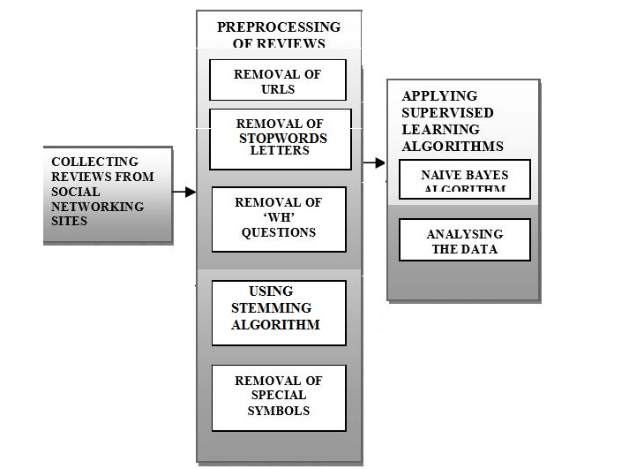

**Class Diagram and Classes (represent Inheritance, Aggregation and Association)**

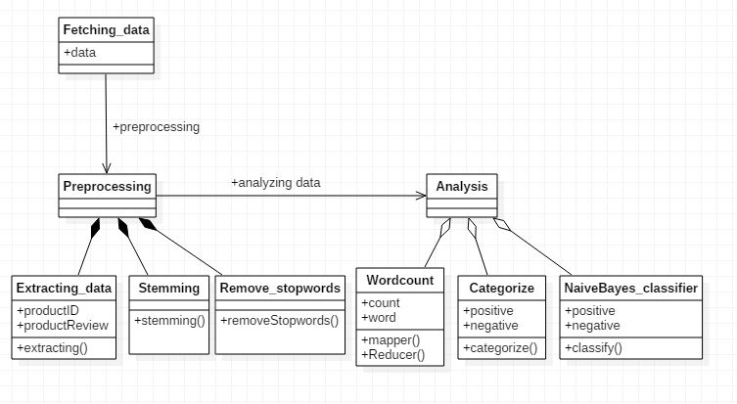

**Sequence Diagram**

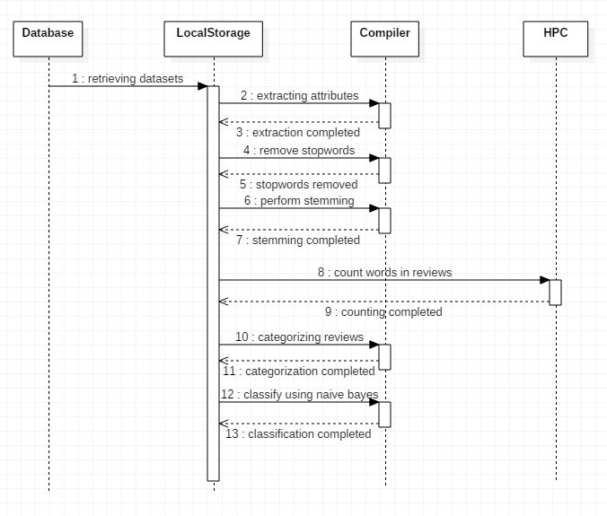

**Data flow diagram**

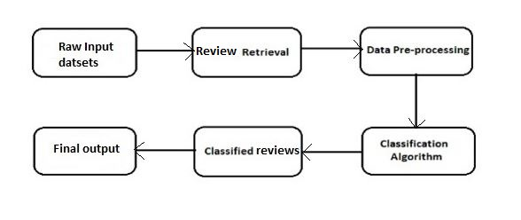

* 1. **Metric calculation**



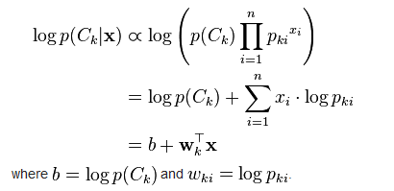

**IMPLEMENTATION**

**Tools Introduction**

1. Eclipse - Eclipse is an integrated development environment (IDE). It contains a base workspace and an extensible plug-in system for customizing the environment. Eclipse is written mostly in Java and its primary use is for developing Java applications, but it may also be used to develop applications in other programming languages through the use of plugins, including: Ada, ABAP, C, C++, COBOL, Fortran, Haskell, JavaScript, Lasso, Lua, NATURAL, Perl, PHP, Prolog, Python, R, Ruby (including Ruby on Rails framework), Scala, Clojure, Groovy, Scheme, and Erlang. It can also be used to develop packages for the software Mathematica. Development environments include the Eclipse Java development tools (JDT) for Java and Scala, Eclipse CDT for C/C++ and Eclipse PDT for PHP, among others.
2. Hadoop - Apache Hadoop is a framework for running applications on large cluster built of commodity hardware. The Hadoop framework transparently provides applications both reliability and data motion. Hadoop implements a computational paradigm named Map/Reduce, where the application is divided into many small fragments of work, each of which may be executed or re-executed on any node in the cluster. In addition, it provides a distributed file system (HDFS) that stores data on the compute nodes, providing very high aggregate bandwidth across the cluster. Both MapReduce and the Hadoop Distributed File System are designed so that node failures are automatically handled by the framework.
3. Hive - Apache Hive is a data warehouse infrastructure built on top of Hadoop for providing data summarization, query, and analysis.[While initially developed by Facebook, Apache Hive is now used and developed by other companies such as Netflix.Amazon maintains a software fork of Apache Hive that is included in Amazon Elastic MapReduce on Amazon Web Services.
4. EM Editor - EmEditor is a lightweight extensible commercial text editor for Microsoft Windows. It was developed by Yutaka Emura of Emurasoft, Inc. It includes full Unicode support, 32-bit and 64-bit builds, syntax highlighting, find and replace with regular expressions, vertical selection editing, editing of large files (up to 248 GB or 2.1 billion lines), and is extensible via plugins and scripts

**Technology Introduction**

1. High-performance computing (HPC) - High-performance computing (HPC) is the use of parallel processing for running advanced application programs efficiently, reliably and quickly. The term applies especially to systems that function above a teraflop or 1012 floating-point operations per second. The term HPC is occasionally used as a synonym for supercomputing, although technically a supercomputer is a system that performs at or near the currently highest operational rate for computers. Some supercomputers work at more than a petaflop or 1015 floating-point operations per second.The most common users of HPC systems are scientific researchers, engineers and academic institutions. Some government agencies, particularly the military, also rely on HPC for complex applications. High-performance systems often use custom-made components in addition to so-called commodity components. As demand for processing power and speed grows, HPC will likely interest businesses of all sizes, particularly for transaction processing and data warehouses. An occasional techno-fiends might use an HPC system to satisfy an exceptional desire for advanced technology.
2. Map-Reduce Technique - MapReduce is a programming model and an associated implementation for processing and generating large data sets with a parallel, distributed algorithm on a cluster. Conceptually similar approaches have been very well known since 1995 with the Message Passing Interface standard having reduce and scatter operations.A MapReduce program is composed of a Map() procedure (method) that performs filtering and sorting (such as sorting students by first name into queues, one queue for each name) and a Reduce() method that performs a summary operation (such as counting the number of students in each queue, yielding name frequencies). The "MapReduce System" (also called "infrastructure" or "framework") orchestrates the processing by marshalling the distributed servers, running the various tasks in parallel, managing all communications and data transfers between the various parts of the system, and providing for redundancy and fault tolerance. The model is inspired by the map and reduce functions commonly used in functional programming, although their purpose in the MapReduce framework is not the same as in their original forms. The key contributions of the MapReduce framework are not the actual map and reduce functions, but the scalability and fault-tolerance achieved for a variety of applications by optimizing the execution engine once. As such, a single-threaded implementation of MapReduce will usually not be faster than a traditional (non-MapReduce) implementation, any gains are usually only seen with multi-threaded implementations. The use of this model is beneficial only when the optimized distributed shuffle operation (which reduces network communication cost) and fault tolerance features of the MapReduce framework come into play. Optimizing the communication cost is essential to a good MapReduce algorithm. MapReduce libraries have been written in many programming languages, with different levels of optimization. A popular open-source implementation that has support for distributed shuffles is part of Apache Hadoop. The name MapReduce originally referred to the proprietary Google technology, but has since been generalized. By 2014, Google were no longer using MapReduce as a big data processing model, and development on Apache Mahout had moved on to more capable and less disk-oriented mechanisms that incorporated full map and reduce capabilities
   1. **Overall view of the project in terms of implementation**

There are 4 modules used in this project for the analysis

* Module for retrieving the datasets
* Module for preprocessing the data
* Sentiment analysis module
* Filtering or classification module

Explanation of Algorithm and how it is been implemented. Information about the implementation of Modules.

**Implementation of the Modules.**

The 4 modules can be described as follows:

* Retrieving the datasets: The datasets that has been fetched is in the raw format, we have to retrieve the datasets in the proper format. The attributes required for the analysis should extracted so that so they can be further used.
* Preprocessing of the data: The datasets or the reviews that are extracted have to be processing before being used for analysis. Preprocessing can done by

1. Removing the stop words.
2. Stemming of the reviews.

* Sentiment analysis module: The reviews are categorized and word count is done using the HPC tool like Hadoop and categorizing is done on the reviews and divided into positive or negative words.
* Classifying and filtering module: The classification of the reviews are done using the Naïve Bayes classifier and the final output is retrieved.
  1. **Algorithm design**

**1). Porter’s Algorithm (stemming)**

Step 1: Gets rid of plurals and -ed or -ing suffixes.

Step 2: Turns terminal y to i when there is another vowel in the stem.

Step 3: Maps double suffixes to single ones: -ization, -ational, etc.

Step 4: Deals with suffixes, -full, -ness etc.

Step 5: Takes off -ant, -ence, etc.

Step 6: Removes a final –e.

**2). Naive bayes algorithm (classification*)***

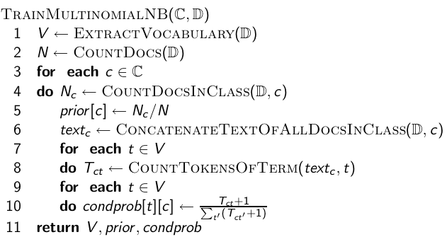

**TESTING**

Results and snapshots

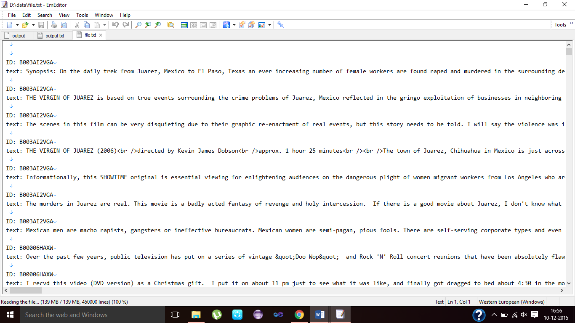

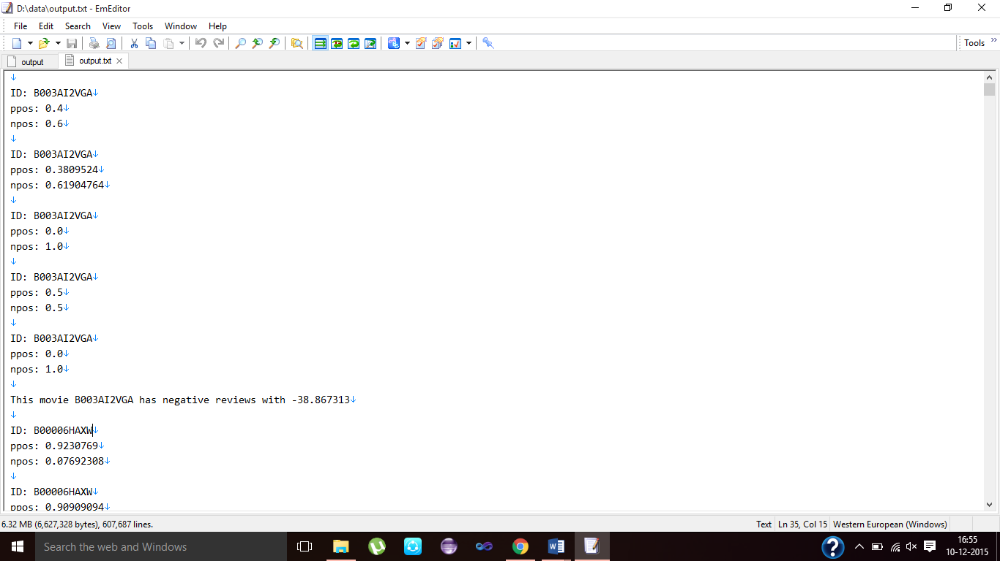

**CONCLUSION & SCOPE FOR FUTURE WORK**

Our basis of the project is roughly based on the above techniques discussed to build a custom database of these movie reviews with the score on the positive and negative scale. So, that the user community can have these somewhat processed raw data for this dataset to be expanded to produce different products in this topic.

The scope of this project aims to satisfy the user community to make their own analysis of this classified data and also can be used for further research topic.

Creating more and new path of exploration in the field of entertainment in this case movies. This expands the horizons of these current fields which were not possible before this.

**REFERENCES**

1. https://snap.stanford.edu/data/
2. https://en.wikipedia.org/wiki/Sentiment_analysis
3. http://www.bogotobogo.com/Hadoop/BigData_hadoop_Install_on_ubuntu_single_node_cluster.php
4. https://Hadoop.apache.org/
5. https://hive.apache.org