Human and Energy Resource Management

Vikas H. and Tejas D. Hasarali

Department of Computer Science and Engineering,

M.S. Ramaiah Institute of Technology, Bangalore 560054, India

vikas.hanumegowda@gmail.com, tejasdhasrali@gmail.com

Abstract: Energy and Human Resources are not efficiently managed in most organizations thusly, our project aims at managing these resources by making energy consuming equipment automated and delineated human resource monitoring. Human and Energy resources management refers to the use of computer and information technology to control home appliances and features (such as windows or lighting). Systems can range from simple remote control of lighting through to complex computer/micro-controller based networks with varying degrees of intelligence and automation. Our system is adopted for reasons of ease, security and energy efficiency. In modern construction in industrialized nations, most homes have been wired for electrical power, telephones, TV outlets (cable or antenna), and a doorbell. Many household tasks were automated by the development of specialized automated appliances. For instance, automatic washing machines were developed to reduce the manual labor of cleaning clothes, and water heaters reduced the labor necessary for bathing. The use of gaseous or liquid fuels, and later the use of electricity enabled increased automation in heating, reducing the labor necessary to manually refuel heaters and stoves. Development of thermostats allowed more automated control of heating, and later cooling.
Keywords: Raspberry pi2, TightVNCServer, SMTP, LAN, MQTT, Paho, Android
1. Introduction
Raspberry Pi is a mini computer which is of the size of a credit card [8]. The operating system is called Raspbian OS which is simple and is optimized for Raspberry pi. It’s an open source operating system based on Debian ^{[1]}. Once the operating system has been loaded in the Raspberry Pi using the SD card which is of class 10 or higher the necessary hardware connections are made as described in section 3. The function of each component that is used is specified in section 2. Later the procedure which involves the task of writing python code to achieve all the functionalities of the system are described in section 4.
2. Functional Description
It is essential to be well versed with functions of various components before plunging into other details regarding the system. The functions of the various components that are used in developing the system are given below.
- IR Proximity Sensor:
It works by applying a voltage to a pair of IR light emitting diodes (LED’s) which in turn, emit infrared light. This light propagates through the air and once it hits an object it is reflected back towards the sensor. The sensing unit, in the form of an integrated circuit (IC), detects the reflected infrared light and sends a corresponding signal to the output terminal.
- Temperature Sensor:
It can be used to detect the changes in the surrounding temperature with the help of temperature dependent variable resistors. The output current inversely depends on the temperature sensed by the sensor.
- Pressure Sensor
In an absolute Pressure Sensor, pressure is measured relative to perfect vacuum condition. Perfect vacuum is a condition where there is no matter present in the atmosphere and hence, nil air pressure exists in that region. Sensors based on absolute pressure measurement require strict specifications for precise outputs. Sensors based on this type of measurement are used in barometric or altitude related pressure measurements.
- Raspberry Pi:
The various components of Raspberry- Pi are:
• SD Card slot is used for inserting an SD card which of class 10 or higher to load the raspbian OS and to provide persistent storage.
• Micro USB Power Port enables the Raspberry pi to obtain current that’s needed for booting OS and running various applications. It usually requires a 5volt ,1amp charger [8].
• Ethernet Port is used to connect to the Internet using RJ45 lan cable.
• HDMI OUT(High Definition Multimedia Interface) is used with HDTVs and monitors with HDMI input.If not and HDMI-VGA adapter is used to make it compatible with VGA monitors. This is needed only during the initial stage of loading the OS.
• BROADCOM BCM 2835: Raspberrypi2 uses the Broadcom BCM2836 as the Soc which contains a quad-core ARM Cortex-a7 processor with floating point & NEON, running at 900MHz and a Video core 4 GPU. The GPU is capable of Blu-Ray-quality playback, using H.264 at 40MBits/s. It has 1 GB of RAM and 4 USB 2.0 ports and one micro USB for 5v power supply [3].
• GPIO pins allows us to control and interact with real world .
Figure 1 shows all the fucntional components of a Raspberry Pi2.

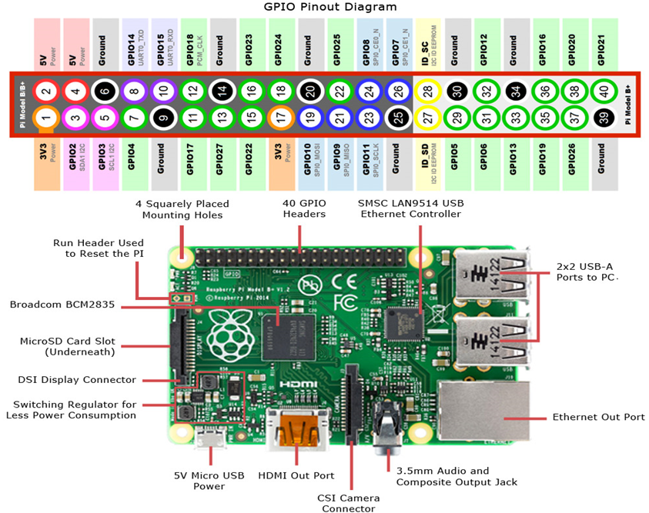
Figure 1 Raspberry Pi.

3. HARDWARE ARCHITECTURE
The GPIO connections are made as shown in figure 2. A resistor is used to control the fluctuations in the Distance values. The SD card is inserted into its slot and the 5V, 1A power adapter is connected to the micro USB slot and the Wi-Fi adapter is connected to the USB port [3]. For the initial loading of OS we need a keyboard, mouse and a monitor which are connected to the remaining 3 USB ports. These non pin hardware connections are shown in the figure 3. Also the features that are provided by system are depicted in it.
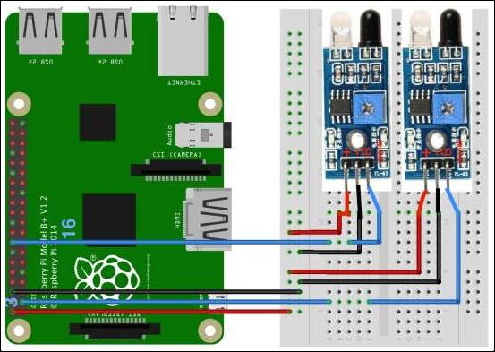
Figure 2 GPIO connections IR sensors.
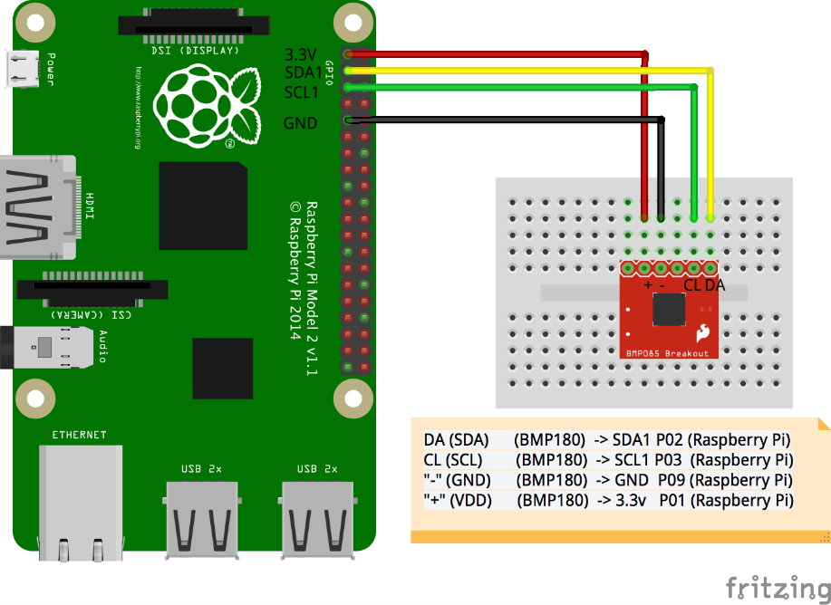
Figure 3 GPIO connections Pressure & Temperature sensor.
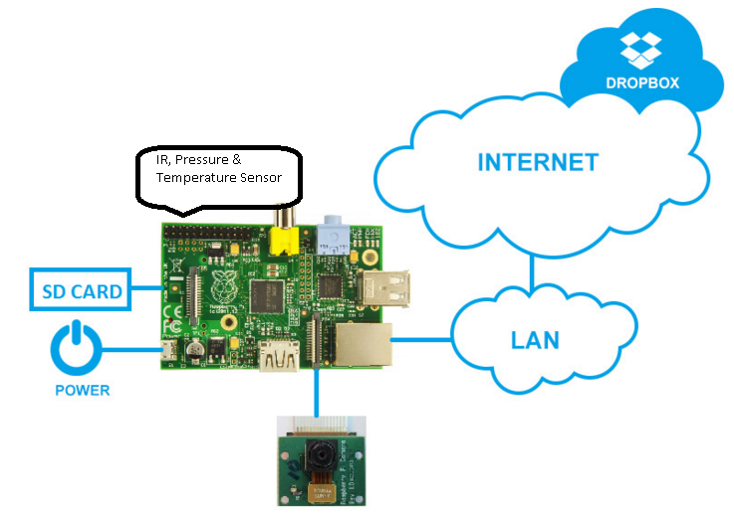
Figure 4 System Design.
The features provided include Raspberry pi2, TightVNCServer, SMTP, LAN, MQTT, Paho, and Android from an Android phone.
4. INTIAL SETUP
4.1 Loading Raspbian OS
Download NOOBS (New out Of Box Software) from the raspberry pi website as a zip file [2]. Use the SD card formatter software to format the card and later extract the zip file into the card. Insert the SD card into the slot and power up the device by connecting a VGA monitor to the HDMI output of pi using HDMI to VGA convertor and also the keyboard and mouse needs to be connected to the USB ports. On successful loading of OS figure 4 will be seen [8].
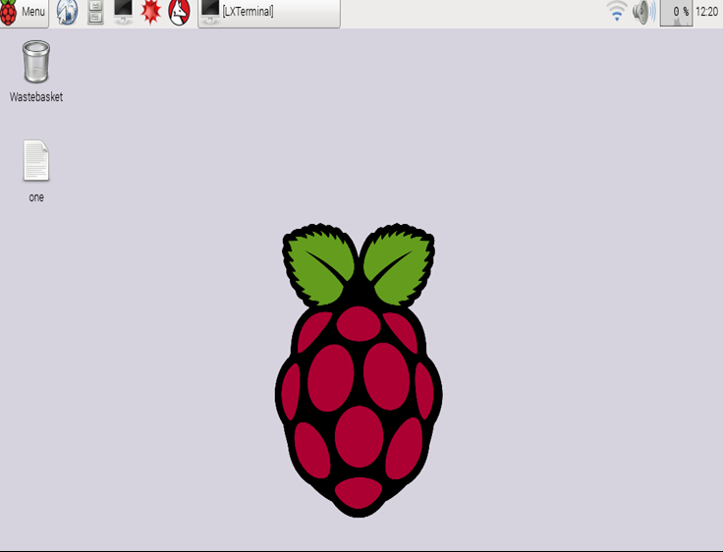
Figure 5 Successful Loading of OS

4.2 Remote Access
Make sure that the laptop from which you wish to access the Raspberry pi is connected to a Wi-Fi network which can be shared over the LAN cable connected between the Raspberry pi and the laptop. Download and install putty, angry IP scanner and VNC viewer. Using the IP scanner the IP address of the Raspberry pi can be determined which has to be entered in putty which is a telnet client which remotely accesses the Raspberry pi’s terminal. Then VNC viewer can be used to remotely access the Raspbian OS from the laptop.
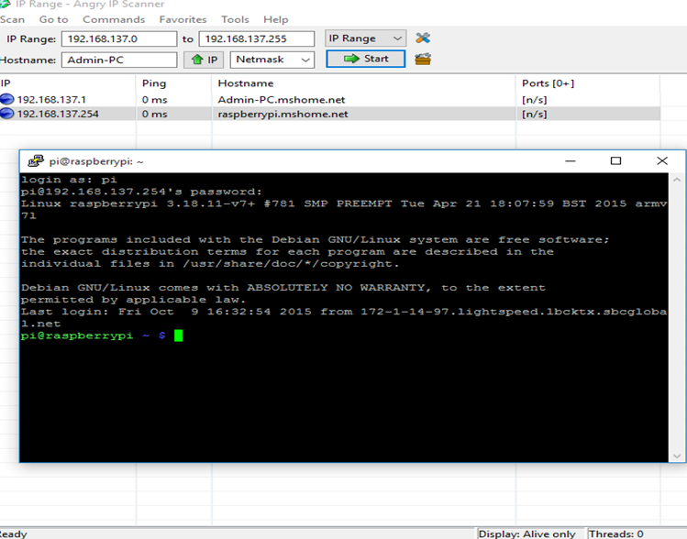
Figure 6 Remote Access

5. SOFWATRE REQUIREMENTS SPECIFICATION
5.1External Interface Requirements
- User Interfaces: Dropbox is used as a cloud service interface, which is customized for Raspberry Pi 2. At any given time a Manager should be able to check the number of employees inside the office and the number of employees who are sitting at their desk and working. At the end of the day the manger should be sent a mail containing information about total number of hours worked by every employee. If any employee’s number of working hours exceeds a certain limit per week then the Human Resource Department as well as the Respective Manger should be informed. The interface should be able to accept required inputs, it should be simple and easy to use. The user should be able to access the above information through any device.

- Hardware Interfaces: Raspberry Pi 2 Model B should be the hardware device which is responsible for co-coordinating various activities of different components of the project. Infrared proximity sensors has to be used to keep track the number of employees inside the office. Pressure and Temperature sensor has to be used to keep track the number of hours worked by every employee. RaspberryPi2 along with three different sensors should acts as the hardware interface in the project.

- Software Interfaces: Python has to be used as programming language to keep track the number of people inside the office with the help of IR proximity sensor. Using this data the energy consuming equipment should be controlled. Also to keep track the number of hours worked by every employee with the help of Temperature and Pressure sensors python has to be used. At the end of the day number of hours worked by every employee should be sent to the Manger using SMTP protocol. If number of hours worked by any employee exceeds a predefined hours per week then the Human Resource Department as well as Manger should be informed. Thus the python together with the library routines should act as the software interface.

- Communication Interfaces: A Manager should be able to access the required information through internet using the cloud service or by using the android mobile application. SMTP should be the protocol used for sending the required information through e-mail and MQTT as a communication protocol between the hand-held devices and the cloud services as well as between the Raspberry Pi and could services. Hence MQTT and SMTP are used as communication protocol between different components.

5.2 Functional Requirements
- Functional Requirement 1.1: Manger Allocation: A manager should be allocated to a set of employees and all the information related to these employees should be sent to this manager.

- Functional Requirement 1.2: Accessing Raspberry Pi Remotely: The user should be able to access the Raspberry Pi interface remotely to change the functionalities remotely by using Putty and VNC viewer.

- Functional Requirement 1.3: Cabin Resource monitor: With the help of the data collected from Temperature and Pressure sensor the resources inside the cabin of every employee should be controlled.

- Functional Requirement 1.4: Office resource monitor: Using the data collected from the IR proximity sensor the number employees inside the office is kept track and depending on the number of employees inside the building the resources hast to be controlled.

- Functional Requirement 1.5: Human Resource monitor: Using the data obtained from Temperature and Pressure sensors the number hours worked by each employee is kept track and if any employees working hours exceed a pre-defined limit then alert message should be sent to the respective Manger and the Human Resource Department.
- Functional Requirement 1.6: Could service Interface: Manger and Human Resource Department should be able to access the employee information through the cloud interface and should be able to make necessary changes.

- Functional Requirement 1.7: Android Application: An android application has to be developed to obtain the information through cloud services and to get alert messages.

- Functional Requirement 1.8: Storage: The number of hours worked by every employee has to be logged in the storage provided. Interface to access this information has to be created in a simple manner.

- Functional Requirement 1.9: MQTT: Manager and Human Resource Department has to be informed and alerted through the android application using MQTT protocol

- Functional Requirement 1.10: SMTP: Manager and Human Resource Department has to be informed and alerted through Email using SMTP protocol.

  - Software System Attributes

- Reliability: The system should be free of errors and it should be able to handle the worst case scenarios. The permissible rate of system crash per month should be less than one.

- Availability: The system should be available all the time and the maintenance has to be done only at night when the load is minimum. The system should be able to respond to changes in the state of sensors and log those data.

- Security: The system should be safe and secure, should be able to resist the hacking attacks. The employee data log should be very secure and only authorized persons can be able to access it. Also these data should be Read Only.

- Portability: The system should be able to work in different operating systems without or minimal changes. Changing the platform on which the system works should be a very easy task.

- Maintainability: The system needs to be continuously monitored and maintained. If the system goes down by any failures then it should be repaired immediately. If any changes are required in the system it should be provided by updates.

- Performance: The system’s performance is measured in terms of responsiveness, efficiency and user experience. A system with high performance is desired. Performance is high if the throughput is high, latency is low, response time is less and system dependability exists. The system should respond as soon as there is any changes in the sensor state and it take necessary actions.

- Reliability: The reliability of the system will be in terms of as to how accurate the Distance readings are sensed by DS18B20 and also the lifetime of the board and the sensors. As lifetime is high, reliability is also high.

- Availability: The availability of the system refers to the system’s capability to be in the on state throughout i.e. 24*7. This means the sensors need to continuously sense the Distance and this sensed is constantly updated to the open source cloud so that it can be accessible from anywhere. It includes system availability, Internet connection availability.

- Security: The system needs to be secure and safe and must prevent security attacks which could violate the goals or might manipulate the RaspberryPi. It includes system security and cloud account security.

- Portability: The code that is used for measuring the distance needs to be portable i.e. the same code should run on any version of RaspberryPi. This is called architecture neutrality. Also the application needs to be portable across a wide range of operating systems.

- Maintainability: The system needs to be continuously monitored and maintenance service has to be provided if the system’s performance has degraded due to some glitch. It includes application extensibility and application testability.

- Performance: The system’s performance is measured in terms of responsiveness, efficiency and user experience. A system with high performance is desired. Performance is high if the throughput is high, latency is low, response time is less and system dependability exists. The changes in the actual Distance must be monitored.

  - Performance requirements

The only way in which systems will meet their performance targets is for them to be specified clearly and unambiguously. It is a simple fact that if performance is not a stated criterion of the system requirements then the system designers will generally not consider performance issues. While loose or incorrectly defined performance specifications can lead to disputes between clients and suppliers. In many cases performance requirements are never ridged as system that does not fully meet its defined performance requirements may still be released as other consideration such as time to market.
In order to assess the performance of a system the following must be clearly specified:
• Response Time- The storage should be able to log the data as soon as the state of the sensor changes. It should not take more than 30 seconds for this operation. Also the Manager and the HR department should be informed within 1 minute of event.
• Workload- At a time the system should be able to process the data of 500 users and log them. Also 100 users should be able to access could service interface.
• Scalability- If the number of users increases then the by just adding new hardware the software should be able to handle the extra users. The system should be able to accommodate changes as and when required.
• Platform- The system should work in Windows, Linux and iOS platforms with minimum or no changes. The mobile application for Android, Windows and iOS should be developed. The system should work in all the platform mentioned above without any performance degradation.

  - Database requirements
The database is used to log the working duration of every employee, based on this data the number of hours worked by the employee is kept track and it can be used to track the performance of the employees. Also the number of employees inside the office is logged in the database. The database is highly dynamic as the data in it constantly gets updated based on the state of the sensors. This data has to be processed as and when it arrives and if it meets any constraints then the desired operation has to be performed. This logged data has to be cleared every year to save storage and just the total number of hours worked should be saved. MySQL is used as query language, as it is simple and efficient for Relational Database Management Systems.

  - Design Constraints
- Hard drive space: The amount of space an application needs for storage and execution purpose is major design limitation as Raspberry Pi uses a SD card for persistent storage.

- Application memory Usage: The amount of memory space needed for an application to run is an important limitation in the design as Raspberry Pi has only 1GB RAM and it needs to effectively utilize it.

- Budget: The system should be efficient with high performance at the same time it should be within the budget.

- Application Quality: The system should be free of errors and it has to be tested extensively to achieve this. The crash rate should be very minimum.

  - Other requirements
- Implementation Requirement: Python should be used as programming language for extracting the data, Java for Mobile application and MySQL as querying language for database.

- Loading OS Requirement: To load the OS into the SD card another PC is used and then it is installed using Raspberry Pi board.

- Network Requirement: To enable raspberry pi to access internet through Wi-Fi, adapter is used. The internet connection should be of standard bandwidth for uninterrupted functioning of system.

- SD card Requirement: The SD card that is used for loading OS and which provides persistent storage for Raspberry Pi must be of class 10 or higher to increase the performance

- Jumper Wire Requirement: Female-male, Male-female, Male-male and Female-female jumper wires are used.

6. DESIGN
6.1 Introduction

In order in to optimize the design process and also to ensure that the design is efficient and the final product designed meets the desired requirements and achieves the goals and objectives of the project, it is essential to divide the project into various components or modules whose description has to be defined clearly.Modular design, or "modularity in design", is a design approach that subdivides a system into smaller parts called modules or skids ^{[8]}, which can be independently created and then used in different systems. A modular system can be characterized by functional partitioning into discrete scalable, reusable modules, rigorous use of well-defined modular interfaces, and making use of industry standards for interfaces.The different modules needed and their description for the Human and Energy Resource Management are given below
- People Counter Module – The module constitutes of detecting direction of movement using two IR sensors to increment or decrement the count of number of people in the room.

- Time Calculation – The module qualifies the work output of employees using a pressure and heat detector. The occupancy of a cubicle chair implies some weight and heat is present on it. Thus this module calculates time by taking input from the sensor.

- MQTT communication - Enable the Raspberry Pi and mobile devices to send and receive small messages and data to and from each other.

- Cloud storage Module – Real time Data storage and access through the cloud.

- Local DB Module – Provide the local database storage for the RTO database and stores the image in binary format.

  - Algorithm

6.2.1 Algorithm 1

Input pins:
6 - Input from IR detector I
40 - Input from IR detector II
Output pins:
39 - Output to LED/Relay Circuit-230V light
Count is managed by the following algorithm
Count():
while(true):
if(Outside_detector==First_obstructed&&Inside_detector==Second_obstructed)
{
Increment count
If count == 1:
Switch on resources
}
elif(Outside_detector==Second_obstructed&&Inside_detector==First_obstructed)
{
Decrement count
If count == 0:
Switch off resources
}
6.2.2 Algorithm 2

Input pins:
6 - Input from IR detector I
40 - Input from IR detector II
Time worked or Spin-up time is calculated by the following algorithm
Spin_up():
While true:
if(temp_sensed~human_temp&&pressure_sensed>=critical_pressure)
{
Continue_time_calculation
}
if(temp_sensed!~human_temp&&pressure_sensed<critical_pressure)
{
Pause_time_calculation
Update database
}
if(time_calculated>=max_work_hours_per_week)
{
Send email to HR and authorities concerned
}

  - Sequence diagram
Sequence diagram is an interaction diagram that shows how processes operate with one another and in what order. It is a construct of a Message Sequence Chart. A sequence diagram shows object interactions arranged in time sequence. It depicts the objects and classes involved in the scenario and the sequence of messages exchanged between the objects needed to carry out the functionality of the scenario. Sequence diagrams are typically associated with use case realizations in the Logical View of the system under development. Sequence diagrams are sometimes called event diagrams or event scenarios [8]. This is shown in Figure 7,8,9.

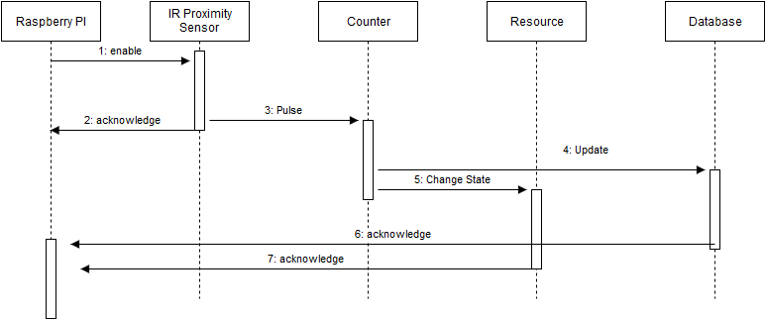
Figure 7 Calculation of number of people

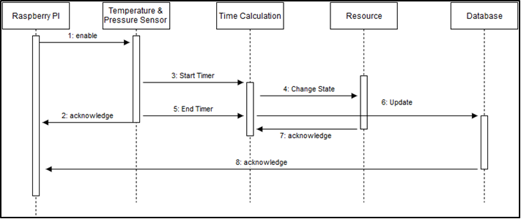
Figure 8 Calculation of time worked

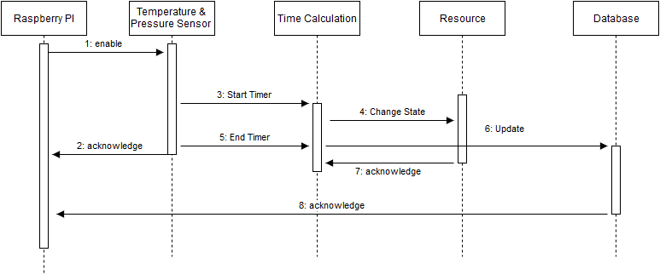
Figure 9 Intimation to authorities

  - Class Diagram
In software engineering, a class diagram in the Unified Modeling Language (UML) is a type of static structure diagram that describes the structure of a system by showing the system's classes, their attributes, operations (or methods), and the relationships among objects [8]. It’s shown in figure 10..

  - Data Flow Diagram
A data flow diagram (DFD) is a graphical representation of the "flow" of data through an information system, modeling its process aspects [8]. A DFD is often used as a preliminary step to create an overview of the system, which can later be elaborated. DFDs can also be used for the visualization of data processing (structured design). It’s shown in figure 11.

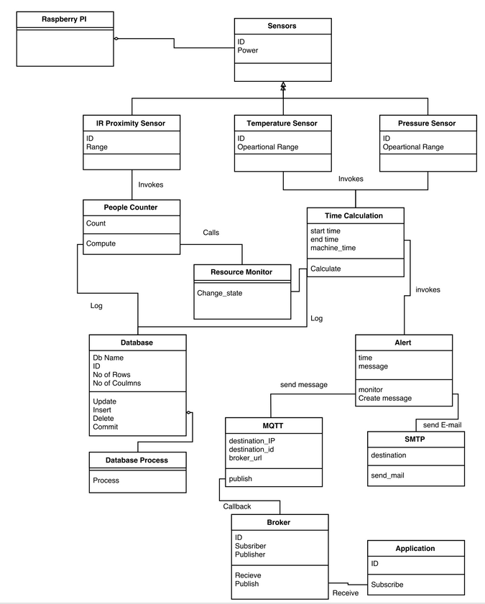
Figure 10 Class Diagram

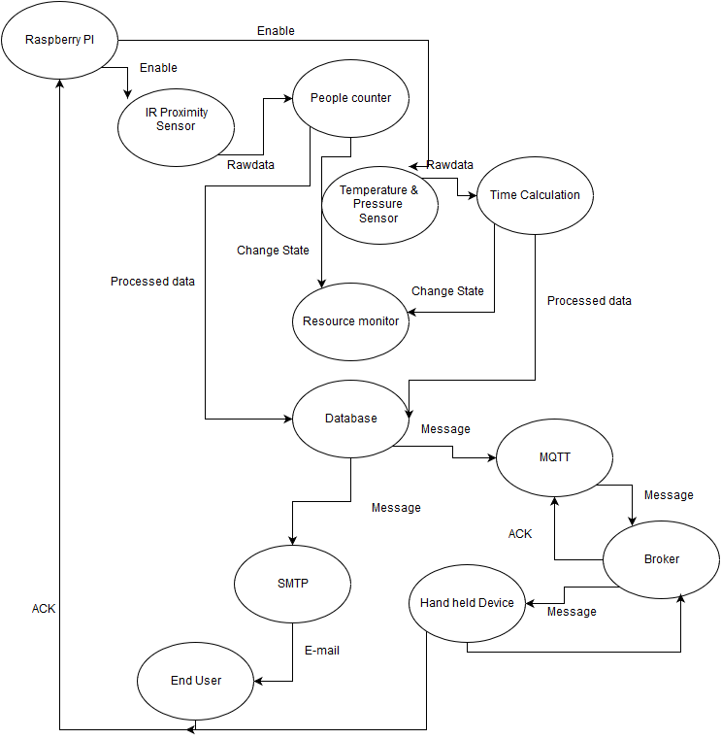
Figure 11 Data Flow Diagram

7. Working
7.1 Reading Distance values from sensors
Two proximity sensors are used to detect direction of motion of the employee.
The energy consuming equipment in the area are managed according to the direction of employee sensed.
Pressure and temperature sensors are used to detect employee presence in the cubicle.
This data can be used to manage cubicle resources and calculate the number of hours worked per week.

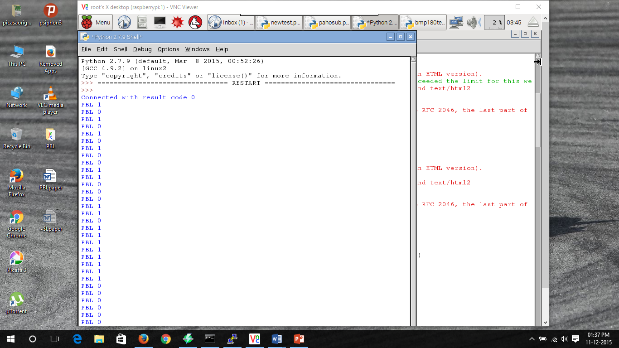
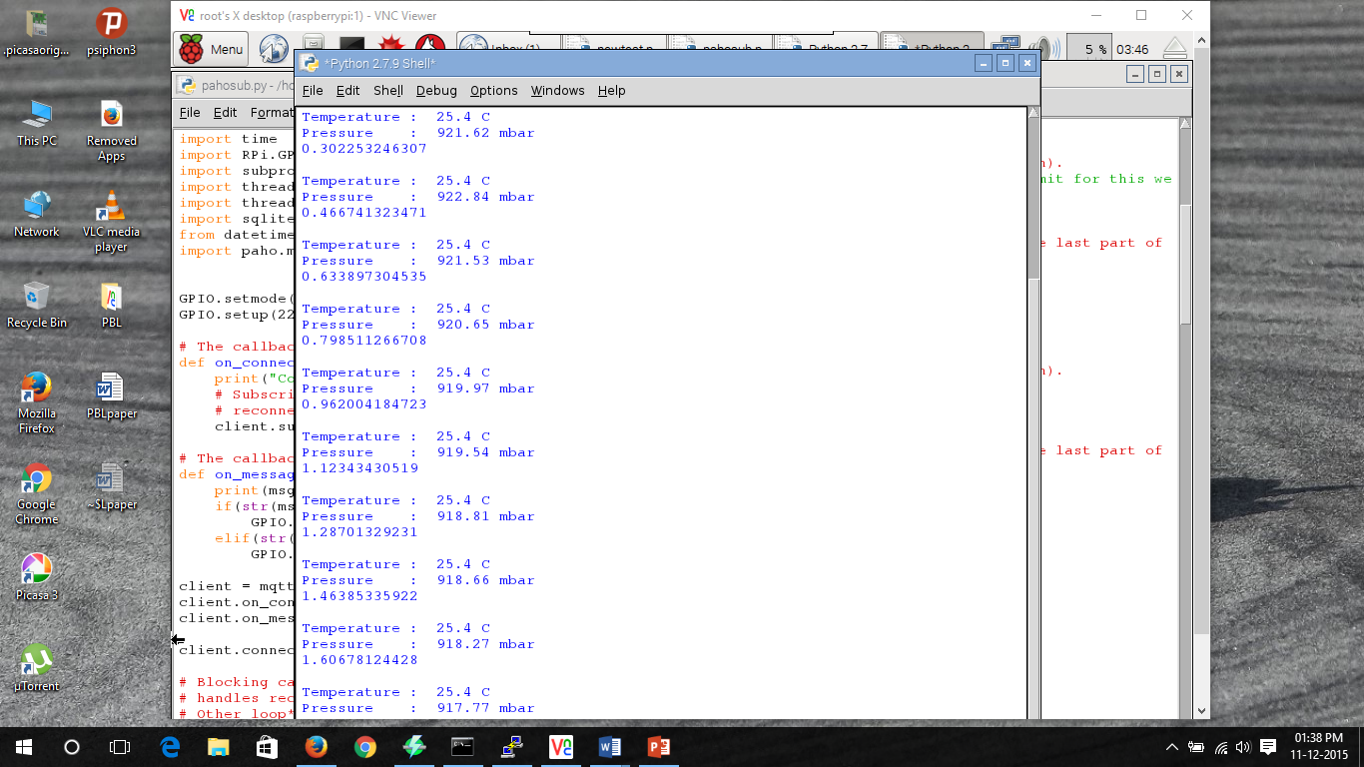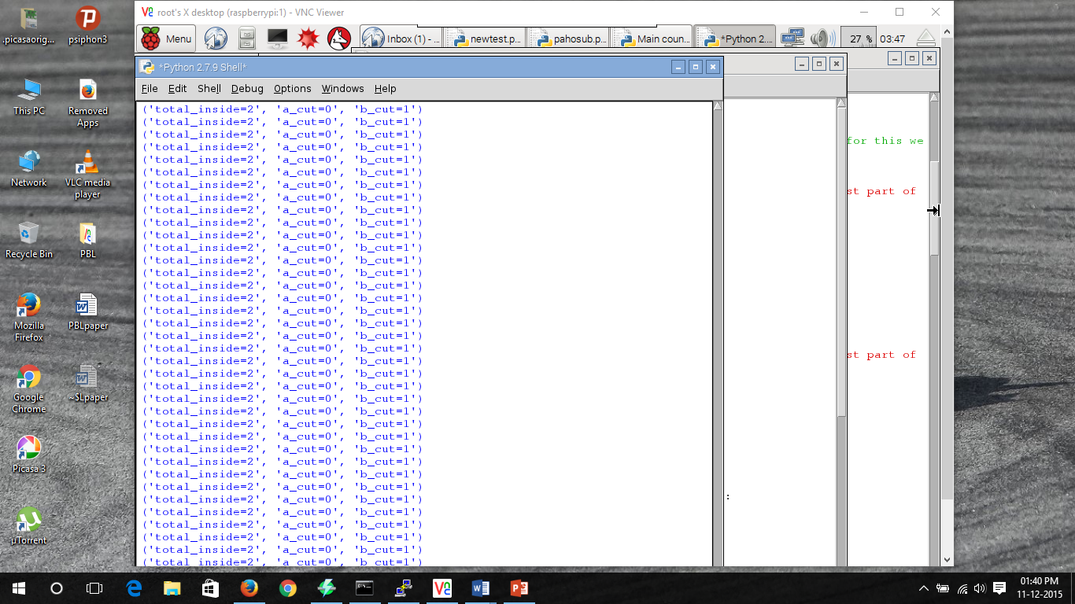
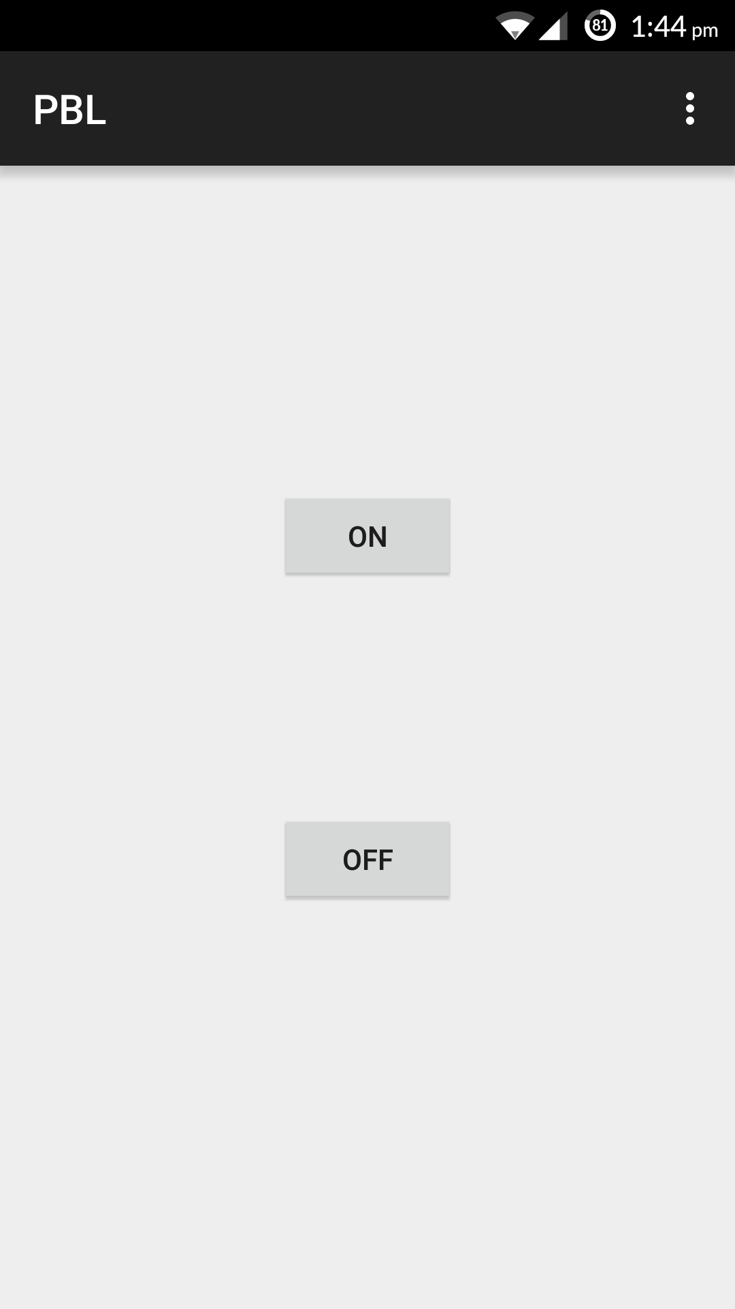
Figure 12 Output screenshots
Mobile app output
Time calculation output
No. of people count
Mobile interface

7.2 Gmail alerts and Cloud Updates
As per the users command, the messages are sent to the broker cloud service and the status of the energy consuming resource is controlled. When the working hours of a particular employee exceeds the pre-determined time limit, a mail is sent to the manager. Also, daily reports are sent to the manager concerned about his subordinates’ working statistics
.
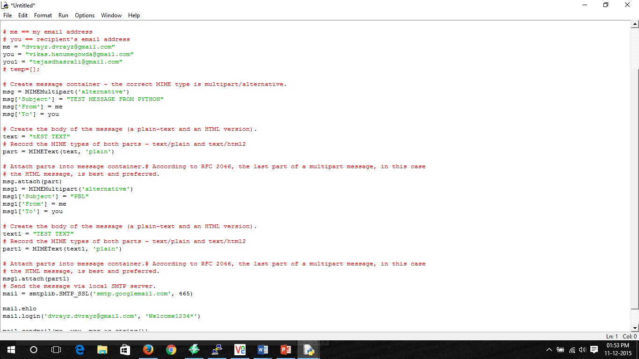
Figure 13 Gmail Alert

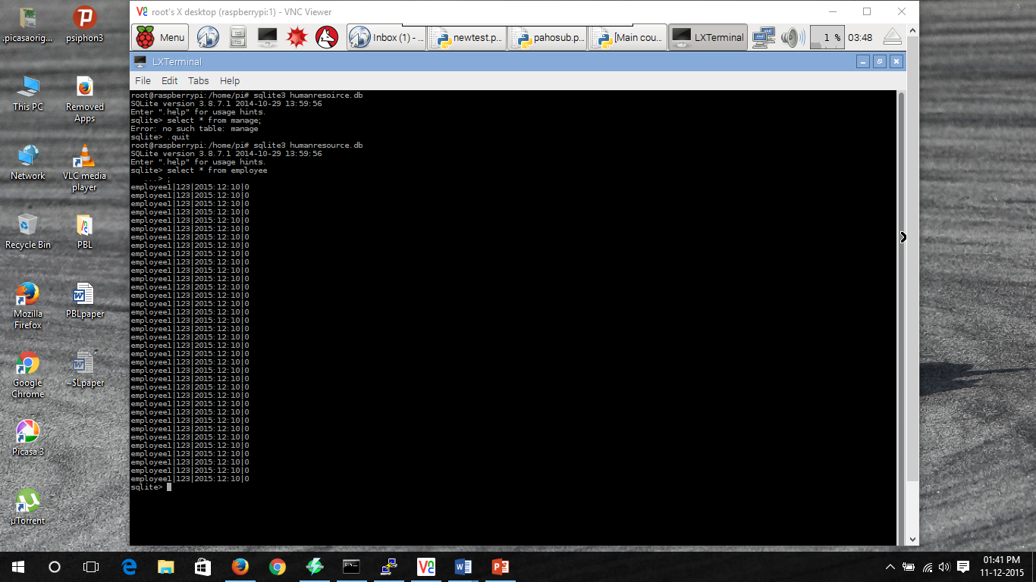

Figure 14 SQLite Database output

8. CONCLUSION
- Thus we have designed a Human and Energy management system. It is important to conserve energy because the natural resources that are essential for production of these energy are being depleted faster than they can be regenerated. This problem can be minimised by automating resource usage using our proposed model.
- The man force in a particular company though eminent in their fields are still humans. Workaholics need to be managed by HR department and our project does exactly that by informing authorities when an employee exceeds his maximum working hours per week. Contrary to that, there will be employees who spend time in the campus without working. Our model gives statistics on the number of hours an employee has worked.

References
[1]. Shan and M. Richardson Getting Started with Raspberry pi, 2012:O'Reilly Media, Inc.
[2]. Ali M., Vlaskamp J.H.A, Eddiny N.N., Falconer B. and Oram C., "Technical Development and Socioeconomic Implications of the Raspberry Pi as a Learning Tool in Developing Countries", 5th Computer Science and Electronic Engineering Conference (CEEC), pp. 103-108, 2013.

[3]. [online] Available: http://www.raspberrypi.org/products/model-b-plus/
[4]. Bromley K., Perry M., and Webb G. "Trends in Smart Home Systems, Connectivity and Services", www.nextwave.org.uk, 2003
[5]. Sarthak Jain, Anant Vaibhav and Lovely Goyal "Raspberry Pi based Interactive Home Automation System through E-mail", International Conference on Reliability, Optimization and Information Technology-ICROIT 2014,
[6]. Norris Donald Raspberry Pi for the Evil Genius, pp.1 -51 2014: McGraw-Hill Education
[7]. Python Software Foundation [US], [online] Available: https://pypi.python.org/pypi
[8]. Pi Raspberry [online] Available: http://en.wikipedia.org/wiki/Raspberry_Pi

