**M S Ramaiah Institute of Technology**

(An Autonomous Institute, Affiliated to VTU)

MSR nagar, MSRIT post, Bangalore-54

A Dissertation Report on

Smart Agriculture And Storage System

Submitted by

Vikash Bajoria 1MS12CS131

Rajan Kumar Sah 1MS12CS084

Monu Singh 1MS12CS058

Yogesh M 1MS12CS136

*in partial fulfillment for the award of the degree of*

# *Bachelor of Engineering in Computer Science & Engineering*



**DEPARTMENT OF COMPUTER SCIENCE & ENGINEERING**

**M.S.RAMAIAH INSTITUTE OF TECHNOLOGY**

# Abstract

Use of technology in different areas to get various benefits in itself is research of big area. Use of sensor in the agriculture is not a new trend. The use of technology to benefit the agriculture is always a encouraging thing for human being. There is a lot of environmental condition which affect the crop and its production. So we thought we should come with a unique idea of making use of current available technology to bring some major change in how agriculture sector is working these days. This is just a small effort to make innovative and smart agriculture system.

In this project ,the concept of smart agriculture and storage system is described and use of different advanced technology towards agriculture sector is highlighted. The evolution of different advanced technology is also presented. Some details about the development of smart agriculture[1] prototype for irrigation control.We have used four sensor to read datat from environment and using the help of raspberry pi data is being sent to the cloud

**ACKNOWLEDGEMENT**

We cordially thank our respected HOD Sir, Dr. K. G. Srinivasa for assisting us in presenting this paper and giving us the opportunity to work on some real life problem..

We thank our department faculty who provided insight and expertise that greatly assisted and motivated us.

We would also like to show our gratitude to our respected teacher Dr.Anita Kanavalli,  Mrs. Sowmya B. J for sharing their pearls of wisdom with us during the course of this project work.

We are also immensely grateful to our family without whose blessing it could not had been possible.

We are cordially thankful my friend and colleague for supporting and assisting us during the course of this project.

#### Contents

1 **INTRODUCTION**

* 1. General Introduction……………….
  2. Statement of the Problem…………..
  3. Objectives of the project……………
  4. Project deliverables……………
  5. Current Scope………………………
  6. Future Scope……………………….

1. **PROJECT ORGANIZATION**
   1. Software Process Models
   2. Roles and Responsibilities
2. **SOFTWARE REQUIREMENT SPECIFICATIONS**

5.1 Product Overview

5.2 External Interface Requirements

5.2.1 User Interfaces

5.2.2 Hardware Interfaces

5.2.3 Software Interfaces

5.2.4 Communication Interfaces

5.3 Functional Requirements

5.3.1 Functional Requirement 1.1

:

5.3.n Functional Requirement 1.n

5.4 Software System Attributes

5.4.1 Reliability

5.4.2 Availability

5.4.3 Security

5.4.4 Portability

5.4.5 Maintainability

5.4.6 Performance

5.5 Performance Requirements

5.6 Database Requirement

5.7 Design Constraints

5.8 Other Requirements

1. **DESIGN**
   1. Introduction
   2. Architecture Design
   3. Graphical User Interface
   4. Class Diagram and Classes (represent Inheritance, Aggregation and Association)
   5. Sequence Diagram
   6. Data flow diagram
   7. Metric calculation
2. **IMPLEMENTATION**
   1. Tools Introduction
   2. Technology Introduction
   3. Overall view of the project in terms of implementation
   4. Explanation of Algorithm and how it is been implemented
   5. Information about the implementation of Modules
3. **TESTING**

**7.1** Results and Snapshots

1. **CONCLUSION & SCOPE FOR FUTURE WORK**
2. **REFERENCES**

**1.INTRODUCTION**

**1.1General introduction**

Different areas of life are getting a great impact by the advancement in technology .People are working towards the automation with some level of intelligence to replace or minimize the human factor from the process. people are relying more on devices and they are trying to make their life more comfortable and easy.

Now-a-days everything is termed as smart and exactly what does smart means. Smart means working towards developing the autonomous system that could take some level of decision by their own in different levels of simple circumstances. And in this race of make everything more modern, somewhere agriculture has been left behind and especially we could see very less organization is working towards making agriculture modernised and i think we should do something innovative for them and here we are with this unique way to help farmer to grow their crop and its storage. We often see a thousand tons of crops gets destroyed in godown which could have been food for thousand of poor people and i think using the help of modern technology we could help people in saving the crop so the farmer could get what they deserve for and a lot of money could be saved.

Major problem faced by farmer in agriculture and storage of crops due to climate change.[2] The damage to the crop stored in storage room cost them a lot and thus they could not get the money what they deserve for. Also the crop residual material which could also be used as fuel got damaged and become useless. So we are coming up with the unique solution which will help farmer to prevent and reduce the damage. This system will notify farmer about the situation of the storage facility room. The Motion detector will give them information of any intruder trepassing the property. Sometime cattle enter the crop destroy all of it so motion detector[3] will help in inform farmer about it so that he/she could prevent it. Also the motion detector will detect presence of anyone near or in storage facility room. The farmer does not know the exact pattern of rainfall and they water the field and sometime does not water it so due to excessive or shortage of water in soil crop get affected. We are using soil moisture detector[4] to measure presence of moisture in soil and thus farmer could take the measure. Smart Agriculture could be defined as “an approach to understand the requirement as well as change in current environment.

**1.2Statement of problem**

Major problem faced by farmer in agriculture and storage of crops due to climate change. The damage to the crop stored in storage room cost them a lot and thus they could not get the money what they deserve for. Also the crop residual material which could also be used as fuel got damaged and become useless. So we are coming up with the unique solution which will help farmer to prevent and reduce the damage. This system will notify farmer about the situation of the storage facility room. The Motion detector will give them information of any intruder trepassing the property. Sometime cattle enter the crop destroy all of it so motion detector will help in inform farmer about it so that he/she could prevent it. Also the motion detector will detect presence of anyone near or in storage facility room. The farmer does not know the exact pattern of rainfall and they water the field and sometime does not water it sodue to excessive or shortage of water in soil crop get affected. We are using soilmoisture detector to measure presence of moisture in soil and thus farmer could take the measure.

**1.3 Objective of the project**

The project is done with objective of helping farmer who composes the large %of india’s population.This project highlight the problem faced by farmer and how this problem could be resolved by using the available technology and how it could be implemented in real world.This project is done with objective of showing how technology could change the life of common people and impact the life of the people.

**1.4 Project deliverables**

|  |  |
| --- | --- |
| Deliverables | month |
| Requirement Definition | september |
| Software model | Mid September |
| -Analysis of technical requirement  -System design(diagram of sequence,components,classes,DB MODELmetc)  -System Prototype | October |
| Software Development | Mid october |
| -Software Development  -Test cases | november |
| Software development  -test cases | Mid november |
| Software development  -Software done | First week of december |

**1.5 Current Scope**

The current scope is limited to sensing data and on analyzing the data and further action is taken to minimize the effect.Presently we are only using simple concept of using sensor to read data and futher sending data to cloud where it is being stored.

**1.6 Future Scope**

The project could be extended for further use. We could use the idea of automation of the water motor which will start functioning when the percentage of humidity in the soil is below the critical point and it will stop watering if the percentage go beyond the certain limit .We could use something to distract animal and human from crop field. The cooling machine installed in storage house could start functioning and stop functioning if the environmental condition go beyond it. We could also use some sensor to read the data of pesticides and could control the The farmer could control the crop and storage facility just by sitting at his doorstep and which would make their life more comfortable and prosperous.

**2.PROJECT ORGANIZATION**

***2.1 Software Process Models:***

The various software module used in the project are-

* Putty
* Vncserver
* Vncviewer
* Win32diskimager
* Ipscan
* Ubidots cloud package
* Python tools

**Putty-**

This software uses a ssh client to connect to the terminal of raspberry pi to install the vnc server.

**Vnc server and viewer-**

Vnc server module is installed on the raspberry pi.it runs a server on the pi which sends out data to the Ethernet so that the display of the pi can be viewed from the monitor of the laptop where the vnc viewer is installed.

**Win32diskimager-**

This software module is used to extract the .img file of the pi os to burn to the sd card.

**Ipscan-**

This software scans the devices connected to the local network and the ip addresses allocated to them.

**Python-**

Python library is installed to run python scripts to sense the GPIO pins of the pi.

The software models are interdependent as the ubidots module depends on the python libraries to sense the pi.

The python module after sensing the data pushes it onto the cloud

Some more dependencies come when we talk about the cloud as the cloud may run into problems like memory leak etc.

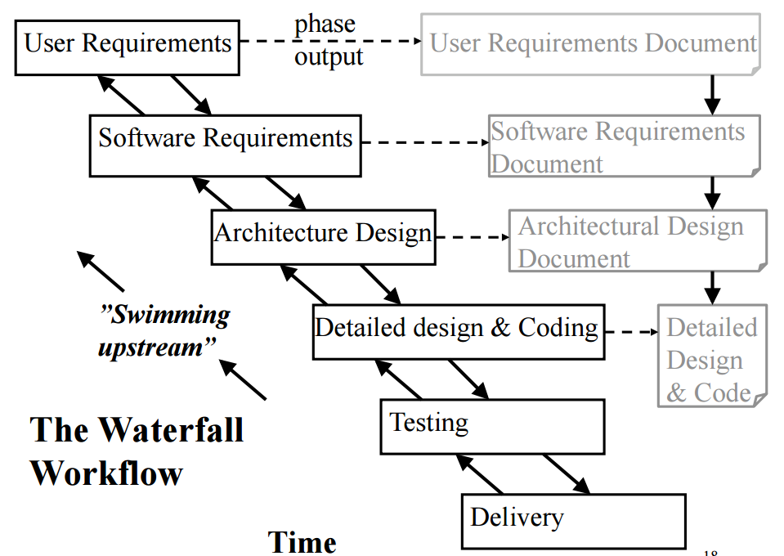

***2.2 Roles and Responsibilities:***

***The roles shared by the group members for the project:***

Program Planner

Program Planner

Status and Tracking Reporting

Issues Management

Communication Coordinator

Software Methodology Support

Infrastructure and Technical

Facilities Administrator

Risk Manager

Project Deliverables

Resource administrator

**3.LITERATURE SURVEY**

**3.1 Introduction**

The iot has become the new trend of technology and this is the area which are going to develop.The concept of using different sensor to read data from environment is amazing in its way and then dealing with the data is something complicated in its way and the implementation of this data to give desirable result is something which we have focussed on.

**3.2 Main body**

Portable computers and smartphones are destined to widely populate farm tractor cabs, pickups and offices in the future.Apple’s iPhone (which now is available through Verizon as well as AT & T) and smartphones using Google’s Android operating system are becoming the cellular communicators of choice for many farmers. That’s despite the reality that few of the tens of thousands of phone applications are specific to agriculture.

Farmers frustrated by lack of access to higher-speed Internet services could find themselves in the Internet fast lane in the next couple of years, because of 4G (fourth generation) cellular communications networks.Although a variety of technologies will be harnessed, the new 4G networks will be the most important in deploying high-speed Internet services in rural areas, according to a network communications analyst.

More farm equipment today is being outfitted with smart sensors that can read everything from plant health and water needs in the crop to nitrogen levels in the soil. The sensors then enable on-the-go application of inputs based on real-time field conditions.The newest area of sensor use is in irrigation where the sensors measure water needs. Sensors help optimize water use and avoid yield loss, according to Viacheslav Adamchuk, ag engineer, McGill University.

# There is a lot of research paper written on this topic.A lot number of book has been written by eminet author of the world. The Biological Farmer: A Complete Guide to the Sustainable & Profitable Biological System of Farming is one of the wonderful book in this field.

# Research in organic agriculture is currently conducted in almost all countries of Europe. The amount of on-going research is highest in Scandinavia and the German speaking regions of Europe. It takes place in private institutions but also at university institutes and research stations, some of which dedicate all their activities to organic agriculture. In several countries research in ecological agriculture originated at independent institutes like FiBl.

# It is really challenging to read data from the field as it is not user friendly. Implementation of data to give solution to the people. As there is variation in the data ,it is tough to analyze the data and give appropriate solution.

**3.3 Conclusion of survey**

The agriculture sector has lot of future scope which if implemented could make the life of farmer a lot easiredr and the production of crop could increase and hopefully it would fulfil the ever increasing demand of food requirement.

**4.SOFTWARE REQUIREMENT SPECIFICATIONS**

This section provides a detailed description of all inputs into and outputs from the system. It also gives a description of the hardware, software and communication interfaces and provides basic prototypes of the user interface.

**4.1 Product Overview**

The project will help the farmers to keep track of their land and storage system. This will help him to produce their crops sustainable. This will help him to prevent him to destroy the crops from other intruder and from change in climate. This product will help them to increase his salary and increase his financial condition. This product is cost efficient as the poor farmer will not buy a huge storage system so it will help them to keep track of the condition of the crops. The storage system provider will also implement this product and provide the storage to farmers at very low cost.

**4.2External interface Requirements**

This section provides a detailed description of all inputs into and outputs from the system. It also gives a description of the hardware, software and communication interfaces and provides basic prototypes of the user interface.

**4.2.1User interfaces**

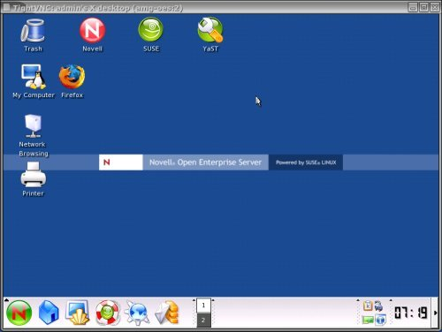

We are using raspberry pi and installed an operating system which is raspbian linux.We hav used the NOOBS IMAGE. provide user interface .It has wifi interface through which we could connect to internet and could send data obtained through sensor to the cloud for further use. We can use it just as laptop.The user could run program and could see the result.

**4.2.2Hardware interfaces**

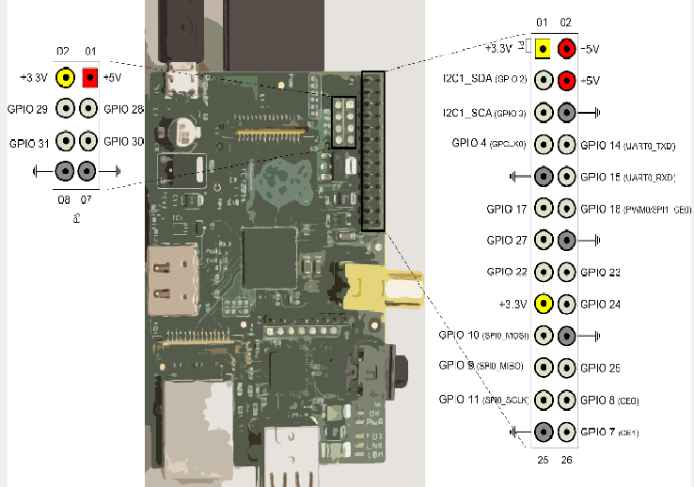

The Pi has always supported 1-wire, I2C and SPI interfaces via the GPIO header. These allow various devices to be connected to the Pi and controlled via software.SPI Interface,General GPIO,i2c Interface,1-wire Interface.These interface make it easy to use.

**4.2.3Software interfaces**

The application communicate and try to retrieve information from environment about the temperature humidity. It also get the information of the any presence of object and send data to the cloud from where notification is sent to the users. Vnc server provide the GUI for raspberry pi.It gives user to interact with system.

**4.2.4Communications interfaces**

The communication between the different parts of the system is important since they depend on each other. However, in what way the communication is achieved is not important for the system and is therefore handled by the underlying operating systems for both the mobile application and the web portal.They communicate and provide the required result.

**4.3Functional requirements**

**4.3.1.1Functional requirement 1.1**

A user should be able to get the notification if some problem occur.The user should get message regarding the condition of the storage system,the presence of any intruder in the field.If the humidity presence in the soil decreases,user must get notification.

**4.3.2.Functional requirement 1.2**

The storage facility should have the inbuilt temperature and humidity sensor which gives user about the condition.It should read the data and send the data to the cloud.

**4.3.3Functional requirement 1.3**

The field have the motion detector sensor which send the data to the cloud .if there is intruder,it send the the data to the cloud.

**4.3.4Functional requirement1.4**

The cloud is the platform which store the data on virtual memory and and get the data from sensor and send the data to the email or cloud.

**4.4.Software system attributes:**

**4.4.1Reliability**

GIST: The reliability of the system. SCALE: The reliability that the system gives the right result when temperature change. METER: Measurements obtained is in some range.. MUST: More than 98% of change should be catched.. PLAN: More than 99% of the searches. WISH: 100% of the changes..

**4.4.2 Availability**

SystemAvailability GIST: The availability of the system when it is used. SCALE: The average system availability (not considering network failing). METER: Measurements obtained from 1000 hours of usage during testing. MUST: More than 98% of the time. PLAN: More than 99% of the time. WISH: 100% of the time.

**4.4.3 Security**

CommunicationSecurity GIST: Security of the communication between the system and server. SCALE: The messages should be encrypted for log-in communications, so others cannot get user-name and password from those messages. METER: Attempts to get user-name and password through obtained messages on 1000 log-in session during testing. MUST: 100% of the Communication Messages in the communication of a log-in session should be encrypted. Communication Messages: Defined: Every exchanged of information between client and server.

**4.4.5 Maintainability**

TITLE: Application extendibility DESC: The application should be easy to extend. The code should be written in a way that it favors implementation of new functions. RAT: In order for future functions to be implemented easily to the application.

**4.4.6 Portability**

Application portability DESC: The application should be portable with iOS and Android. RAT: The adaptable platform for the application to run on.

**4.5.Performance requirements**

The requirements in this section provide a detailed specification of the user interaction with the software and measurements placed on the system performance. First, this application will be used by a single useror multiple user. There will be no multiple user handling since the application runs on a single portable device using any network. The amount of the input is moderate since the input data of the application is the varying temperature data,humidity data,any presence of object in storage room and field. We only have to monitor changes in the environment and notify the user about the real world.The information among the data will be achieved by reducing input into a set of features of the interested objects, which is also essential in object recognition. Also, the objects may be moving, or non-moving, and this fact should not effect the performance of the application. The major issue here is the application should answer in real-time, namely, the recognizing and labeling operations has to be handled in less than 1 second. Also the application should be able to recognize changes in the data.

**4.6.Database requirement**

The requirement is used very less. Only the data variation is used so that if the corresponding changes comes in the environment,i t notify the user.

**4.7. Design constraints**

This section includes the design constraints on the software caused by the hardware. We coded program in python,which provide multiple design.The portability of the system depends on portability of the devices we have used. Since the system will run on a single machine and it will not be dependent to a bigger system or any other computers, there will not be any security or reliability problems. Smart agriculture project is designed to be extensible, that is open to changes. Whenever new patterns are added to the memory of the **program, by the help of some additions, the application will handle recognizing them.**

**4.8 Other Requirement**

**4.8.1 Hard drive space**

Hard Drive Space GIST: Hard drive space. SCALE: The application’s need of hard drive space. METER: MB. MUST: No more than 20 MB. PLAN: No more than 15 MB. WISH: No more than 10 MB. MB: DEFINED: Megabyte

**4.8.2 Application memory usage**

Application Memory Usage GIST: The amount of Operate System memory occupied by the application. SCALE: MB. METER: Observations done from the performance log during testing MUST: No more than 20 MB. PLAN: No more than 16 MB WISH: No more than 10 MB Operate System: DEFINED: The mobile Operate System which the application is running on. MB: DEFINED: Megabyte.

**5.Design**

**5.1Introduction**

In this section we have tried to explain the relationship of the different attributes of the project.

**5.2Architectural Design**

Data is collected from storage system and field through sensors which are interfaced with raspberry pi, the data acquired is sent to cloud. The data stored in cloud is mailed to the farmer.

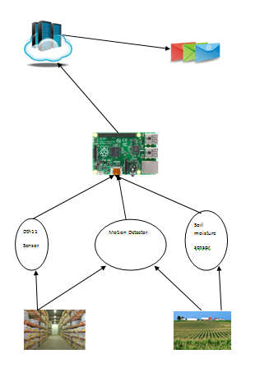

**5.3 Class Diagram**

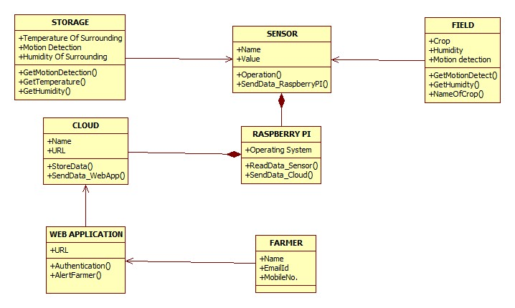

**5.4 Sequence Diagram**

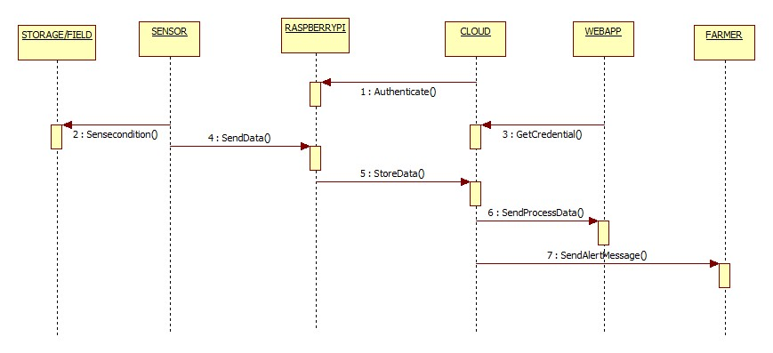

**5.5Data Flow Diagram**

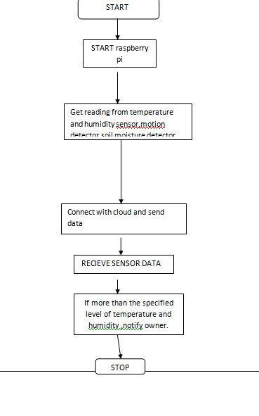

**5.6Metrics Calculation**

|  |  |  |
| --- | --- | --- |
| **Term** | **Description** | **Interpretation** |
| **PV (BCWS)** | Planned Value (Budgeted Cost of Work Schedule) | What is the estimated value of the work planned to be done? |
| **EV (BCWP)** | Earned Value (Budgeted Cost of Work Performed) | What is the estimated value of the work actually accomplished? |
| **AC (ACWP)** | Actual Cost (Actual Cost of Work Performed) | What is the actual cost incurred? |
| **BAC** | Budget at Completion | How much did you BUDGET for the TOTAL JOB? |
| **EAC** | Estimate at Completion | What do we currently expect the TOTAL project to cost? |
| **ETC** | Estimate to Complete | From this point on, how much MORE do we expect it to cost to finish the job? |
| **VAC** | Variance at Completion | How much over or under budget do we expect to be? |

**EARNED VALUE MANAGEMENT FORMULAS & INTERPRETATION**

|  |  |  |
| --- | --- | --- |
| **Name** | **Formula** | **Interpretation** |
| **Earned Value (EV)** | Total Estimated Cost * % Complete | Amount of budget earned so far based on physical work accomplished, without reference to actual costs |
| **Cost Variance (CV)** | EV – AC | NEGATIVE is over budget POSITIVE is under budget |
| **Schedule Variance (SV)** | EV – PV | NEGATIVE is behind schedule POSITIVE is ahead of schedule |
| **Cost Performance Index (CPI)** | EV / AC | I am getting _____ cents out of every $1 |
| **Schedule Performance Index (SPI)** | EV / PV | I am progressing at ___% of the rate originally planned |
| **Estimate At Completion (EAC)** Note: There are many ways to calculate EAC | BAC / CPI | As of now how much do we expect the total project to cost $_____. Used if no variances from the BAC have occurred |
| AC + ETC | Actual plus a new estimate for remaining work. Used when original estimate was fundamentally flawed |

The budget of the project is around 5000.

**6.IMPLEMENTATION**

**6.1** **Tools Introduction**

**6.1.1 Raspberry pi**

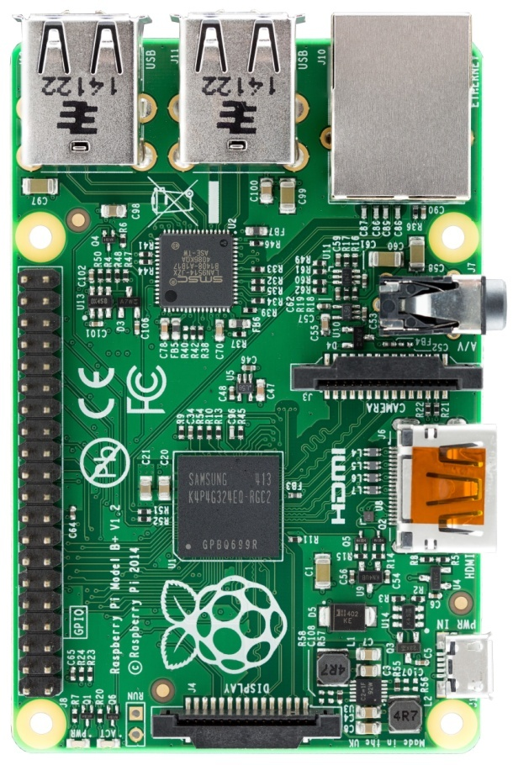

The Raspberry Pi is a series of [credit card](https://en.wikipedia.org/wiki/Credit_card)–sized [single-board computers](https://en.wikipedia.org/wiki/Single-board_computer) developed in the [United Kingdom](https://en.wikipedia.org/wiki/United_Kingdom) by the [Raspberry Pi Foundation](https://en.wikipedia.org/wiki/Raspberry_Pi_Foundation)

All Raspberry Pis include the same [VideoCore](https://en.wikipedia.org/wiki/VideoCore) IV [GPU](https://en.wikipedia.org/wiki/Graphics_processing_unit), and either a single-core [ARMv6](https://en.wikipedia.org/wiki/ARM_architecture#32-bit_architecture)-compatible [CPU](https://en.wikipedia.org/wiki/Central_processing_unit) or a newer [ARMv7](https://en.wikipedia.org/wiki/ARM_architecture#32-bit_architecture)-compatible [quad-core](https://en.wikipedia.org/wiki/Multi-core_processor) one (in Pi 2); and 1 [GB](https://en.wikipedia.org/wiki/Gibibyte) of [RAM](https://en.wikipedia.org/wiki/Random-access_memory) (in Pi 2), 512 [MB](https://en.wikipedia.org/wiki/Mebibyte), or 256 MB (in older models A and A+). They have [Secure Digital](https://en.wikipedia.org/wiki/Secure_Digital) (SD) (models A and B) or MicroSD (models A+ and B+) sockets for boot media and persistent storage. In 2014, the Raspberry Pi Foundation launched the *Compute Module*, for use as a part of embedded systems for the same compute power as the original Pi.

It  is an series of ARM powered, credit card sized single-board computers (developer boards) made in the UK by the non-profit Raspberry Pi Foundation organization for educational and hobbyist purposes. These low power computers is mass produced at very low prices and the high number of units sold gives it massive community support. As an Kodi HTPC, all Raspberry Pis supports full 1080p (Full HD) video playback of the most commonly used codecs, support for most if not all Kodi [add-ons](http://kodi.wiki/view/Add-ons), and reasonably responsive GUI performance.

**6.1.2Router**

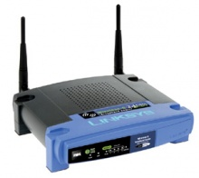

A **router**is a networking device that forwards data packets between computer networks Routers perform the "traffic directing" functions on the Internet. A data packet is typically forwarded from one router to another through the networks that constitute the internetwork until it reaches its destination node.

A router is connected to two or more data lines from different networks (as opposed to a network switch, which connects data lines from one single network). When a data packet comes in on one of the lines, the router reads the address information in the packet to determine its ultimate destination. Then, using information in its routing table or routing policy, it directs the packet to the next network on its journey.

**6.2** **Technology Introduction**

**6.2.1 Ubidots**

Ubidots offers a REST API through which the Data Sources, Variables and Values, can be created, read, edited or erased.It is open source application service provider client who provide us the feature to store data on the cloud and also giving us the feature to send data on the mobile or email.

**6.2.2 Email**

**Email is used to receive data which is being sent from the cloud and the user could see the message and take appropriate steps.**

**6.2.3 Putty**

PuTTY is a [free and open-source](https://en.wikipedia.org/wiki/Free_and_open-source) terminal emulator, serial console and network file transfer application. It supports several network protocols, including SCP, SSH, Telnet, login and raw socket connection. It can also connect to a serial port. The name "PuTTY" has no definitive meaning.PuTTY was originally written for Microsoft Windows, but it has been ported to various other operating systems. Official ports are available for some Unix-like platforms, with work-in-progress ports to Classic Mac OS and Mac OS X and unofficial ports have been contributed to platforms such as [Symbian](https://en.wikipedia.org/wiki/Symbian),Windows Mobile and Windows Phone.

**6.3 Overall view of the project in terms of implementation**

The project is challenging to implement.We have used raspberry pi which is connected to every devices.The motion detector sensor detect the presence of infrared in its surrounding areas thus detect the presence of the living organism.The soil moisture sensor is being used to detect the presence of the humidity in the soil.The Dth11 is used to give the information about the temperature and humidity sensor.The data is being analyzed and we have used the UBIDOTS where we are creating variables and putting up the condition based on which email is being sent to the user and thus he is being notified about the environment and its surrounding.

**6.4.Explanation of Algorithm and how it is been implemented**

Read temperature_sensor()

Read humidity_sensor()

Read motion_sensor()

Read soil_moisture_sensor()

Upload data to cloud

If temperature_sensed >20 :

Notify the user

If motion_sensed ==1:

Send email to user about the intruder

If soil_moisture_sensed ==0

Send email to user about the condition of the land

If humidity_sensed >80

Send email to user about the humidity of storage system

In this algorithm we read the data from the sensor and that data is send to the raspberry pi (it is a small computer). In raspberry pi we will decide whether or when to send data into the cloud. The data is uploaded to the cloud(ubidots). Ubidots provide us to create some event on the basis of data uploaded on the cloud. On the basis of the requirement we will notify the farmer by sending alert message to the cloud.

Information about the implementation of Modules

In this project we used four modules in which we are checking the condition on the data received on the cloud. The four modules are:

* Sensing data from the Sensor: in this module we are checking the pins voltage and based on the data we send data.
* Sending the data to the cloud: checking the condition for the data and sending data to the cloud.
* Creating event : On the cloud we are creating some event.
* Notify the user: On the basis of event we notify the user.

**6.5Information about the implementation of Modules**

The implementation of the project starts with the collecting information about the requirement of the project . After that we find out the information about different hardware and software component. After that we connect the circuit and sensing the data and using raspberry pi we decide whether to send data to the cloud or not .the data is stored in the cloud and then we are creating som events and that event is used to notify the farmers

**7.TESTING**

We have done the testing of the code and analyzed the data .We saw the pattern in the data and based on that we are implementing the project.

**7.1 Results and Snapshots**

**7.1.1Reading the temperature**

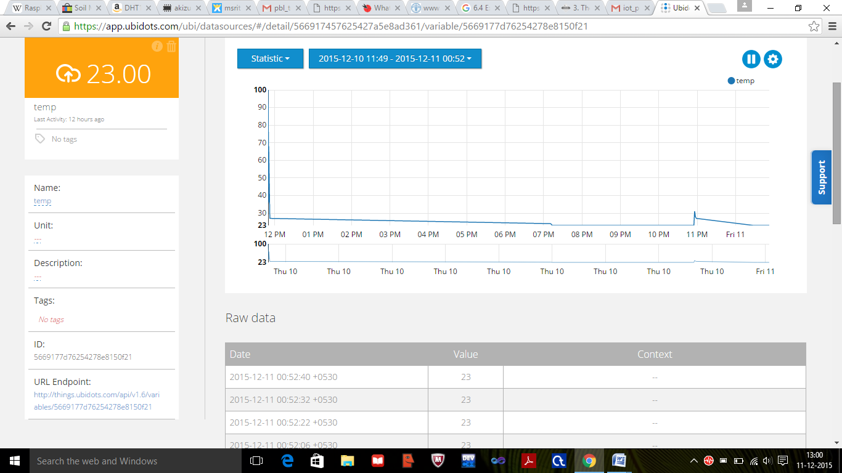

**7.1.2**

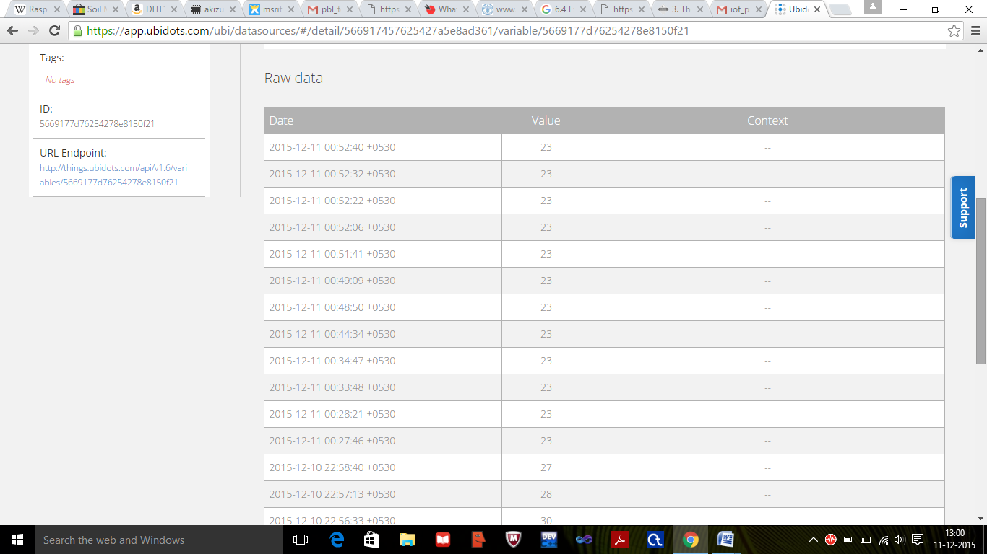

**7.1.3 Reading data from motion sensor**

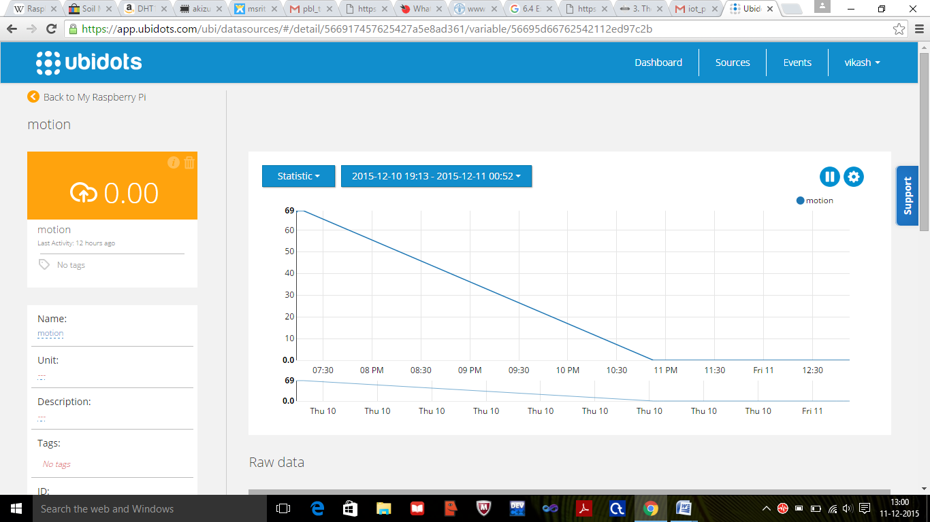

**7.1.4**

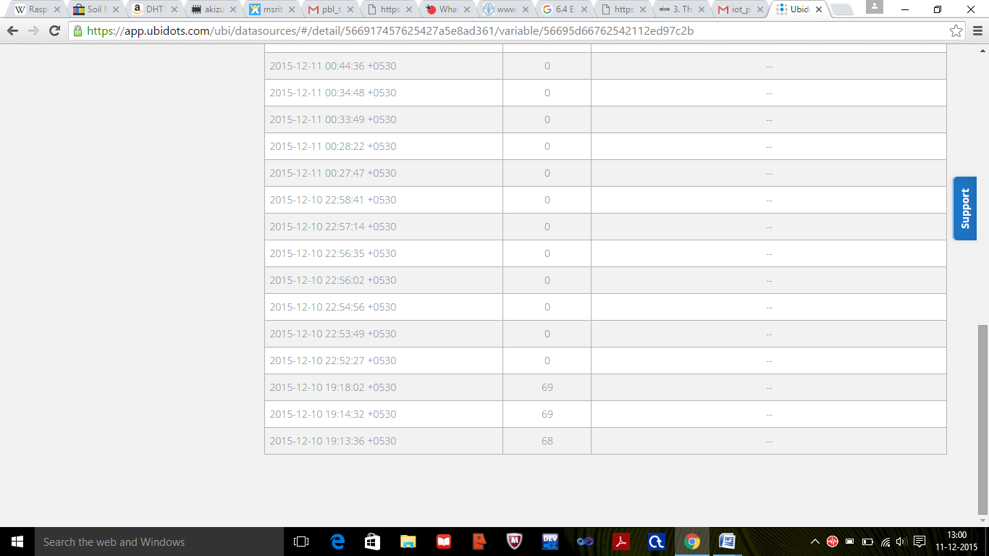

**7.1.5Reading data from humidity sensor**

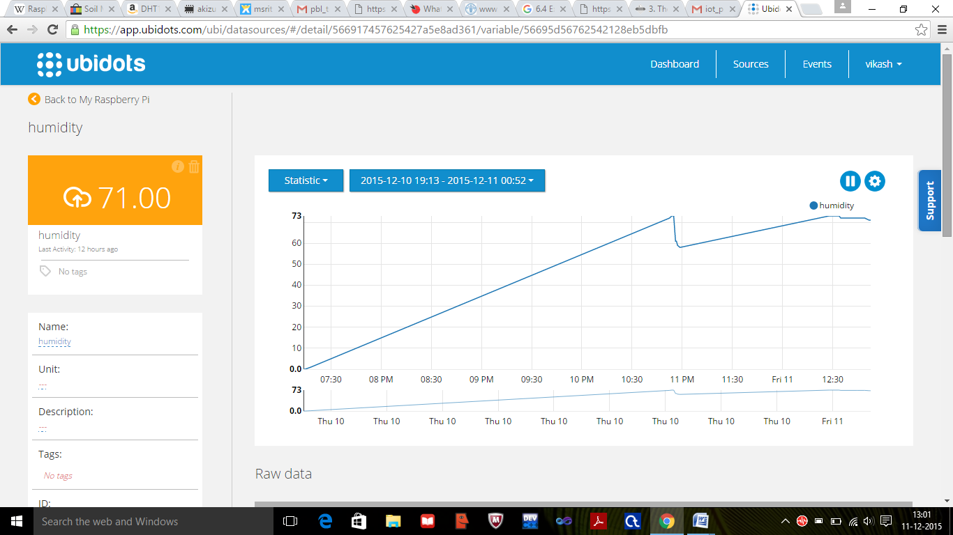

**7.1.6**

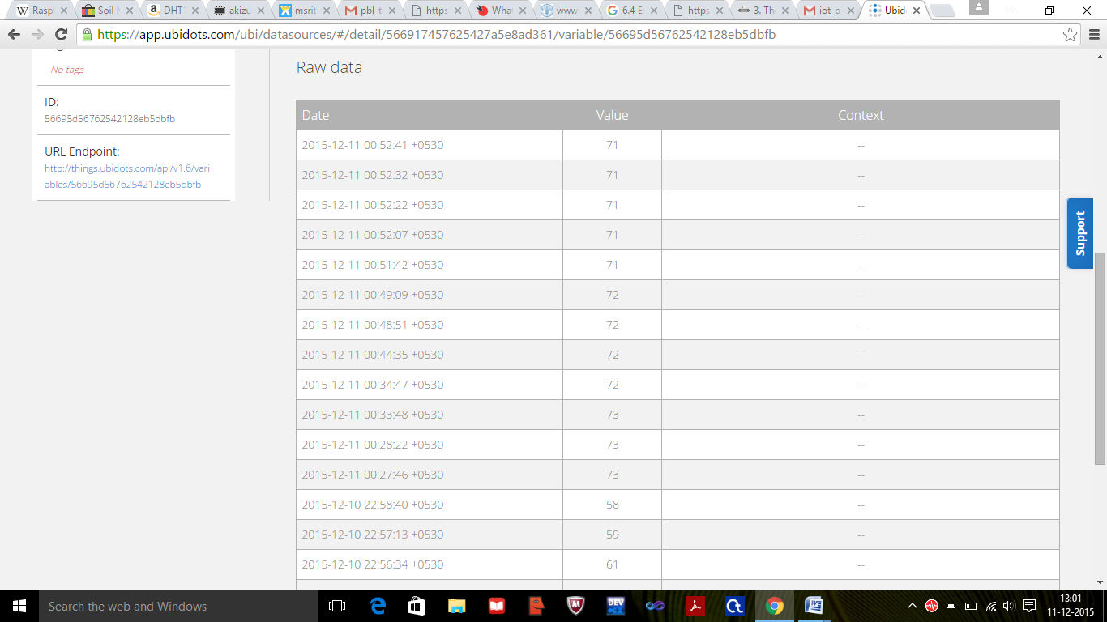

**7.1.7 reading data from soil moisture**

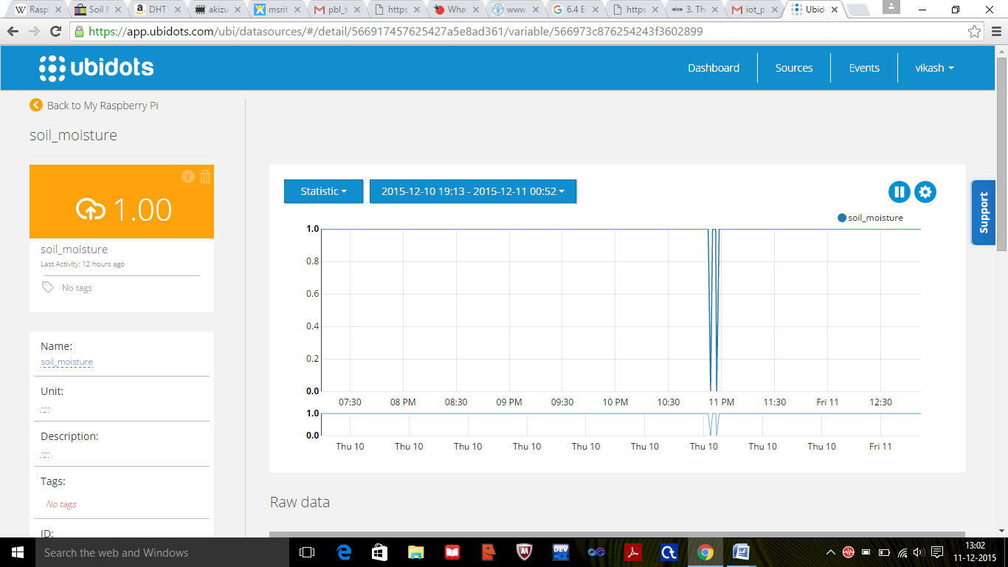

**7.1.8**

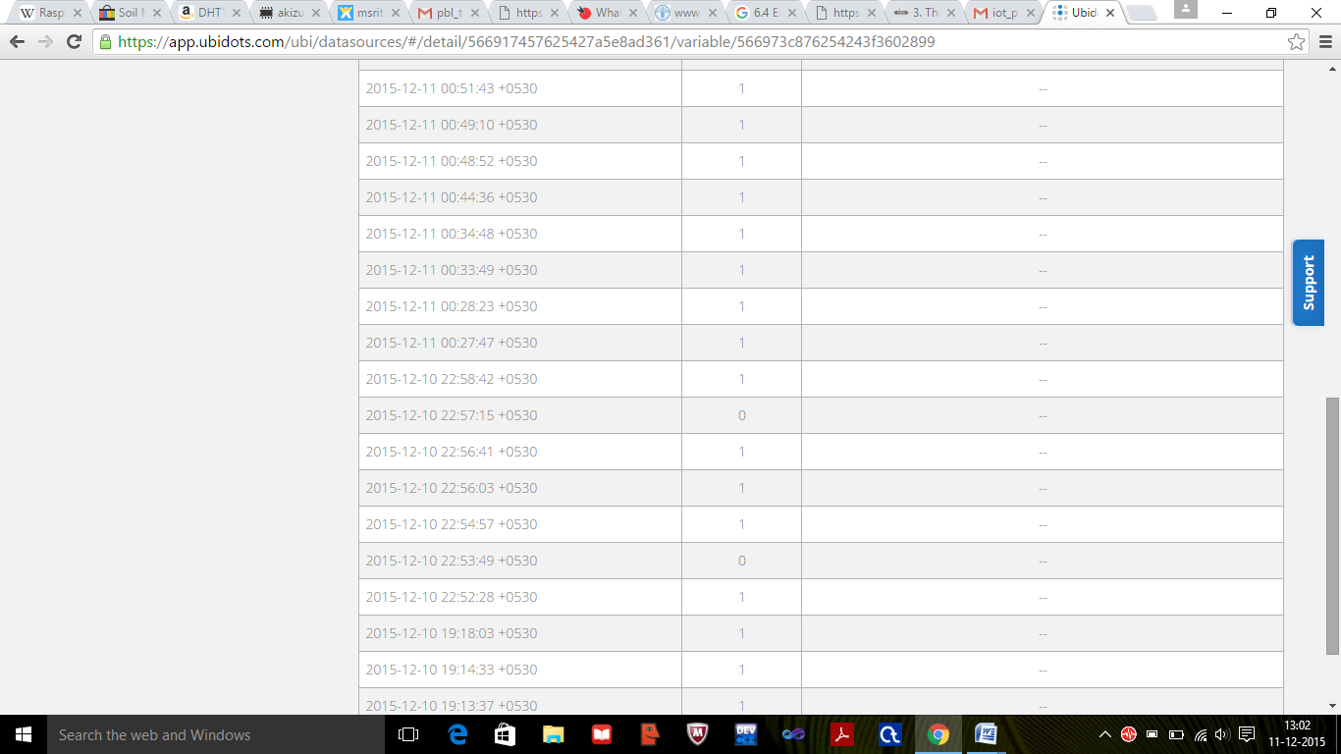

**8.CONCLUSION & SCOPE FOR FUTURE**

We concluded that how using technology could solve the real life problem of the people in much efficient and better way. How technology has made the life of human being so easy and how it could eliminate problem of the people, society and any other organization. So such an idea could change the scenario of the society and the people and it has become integral part of the human world.

As this project is about analysing data which deals with agriculture, it has got great scope. It would help farmer who could not help himself in many situation and this project is all about eliminating all these problem and giving them the simple and easy way to prevent this situation. As india has 50% of farmer so i think it would benefit country in a greater and efficient way and which would ultimately help in development of country. This project will increase the yield of the production and thus the a large quantity of the crop stored could be prevented from rotting. Also the power consumption for maintain temperature in the storage facility would decrease as the farmer would know when to use the machine to maintain appropriate condition.

The project could be extended for further use. We could use the idea of automation of the water motor which will start functioning when the percentage of humidity in the soil is below the critical point and it will stop watering if the percentage go beyond the certain limit .We could use something to distract animal and human from crop field. The cooling machine installed in storage house could start functioning and stop functioning if the environmental condition go beyond it. We could also use some sensor to read the data of pesticides and could control the The farmer could control the crop and storage facility just by sitting at his doorstep and which would make their life more comfortable and prosperous.

**9.REFERENCES**

1.http://www.thingworx.com/Markets/Smart-Agriculture

2.https://en.wikipedia.org/wiki/Climate_change_and_agriculture

3. https://en.wikipedia.org/wiki/Motion_detector

4. https://www.sparkfun.com/products/13322

5.http://searchcloudcomputing.techtarget.com/definition/cloud-computing

6.http://www.engineersgarage.com/articles/humidity-sensor

7. http://www.electronics-tutorials.ws/io/io_3.html

8. https://www.raspberrypi.org

9. https://www.google.co.in/#q=email

10.http://www.instructables.com/id/How-to-interface-Humidity-and-Temperature-DTH11-Se