Smart Doorbell using Internet of Things

Annapurna T, Sunayana Bhowmik , Santhoshi R, Bindu Shree G

**Abstract**: The objective of the project is to facilitate the user with a simple customized technology to effectively manage his visitor flowing to the premises. The project employs the dooebell in smart way with a camera model to give a life recording with no matter person is located anywhere in globe. The project notifies the owner with text message.

Keywords:Raspberry Pi, Automation ,Smart Doorbell

1. **Introduction**

The paper basically deals with project of connecting doorbell to the internet. Available doorbell interphone systems are designed under the assumption that residents would be at home to enable the communication between them and their visitors. However, people spend a large fraction of their time away from home, thus undermining the basic assumptions of existing doorbell solutions. Enable video-based communication between visitors and (possibly remote available) home residents.This can be considered as kind of Home Automation can be considered as an act of using electronic systems/devices and programming them to replace a number of human interactions for the control of basic home functions. This operates on the base of connecting sensors and devices to the IoT. IoT can be considered as a network of physical objects which can be accessed via the Internet. For objects to considered IoT based, networks need to be converted to an IP-based network for proprietary protocols. The object being connected to the internet can represent itself digitally thereby being controlled from anywhere there is an internet connection. These objects have ability to transmit and receive data over a network without human-tohuman or human-to-computer interaction. This also means that more data can be gathered from these objects, even at a number of places with real-time information being presented from the objects. This super task can increase efficiency, safety and security.

The project help in enhancing security and efficiency of a home, which also gives real time monitoring via the internet. Apart from controlling the sensors and components via a device connected to the internet, a centrallycontrolled panel having an LCD screen with keypad or an LCD touchscreen.

The Raspberry Pi and the subject of smart doorbell is a remarkable one. The Raspberry Pi can be used to automate a home at a relatively low cost. It operates on the concept as the IoT. There are numerous things that make the Raspberry Pi essential for home automation but the one that stands out the most has to be the remarkably affordable cost. The vast amount of sensors at extremely

low cost makes it’s superb. Raspberry Pi can be programed to be with as much sensors as you desire, for a

fraction of the cost . Figure 1 shows the Raspberry Pi B model with its specifications:

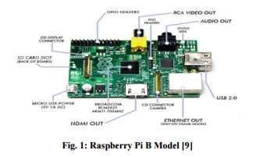

In the present study an IP-based network was established, Python codes were written for the sensors, which were connected to the Pi, a command was then carried out from the network website, which was processed by the Pi and reacted with the connected sensors. The purpose of present study is to build a system of interconnected devices and sensors, which allow the user to control and monitor certain electrical/electronic devices in their home via the internet from the Raspberry Pi. This means implementing a system which allows real time monitoring of the home, also forwarding emails to the user when certain devices are triggered.

1. **Implementation**

Main controller unit was built around Raspberry Pi. Controller was attached with Wi-Fi module, smart phone, computer, LCD module, power supply and various sensors. The Raspberry Pi operates on a Linux based open source operating system called Raspbian OS. This allows more control and flexibility in the software therefore making it easy to program the Pi. The Raspberry Pi communicates with the attached devices and sensors through PYTHON codes to control their functions. The Raspbian operating system was installed onto Raspberry pi, which was obtained by downloading NOOBS onto the SD card from the manufacturer’s website. PiFace Rack, which is an expansion board with 4 set of 26 GPIO pins, was used to connect Piface digital expander and Adafruit LCD Pi plate with the Raspberry Pi. . Piface digital expander was used to increase number of digital I/Os and LCD Pi plate was used to display the status of Raspberry Pi. The sensor PIR motion sensor connected to Raspberry Pi through PiFace digital board through PIN 17.

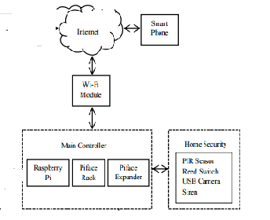

**Fig 2.Schematic Diagram**

1. **DESIGN**

In software engineering, a class diagram in the Unified Modeling Language (UML) is a type of static structure diagram that describes the structure of a system by showing the system's classes, their attributes, operations (or methods), and the relationships among objects.The Fig 3.gives the class digram.

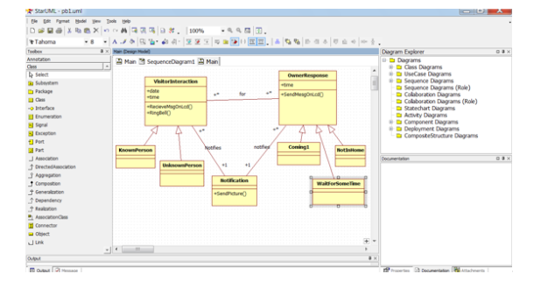

Fig 3.class digram

A Sequence diagram is an interaction diagram that shows how processes operate with one another and in what order. A sequence diagram shows object interactions arranged in time sequence. It depicts the objects and classes involved in the scenario and the sequence of messages exchanged

between the objects needed to carry out the functionality of the scenario.Fig 4 represent sequence digram.

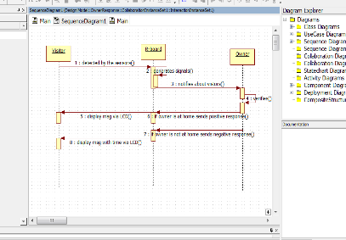

Fig 4.sequence digram

**IV.TESTING AND RESULTS**

Software Testing is evaluation of the software against requirements gathered from users and system specifications. Testing is conducted at the phase level in software development life cycle. Testing can either be done manually or using an automated testing tool.In our project we use automated way for testing.The testing part of our project is to check whether the code is running properly or not.

Testing

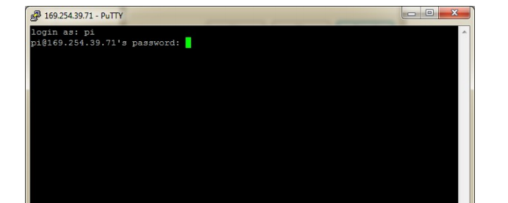

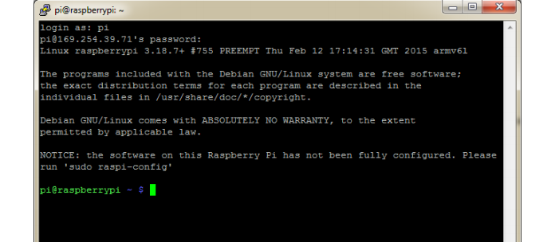

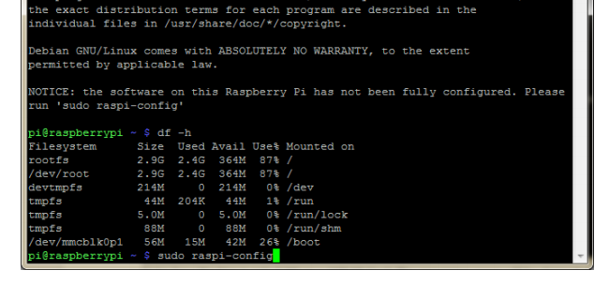

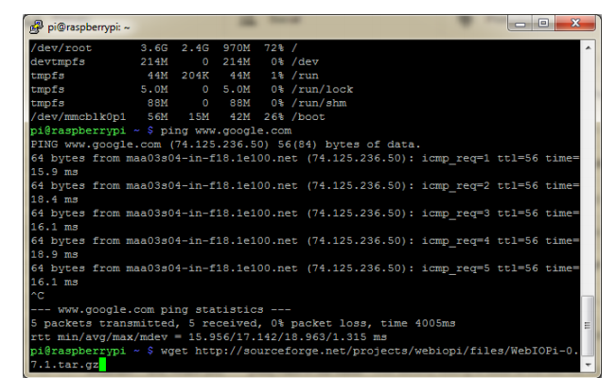

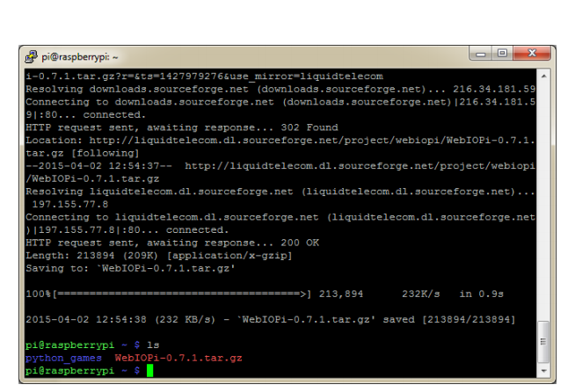

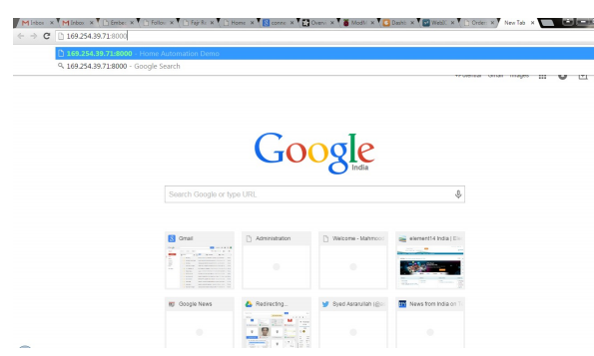

**Python Program:Backend Program**

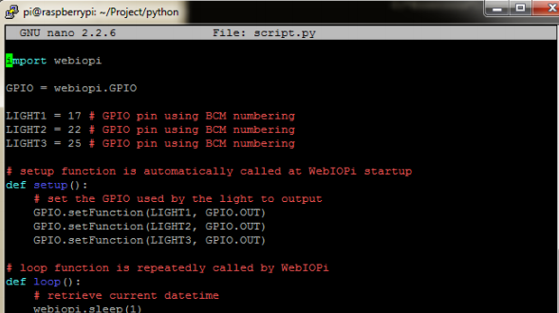

**HTML code:Front End**

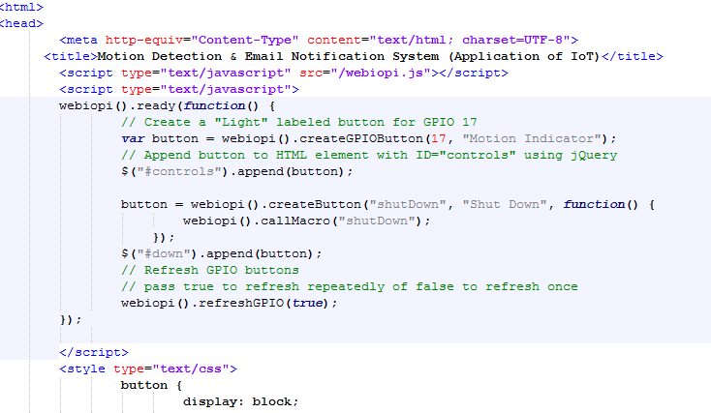

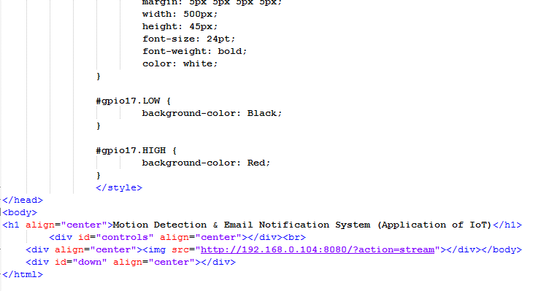

**Results:Live Streaming and capturing**



**v.CONCLUSION**

Present paper sought to design a smart home using various sensors to be controlled and monitored by the Raspberry Pi via the IoT .For Smart doorbell, the Raspberry Pi is programed to operate as a notifier as it detects any delivery person outside home and don’t miss to communicate. This system is also equipped with automated lights and virtual switches for controlling lights and appliances in the home remotely using external and / or internal networking with the Raspberry Pi via an HTML page. Full functionality of prototype indicates that devices like Raspberry Pi can play very important role in designing.

**ACKNOWLEDGMENT**

Authors are thankful to Faculty and Project Incharge to guide us and support us to carry out present work through project on “Smart doorbell using IOT”

**References**

[1] Peter A. Blume, The LabVIEW Style Book. New jersey, United states: Prentice Hall,2007

[2]http://www.engineersgarage.com/electroniccircuit/ infrared-ir-sensor .

[3]http://electroneecs-project.blogspot.in/ 2013-03-01-archive.html  (2002) The IEEE website. [Online]. Available: <http://www.ieee.org/>

[4] http://research.ijcaonline.org/volume119/number4/pxc3903700.pdf