**SMART HELMET FOR BIKE**

**Saddamhussain Sreekant Nayak Anil Power Darshan K P**

**Dept. of CSE Dept. of CSE Dept. of CSE Dept. of CSE**

**M.S.R.I.T M.S.R.I.T M.S.R.I.T M.S.R.I.T**

**Bengaluru.India Bengaluru.India Bengaluru.India Bengaluru.India**

***sahmh07@gmail.com*** [***sv1598@gmail.com***](mailto:sv1598@gmail.com)[***pawaranil131@gmail.com***](mailto:pawaranil131@gmail.com) ***kpdarshan9@gmail.com***

Abstract **: Nowadays almost all countries are making the use of helmets mandatory and cracking down strictly on drunken driving. But still in many places, the rules are being violated. In order to overcome this problem, a system named ―Smart Helmet is proposed in this paper. A smart helmet is a special idea which makes motorcycle driving safer. The proposed system describes the interaction between modules mounted on the vehicle and helmet to ensure the vehicle can be started only when the user is wearing a helmet and is not under the influence of alcohol. After giving an overview of the system, the paper describes the system architecture, specific components used, logic flow employed and benefits of the system. This proposed system aims at making safety the norm and not a choice.**

**Keywords : Safety, Sensor, Vehicle, Accident, Drunken Driving, Helmet**

**1. INTRODUCTION**

**The thought of developing this project comes to do some good things towards the society. Day by day the two wheeler accidents are increasing and leads to loss of many lives. Accord to a survey of India there are around 698 accidents occurring due to bike crashes per year. The reasons may be many such as no proper driving knowledge, no fitness of the bike, fast riding of bike, drunken and drive etc. Considering two major factors for avoiding the accident causes such as I. Make wearing the helmet compulsory. II. Avoid drunk and drive.**

**A recent report says that in an annual average of 700,000 road accidents, 10 percentage occurs in India, which has overtaken China. The latest annual statistics revealed by the World Health organization (WHO) in its first Global status report on road safety, 80,000 people are killed on Indian roads due to speeding, drunken driving, less usage of helmets, seat belts and child restraints in vehicles. Another latest report of National Crime Records Bureau or NCRB says that 40 people under the age of 25 die in road accidents all around the world.It states that the drunken driving is a major factor for the rising of death on roads. The drunk driving fatalities in the year 2009, till the 27th November were 11,769. The numbers for 2007 and 2008 were 12,998 and 11,773 respectively. It shows that the problem of drunk driving is far from over. In the 2009 DUI national statistics released by the NHTSA (National Highway Traffic Safety dministration) 11,773 people died in alcohol-related crashes.**

**Due to rise in deaths after accidents, due to negligence, it is necessary to generate a system to limit accidental deaths. This system has following features :**

**A smart helmet is a special idea which makes motorcycle driving much safer than the existing system i.e helmet . This is implemented using Microcontroller. The working of this smart helmet using Microcontroller is very simple, here we place the object detect sensors in helmet to check rider wear helmet or not and if wear means the bike will be start and then alcohol detect sensor will detect whether the rider drunk or not if the rider drunk means means bike will not start.**

**2. DESIGN**

**This paper mainly focuses on avoidance of drunken driving. Hence this system will not turn on the vehicle, when the user is in drunken condition. In addition to this, it will not allow the user to park drive the vehicle in the no parking or no entry area respectively. The system will send short message service to the friends or relatives when an accident occurs. It also employs theft detection. Our system consists of two major parts. They are**

**1) Helmet unit and 2) Vehicle unit as shown in fig.1 & 2.**

1. **Helemet Unit**

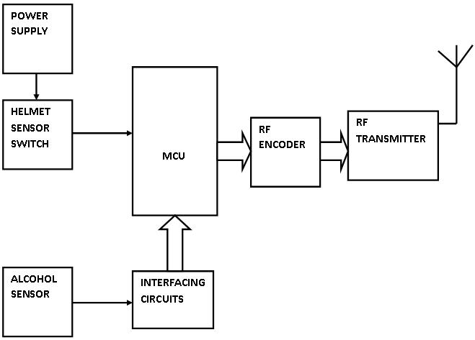

1. **Vehicle unit :**

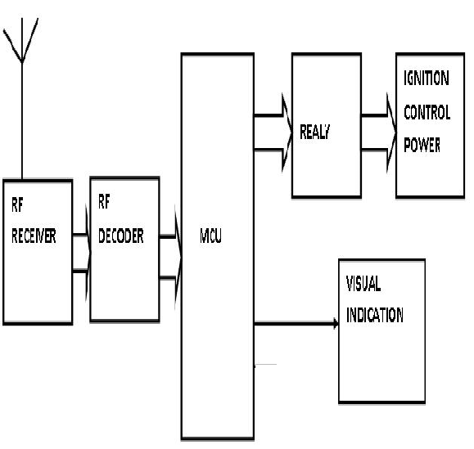

**3. IMPLEMENTATION**

***1. Helmet side*:**

**This module consists of various sensors and a transmitter**

**circuitry. Two sensors have been used, namely alcohol sensor**

**and obstacle sensor. Alcohol sensor has been used to detect the alcohol concentration. The alcohol sensor will be placed near the mouth of the rider, inside the helmet. and obstacle sensor is put on the head to detect whether rider wear helmet or not. The RF transmitter transmits the data from the microcontroller on the helmet side to the receiver on the vehicle side**

***2. Vehicle side :***

**This module consists of RF receiver, relay switch. The RF receiver receives the data and sends it to the microcontroller for further processing. Microcontroller receive these signal status and convert it into command for operating the relay switch to control on and off operations in bike engine. status is controlled by the microcontroller depending on various conditions such as wearing of helmet, alcohol concentration level.**

**Logic Flow of the System :**

**When a user approaches a vehicle with the proposed system**

**installed and tries to turn on the vehicle ignition, the vehicle**

**module communicates with the helmet module to check if the**

**helmet has been worn by the user. The helmet module checks**

**if the sensing switch has been activated. If activated, it means**

**the helmet has been worn and hence sends a corresponding**

**signal to the vehicle module. Along with the activation of the**

**switch, the helmet module also checks if the user has**

**consumed alcohol and sends a corresponding signal to the**

**vehicle module. The vehicle module, on receiving a correct combination of signals from the helmet module, proceeds to activating the electrical system of the vehicle accordingly. The combination of signals received from the helmet module and resultant action of the vehicle module are tabulated below.**

**IGNITION STATUS BASED ON HELMET MODULE INPUTS**

|  |  |  |
| --- | --- | --- |
| **Helmet Switch**  **status** | **Alcohol**  **status** | **Ignition**  **status** |
| **Off** | **NA** | **Off** |
| **Activated** | **Present** | **Off** |
| **Activated** | **Absent** | **On** |

**TABLE 1**

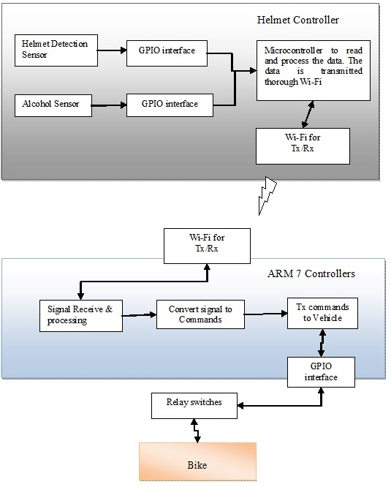

**4. RESULT**

**1, bike section :**



**2. Helmet section :**



**Nowadays, most cases of accidents area unit by motor bikes. The severities of those accidents are increased because of the absence of helmet or by the usage of alcoholic drinks. In our project we have a tendency to develop an electronic smart helmet system that efficiently checks the wearing of helmet**

**and drunken driving. By implementing this system a safe 2 wheeler journey is possible which would decrease the head injuries throughout accidents caused from the absence of helmet and additionally reduce the accident rate due to drunken driving. We have a tendency to introduce advanced sensors techniques and communications are included in this project to make it a good one. Our system efficiently checks the wearing of helmet and drunken driving. By implementing this system a safe 2 wheeler journey is possible which would decrease the head injuries during accidents and also reduce the accident rate because of drunken driving.**

**5. FUTURE SCOPE**

**In future we have a tendency to planned to construct our intelligent system during a compact size and additionally as globally acceptable to notify the No entry and No parking areas. Government should enforce laws to install such system in each 2 wheeler. y implementing such mechanism in 2 wheelers, the deaths attributable to due to driving and alternative road fatalities are often brought to zero p.c. And also indicates No parking area which would reduce the crowd of the vehicle in those areas. No entry area is mainly allocated during the development or repairing of the road, if the rider enters in such area this system would immediately intimate as No entry area and vehicle can stop automatically. in case of any accident it might send the messages to the friends continuously about the location of the accident happened until the first aid reaches the rider. Our system helps to know the location of the vehicle for rescuing in the case of theft incidents.**

**6. CONCLUSION**

**This system is very effective for the safety purpose of the user. User has to wear helmet to ride two wheeler vehicle and hence traffic rules will follow with this. This system is under pocket control ie. Ride two wheeler vehicle having safety in hand and in budget also. Easy functioning to operate this system. It provides a better security to the biker.**

**REFERENCES**

**[1] International Journal of Emerging Technology in Computer Science & Electronics (IJETCSE) ISSN: 0976-1353 Volume 8 Issue 1 –APRIL 2014.**

**[2] International Journal of Science and Research (IJSR) ISSN (Online): 2319‐7064 Volume 3 Issue 3, March 2014.**

**[3] International Journal Of Computer Science And Applications Vol. 6, No.2, Apr 2013 ISSN: 0974-1011 (Open Access)**

**[4] http://www.indiatransportportal.com**

**[5] http://drivingtest.in/road-accidents-in-india-a-concern.html**

**[6] Research paper on Effects of temperature on bleeding time and clotting time in normal male and female volunteers, authors: Valeri CR, MacGregor H, Cassidy G, Tinney R, Pompei F., Worldlibrary of MedicineNational Institutes of HealthSearch database**

**[7] The 8051 Microcontroller and Embedded Systems using assembly and C, Muhammad Ali Mazidi& Janice GillispieMazidi.**

**[8]** [**http://wiringpi.com/download-and-install/**](http://wiringpi.com/download-and-install/)

**[9]** [**http://www.gtk.org/download/linux.php**](http://www.gtk.org/download/linux.php)

**[10]** [**https://www.raspberrypi.org/documentation/usage/gpio-plus-and-raspi2/**](https://www.raspberrypi.org/documentation/usage/gpio-plus-and-raspi2/)