Wireless Temperature Monitoring System with open source cloud using RaspberryPi2

Sanjana K.S ^{#1}, Vidit Jain ^{#2}, Vignesh P ^{#3}, Vishal H ^{#4}

Department of Computer Science and Engineering,

M.S. Ramaiah Institute of Technology, Bangalore 560054, India

¹sanjanasukumar2012@gmail.com
²viditjain27@gmail.com
³vigneshp8080@gmail.com
⁴vishalh08@gmail.com

Abstract: This paper deals with design and implementation of Wireless Temperature Monitoring System using Raspberry pi2, DS18B20 temperature sensors, and Raspberry pi camera module. This system is essential in both industries as well as in homes to remotely monitor the temperature and constantly update it to the open source cloud named PrivateEyePi which provides relatively simple cloud interfacing and data analysis for Raspberry pi projects. The proposed system reads the temperature value of the surroundings and updates it to the cloud and sends a Gmail alert along with a picture of the place using SMTP protocol if the temperature exceeds the user defined threshold temperature value. Raspberry pi is connected to a Wi-Fi network using Tenda Wireless Wi-Fi adapter. Thus internet connectivity is established to perform the operations described above. Also the temperature values are entered into a database for providing offline storage. A preexisting Android application called RaspiCheck has been configured to display the temperature values that are read by the sensors.
Keywords: Raspberry pi2, DS18B20, PrivateEyePi, SMTP, Wi-Fi, Tenda, RaspiCheck
1. Introduction
Raspberry Pi is a mini computer which is of the size of a credit card [8]. The operating system is called Raspbian OS which is simple and is optimized for Raspberry pi. It’s an open source operating system based on Debian [1]. Once the operating system has been loaded in the Raspberry Pi using the SD card which is of class 10 or higher the necessary hardware connections are made as described in section 3. The function of each component that is used is specified in section 2. Later the procedure which involves the task of writing python code to achieve all the functionalities of the system are described in section 4.
2. Functional Description
It is essential to be well versed with functions of various components before plunging into other details regarding the system. The functions of the various components that are used in developing the system are given below.
- DS18B20 sensors:
Two DS18B20 sensors are used in this project. This semiconductor temperature sensor offers high accuracy and high linearity over an operating range of about 55 degree centigrade to 150 degree centigrade [8]. It is an integrated circuit, and can therefore include extensive signal processing circuitry within the same package as the sensor thus eliminating additional circuitries. This sensor can be directly connected to the Raspberry pi’s GPIO pin and thus capable of direct and reliable communication with it. Other features are that it’s lightweight and has a wide power supply range (2.7 V to 5.5 V) and converts the temperature to a digital value in less than 1second [8].
- Raspberry Pi camera module:
The Raspberry Pi camera module can be used to take high-definition video, as well as stills photographs. So the Raspberry pi camera module takes pictures of the surroundings when the temperature exceeds the user defined value.
- Raspberry Pi:
The various components of Raspberry- Pi are:
• SD Card slot is used for inserting an SD card which of class 10 or higher to load the raspbian OS and to provide persistent storage.
• Micro USB Power Port enables the Raspberry pi to obtain current that’s needed for booting OS and running various applications. It usually requires a 5volt ,1amp charger [8].
• Ethernet Port is used to connect to the Internet using RJ45 lan cable.
• HDMI OUT(High Definition Multimedia Interface) is used with HDTVs and monitors with HDMI input.If not and HDMI-VGA adapter is used to make it compatible with VGA monitors. This is needed only during the initial stage of loading the OS.
• BROADCOM BCM 2835: Raspberrypi2 uses the Broadcom BCM2836 as the Soc which contains a quad-core ARM Cortex-a7 processor with floating point & NEON, running at 900MHz and a Video core 4 GPU. The GPU is capable of Blu-Ray-quality playback, using H.264 at 40MBits/s. It has 1 GB of RAM and 4 USB 2.0 ports and one micro USB for 5v power supply [3].
• GPIO pins allows us to control and interact with real world .
Figure 1 shows all the fucntional components of a Raspberry Pi2.

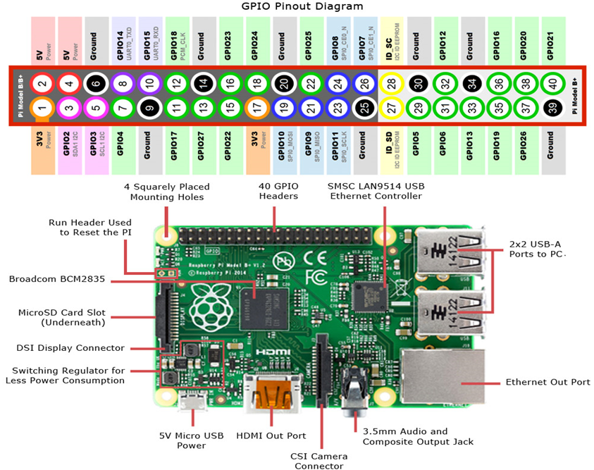
Figure 1 Raspberry Pi.

3. HARDWARE ARCHITECTURE
The GPIO connections are made as shown in figure 2. A resistor is used to control the fluctuations in the temperature values. The SD card is inserted into its slot and the 5V, 1A power adapter is connected to the micro USB slot and the Wi-Fi adapter is connected to the USB port [3]. For the initial loading of OS we need a keyboard, mouse and a monitor which are connected to the remaining 3 USB ports. These non pin hardware connections are shown in the figure 3. Also the features that are provided by system are depicted in it.
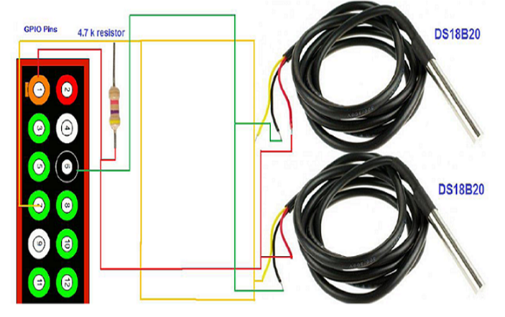
Figure 2 GPIO connections.
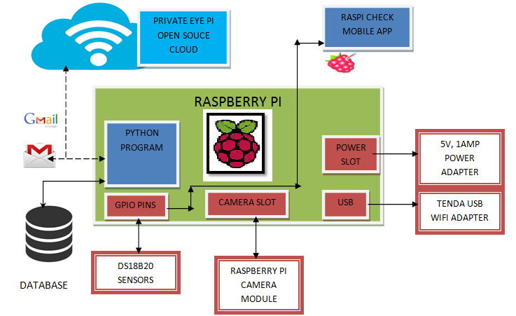
Figure 3 System Design.
The features provided include Gmail alerts, MySQL database updates, PrivateEyePi cloud updates and remotely accessing the Raspberry Pi from an Android phone.
4. INTIAL SETUP
4.1 Loading Raspbian OS
Download NOOBS (New out Of Box Software) from the raspberry pi website as a zip file [2]. Use the SD card formatter software to format the card and later extract the zip file into the card. Insert the SD card into the slot and power up the device by connecting a VGA monitor to the HDMI output of pi using HDMI to VGA convertor and also the keyboard and mouse needs to be connected to the USB ports. On successful loading of OS figure 4 will be seen [8].
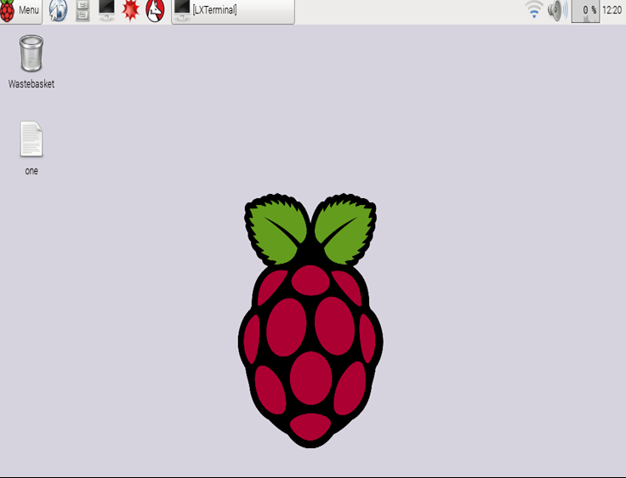
Figure 4 Successful Loading of OS
4.2 Remote Access
Make sure that the laptop from which you wish to access the Raspberry pi is connected to a Wi-Fi network which can be shared over the LAN cable connected between the Raspberry pi and the laptop. Download and install putty, angry IP scanner and VNC viewer. Using the IP scanner the IP address of the Raspberry pi can be determined which has to be entered in putty which is a telnet client which remotely accesses the Raspberry pi’s terminal. Then VNC viewer can be used to remotely access the Raspbian OS from the laptop.
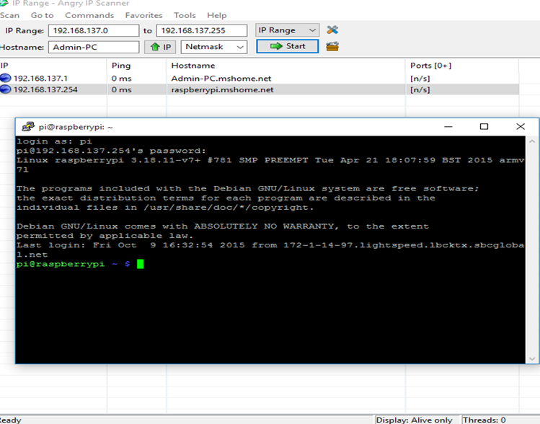
Figure 5 Remote Access

5. DESIGN
5.1 Introduction
In order in to optimize the design process and also to ensure that the design is efficient and the final product designed meets the desired requirements and achieves the goals and objectives of the project [8], it is essential to divide the project into various components or modules whose description has to be defined clearly.Modular design, or "modularity in design", is a design approach that subdivides a system into smaller parts called modules or skids [8], which can be independently created and then used in different systems. A modular system can be characterized by functional partitioning into discrete scalable, reusable modules, rigorous use of well-defined modular interfaces, and making use of industry standards for interfaces.The different modules needed and their description for the wireless temperature monitoring system are given below
- Remote Temperature Measurement Module: This module is responsible for retrieving the raw data from the DS18B20 sensors and parses it to obtain the actual temperature and the temperature can be accessed remotely using Putty and VNCviewer.
- Camera Module:
This module is responsible to interfacing with the raspberry pi camera module and to take a picture of the surroundings when the room temperature exceeds the threshold value.
- Database Module: This module’s function is to update the data into the backend MySQL database using python code.
- .Cloud Module: This module’s function is to update the temperature values into the cloud so that it can be accessible anywhere
- Email Module: This module’s function is to send an Email alert to the intended recipient’s Gmail account if the temperature exceeds the predefined value using python code.
- Mobile App Module: This module’s function is to remotely connect to the raspberry pi and determine the current inside and outside room temperature using RaspiCheck Android Application.

  - Algorithm

Algorithm for Remote Temperature Measurement Module:
Output: Actual inside and outside room temperature of surroundings
Input: Raspberry Pi Board with necessary connections
- Obtain the raw data from the two DS18B20 sensors.
- Parse this raw data and convert it into Actual Temperature using necessary formula.
Algorithm for cloud module:
Input: Actual inside and outside room temperature of surroundings
Output: Successfully updating it to PrivateEyePi
- Front End Configuration- Register an account in PrivateEyePi and enter necessary information.
- Back End Configuration- Download the install.sh file from PrivateEyePi.
- Modify globals.py file
- Run dallas.py [6].
Algorithm for Email and camera module [3]:
Input: Intended recipients’ username and password
Output: Successfully sending mails with photo attachment
- Determine if inside room temperature is greater than 30 degree Celsius.
- If so, take a picture of the surroundings.
- Send a mail using python code with the photo as an attachment.
Algorithm for database module:
Input: Actual inside and outside room temperature values
Output: Successfully committing the data to the database
- Write python code to insert new temperature values into the database along with the DS18B20 sensors’ unique identifier and the time of temperature reading.
- Use real time processing to make sure that the data is successfully committed to the database.
Algorithm for mobile module:
Input: Raspberry Pi’s IP address
Output: Displaying temperature values on an android phone
- Use the IP scanner software to determine the IP address of raspberry pi.
- Display the temperature values on the phone by remotely running the script from the phone.
Overall Algorithm:
Input: RaspberryPi with all the necessary connections.
Output: Updating Temperature values to cloud, database and sending Email Alert
- Rd ← Raw data from DS18B20sensors
- P (Rd) // parsing the raw data to obtain the actual temperature values.
- Update inside and outside room temperatures to the cloud.
- While(InsideRt > 30 ) //InsideRt refers to inside room temperature
Img ← Picture taken using raspberry pi camera module. Send Email Alert with Img as attachment
- Update temperature values to database.
- Loop back to step 1

  - Sequence diagram
Sequence diagram is an interaction diagram that shows how processes operate with one another and in what order. It is a construct of a Message Sequence Chart. A sequence diagram shows object interactions arranged in time sequence. It depicts the objects and classes involved in the scenario and the sequence of messages exchanged between the objects needed to carry out the functionality of the scenario. Sequence diagrams are typically associated with use case realizations in the Logical View of the system under development. Sequence diagrams are sometimes called event diagrams or event scenarios [8]. This is shown in Figure 5.

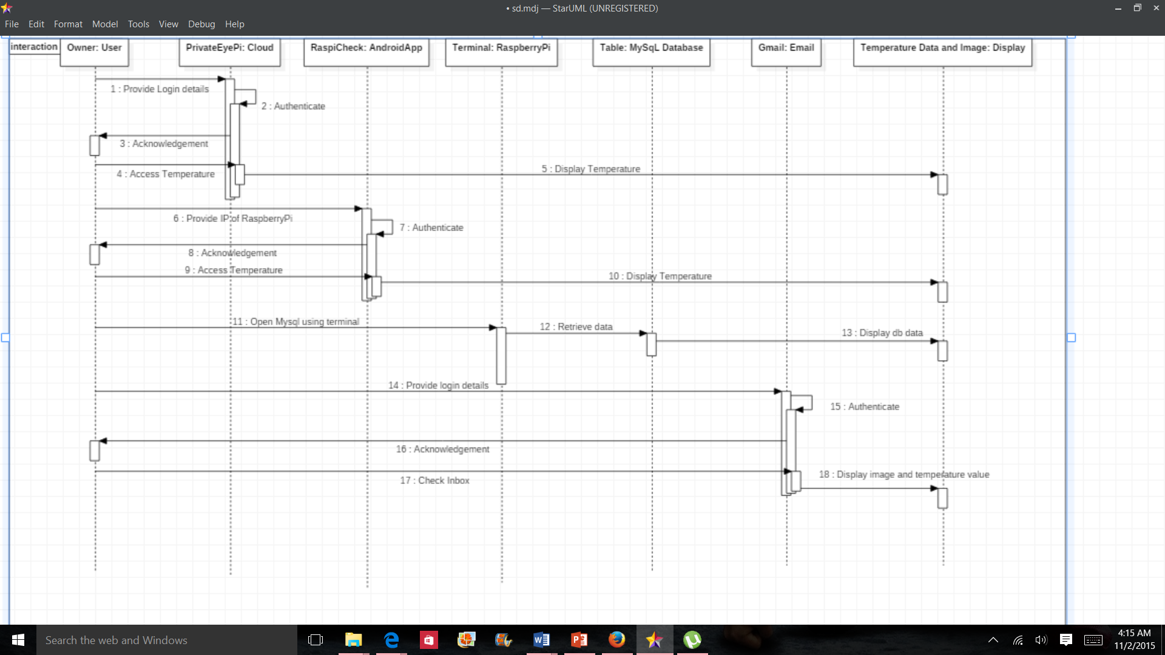
Figure 6 Sequence Diagram

  - Class Diagram
In software engineering, a class diagram in the Unified Modeling Language (UML) is a type of static structure diagram that describes the structure of a system by showing the system's classes, their attributes, operations (or methods), and the relationships among objects [8]. It’s shown in figure 7.
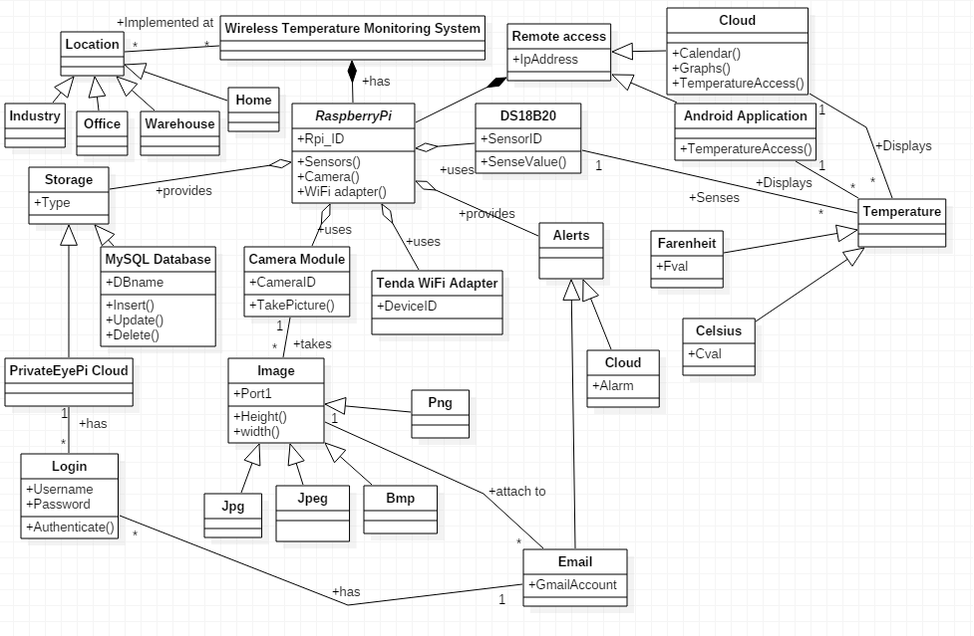
Figure 7 Class Diagram
  - Data Flow Diagram
A data flow diagram (DFD) is a graphical representation of the "flow" of data through an information system, modeling its process aspects [8]. A DFD is often used as a preliminary step to create an overview of the system, which can later be elaborated. DFDs can also be used for the visualization of data processing (structured design). It’s shown in figure 8.

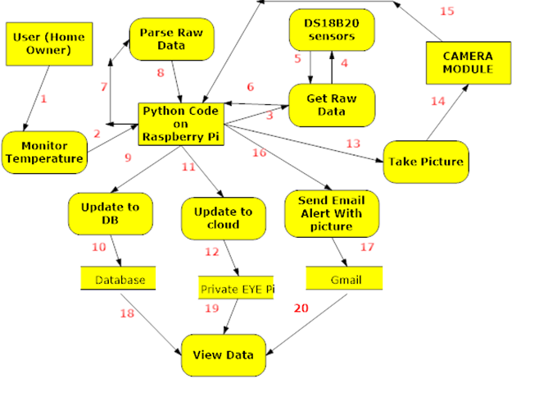
Figure 8 Data Flow Diagram
6. Working
6.1 Reading temperature values from sensors
The sensor ids are obtained by typing commands on the terminal as shown in Figure 9. Initially connections are made as shown in Figure 2 and a python code is written to extract the raw data from the sensors and this is parsed to obtain the actual temperature values which are constantly printed on the console as shown in Figure 10 [3].
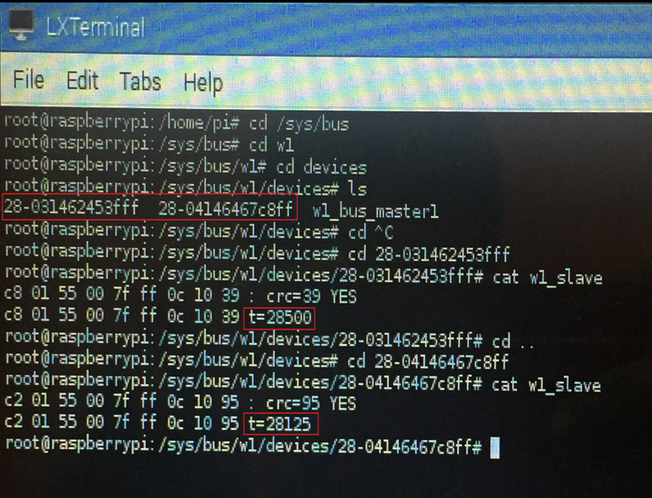
Figure 9 Obtaining Sensor ID’s

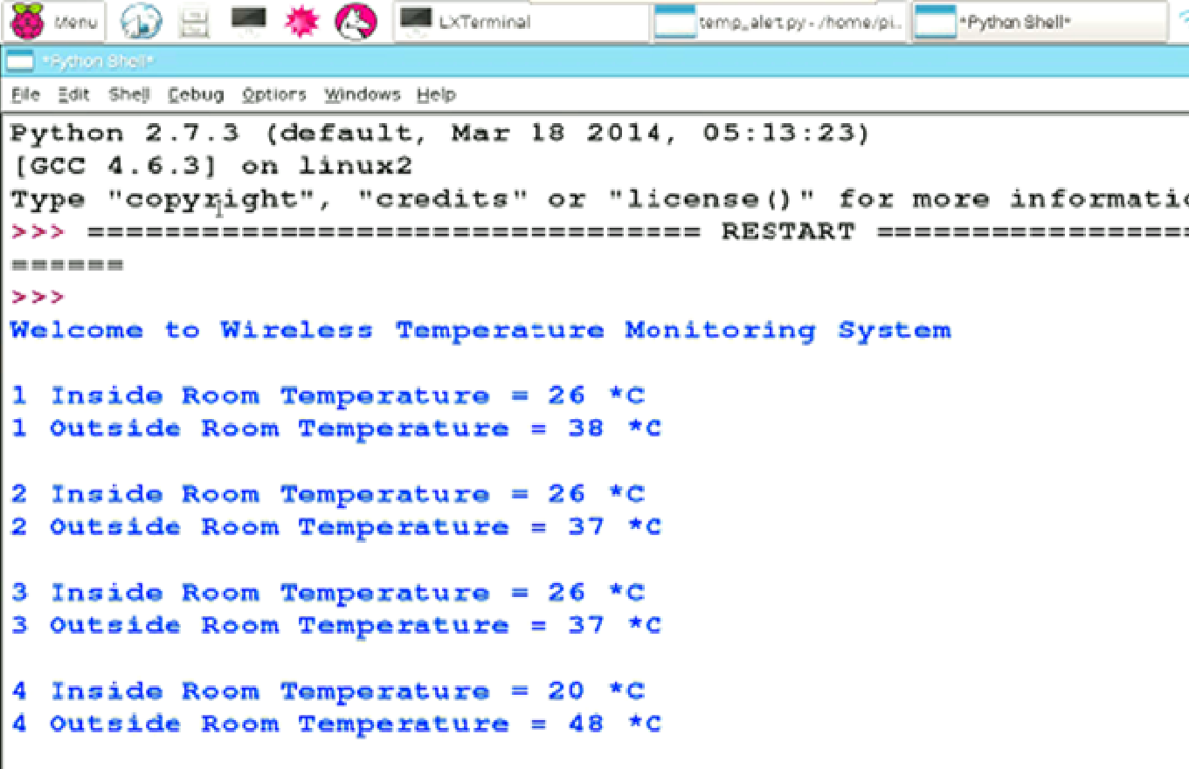
Figure 10 Printing temperature on console
6.2 Gmail alerts and Cloud Updates
The temperatures are constantly updated to the open source cloud called PrivateEyePi. When the temperature exceeds the user defined value a picture is taken and is sent along with an email to the intended recipient’s Gmail account. This is shown in Figure11. The cloud updates are shown in figure12. The Gmail alerts are implemented using python code where the sender’s username, password and the intended recipient’s username must be known for sending the Email [4].

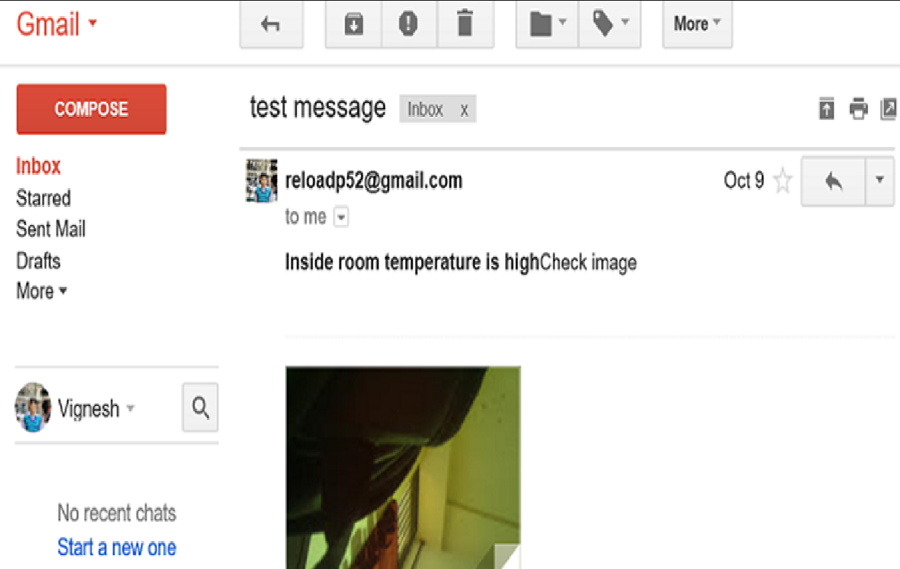
Figure 11 Gmail Alert

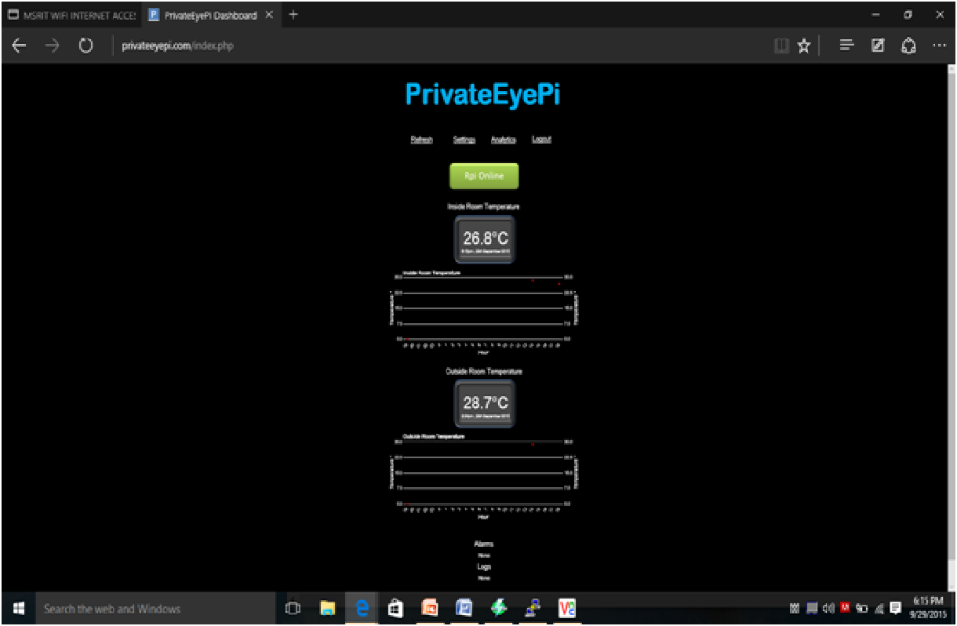
Figure 12 Cloud Updates

Further the open source cloud apart from providing storage facilities also provides pictorial representation of data in the form of graphs and calendar as shown in Figure 13.These help in analyzing the data that is collected over a period of time. Figure 14 depicts the timeline of the project which includes the details regarding the dates and the days on which the specific tasks were completed.

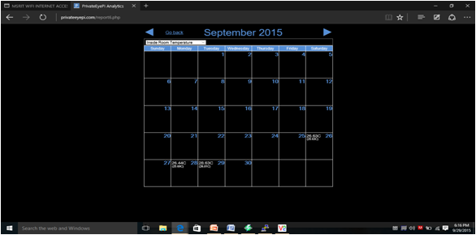
Figure 11 Calendar

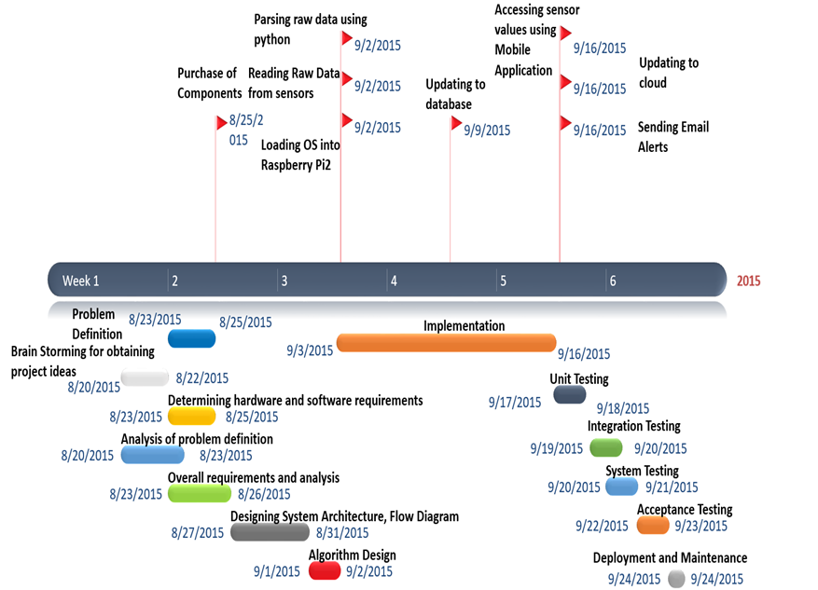
Figure 14 Project Timeline

Further the overall working of the wireless temperature monitoring system can be better understood with the help of the flowchart given in Figure 15.

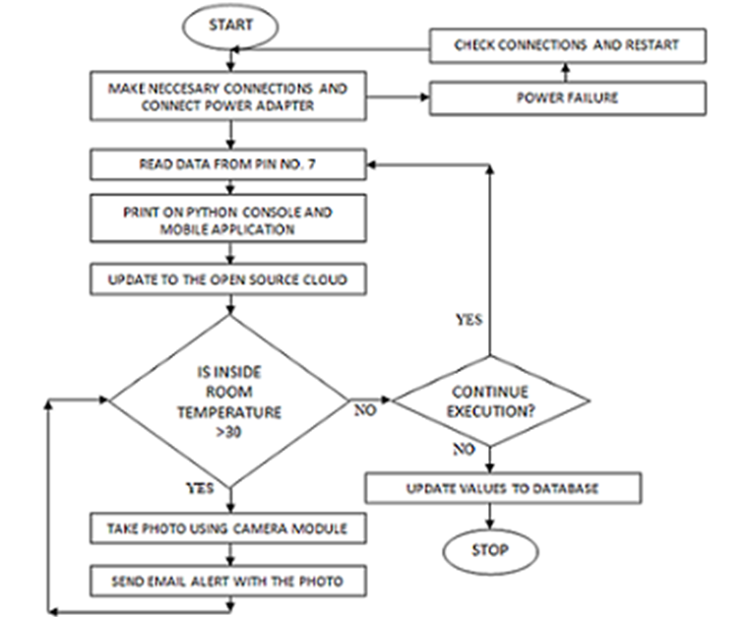
Figure 15 Flowchart of Working
7. CONCLUSION
Thus we have designed a wireless temperature monitoring system that is capable of remotely measuring the temperature and updating the values to the cloud and database and also send Gmail alerts along with pictures when the temperature exceeds the user defined limit. We would like to extend this project by examining or analyzing the effectiveness and the responsiveness of the open source cloud and to find out ways to improve them.
References
[1]. Ali M., Vlaskamp J.H.A, Eddiny N.N., Falconer B. and Oram C., "Technical Development and Socioeconomic Implications of the Raspberry Pi as a Learning Tool in Developing Countries", 5th Computer Science and Electronic Engineering Conference (CEEC), pp. 103-108, 2013.
[2]. Shan and M. Richardson Getting Started with Raspberry pi, 2012 :O'Reilly Media, Inc
[3]. [online] Available: http://www.raspberrypi.org/products/model-b-plus/
[4]. Bromley K., Perry M., and Webb G. "Trends in Smart Home Systems, Connectivity and Services", www.nextwave.org.uk, 2003
[5]. Sarthak Jain, Anant Vaibhav and Lovely Goyal "Raspberry Pi based Interactive Home Automation System through E-mail", International Conference on Reliability, Optimization and Information Technology-ICROIT 2014,
[6]. Norris Donald Raspberry Pi for the Evil Genius, pp.1 -51 2014: McGraw-Hill Education
[7]. Python Software Foundation [US], [online] Available: https://pypi.python.org/pypi
[8]. Pi Raspberry [online] Available: http://en.wikipedia.org/wiki/Raspberry_Pi

