BOARD OF STUDIES · MUSLIM STUDENTS’ SOCIETY OF NIGERIA (MSSN) · UNIVERSITY OF ILORIN
DOS SITE
Development Proposal & Requirements Confirmation
A free learning and assessment platform for Muslim students and JAMB aspirants
PREPARED FOR BOARD & TEAM REVIEW
Draft for Discussion — Version 2.0
19 August 2026

Contents
1. Executive Summary
2. Purpose & Audience
3. Roles & Capabilities
4. Academic Structure & Onboarding
5. How the Platform Works
6. Technical Overview (Plain-Language)
7. Infrastructure & Services Required
8. Recommended Path to Launch
9. Estimated Costs & Growth Triggers
10. Open Items Requiring Board Confirmation
11. Proposed Next Steps & Timeline

1. Executive Summary
The DOS Site is a proposed free learning and assessment platform for the Board of Studies (MSSN, University of Ilorin), built to serve two audiences: enrolled Muslim undergraduates and JAMB aspirants preparing for admission. It centers on a shared question bank organized under a Faculty → Department → Course → Topic hierarchy, two distinct quiz types (practice Topic Quizzes and graded weekly Course Quizzes), and fully platform-computed weekly performance tracking — CGPA for students, and a converted Post-UTME score for aspirants.
This document translates the original requirements note into a plain-language proposal for Board review: what each role can do, how onboarding and the academic calendar work, how the core flows run, what needs to be built and hosted, and the one real technical trade-off worth the Board's attention. A number of details still need Board confirmation before development begins — these are gathered in Section 10 for a single, focused review.

2. Purpose & Audience
The platform is entirely free to use — there is no payment or subscription flow. Access is controlled by registration credentials rather than by payment, and serves two distinct tracks:
Audience | Registers With | Primary Goal
Students (Undergraduates) | Matric Number, Name, Password | Reinforce coursework via weekly Course Quizzes; track CGPA
Aspirants (JAMB candidates) | JAMB Registration Number, Name, Password | Practice JAMB-style quizzes; track a weekly, converted Post-UTME score
Note: confirmed with the Board's IT team (19 Aug 2026) — Students register with Matric Number; Aspirants register with JAMB Registration Number. This is the standard mapping and corrects the reversed pairing in the previous draft.

3. Roles & Capabilities
Four roles share the platform, each scoped to what they need to do their part:
Role | Key Capabilities
Admin | - Declare the academic structure: Levels, Faculties, Departments, and Courses under each Department  - Create and manage Teacher accounts  - View all Students and Aspirants; track performance over time  - Set or review/approve quizzes and Topics; release scores immediately or on a delay  - Upload PDFs and weekly articles  - View the leaderboard (admin-only)  - Release weekly Post-UTME scores, converted to the Unilorin 50-point scale
Teacher | - Create Topics within a course (alongside Admin)  - Build and maintain the question bank (Fill-in-the-Gap and Options types)  - Configure and publish quizzes — both Topic Quizzes and Course Quizzes  - Save incomplete questions as drafts — cannot publish until complete  - View results for quizzes they created
Student | - Register with Matric Number, Name & Password  - Take quizzes assigned to their Faculty/Department/Level/Course  - View their own CGPA — 100% platform-computed weekly from Course Quiz results — and quiz history
Aspirant | - Register with JAMB Registration Number, Name & Password  - Take JAMB-focused quizzes  - View their own weekly Post-UTME score — 100% platform-computed, converted to the 50-point scale — and quiz history

4. Academic Structure & Onboarding
Account creation alone isn't enough to show someone the right content. Immediately after registering, each Student and Aspirant completes a short onboarding step that determines what they see from then on.

Onboarding fields
Track | Selects / Enters | Required?
Student | Faculty, then Department (filtered by Faculty)  Level — options depend on the Department chosen | Required  Required
Aspirant | Department of Aspiration | Required
No GPA/CGPA or JAMB score is collected at onboarding (removed in this revision, per the Board's IT team). The platform now computes CGPA and Post-UTME score itself, entirely from quiz performance — so a self-reported starting figure is unnecessary. This also resolves the earlier open question about first-time Aspirants who haven't yet sat the JAMB exam.

Academic hierarchy (new in this revision)
Content is now organized under a four-level hierarchy, declared by Admin before the platform goes live:
Level | Examples
Faculty | Faculty of Science, Faculty of Engineering
Department | Computer Science, Electrical Engineering
Course | MAT 101, CSC 201
Topic | Trigonometry, Data Structures — created by Admin or Teacher

Course scope types
Every Course is assigned one of four scopes, controlling which Students can see it:
Scope | Meaning
Department | Visible only to students in that one department
Faculty | Visible to every department under one faculty
General | Visible to all students, university-wide, regardless of department or faculty
Interfaculty | Visible to a specific set of faculties, manually picked by Admin per course (e.g. Faculty of Science + Faculty of Engineering)

Two semesters, and how content is scoped
The undergraduate calendar runs on two semesters per session — Harmattan (1st Semester) and Rain (2nd Semester). Courses, quizzes, and uploaded resources are all scoped to a Student's Faculty, Department, Level, and the currently active Semester, so a Student only ever sees what's relevant to them.
Aspirants sit outside this structure entirely. Since they are not yet enrolled in any Unilorin course, their quizzes and resources are organized by JAMB subject (Physics, Use of English, and so on) instead of by Faculty/Department/Level/Semester/Course.

5. How the Platform Works
Three flows sit at the heart of the platform. Each is shown below in simplified form for non-technical review.

Registration & Onboarding
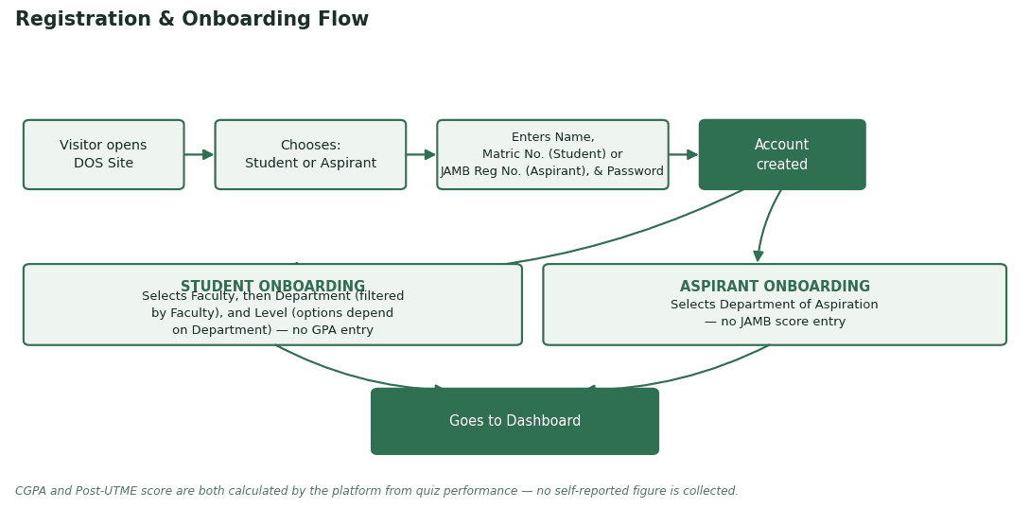
Figure 1 — Registration & Onboarding Flow

Taking a Quiz & Scoring
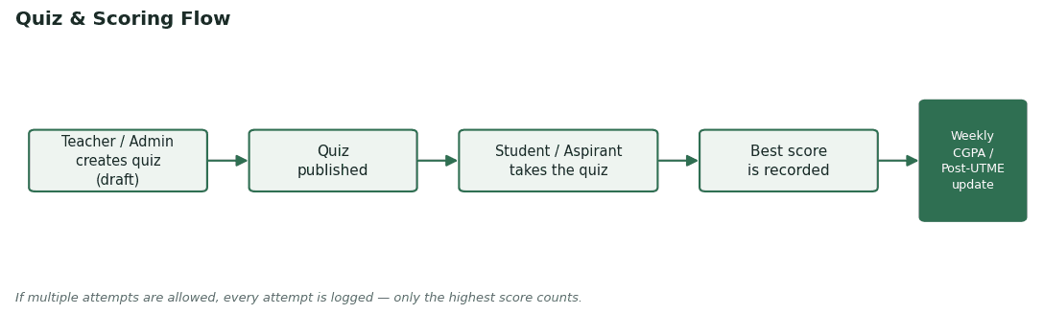
Figure 2 — Quiz & Scoring Flow
Every attempt a student or aspirant makes is recorded, but only the highest-scoring attempt counts toward their official record — so repeated practice is encouraged without penalty. A Student's available quizzes are limited to their own Faculty, Department, Level, and the active Semester; an Aspirant's are limited to JAMB subjects.

Quiz Types (new in this revision)
Quizzes now split into two distinct purposes — one for practice, one for grading:
 | Topic Quiz | Course Quiz
Scope | One specific Topic (e.g. Trigonometry under MAT 101) | The whole Course, pooling that week's topics together
Cadence | Whenever a Teacher sets one, after teaching a topic | Weekly — released every weekend
Question count | Set by Teacher/Admin | Fixed at 50 questions
Counts toward CGPA / Post-UTME / leaderboard? | No — practice only | Yes — the only quiz type that counts
In short: the Topic Quiz is formative practice; the Course Quiz is the one weekly assessment that actually determines a student's CGPA (or an aspirant's Post-UTME score) and leaderboard position. No credit-unit weighting is applied — every Course Quiz is the same fixed 50-question format, so all courses count equally.

6. Technical Overview
In plain language, before any code is written: every website like this is made of three basic pieces working together.
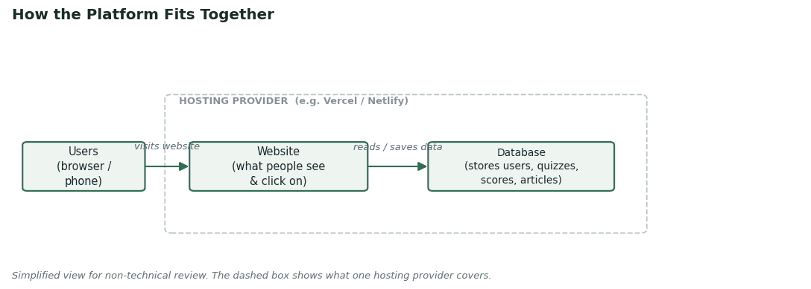
Figure 3 — How the Platform Fits Together
Term | In Plain Language
Website (Frontend) | What people see and click on, in their browser or on their phone
Database | Where all information is stored — accounts, quizzes, scores, articles
Hosting | The service that keeps the website online and reachable at all times
Domain name | The web address people type in, e.g. dossite-mssnunilorin.org

7. Infrastructure & Services Required
A working platform needs the following pieces in place. None of these require custom development on their own, with one exception noted below — they are existing services the platform will be built on top of.
Service | Purpose | Required at Launch?
Domain name | The platform's web address | Yes — small recurring cost
Hosting | Keeps the website running and reachable | Yes — can start free
Database | Stores accounts, departments, courses, quizzes, scores | Yes — can start free
File storage | Hosting uploaded PDFs & articles (resources) | Yes — can start free
Authentication (login system) | Registration & sign-in for all four roles | Custom-built — see note below
Email / notifications | Alerting users to new quizzes or released scores | Optional at launch — can be added later
On authentication: login uses a Matric Number (Students) or JAMB Registration Number (Aspirants), not an email address. That doesn't fit the built-in login systems that Supabase or Firebase offer out of the box, both of which are designed around email/phone/social sign-in. Rather than fight that mismatch, the plan is a small custom login layer written directly into the platform's code — this applies no matter which database provider is chosen.

Resource storage (PDFs & articles)
Uploaded PDFs and articles are organized the same way quizzes are, so a Student or Aspirant only ever browses resources relevant to them:
Track | Folder Structure
Students | /resources/{faculty}/{department}/{level}/{semester}/{course}/
Aspirants | /resources/jamb/{subject}/
Both Supabase and Firebase offer a file storage bucket alongside their database — the choice of provider for storage follows the same decision as the database itself, covered next.

8. Recommended Path to Launch
It's worth separating four independent decisions that are easy to lump together into one "tech stack" choice. Framework, hosting, and login are fairly settled by the project's own constraints; database & file storage is the one decision with a real trade-off, and is compared on its own below.
Layer | Recommended | Why
Framework  (builds the site) | Next.js | Lets one small dev team build and maintain the website and its backend logic as a single codebase, rather than two separate projects
Hosting  (where it runs) | Vercel (alt: Netlify) | Both free to start; Vercel pairs most directly with Next.js, so it's the simpler default
Login  (who's allowed in) | Custom-built in code | Matric/JAMB Reg Number login doesn't fit Supabase's or Firebase's built-in auth — see note in Section 7
Database & File Storage  (where the data & resources live) | Supabase — see below | This is the one decision genuinely worth the Board's attention. Compared on its own next.

Database & File Storage: Supabase vs. Firebase
This is a database-and-storage comparison specifically — not a comparison of frameworks, hosting, or company ecosystems. Both providers offer a free-to-start database plus file storage bucket; the real difference is how well each fits this project's actual data.
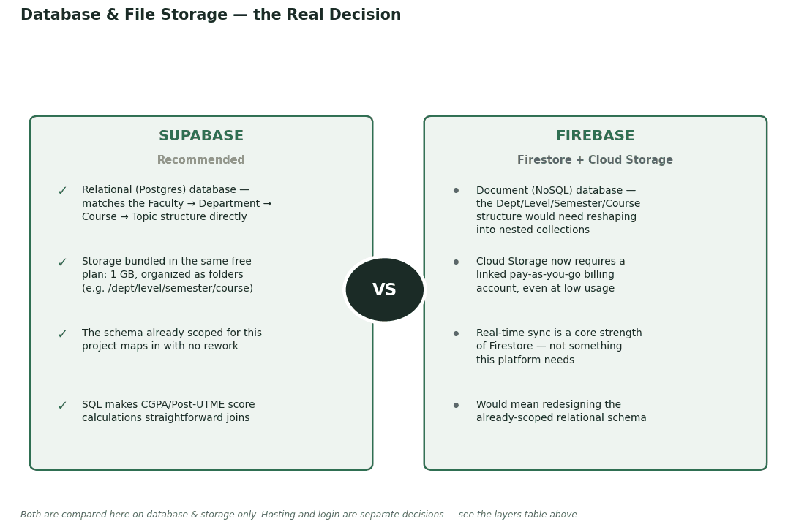
Figure 4 — Database & File Storage, Compared on Technical Fit

Recommendation
Supabase is the suggested starting point for database and file storage. Its relational (Postgres) structure maps directly onto the Faculty → Department → Course → Topic hierarchy already scoped in the accompanying database schema, and its storage bucket is genuinely free at this project's scale — 1 GB included, no billing account required. Firebase's Firestore is a capable database in its own right, but it's document-based (NoSQL): the relational schema already scoped for this project would need to be reshaped into nested collections, and its Cloud Storage now requires a linked pay-as-you-go billing account even for light usage, which undercuts the "free to start" appeal for a resource library that will keep growing.

9. Estimated Costs & Growth Triggers
Assuming the recommended path in Section 8, here is what's realistically free today and what would eventually trigger a paid plan:
Item | Free Tier Today (Aug 2026) | Likely to Need Paying When…
Domain name | — (not free anywhere) | Always a small annual fee, roughly $10–15/year — the only near-certain cost from day one
Hosting (Vercel) | 100 GB of monthly traffic; generous free usage for a launch-stage site | Traffic grows heavily, or the account needs to move to commercial/team use
Database (Supabase) | 500 MB database; up to 50,000 monthly active users | Question bank, course catalogue & user records exceed 500 MB, or automatic backups become necessary
File storage (Supabase) | 1 GB included | The PDF/article resource library grows past 1 GB in total
Figures reflect each provider's published terms as of August 2026. Free-tier terms shift periodically across the industry — reconfirm exact numbers with the development team at the start of the build.

10. Open Items Requiring Board Confirmation

Resolved at IT Team Review (19 Aug 2026)
# | Item | Resolution
1 | Reg Number vs. Matric Number mapping | RESOLVED. Students register with Matric Number; Aspirants register with JAMB Registration Number.
2 | GPA / JAMB score during registration | RESOLVED. Neither is collected at onboarding — the app calculates CGPA and Post-UTME score entirely from quiz performance.
3 | Academic structure | RESOLVED. Faculty → Department → Course → Topic hierarchy. Admin declares Levels, Faculties, Departments, and Courses. Course scopes: Department, Faculty, General, Interfaculty.
4 | Interfaculty courses | RESOLVED. Admin manually picks the specific faculties that share each interfaculty course.
5 | Topic creation | RESOLVED. Both Admin and Teachers can create Topics under a course.
6 | Quiz types & CGPA weighting | RESOLVED. Two types: Topic Quiz (practice, doesn't count) and Course Quiz (weekly, 50 questions, the only type that counts). No credit-unit weighting — every course counts equally.

Remaining Open Items
The following points still need Board confirmation before development begins.
# | Item | Why It Matters
1 | Identifier validation | Whether Matric/JAMB Reg numbers are checked against an existing MSSN/Unilorin list, or accepted as entered
2 | Admin vs. Teacher boundary | Determines whether Teachers publish quizzes and topics directly, or need Admin approval first
3 | Content upload permissions | Whether Teachers, not just Admin, can upload PDFs and articles
4 | Fill-in-the-gap grading | Exact match, case-insensitive match, or manual grading by a Teacher
5 | Notifications | How Students and Aspirants learn a new quiz or score release is available
6 | Department list source | Whether there's an authoritative list of Unilorin faculties/departments (and each one's max Level) to seed the platform with
7 | Course catalogue ownership | Who populates the Course list per Department/Level/Semester — the Board, individual Teachers, or an existing Unilorin source
8 | Topic Quiz question count | Whether this is fully free-form (Teacher decides per topic) or should also follow a fixed format like the 50-question Course Quiz
9 | Weekly release timing | Whether the Course Quiz is always released on a fixed day (e.g. every Saturday), and how long it stays open

11. Proposed Next Steps & Timeline
Phase | What Happens | Rough Duration
1. Confirm requirements | Board reviews and answers the open items in Section 10 | ~2–3 days
2. Design sign-off | Review and approve the wireframes | ~2–3 days
3. Development | Build registration, academic structure, quizzes, dashboards, and score tracking | ~3–4 weeks
4. Pilot testing | A small group of Students & Aspirants test the platform | ~3–5 days
5. Launch | Full rollout to all Students & Aspirants | —
Timeline is a rough placeholder for discussion, to be finalized once a developer scopes the confirmed requirements.

