Product manager

Add product page:

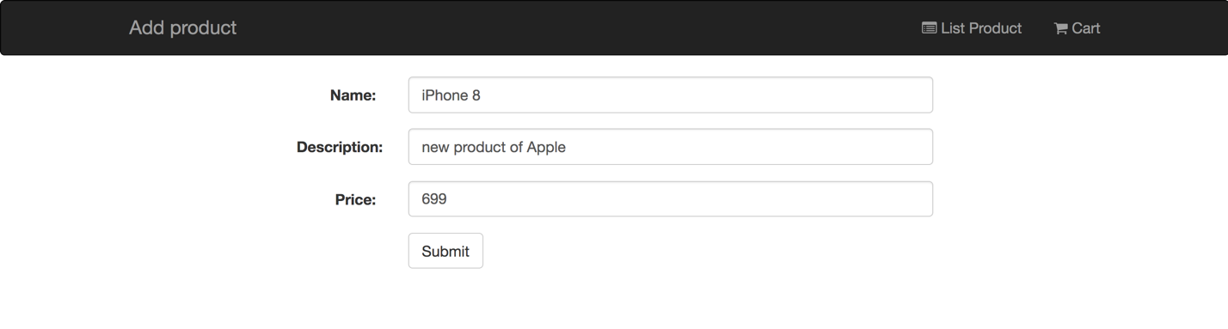

List product:

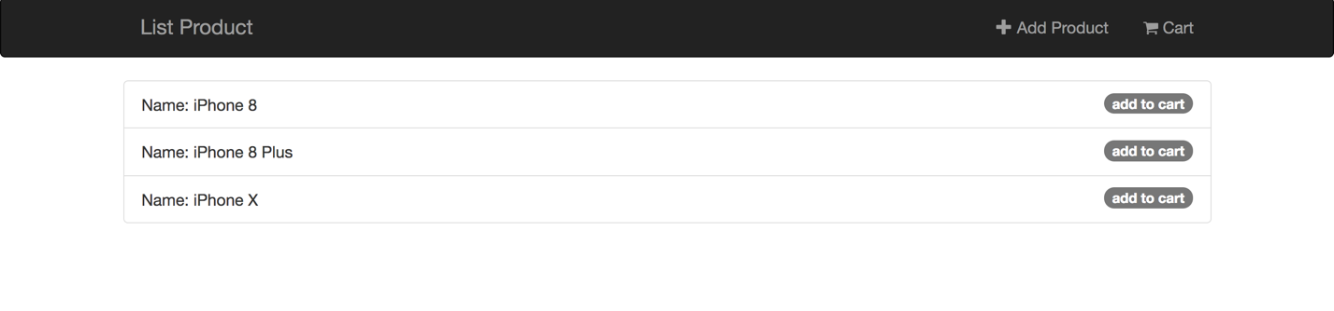

Show cart:

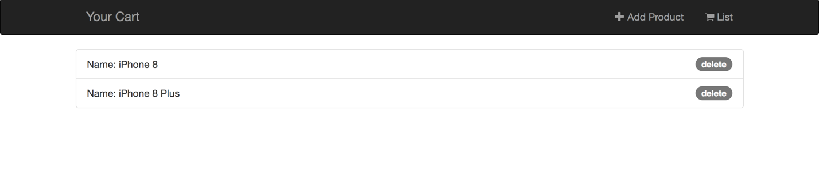

Delete:

