Mars Rover design Team Power train

**Main Electric Motor**

The main electric motor for the rover wheels are the backbone of the rover design. The 2014 competition rules specify that the rover needs to be capable of traversing sandy and rocky terrain with inclines of up to 60 degrees. In addition, strict time limits are set to complete terrain traverse tasks. This requires the rover to move at reasonable speeds ( above 10mph) on flat ground. These operating considerations had to be taken into account when selecting an appropriate motor and gearbox.

**Motor Load Torque requirement**

Difficult terrain traversing is a dedicated task for the Mars rover. Therefore great care has to be taken to insure the motors can produce sufficient torque to overcome any obstacles or inclines it might encounter. A large number of factors determine the required torque, with Grade Resistance and Rolling Resistance being the major ones. Therefore only these factors are considered. A safety factor is added later to account for other loss mechanism like air resistance and gear box inefficiencies. The Grade resistance of the rover was determined using,

where α is the maximum incline angle in degrees, *M* is the mass of the rover in kg and *g* is the gravitational constant. Assuming a maximum rover weight of 50kg and an incline angle of 60 degrees the maximum grade resistance is equal to

The rolling resistance is harder to determine as it depends on the contact surface and the used wheel. For the torque calculations the worst case scenario (dune sand) was used,

(flat ground)

(incline 60 degree)

where is the rolling resistance coefficient. Table 1 shows a table for different rolling resistance coefficients [[1]](http://www2.mae.ufl.edu/designlab/motors/EML2322L%20Drive%20Wheel%20Motor%20Torque%20Calculations.pdf).

The worst case total tractive effort was determined to be,

A 10% safety margin was included to account for inefficiencies in the motor and the gearing.

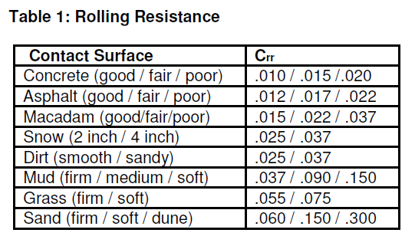

The required torque can be determined from the total tractive effort by considering the number of wheels and the diameter of them. The total force is split between all 6 wheels of the rover. This will not be true in all operating conditions (obstacle in front of one wheel), but is a good steady state assumption. The wheel radius was specified as 5 inches by the Mechanical subteam. These numbers can be used to calculate the required wheel torque:

The worst case steady state torque per wheel was determined to be 11.6Nm. This torque value is extremely difficult to achieve with a small electric motor, therefore an appropriate gear ratio needs to be chosen. The Mechanical team has indicated that they are planning on utilizing a 12 or 15 times speed reduction, which would reduce the required maximum motor torque by a factor of 12 or 15 respectively. This would require the electric motor to produce a maximum steady state torque between 0.966Nm and 0.7733Nm.

**Motor Speed Requirements**

The required speed for the rover is another concern when selecting an appropriate motor. It was specified that the rover should be capable of driving at speeds between 10 and 15mph on a flat surface. Assuming a tire radius of 5 inches the required wheel RPMs can be calculated:

For a 12:1 gear ratio this would require a motor RPM of . For a 15:1 gear ratio this would require a motor RPM of . These RPM numbers were considered when choosing a motor.

**Electric motor selection**

A variety of brushed DC motors were researched to find a motor that fits the specified requirements. A brushed motor was chosen as they are easy to drive and control. Brushless DC motors would have been an alternative, however their drive and control circuit is far more complex. The following list of motors was considered:

|  |  |  |  |  |  |  |  |  |  |
| --- | --- | --- | --- | --- | --- | --- | --- | --- | --- |
| **Company** | **Model** | **Stall Torque** | **Output Power (W)** | **No-Load RPM** | **Load RPM** | **Weight** | **Cost** | **General Size** | |
| SEI Automation | 9028T | 0.5268Nm | 165 | 3300 | 3000 |  |  | 122x122 mm^2 | 147 mm |
| SEI Automation |  | 0.73299Nm | 230 | 3500 | 3000 |  |  | 122x122 mm^3 | 172 mm |
| Midwest Motion | d33-455E-24V | 6.002Nm | 223 | 3430 | 3020 |  | Call | 3" diameter | 4.25" long |
| Ampflow | A23-150 | 4.025Nm | 678 | 6400 | 5900 | 2.1 lbs | 265 | 2.3" diameter | 3.5" long |
| Ampflow | F29-150 | 1.483Nm | 100 | 2600 | 2300 | 2.4 lbs | 67 | 2.4" diameter | 4" long |

From the above list the Amp Flow A23-150 motor was chosen. The A23-150’s operating RPM lies in the desired RPM region. In addition, the motor can produce high torque levels to overcome terrain obstacles. The A23-150, while being the most powerful, is also the lightest of the researched motors. The downside is that the A23-150 does not accept standard gearboxes, which complicates integration into the drive system. In addition, the A23-150 is very expensive compared to other motor options.

**A23-150 Specifications**

The behavior of the selected motor needs to be modeled to anticipate how it will operate in the field. This data will help develop a stable power supply for the motors and determine the overall power requirement for the rover depending on the terrain. The provided specification of the A23-150 are the following:

|  |  |
| --- | --- |
| Model | **A23-150** |
| Diameter (inches) | 2.3 |
| Length (inches) | 3.5 |
| Peak HP | 0.90 |
| Stall Torque | 570(oz in)/4.025Nm |
| Max. Efficiency  (@ 5900RPM & 0.3178Nm) | 82% |
| Max. System Voltage | 24V |
| No load RPM | 6400 |
| Shaft Dia. (inches) | 3/8 |
| Shaft Length (inches) | 1.0 |
| Magnet Type | Neodymium |
| No Load Amps | 1.0 |
| Resistance (Ohms) | 0.21 |
| Torque Constant (Kt) | 5.03 oz-in/A or 0.03552Nm/A |
| Motor Constant (Kv) | 269RPM/V or 0.0355V/(rad/sec) |
| Friction Constant (Bm) | 0.00005299859 |
| Weight (pounds) | 2.1 |
| Price | $265 |

The Permanent magnet DC motor equations can be modified to calculate the steady state operating condition for the A23-150 with different load torques and input voltages:

The derived equations were used to generate the RPM, Current and Efficiency curve for the A23-150 with different load torques and input voltages:

C:\Users\Rabbitfox\Documents\MATLAB\A23150NiceRPM.tifC:\Users\Rabbitfox\Documents\MATLAB\A23150NiceEff.tif

C:\Users\Rabbitfox\Documents\MATLAB\A23150NiceC.tif

The figures above show that the motor operates more efficiently at high RPM and low torque values. Therefore a higher gear ratio would be preferable to maximize motor efficiency.

For the practical design it is more interesting to know how fast the rover will move given a specific load torque. The following graph can be used to determine how fast the rover will traverse terrain subjected to a specific load torque assuming a 15:1 gearbox:

C:\Users\Rabbitfox\Documents\MATLAB\speed.tif

The maximum speed of the rover on optimal terrain (flat smooth ground) will be around 12.5mph. Moving up a hill the rover can still travel at 10mph, however this will require a large amount of current ( and with it power). The motor controller and battery system need to be designed to insure that they can safely supply the rover motors in all encountered operating conditions.

**Motor Control Board**

The speed of the rover needs to be controlled to insure proper operation. As seen in the motor section, the speed of the rovers can be controlled by varying the load torque or the input voltage to the motor. The load torque is determined by the rover environment (terrain composition, slope, weight) and cannot be adjusted by the rover operator. However the input voltage to the motor, which is supplied by the rover power system can be adjusted. The purpose of the motor control board is to condition the average voltage across the rover motor to such a level that it will go at the desired speed.

**Theory & Equations**

The voltage level from the battery is fixed around 24 Volts. Therefore the motor cannot be connected straight to the battery. The easiest way to step down and regulate a voltage in a DC system is with a Chopper circuit. A chopper circuit consists of switches and a low pass filter. The switches turn on and off in such a way that the input voltage is applied across the load for a fraction of the time. The average voltage across the load is then determined by the input voltage multiplied by the time the load is applied to the load divided by the total time. The low pass filter is used to smooth out the resulting voltage waveform it is not a choppy square wave but a constant voltage at the desired level.

For a 1 quadrant chopper circuit the following equation can be used to describe its operation condition (CCM):

where d is defined as .

A 1 quadrant chopper circuit can only produce positive voltage between 0V and the input voltage. However the rover motor needs to be able to move in both directions, therefore the motor controller should be capable of applying both a positive and negative voltage. A 4 quadrant chopper circuit accomplishes this. The steady state CCM output voltage equation is the following:

The 4 quadrant chopper can produce a voltage between negative Vin and positive Vin. This allows the motor to be driven from full speed reverse to full speed forward.

Another useful relation of the chopper circuit that it not only changes voltage but also current. This comes from the fact that, assuming no losses, the chopper is a constant power device. Therefore the current the rover power system needs to supply to the motor is given by the following equation:

This fact can be used to supply very large amounts of current to the motors (during high torque conditions) without damaging the batteries or the power system. This also allows the motor to be supplied with higher continuous current than the battery system is rated for.

Using the fact that the motor controller is a constant power device and that the power can be controlled, the motors can be supported under extreme operating conditions without damaging the batteries. The following charts show the motor characteristics given that the power to the motors is limited to a certain value. Again the gearing ratio is assumed to be 15:1.

C:\Users\Rabbitfox\Documents\MATLAB\MotorControlSpeed.tifC:\Users\Rabbitfox\Documents\MATLAB\MotorControlEfficiency.tifC:\Users\Rabbitfox\Documents\MATLAB\Motorcontrolpowerloss.tif

The curves indicate that a minimum input power of 120Watts is required to allow the motor to climb the 60 degree incline. However, at this point it would move extremely slow. All these curves were generate neglecting losses in the actual motor control circuit! High currents will increase losses in the motor controller, further reducing the efficiency and rover speed.

**Main Motor Controller Design**

The main motor controller needs to control a brushed DC motor. The controller needs to be capable of controlling the speed of the motor in both forward and reverse direction. An H-Bridge is used to implement the drive circuitry as it allows the required features to be implemented. In addition to the H-Bridge circuit additional circuitry needs to be designed to properly control and protect the circuit.

Based on the motor specifications the motor controller has to be capable of withstanding up to 24V of input voltage and 40A of continuous output current. The motor controller should have the control algorithm implemented on an local IC. In addition, the local IC should monitor for over/under voltages, overcurrents and ambient temperature. The IC needs to interface with the rest of the system through an RS485 link.

The components of the motor drive need to be selected to implement all the listed features. An overview of all the used parts is given below.

**Main Component Selection**

**Main Switches**

The H-Bridge circuit is implemented using 4 switches. The switches could be realized using Bipolar junction transistors (BJTs), Insulated-gate bipolar transistors (IGBTs) or Metal-oxide-semiconductor field-effect transistors (MOSFET). BJTs are generally used for low current applications, making them a poor choice for an efficient high current drive. In addition BJTs are current driven which makes the drive circuitry more difficult to implement and lossy. IGBTs are capable of handling very high voltages and currents, making them the preferable choice in high power drives. IGBTs are used in drives with several hundredths of volts which would be overkill with a 24V motor drive. IGBTs also have poor switching characteristics, which would limit the maximum allowable switching frequency. Low voltage MOSFETs have small on state resistances and much better switching characteristics than IGBTs. This allows MOSFETs to operate very efficiently at high currents and high switching frequencies, making them an optimal choice.

There are two types of practical MOSFETs to chose from P-type and N-Type. P-type are easier to drive as a high side switch, but they are also more expensive and less efficient than N-Type MOSFETs. To insure the highest possible efficiency only N-Type MOSFETs were chosen in the H-Bridge. This design decisions requires a high side driver to be selected later.

The maximum input voltage is equal to 24V. To account for switching overshoot and provide a factor of safety a switch with at least twice that voltage rating should be chosen. Therefore only MOSFETs with a minimum rating of 48V were considered. The maximum continuous current requirement was specified at 40A. One can find a wide variety of MOSFETs that are “rated” for currents well above 40A. This current rating is only valid for a set of specific operating conditions, which rarely occur in actual operation. Instead of working with the rated current figure, the equivalent resistance of the MOSFET was used to evaluate how much current it can handle. The current limit in MOSFETs is really a thermal limit, therefore reducing the conduction losses in the switch due to current increases the amount of current it can handle. A switch with low on state resistance will incur the least conduction losses due to current. Therefore the MOSFET was selected based on the lowest available on state resistance. It is very likely that any MOSFET selected requires some type of heatsink. The heatsink is selected later in this paper.

The International Rectifier IRLB3036PbF N-Channel MOSFET was selected as the main switch of the H-Bridge. The IRLB3036PbF can block 60V, providing a large margin of safety voltage wise. The CSD18532KCS is “rated” for up to 195A, however it really was selected as it has a low on-state resistance of 2.4 milliohm. The CSD18532KCS is packaged in a standard TO-220 package, which can dissipated up to 1W of heat. Without a heat sink the CSD18532KCS could handle approximately 26.92A continuously, which is below the 40A requirement. This number does not include additional switching losses either. Therefore a heat sink will be required with the IRLB3036PbF.

An overview of the main electrical characteristics from the IRLB3036PbF data sheet is shown below:

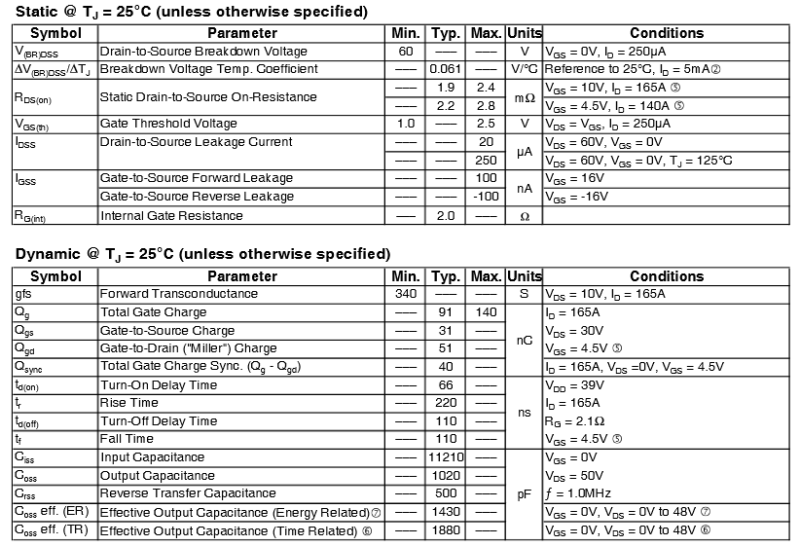

A gate driver capable of driving the CSD18532KCS in both the high and low side needs to be chosen next. The provided total gate charge (91nC) of the MOSFET can be used to evaluate the performance of the selected gate driver.

**Gate driver**

The individual MOSFETs need to be externally driven in order to turn on and off. The switches on the bottom leg of the H-Bridge connected to ground can be drive using a low side driver. The high side switches connected to the input voltage require a voltage higher than the input in order to turn on. A high side driver with a charge pump or bootstrapping needs to be utilized to control the high side switches.

The H-Bridge topology is widely used in industry, therefore a variety of products exist to support it. Complete H-Bridge drivers are available that implement all the required functions. Of the available drivers the Intersil HIP4081AIPZ was chosen. The HIP4081AIPZ supports bootstrapping voltage in excess of 70V, more than sufficient to drive the high side switches (36V). The driver’s average peak pull up current is equal to 2.6A. This allows the driver to turn on the MOSFETs at an average speed of:

The driver’s average peak sink current is 2.4A which enables the driver to turn of the switches in:

The switching frequency in motor drives ranges between 5kHz and 50kHz. This makes an entire switching period tenths of micro seconds long. With an transition time of less than 100ns the switches transitions are an insignificantly small portion of the total conduction time of the converter. In the default operation the switches operate so fast that there could actually be problems with switch overshoots. Therefore a small gate resistor should be added between the gate driver and the gate of the MOSFETs.

The HIP4081AIPZ implements a number of other important functions. For instance it features a build in turn on/off delay for the switches. This features prevents shoot through in the H-Bridge legs. No additional circuitry is required to prevent switch conduction overlapping in one leg.

The logic of the HIP4081AIPZ is arranged in such a way that the H-Bridge can be controlled with two PWM signals. To implement the forced conduction mode operation, a PWM signal and the inverse of that signal is required. In this configuration a duty cycle of 50% will result in no net voltage over the motor. A 100% duty cycle translates to full speed forward, while 0% translates to full speed back. This is the same operating condition as described in the previous section. The driver also features a Disable pin that turns of all the switches connected to the gate driver. The disable can be used to cut power when the motor is at a standstill. Operating the disable pin while the motor is rotating will cause the motor to break until it comes to a full stop.

The HIP4081AIPZ requires two bootstrapping circuits to provide a high voltage source to the high side drivers. The bootstrapping circuits can be implemented using two diodes and two capacitors. The supply voltage to the gate driver can be used as the source of the bootstrapping circuit. The bootstrapping circuit will prohibit 100% duty cycle operation for extended periods of time.

A schematic of the H-Bridge with the gate driver is shown below:

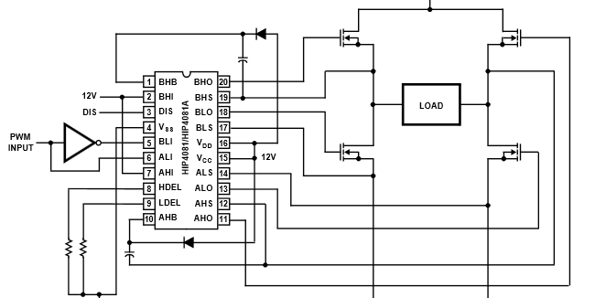

**Flyback Diodes**

During the switch transition period or when the drives is disabled the H-Bridge requires diodes to properly function. The MOSFETs have build in diodes, that could be utilized. However the internal MOSFET diodes have very poor performance characteristics. Therefore a set of Shottky diodes is placed in parallel with each MOSFET to support its operation. The MBR10100 was selected as it has a blocking voltage of 100V and current handling capability of 10A. The MBR10100 does not need to be capable of handling the full output current as it will only be utilized for short periods of time, like switching transitions or motor stopping.

**Input capacitors**

The input capacitors to the drive are critical to insure voltage stability, especially during transients such as motor starts/stops. The motor drive is located a fair distance from the main power source, which produces a noticeable amount of line inductance between the supply and the motor drive. This line inductance can cause the input voltage to dip down if the load current of the motor drive changes. In addition, the motor drive produces very high ripple currents that need to be filtered somewhere in the system. Lastly, high frequency currents can radiate as EM interference from the board. Therefore the ripple current at all frequencies needs to be controlled tightly. The input capacitors have to accomplish three different tasks, therefore three different types of capacitor are used to address these tasks.

* **Transient Suppression Capacitor**

A large change in load current can cause the input voltage to the sack or swell. This is due to the fact that the inductance in the wire connecting to the power board will try to resist a change in supplied current. Therefore if the load current for example increases the input capacitance of the board has to supply the missing current until the load current can be supplied by the line. A 1mF capacitor was chosen to handle this transient operation. At 1mF the capacitor can supply large load currents for short times with little change in the bus voltage. The 35PX1000MEFC10X20 was chosen to implement this capacitor. It is rated for up to 35V, well above the required voltage level.

* **Current Ripple Suppression**

The switching action of the H-Bridge produces very large ripple currents. The motor controller goes from having to supply the full motor current to having to sink the full motor current. This current ripple needs to be absorbed in Capacitors to smoothen out the input current to the motor drive to an average value. Traditional Aluminum Electrolytic Capacitors have too large of an ESR to support high ripple currents. OS-CON type capacitors were selected instead as they feature low temperature independent ESRs. Based on the motor drive requirements the 35SEPF120M from Panasonic was chosen. The 35SEPF120M is rated for 35V (40V surge) with a capacitance of 120uF. This capacitor is also capable of supporting ripple currents of up to 4.4A at an ambient temperature of 105 degrees. An array of these capacitors is used to supply the required ripple current for the converter.

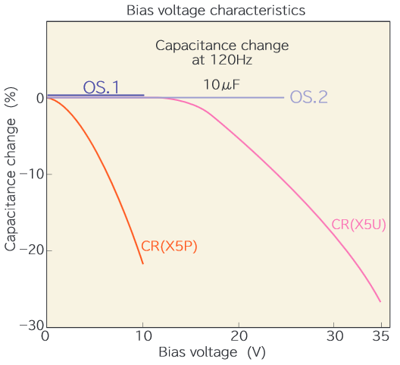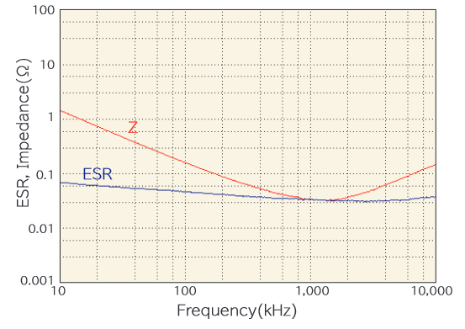

* **Noise Suppression**

The switching action of the H-Bridge produces electric noise into the Megahertz range. The previously shown Aluminum Electrolytic Capacitors stop behaving like capacitors at high switching frequencies (above 100kHz), which makes them ineffective in filtering this high frequency noise. A set of ceramic capacitors are added close to the H-Bridge in an attempt to divert the high frequency noise. There is room for four 1206 chip ceramic capacitors. It is recommended to place 2 C3216X5R1V226M160AC ceramic caps in this spot. The C3216X5R1V226M160AC has a capacitance of 22uF, which allows it to filter intermediate noise and assist the ripple current capacitors. The other two spots should be filled with C3216X7R1E105M085AA, which have a capacitance of 1uF. The smaller capacitance allows the capacitor to be more effective at a higher frequency range. If there is still noticeable high frequency noise during operation the 1uF capacitor can be replaced with a 0.1uF capacitor to further increase the frequency that can be filtered.

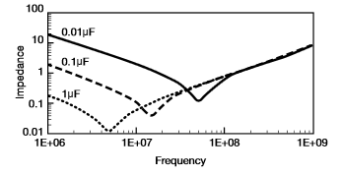

**Sensors**

**Current Sensor (NOTE: THIS CHANGED TO THE ACS711)**

The ZXCT1109SA-7 uni-direction current sensor is used to determine the average current into the motor drive. A 0.005Ω sense resistor is used with the ZXCT1109SA-7. In the specified setup the current sensor can handle input currents of up to 160A. While it cannot measure reverse currents the setup can withstand reverse currents of up to 50A. A 5kΩ gain resistor is used to convert the current measurement to a voltage the microcontroller can read. One volt over the gain resistors equals 10A through the sense resistor.

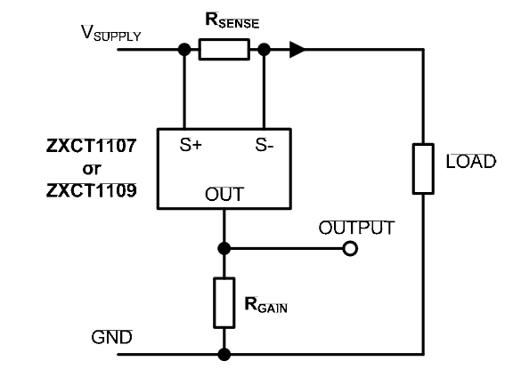

**Voltage Measurement**

The voltage measurement is accomplished using a simple voltage divider. The high side resistor is equal to 84.5kΩ, the low side resistor is equal to 10kΩ. A 0.1µF capacitor is used to filter the voltage measurement. The voltage divider is directly connected to the ADC pin of the Atmega. A full 5V measurement on the ADC pin of the Atmega would be equivalent to a system voltage of 47.25V.

**Temperature Measurement**

Temperature sensing in accomplished using an LM35 Precision Centigrade Temperature sensor. The LM35 does not require any biasing circuitry (for a 2 to 150 degree temperature range) and is simply connected to Power ground and the ADC of the Atmega 328P. The output voltage of the LM35 will increase by 10mV for each degree above 0 degrees C.

**Thermal Considerations**

High Torque operation of the motor will result in excessive current flows in the controller. Joule heating of the individual components is proportional to the square of the current flowing through the component and the resistance of that component:

At high current levels the power losses due to component heating will rapidly increase due to the square dependency on current. The heat dissipation capability of the individual components has to be verified to insure that they can safely dissipate the heat that is generate in them. This is especially true for the MOSFET switches and the capacitors as they handle the bulk of the current. Standby losses in the gate driver should be considered as well as they generate additional power losses in the gate driver.

**MOSFET**

To determine the heat generate in the different components, the losses need to be evaluate first. The power losses in the MOSFET can be separated into two categories: conduction losses and switching losses. The conduction losses can be calculated using the largest anticipated RMS current and multiplying it by the switch resistance. The maximum current was specified at 40A. The highest RMS current will be encountered at 100% duty cycle. Therefore the maximum conduction losses are equal to:

The switching losses can be approximated using the output capacitance of the MOSFET:

Combining the conduction and switching losses yields the maximum power loss in the MOSFETs which is equal to approximately 3.853W. The heat dissipation capability of a TO-220 is 1W, however the expected power losses in the MOSFET are 5 times higher. Therefore, a heatsink will be required to cool the MOSFET. The Alegro 6025DG heatsink with a thermal resistance of was chosen for the switches. The 6025DG has a very small form factor making it ideal for the small motor drive design. Considering the ambient temperatures and all the thermal resistances the expected worst case junction temperature of the MOSFETs is equal to:

The maximum junction temperature of the IRLB3036PBF is equal to , far above the expected maximum temperature. This provides a margin of safety in the event the ambient temperature in the gate driver enclosure increases or the current by the motor increases. The ambient temperature inside the motor enclosure should not be allowed to rise above to protect the MOSFET switches from overheating at high load levels.

**Gate Driver**

The gate driver losses for 1 of the MOSGETs can be calculated using:

This leads to a gate driver power loss of approximately 0.0864W. The thermal resistance of the DIP-20 package is approximately which can be used to calculate the maximum expected junction temperature of the gate driver:

The power dissipation in the gate driver is too small to produce a significant temperature rise in the component.

**Capacitor**

Finding an accurate and consistent thermal resistance for can type capacitors is challenging. Instead of relying on heat rise calculations using thermal resistance, the manufacturers current handling capability for a specified ambient temperature can be used.

The load transient capacitor only operates during transients, therefore it is not used continuously. This limits the current the capacitor has to handle to short pulses. As long as the transient capacitor is not used frequently it has enough time to dissipate the generated heat in it.

The noise suppression capacitors are ceramic type, which have such low ESR values that they produce very little heat even when conducting high current levels. However they use the X5R dielectric which losses capacitance at temperature above . X5R is rated up to , therefore the ambient temperature will need to remain below that value. Lower ambient temperatures will generally result in better performance of this type of capacitor.

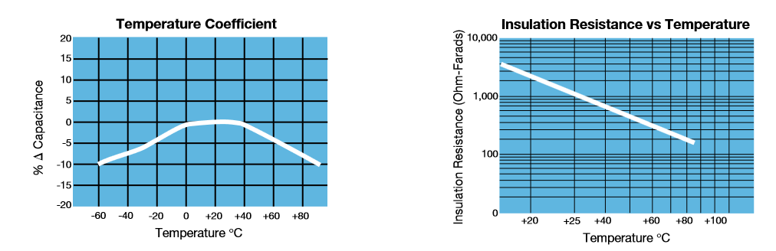

The motor current ripple suppressing capacitors are of greatest concern thermally as they handle the entire motor current during normal operation. Panasonic specifies that the 35SEPF120M can handle 4.4A of ripple current at case temperature. Seven 35SEPF120M are used in the drive giving a total ripple current rating of 30.8A at . To meet the 40A motor current specification the ambient temperature has to stay well below the mark. As described earlier the ambient temperature should be limited to for the MOSFET switches. With a much lower ambient temperature the chosen capacitors will be able to handle additional ripple current [[R]](http://www.vishay.com/docs/40031/apprippl.pdf). Another benefit of OS-Con capacitors compared to ceramic caps is that the capacitance will increase with higher temperatures not decrease.

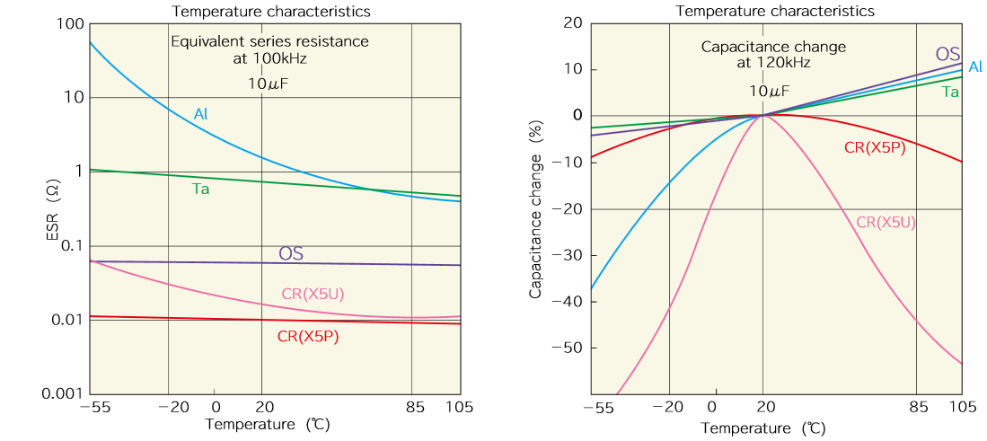

**Max Ambient Temperature**

To insure safe operation of all components in the motor drive the ambient temperature in the motor drive casing needs to stay below . The board is equipped with a temperature sensor to track the air temperature in the motor drive during operation. If the temperature approaches the microcontroller must either limit the power dissipated in the circuit or completely turn of the drive. After high demanding operation periods (excessively high torque) the motor drive might need to be disable to allow the components to cool down. Not observing these thermal limits can cause a capacitor or MOSFET to fail causing a permanent short circuit that will require the motor drive to be repaired!

**Microcontroller**

An Atmel Atmega 328P was chosen to control the motor drive. The Atmega 328P is a 8-bit Microcontroller operating at 16Mhz. The Atmega features 2 high speed PWM outputs, 6 Analog to Digital converters (ADC) and enough additional I/O pins to implement additional functions. The Atmega can communicated over UART to other microcontrollers.

One of the Atmega’s PWM outputs is used to generate the input signal to the gate driver. An inverter on the PWM signal is used to generate the inverse of that signal. The ADCs are used to measure the operating conditions of the motor controller. The Atmega can determine the current system voltage, current and temperature through measurements on the ADCs. The I/O pins are used to control the disable function on the gate driver or read in the pulses from the encoder. An overview of the different pins on the Atmega 328P are shown in the table below:

|  |  |  |  |  |
| --- | --- | --- | --- | --- |
| Pin Name | DIP28 Pin | Arduino Equivalent | Type | Controls/Reads |
| PC6 | 1 | Reset | Input | Resets Atmega 328P |
| PD0(RXD) | 2 | Digital 0 (RX) | Input | Receives serial data |
| PD1(TXD) | 3 | Digital 1 (TX) | Output | Sends serial data |
| PD2 | 4 | Digital 2 (Interrupt 0) | Input | Reads Motor Encoder |
| PD3 | 5 | Digital 3 (Interrupt 1) | Input | Reads Motor Encoder |
| VCC | 7 | N/A | Input | 5V supply IC |
| GND | 8 | N/A | Output | Ground Connection |
| PB6 | 9 | N/A | Clock | Clock pin for 16Mhz clock |
| PB7 | 10 | N/A | Clock | Clock pin for 16Mhz clock |
| PD5 | 11 | Digital 5 | Counter | Counts Encoder Pulses |
| PD7 | 13 | Digital 7 | I/O | Free pin that can be accessed if needed |
| PB0 | 14 | Digital 8 | I/O | Free pin that can be accessed if needed |
| PB3 | 17 | Digital 11 | PWM | Generates PWM for Motor Controller (8bit) |
| PB5 | 19 | Digital 13 (LED) | Output | Digital Output that enables/disables driver |
| AVCC | 20 | N/A | Input | 5V supply for ADC |
| GND | 22 | N/A | Output | Ground Signal for IC |
| PC3 | 26 | Analog Input 3 | Input | Reads Temperature sensor |
| PC4 | 27 | Analog Input 4 | Input | Reads System Voltage |
| PC5 | 28 | Analog Input 5 | Input | Reads Average input current |

All pins not listed are not used and cannot be accessed. There are 2 free pins that can be accessed through holes on the PCB. There is a Ground connection next to these free pins to connect external devices.

**Sensor Readings**

The following equations need to be implemented in the Atmega 328P program to converter the raw ADC measurement to an equivalent REAL data.

* Temperature: .0
* Voltage:
* Current: (already fixed for new sensor)

**PWM output**

The PWM output on PIN11 is used to generate the signal for the gate driver. The Atmega’s Timer 2 is utilized to generate this PWM signal. The following code can be used to setup the PWM with a frequency of 31.5kHz:

TCCR2A |= (1 << COM2A1); // set none-inverting mode

TCCR2A |= (0 << WGM22) | (0 << WGM21) | (1 << WGM20); // PWM Phase Corrected

TCCR2B = TCCR2B & 0b11111000 | 0x01; // set prescaler to 1 and starts PWM

OCR2A = 128; // Duty cycle value -> changing this value will change the duty cycle

**IMPORTANT : Disabling the PWM channel will cause the motor drive o set the motor to full reverse speed due to the presence of the signal inverter. The PWM may only be turned off if the Disable PIN is used to turn off the driver. A PWM value of 128 translates to 0V over the motor!**

**Reset**

A reset button is provided on the Printed circuit board to reset the Atmega 328P.

**Clock signal**

The Atmega 328P clock is generated using a 16Mhz crystal and 15pF load capacitors. The crystal is somewhat isolated from the other parts on the drive to insure the 16Mhz signal does not couple to other signals.

**Communication**

Serial Communication to other parts of the rover is realized through RS485. The LTC490CN is used to convert the unbalanced signal from the Atmega 328P to a differential signal. The characteristic of the transmission line is assumed to be 120Ω. The communication lines are both terminated with a 120Ω resistor to insure impedance matching. The differential signal leaves the board through an RJ45 connector. A schematic of the communication scheme is shown below:

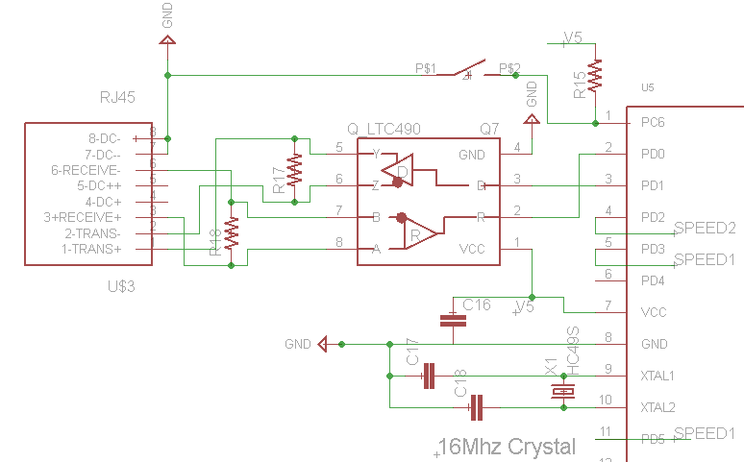

**Encoder Reading**

The pulses from the encoder are read using the Atmega 328P’s Timer 1. The timer is set up in such a way that each time it receives a pulse from the encoder it will increment its internal count. Timer 1 is a 16bit counter, therefore it can capture 65536 pulses before it rolls over and resets itself. This sets the upper limit on the sampling time, motor speed and Encoder resolution. The main motor maximum speed is 6900RPM or 115 rotations per seconds (RPS). This requires the controller sampling time and encoder to fulfill the following equation:

For instance, if the controller reads Timer 1 every second the encoder may only produce 569 pulses per rotation to still yield an accurate result.

As long as the condition described above is fulfilled the controller can determine the maximum motor speed. The slowest speed the controller can determine is given by:

The hardware counter can only determine the speed of the motor, not the direction. Therefore an interrupt based read of the encoder is required to determine the direction of the motor.

The Timer 1 hardware counter is setup and read out using the following way:

TCCR1A=0; // reset timer / the current count is stored here

bitSet(TCCR1B ,CS12); // Counter Clock source is external pin

bitSet(TCCR1B ,CS11); // Clock on rising edge

The counter should be readout in a fixed know time interval using an interrupt. Timer 0 can be used to generate an interrupt at a fixed interval. The ISR to read out the counter can be implemented the following way:

ISR (TIMER0_COMPA_vect) // timer0 overflow interrupt

{

TCCR1B = 0; //Stops counting to read counter

count = TCNT1; //Put current count into memory

TCNT1 = 0; // Resets counter

bitSet(TCCR1B ,CS12); // Counter Clock source is external pin

bitSet(TCCR1B ,CS11); // Clock on rising edge

}

**Motor control algorithm**

The motor controller implements a voltage mode control scheme. A PI or PID loop are the most appropriate control algorithms to control the motor speed. The loops can be tuned using a large variety of tuning techniques such as Ziegler-Nickolas, Coheen-Coon or Fertik. The Fertik tuning method is the best option as it provides an critically damped response with no overshoot and an small AIE (absolute integrated error) . The downside would be slow response to both set point changes or disturbances.

The selected motor can be modeled in the S-domain using state space averaging. The following equations need to be solved in Matlab to obtain the different transfer functions:

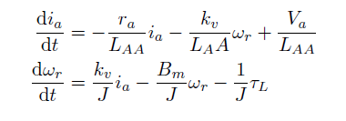

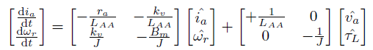

This requires the inertia and the winding inductance of the motor to be determined as this information is not provided in the datasheet. Alternatively the dynamics of the motor can be modeled by applying know set point changes to the motor and measuring the motor response.

The motor tuning will have to be completed by the Telemetry and Control team once a functional motor setup is provided by the Powertrain team.

**Micro Controller overview**

The full schematic of the Atemega connections is shown in the diagram below:

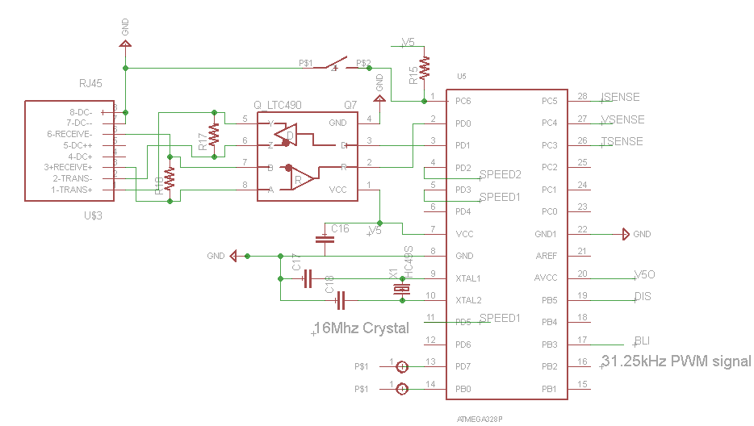

**Part list**

The complete part list for the motor drive is given below:

|  |  |  |  |
| --- | --- | --- | --- |
|  | **Component** | **Description** | **Quantity** |
| Capacitors | 35SEPF120M | OS-CON, 120uF, 20% 35V | 42 |
| **ALT to 1** | RNU1V151MDN1PH | ALUM ELECT, 150UF, 20%, 35V | 0 |
|  | EEU-FR1V471LB | ALUM ELEC, 470UF, 35V, 20% | 6 |
|  | 35PX1000MEFC10X20 | ALUM ELEC, 1000UF, 35V, 20% | 6 |
|  | EEA-GA1E150 | ALUM ELEC, 15UF, 20%, 25V | 12 |
|  | MC1206N150J201CT | CERAMIC 15PF 200V, C0G, 5%, 1206 | 12 |
|  | CC1206KRX7R9BB104 | CERAMIC, 0.1UF, 50V, X7R, 10%, 1206 | 30 |
|  | C3216X7R1E105M085AA | CERAMIC, 1UF, 25V, X7R, 20%, 1206 | 12 |
|  | C3216X5R1V226M160AC | CERAMIC, 22UF, 35V, X5R, 1206 | 24 |
| ICs | HIP4081AIPZ | MOSFET DRIVER, FULL BRIDGE, DIP-20 | 6 |
|  | ATMEGA328P-PN | MCU, 8BIT, AVR, 20MHZ, DIP-28 | 6 |
|  | LTC490CN8#PBF | RS485 TRANSCEIVER FDP 5V | 6 |
|  | CD74ACT14E | HEX INVERTER, SCHMITT TRIGGER, DIP14 | 6 |
|  | ZXCT1109SA-7 | MONITOR, CURRENT, 650KHZ, SOT-23-3 | 6 |
|  | MC7805ACTG | LDO VOLT REG, 5V, 1A, TO-220 | 6 |
|  | MC7812CTG | LDO VOLT REG, 12V, 1A, TO-220 | 6 |
|  | VS-11DQ06 | SCHOTTKY RECTIFIER, 1.1A, 60V | 12 |
|  | LM35DZ/NOPB | TEMPERATURE SENSOR, 0.4°C, TO-92-3 | 6 |
|  | IRLB3036PBF | N CH MOSFET, 60V, 195A, TO-220AB | 24 |
|  | MBR10100 | SCHOTTKY DIODE, 10A, 100V, TO-220A | 30 |
|  | 1.5KE30A-E3/54 | TVS DIODE, 1.5KW, 30V, 1.5KE | 6 |
|  | MCL034GD | LED, GREEN, T-1 (3MM), 6MCD, 570NM | 6 |
| Resistors | MCZOT0W400000A50 | RESISTOR, CERAMIC, JUMPER, 0 OHM | 24 |
|  | MF25 1R | RESISTOR, METAL FILM, 1 OHM, 250mW, 1% | 26 |
|  | CR1206-FX-1002ELF | RESISTOR, THICK FILM, 10KOHM, 250mW, 1% | 12 |
|  | CRCW120684K5FKEA | THICK FILM, 84.5KOHM, 250mW, 1% | 6 |
|  | CRF2512-FX-R005ELF | RESISTOR, THICK FILM, 0.005 OHM, 2W, 1% | 6 |
|  | MC1206S4F1200T5E | RESISTOR, THICK FILM, 120 OHM, 250mW, 1% | 12 |
|  | MC0125W12061200R | RESISTOR, 200 OHM, 125MW, ±1% | 12 |
| Crystal | HC49S-16-30-50-70-30-ATF | CRYSTAL, 16MHz, 30pF | 6 |
| Mechanical | 6025DG | HEAT SINK TO-220 | 24 |
|  | 1546074-2 | TERMINAL BLOCK, PCB, 2POS, 30-12AWG | 12 |
|  | 640454-4 | CONNECTOR HEADER 4POS, 2.54MM | 6 |
|  | MC32857 | SWITCH, TACTILE, SPST-NO, 50mA | 6 |
|  | 2227MC-08-03-18-F1 | CONNECTOR, DIP SOCKET, 8WAY, PC BOARD | 6 |
|  | 1-390262-2 | DIP SOCKET, 28POS, THROUGH HOLE | 6 |
|  | 1-390261-3 | DIP SOCKET, 14POS, THROUGH HOLE | 6 |
|  |  |  |  |

**Full Schematic**

